Supplementary information

Supplementary Table 1. Specifications of used antibodies.

 | Antigen | Immunogen | Manufacturer, species, mono- or polyclonal, catalog or lot No., RRID | Dilution used
Primary antibodies | FoxP2 | Synthetic peptide derived from C-terminal amino acids of isoforms I, II, IV, and V of human FOXP2: REIEEEPLSEDLE | Everest Biotech, goat polyclonal, Cat.# EB05226, Lot # 160409, RRID: AB_2107112 | 1:5000
Primary antibodies | FoxP2 | Full length protein corresponding to human FOXP2 | Abcam, mouse monoclonal, ab172320 | 1:1000
Primary antibodies | Pcdh10 | The cytoplasmic domain of the OL-protocadherin isoform | Millipore, rat monoclonal, clone 5G10, Cat. # MABT20, Lot # NRG1759424, RRID:AB_10807416 | 1:1600
Secondary antibodies | Anti-goat IgG, Alexa Fluor 488-conjugated |  | Jackson ImmunoResearch, donkey, Cat. # 705-545-147 | 1:333
Secondary antibodies | Anti-mouse IgG, Alexa Fluor 647-conjugated |  | Jackson ImmunoResearch, donkey, Cat. # 715-605-150 | 1:333
Secondary antibodies | Anti-rat IgG, Alexa Fluor 647-conjugated |  | Jackson ImmunoResearch, donkey, Cat. # 712-605-150 | 1:333

Supplementary Table 2. The number of labeled neurons in the IO subdivisions in G2A::Ai9 mice with tamoxifen injection at different embryonic dates.
Tam timing | Mouse | Subdivisions | cMAO-a | cMAO-b | cMAO-c | Beta | DC/VLO | dDAO, medial | dDAO, lateral | vDAO, medial | vDAO, interm. | vDAO, lateral | dPO, medial | dPO, lateral | vPO, medial | vPO, lateral | DM | DMCC | rMAO | Total
E9.5 | HG11b | Left | 0 | 0 | 0 | 0 | 0 | 0 | 0 | 0 | 0 | 0 | 0 | 0 | 0 | 0 | 0 | 0 | 0 | 0
E9.5 | HG11b | Right | 0 | 0 | 0 | 0 | 0 | 0 | 0 | 0 | 0 | 0 | 0 | 0 | 0 | 0 | 0 | 0 | 0 | 0
E10.0 | HG07a | Left | 2 | 8 | 7 | 18 | 14 | 22 | 18 | 16 | 31 | 39 | 12 | 15 | 9 | 4 | 5 | 0 | 1 | 221
E10.0 | HG07a | Right | 3 | 9 | 7 | 24 | 26 | 25 | 13 | 31 | 45 | 57 | 20 | 27 | 4 | 9 | 8 | 1 | 3 | 324
E10.0 | HG07b | Left | 1 | 3 | 8 | 15 | 15 | 24 | 12 | 35 | 19 | 27 | 15 | 10 | 10 | 4 | 3 | 1 | 2 | 204
E10.0 | HG07b | Right | 2 | 4 | 4 | 9 | 18 | 21 | 12 | 20 | 11 | 33 | 15 | 12 | 3 | 3 | 3 | 1 | 3 | 180
E10.5 | HG02a | Left | 10 | 47 | 52 | 97 | 53 | 40 | 53 | 93 | 134 | 134 | 80 | 95 | 22 | 28 | 68 | 7 | 24 | 1037
E10.5 | HG02a | Right | 12 | 41 | 71 | 92 | 50 | 62 | 59 | 127 | 107 | 124 | 61 | 105 | 29 | 33 | 53 | 11 | 31 | 1068
E10.5 | HG02b | Left | 8 | 61 | 61 | 86 | 63 | 72 | 66 | 64 | 159 | 129 | 47 | 97 | 32 | 47 | 51 | 9 | 24 | 1076
E10.5 | HG02b | Right | 11 | 50 | 73 | 81 | 58 | 74 | 63 | 83 | 131 | 109 | 50 | 113 | 36 | 42 | 66 | 4 | 17 | 1061
E11.0 | HG22a | Left | 40 | 134 | 121 | 107 | 65 | 44 | 49 | 151 | 141 | 101 | 100 | 167 | 69 | 66 | 89 | 24 | 92 | 1560
E11.0 | HG22a | Right | 39 | 128 | 117 | 110 | 64 | 48 | 47 | 141 | 111 | 109 | 83 | 149 | 61 | 78 | 106 | 15 | 54 | 1460
E11.0 | HG04c | Left | 8 | 49 | 38 | 42 | 23 | 32 | 10 | 41 | 55 | 39 | 42 | 42 | 18 | 23 | 24 | 3 | 36 | 525
E11.0 | HG04c | Right | 6 | 30 | 39 | 36 | 34 | 31 | 20 | 45 | 60 | 42 | 29 | 34 | 22 | 8 | 40 | 4 | 21 | 501
E11.5 | HG03b | Left | 42 | 176 | 100 | 52 | 21 | 8 | 1 | 7 | 4 | 3 | 20 | 70 | 76 | 50 | 101 | 24 | 142 | 897
E11.5 | HG03b | Right | 58 | 226 | 165 | 53 | 16 | 0 | 0 | 17 | 8 | 4 | 36 | 77 | 92 | 56 | 131 | 26 | 156 | 1121
E11.5 | HG03c | Left | 27 | 87 | 39 | 23 | 4 | 0 | 0 | 6 | 8 | 3 | 9 | 36 | 30 | 44 | 70 | 7 | 95 | 488
E11.5 | HG03c | Right | 27 | 91 | 39 | 23 | 4 | 0 | 0 | 6 | 8 | 3 | 9 | 36 | 30 | 44 | 70 | 7 | 95 | 492
E12.0 | HG05a | Left | 5 | 2 | 0 | 0 | 0 | 0 | 0 | 0 | 0 | 0 | 0 | 0 | 0 | 1 | 2 | 0 | 15 | 25
E12.0 | HG05a | Right | 5 | 6 | 1 | 0 | 0 | 0 | 0 | 0 | 0 | 0 | 0 | 1 | 1 | 0 | 2 | 2 | 18 | 36
E12.0 | HG05b | Left | 8 | 5 | 0 | 0 | 0 | 0 | 1 | 0 | 0 | 0 | 0 | 0 | 0 | 2 | 1 | 0 | 34 | 51
E12.0 | HG05b | Right | 13 | 9 | 2 | 0 | 0 | 2 | 0 | 0 | 0 | 0 | 0 | 0 | 0 | 1 | 1 | 0 | 13 | 41
E12.5 | HG01a | Left | 0 | 0 | 0 | 0 | 0 | 0 | 0 | 0 | 0 | 0 | 0 | 0 | 0 | 0 | 0 | 0 | 0 | 0
E12.5 | HG01a | Right | 0 | 0 | 0 | 0 | 2 | 0 | 0 | 0 | 0 | 0 | 0 | 0 | 0 | 0 | 0 | 0 | 0 | 2
E13.0 | HG08c | Left | 0 | 0 | 0 | 0 | 1 | 0 | 0 | 1 | 0 | 1 | 0 | 0 | 0 | 1 | 0 | 0 | 0 | 4
E13.0 | HG08c | Right | 0 | 1 | 0 | 0 | 0 | 0 | 0 | 0 | 0 | 0 | 0 | 0 | 0 | 0 | 0 | 0 | 0 | 1
All IO Neurons | HG03b | Left | 582 | 1852 | 1003 | 701 | 472 | 400 | 245 | 974 | 837 | 714 | 585 | 848 | 649 | 405 | 1011 | 115 | 1328 | 12721
All IO Neurons | HG03b | Right | 749 | 1876 | 1381 | 694 | 383 | 427 | 177 | 826 | 999 | 620 | 607 | 576 | 685 | 343 | 990 | 133 | 1283 | 12749
Counted manually in serial sections immunostained for FoxP2. Tamoxifen injection at E13.5 did not produce any labeling in IO neurons.

Supplementary Figure 1.

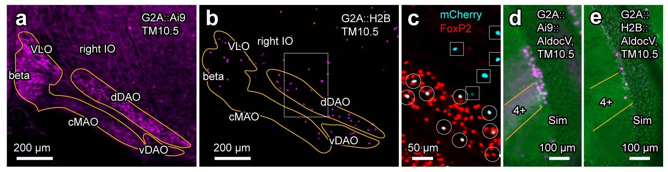
Supplementary Figure 1. Sensitivity and specificity of R26R-H2B-mCherry (“H2B”) reporter mice. (a, b) Neuronal labeling in the right IO at the level of 40% from the caudal edge in coronal sections of G2A::Ai9::AldocV (a) and G2A::H2B (b) mice in which tamoxifen was given at E10.5. Yellow lines indicate the contour of the IO. White square indicates the area shown in (c). The tdTomato expression in Ai9 strain and the mCherry expression in H2B strain are shown in magenta pseudo color. (c) Higher magnification of the image of the same section as shown in (b). The FoxP2 immunostaining signal is shown in red pseudo color, whereas the mCherry H2B reporter signal is shown in cyan pseudo color. H2B reporter labeling in IO neurons was co-localized with the FoxP2 signal (white circles) indicating they are localized in the nucleus. On the contrary, H2B reporter labeling outside the IO was not co-localized with the FoxP2 signal (white squares). (d, e) Purkinje cell labeling in the right simple lobule of the cerebellum in coronal sections of G2A::Ai9::AldocV (d) and G2A::H2B::AldocV (e) mice in which tamoxifen was given at E10.5. Yellow lines indicate boundaries of zebrin stripe 4+. The Venus expression of these mice is shown in green pseudo color, whereas the tdTomato Ai9 reporter signal in the G2A::Ai9::AldocV mouse and the mCherry H2B reporter signal in the G2A::H2B::AldocV mouse are shown in magenta pseudo color. See the separate list for abbreviations.

Supplementary Figure 2.

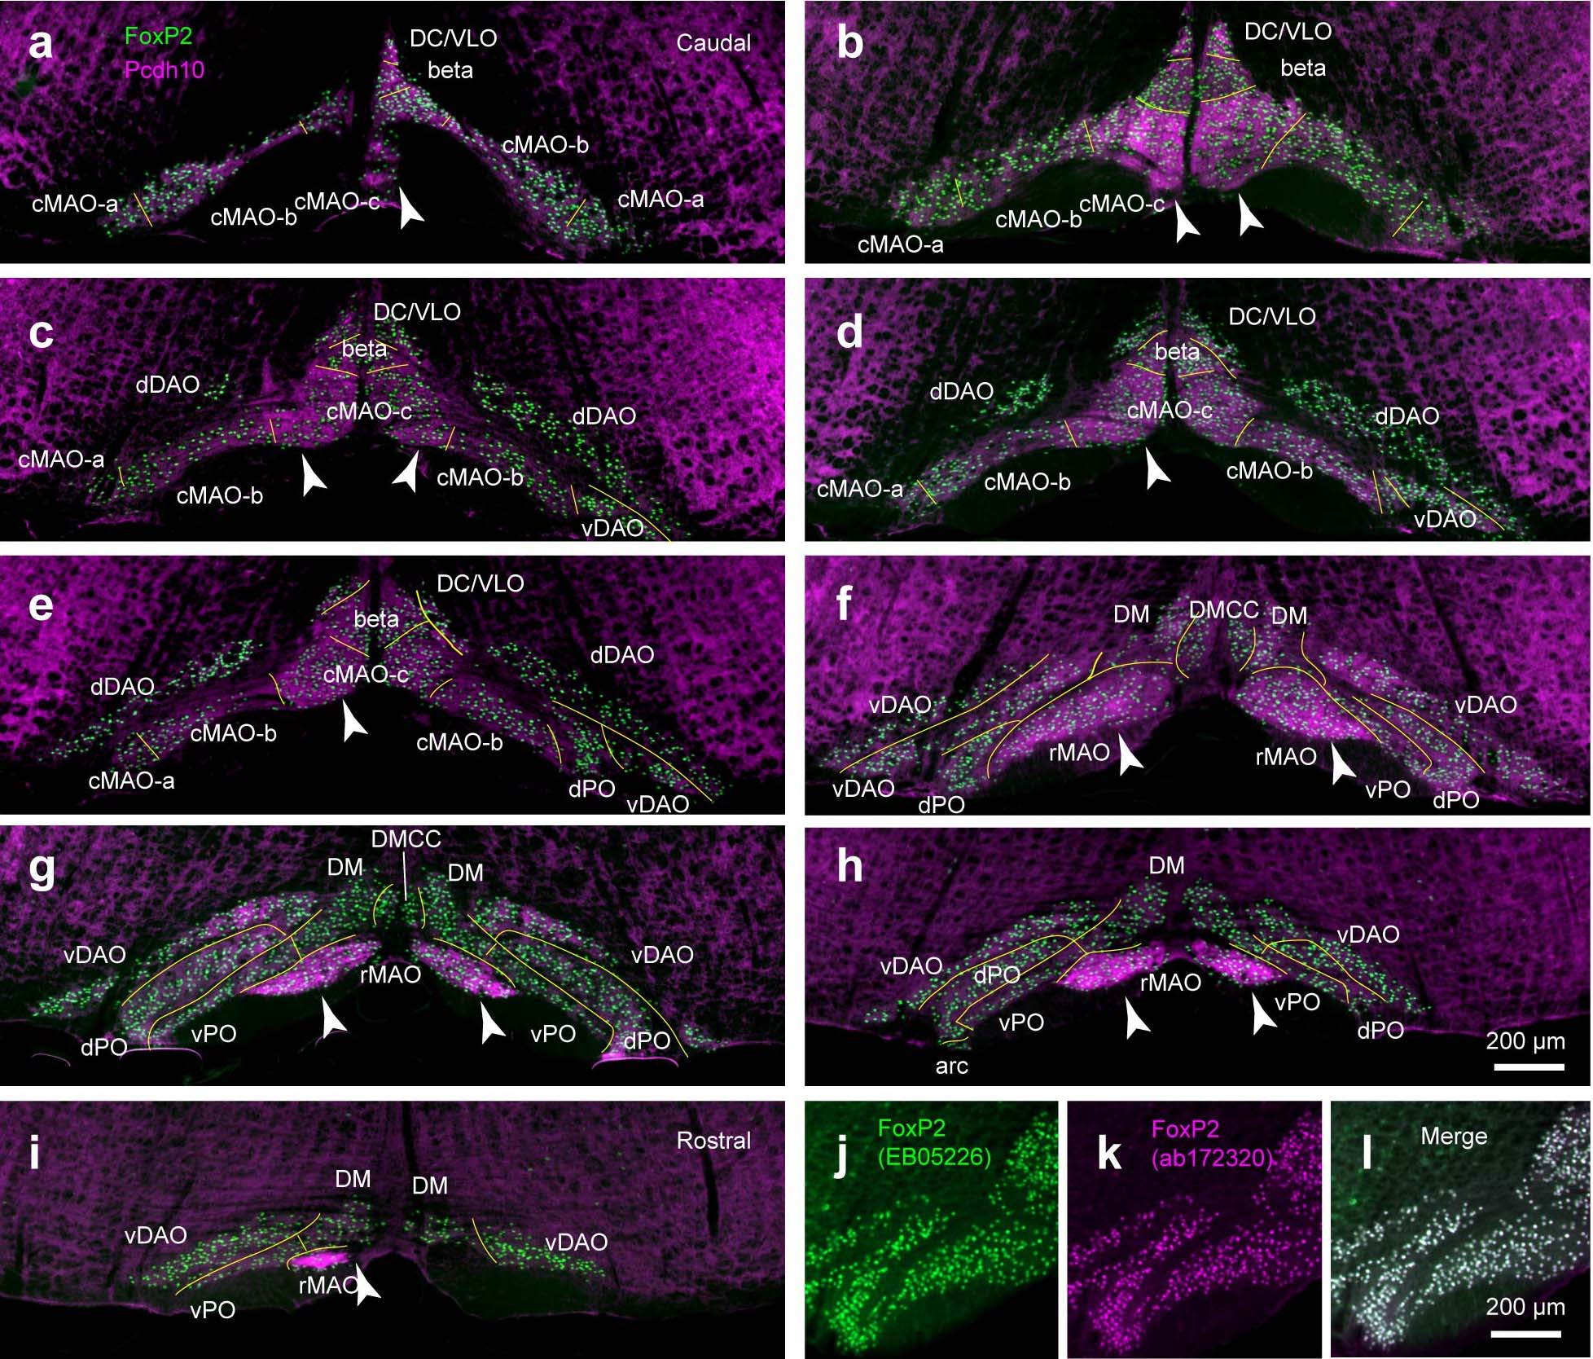
Supplementary Figure 2. Marker molecule expression patterns and subdivisions of the IO. (a–i) Coronal sections of the IO immunostained for FoxP2 (green) and Pcdh10 (magenta). Sections are from different caudorostral levels of the IO with an approximately 10% interval in an H2B::Ai9::AldocV mouse at P40–42. Arrowheads show areas with relatively higher Pcdh10 immunoreactivity. (j–l) FoxP2 immunostaining with different antibodies (Everest goat antibody in green, SantaCruz mouse monoclonal antibody in magenta) producing virtually the same pattern. See the separate list for abbreviations.

Supplementary Figure 3.

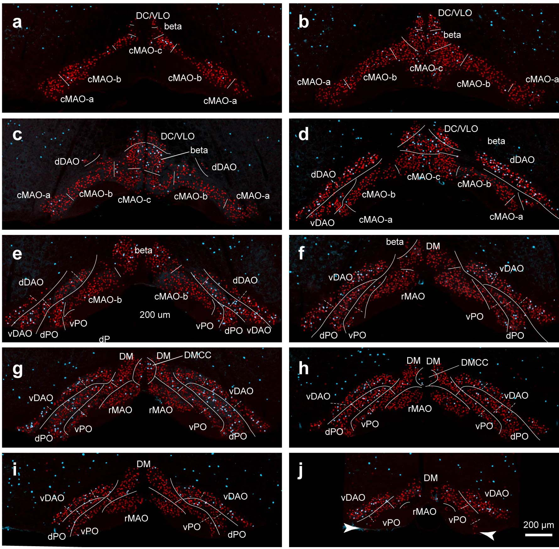
Supplementary Figure 3. Definition of IO subdivisions in the present study. (a–j) Coronal sections showing 10 different levels with an approximately 9% interval in a G2A::H2B mouse at P40–42. Signals indicate immunostaining for FoxP2 (red) and H2B reporter labeling (cyan, TM10.5). White lines indicate boundaries between IO subdivisions. Arrowheads in (j) indicate the lateral arcuate nucleus. See the separate list for abbreviations.

