Supplementary information

Prevalence of Metal Contaminants In Rice And Their Potential Health Risks to The Bahamian Population – A Preliminary Study

Carlton Watson ª, Patricia J. Johnson ^{b} and Williamson Gustave ^{*c}

ª Small Island Sustainability Research Institute, University of the Bahamas, New Providence, Nassau, Bahamas
^{b} Bahamas Agricultural Health and Food Safety Authority, New Providence, Nassau, Bahamas
^{c} The School of Chemistry, Environmental & Life Sciences, University of the Bahamas, New Providence, Nassau, Bahamas

* Corresponding author. The School of Chemistry, Environmental & Life Sciences, University of the Bahamas, New Providence, Nassau, Bahamas
E-mail address: Gutsavewill@hotmail.com; Williamson.Gustave@ub.edu.bs (W. Gustave)

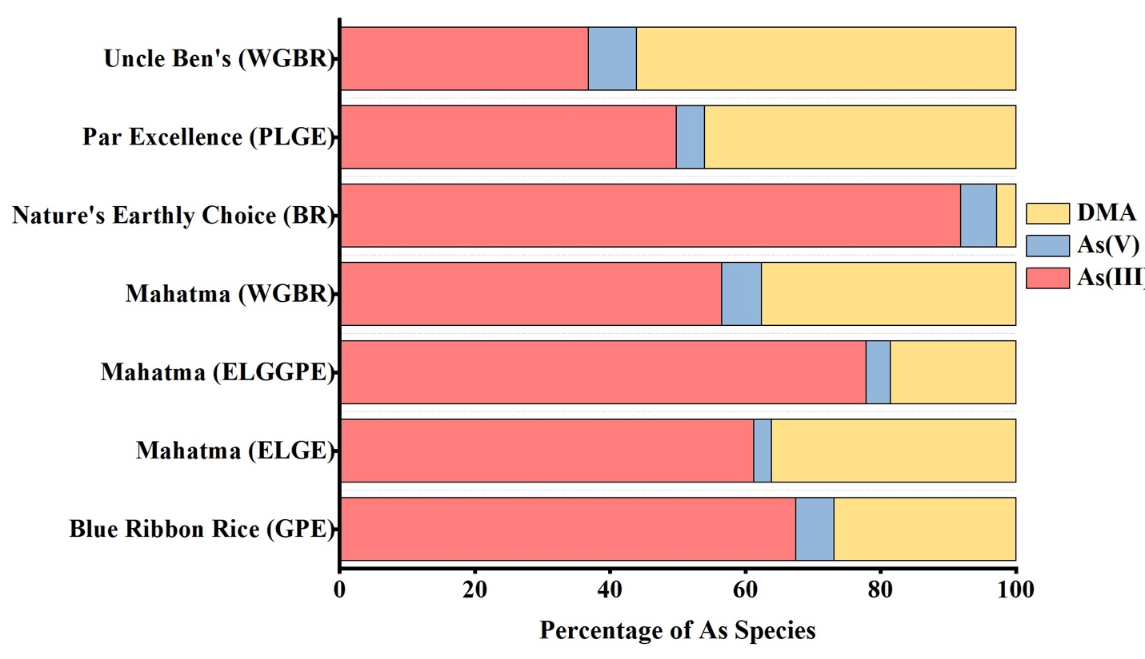
Figure S1. Results from arsenic(As) speciation measurements from selected rice samples (those with high overall arsenic content). The red and blue represent the toxic inorganic arsenic(iAs) species while the yellow represents the organic forms of As. Recently there has been some debate as to the toxicity of organic As. In general, the more toxic inorganic (As(III) and As(V)) forms of As were the major As species detected in the rice samples. As(III) = arsenite; As(V) = arsenate and DMA = Dimethylarsinic acid.

Dimethylarsinic acid (DMA) is an organic arsenic species that is less toxic than inorganic arsenic for animals and humans. The 200-ppb permissible level of arsenic in rice only consider inorganic arsenic species, therefore measuring total arsenic is not sufficient when calculating risk associated with arsenic exposure. The organic arsenic contribution must be removed. This is why we measure monomethylarsonic acid (MMA) and DMA concentration. For example, if total arsenic concentration is high (above the 200-ppb permissible level) in a rice sample and organic arsenic species make up the majority, then this rice sample may still be safe for consumption since organic arsenic (DMA) has a low toxicity to human and animals.

Brand
1 | A Taste of Thai | 11 | Mahatma
2 | Arroz Rico | 12 | Minute
3 | Asian Best | 13 | Nature's Earthly Choice
4 | Blue Ribbon | 14 | Par Excellence
5 | Camil | 15 | Rice A Roni
6 | Della | 16 | Rice Select
7 | Essential Everyday | 17 | Riceland
8 | Goya | 18 | Sun Supreme
9 | Jamaica Bahama Imports | 19 | Uncle Ben's
10 | Lundberg | 20 | Veetee
 |  | 21 | Vigo

Table S1. The Key rice brand used in this study.

Variety
AI | Arroz Integral |  | GPE | Golden Parboiled (Enriched)
B | Basmati |  | J | Jasmine
BA | Basmati Aged |  | LGE | Long Grain (Enriched)
BC | Basmati California |  | LGP | Long Grain Parboiled
BSB | Basmati Sprouted Brown |  | LGW | Long Grain White
BW | Basmati White |  | LGWE | Long Grain White (Enriched)
BLR | Black Rice |  | MG | Medium Grain
BLGN | Brown Long Grain Natural |  | PLGE | Parboiled Long Grain (Enriched)
BR | Brown Rice |  | RP | Rice Pilaf
ELG | Extra Long Grain |  | SR | Sushi Rice
ELGE | Extra Long Grain (Enriched) |  | VSGE | Valencia Short Grain (Enriched)
ELGGPE | Extra Long Grain Gold Parboiled (Enriched) |  | WGBR | Whole Grain Brown Rice
ELGWE | Extra Long Grain White (Enriched) |  | YRS | Yellow Rice (Seasoned)

Table S2. The variety of rice used in this study.

