Supplementary Materials

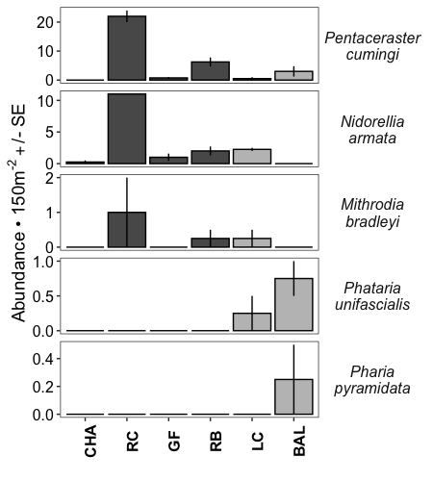

Supplementary Figure 1. Sea star densities observed in 150 m² plots on large horizontal- sloping areas of reef at 6 sites, 4 terraced (in dark grey bars) and 2 mixed substrate (light grey bars), adjacent to vertical walls where band transects took place. Data represent pooled surveys conducted in July 2014 and in January 2015. A. carinifera was not observed in these plots.

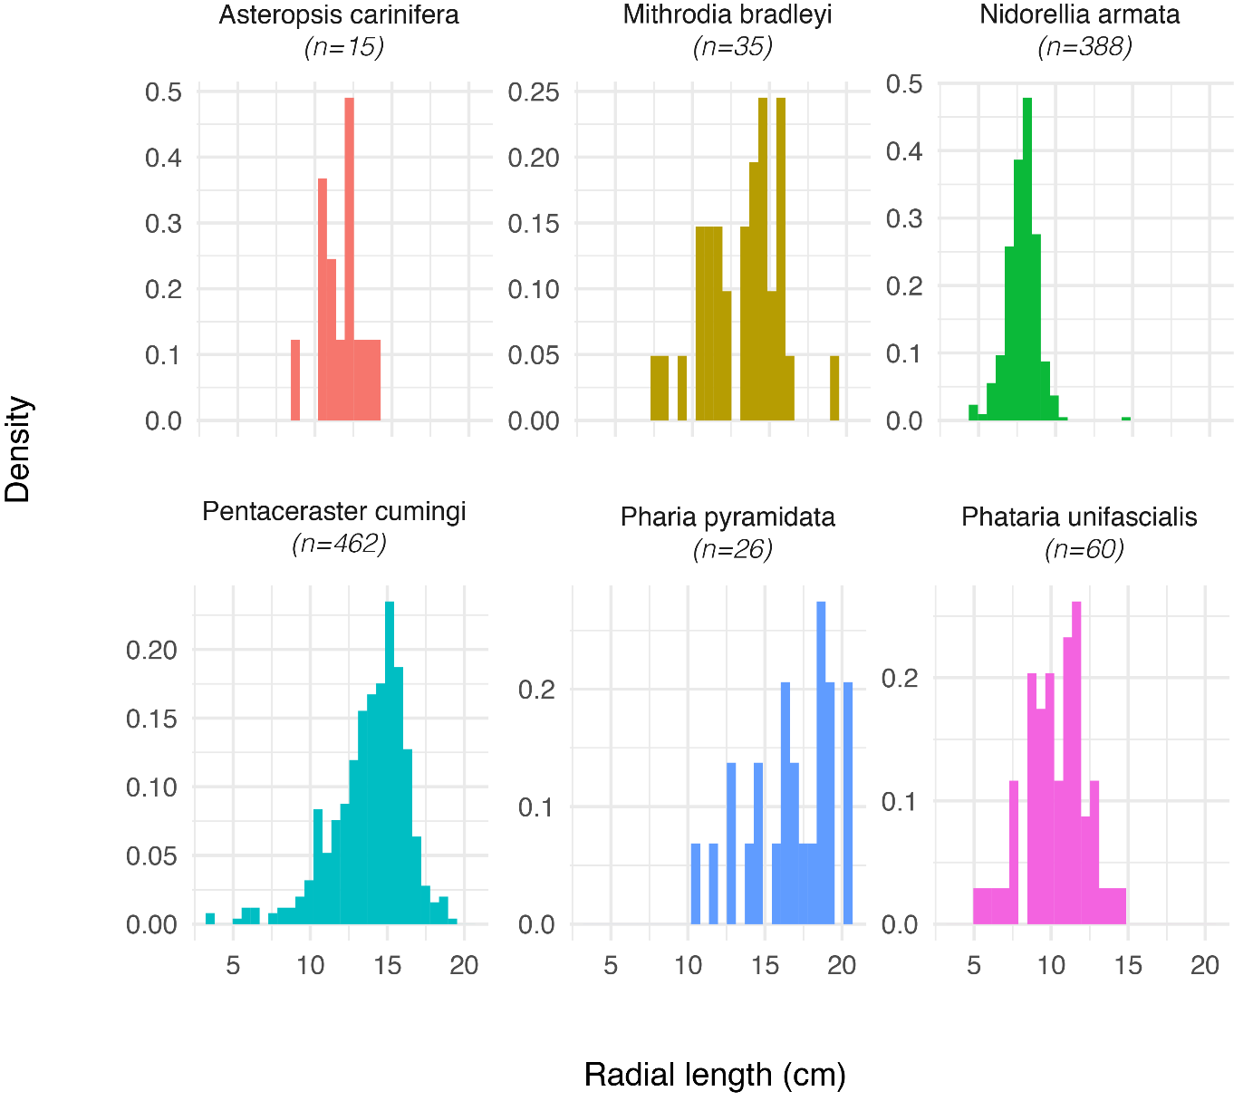

Supplementary Figure 2. Size frequency plots for most common sea star species in Galápagos, showing size as measure of radial length (R).

Supplementary Table 1. Location of study sites.

Site name | Easting | Northing
Champion | -90.38498 | -1.23683
Cousins | -90.573092 | -0.236963
Daphne Menor | -90.353209 | -0.394639
Guy Fawkes | -90.512222 | -0.498966
Cuatro Hermanos | -90.748095 | -0.848474
Islote Gardner | -90.294292 | -1.328788
La Botella | -90.498998 | -1.289917
Las Cuevas | -90.356412 | -1.26508
Norte Baltra | -90.274449 | -0.411553
Pinzón | -90.685954 | -0.590869
Rocas Beagle | -90.627996 | -0.412717
Rocas Gordon | -90.14065 | -0.565962

Supplementary Table 2. Temperature regimes during the sea star feeding experiments. Temperatures in ºC, measured at 10 min intervals and at 12-15 m depth (n = number of temperature measurements).

Experiment, Site, Month, Year | Average Temperature | Standard Deviation | Maximum Temperature | Minimum Temperature | n
P. cumingi predation on E. galapagensis, Baltra, January 2012 | 24.6 | 1.8 | 25.8 | 17.6 | 576
N. armata grazing, Baltra, September – November 2013 | 21.2 | 1.1 | 23.1 | 15.3 | 13,105

Supplementary Table 3. Results of Tukey multiple comparisons tests for pairwise differences in abundance of each sea star species among study sites. Compact letter display is used to indicate no significant difference between sites that have the same letter. These site assignments by letter are independent for each species (i.e., all sites with the letter "a" for A. carinifera have similar densities of this species, all sites with letter "a" for M. bradleyi have similar densities of this species, etc.)

Site | Asteropsis carinifera | Mithrodia  bradleyi | Nidorellia  armata | Pentaceraster  cumingi | Pharia  pyramidata | Phataria unifascialis
champion | a | a | a | a | b | ab
cousins | a | a | bc | d | ab | a
cuatro.  hermanos | ab | a | ab | a | ab | a
daphne.  menor | a | a | a | a | b | b
guy.fawkes | a | a | b | ab | a | b
islote.  gardner | a | a | ab | a | ab | a
la.botella | ab | a | ab | a | ab | a
las.cuevas | b | b | bc | bc | ab | a
norte.baltra | a | a | a | a | ab | a
pinzon | a | a | a | a | ab | a
rocas.beagle | ab | a | c | c | ab | ab
rocas.gordon | ab | ab | ab | a | ab | ab

Supplementary Table 4. ANOVA and multiple comparisons tests for differences in sea star abundance between six sites in 150m² plots.

Mithrodia bradleyi
 | Df | Sum Sq | Mean Sq | F value | Pr(>F)
site | 5 | 0.106 | 0.021 | 1.361 | 0.2903
Residuals | 16 | 0.250 | 0.016
Nidorellia armata
 | Df | Sum Sq | Mean Sq | F value | Pr(>F)
site | 5 | 2.010 | 0.402 | 11.627 | <0.001 | ***
Residuals | 16 | 0.553 | 0.035
Pairwise Comparison | Difference | Lower | Upper | Adjusted pvalue
Cousins-champion | 1.004 | 0.485 | 1.523 | <0.001
las.cuevas-champion | 0.433 | 0.009 | 0.857 | 0.044
guy.fawkes-cousins | -0.841 | -1.360 | -0.322 | 0.001
las.cuevas-cousins | -0.571 | -1.090 | -0.052 | 0.027
norte.baltra-cousins | -1.079 | -1.598 | -0.560 | <0.001
rocas.beagle-cousins | -0.659 | -1.178 | -0.140 | 0.009
norte.baltra-las.cuevas | -0.508 | -0.932 | -0.085 | 0.014
Pentaceraster cumingi
 | Df | Sum Sq | Mean Sq | F value | Pr(>F)
site | 5 | 3.631 | 0.726 | 12.748 | <0.001 | ***
Residuals | 16 | 0.911 | 0.057
Pairwise Comparison | Difference | Lower | Upper | Adjusted p-value
cousins-champion | 1.360 | 0.694 | 2.026 | <0.001
rocas.beagle-champion | 0.819 | 0.275 | 1.363 | 0.002
guy.fawkes-cousins | -1.134 | -1.800 | -0.468 | 0.001
las.cuevas-cousins | -1.241 | -1.907 | -0.575 | <0.001
norte.baltra-cousins | -0.896 | -1.562 | -0.230 | 0.006
rocas.beagle-guy.fawkes | 0.593 | 0.050 | 1.137 | 0.028
rocas.beagle-las.cuevas | 0.700 | 0.156 | 1.244 | 0.008
Pharia pyramidata
 | Df | Sum Sq | Mean Sq | F value | Pr(>F)
site | 5 | 0.019 | 0.004 | 0.873 | 0.521
Residuals | 16 | 0.068 | 0.004
Phataria unifascialis
 | Df | Sum Sq | Mean Sq | F value | Pr(>F)
site | 5 | 0.16064 | 0.032129 | 3.7818 | 0.01882 | *
Residuals | 16 | 0.13593 | 0.008496
Pairwise Comparison | Difference | Lower | Upper | Adjusted p-value
norte.baltra-champion | 0.226 | 0.016 | 0.436 | 0.031
rocas.beagle-norte.baltra | -0.226 | -0.436 | -0.016 | 0.031

Supplementary Table 5. Non-metric Multi-Dimensional Scaling (nMDS) tests on multivariate composition of sea star diets.

PERMANOVA table

 | Df | SumsOfSqs | MeanSqs | F.Model | R2 | Pr(>F)
feeding_PCA$Species | 4 | 2.0234 | 0.5058 | 3.1853 | 0.3206 | 0.001
Residuals | 27 | 4.2878 | 0.1588 |  | 0.6794
Total | 31 | 6.3111 |  |  | 1.0000

SIMPER table

Contrast: | Mithrodia_Pentaceraster
 | average | sd | ratio | ava | avb | cumsum
Macroalgae | 0.1577 | 0.0667 | 2.3666 | 0.3366 | 0.6577 | 0.2442
Sediment | 0.1282 | 0.0915 | 1.4007 | 0.4344 | 0.4485 | 0.4426
Invertebrates | 0.1116 | 0.0618 | 1.8073 | 0.4718 | 0.2246 | 0.6153
CCA | 0.0878 | 0.0556 | 1.5782 | 0.1638 | 0.3666 | 0.7512
Urchins | 0.0829 | 0.0149 | 5.5699 | 0.0000 | 0.3243 | 0.8795
Diatoms | 0.0669 | 0.0528 | 1.2673 | 0.2301 | 0.2174 | 0.9830
Crustose | 0.0110 | 0.0248 | 0.4417 | 0.0000 | 0.0421 | 1.0000
Contrast: | Mithrodia_Pharia
 | average | sd | ratio | ava | avb | cumsum
Invertebrates | 0.1866 | 0.1399 | 1.3338 | 0.4718 | 0.9013 | 0.2900
Macroalgae | 0.1603 | 0.1531 | 1.0467 | 0.3366 | 0.4017 | 0.5391
Sediment | 0.1373 | 0.1650 | 0.8320 | 0.4344 | 0.0804 | 0.7526
Diatoms | 0.1088 | 0.1157 | 0.9406 | 0.2301 | 0.2388 | 0.9217
CCA | 0.0504 | 0.0896 | 0.5622 | 0.1638 | 0.0000 | 1.0000
Crustose | 0.0000 | 0.0000 | NaN | 0.0000 | 0.0000 | 1.0000
Urchins | 0.0000 | 0.0000 | NaN | 0.0000 | 0.0000 | 1.0000
Contrast: | Mithrodia_Phataria
 | average | sd | ratio | ava | avb | cumsum
Macroalgae | 0.2066 | 0.1599 | 1.2930 | 0.3366 | 0.7260 | 0.3270
Sediment | 0.1439 | 0.1357 | 1.0600 | 0.4344 | 0.3271 | 0.5546
Invertebrates | 0.1252 | 0.1021 | 1.2260 | 0.4718 | 0.3555 | 0.7527
Diatoms | 0.0850 | 0.0820 | 1.0370 | 0.2301 | 0.2198 | 0.8871
CCA | 0.0713 | 0.0840 | 0.8490 | 0.1638 | 0.1561 | 1.0000
Crustose | 0.0000 | 0.0000 | NaN | 0.0000 | 0.0000 | 1.0000
Urchins | 0.0000 | 0.0000 | NaN | 0.0000 | 0.0000 | 1.0000
Contrast: | Mithrodia_Nidorellia
 | average | sd | ratio | ava | avb | cumsum
CCA | 0.2008 | 0.1252 | 1.6036 | 0.1638 | 0.8272 | 0.2796
Macroalgae | 0.1595 | 0.0986 | 1.6177 | 0.3366 | 0.5147 | 0.5018
Sediment | 0.1355 | 0.1178 | 1.1500 | 0.4344 | 0.2934 | 0.6904
Invertebrates | 0.1274 | 0.0959 | 1.3286 | 0.4718 | 0.1029 | 0.8678
Diatoms | 0.0679 | 0.0706 | 0.9619 | 0.2301 | 0.0901 | 0.9624
Crustose | 0.0270 | 0.0330 | 0.8193 | 0.0000 | 0.0997 | 1.0000
Urchins | 0.0000 | 0.0000 | NaN | 0.0000 | 0.0000 | 1.0000
Contrast: | Pentaceraster_Pharia
 | average | sd | ratio | ava | avb | cumsum
Invertebrates | 0.1749 | 0.1182 | 1.4802 | 0.2246 | 0.9013 | 0.2614
Macroalgae | 0.1146 | 0.0669 | 1.7135 | 0.6577 | 0.4017 | 0.4327
Sediment | 0.1015 | 0.0589 | 1.7240 | 0.4485 | 0.0804 | 0.5845
CCA | 0.0945 | 0.0535 | 1.7684 | 0.3666 | 0.0000 | 0.7257
Diatoms | 0.0894 | 0.0730 | 1.2248 | 0.2174 | 0.2388 | 0.8593
Urchins | 0.0832 | 0.0150 | 5.5360 | 0.3243 | 0.0000 | 0.9836
Crustose | 0.0110 | 0.0251 | 0.4377 | 0.0421 | 0.0000 | 1.0000
Contrast: | Pentaceraster_Phataria
 | average | sd | ratio | ava | avb | cumsum
Macroalgae | 0.1064 | 0.0876 | 1.2160 | 0.6577 | 0.7260 | 0.2113
Sediment | 0.0853 | 0.0576 | 1.4810 | 0.4485 | 0.3271 | 0.3807
CCA | 0.0804 | 0.0504 | 1.5940 | 0.3666 | 0.1561 | 0.5402
Urchins | 0.0800 | 0.0148 | 5.3960 | 0.3243 | 0.0000 | 0.6990
Invertebrates | 0.0765 | 0.0476 | 1.6090 | 0.2246 | 0.3555 | 0.8509
Diatoms | 0.0645 | 0.0423 | 1.5250 | 0.2174 | 0.2198 | 0.9790
Crustose | 0.0106 | 0.0241 | 0.4390 | 0.0421 | 0.0000 | 1.0000
Contrast: | Pentaceraster_Nidorellia
 | average | sd | ratio | ava | avb | cumsum
CCA | 0.1314 | 0.0815 | 1.6124 | 0.3666 | 0.8272 | 0.2888
Urchins | 0.0772 | 0.0141 | 5.4778 | 0.3243 | 0.0000 | 0.4585
Sediment | 0.0716 | 0.0477 | 1.5012 | 0.4485 | 0.2934 | 0.6159
Macroalgae | 0.0647 | 0.0511 | 1.2653 | 0.6577 | 0.5147 | 0.7581
Diatoms | 0.0446 | 0.0341 | 1.3106 | 0.2174 | 0.0901 | 0.8562
Invertebrates | 0.0390 | 0.0278 | 1.4057 | 0.2246 | 0.1029 | 0.9420
Crustose | 0.0264 | 0.0280 | 0.9418 | 0.0421 | 0.0997 | 1.0000
Contrast: | Pharia_Phataria
 | average | sd | ratio | ava | avb | cumsum
Invertebrates | 0.1844 | 0.1471 | 1.2536 | 0.9013 | 0.3555 | 0.3049
Macroalgae | 0.1787 | 0.1441 | 1.2396 | 0.4017 | 0.7260 | 0.6003
Diatoms | 0.1017 | 0.1094 | 0.9300 | 0.2388 | 0.2198 | 0.7685
Sediment | 0.0956 | 0.0915 | 1.0457 | 0.0804 | 0.3271 | 0.9267
CCA | 0.0444 | 0.0706 | 0.6285 | 0.0000 | 0.1561 | 1.0000
Crustose | 0.0000 | 0.0000 | NaN | 0.0000 | 0.0000 | 1.0000
Urchins | 0.0000 | 0.0000 | NaN | 0.0000 | 0.0000 | 1.0000
Contrast: | Pharia_Nidorellia
 | average | sd | ratio | ava | avb | cumsum
CCA | 0.2352 | 0.1207 | 1.9486 | 0.0000 | 0.8272 | 0.3052
Invertebrates | 0.2284 | 0.1307 | 1.7485 | 0.9013 | 0.1029 | 0.6017
Macroalgae | 0.1235 | 0.0805 | 1.5353 | 0.4017 | 0.5147 | 0.7620
Diatoms | 0.0808 | 0.1045 | 0.7733 | 0.2388 | 0.0901 | 0.8669
Sediment | 0.0754 | 0.0631 | 1.1944 | 0.0804 | 0.2934 | 0.9648
Crustose | 0.0271 | 0.0333 | 0.8150 | 0.0000 | 0.0997 | 1.0000
Urchins | 0.0000 | 0.0000 | NaN | 0.0000 | 0.0000 | 1.0000
Contrast: | Phataria_Nidorellia
 | average | sd | ratio | ava | avb | cumsum
CCA | 0.1940 | 0.1193 | 1.6260 | 0.1561 | 0.8272 | 0.3239
Macroalgae | 0.1380 | 0.1108 | 1.2460 | 0.7260 | 0.5147 | 0.5544
Invertebrates | 0.0892 | 0.0685 | 1.3026 | 0.3555 | 0.1029 | 0.7033
Sediment | 0.0892 | 0.0660 | 1.3507 | 0.3271 | 0.2934 | 0.8522
Diatoms | 0.0625 | 0.0592 | 1.0546 | 0.2198 | 0.0901 | 0.9565
Crustose | 0.0260 | 0.0319 | 0.8155 | 0.0000 | 0.0997 | 1.0000
Urchins | 0.0000 | 0.0000 | NaN | 0.0000 | 0.0000 | 1.0000

Supplementary Table 6. Permutation test of dispersion and pairwise comparison (Tukey HSD) for sea star diets.

Permutation test of dispersion
 | Df | Sum Sq | Mean Sq | F value | p-value
Groups | 4 | 0.44 | 0.11 | 2.99 | 0.036
Residuals | 27 | 1.00 | 0.04
Pairwise comparison (Tukey HSD)
 | Mean diff | lower | upper | Adj. pvalue
Nidorellia-Mithrodia | 0.25 | 0.53 | 0.03 | 0.042
Pentaceraster-Mithrodia | 0.33 | 0.65 | 0.02 | 0.032
Pharia-Mithrodia | 0.16 | 0.52 | 0.19 | 0.655
Phataria-Mithrodia | 0.11 | 0.44 | 0.22 | 0.861
Pentaceraster-Nidorellia | 0.08 | 0.37 | 0.21 | 0.915
Pharia-Nidorellia | 0.09 | 0.25 | 0.42 | 0.942
Phataria-Nidorellia | 0.14 | 0.17 | 0.45 | 0.681
Pharia-Pentaceraster | 0.17 | 0.19 | 0.53 | 0.656
Phataria-Pentaceraster | 0.22 | 0.12 | 0.56 | 0.335
Phataria-Pharia | 0.05 | 0.32 | 0.43 | 0.993

