Supplemental materials
Table S1 Search strategy developed for umbrella review and meta-meta analysis in Pubmed, Web of Science and Scopus databases
Database | Keywords
Pubmed
#1 | "covid 19"[All Fields] OR "covid 19"[MeSH Terms] OR "covid 19 vaccines"[All Fields] OR "covid 19 vaccines"[MeSH Terms] OR "covid 19 serotherapy"[All Fields] OR "covid 19 serotherapy"[Supplementary Concept] OR "covid 19 nucleic acid testing"[All Fields] OR "covid 19 nucleic acid testing"[MeSH Terms] OR "covid 19 serological testing"[All Fields] OR "covid 19 serological testing"[MeSH Terms] OR "covid 19 testing"[All Fields] OR "covid 19 testing"[MeSH Terms] OR "sars cov 2"[All Fields] OR "sars cov 2"[MeSH Terms] OR "severe acute respiratory syndrome coronavirus 2"[All Fields] OR "ncov"[All Fields] OR "2019 ncov"[All Fields] OR (("coronavirus"[MeSH Terms] OR "coronavirus"[All Fields] OR "cov"[All Fields]) AND 2019/11/01:3000/12/31[Date - Publication]) OR ("sars cov 2"[MeSH Terms] OR "sars cov 2"[All Fields] OR "sars cov 2"[All Fields]) OR ("coronavirus"[MeSH Terms] OR "coronavirus"[All Fields] OR "coronaviruses"[All Fields]) OR ("sars cov 2"[MeSH Terms] OR "sars cov 2"[All Fields] OR "severe acute respiratory syndrome coronavirus 2"[All Fields]) OR ("sars cov 2"[MeSH Terms] OR "sars cov 2"[All Fields] OR "2019 ncov"[All Fields])  Translations  COVID-19: ("COVID-19" OR "COVID-19"[MeSH Terms] OR "COVID-19 Vaccines" OR "COVID-19 Vaccines"[MeSH Terms] OR "COVID-19 serotherapy" OR "COVID-19 serotherapy"[Supplementary Concept] OR "COVID-19 Nucleic Acid Testing" OR "covid-19 nucleic acid testing"[MeSH Terms] OR "COVID-19 Serological Testing" OR "covid-19 serological testing"[MeSH Terms] OR "COVID-19 Testing" OR "covid-19 testing"[MeSH Terms] OR "SARS-CoV-2" OR "sars-cov-2"[MeSH Terms] OR "Severe Acute Respiratory Syndrome Coronavirus 2" OR "NCOV" OR "2019 NCOV" OR (("coronavirus"[MeSH Terms] OR "coronavirus" OR "COV") AND 2019/11/01[PDAT] : 3000/12/31[PDAT]))  SARS-CoV-2: "sars-cov-2"[MeSH Terms] OR "sars-cov-2"[All Fields] OR "sars cov 2"[All Fields]  coronavirus: "coronavirus"[MeSH Terms] OR "coronavirus"[All Fields] OR "coronaviruses"[All Fields]  severe acute respiratory syndrome coronavirus 2: "sars-cov-2"[MeSH Terms] OR "sars-cov-2"[All Fields] OR "severe acute respiratory syndrome coronavirus 2"[All Fields]  2019 ncov: "sars-cov-2"[MeSH Terms] OR "sars-cov-2"[All Fields] OR "2019 ncov"[All Fields]
#2 | "cancer s"[All Fields] OR "cancerated"[All Fields] OR "canceration"[All Fields] OR "cancerization"[All Fields] OR "cancerized"[All Fields] OR "cancerous"[All Fields] OR "neoplasms"[MeSH Terms] OR "neoplasms"[All Fields] OR "cancer"[All Fields] OR "cancers"[All Fields] OR "cysts"[MeSH Terms] OR "cysts"[All Fields] OR "cyst"[All Fields] OR "neurofibroma"[MeSH Terms] OR "neurofibroma"[All Fields] OR "neurofibromas"[All Fields] OR "tumor s"[All Fields] OR "tumoral"[All Fields] OR "tumorous"[All Fields] OR "tumour"[All Fields] OR "neoplasms"[MeSH Terms] OR "neoplasms"[All Fields] OR "tumor"[All Fields] OR "tumour s"[All Fields] OR "tumoural"[All Fields] OR "tumourous"[All Fields] OR "tumours"[All Fields] OR "tumors"[All Fields] OR "neoplasm s"[All Fields] OR "neoplasms"[MeSH Terms] OR "neoplasms"[All Fields] OR "neoplasm"[All Fields] OR "malign"[All Fields] OR "malignance"[All Fields] OR "malignances"[All Fields] OR "malignant"[All Fields] OR "malignants"[All Fields] OR "malignities"[All Fields] OR "malignity"[All Fields] OR "malignization"[All Fields] OR "malignized"[All Fields] OR "maligns"[All Fields] OR "neoplasms"[MeSH Terms] OR "neoplasms"[All Fields] OR "malignancies"[All Fields] OR "malignancy"[All Fields]  Translations  cancer: "cancer's"[All Fields] OR "cancerated"[All Fields] OR "canceration"[All Fields] OR "cancerization"[All Fields] OR "cancerized"[All Fields] OR "cancerous"[All Fields] OR "neoplasms"[MeSH Terms] OR "neoplasms"[All Fields] OR "cancer"[All Fields] OR "cancers"[All Fields]  tumour: "cysts"[MeSH Terms] OR "cysts"[All Fields] OR "cyst"[All Fields] OR "neurofibroma"[MeSH Terms] OR "neurofibroma"[All Fields] OR "neurofibromas"[All Fields] OR "tumor's"[All Fields] OR "tumoral"[All Fields] OR "tumorous"[All Fields] OR "tumour"[All Fields] OR "neoplasms"[MeSH Terms] OR "neoplasms"[All Fields] OR "tumor"[All Fields] OR "tumour's"[All Fields] OR "tumoural"[All Fields] OR "tumourous"[All Fields] OR "tumours"[All Fields] OR "tumors"[All Fields]  neoplasms: "neoplasm's"[All Fields] OR "neoplasms"[MeSH Terms] OR "neoplasms"[All Fields] OR "neoplasm"[All Fields]  malignancy: "malign"[All Fields] OR "malignance"[All Fields] OR "malignances"[All Fields] OR "malignant"[All Fields] OR "malignants"[All Fields] OR "malignities"[All Fields] OR "malignity"[All Fields] OR "malignization"[All Fields] OR "malignized"[All Fields] OR "maligns"[All Fields] OR "neoplasms"[MeSH Terms] OR "neoplasms"[All Fields] OR "malignancies"[All Fields] OR "malignancy"[All Fields]
#3 | (("intensive care units"[MeSH Terms] OR ("intensive"[All Fields] AND "care"[All Fields] AND "units"[All Fields]) OR "intensive care units"[All Fields] OR "icu"[All Fields]) AND ("admission"[All Fields] OR "admissions"[All Fields])) OR ("mortality"[MeSH Terms] OR "mortality"[All Fields] OR "mortalities"[All Fields] OR "mortality"[MeSH Subheading]) OR ("death"[MeSH Terms] OR "death"[All Fields] OR "deaths"[All Fields])  Translations  ICU: "intensive care units"[MeSH Terms] OR ("intensive"[All Fields] AND "care"[All Fields] AND "units"[All Fields]) OR "intensive care units"[All Fields] OR "icu"[All Fields]  admission: "admission"[All Fields] OR "admissions"[All Fields]  mortality: "mortality"[MeSH Terms] OR "mortality"[All Fields] OR "mortalities"[All Fields] OR "mortality"[Subheading]  death: "death"[MeSH Terms] OR "death"[All Fields] OR "deaths"[All Fields]
#4 | Search: meta-analysis[Title]  "meta-analysis"[Title]
#5 | #1 AND #2 AND #3  ("covid 19"[All Fields] OR "covid 19"[MeSH Terms] OR "covid 19 vaccines"[All Fields] OR "covid 19 vaccines"[MeSH Terms] OR "covid 19 serotherapy"[All Fields] OR "covid 19 serotherapy"[Supplementary Concept] OR "covid 19 nucleic acid testing"[All Fields] OR "covid 19 nucleic acid testing"[MeSH Terms] OR "covid 19 serological testing"[All Fields] OR "covid 19 serological testing"[MeSH Terms] OR "covid 19 testing"[All Fields] OR "covid 19 testing"[MeSH Terms] OR "sars cov 2"[All Fields] OR "sars cov 2"[MeSH Terms] OR "severe acute respiratory syndrome coronavirus 2"[All Fields] OR "ncov"[All Fields] OR "2019 ncov"[All Fields] OR (("coronavirus"[MeSH Terms] OR "coronavirus"[All Fields] OR "cov"[All Fields]) AND 2019/11/01:3000/12/31[Date - Publication]) OR ("sars cov 2"[MeSH Terms] OR "sars cov 2"[All Fields] OR "sars cov 2"[All Fields]) OR ("coronavirus"[MeSH Terms] OR "coronavirus"[All Fields] OR "coronaviruses"[All Fields]) OR ("sars cov 2"[MeSH Terms] OR "sars cov 2"[All Fields] OR "severe acute respiratory syndrome coronavirus 2"[All Fields]) OR ("sars cov 2"[MeSH Terms] OR "sars cov 2"[All Fields] OR "2019 ncov"[All Fields])) AND ("cancer s"[All Fields] OR "cancerated"[All Fields] OR "canceration"[All Fields] OR "cancerization"[All Fields] OR "cancerized"[All Fields] OR "cancerous"[All Fields] OR "neoplasms"[MeSH Terms] OR "neoplasms"[All Fields] OR "cancer"[All Fields] OR "cancers"[All Fields] OR ("cysts"[MeSH Terms] OR "cysts"[All Fields] OR "cyst"[All Fields] OR "neurofibroma"[MeSH Terms] OR "neurofibroma"[All Fields] OR "neurofibromas"[All Fields] OR "tumor s"[All Fields] OR "tumoral"[All Fields] OR "tumorous"[All Fields] OR "tumour"[All Fields] OR "neoplasms"[MeSH Terms] OR "neoplasms"[All Fields] OR "tumor"[All Fields] OR "tumour s"[All Fields] OR "tumoural"[All Fields] OR "tumourous"[All Fields] OR "tumours"[All Fields] OR "tumors"[All Fields]) OR ("neoplasm s"[All Fields] OR "neoplasms"[MeSH Terms] OR "neoplasms"[All Fields] OR "neoplasm"[All Fields]) OR ("malign"[All Fields] OR "malignance"[All Fields] OR "malignances"[All Fields] OR "malignant"[All Fields] OR "malignants"[All Fields] OR "malignities"[All Fields] OR "malignity"[All Fields] OR "malignization"[All Fields] OR "malignized"[All Fields] OR "maligns"[All Fields] OR "neoplasms"[MeSH Terms] OR "neoplasms"[All Fields] OR "malignancies"[All Fields] OR "malignancy"[All Fields])) AND ((("intensive care units"[MeSH Terms] OR ("intensive"[All Fields] AND "care"[All Fields] AND "units"[All Fields]) OR "intensive care units"[All Fields] OR "icu"[All Fields]) AND ("admission"[All Fields] OR "admissions"[All Fields])) OR ("mortality"[MeSH Terms] OR "mortality"[All Fields] OR "mortalities"[All Fields] OR "mortality"[MeSH Subheading]) OR ("death"[MeSH Terms] OR "death"[All Fields] OR "deaths"[All Fields]))  Translations  COVID-19: ("COVID-19" OR "COVID-19"[MeSH Terms] OR "COVID-19 Vaccines" OR "COVID-19 Vaccines"[MeSH Terms] OR "COVID-19 serotherapy" OR "COVID-19 serotherapy"[Supplementary Concept] OR "COVID-19 Nucleic Acid Testing" OR "covid-19 nucleic acid testing"[MeSH Terms] OR "COVID-19 Serological Testing" OR "covid-19 serological testing"[MeSH Terms] OR "COVID-19 Testing" OR "covid-19 testing"[MeSH Terms] OR "SARS-CoV-2" OR "sars-cov-2"[MeSH Terms] OR "Severe Acute Respiratory Syndrome Coronavirus 2" OR "NCOV" OR "2019 NCOV" OR (("coronavirus"[MeSH Terms] OR "coronavirus" OR "COV") AND 2019/11/01[PDAT] : 3000/12/31[PDAT]))  SARS-CoV-2: "sars-cov-2"[MeSH Terms] OR "sars-cov-2"[All Fields] OR "sars cov 2"[All Fields]  coronavirus: "coronavirus"[MeSH Terms] OR "coronavirus"[All Fields] OR "coronaviruses"[All Fields]  severe acute respiratory syndrome coronavirus 2: "sars-cov-2"[MeSH Terms] OR "sars-cov-2"[All Fields] OR "severe acute respiratory syndrome coronavirus 2"[All Fields]  2019 ncov: "sars-cov-2"[MeSH Terms] OR "sars-cov-2"[All Fields] OR "2019 ncov"[All Fields]  cancer: "cancer's"[All Fields] OR "cancerated"[All Fields] OR "canceration"[All Fields] OR "cancerization"[All Fields] OR "cancerized"[All Fields] OR "cancerous"[All Fields] OR "neoplasms"[MeSH Terms] OR "neoplasms"[All Fields] OR "cancer"[All Fields] OR "cancers"[All Fields]  tumour: "cysts"[MeSH Terms] OR "cysts"[All Fields] OR "cyst"[All Fields] OR "neurofibroma"[MeSH Terms] OR "neurofibroma"[All Fields] OR "neurofibromas"[All Fields] OR "tumor's"[All Fields] OR "tumoral"[All Fields] OR "tumorous"[All Fields] OR "tumour"[All Fields] OR "neoplasms"[MeSH Terms] OR "neoplasms"[All Fields] OR "tumor"[All Fields] OR "tumour's"[All Fields] OR "tumoural"[All Fields] OR "tumourous"[All Fields] OR "tumours"[All Fields] OR "tumors"[All Fields]  neoplasms: "neoplasm's"[All Fields] OR "neoplasms"[MeSH Terms] OR "neoplasms"[All Fields] OR "neoplasm"[All Fields]  malignancy: "malign"[All Fields] OR "malignance"[All Fields] OR "malignances"[All Fields] OR "malignant"[All Fields] OR "malignants"[All Fields] OR "malignities"[All Fields] OR "malignity"[All Fields] OR "malignization"[All Fields] OR "malignized"[All Fields] OR "maligns"[All Fields] OR "neoplasms"[MeSH Terms] OR "neoplasms"[All Fields] OR "malignancies"[All Fields] OR "malignancy"[All Fields]  ICU: "intensive care units"[MeSH Terms] OR ("intensive"[All Fields] AND "care"[All Fields] AND "units"[All Fields]) OR "intensive care units"[All Fields] OR "icu"[All Fields]  admission: "admission"[All Fields] OR "admissions"[All Fields]  mortality: "mortality"[MeSH Terms] OR "mortality"[All Fields] OR "mortalities"[All Fields] OR "mortality"[Subheading]  death: "death"[MeSH Terms] OR "death"[All Fields] OR "deaths"[All Fields]
#6 | #4 AND #5  Search: (meta-analysis[Title]) AND (((((((COVID-19) OR (SARS-CoV-2)) OR (coronavirus)) OR (severe acute respiratory syndrome coronavirus 2)) OR (2019 ncov)) AND ((((cancer) OR (tumour)) OR (neoplasms)) OR (malignancy))) AND (((ICU admission) OR (mortality)) OR (death)))  "meta-analysis"[Title] AND (("covid 19"[All Fields] OR "covid 19"[MeSH Terms] OR "covid 19 vaccines"[All Fields] OR "covid 19 vaccines"[MeSH Terms] OR "covid 19 serotherapy"[All Fields] OR "covid 19 serotherapy"[Supplementary Concept] OR "covid 19 nucleic acid testing"[All Fields] OR "covid 19 nucleic acid testing"[MeSH Terms] OR "covid 19 serological testing"[All Fields] OR "covid 19 serological testing"[MeSH Terms] OR "covid 19 testing"[All Fields] OR "covid 19 testing"[MeSH Terms] OR "sars cov 2"[All Fields] OR "sars cov 2"[MeSH Terms] OR "severe acute respiratory syndrome coronavirus 2"[All Fields] OR "ncov"[All Fields] OR "2019 ncov"[All Fields] OR (("coronavirus"[MeSH Terms] OR "coronavirus"[All Fields] OR "cov"[All Fields]) AND 2019/11/01:3000/12/31[Date - Publication]) OR ("sars cov 2"[MeSH Terms] OR "sars cov 2"[All Fields] OR "sars cov 2"[All Fields]) OR ("coronavirus"[MeSH Terms] OR "coronavirus"[All Fields] OR "coronaviruses"[All Fields]) OR ("sars cov 2"[MeSH Terms] OR "sars cov 2"[All Fields] OR "severe acute respiratory syndrome coronavirus 2"[All Fields]) OR ("sars cov 2"[MeSH Terms] OR "sars cov 2"[All Fields] OR "2019 ncov"[All Fields])) AND ("cancer s"[All Fields] OR "cancerated"[All Fields] OR "canceration"[All Fields] OR "cancerization"[All Fields] OR "cancerized"[All Fields] OR "cancerous"[All Fields] OR "neoplasms"[MeSH Terms] OR "neoplasms"[All Fields] OR "cancer"[All Fields] OR "cancers"[All Fields] OR ("cysts"[MeSH Terms] OR "cysts"[All Fields] OR "cyst"[All Fields] OR "neurofibroma"[MeSH Terms] OR "neurofibroma"[All Fields] OR "neurofibromas"[All Fields] OR "tumor s"[All Fields] OR "tumoral"[All Fields] OR "tumorous"[All Fields] OR "tumour"[All Fields] OR "neoplasms"[MeSH Terms] OR "neoplasms"[All Fields] OR "tumor"[All Fields] OR "tumour s"[All Fields] OR "tumoural"[All Fields] OR "tumourous"[All Fields] OR "tumours"[All Fields] OR "tumors"[All Fields]) OR ("neoplasm s"[All Fields] OR "neoplasms"[MeSH Terms] OR "neoplasms"[All Fields] OR "neoplasm"[All Fields]) OR ("malign"[All Fields] OR "malignance"[All Fields] OR "malignances"[All Fields] OR "malignant"[All Fields] OR "malignants"[All Fields] OR "malignities"[All Fields] OR "malignity"[All Fields] OR "malignization"[All Fields] OR "malignized"[All Fields] OR "maligns"[All Fields] OR "neoplasms"[MeSH Terms] OR "neoplasms"[All Fields] OR "malignancies"[All Fields] OR "malignancy"[All Fields])) AND ((("intensive care units"[MeSH Terms] OR ("intensive"[All Fields] AND "care"[All Fields] AND "units"[All Fields]) OR "intensive care units"[All Fields] OR "icu"[All Fields]) AND ("admission"[All Fields] OR "admissions"[All Fields])) OR ("mortality"[MeSH Terms] OR "mortality"[All Fields] OR "mortalities"[All Fields] OR "mortality"[MeSH Subheading]) OR ("death"[MeSH Terms] OR "death"[All Fields] OR "deaths"[All Fields])))  Translations  COVID-19: ("COVID-19" OR "COVID-19"[MeSH Terms] OR "COVID-19 Vaccines" OR "COVID-19 Vaccines"[MeSH Terms] OR "COVID-19 serotherapy" OR "COVID-19 serotherapy"[Supplementary Concept] OR "COVID-19 Nucleic Acid Testing" OR "covid-19 nucleic acid testing"[MeSH Terms] OR "COVID-19 Serological Testing" OR "covid-19 serological testing"[MeSH Terms] OR "COVID-19 Testing" OR "covid-19 testing"[MeSH Terms] OR "SARS-CoV-2" OR "sars-cov-2"[MeSH Terms] OR "Severe Acute Respiratory Syndrome Coronavirus 2" OR "NCOV" OR "2019 NCOV" OR (("coronavirus"[MeSH Terms] OR "coronavirus" OR "COV") AND 2019/11/01[PDAT] : 3000/12/31[PDAT]))  SARS-CoV-2: "sars-cov-2"[MeSH Terms] OR "sars-cov-2"[All Fields] OR "sars cov 2"[All Fields]  coronavirus: "coronavirus"[MeSH Terms] OR "coronavirus"[All Fields] OR "coronaviruses"[All Fields]  severe acute respiratory syndrome coronavirus 2: "sars-cov-2"[MeSH Terms] OR "sars-cov-2"[All Fields] OR "severe acute respiratory syndrome coronavirus 2"[All Fields]  2019 ncov: "sars-cov-2"[MeSH Terms] OR "sars-cov-2"[All Fields] OR "2019 ncov"[All Fields]  cancer: "cancer's"[All Fields] OR "cancerated"[All Fields] OR "canceration"[All Fields] OR "cancerization"[All Fields] OR "cancerized"[All Fields] OR "cancerous"[All Fields] OR "neoplasms"[MeSH Terms] OR "neoplasms"[All Fields] OR "cancer"[All Fields] OR "cancers"[All Fields]  tumour: "cysts"[MeSH Terms] OR "cysts"[All Fields] OR "cyst"[All Fields] OR "neurofibroma"[MeSH Terms] OR "neurofibroma"[All Fields] OR "neurofibromas"[All Fields] OR "tumor's"[All Fields] OR "tumoral"[All Fields] OR "tumorous"[All Fields] OR "tumour"[All Fields] OR "neoplasms"[MeSH Terms] OR "neoplasms"[All Fields] OR "tumor"[All Fields] OR "tumour's"[All Fields] OR "tumoural"[All Fields] OR "tumourous"[All Fields] OR "tumours"[All Fields] OR "tumors"[All Fields]  neoplasms: "neoplasm's"[All Fields] OR "neoplasms"[MeSH Terms] OR "neoplasms"[All Fields] OR "neoplasm"[All Fields]  malignancy: "malign"[All Fields] OR "malignance"[All Fields] OR "malignances"[All Fields] OR "malignant"[All Fields] OR "malignants"[All Fields] OR "malignities"[All Fields] OR "malignity"[All Fields] OR "malignization"[All Fields] OR "malignized"[All Fields] OR "maligns"[All Fields] OR "neoplasms"[MeSH Terms] OR "neoplasms"[All Fields] OR "malignancies"[All Fields] OR "malignancy"[All Fields]  ICU: "intensive care units"[MeSH Terms] OR ("intensive"[All Fields] AND "care"[All Fields] AND "units"[All Fields]) OR "intensive care units"[All Fields] OR "icu"[All Fields]  admission: "admission"[All Fields] OR "admissions"[All Fields]  mortality: "mortality"[MeSH Terms] OR "mortality"[All Fields] OR "mortalities"[All Fields] OR "mortality"[Subheading]  death: "death"[MeSH Terms] OR "death"[All Fields] OR "deaths"[All Fields]
Web of Science (WoS)
#1 | ALL=(COVID-19 OR SARS-CoV-2 OR coronavirus OR severe acute respiratory syndrome coronavirus 2 OR 2019 ncov) Indexes=SCI-EXPANDED, SSCI, A&HCI, CPCI-S, CPCI-SSH, BKCIS, BKCI-SSH, ESCI, CCR-EXPANDED
#2 | ALL=(cancer OR tumour OR neoplasms OR malignancy ) Indexes=SCI-EXPANDED, SSCI, A&HCI, CPCI-S, CPCI-SSH, BKCIS, BKCI-SSH, ESCI, CCR-EXPANDED
#3 | ALL=(ICU admission OR mortality OR death) Indexes=SCI-EXPANDED, SSCI, A&HCI, CPCI-S, CPCI-SSH, BKCIS, BKCI-SSH, ESCI, CCR-EXPANDED
#4 | #1 AND #2 AND #3 Indexes=SCI-EXPANDED, SSCI, A&HCI, CPCI-S, CPCI-SSH, BKCIS, BKCI-SSH, ESCI, CCR-EXPANDED
#5 | #5 AND #4 Indexes=SCI-EXPANDED, SSCI, A&HCI, CPCI-S, CPCI-SSH, BKCIS, BKCI-SSH, ESCI, CCR-EXPANDED
Scopus
#1 | Cancer
#2 | malignan*
#3 | tumour
#4 | neoplasm
#5 | ( TITLE-ABS-KEY ( cancer ) ) OR ( TITLE-ABSKEY ( malignan* ) ) OR ( TITLE-ABSKEY ( tumour ) ) OR ( TITLE-ABS-KEY ( neoplasm ) )
#6 | 2019-ncov AND pneumonia
#7 | sars-cov-2
#8 | coronavirus
#9 | covid-19
#10 | Meta-analysis
#11 | ( 2019-ncov AND pneumonia ) OR ( sars-cov2 ) OR ( coronavirus ) OR ( covid-19 )
#12 | ( ( TITLE-ABS-KEY ( cancer ) ) OR ( TITLE-ABSKEY ( malignan* ) ) OR ( TITLE-ABSKEY ( tumour ) ) OR ( TITLE-ABSKEY ( neoplasm ) ) ) AND ( ( 2019- ncov AND pneumonia ) OR ( sars-cov2 ) OR ( coronavirus ) OR ( covid19 ) ) AND (meta-analysis))

Table S2 Quality assessment of studies included in umbrella review and meta-meta analysis
First author | Number of studies / sample size | Selection | Comparability | Outcome | Total
Arayici et al. 2021 (1) | 58 / 709,908 | *** | *** | ** | ********
Khoury et al. 2022 (2) | 81 / 61,532 | *** | ** | ** | *******
Di Felice et al. 2022 (3) | 35 / 142,355 | *** | *** | ** | ********
Han et al. 2022 (5) | 57 / 63,413 | ** | ** | ** | ******
Venkatesulu et al. 2021 (6) | 26 / 181,323 | *** | *** | ** | ********
Yang et al. 2021 (7) | 19 / 63,019 | *** | ** | ** | ******
Salunke et al. 2020 (9) | 13 / 3,775 | *** | ** | *** | ********
Tian et al. 2020 (8) | 38 / 7,094 | ** | ** | ** | ******
Giannakoulis et al. 2020 (4) | 32 / 46,499 | *** | *** | ** | ********
Parohan et al. 2020 (10) | 14 / 29,900 | *** | ** | ** | *******

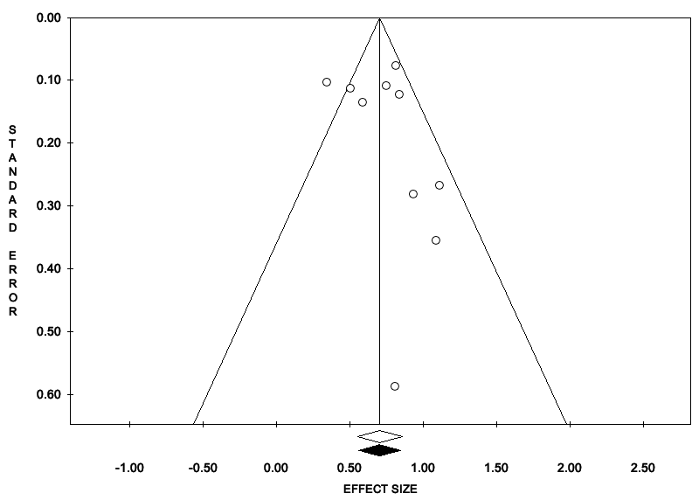
Fig. S1 The funnel plot of OR for mortality in patients with cancer affected by COVID-19 is approximately symmetrical and, in accordance to the results of Egger’s (P = 0.464) and Begg’s (P = 0.788) tests, fades the possibility of potential publication bias

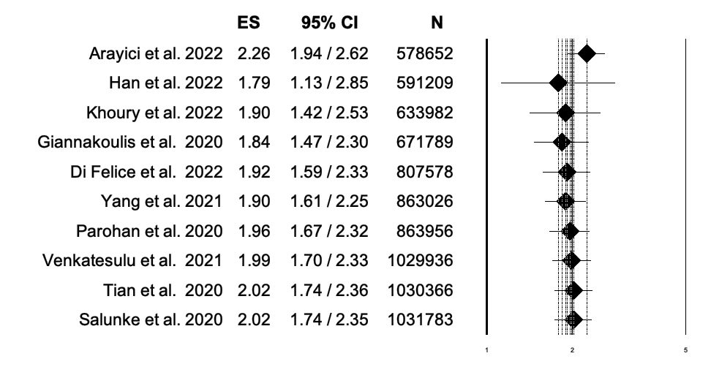
Fig. S2 Cumulative analysis of mortality in patients with cancer affected by COVID-19

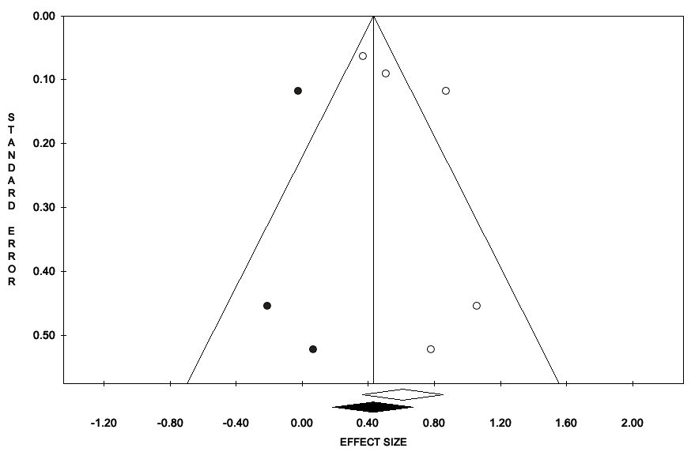
Fig. S3 The funnel plot of OR for ICU admission in patients with cancer affected by COVID-19 is approximately symmetrical and, in accordance to the results of Egger’s (P = 0.273) and Begg’s (P = 0.327) tests, fades the possibility of potential publication bias

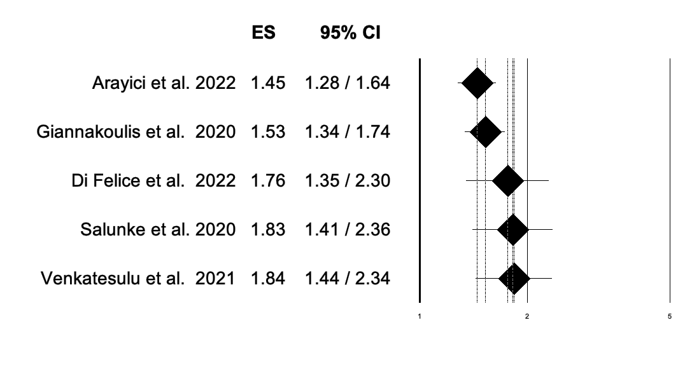
Fig. S4 Cumulative analysis of ICU admission in patients with cancer affected by COVID-19

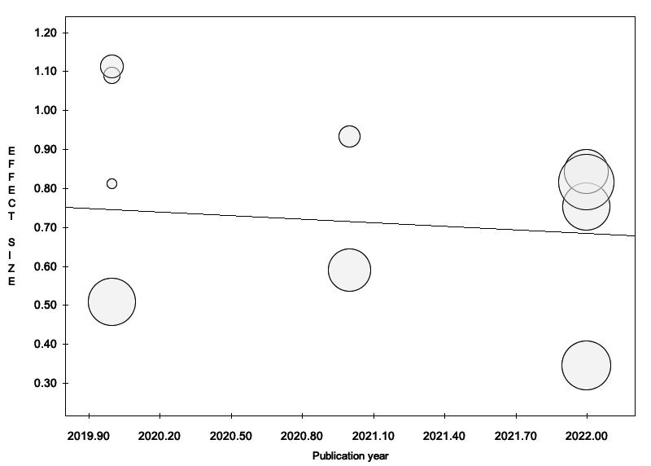
Fig. S5 Publication year analysis (Bubble plot) of the included studies for mortality

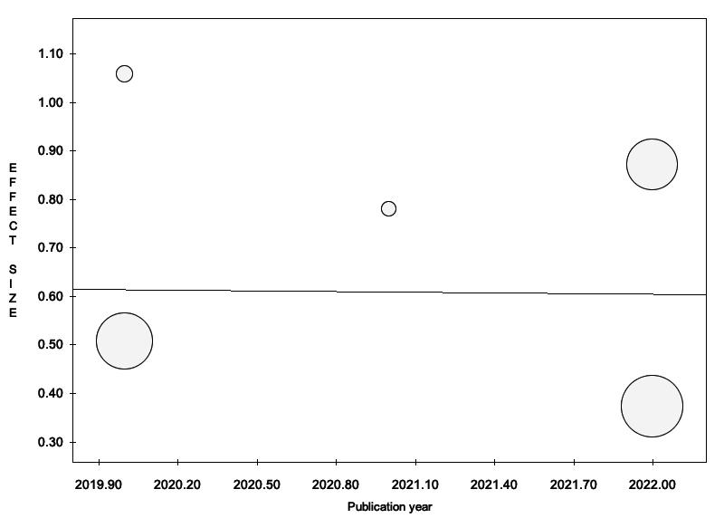
Fig. S6 Publication year analysis (Bubble plot) of the included studies for ICU admission
Section/topic | # | Checklist item | Reported on page #
TITLE
Title | 1 | Identify the report as a systematic review, meta-analysis, or both. | 1
ABSTRACT
Structured summary | 2 | Provide a structured summary including, as applicable: background; objectives; data sources; study eligibility criteria, participants, and interventions; study appraisal and synthesis methods; results; limitations; conclusions and implications of key findings; systematic review registration number. | 2
INTRODUCTION
Rationale | 3 | Describe the rationale for the review in the context of what is already known. | 3
Objectives | 4 | Provide an explicit statement of questions being addressed with reference to participants, interventions, comparisons, outcomes, and study design (PICOS). | 3
METHODS
Protocol and registration | 5 | Indicate if a review protocol exists, if and where it can be accessed (e.g., Web address), and, if available, provide registration information including registration number. | 3-4
Eligibility criteria | 6 | Specify study characteristics (e.g., PICOS, length of follow-up) and report characteristics (e.g., years considered, language, publication status) used as criteria for eligibility, giving rationale. | 3-4
Information sources | 7 | Describe all information sources (e.g., databases with dates of coverage, contact with study authors to identify additional studies) in the search and date last searched. | 3-4
Search | 8 | Present full electronic search strategy for at least one database, including any limits used, such that it could be repeated. | 3
Study selection | 9 | State the process for selecting studies (i.e., screening, eligibility, included in systematic review, and, if applicable, included in the meta-analysis). | 3, 4
Data collection process | 10 | Describe method of data extraction from reports (e.g., piloted forms, independently, in duplicate) and any processes for obtaining and confirming data from investigators. | 3, 4
Data items | 11 | List and define all variables for which data were sought (e.g., PICOS, funding sources) and any assumptions and simplifications made. | 4
Risk of bias in individual studies | 12 | Describe methods used for assessing risk of bias of individual studies (including specification of whether this was done at the study or outcome level), and how this information is to be used in any data synthesis. | 4
Summary measures | 13 | State the principal summary measures (e.g., risk ratio, difference in means). | 4
Synthesis of results | 14 | Describe the methods of handling data and combining results of studies, if done, including measures of consistency (e.g., I²) for each meta-analysis. | 4

Page 1 of 2
Section/topic | # | Checklist item | Reported on page #
Risk of bias across studies | 15 | Specify any assessment of risk of bias that may affect the cumulative evidence (e.g., publication bias, selective reporting within studies). | 4
Additional analyses | 16 | Describe methods of additional analyses (e.g., sensitivity or subgroup analyses, meta-regression), if done, indicating which were pre-specified. | 4
RESULTS
Study selection | 17 | Give numbers of studies screened, assessed for eligibility, and included in the review, with reasons for exclusions at each stage, ideally with a flow diagram. | 4
Study characteristics | 18 | For each study, present characteristics for which data were extracted (e.g., study size, PICOS, follow-up period) and provide the citations. | 4
Risk of bias within studies | 19 | Present data on risk of bias of each study and, if available, any outcome level assessment (see item 12). | 5
Results of individual studies | 20 | For all outcomes considered (benefits or harms), present, for each study: (a) simple summary data for each intervention group (b) effect estimates and confidence intervals, ideally with a forest plot. | 4, 5
Synthesis of results | 21 | Present results of each meta-analysis done, including confidence intervals and measures of consistency. | 4,5
Risk of bias across studies | 22 | Present results of any assessment of risk of bias across studies (see Item 15). | 4,5
Additional analysis | 23 | Give results of additional analyses, if done (e.g., sensitivity or subgroup analyses, meta-regression [see Item 16]). | 4,5
DISCUSSION
Summary of evidence | 24 | Summarize the main findings including the strength of evidence for each main outcome; consider their relevance to key groups (e.g., healthcare providers, users, and policy makers). | 6
Limitations | 25 | Discuss limitations at study and outcome level (e.g., risk of bias), and at review-level (e.g., incomplete retrieval of identified research, reporting bias). | 6, 7
Conclusions | 26 | Provide a general interpretation of the results in the context of other evidence, and implications for future research. | 7
FUNDING
Funding | 27 | Describe sources of funding for the systematic review and other support (e.g., supply of data); role of funders for the systematic review. | 7

Table S7 The PRISMA Checklist
References

- Arayici ME, Kipcak N, Kayacik U, Kelbat C, Keskin D, Kilicarslan ME, et al. Effects of SARS-CoV-2 infections in patients with cancer on mortality, ICU admission and incidence: a systematic review with meta-analysis involving 709,908 participants and 31,732 cancer patients. J Cancer Res Clin Oncol, 2022; 13: 1–14.
- Khoury E, Nevitt S, Madsen WR, Turtle L, Davies G, Palmieri C. Differences in Outcomes and Factors Associated With Mortality Among Patients With SARS-CoV-2 Infection and Cancer Compared With Those Without Cancer: A Systematic Review and Meta-analysis. JAMA Netw Open, 2022; 5: e2210880.
- Di Felice G, Visci G, Teglia F, Angelini M, Boffetta P. Effect of cancer on outcome of COVID-19 patients: a systematic review and meta-analysis of studies of unvaccinated patients. Elife, 2022; 11: e74634.
- Giannakoulis VG, Papoutsi E, Siempos II. Effect of Cancer on Clinical Outcomes of Patients With COVID-19: A Meta-Analysis of Patient Data. JCO Glob Oncol, 2020; 6: 799-808.
- Han S, Zhuang Q, Chiang J, Tan SH, Chua GWY, Xie C, et al. Impact of cancer diagnoses on the outcomes of patients with COVID-19: a systematic review and meta-analysis. BMJ Open, 2022; 12: e044661.
- Venkatesulu BP, Chandrasekar VT, Girdhar P, Advani P, Sharma A, Elumalai T, et al. A Systematic Review and Meta-Analysis of Cancer Patients Affected by a Novel Coronavirus. JNCI Cancer Spectr, 2021; 5: pkaa102.
- Yang L, Chai P, Yu J, Fan X. Efects of cancer on patients with COVID-19: a systematic review and meta-analysis of 63,019 participants. Cancer Biol Med, 2021; 18: 298.
- Tian Y, Qiu X, Wang C, Zhao J, Jiang X, Niu W, et al. Cancer associates with risk and severe events of COVID-19: A systematic review and meta-analysis. Int J Cancer, 2021; 148: 363-374.
- Salunke AA, Nandy K, Pathak SK, Shah J, Kamani M, Kottakota V, et al. Impact of COVID-19 in cancer patients on severity of disease and fatal outcomes: a systematic review and metaanalysis. Diabetes Metab Syndr, 2020; 14: 1431–1437.
- Parohan M, Yaghoubi S, Seraji A, Javanbakht MH, Sarraf P, Djalali M. Risk factors for mortality in patients with Coronavirus disease 2019 (COVID-19) infection: a systematic review and meta-analysis of observational studies. Aging Male, 2020; 23: 1416-1424.

