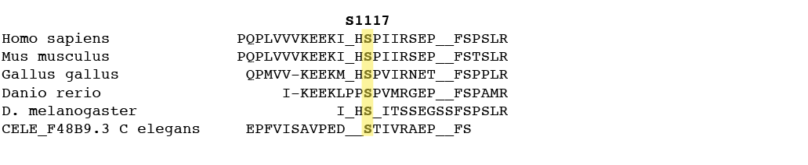
Supplementary Figure Legends
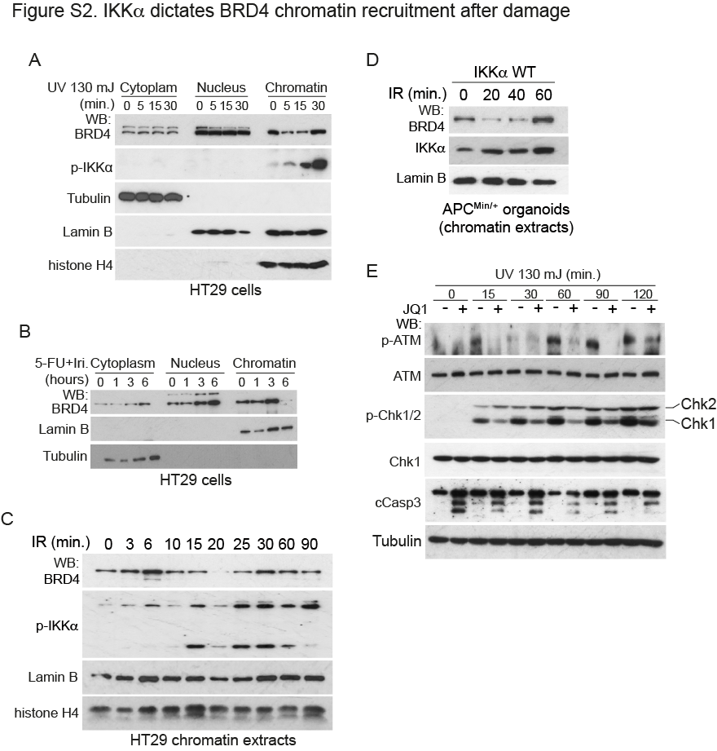
Figure S1: COBALT BLAST. Multiple sequence alignment of BRD4 from different organisms. Residue conservation of position S1117A is highlighted in yellow in the alignment of the BRD4 proteins.
Figure S2. BRD4 chromatin dynamics after DNA damage.
(A, B) WB analysis of cytoplasmic, nuclear and chromatin extract from HT29 cell line collected at different time points after UV treatment (130mJ) (A) or treated with 5 FU+ Irinotecan (5FU=5 ug/ml, Irinotecan =2 ug/ml) at the indicated time points (B).
(C, D) WB analysis of chromatin extract from HT29 cells (C) or APC^{Min/+} organoids (D) collected at different time points after IR exposure (10Gy).
(E) WB analysis of HCT116 cells untreated or pretreated with the BRD4 inhibitor JQ1 for 16 hours and the exposed to UV as indicated.

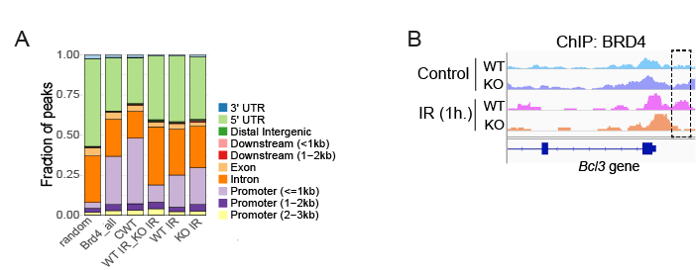
Figure S3. IKKα dictates BRD4 chromatin recruitment upon damage.
(A) Genomic distribution of the different BRD4-enriched regions. Random: randomly selected regions of the genome; BRD4_all: BRD4-bound regions regardless IKKα genotype and treatment conditions; CWT: BRD4-bound regions in untreated WT cells, WTIR_KOIR: BRD4-bound upon treatment independent of IKKα genotype; WTIR: BRD4-bound regions upon IR in WT and, KOIR: BRD4-bound upon IR in IKKα KO.
(B) Representation of BRD4 distribution (from ChIP sequencing) in the Bcl3 gene promoter in untreated or IR-treated WT and IKKα KO APC^{Min/+} organoids. The promoter region that is specifically bound by BRD4 in IR-treated IKKα WT cells is outlined in the figure.
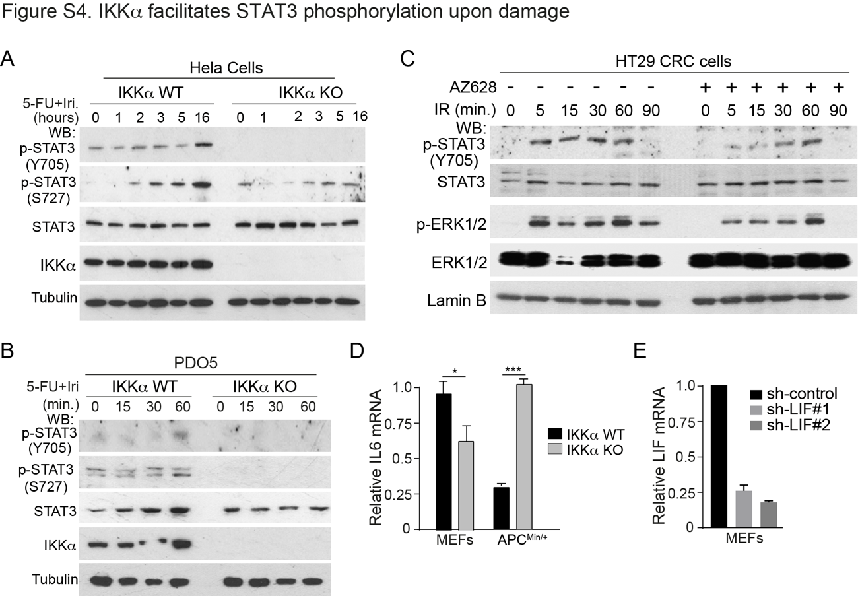
Figure S4. IKKα facilitates STAT3 phosphorylation and transcriptional activity after damage.
(A, B) WB analysis of WT and IKKα KO Hela cells (A) and PDO5 cells (B) after treatment with 5-FU+Iri. (1 µg/ml) at the indicated time points.
(C) WB analysis of HT29 CRC cells untreated or pretreated with the BRAF inhibitor AZ628 for 16 hours and then exposed to IR.
(D) qPCR analysis of IL6 mRNA levels in the indicated IKKα WT and KO cells.
(E) qPCR analysis of LIF mRNA levels in MEFs cells transduced with control sh-RNA or two different sh-RNAs against LIF.
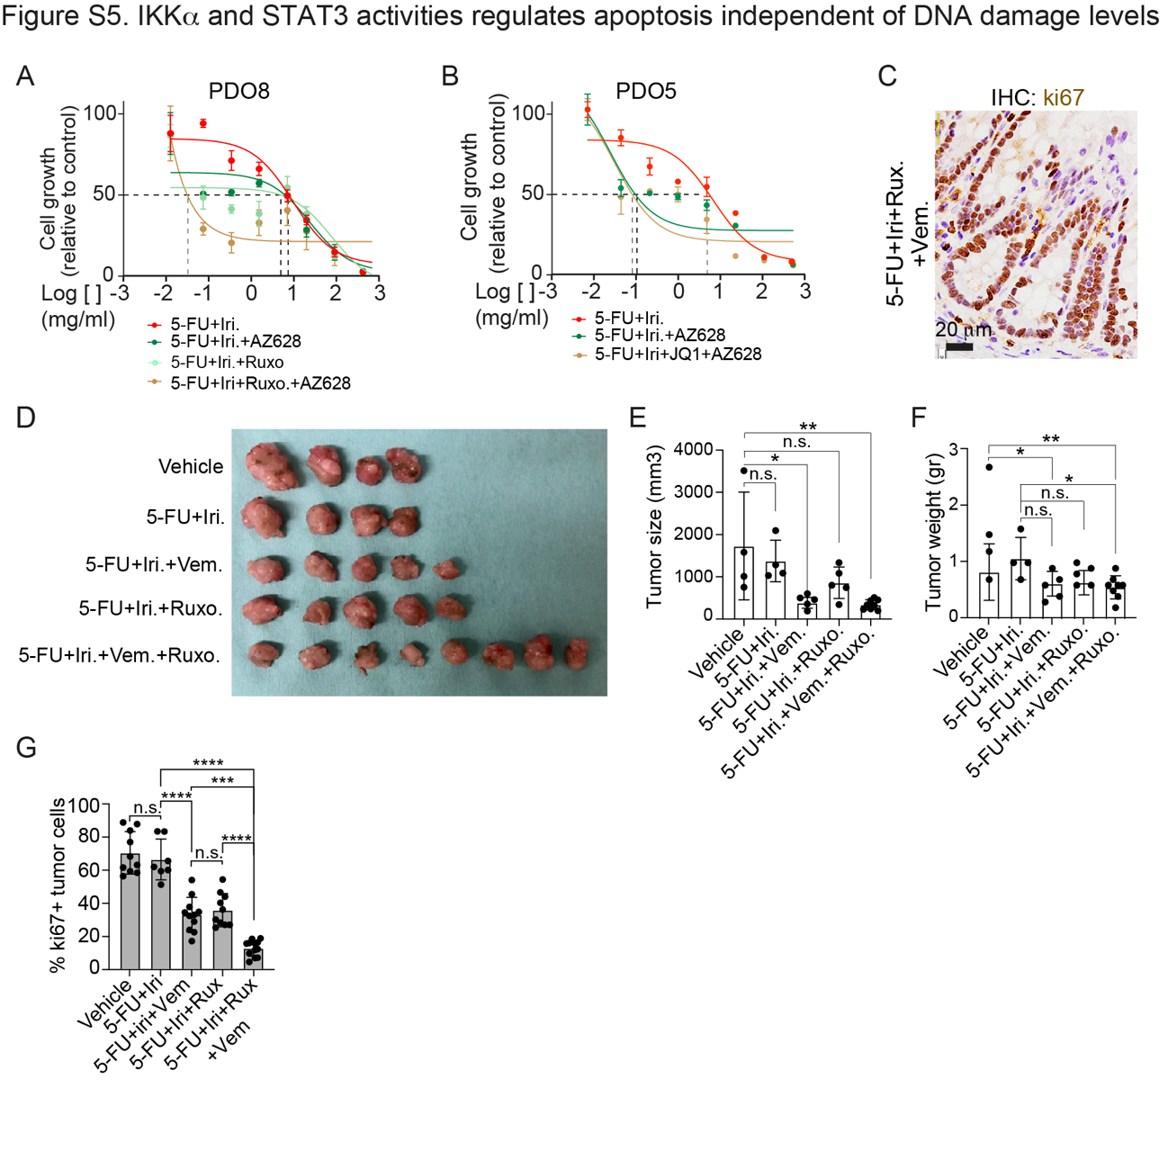
Figure S5. Increased cell death of IKKα KO cells in response to CT.
(A, B) Dose response assay of PDO4 (G) and PDO5 cells (H) treated as indicated.
(C) Representative image of ki67 staining in the normal colonic mucosa adjacent to the tumors treated with the triple combination 5-FU+Iri. plus vemurafenib plus ruxolitinib.
(D-G) Photograph of tumors recovered from mice in the indicated groups of treatment (D) and quantification of the size (E), weight (F) and percent of proliferating (ki67+) cells (G) in the different tumors. Mean values and standard deviation are represented. Statistical significance was determined by One-Way ANOVA test and the Tukey’s Multiple Comparison Analysis. *p-value < 0.05, **p-value <0.01.
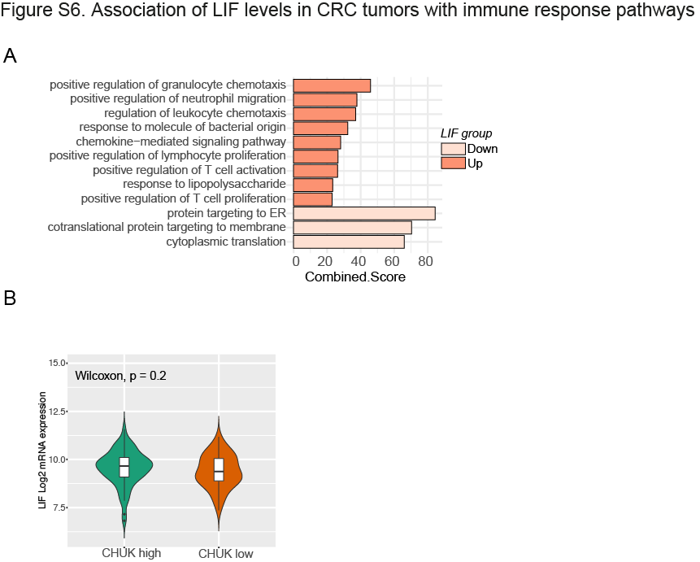
Figure S6. LIF-high tumors are enriched in T cell related functions.
(A) Barplot depicting the top significant Gene Ontology Biological Process obtained for DEG genes in LIF high and LIF low tumors from TCGA dataset.
(B) Violin plots showing LIF mRNA levels in the CRC tumors classified as CHUK high and CHUK low in the TCGA dataset.

