Appendix 4
Risk of Bias Assessment & Example

Study: Nielsen 2010

Tool: Revised Cochrane risk-of-bias tool for randomized trials (RoB 2) for individually randomized parallel-group trial
N.B. Risk of bias assessment
Responses underlined in green are potential markers for low risk of bias, and responses in red are potential markers for a risk of bias. Where questions relate only to sign posts to other questions, no formatting is used.

  - Domain 1: Risk of bias arising from the randomization process
Signalling questions | Comments | Response options
1.1 Was the allocation sequence random? |  | Y / PY / PN / N / NI
1.2 Was the allocation sequence concealed until participants were enrolled and assigned to interventions? |  | Y / PY / PN / N / NI
1.3 Did baseline differences between intervention groups suggest a problem with the randomization process? |  | Y / PY / PN / N / NI
Risk-of-bias judgement |  | Low / High / Some concerns
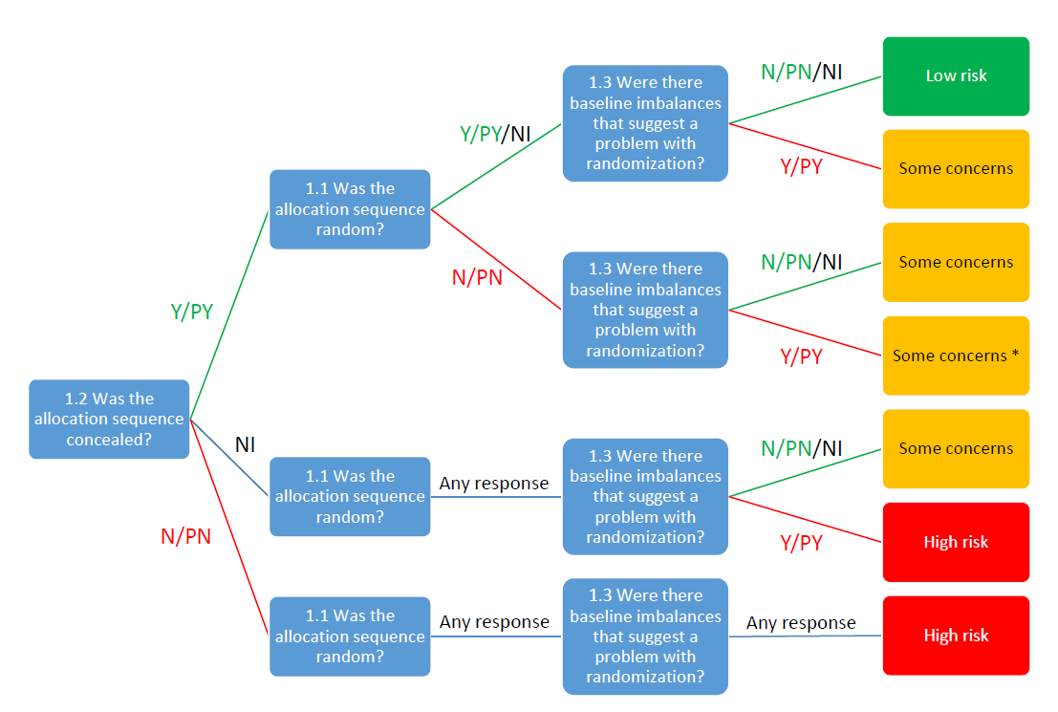

  - Domain 2: Risk of bias due to deviations from the intended interventions (effect of assignment to intervention)
Signalling questions | Comments | Response options
2.1. Were participants aware of their assigned intervention during the trial? | “Double blind” – author assumes this means at least the participants were blinded. | Y / PY / PN / N / NI
2.2. Were carers and people delivering the interventions aware of participants' assigned intervention during the trial? |  | Y / PY / PN / N / NI
2.3. If Y/PY/NI to 2.1 or 2.2: Were there deviations from the intended intervention that arose because of the trial context? |  | NA / Y / PY / PN / N / NI
2.4 If Y/PY to 2.3: Were these deviations likely to have affected the outcome? |  | NA / Y / PY / PN / N / NI
2.5. If Y/PY/NI to 2.4: Were these deviations from intended intervention balanced between groups? |  | NA / Y / PY / PN / N / NI
2.6 Was an appropriate analysis used to estimate the effect of assignment to intervention? | No specification of IIT or PPA | Y / PY / PN / N / NI
2.7 If N/PN/NI to 2.6: Was there potential for a substantial impact (on the result) of the failure to analyse participants in the group to which they were randomized? |  | NA / Y / PY / PN / N / NI
Risk-of-bias judgement |  | Low / High / Some concerns
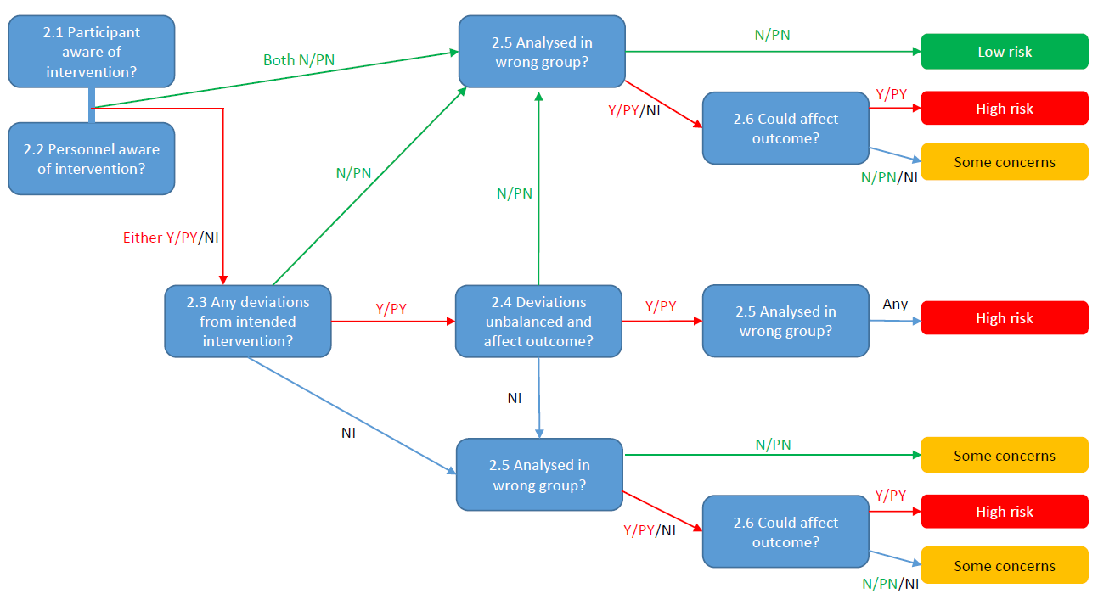
  - Domain 3: Missing outcome data
Signalling questions | Comments | Response options
3.1 Were data for this outcome available for all, or nearly all, participants randomized? | 96/100 | Y / PY / PN / N / NI
3.2 If N/PN/NI to 3.1: Is there evidence that the result was not biased by missing outcome data? |  | NA / Y / PY / PN / N
3.3 If N/PN to 3.2: Could missingness in the outcome depend on its true value? |  | NA / Y / PY / PN / N / NI
3.4 If Y/PY/NI to 3.3: Is it likely that missingness in the outcome depended on its true value? |  | NA / Y / PY / PN / N / NI
Risk-of-bias judgement |  | Low / High / Some concerns

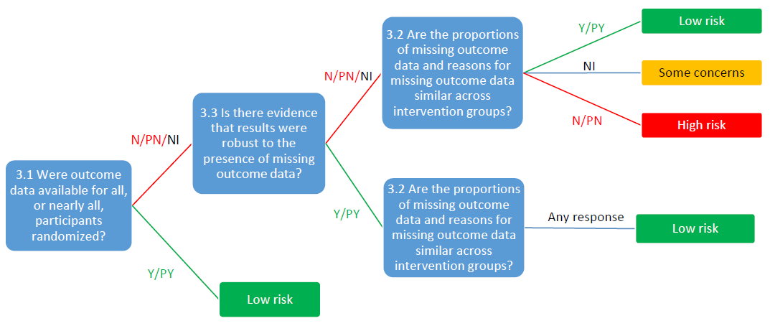
  - Domain 4: Risk of bias in measurement of the outcome
Signalling questions | Comments | Response options
4.1 Was the method of measuring the outcome inappropriate? | PSQI | Y / PY / PN / N / NI
4.2 Could measurement or ascertainment of the outcome have differed between intervention groups? | Subjective scoring system (participants score the PSQI) | Y / PY / PN / N / NI
4.3 If N/PN/NI to 4.1 and 4.2: Were outcome assessors aware of the intervention received by study participants? |  | NA / Y / PY / PN / N / NI
4.4 If Y/PY/NI to 4.3: Could assessment of the outcome have been influenced by knowledge of intervention received? | Same comment as above | NA / Y / PY / PN / N / NI
4.5 If Y/PY/NI to 4.4: Is it likely that assessment of the outcome was influenced by knowledge of intervention received? | Same comment as above | NA / Y / PY / PN / N / NI
Risk-of-bias judgement |  | Low / High / Some concerns

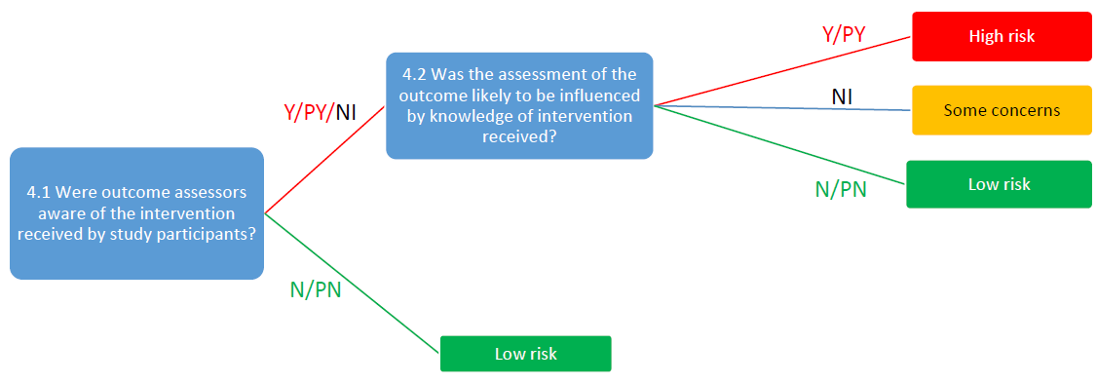
  - Domain 5: Risk of bias in selection of the reported result
Signalling questions | Comments | Response options
5.1 Were the data that produced this result analysed in accordance with a pre-specified analysis plan that was finalized before unblinded outcome data were available for analysis? |  | Y / PY / PN / N / NI
Is the numerical result being assessed likely to have been selected, on the basis of the results, from...
5.2. ... multiple eligible outcome measurements (e.g. scales, definitions, time points) within the outcome domain? | “Analyses of the seven components of the global PSQI, which were similar at the beginning of the study, found a significant change in only the number of sleep disturbances at the end of the study. More magnesium-supplemented than placebo participants had sleep disturbance component scores of 2 or more vs 0-1 at the end of the study.  Since there was no specified analysis plan of the PSQI, it is unclear why this PSQI subscore was chosen other than statistical significance. The arbitrary cut of of 2 or more vs 0-1 is also suspect as the PSQI is typically not presented with such a dichotomy. | Y / PY / PN / N / NI
5.3 ... multiple eligible analyses of the data? |  | Y / PY / PN / N / NI
Risk-of-bias judgement |  | Low / High / Some concerns

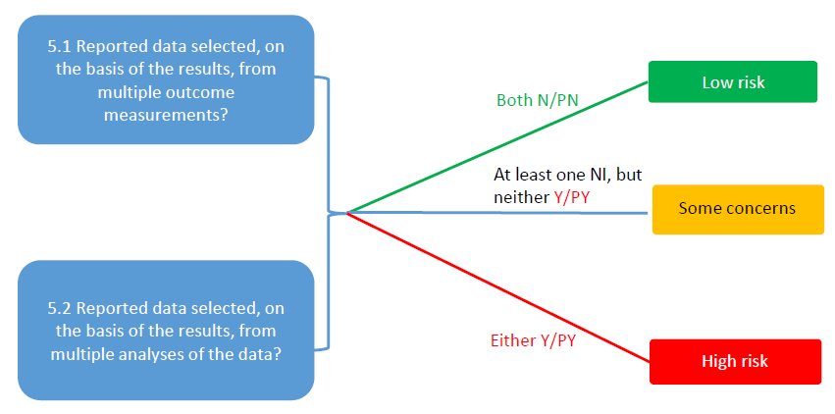
  - Overall risk of bias
Risk-of-bias judgement | High risk in one domain  Some risk in two domains | Low / High / Some concerns

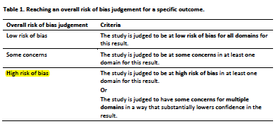

Reference: Sterne JAC, Savović J, Page MJ, Elbers RG, Blencowe NS, Boutron I, Cates CJ, Cheng H-Y, Corbett MS, Eldridge SM, Hernán MA, Hopewell S, Hróbjartsson A, Junqueira DR, Jüni P, Kirkham JJ, Lasserson T, Li T, McAleenan A, Reeves BC, Shepperd S, Shrier I, Stewart LA, Tilling K, White IR, Whiting PF, Higgins JPT. 2019. RoB 2: a revised tool for assessing risk of bias in randomised trials. BMJ; 366: l4898.

This work is licensed under a Creative Commons Attribution-NonCommercial-NoDerivatives 4.0 International License.

