Supplementary Table 1: Cohort demographics, psychiatric history and medical history
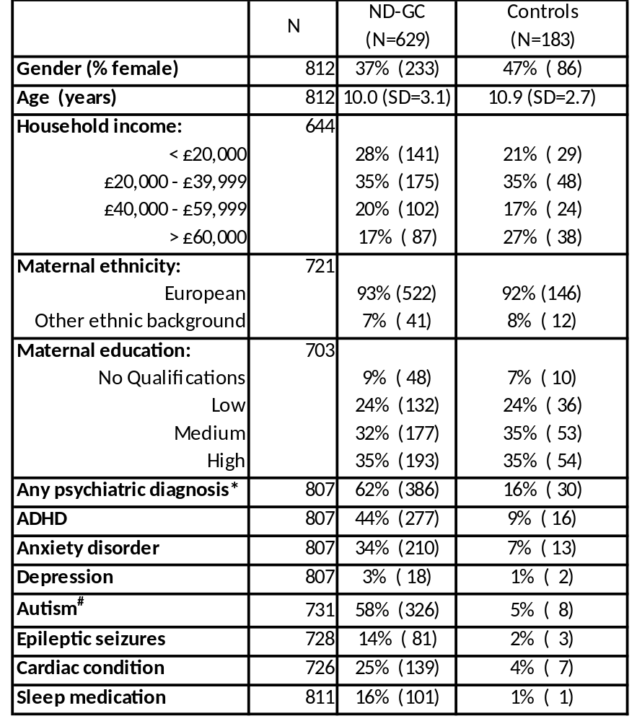

*Any diagnosis as derived from the CAPA, does not include autism as this is derived from other measures
#As derived from the SCQ

Supplementary Table 2: Genotype frequencies
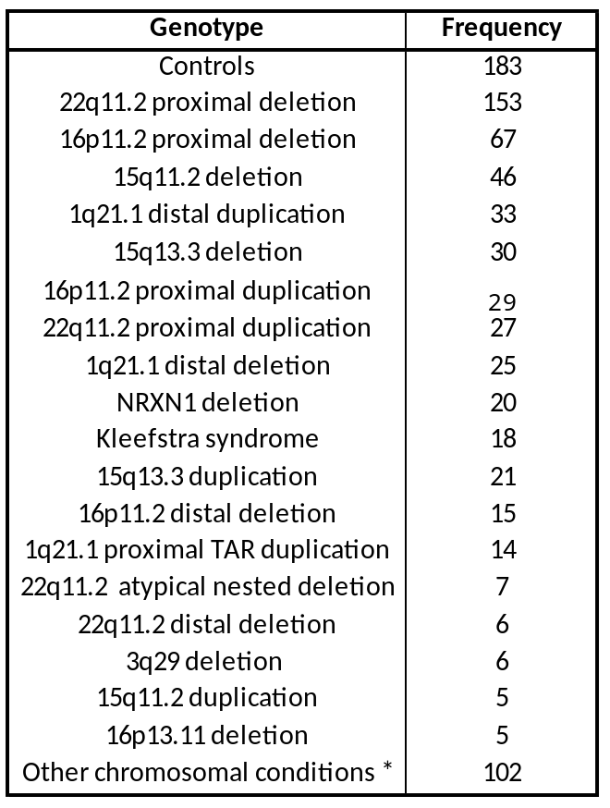
*To preserve anonymity of participants, genotypes with a frequency of less than 5 were included in the other category.

Supplementary Figure 1: Radar graph of functional impact of sleep symptomatology for children with a ND-GC and sibling controls across a range of contexts
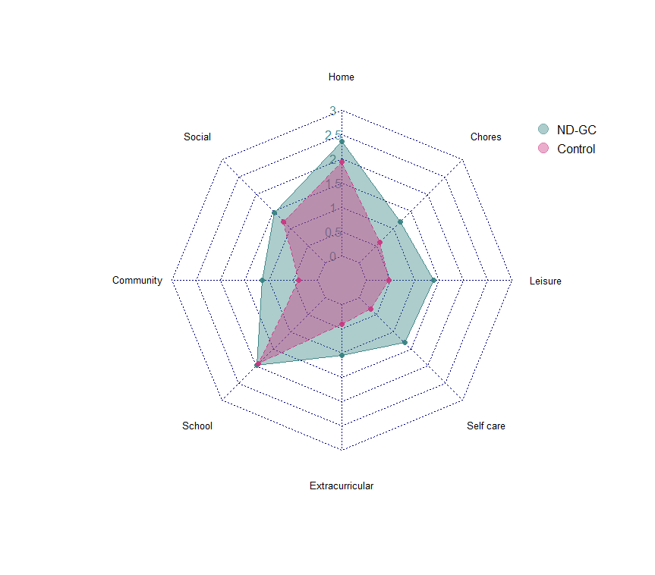
Supplementary Table 3: Impact of sleep symptomatology on child functioning across contexts
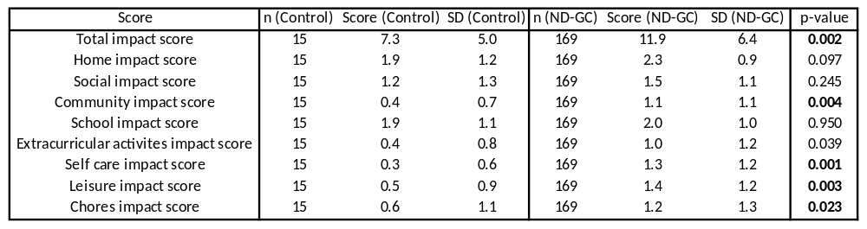
p-values were derived from mixed models whereby relatedness was controlled for as a random effect, and gender and age were controlled for as fixed effects. p-values in bold remained significant following BH-FDR correction for multiple testing.

Supplementary Table 4: Sleep symptomatology profiles of the classes derived from latent class analysis
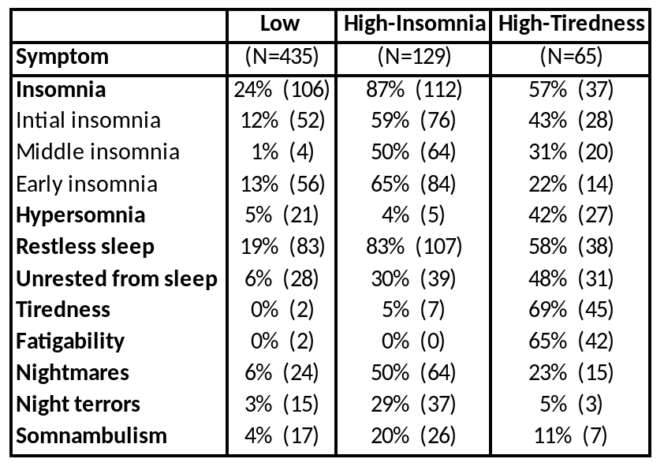
Supplementary Table 5: Proportion of individuals in each sleep class within each CNV genotype
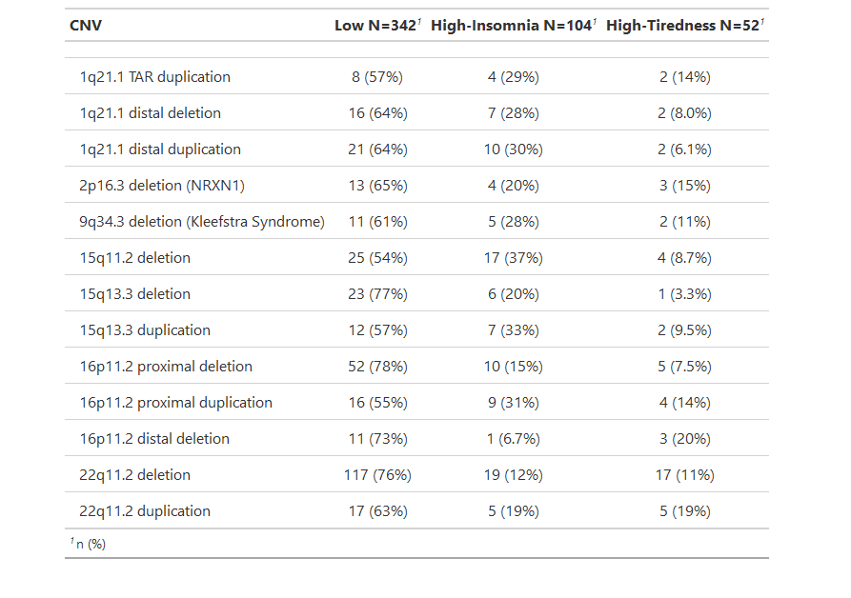

Supplementary Table 6: Categorical neuropsychiatric diagnoses for children with a ND-GC presented by sleep class subgroup
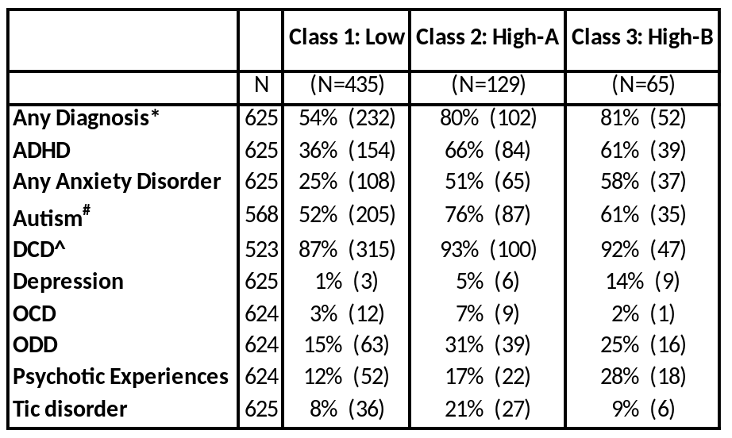
*Any diagnosis as derived from the CAPA, does not include Autism or DCD as these are derived from other measures
#As derived from the SCQ
^As derived from the DCDQ

Supplementary Table 7: Continuous neuropsychiatric and cognitive trait scores for children with a ND-GC presented by sleep class subgroup
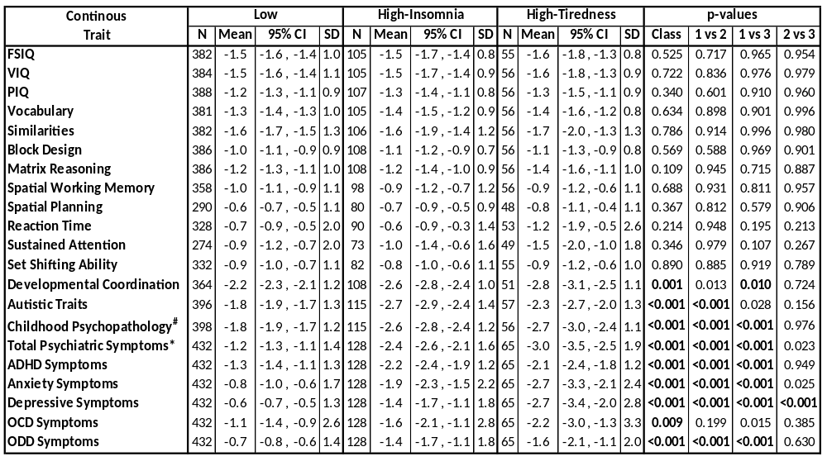
p-values derive from Tukey tests applied post hoc to ANOVA models including age and gender as covariates. p-values in bold remained significant following BH-FDR correction for multiple testing.
#Childhood Psychopathology, as measured by total SDQ score
*Total Psychiatric symptoms as derived by the CAPA instrument

Supplementary Table 8: Sensitivity analysis of phenotypic contrasts between sleep class subgroups taking account of education, maternal ethnicity, household income and presence of sleep medication

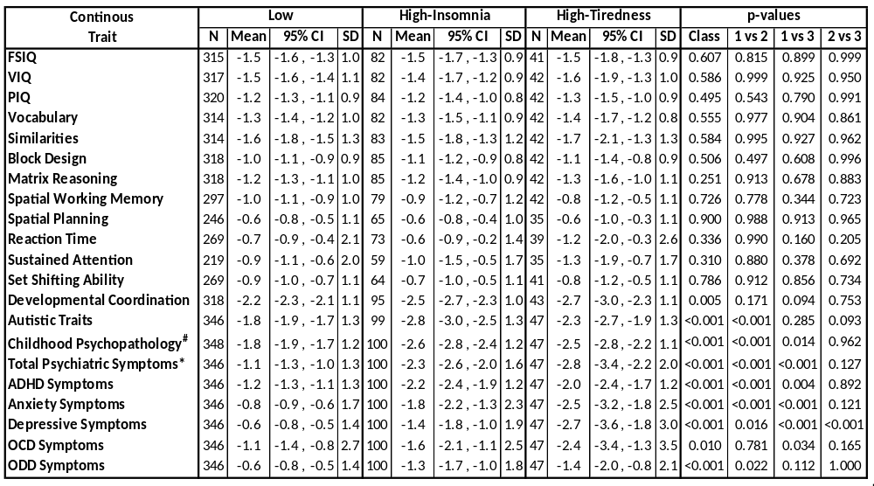

p-values derive from Tukey tests applied post hoc to ANOVA models including age, gender, maternal education, maternal ethnicity, household income and presence of sleep medication in the child, as covariates. p-values in bold remained significant following BH-FDR correction for multiple testing.
#Childhood Psychopathology, as measured by total SDQ score
*Total Psychiatric symptoms as derived by the CAPA instrument

