7. Supporting information
Impacts of forest management on stand and landscape-level microclimate heterogeneity of European beech forests

Joscha H. Menge^{1,2*}, Paul Magdon³, Stephan Wöllauer⁴, Martin Ehbrecht¹
*Corresponding author: JoschaMenge@gmail.com
¹Department of Silviculture and Forest Ecology of the Temperate Zones, Faculty of Forest Science, University of Göttingen, Büsgenweg 1, 37077 Göttingen, Germany
²Forestry Research and Competence Centre, ThüringenForst, Jägerstrasse 1, 99867 Gotha, Germany
³Faculty of Resource Management, HAWK University of Applied Sciences and Arts, Büsgenweg 1a, 37077 Göttingen, Germany
⁴Philipps-University Marburg, Environmental Informatics, Faculty of Geography, Deutschhausstrasse 12, 35032, Marburg, Germany, https://orcid.org/0000-0002-3623-8294

7.1 Correlations of ALS and temperature variables
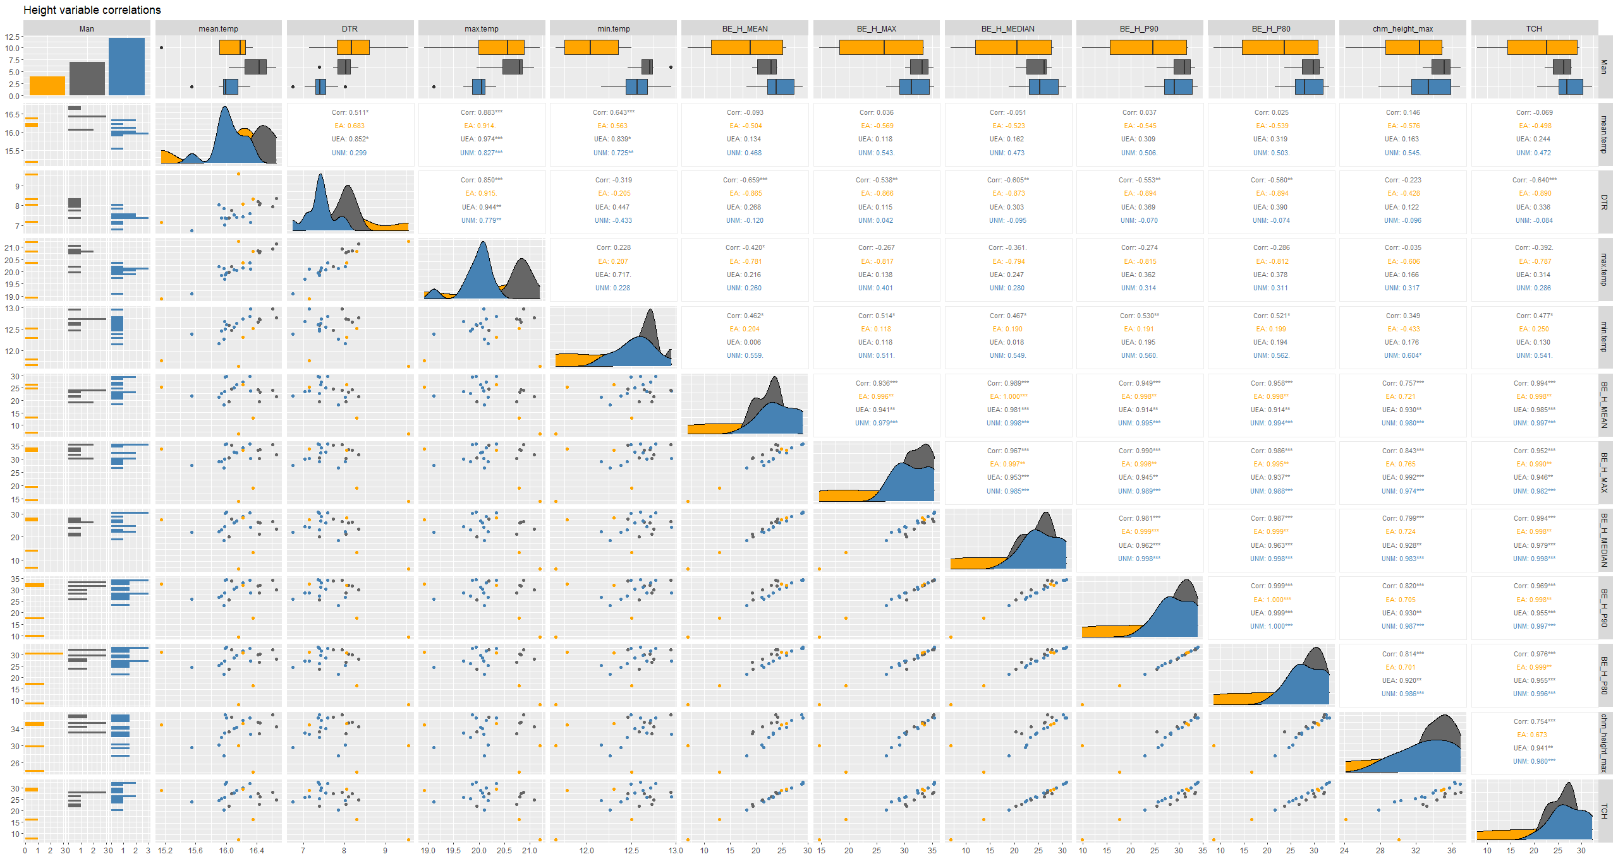
Fig. 7 Correlations between DTR, maximum, minimum and mean temperature and different ALS-based stand-height variables.
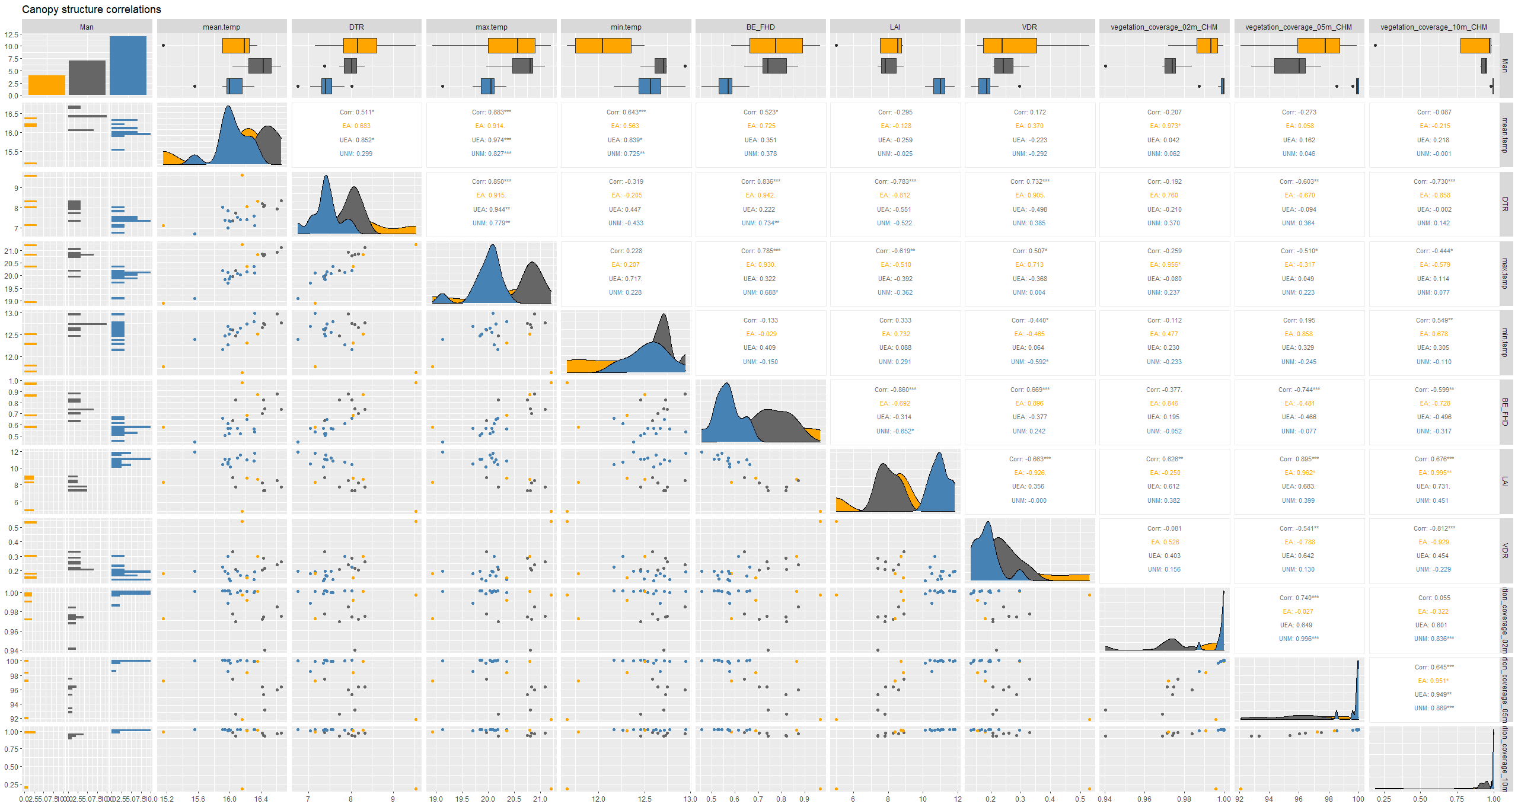
Fig. 8 Correlations between DTR, maximum, minimum and mean temperature and different ALS-based canopy structural variables.

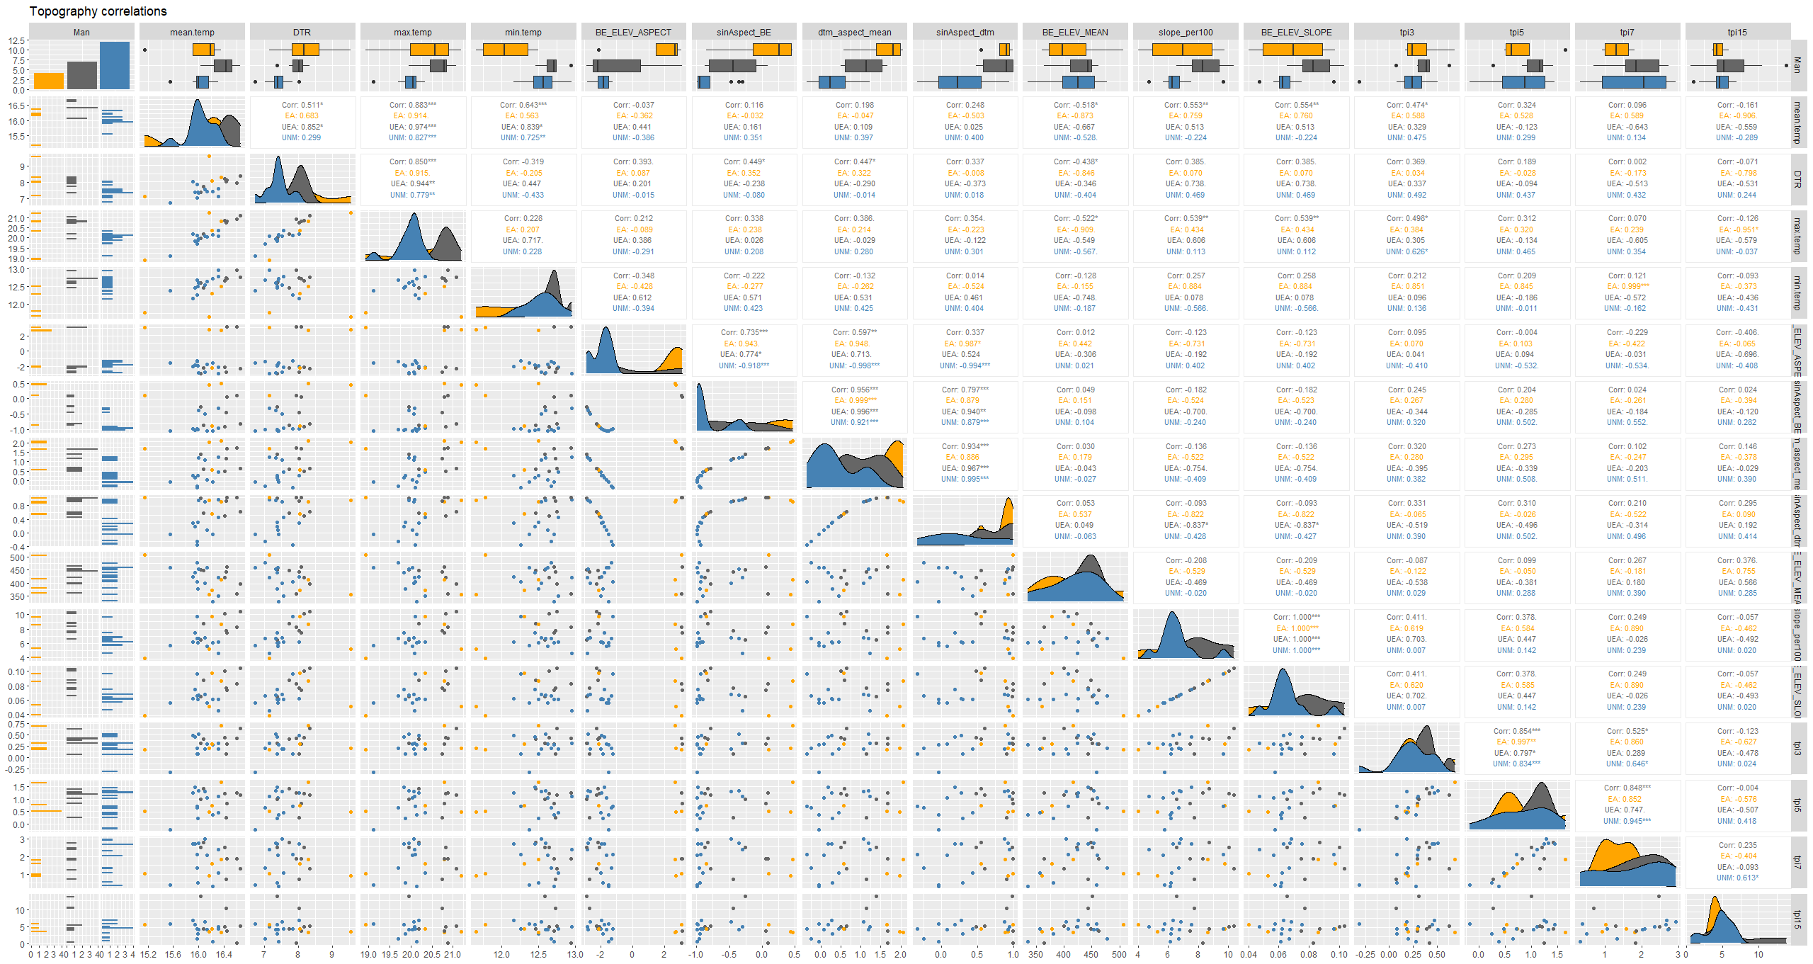
Fig. 9 Correlations between DTR, maximum, minimum and mean temperature and different ALS-based topographical variables.
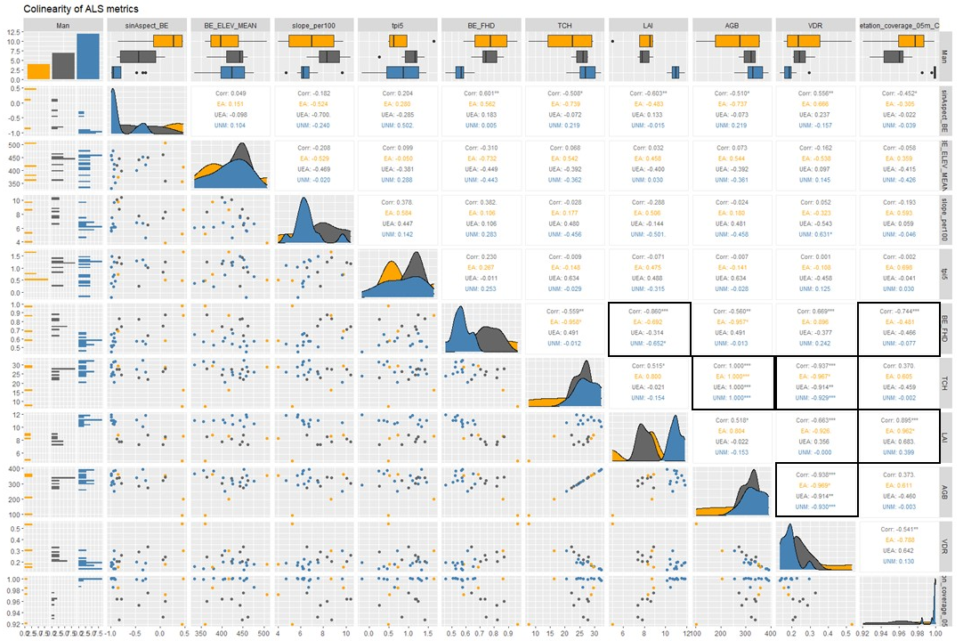
Fig. 10 Correlations among selected ALS-based stand structural and topographical variables. Highlighted variable combinations depict strong co-linearity of |r| > 0.7, surpassing the critical benchmark identified by Dormann et al. (2013), when collinearity begins to severely distort model estimation and subsequent predictions. Therefore, we excluded these variable combinations from the MLR model selection.

7.2 Description of selected ALS-based indices
We selected four topographic metrics that are known to impact air temperature and other climate variables due to changes in atmospheric pressure and site exposure (Bennie et al., 2008; Dobrowski, 2011; Jucker et al., 2018a): Elevation, as the mean height of ground above ellipsoid (WGS1984) l (based on DTM raster pixels ); slope (based on DTM raster pixels bilinear regression [%]; the sinus of aspect (based on DTM raster pixels bilinear regression [sin(rad)]); and. TPI represents the relative position of a pixel (or cell) within the landscape ranging from negative (concave terrain, e.g. gulleys) to positive (convex terrain, i.e. ridges). It was calculated from the DTM raster for square neighbourhoods of 2.25 ha, 6.35 ha, 12.25 ha, and 56.25 ha around the central cell respectively, using a moving window algorithm as implemented in the spatialEco-package in R (Evans, 2022). Aspect was sine-transformed so that positive numbers represented south and negative numbers north (Jucker et al., 2018a).
Six canopy structural metrics were considered in the model selection, which were significantly correlated with DTR and have been shown to affect DTR and other climatic variables through shading, interception or modified air-flow (Aussenac, 2000; Bramer et al., 2018; Ehbrecht et al., 2019; Gunton et al., 2015; Hardwick et al., 2015; Jucker et al., 2018b):Vegetation cover (VC) with a cut-off at 5 meters above ground level (based on CHM); mean top of canopy height (TCH) [m] (i.e. the mean of the CHM for each pixel); vertical distribution ratio (VDR) based on the normalised point cloud, as in (Goetz et al., 2007) and (Müller et al., 2018); foliage height diversity (FHD), as in (MacArthur and MacArthur, 1961); Leaf area index as in at 5 m above-ground-level cut-off , based on normalized point cloud, as in (Detto et al., 2015; Getzin et al., 2017).
Both TCH and VC were calculated from the CHM. TCH is the mean of the CHM and VC is defined as the ratio of pixels above a given height cut-off, in this case 5 m above ground. VDR, FHD and LAI are indicative of the vertical structure of a stand. LAI was calculated as in (Getzin et al., 2017) and is based on an approach laid out in (Harding et al., 2001), also used in (Detto et al., 2015): The normalised point cloud is subdivided into 1-m height bins, which results in a vertical profile (histogram) of the canopy foliage returns representing point-counts per 1 m height class. As with VC, the profile is cut-off at 5 m above ground level. Below this threshold points are no longer classified as canopy profile returns. Furthermore, a light extinction coefficient $k$is applied in order to account for occlusion, which was set to 0.3 in this case, based on a method described in (Tang et al., 2012). The LAI values are the sum of vertical foliage profile zones.

7.3 Linear regression models of ALS-based stand structural and topographical metrics and temperature measurements
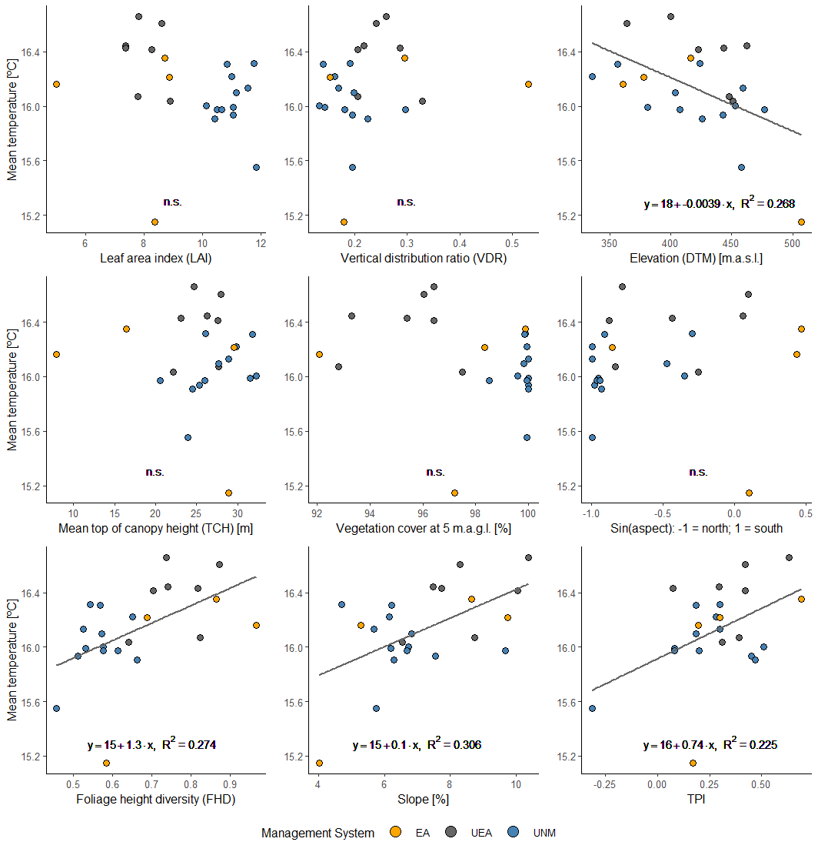
Fig. 11: Linear regression models of ALS-derived topographical and canopy structural metrics and mean temperature (DTR), measured at 23 plots in even-aged (EA) uneven-aged (UEA) and unmanaged forests (UNM), during the vegetation periods of 2014-2016. The coefficient of determination (R²) and the equation of the linear regression model are shown for each variable, unless they were not significantly correlated (p < 0.01) with mean temperature in the Hainich.
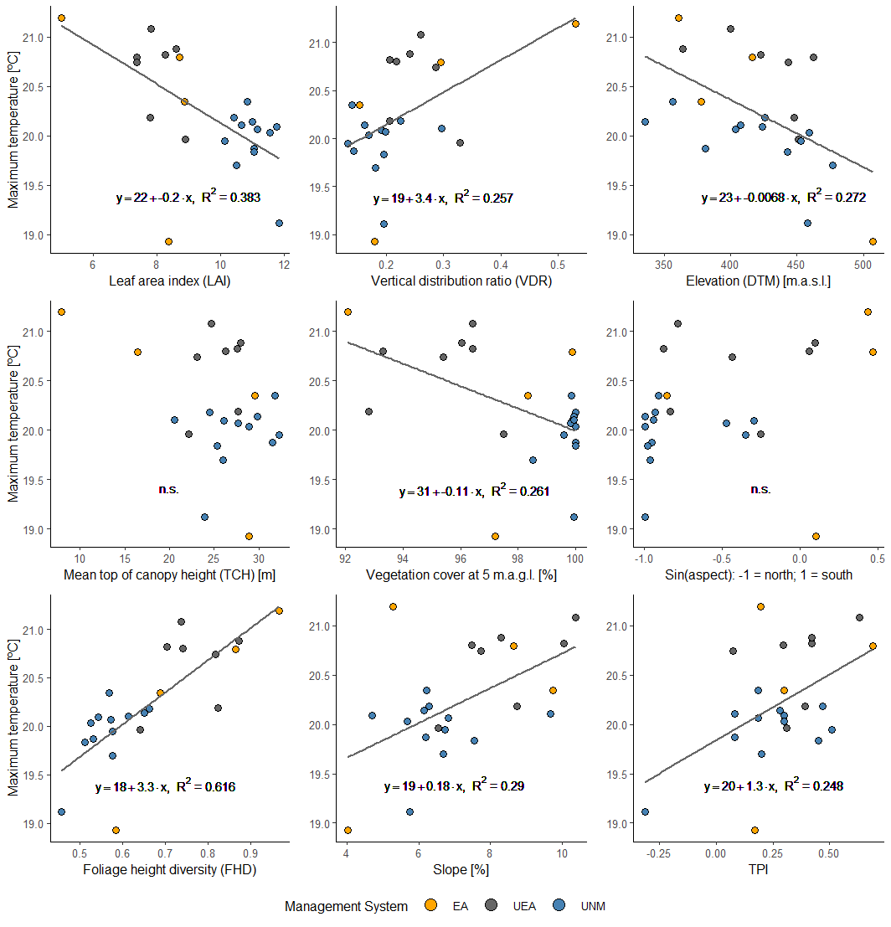
Fig. 12: Linear regression models of ALS-derived topographical and canopy structural metrics and maximum temperature (DTR), measured at 23 plots in even-aged (EA) uneven-aged (UEA) and unmanaged forests (UNM), during the vegetation periods of 2014-2016. The coefficient of determination (R²) and the equation of the linear regression model are shown for each variable, unless they were not significantly correlated (p < 0.01) with maximum temperature in the Hainich.
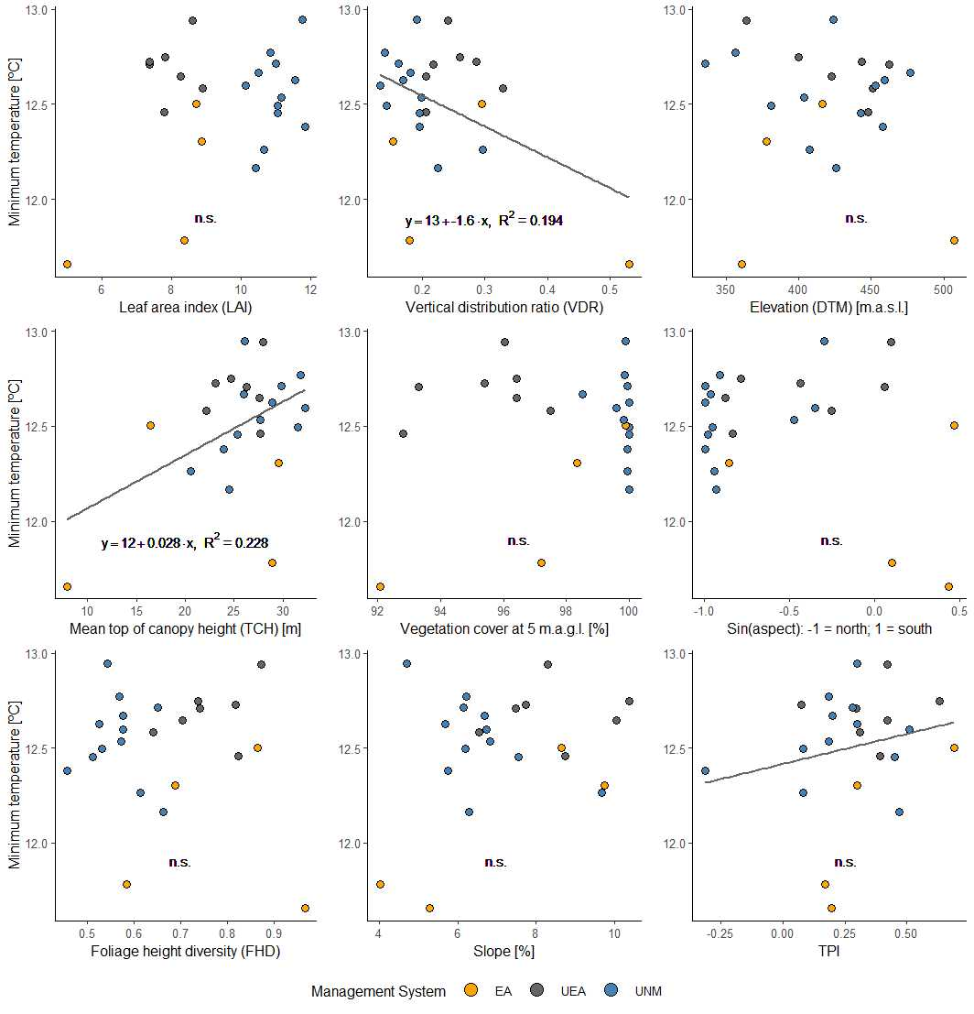Fig. 13: Linear regression models of ALS-derived topographical and canopy structural metrics and minimum temperature (DTR), measured at 23 plots in even-aged (EA) uneven-aged (UEA) and unmanaged forests (UNM), during the vegetation periods of 2014-2016. The coefficient of determination (R²) and the equation of the linear regression model are shown for each variable, unless they were not significantly correlated (p < 0.01) with minimum temperature in the Hainich.

7.4 Calculation of microclimate indices
To calculate α diversity for different scales, we assigned 4, 9, and 16 pixel to a neighbourhood (plot) respectively, by overlaying square grids with side length 100 m, 150 m, and 200 m over the extent of the DTR raster. Hereby, only those plots which were fully contained within a certain management system were included in the analysis of microclimate heterogeneity.
Predicted DTR values were aggregated into DTR-classes $c$ by rounding to the next 0.25 °C. In the context of this study, aggregated DTR classes can be interpreted as thermal niches. This distinction is useful when studying the heterogeneity of microclimates, as the concepts and indices applied here are normally used in ecology for calculations of species diversity. We calculated within-patch α-diversity of thermal niches (¹D_{α}) for each neighbourhood size separately, based on abundance matrices of DTR-classes per plot. Similarly, overall γ-diversity (¹D_{γ}) was calculated from abundance matrices of DTR classes per management system (i.e. the pooled sample) and for each neighbourhood size separately. All diversity calculations were carried out using the vegan package in R Studio (Oksanen, 2019).
With $N$ as the total number of pixels included in a calculation (given by the plot size in case of ¹D_{α}) and $n_{c}$ as the number of pixels belonging to a certain DTR class, the relative abundance $p_{c}$ of a given DTR class was calculated as
$p_{c}=\frac{n_{c}}{N}$ (1)
And ${}_{ }^{1}{D }$ as:
${}_{ }^{1}{D }=exp⁡(-\sum_{c=1}^{N}{p_{c}}×\ln\left(p_{c}\right))$ (2)
Following the approach described in Jost (2007), both thermal niche richness ⁰D and exponential Shannon index ¹D could thus be partitioned into α-, β-, γ-components as
$D_{β}=\frac{D_{γ}}{D_{α}}$ (3)
We then compared differences in means and distributions of DTR and ¹$D_{α}$between management systems by means of one-way ANOVA and post-hoc Tukey test.

