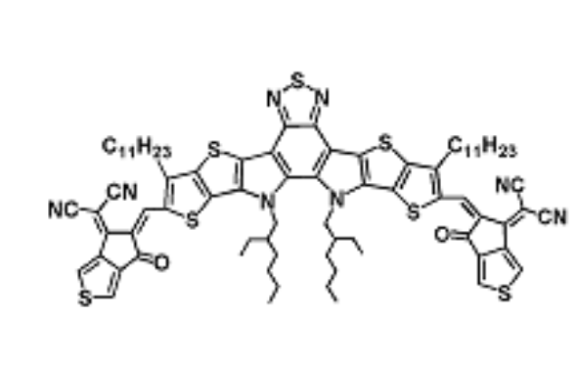

Figure S1. The Molecular Structure of Y8
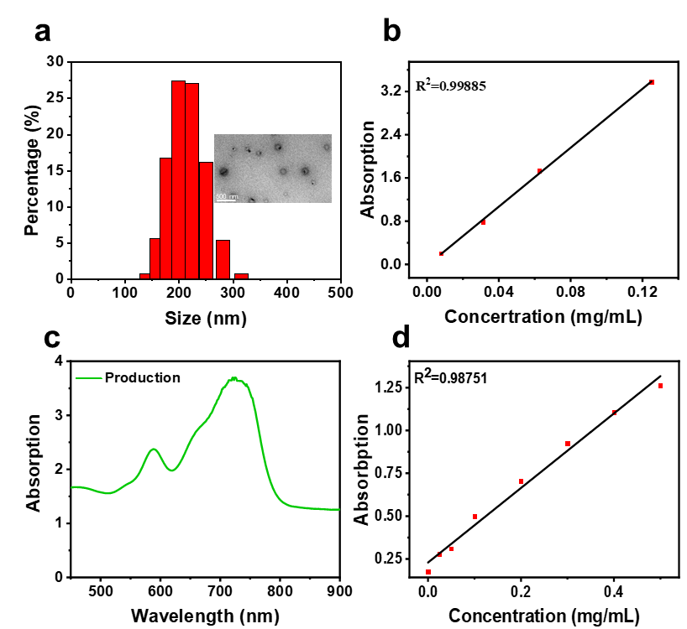
Figure S2. (a) The TEM image and DLS of Y8U@P. (b) The standard curve of Y8 in DCM at 600 nm. (c) The absorption spectrum of GPRPP-Y8U@P in DCM. (d) The BCA standard curve in the supernatant to calculate the UK loading rate.
Figure S3. (a) Raw264.7 viability after simple co-culturing with GPRPP-Y8U@P by fluorescence microscopy. (b) Raw264.7 viability after simple co-culturing with GPRPP-Y8U@P by a microplate reader. (c) Raw264.7 viability after laser co-culturing with GPRPP-Y8U@P by fluorescence microscopy. (d) Raw264.7 viability after laser co-culturing with GPRPP-Y8U@P by a microplate reader. (e) Apoptosis of Raw264.7 under co-culturing with GPRPP-Y8U@P at different concentrations. (d) Apoptosis of Raw264.7 under laser co-culturing with GPRPP-Y8U@P at different powers.

Figure S4. (a) Distribution of nanoparticles in organs. (b) Quantitative statistics in (a). (c) Organ metabolism. (d) Blood metabolism. Group 1 in (c) and (d) represents the blank group, 2-8 represent 2h, 4h, 8h, 16h, 1d, 3d, and 5d after injection.

