Evolution and genomic organization of the sHSP gene cluster in Arthropods

Supplementary Figures 1-3
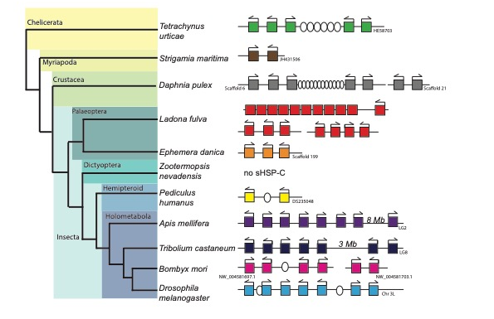
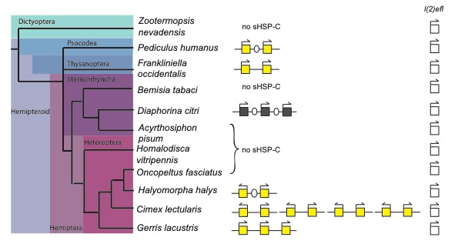
Supplementary Figure 1. sHSP-C genomic organisation in Arthropods. BLASTx analysis was carried out to identify the sHSP sequences in the genome of Biomphalaria glabrata [mollusca] and the genomes the arthropods (Tetrachynus urticae [chelicerate]; Daphnia pulex [crustacea]; Strigamia maritima [myriapoda]; Ladona fulvata, Ephemera danica, Zootermopsis nevadensis, Pediculus humanus, Apis mellifera, Tribolium casteneum, Bombyx mori, and Drosophila melanogaster [insecta]). In Drosophila, a sHSP-C of seven genes lies on linkage group 3L. There were also two intervening genes identified, Hsp67Bb (CG4456), is not a HSP and is instead a member of the Rhodanese Homology Domain superfamily which overlaps the hsp22 open reading frame with transcription in the same direction and a non-coding RNA CR43481. In Bombyx we identified two sHSP-C on chromosomes 27 and 8 consisting of four and two genes respectively. The cluster of four sHSP genes has an intervening gene HspB1 which is orthologous with all other insect HspB1 genes rather than the sHSPs. In Tribolium seven sHSP genes were identified on chromosome LG8. However, TC005338 and TC006793 were separated from the other five genes by 3 Mb. In Apis, eight sHSPs genes were identified on Chr LG2. Apis LOC410857 was separated from the other seven sHSP-C genes by 8 Mb. In each of the holometabolous insect genomes we also identify multiple non-linked sHSP. We identified three sHSP-C in the Ladona fulvata (dragonfly) genome. One cluster contained 10 genes, another five genes and the third three genes. In contrast, another deeply branching hemimetabolous insect, Ephemera (mayfly) has only a single cluster containing three sHSP genes and no other sHSP genes in the genome. Two clustered sHSPs were identified in the hemipteroid body louse Pediculus with an intervening gene, the odorant receptor PhOr6. In addition, while two sHSP genes could be identified in Zooptermopsis (termite), these were not clustered. In Daphnia we identified two sHSP-C. The first sHSP-C contains two sHSP on scaffold 21, arranged in a head to head arrangement. The second sHSP-C contains five genes on scaffold 6. This complex is interrupted by 12 intervening genes. Similarly, in Tetrachynus we identified a five-gene sHSP-C on scaffold HE58703 that is also interrupted by six intervening genes. In contrast we identified only a pair of sHSP in Strigamia

Supplementary Figure 2. sHSP-C genomic organisation in Hemimetabolous insects. BLASTx analysis was carried out to identify the sHSP sequences in the genome of Frankliniella, Acyrthosiphon pisum (aphid), Diaphorina, Halyomorpha (stink bug), Bemisia (white-fly), Oncopeltus (milk weed bug), Gerris (water strider) . Zooptermopsis (termite) does not have a sHSP-C. In Frankliniella (thrip) a cluster of two sHSP genes was identified, adjacent to these two sHSP was an hsp68 gene homologous to insect Hsp70 family of genes. In a psyllid (Diaphorina) two gene clusters were identified with two and three sHSP genes respectively, each with intervening genes. The first cluster of three sHSPs in Diaphorina is made up of three tandem repeats of a sHSP and a gene for guanine nucleotide-binding protein subunit beta-5-like. The second cluster in Diaphorina consisting of two sHSP genes aligns with the alpha crystallin gene from Acyrthosiphon pisum (aphid) and Honeybee and therefore is not considered a sHSP-C (data not shown). In Cimex (bed bug) eight-clustered sHSP were found as tandem repeats in a tail-to-tail orientation. Two clustered sHSP genes were also found in Halyomorpha (stink bug) separated by an intervening gene. Three sHSP genes were found in a cluster in the Gerris (water strider) genome. sHSPs clusters could not be identified in the genomes of Hemipteran insects including Acyrthosiphon (pea aphid), Bemisia (white-fly) Oncopeltus (milk weed bug) and Homalodisca (glassy-winged sharp shooter). Once again, multiple non-linked sHSP paralogs (not shown) were found in the genomes of all hemipteroid insects and all hemipteroid insects had one copy of the homologous insect l(2)efl gene.

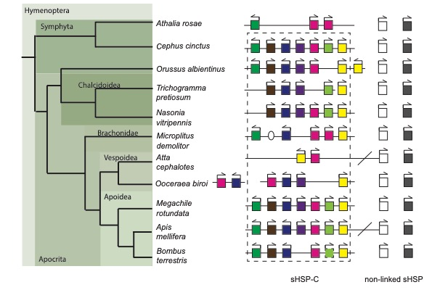

Supplementary Figure 3. sHSP-C genomic organisation in Hymenoptera. BLASTx analysis was carried out to identify the sHSP sequences in the genomes of Hymenopteran species; Athalia rosae (turnip sawfly), Cephus cinctus (wheat stem sawfly), Orussus albientinus (wood wasp), Trichogamma pretiosum (wasp), Nasonia vitripennis (parasitoid wasp), Microplitus demolitor (parasitoid wasp), Atta cephalotes (leaf-cutter ant), Ooceraea biroi (clonal raider ant), Megachile rotundata (leaf-cutting bee), Apis mellifera (honeybee), Bombus terrestris (buff-tailed bumblebee). We identified five sHSP genes in Athalia, three of which were contained in a cluster. In Cephus cinctus nine sHSP genes were identified of which seven were found clustered on the genome. Eight sHSP genes were identified in the Orussus genome of which seven were linked. Six sHSP genes were identified in the Trichogamma genome of which 5 comprised of a cluster. Seven sHSP genes were identified in the Nasonia genome of which 6 were linked. Seven sHSP genes were identified in the Microplitus genome of which 5 were linked. One intervening gene was also identified separating XP_008551687.1 and XP_008551690.1. Four sHSP genes were identified in the Atta genome of which only 2 were linked. Three other ORFs which shared similar sequences to the sHSPs were identified at this genomic location however they were heavily truncated and likely represent pseudogenes and therefore provide evidence for loss of sHSP-C genes in Atta. In the ant species Ooceraea biroi eight sHSP genes were identified with two sHSP-Cs of four and two genes. The three bee species had a very similar configuration. Nine sHSP genes were identified in the Apis genome of which seven were linked. Seven sHSP genes were identified in the Megachile genome of which five were linked. Five sHSP genes were identified in the Bombus genome of which five were linked. Another ORF was identified within the Bombus sHSP-C, however it was characterized as a pseudogene in the NCBI database. In the newest Bombus genome release (GCA_000214255.1) the corresponding protein sequence aligns with the respective sHSP-C genes from other hymenoptera.

