Supplementary Information

Jia-Wei Wang et al.

Experimental details

Synthesis of IrQPY
After obtaining the chloride salt, [Ir(qpy)(ppy)₂]Cl,¹ it was dissolved in water as a saturated solution. Excess HBF₄ was dropped in the above solution until no more precipitation took place. After filtration, the solid was dried under vacuum and darkness, affording the orange powder of IrQPY as the product (94% yield). The orange block crystals were isolated by evaporation of a chloroform solution of IrQPY. ESI-MS(+) from Q-TOF: [Ir(qpy)(ppy)₂]⁺ (measured: 811.2161; simulated: 811.2156). ¹H NMR (400 MHz, acetonitrile-d₃): δ 9.00 (s, 2H), 8.84 (d, J = 5.1 Hz, 4H), 8.12 (d, J = 6.1 Hz, 4H), 7.87 (m, J = 11.1, 6.1 Hz, 10H), 7.72 (d, J = 5.9 Hz, 2H), 7.10 (q, J = 8.1 Hz, 4H), 6.99 (t, J = 7.4 Hz, 2H), 6.35 (d, J = 7.6 Hz, 2H). Elemental analysis: Calcualted (IrC₄₂N₆H₃₀BF₄), C, 56.19; H, 3.37; N, 9.36; Measured, C, 56.26; H, 3.41; N, 9.44.

Synthesis of [Cu(DPEphos)(pbcp)](PF₆).
The synthesis follows a similar procedure for preparing heterolytic copper(I) PS.² In a 100 mL Schlenk tube, [Cu(CH₃CN)₄]PF₆ (372 mg, 1 mmol) and DPEphos (538 mg, 1 mmol) are dissolved in 50 mL dry DCM at room temperature under N₂ and darkness. The resulting solution is stirred at 45 °C for 2 h. The reaction mixture is then allowed to cool to room temperature and the pbcp ligand (360 mg, 1 mmol) is added at room temperature under N₂ flow. The resulting mixture is then heated at 45 °C for 2 h. The reaction mixture was then allowed to cool to room temperature and the solvent was evaporated under reduced pressure. Then a minimal volume of dry CH₃CN (ca. 5 mL) was added to dissolve the red residue by sonication and heating at 70 °C, which was filtrated via a 0.45 μM nylon membrane to drop in 300 mL dry ether. The product was collected as yellow precipitates from the resulting mixture (65% yield). It should be noted that the presence of trace water will make the product. The yellow prism crystals were obtained by the gaseous diffusion of ether into a dry CH₃CN solution of the Cu PS. ESI-MS(+) from Q-TOF: [Cu(DPEphos)(pbcp)]⁺ (measured: 963.2444; simulated: 963.2437). Elemental analysis: Calcualted (CuC₆₀H₄₆F₆N₄OP₃), C, 64.95; H, 4.18; N, 5.05; Measured, C, 65.03; H, 4.15; N, 4.97.

Determination of binding constant
Binding isotherms for the titration were calculated from a global proton shift analysis (using four signals) using BINDFIT.³ The equations used for these analyses are available in the review by Thordarson.⁴ The covariance of the fit (variance of the residuals divided by the variance in the data), along with a visual inspection of the residuals from the fit, was used to conclude the models that best describe the binding between IrQPY and metal complexes.

DFT calculation
All the calculations were performed with Gaussian 09 program.⁵ All the structures were fully optimized at the M06⁶/BSI level of theory in gas phase (BSI designated the basis set combination of Lanl2DZ⁷ for Co and Ir atoms, 6-31G(d) for nonmetal atoms). Frequency analysis calculations were performed to characterize the structures to be the minima. With M06/BSI optimized geometries, the energy results were refined by single-point calculations at the M06/BSI level of theory. The Co(II) center is calculated as low-spin for its lower energy by 20.6 kcal mol⁻¹ than that of its high-spin state, consistent with the previous reports.⁸ The Ir(III) atom should also be low-spin for the sharp peaks in its ¹H NMR spectra. The solvation effect of acetonitrile was also evaluated with the SMD solvent model at the BP86/BSII (BSII designated the basis set combination of Lanl2DZ for Co and Ir atoms, 6-311+G(d) for nonmetal atoms) level of theory. A concentration correction of 1.9 kcal mol⁻¹ was added to the free energy values for all the species to obtain the results at the standard state of 1.0 M solution since the frequency calculations were carried out with the ideal gas model (1 atm, 24.5 M, 298.15 K). The 3D optimized structure figures in this paper were drawn by Olex2 program. The Mayer bond order analysis is performed with Multiwfn⁹ program.

Cyclic voltammetry
Cyclic voltammetry was performed in a 25 mL gas-tight three-neck flask with a three-electrode system, where a 3 mm glassy carbon disc electrode, a Pt wire counter electrode, and a Pt wire pseudo-reference electrode were placed in a 0.1 M tetrabutylammonium hexafluorophosphate CH₃CN solution (8.0 mL). In the cases of CoPc and CoTAPc, N-methyl pyrrolidone/CH₃CN mixed solvent (v:v = 1:1; 8.0 mL) was used for a better solubility. The solution was bubbled with N₂/CO₂ for 15 min prior to each experiment. Scan rate is 100 mV s⁻¹. All potentials were referenced against ferrocenium/ferrocene (Fc⁺/Fc) as an internal standard. Unless otherwise stated, all potentials were footnoted as vs. Fc⁺/Fc.

Photocatalytic experiments
The photocatalytic reduction of CO₂ to CO was conducted in a 17 mL home-made reactor upon successive addition of catalyst, proton source, a CH₃CN solution containing Ir PS and BIH, and finally TEA, under 1 atm CO₂ atmosphere at 293±2 K. PhOH was placed in a N₂-saturated Schlenk flask and heated to liquid state at 70 °C prior to use. After the reaction system purged with CO₂ for 10 min, the photocatalytic reaction was initiated by irradiation under an LED light (typically λ = 450 ± 5 nm, light intensity = 100 mW cm⁻², irradiated area is 0.80 cm²). The generated gases in the headspace were analyzed by a gas chromatography, and the possible products in the solution were analyzed by an ion chromatograph. The main products are CO and H₂ in the headspace. No formate was detected in the liquid phase.

Determination of QEs for CO production
A reported method¹⁰ was used to determine QE. A typical experiment employed a mixture of CoPc (0.1 mM), IrQPY (0.1 mM), TEA (2.5 v%), PhOH (6.0 v%), BIH (80 mM) in 4.0 mL CH₃CN as the sample solution for evaluation. The temperature was kept at 25 °C. The light source is an LED light (λ = 450 ± 5 nm, light intensity = 100 mW cm⁻², irradiated area is 0.8 cm²). The photon flux was determined to be 3.01 × 10⁻⁷ einstein s⁻¹.¹¹ Under these conditions, the light entering the reaction solution was considered to be fully absorbed by PS, suggesting the evaluated QE is a lower limit. The 1 h of light irradiation is consistent with the total number of photons n_{p} = 1.08 × 10⁻³ einstein. The QE was evaluated by the equation 7 for two-electron reduction of CO₂ with BIH.
QE = n (CO) / n_{p} (S1)
A typical QE of 10.2% was determined by the measured n (CO) = 110.1 μmol by GC-TCD after 1 h of irradiation. In the case of IrQPY/FePor system, the highest QE of 1.7% was determined by the measured n (CO) = 71.7 μmol after 4 h of irradiation.

Determination of quenching rate (k_{q})
A reported method¹² was followed to calculate the k_{q}, where the fluorescence intensity of photo-excited Ir PS in the presence of quencher was measured and fitted to the Stern-Volmer equation,
$\frac{I_{0}}{I}=1+K[Q]=1+k_{q}τ_{0}[Q]$ (S2)
In this equation, I₀ and I are the fluorescence intensity values in the absence and presence of the quencher, K is the Stern-Volmer constant for dynamic quenching, k_{q} is the apparent rate of bimolecular quenching, τ₀ is the lifetime of the excited state without quencher, and [Q] is the concentration of the quencher.

Supplementary figures

Supplementary Figure 1 | Crystal structure. Crystal structure of the cation of IrQPY. Counter anions and solvent molecules are omitted for clarity.

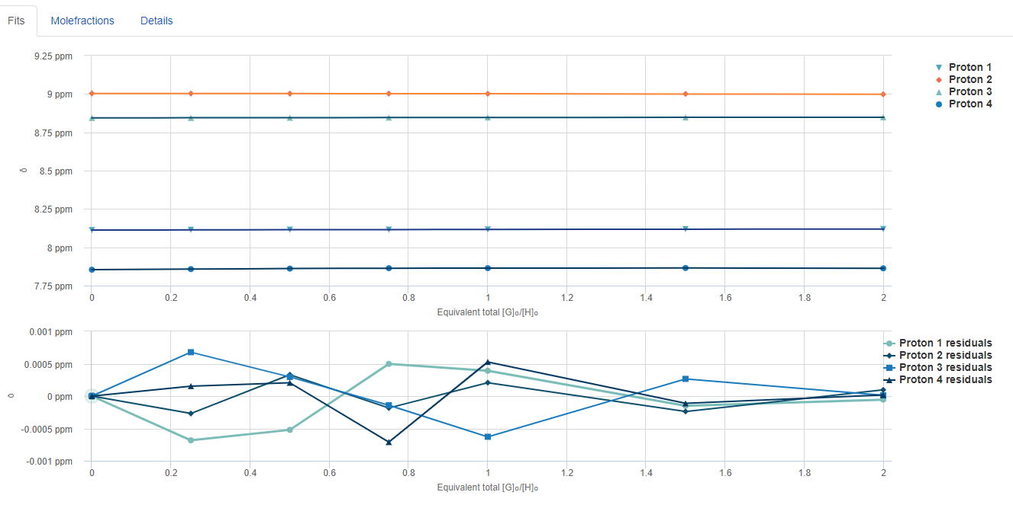
Supplementary Figure 2 | ¹H NMR titration. Binding isotherms (non-cooperative 1:2 system) fitted to the chemical shift of four proton signals of IrQPY versus the equivalents of CoPc added to determine the binding affinity (top); and the residual plot from the fit (bottom).
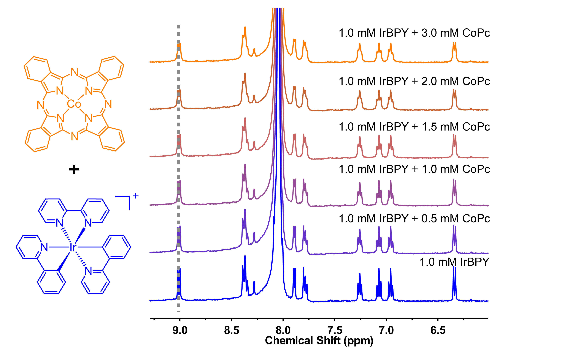
Supplementary Figure 3 | ¹H NMR titration. ¹H NMR titration of CoPc into a 1.0 mM DMF-d₇ solution of IrBPY.

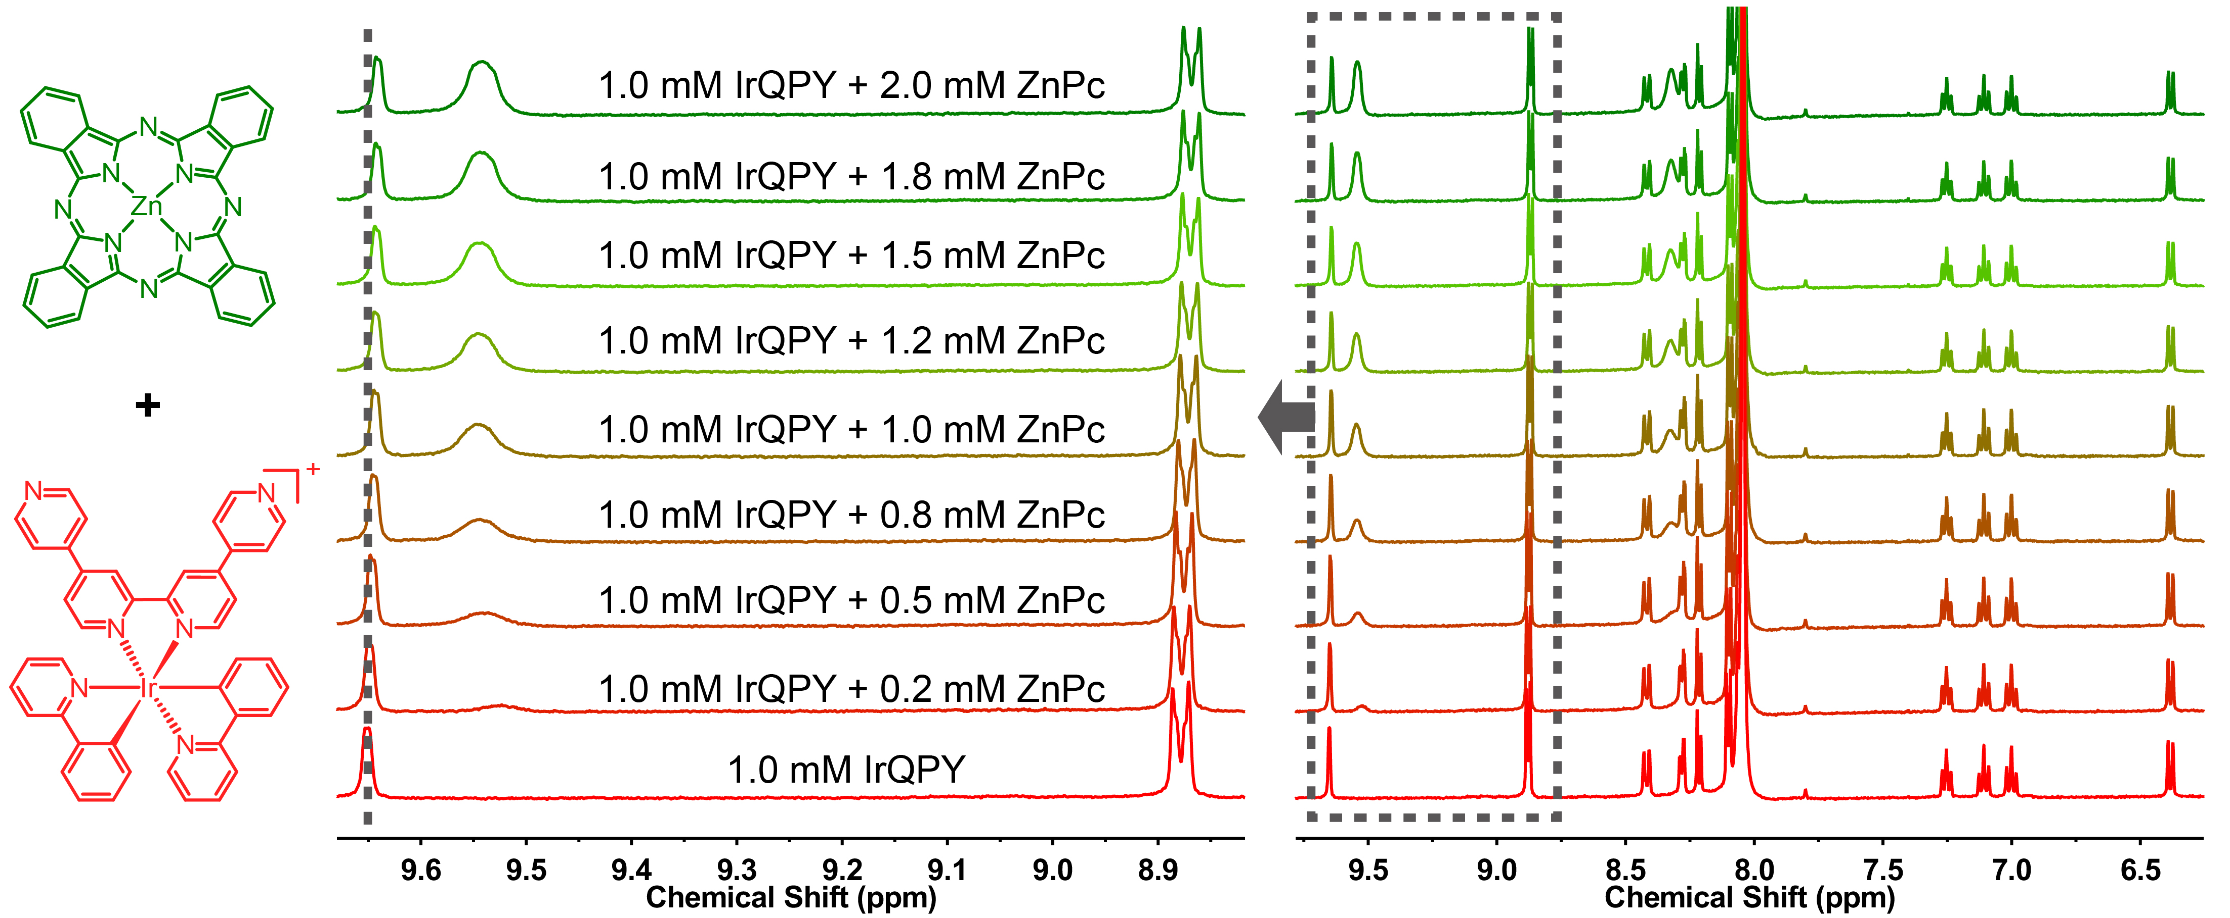

Supplementary Figure 4 | ¹H NMR titration. ¹H NMR titration of ZnPc into a 1.0 mM DMF-d₇ solution of IrQPY.

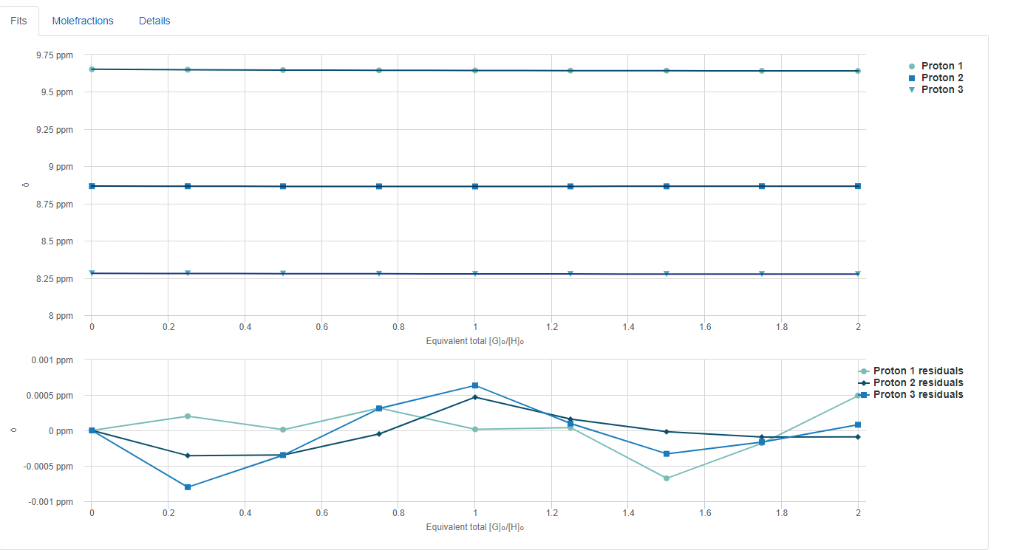
Supplementary Figure 5 | ¹H NMR titration. Binding isotherms fitted to the chemical shift of four proton signals of IrQPY versus the equivalents of ZnPc added to determine the binding affinity (top); and the residual plot from the fit (bottom).

Supplementary Figure 6 | Cyclic voltammetry. CVs of 0.5 mM CoPc under N₂ (black), under CO₂ (brown) or added 6 v% PhOH under CO₂ (orange) in CH₃CN.

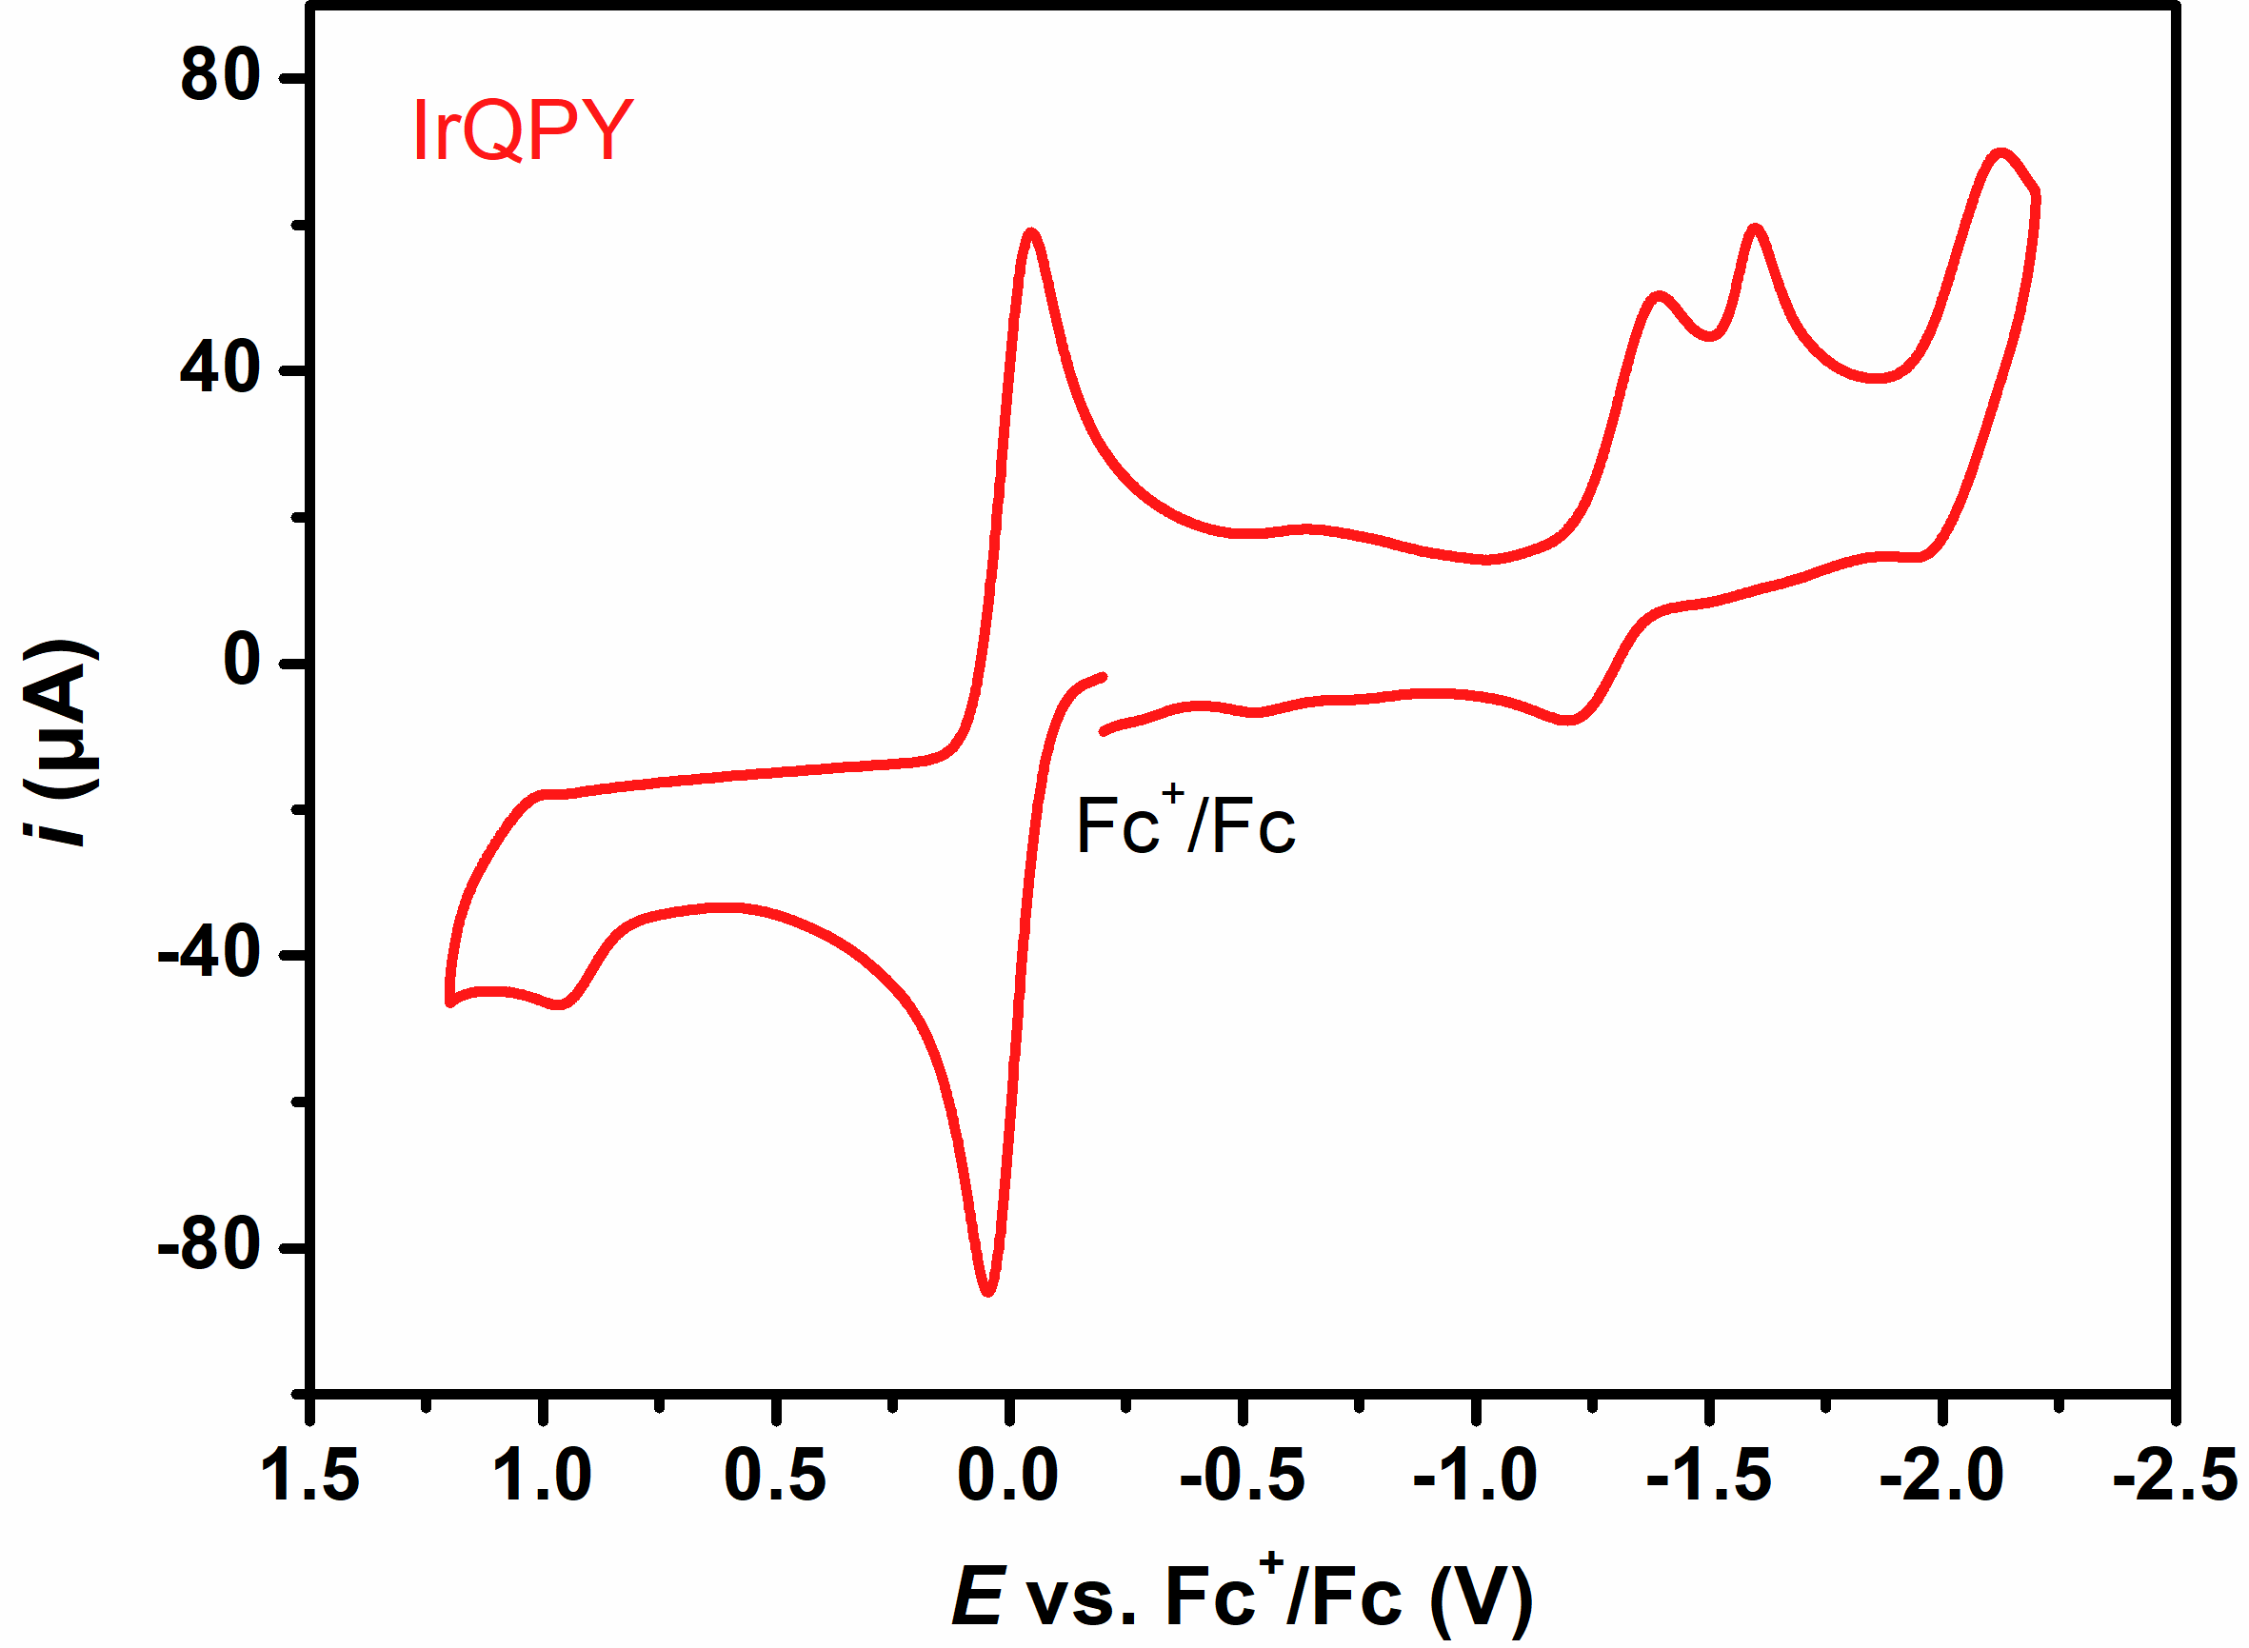
Supplementary Figure 7 | Cyclic voltammetry. CV of 0.5 mM IrQPY in dry CH₃CN under N₂.

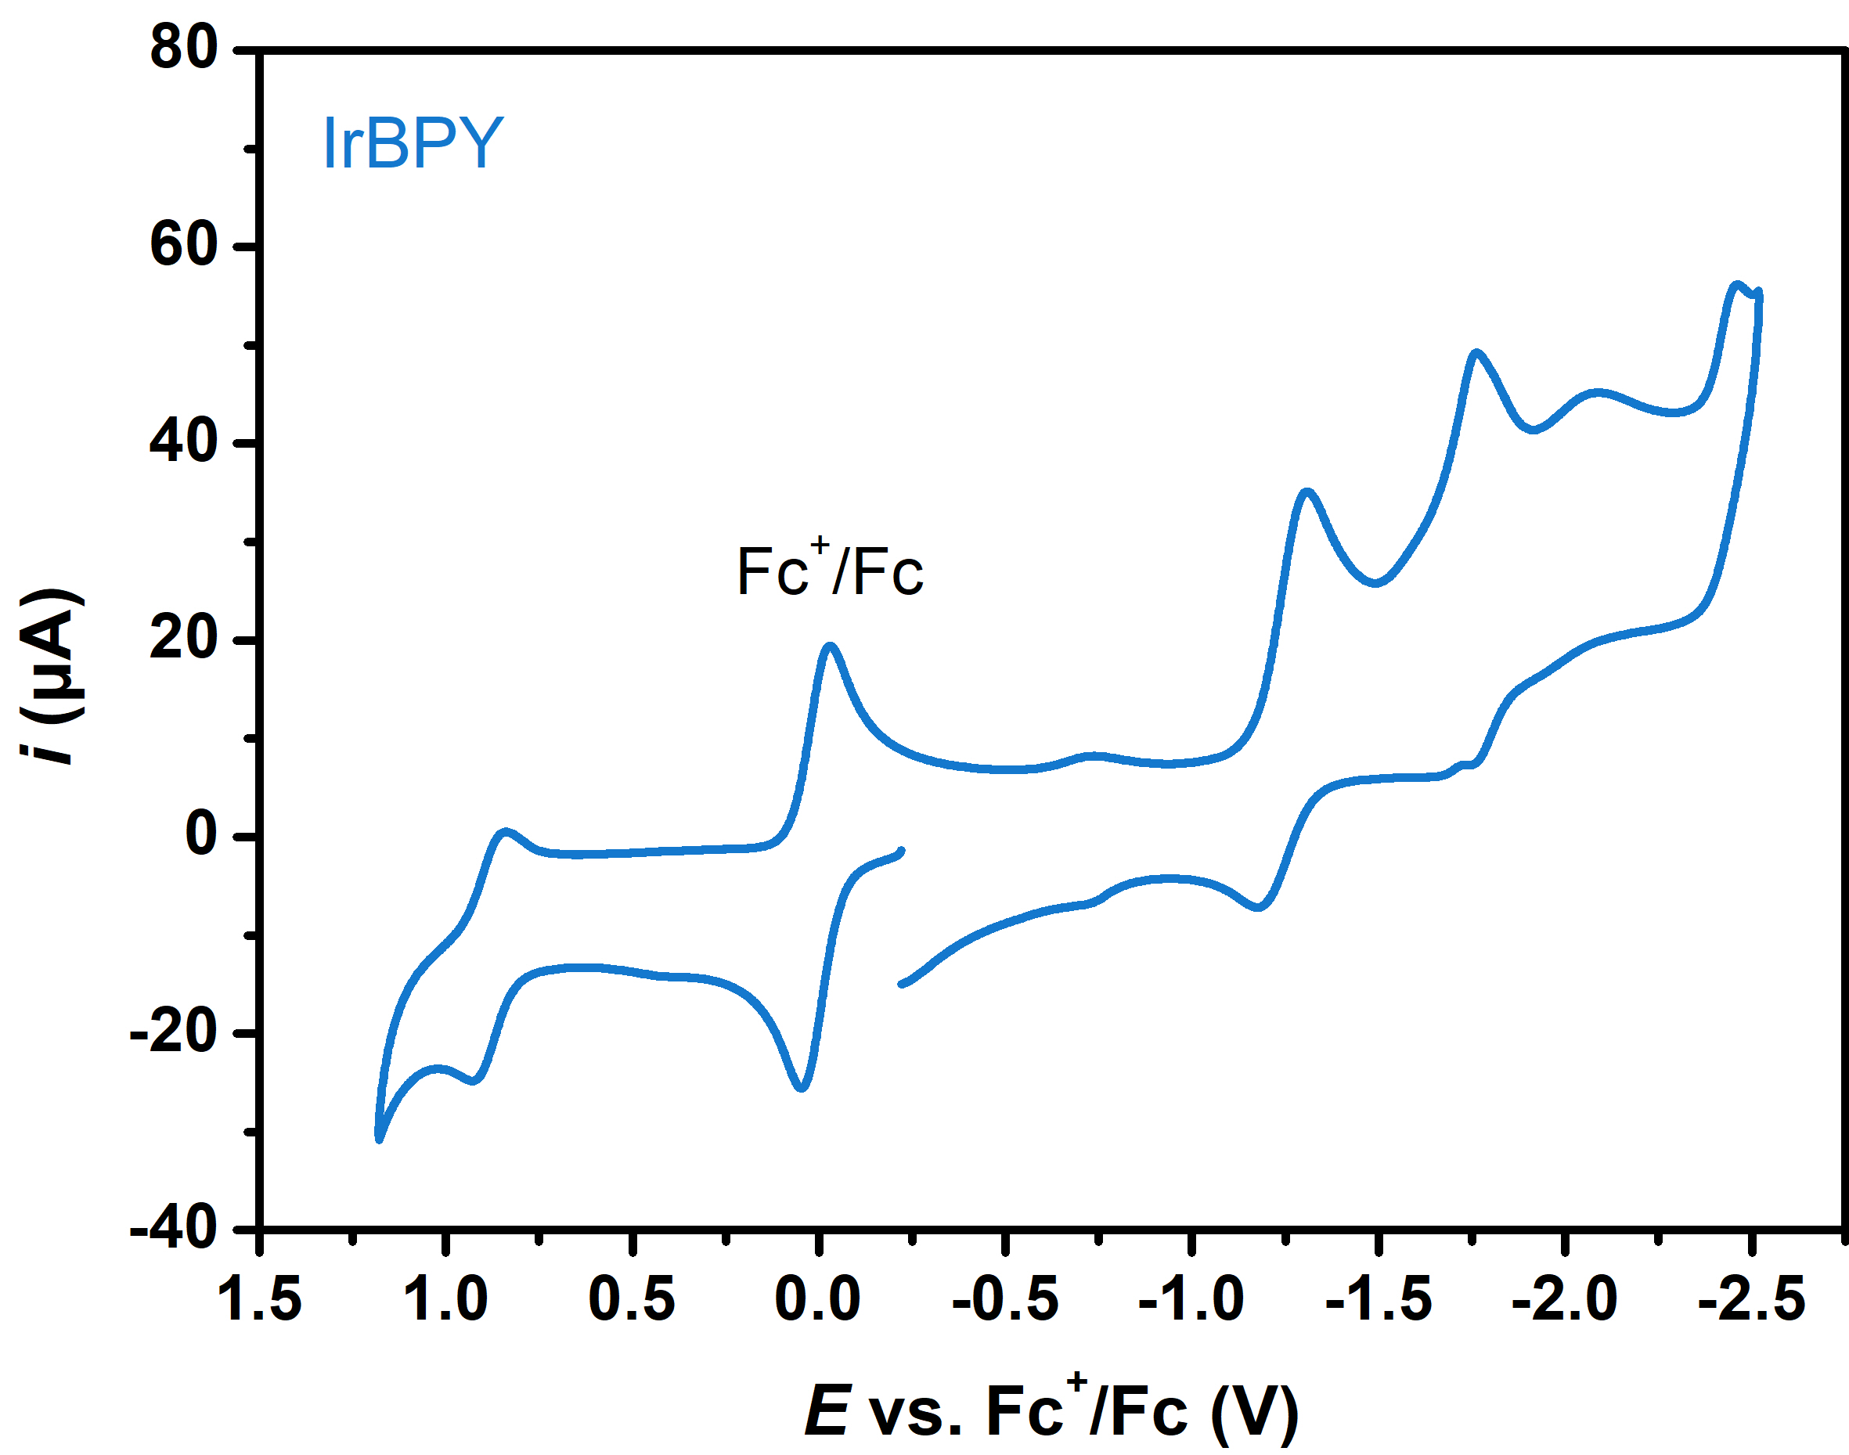
Supplementary Figure 8 | Cyclic voltammetry. CV of 0.5 mM IrBPY in dry CH₃CN under N₂.

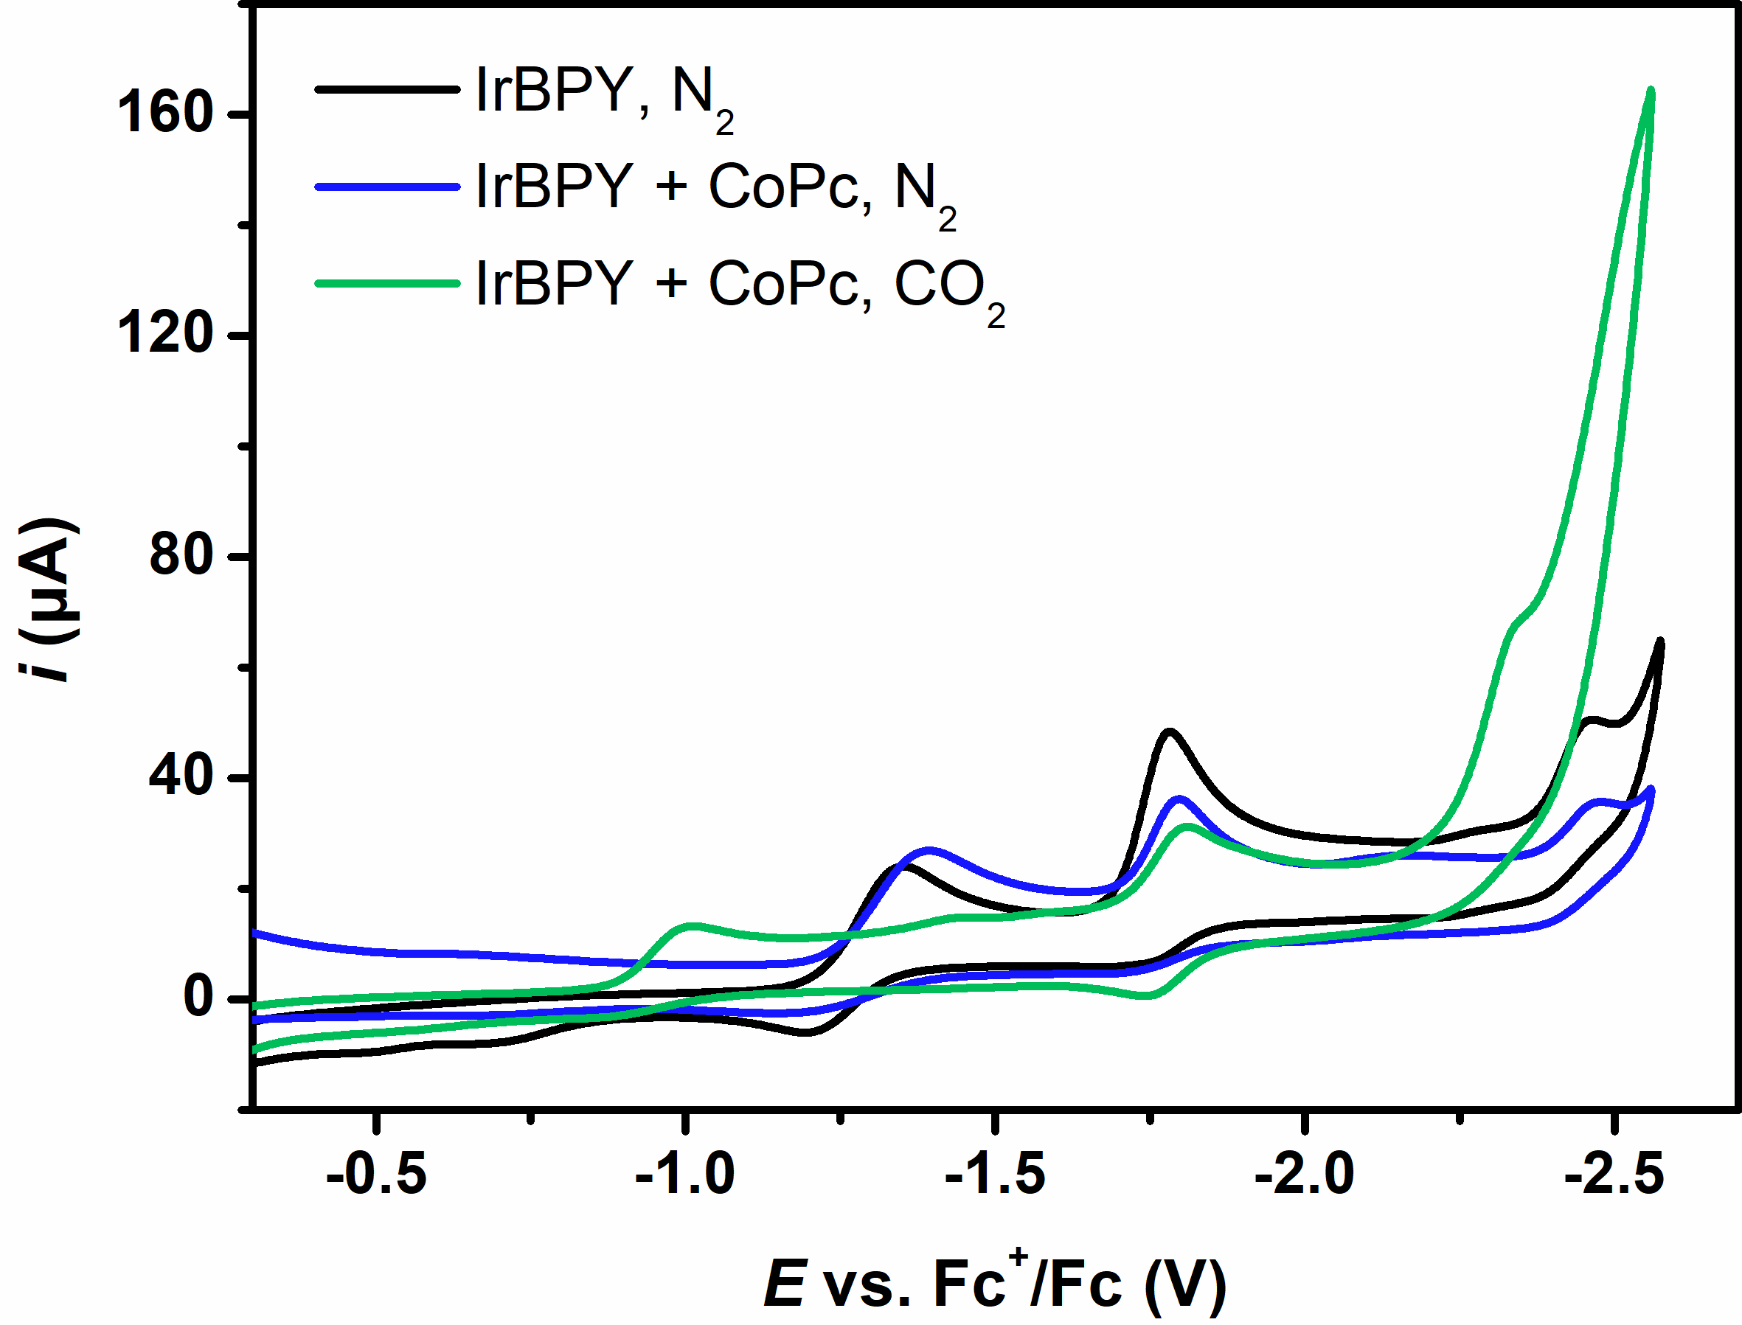
Supplementary Figure 9 | Cyclic voltammetry. CVs of 0.5 mM IrBPY under N₂ (black), added 0.5 mM CoPc under N₂ (blue) or added 0.5 mM CoPc under CO₂ (green).

Supplementary Table 1. Reported QEs from pioneering molecular systems for photocatalytic CO₂-to-CO conversion with noble-metal PSs and earth-abundant catalysts.
Entry | Catalyst | PS | QE (%) | CO (%) | Ref.
1 | CoPc | IrQPY | 20.4±1.0 at 450 nm | 98 | This work
2 | CoPc | IrBPY | 4.9±0.5 at 450 nm | 91 | This work
3 | CoTAPc | IrQPY | 55.7±1.6 at 425 nm | 99 | This work
4 |  |  | 4.9 at 450 nm | 98 | ¹³

5 |  |  | 1.43 at 450 nm | 99 | ¹⁴
6 |  |  | 11.1 at 450 nm | 99 | ¹⁵
7 |  |  | 2.8 at 458 nm | 98 | ¹⁶
7 |  |  | 8.8 at 458 nm | 95 | ¹⁶

Supplementary Table 2. Photocatalytic CO₂ reduction to CO by IrQPY/CoPc in the absence of certain component.*
Entry | Conditions | n(CO) (μmol) | n(H₂) (μmol)
1 | No CoPc | N.D. | 0.08±0.01
2 | No IrQPY | N.D. | N.D.
3 | Under N₂ instead of CO₂ | N.D. | N.D.
4 | No irradiation | N.D. | N.D.
5 | 10% CO₂/argon | 89.7±2.0 | 18.50±0.55
6 | No TEA | 66.9±0.8 | 6.50±0.05
7 | No BIH | N.D. | 0.14±0.02
*Standard condition: CoPc (0.1 mM), IrQPY (0.1 mM), PhOH (6.0 v%), TEA (2.5 v%), and BIH (80 mM) in 4.0 mL CH₃CN within 4 h of 450 nm irradiation under 1 atm CO₂.

Supplementary Table 3. Photocatalytic CO₂ reduction to CO by IrQPY/CoPc with varied volume ratios (v%) of different proton sources.*
Entry | Proton source | Volume ratio (v%) | n(CO) (μmol) | n(H₂) (μmol) | CO%
1 | No proton source | 0 | 13.9±0.2 | 0.60±0.10 | 96
2 | PhOH | 2.0 | 106.9±1.4 | 2.30±0.02 | 98
3 | PhOH | 4.0 | 126.8±0.8 | 2.39±0.14 | 98
4 | PhOH | 6.0 | 156.4±2.8 | 3.97±0.06 | 98
5 | PhOH | 8.0 | 145.9±1.9 | 4.71±0.08 | 97
6 | TFE | 2.0 | 50.1±0.7 | 3.51±0.04 | 93
7 | TFE | 4.0 | 82.2±3.4 | 11.30±0.04 | 92
8 | TFE | 6.0 | 62.4±0.5 | 2.30±0.02 | 85
9 | H₂O | 2.0 | 34.2±1.2 | 2.48±0.10 | 93
10 | H₂O | 4.0 | 56.3±1.0 | 3.74±0.08 | 94
11 | H₂O | 6.0 | 66.9±2.0 | 4.98±0.07 | 93
12 | H₂O | 10.0 | 34.8±0.3 | 2.21±0.03 | 94
13 | H₂O | 25.0 | 24.1±0.2 | 1.67±0.10 | 93
14 | H₂O | 50.0 | 1.1±0.1 | 12.15±0.90 | 8.3
*Condition: CoPc (0.1 mM), IrQPY (0.1 mM), TEA (2.5 v%), and BIH (80 mM) in 4.0 mL CH₃CN within 4 h of 450 nm irradiation under 1 atm CO₂.

Supplementary Table 4. Photocatalytic CO₂ reduction to CO for QE determination.*
Entry | Catalysts | Ir PSs | BIH (mM) | Time (h) | Wavelength (nm) | n(CO) (μmol) | n(H₂) (μmol) | QE(CO)  (%)
1 | CoPc | IrQPY | 80 | 1.0 | 450 | 110.2±5.5 | 3.09±0.26 | 20.4±1.0
2 | CoPc | IrBPY | 80 | 1.0 | 450 | 26.5±2.4 | 1.39±0.17 | 4.9±0.4
3 | CoPc | IrQPY | 150 | 0.5 | 450 | 78.5±4.2 | 1.59±0.07 | 29.1±2.6
4 | CoPc | IrQPY | 150 | 0.5 | 425 | 109.9±2.3 | 1.82±0.14 | 38.4±0.8
5 | CoPc | IrQPY | 150 | 0.5 | 405 | 99.9±3.4 | 1.93±0.08 | 33.3±1.1
6 | CoPc | IrBPY | 150 | 0.5 | 425 | 74.4±9.6 | 2.06±0.20 | 26.0±3.4
7 | CoTAPc | IrQPY | 150 | 0.5 | 425 | 159.4±4.7 | 2.15±0.07 | 55.7±1.6
8 | CoTAPc | IrBPY | 150 | 0.5 | 425 | 56.2±6.3 | 1.81±0.25 | 18.7±2.1
*Standard condition: Cobalt phthalocyanine catalysts (0.1 mM), Ir PSs (0.1 mM), PhOH (6.0 v%), TEA (2.5 v%), and BIH (80 or 150 mM) in 4.0 mL CH₃CN within LED irradiation under 1 atm CO₂.

Supplementary Table 5. Emission quantum yields of IrQPY.
Entry | Excitation λ (nm) | Φ (%)
1 | 450 | 6.86
2 | 425 | 11.84
3 | 405 | 7.72

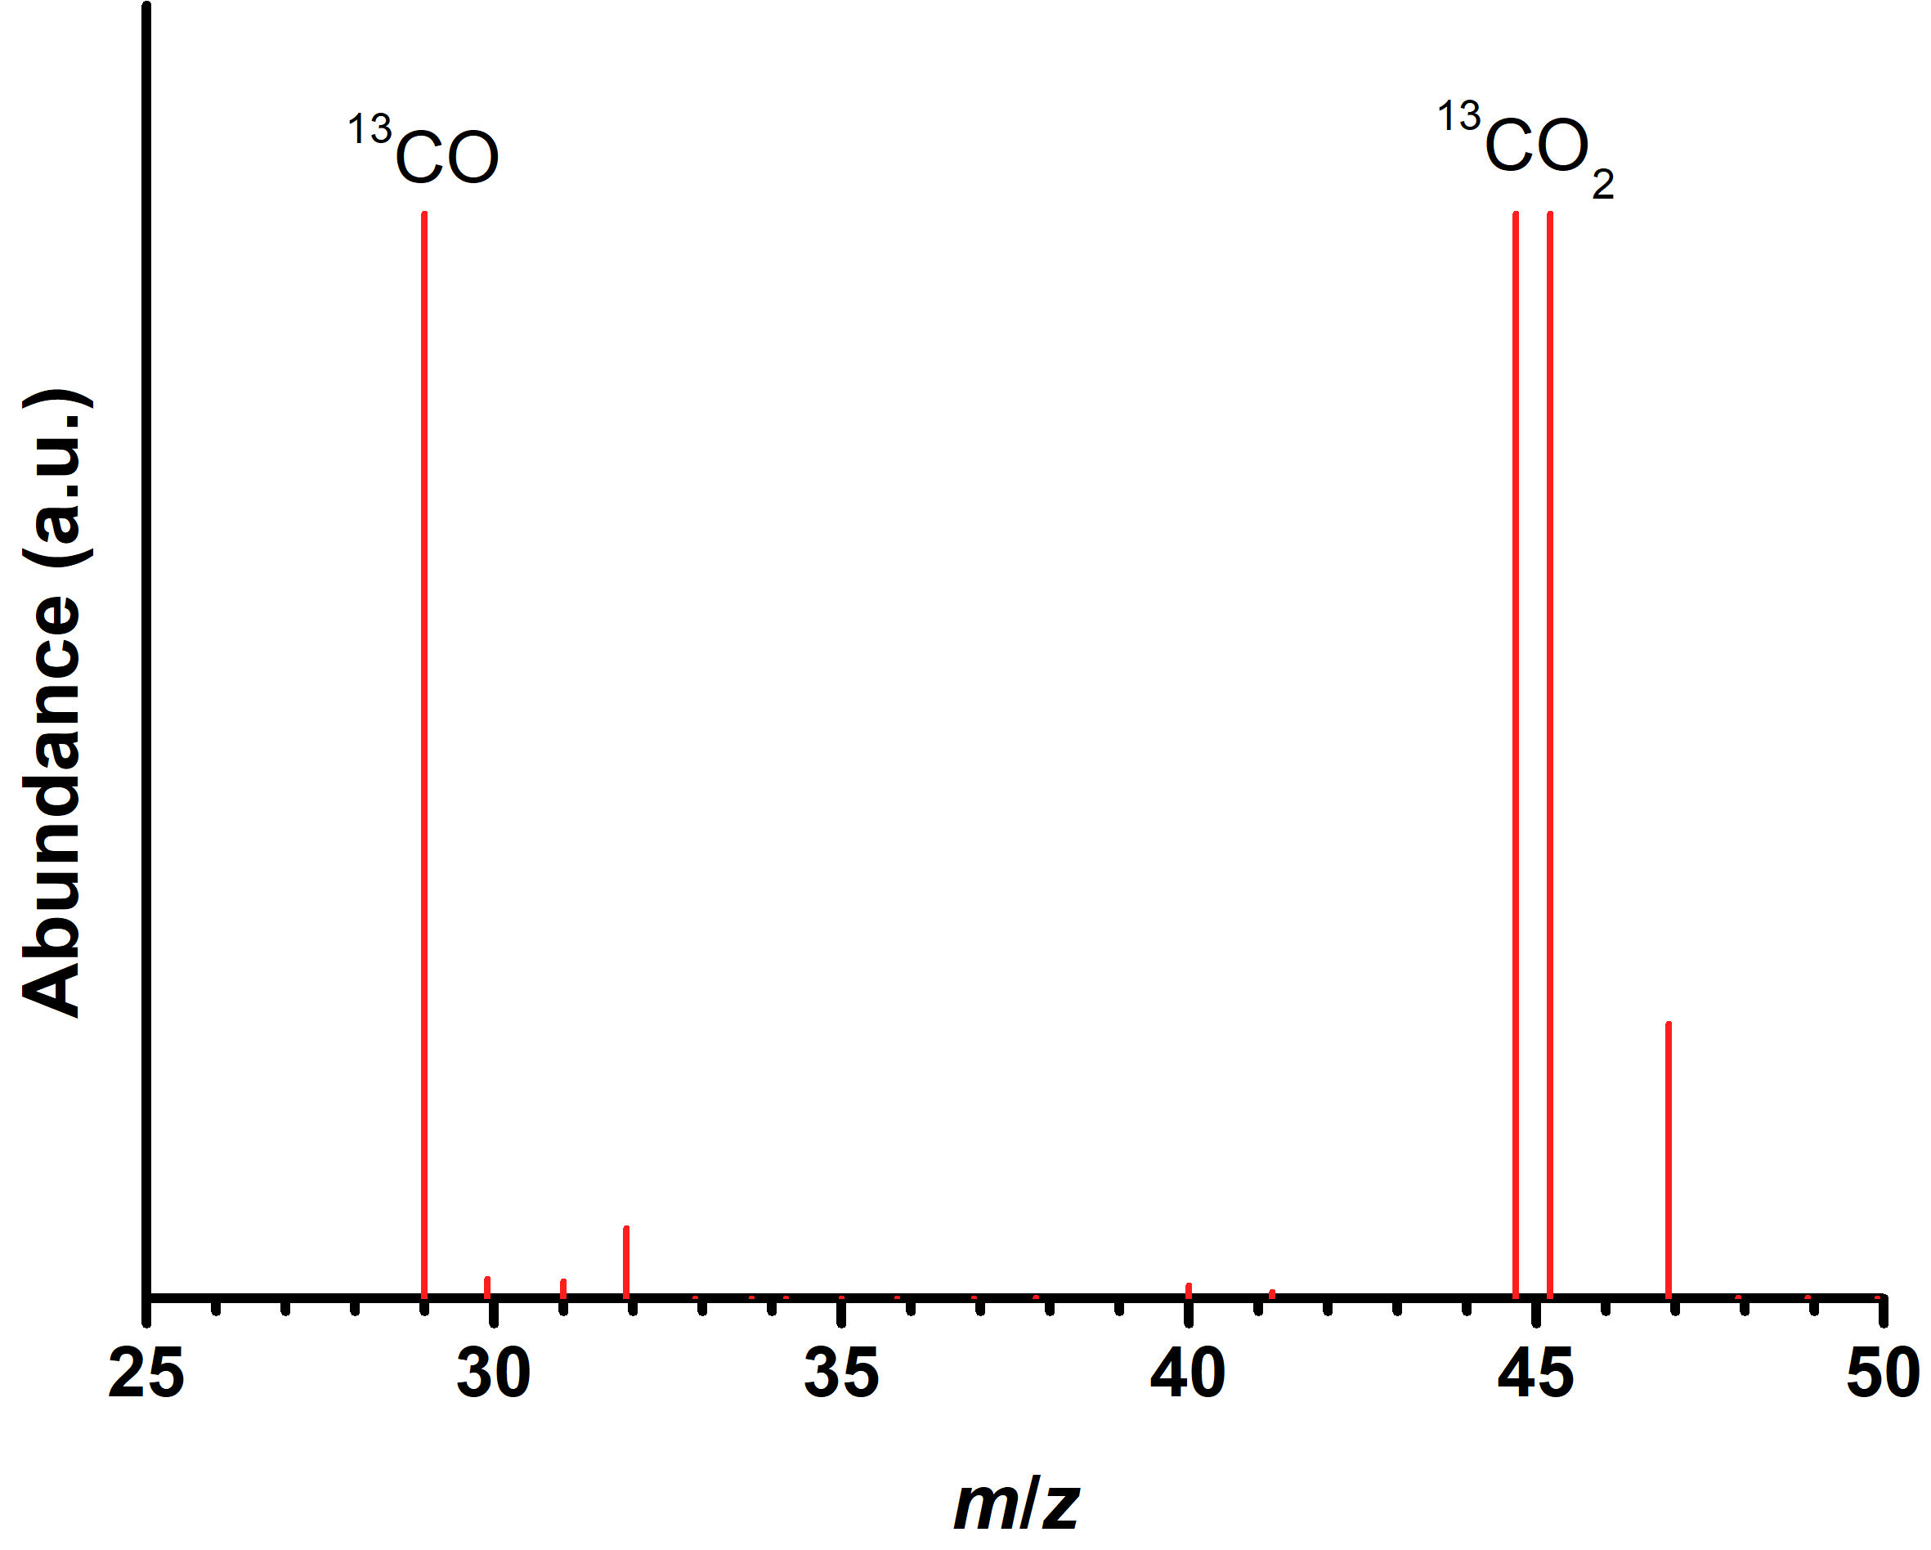
Supplementary Figure 10 | Isotope labelling experiment. Mass spectra analyses via gas chromatography on the generated gas from a mixture of CoPc (0.1 mM), IrQPY (0.1 mM), TEA (2.5 v%), PhOH (6.0 v%), and BIH (80 mM) in 4.0 mL CH₃CN within 4 h of 450 nm irradiation under 1 atm ¹³CO₂.

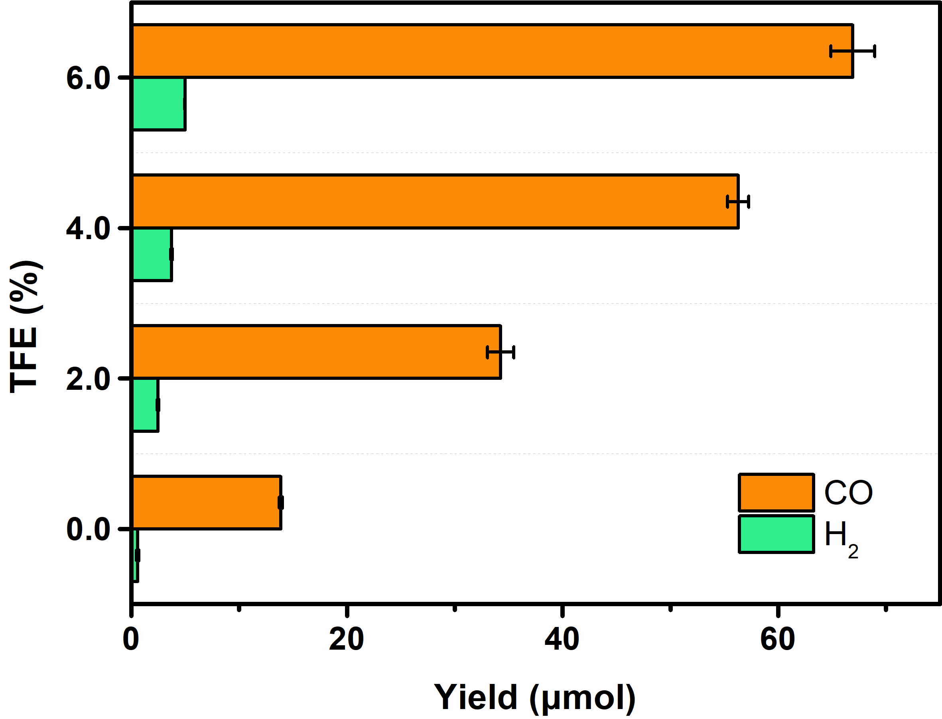
Supplementary Figure 11 | Photocatalytic CO₂ reduction. Photocatalytic CO and H₂ yields from a mixture of CoPc (0.1 mM), IrQPY (0.1 mM), TEA (2.5 v%), TFE (0, 2.0, 4.0 or 6.0 v%), and BIH (80 mM) in 4.0 mL CO₂-saturated CH₃CN within 4 h of 450 nm irradiation under 1 atm CO₂.

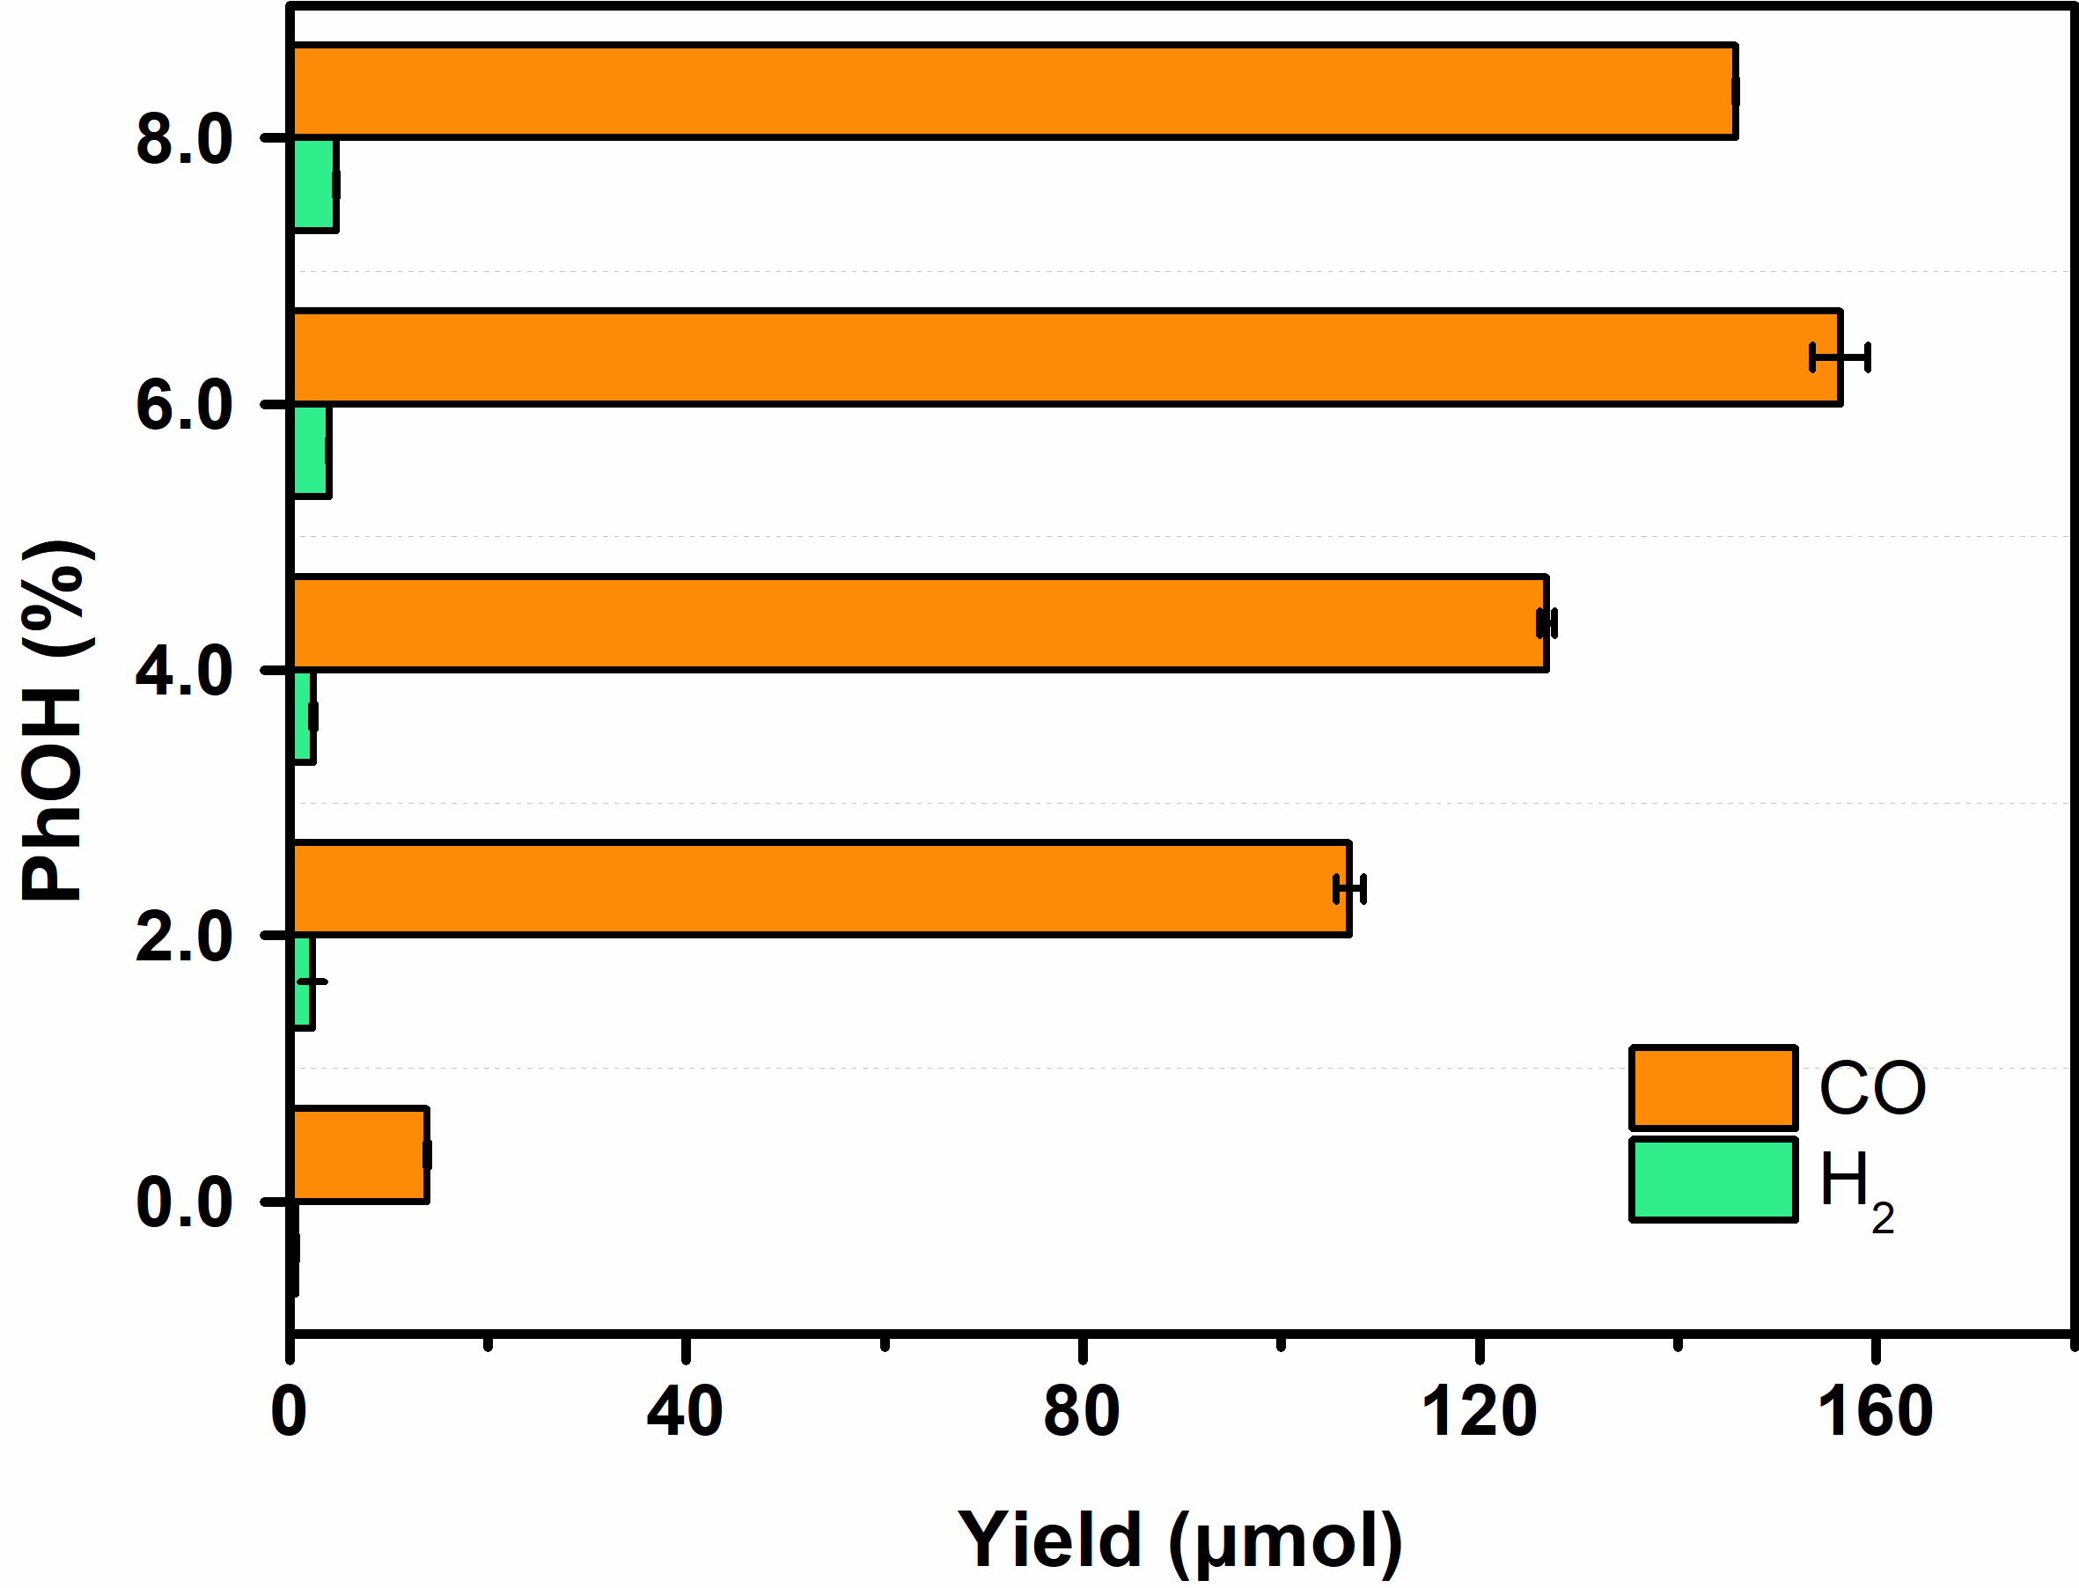
Supplementary Figure 12 | Photocatalytic CO₂ reduction. Photocatalytic CO and H₂ yields from a mixture of CoPc (0.1 mM), IrQPY (0.1 mM), TEA (2.5 v%), PhOH (0, 2.0, 4.0, 6.0 or 8.0 v%), and BIH (80 mM) in 4.0 mL CH₃CN within 4 h of 450 nm irradiation under 1 atm CO₂.

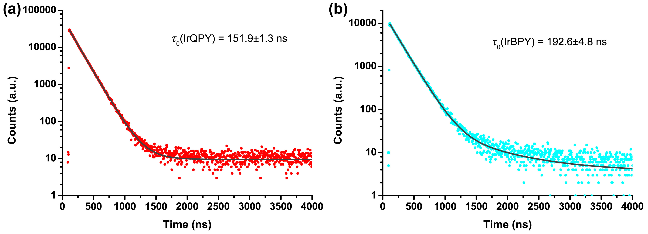
Supplementary Figure 13 | Excited state lifetimes. Fluorescence decays of 50 μM a IrQPY and b IrBPY in CH₃CN under N₂.

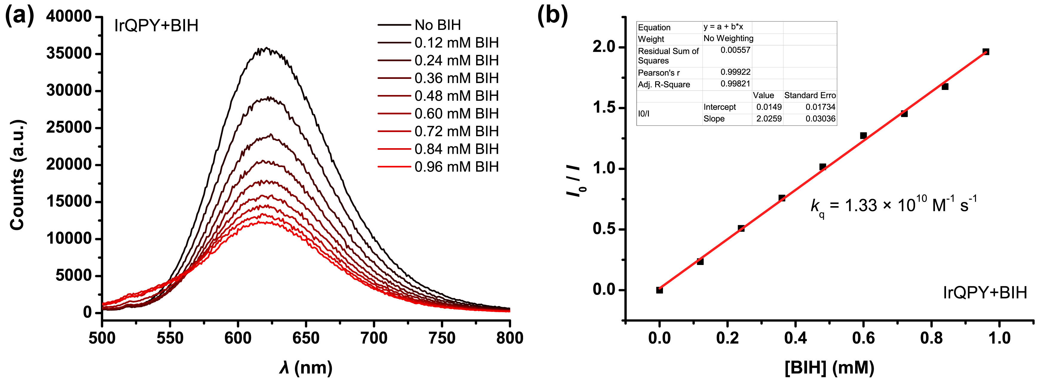
Supplementary Figure 14 | Quenching experiments. a Fluorescence spectra of a CH₃CN solution containing 0.05 mM IrQPY in the absence (black) and presence of 0~0.96 mM BIH, respectively. b Linear fitting of ratio of fluorescence intensity in the absence and presence of BIH versus [BIH].

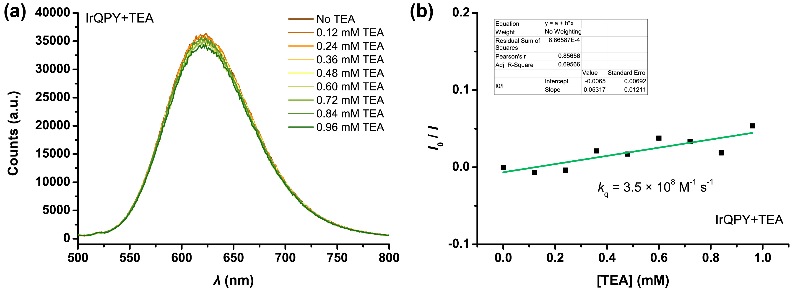
Supplementary Figure 15 | Quenching experiments. a Fluorescence spectra of a CH₃CN solution containing 0.05 mM IrQPY in the absence (black) and presence of 0~0.96 mM TEA, respectively. b Linear fitting of ratio of fluorescence intensity in the absence and presence of TEA versus [TEA].

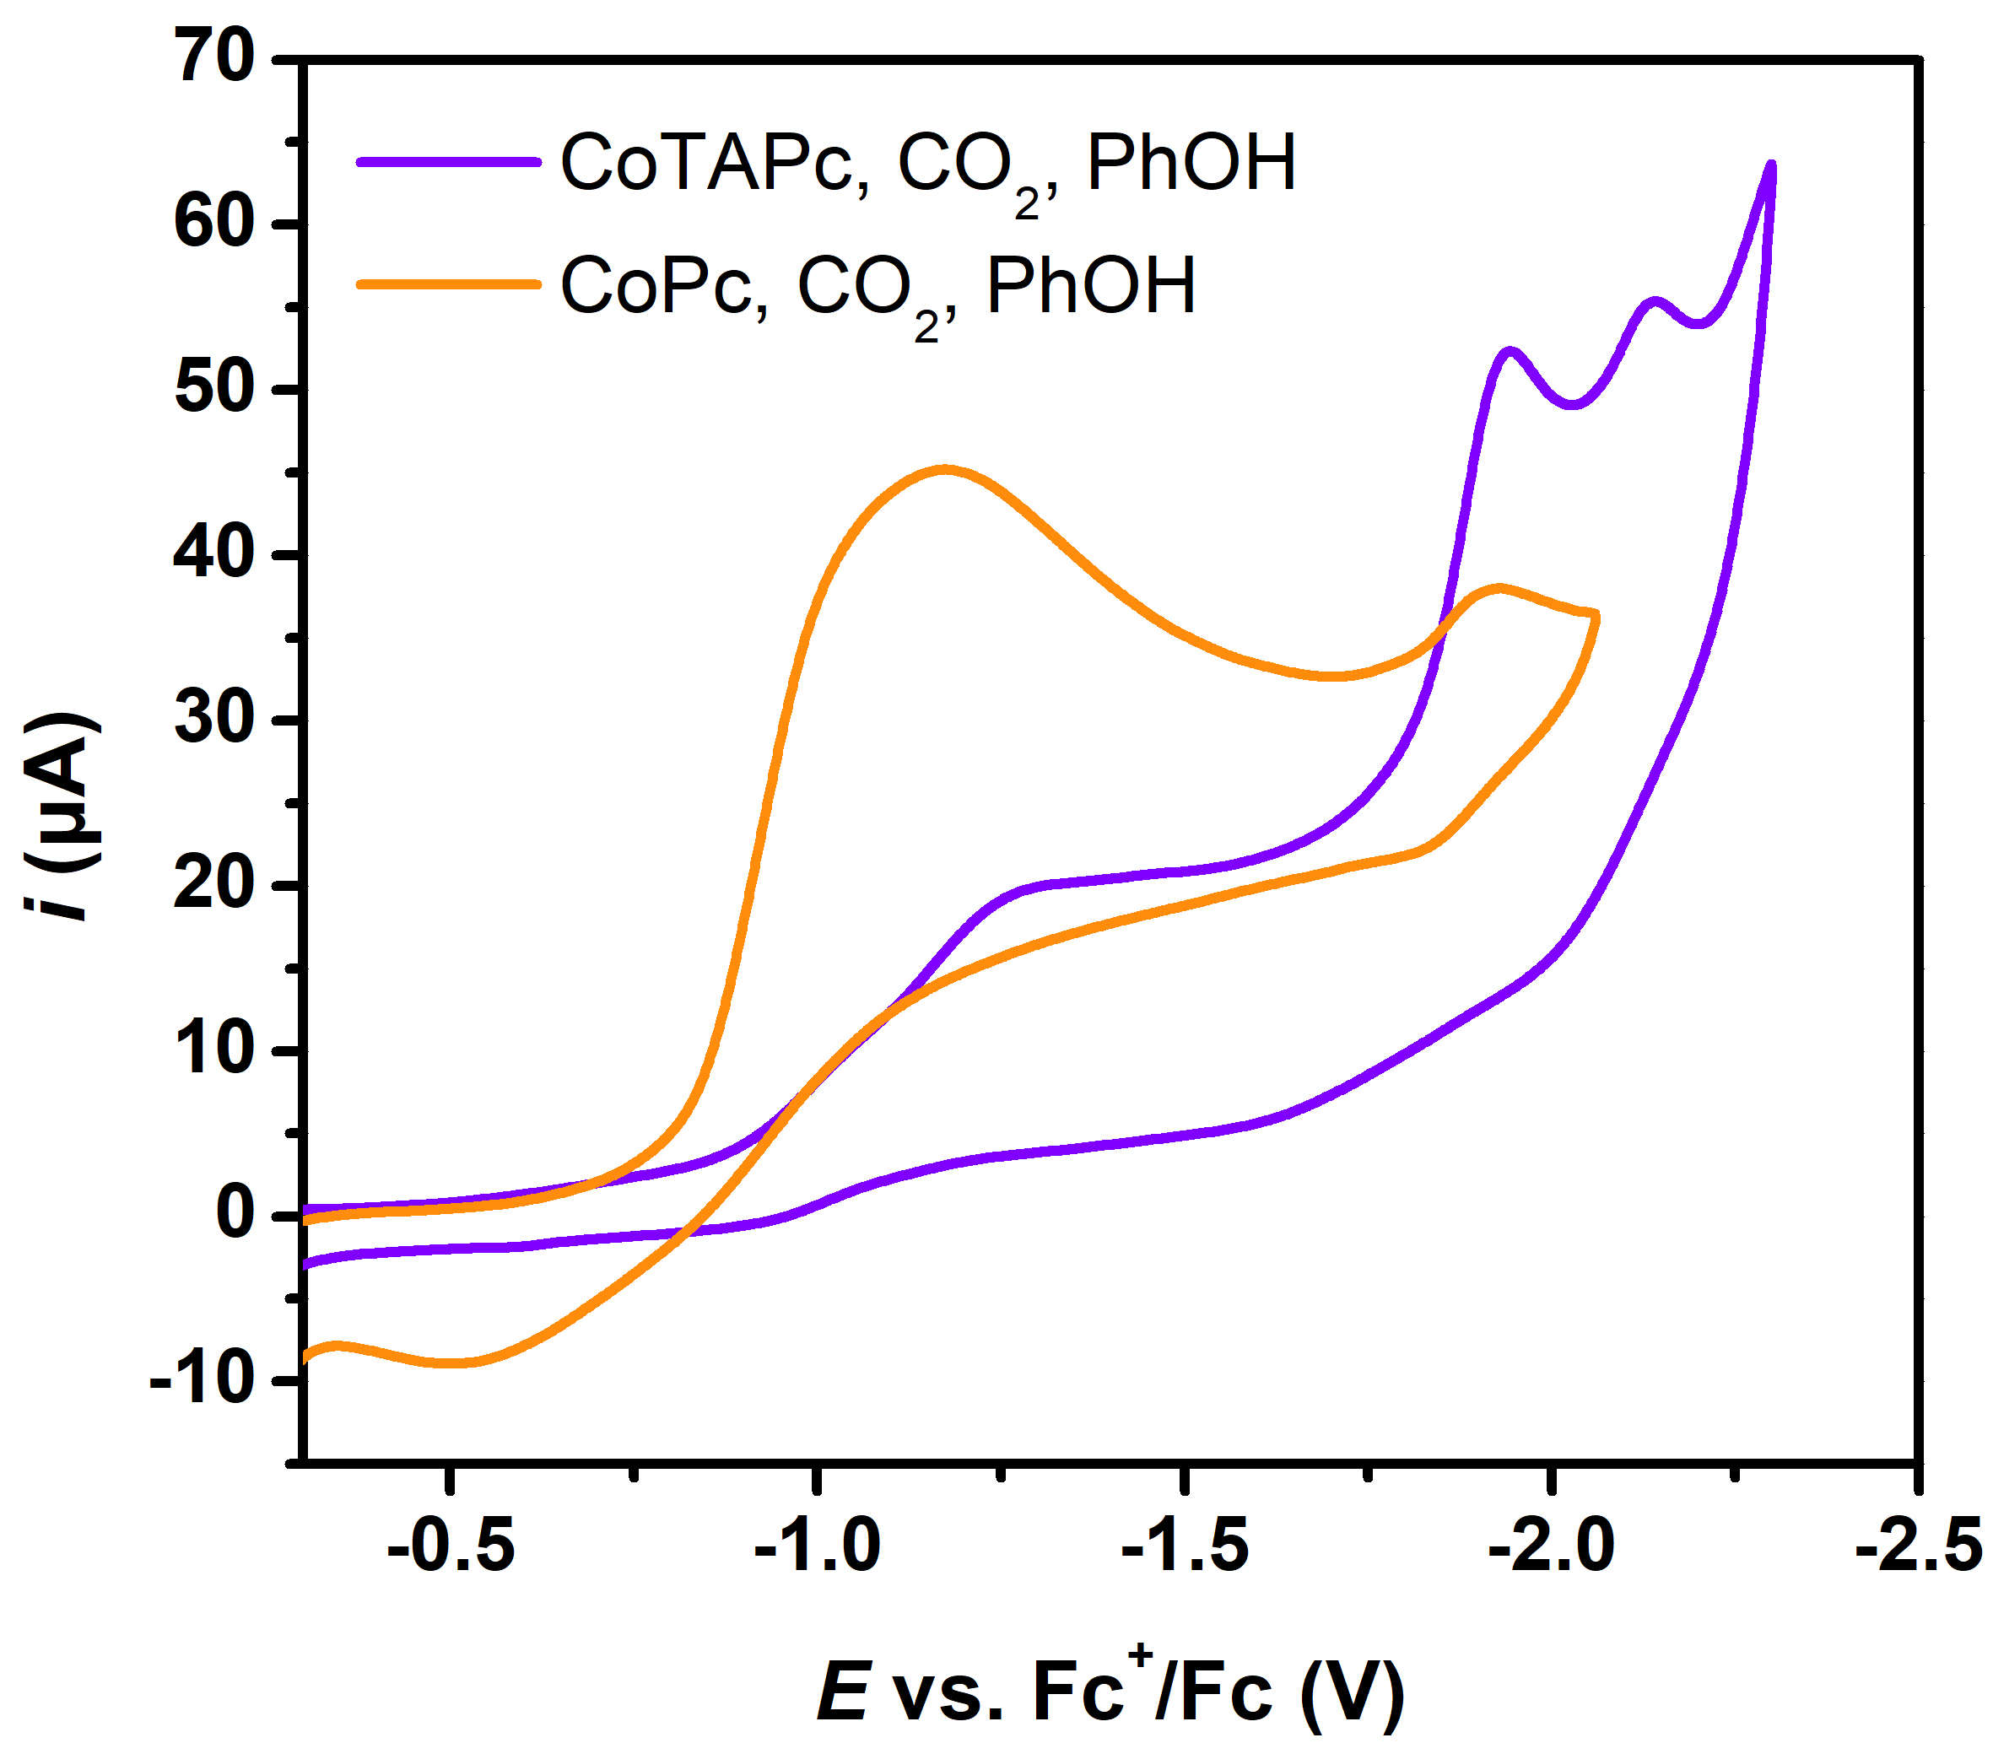
Supplementary Figure 16 | Cyclic voltammetry. CVs of CoPc (orange) and CoTAPc (violet) with addition of 6 v% PhOH under CO₂.

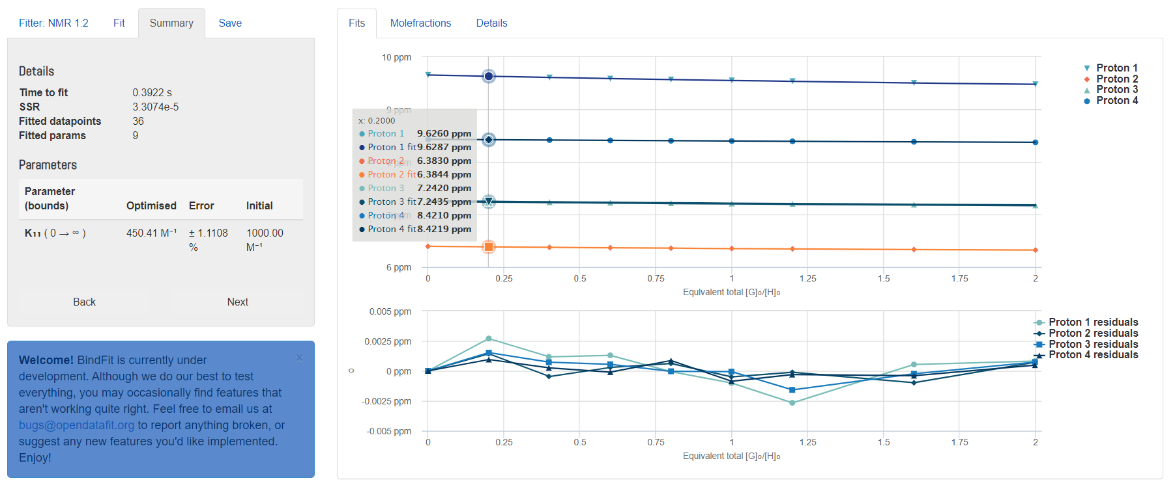
Supplementary Figure 17 | ¹H NMR titration. Binding isotherms (non-cooperative 1:2 system) fitted to the chemical shift of four proton signals of IrQPY versus the equivalents of CoTAPc added to determine the binding affinity (top); and the residual plot from the fit (bottom).

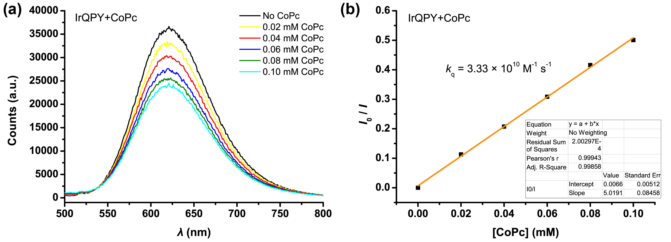
Supplementary Figure 18 | Quenching experiments. a Fluorescence spectra of a CH₃CN solution containing 0.05 mM IrQPY in the absence (black) and presence of 0~0.10 mM CoPc, respectively. b Linear fitting of ratio of fluorescence intensity in the absence and presence of CoPc versus [CoPc].

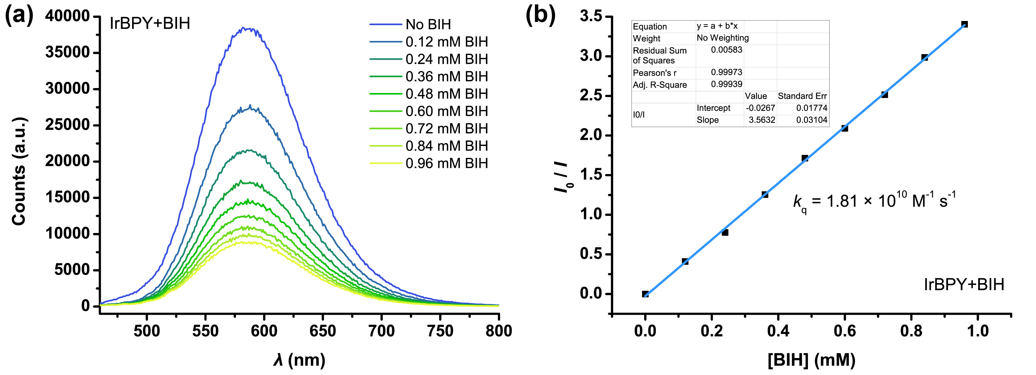
Supplementary Figure 19 | Quenching experiments. a Fluorescence spectra of a CH₃CN solution containing 0.05 mM IrBPY in the absence (black) and presence of 0~0.96 mM BIH, respectively. b Linear fitting of ratio of fluorescence intensity in the absence and presence of BIH versus [BIH].

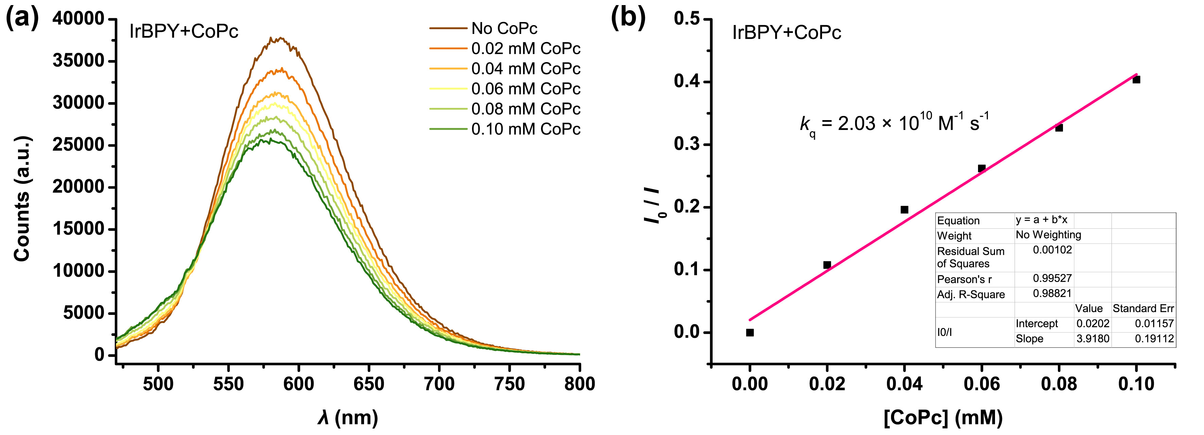
Supplementary Figure 20 | Quenching experiments. a Fluorescence spectra of a CH₃CN solution containing 0.05 mM IrBPY in the absence (black) and presence of 0~0.10 mM CoPc, respectively. b Linear fitting of ratio of fluorescence intensity in the absence and presence of CoPc versus [CoPc].

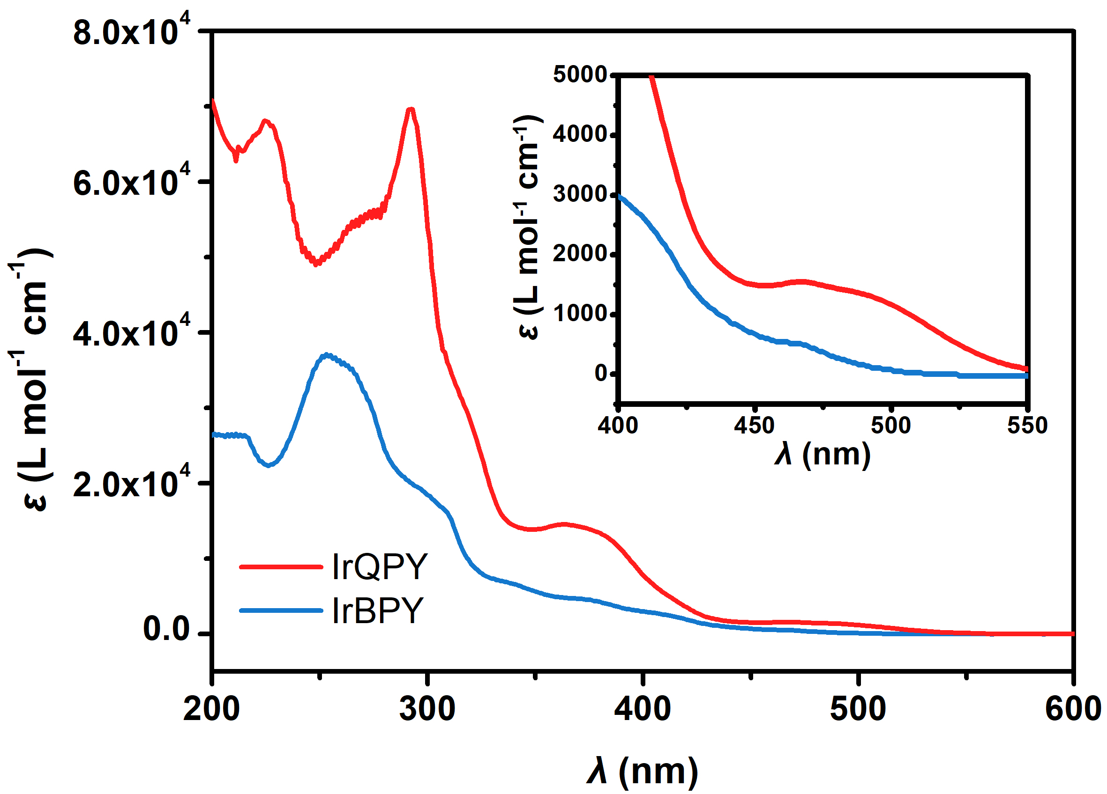
Supplementary Figure 21 | UV-Vis spectroscopy. UV-Vis spectra of 50 μM IrQPY (red) and IrBPY (blue) in CH₃CN.

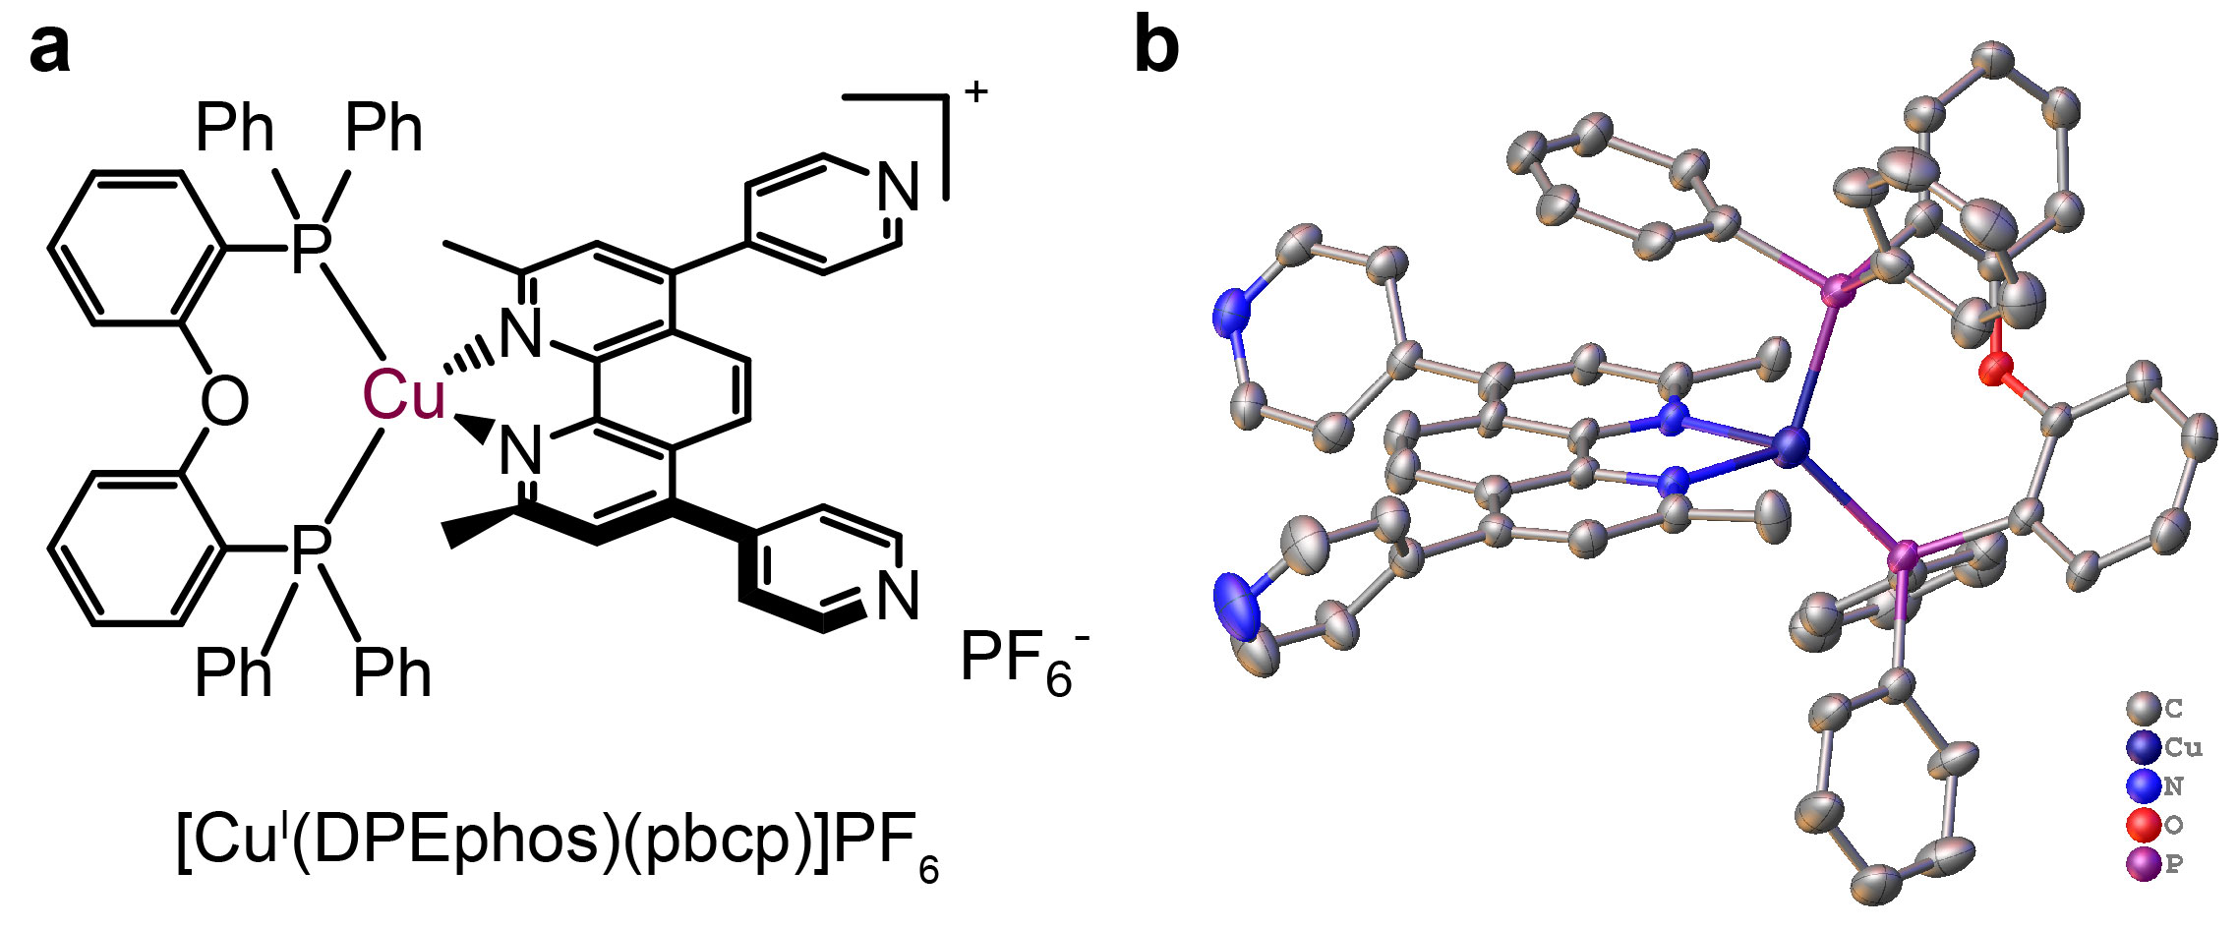
Supplementary Figure 22 | Cu^{I} PS with pyridine pendants. a Schematic and b crystal structures of the newly prepared Cu PS with pyridine pendants. Counter anions and solvent molecules are omitted for clarity.

Reference:

1. DiSalle, B. F. & Bernhard, S. Orchestrated photocatalytic water reduction using surface-adsorbing iridium photosensitizers. J. Am. Chem. Soc. 133, 11819-11821 (2011).
2. Luo, S. P., et al. Photocatalytic water reduction with copper-based photosensitizers: A noble-metal-free system. Angew. Chem. Int. Ed. 52, 419-423 (2013).
3. Bindfit. http://app.supramolecular.org/bindfit/. v0.5 edn.
4. Thordarson, P. Determining association constants from titration experiments in supramolecular chemistry. Chem. Soc. Rev. 40, 1305-1323 (2011).
5. Frisch, M. J., et al. Gaussian 09, Revision C.01 (Gaussian, Inc., 2009)
6. Zhao, Y. & Truhlar, D. G. The m06 suite of density functionals for main group thermochemistry, thermochemical kinetics, noncovalent interactions, excited states, and transition elements: Two new functionals and systematic testing of four M06-class functionals and 12 other functionals. Theor. Chem. Acc. 120, 215-241 (2007).
7. Hay, P. J. & Wadt, W. R. Ab initio effective core potentials for molecular calculations. Potentials for k to au including the outermost core orbitals. J. Chem. Phys. 82, 299-310 (1985).
8. Figgis, B. N., Kucharski, E. S. & Reynolds, P. A. Electronic structure of cobalt phthalocyanine: A charge density study. J. Am. Chem. Soc. 111, 1683-1692 (1989).
9. Lu, T. & Chen, F. Multiwfn: A multifunctional wavefunction analyzer. J. Comput. Chem. 33, 580-592 (2012).
10. Guo, Z., et al. Selectivity control of CO versus HCOO⁻ production in the visible-light-driven catalytic reduction of CO₂ with two cooperative metal sites. Nat. Catal. 2, 801-808 (2019).
11. Kuhn, H., Braslavsky, S. & Schmidt, R. Chemical actinometry (IUPAC technical report). Pure Appl. Chem. 76, 2105-2146 (2004).
12. Thoi, V. S., Kornienko, N., Margarit, C. G., Yang, P. & Chang, C. J. Visible-light photoredox catalysis: Selective reduction of carbon dioxide to carbon monoxide by a nickel N-heterocyclic carbene-isoquinoline complex. J. Am. Chem. Soc. 135, 14413-14424 (2013).
13. Ouyang, T., et al. Dinuclear metal synergistic catalysis boosts photochemical CO₂-to-CO conversion. Angew. Chem. Int. Ed. 57, 16480-16485 (2018).
14. Hong, D., Tsukakoshi, Y., Kotani, H., Ishizuka, T. & Kojima, T. Visible-light-driven photocatalytic CO₂ reduction by a Ni(II) complex bearing a bioinspired tetradentate ligand for selective CO production. J. Am. Chem. Soc. 139, 6538-6541 (2017).
15. Hong, D., Kawanishi, T., Tsukakoshi, Y., Kotani, H., Ishizuka, T. & Kojima, T. Efficient photocatalytic CO₂ reduction by a Ni(II) complex having pyridine pendants through capturing a Mg(2+) ion as a lewis-acid cocatalyst. J. Am. Chem. Soc. 141, 20309-20317 (2019).
16. Guo, Z., et al. Highly efficient and selective photocatalytic CO₂ reduction by iron and cobalt quaterpyridine complexes. J. Am. Chem. Soc. 138, 9413-9416 (2016).

Appendix: Optimized Coordinates (xyz) at the M06/BSI Level

CoPc low-spin
Co 0.00000000 0.00000000 0.00005700
N -1.35053300 1.36981200 -0.00004100
C -2.70858400 1.17033900 -0.00005100
C -3.39381200 2.44706000 0.00001400
C -4.74347900 2.78421700 0.00003900
H -5.50995500 2.01177900 0.00001600
C -5.06331200 4.13574100 0.00006600
H -6.10836700 4.44117700 0.00006700
C -4.06273000 5.12191200 0.00009000
H -4.35303100 6.17127300 0.00010800
C -2.71607300 4.78244600 0.00008400
H -1.93259000 5.53762600 0.00009800
C -2.39860400 3.42807000 0.00003600
C -1.13172700 2.72485100 -0.00003600
N 0.02380800 3.35680900 -0.00004600
N 1.36974800 1.35059800 -0.00012100
C 1.17032900 2.70865000 -0.00009700
C 2.44707300 3.39383500 -0.00009100
C 2.78428700 4.74348800 -0.00006200
H 2.01188400 5.51000000 -0.00000100
C 4.13582500 5.06326500 -0.00013300
H 4.44129900 6.10830900 -0.00013000
C 5.12195700 4.06264500 -0.00021600
H 6.17132900 4.35290800 -0.00027500
C 4.78243600 2.71600300 -0.00022700
H 5.53758000 1.93248600 -0.00029800
C 3.42804700 2.39859100 -0.00017100
C 2.72478500 1.13173800 -0.00021100
N 3.35671200 -0.02380700 -0.00025500
N 1.35053300 -1.36981200 -0.00005700
C 2.70858400 -1.17033900 -0.00018700
C 3.39381200 -2.44706000 -0.00014300
C 4.74347900 -2.78421700 -0.00021400
H 5.50995500 -2.01177900 -0.00031900
C 5.06331100 -4.13574100 -0.00017800
H 6.10836700 -4.44117700 -0.00024900
C 4.06272900 -5.12191200 -0.00005300
H 4.35303100 -6.17127300 -0.00002900
C 2.71607300 -4.78244600 0.00003400
H 1.93259000 -5.53762600 0.00013100
C 2.39860400 -3.42807000 -0.00002100
C 1.13172700 -2.72485100 -0.00000600
N -0.02380800 -3.35680900 0.00009300
N -1.36974800 -1.35059800 0.00002500
C -1.17032900 -2.70865000 0.00010400
C -2.44707300 -3.39383500 0.00024100
C -2.78428700 -4.74348800 0.00036300
H -2.01188400 -5.51000000 0.00040800
C -4.13582500 -5.06326500 0.00040200
H -4.44129900 -6.10830900 0.00047600
C -5.12195700 -4.06264600 0.00033800
H -6.17132900 -4.35290800 0.00036500
C -4.78243600 -2.71600400 0.00023700
H -5.53758000 -1.93248600 0.00017900
C -3.42804700 -2.39859100 0.00017900
C -2.72478500 -1.13173800 0.00002400
N -3.35671200 0.02380700 -0.00003000
CoPc low-spin
Co 0.00000000 0.00000000 -0.00000900
N 1.36305600 -1.35784500 -0.00001700
C 1.14419600 -2.73786300 -0.00007200
C 2.41598600 -3.42753100 -0.00007500
C 2.75447000 -4.77538500 -0.00011800
H 1.98377900 -5.54366100 -0.00016300
C 4.10958500 -5.09564700 -0.00010400
H 4.41252600 -6.14151100 -0.00013600
C 5.09541600 -4.09977500 -0.00004800
H 6.14484600 -4.38898100 -0.00003900
C 4.75107500 -2.74945700 -0.00000600
H 5.50335100 -1.96311000 0.00003800
C 3.40083600 -2.43602600 -0.00002000
C 2.70421000 -1.15600100 0.00001200
N 3.37338800 -0.01043400 0.00006500
N 1.37146600 1.34934400 0.00008100
C 2.71133800 1.13893300 0.00009800
C 3.41604000 2.41473000 0.00015800
C 4.76825900 2.71905600 0.00018500
H 5.51512500 1.92755100 0.00016300
C 5.12158300 4.06705400 0.00023900
H 6.17286800 4.34944100 0.00026000
C 4.14232600 5.06932800 0.00026600
H 4.45204500 6.11320500 0.00030700
C 2.78504100 4.75802800 0.00023900
H 2.01942300 5.53137700 0.00026000
C 2.43765100 3.41249300 0.00018400
C 1.16136300 2.73078000 0.00013800
N 0.01070300 3.36649700 0.00014700
N -1.36305600 1.35784500 0.00000900
C -1.14419700 2.73786300 0.00009300
C -2.41598600 3.42753100 0.00010300
C -2.75447000 4.77538500 0.00016300
H -1.98377900 5.54366100 0.00022500
C -4.10958500 5.09564700 0.00014400
H -4.41252600 6.14151100 0.00018900
C -5.09541600 4.09977500 0.00006600
H -6.14484600 4.38898100 0.00005300
C -4.75107500 2.74945700 0.00000600
H -5.50335100 1.96311000 -0.00005600
C -3.40083600 2.43602600 0.00002700
C -2.70421000 1.15600100 -0.00002000
N -3.37338800 0.01043400 -0.00009200
N -1.37146600 -1.34934400 -0.00008700
C -2.71133800 -1.13893300 -0.00012200
C -3.41604000 -2.41473000 -0.00018200
C -4.76825900 -2.71905600 -0.00022100
H -5.51512500 -1.92755100 -0.00021600
C -5.12158300 -4.06705400 -0.00026500
H -6.17286800 -4.34944100 -0.00029400
C -4.14232600 -5.06932800 -0.00027000
H -4.45204400 -6.11320500 -0.00030300
C -2.78504100 -4.75802800 -0.00023200
H -2.01942200 -5.53137700 -0.00023400
C -2.43765100 -3.41249300 -0.00018700
C -1.16136300 -2.73078000 -0.00013000
N -0.01070300 -3.36649700 -0.00012100
IrQPY
C -1.62362500 0.72717000 0.15410200
C -2.78817400 1.48506600 0.21493100
H -3.75740900 1.01972000 0.05078100
C -2.72689100 2.86270600 0.43928200
C -1.45968600 3.43150300 0.59577000
H -1.34647900 4.49478500 0.79499100
C -0.33782000 2.62397600 0.52086000
H 0.66758300 3.02944400 0.63835400
C -3.95137200 3.67979100 0.49866100
C -5.13150700 3.17625800 1.05013500
H -5.16878800 2.17758500 1.48298300
C -6.25835100 3.98980400 1.07923700
H -7.18863900 3.61930200 1.51235000
C -5.15709500 5.71005700 0.07686700
H -5.19904900 6.72806800 -0.31260400
C -3.97269500 4.98522200 0.00324600
H -3.09151800 5.42403300 -0.46236200
C -1.62326100 -0.73167500 -0.09148200
C -2.78767000 -1.48880400 -0.16688100
H -3.76089500 -1.01691500 -0.05250500
C -2.72528000 -2.86178900 -0.41683900
C -1.45756100 -3.42891900 -0.57514800
H -1.34214300 -4.49703700 -0.74515200
C -0.33580900 -2.62362500 -0.47910100
H 0.67080000 -3.02908900 -0.58598500
C -3.94961700 -3.67481500 -0.51734300
C -5.06386900 -3.41752000 0.28413500
H -5.04512300 -2.63132200 1.03765400
C -6.19371200 -4.21453200 0.13545300
H -7.07207600 -4.03687300 0.75748600
C -5.21806900 -5.45654100 -1.50216700
H -5.31220600 -6.27529900 -2.21681500
C -4.03574800 -4.72834000 -1.42992100
H -3.20833700 -4.96093900 -2.09854700
C 2.37511200 1.71325800 -2.12319300
C 2.54463500 2.24203600 -3.40604200
H 3.27911200 3.02665800 -3.56810300
C 1.79237100 1.75976700 -4.46177600
H 1.92912200 2.16859300 -5.46068800
C 0.86365300 0.74452500 -4.23447800
H 0.25725400 0.33515100 -5.03732300
C 0.73092500 0.25677200 -2.94903100
H 0.03345900 -0.54406000 -2.70859700
C 3.10915700 2.10823100 -0.93047700
C 2.79723900 1.37882100 0.24226100
C 3.48278500 1.70897800 1.41488400
H 3.28412000 1.16068500 2.33705400
C 4.43120200 2.72810400 1.42667700
H 4.95489300 2.96614700 2.35169100
C 4.72345300 3.44399600 0.26545900
H 5.46694800 4.23778400 0.28195000
C 4.06321900 3.13303100 -0.91226500
H 4.29644400 3.69244000 -1.81823600
C 2.41639200 -1.71665300 2.13366600
C 2.61284500 -2.24572300 3.41244300
H 3.34705000 -3.03390900 3.55814300
C 1.88793300 -1.75865500 4.48502100
H 2.04527500 -2.16762300 5.48082500
C 0.95987000 -0.73834600 4.27854800
H 0.37577700 -0.32408800 5.09531600
C 0.79933600 -0.25110100 2.99603800
H 0.10087800 0.55321300 2.77083900
C 3.12102900 -2.11527500 0.92452100
C 2.78772400 -1.38290800 -0.24026900
C 3.44282900 -1.71741700 -1.42889200
H 3.22598300 -1.16703500 -2.34573600
C 4.38280400 -2.74383000 -1.46328900
H 4.88277200 -2.98527500 -2.40047600
C 4.69641600 -3.46267600 -0.30951400
H 5.43289500 -4.26241600 -0.34394500
C 4.06637000 -3.14733100 0.88357500
H 4.31529700 -3.70955300 1.78360600
Ir 1.35274300 -0.00010100 0.01678100
N -0.40988200 1.30415400 0.30723900
N -6.28461200 5.23337900 0.60252500
N -0.40928500 -1.30677800 -0.24829400
N -6.28352100 -5.21424900 -0.74017300
N 1.46072300 0.72297800 -1.92209000
N 1.50212700 -0.72234100 1.95291900
IrQPY-CoPc
C -2.70286000 0.49851100 -0.12823700
C -1.31529300 0.59598500 -0.14879100
H -0.83299800 1.56174100 -0.27823800
C -0.52210800 -0.54839600 -0.03892600
C -1.17809200 -1.77791900 0.07127400
H -0.61760200 -2.70376400 0.17888300
C -2.56193200 -1.80949600 0.08178400
H -3.11099500 -2.74663200 0.17805500
C 0.94843800 -0.45572300 -0.02985800
C 1.59736000 0.62597400 0.57012600
H 1.03704000 1.41507000 1.06836500
C 2.98423900 0.66696500 0.56777900
H 3.51900200 1.49499300 1.03413800
C 3.12220800 -1.32018100 -0.56295200
H 3.76780000 -2.07615500 -1.01009700
C 1.74076300 -1.44912000 -0.60890800
H 1.29466700 -2.30251000 -1.11615600
C -3.59911200 1.67134300 -0.23181800
C -3.13264400 2.97956000 -0.30968000
H -2.06497500 3.18499500 -0.31674100
C -4.02813900 4.04713100 -0.40891200
C -5.39200000 3.74088700 -0.42459300
H -6.14043200 4.52838100 -0.47418300
C -5.79357500 2.41904500 -0.34202000
H -6.84766900 2.14023600 -0.34449800
C -3.55153000 5.43869600 -0.49595700
C -2.41406900 5.86228200 0.19448700
H -1.86406600 5.18366800 0.84481200
C -2.01269600 7.18829300 0.07528100
H -1.13254700 7.54212100 0.61395800
C -3.73410500 7.68110800 -1.32851100
H -4.24018200 8.43135300 -1.93741900
C -4.22592200 6.38179700 -1.27443300
H -5.10349300 6.10689100 -1.85746200
C -5.66258300 -2.58592100 -2.24008100
C -5.70350100 -3.04879000 -3.55827500
H -5.87010100 -4.10620100 -3.74734500
C -5.54697100 -2.16478500 -4.61013000
H -5.58488500 -2.52411100 -5.63624200
C -5.34366400 -0.81116100 -4.34234000
H -5.21648700 -0.08379700 -5.13903600
C -5.31203800 -0.40302200 -3.02297800
H -5.16720500 0.64105000 -2.75024000
C -5.82317500 -3.40027500 -1.04528600
C -5.81613300 -2.68832800 0.17834700
C -5.96374800 -3.42354900 1.35807000
H -5.97943100 -2.91441700 2.32291000
C -6.10043200 -4.80880100 1.32628100
H -6.21378100 -5.35955600 2.25921100
C -6.09888700 -5.49818900 0.11351000
H -6.20740600 -6.58031600 0.09585200
C -5.96260800 -4.79301800 -1.07132800
H -5.96227900 -5.33375700 -2.01780800
C -7.05502400 -0.11267200 2.41625400
C -7.33111800 0.10551100 3.76923300
H -8.35867100 0.26616400 4.08518700
C -6.30565000 0.10444100 4.69725900
H -6.52222900 0.26847800 5.75071300
C -4.99582400 -0.11284800 4.27023400
H -4.16264700 -0.12624900 4.96697800
C -4.77422900 -0.32155200 2.92328000
H -3.77622800 -0.51041900 2.53124100
C -8.03259700 -0.15719400 1.33976700
C -7.51276900 -0.46149100 0.05815700
C -8.41237800 -0.51882500 -1.01041500
H -8.05685000 -0.76443600 -2.01231400
C -9.77010700 -0.27705500 -0.81723000
H -10.45220900 -0.32940900 -1.66487900
C -10.26753000 0.02435300 0.45055200
H -11.32991900 0.20833600 0.59470800
C -9.39864900 0.08339500 1.52813600
H -9.79097700 0.31877600 2.51739200
Ir -5.51789300 -0.70908200 -0.00159300
N -3.31103800 -0.70335600 -0.00540100
N 3.73703900 -0.28566900 0.01437200
N -4.92508800 1.40387200 -0.25059500
N -2.65003400 8.08956600 -0.67048700
N -5.46921300 -1.25876600 -1.99921100
N -5.76848800 -0.32301700 2.01974800
Co 5.99569400 -0.15183600 0.06495300
N 6.17075800 -0.77393500 -1.75482700
C 6.14072600 0.00898800 -2.87929200
C 6.25888600 -0.82288700 -4.06185500
C 6.28815900 -0.52257100 -5.41961500
H 6.21329500 0.50734200 -5.76349700
C 6.42202800 -1.58374600 -6.30636100
H 6.45153300 -1.38949700 -7.37717400
C 6.52772300 -2.90707400 -5.84839900
H 6.63779800 -3.71102500 -6.57422100
C 6.50244100 -3.20430700 -4.49157400
H 6.59221400 -4.22497600 -4.12426200
C 6.36532700 -2.14030400 -3.60631200
C 6.30567200 -2.07664600 -2.15834800
N 6.36451000 -3.15637800 -1.40086400
N 6.19054700 -1.96804600 0.69438200
C 6.32330500 -3.08832400 -0.08333200
C 6.40621900 -4.26694300 0.75881400
C 6.55372800 -5.61917600 0.46846000
H 6.63077000 -5.96228400 -0.56157800
C 6.60565800 -6.50113600 1.54095500
H 6.72484700 -7.56730900 1.35555100
C 6.51486600 -6.04370800 2.86551000
H 6.56573100 -6.76493000 3.67943600
C 6.36919500 -4.69235400 3.15284900
H 6.30497900 -4.32523900 4.17541500
C 6.31440400 -3.81227900 2.07765000
C 6.18189100 -2.36946800 2.00426300
N 6.08512700 -1.61656700 3.08212200
N 6.00532500 0.48227300 1.88993300
C 6.02134900 -0.30108500 3.01330400
C 5.97118100 0.53480900 4.19792100
C 5.97033100 0.23524400 5.55625700
H 6.00907300 -0.79744800 5.89774100
C 5.92380200 1.30124500 6.44603300
H 5.92462600 1.10820400 7.51749000
C 5.88269500 2.62900500 5.99038000
H 5.85292200 3.43807600 6.71829900
C 5.88606600 2.92594000 4.63325900
H 5.86276300 3.95151800 4.26933600
C 5.92982800 1.85671800 3.74447200
C 5.94919400 1.79044500 2.29555200
N 5.89937800 2.87045900 1.53801400
N 5.98503600 1.67654600 -0.56021100
C 5.92887300 2.80153900 0.21995100
C 5.88651700 3.98295000 -0.62037100
C 5.83582100 5.34156800 -0.32571800
H 5.82461100 5.68660800 0.70658000
C 5.81090400 6.22719300 -1.39589300
H 5.77610700 7.29888700 -1.20709800
C 5.83837700 5.76713700 -2.72250500
H 5.82294000 6.49183100 -3.53482900
C 5.89212800 4.40984900 -3.01408300
H 5.92162700 4.04264600 -4.03824000
C 5.91412000 3.52501400 -1.94114300
C 5.97863100 2.07731900 -1.86985400
N 6.03324700 1.32107600 -2.94904500
IrQPY-(CoPc)₂
C 0.70652000 3.26637200 -0.19257500
C 1.38371400 2.05282200 -0.12844100
H 0.83400800 1.11544100 -0.09061100
C 2.77827500 2.02302200 -0.06970000
C 3.45004800 3.24886700 -0.07404300
H 4.53668600 3.29017700 -0.05336300
C 2.71878500 4.42287700 -0.13660200
H 3.20448800 5.39917100 -0.15041200
C 3.50974400 0.74518500 -0.00729700
C 3.05921200 -0.37964300 -0.70144200
H 2.16949700 -0.33894500 -1.32712000
C 3.79263700 -1.55539800 -0.62758300
H 3.48072300 -2.44690000 -1.17351900
C 5.34150200 -0.59878000 0.76404900
H 6.25373800 -0.73000800 1.34718000
C 4.68065000 0.62175200 0.74349900
H 5.06457700 1.45570800 1.32819500
C -0.76812800 3.36454100 -0.25376800
C -1.60146200 2.25286900 -0.30830200
H -1.18692500 1.24807500 -0.29000800
C -2.98841500 2.40942500 -0.34714600
C -3.49255300 3.71244100 -0.33768600
H -4.56340500 3.89665800 -0.38856300
C -2.61026900 4.77846500 -0.28959000
H -2.95970300 5.81125400 -0.28445200
C -3.87102300 1.23075500 -0.37174600
C -3.52078300 0.08322900 -1.08626800
H -2.62336400 0.05339500 -1.70163900
C -4.34828300 -1.02783300 -1.02163700
H -4.10161300 -1.94041000 -1.56510500
C -5.82455400 0.04850300 0.35937200
H -6.74696000 -0.01178400 0.93852200
C -5.06759800 1.21258000 0.34700600
H -5.38564600 2.07259500 0.93374400
C 1.37532300 7.21032100 2.29921400
C 1.58478200 7.36829000 3.67219500
H 2.34748700 8.05983200 4.02085800
C 0.81617900 6.66158200 4.57895000
H 0.97518900 6.79053400 5.64741600
C -0.16582700 5.78896400 4.11047700
H -0.79303200 5.21718500 4.78839400
C -0.33349100 5.66640400 2.74489700
H -1.09234200 5.01207100 2.31879400
C 2.09384900 7.90343300 1.24095400
C 1.64873400 7.63031900 -0.07496900
C 2.30409800 8.27436000 -1.12849500
H 1.98516200 8.10507100 -2.15805600
C 3.36436200 9.14430600 -0.88755200
H 3.85923600 9.63526000 -1.72463800
C 3.79650500 9.39894800 0.41415600
H 4.62366600 10.08177000 0.59501200
C 3.16007500 8.77938400 1.47728300
H 3.49961700 8.98023800 2.49329800
C -0.93162900 7.44813300 -2.64430900
C -1.12738500 7.68052000 -4.00888700
H -1.80940300 8.46562000 -4.32541500
C -0.44660800 6.92644400 -4.94706200
H -0.59450900 7.11186900 -6.00880500
C 0.43420400 5.93348600 -4.51858200
H 0.99410300 5.32413200 -5.22220200
C 0.59032000 5.73977200 -3.15981900
H 1.27453300 4.99126500 -2.76336500
C -1.56097400 8.17960400 -1.55516500
C -1.14872800 7.80374600 -0.25395700
C -1.72347900 8.47579100 0.82884600
H -1.42754500 8.22622000 1.84910200
C -2.67403800 9.47360200 0.62915100
H -3.10823700 9.98329600 1.48837900
C -3.07365700 9.83104000 -0.65861900
H -3.81591900 10.61229700 -0.80674600
C -2.51622000 9.18440700 -1.74973200
H -2.83085500 9.46471800 -2.75483400
Ir 0.16203400 6.28124200 -0.19551600
N 1.38117200 4.43898200 -0.19820100
N 4.91430400 -1.66720200 0.08699900
N -1.28181000 4.61563000 -0.24237500
N 0.41063600 6.35289700 1.86171700
N -0.07081700 6.46973500 -2.24619700
Co 6.18850200 -3.54475200 -0.06617100
N 6.91346200 -3.34354200 1.71146200
C 6.37939500 -3.86372600 2.86137400
C 7.18000600 -3.45997700 4.00207400
C 7.06655300 -3.72022900 5.36345200
H 6.25252600 -4.33292000 5.74623200
C 8.03024500 -3.17299500 6.20129000
H 7.97739300 -3.35497600 7.27330300
C 9.07946200 -2.39104100 5.69142400
H 9.81836900 -1.98315600 6.37912200
C 9.19291800 -2.13583900 4.33046600
H 10.00647400 -1.53765600 3.92443500
C 8.22523100 -2.68262000 3.49422600
C 8.03079700 -2.62806200 2.05759700
N 8.83863800 -1.95509600 1.26010200
N 7.65533100 -2.50412000 -0.77213500
C 8.65571500 -1.91403200 -0.04659500
C 9.53359500 -1.17009200 -0.93012700
C 10.67929800 -0.41716700 -0.69617100
H 11.07963900 -0.30993700 0.31023600
C 11.28735600 0.17867700 -1.79411500
H 12.18882600 0.77258300 -1.65338200
C 10.76532600 0.02448000 -3.08864600
H 11.27213100 0.50380400 -3.92460600
C 9.62216700 -0.73053700 -3.31980800
H 9.21229600 -0.86190200 -4.31949600
C 9.01395900 -1.32387500 -2.21891700
C 7.83977000 -2.16600000 -2.08709500
N 7.10785600 -2.52240900 -3.12416300
N 5.57014300 -3.89461300 -1.86324900
C 6.07628600 -3.33572500 -3.00746500
C 5.30387000 -3.77659200 -4.15307300
C 5.41094800 -3.50799000 -5.51382700
H 6.19161300 -2.84979900 -5.89067400
C 4.49096700 -4.11405100 -6.35979700
H 4.54343700 -3.93119100 -7.43174700
C 3.49413200 -4.96818200 -5.85973400
H 2.79397900 -5.42882700 -6.55468500
C 3.39148600 -5.23841300 -4.50118900
H 2.62897500 -5.90598900 -4.10417200
C 4.31277800 -4.62855900 -3.65545100
C 4.50264700 -4.67769300 -2.21864800
N 3.71088600 -5.37219000 -1.42312800
N 4.82868200 -4.73141900 0.62092200
C 3.88389500 -5.39715700 -0.11569200
C 3.03329100 -6.17703200 0.76317400
C 1.95758100 -7.02442800 0.51618700
H 1.60770100 -7.19797000 -0.49998400
C 1.36075200 -7.63684400 1.61152200
H 0.51510900 -8.30537800 1.46038500
C 1.82993500 -7.41200600 2.91645500
H 1.33819900 -7.91212100 3.74894700
C 2.90632600 -6.56746200 3.16039400
H 3.28347700 -6.39354400 4.16646100
C 3.49956100 -5.95149600 2.06241200
C 4.62535000 -5.04389900 1.93886000
N 5.31773900 -4.63524600 2.98432500
Co -6.34176700 -3.09200300 0.30274100
N -8.09899500 -2.77562000 -0.42602500
C -8.49918000 -3.05045000 -1.70710100
C -9.86940800 -2.61200700 -1.90049200
C -10.71985100 -2.65625800 -2.99941000
H -10.38653000 -3.08190900 -3.94392000
C -11.99904300 -2.13780000 -2.83807500
H -12.69483900 -2.15289900 -3.67516000
C -12.41631200 -1.59663100 -1.61191200
H -13.42749800 -1.20335900 -1.52229600
C -11.56488200 -1.55732400 -0.51399800
H -11.88008300 -1.14474100 0.44254700
C -10.28447500 -2.07212400 -0.68023500
C -9.15436800 -2.19035600 0.22248000
N -9.20528200 -1.77379900 1.47242900
N -6.93447000 -2.39989000 2.00528900
C -8.17466600 -1.89164100 2.28893200
C -8.21573500 -1.43014400 3.66326300
C -9.22390000 -0.85205100 4.42863200
H -10.21153100 -0.67679600 4.00626100
C -8.91826000 -0.52108900 5.74260500
H -9.68153900 -0.07196500 6.37578800
C -7.64147300 -0.76060600 6.27689700
H -7.44195000 -0.49291400 7.31324900
C -6.63657600 -1.33742600 5.51097800
H -5.64560100 -1.53299000 5.91649300
C -6.94406500 -1.66664200 4.19466500
C -6.16346800 -2.27087400 3.13262100
N -4.89844000 -2.60551800 3.28977300
N -4.62727400 -3.53915300 1.07836500
C -4.20392300 -3.19365800 2.33432300
C -2.81461400 -3.57089100 2.50621700
C -1.93269700 -3.43629700 3.57424300
H -2.26009900 -2.98747800 4.51043700
C -0.63512800 -3.89849100 3.39487900
H 0.08671100 -3.81490700 4.20617200
C -0.23053700 -4.48281800 2.18331200
H 0.79374000 -4.83757200 2.07888000
C -1.11659900 -4.62813900 1.12298200
H -0.81237700 -5.09228900 0.18587000
C -2.41505200 -4.16074200 1.30211500
C -3.57387400 -4.12812700 0.43053000
N -3.54311000 -4.59576800 -0.80415100
N -5.80783000 -3.94784800 -1.34341400
C -4.58962300 -4.52508300 -1.60405500
C -4.57067000 -5.04101700 -2.95960600
C -3.59568700 -5.70505500 -3.69678800
H -2.62723800 -5.93666900 -3.25735300
C -3.91268200 -6.05972400 -5.00212600
H -3.17754100 -6.58378000 -5.61061700
C -5.16851100 -5.76063400 -5.55487300
H -5.38081800 -6.05718900 -6.58060100
C -6.14146900 -5.09946200 -4.81597100
H -7.11984100 -4.86663400 -5.23176300
C -5.82128800 -4.74423100 -3.50993500
C -6.57220000 -4.06069600 -2.47383200
N -7.80610300 -3.63480100 -2.66360300
N -5.46894900 -1.05774600 -0.29708900

