Supplementary Material

Cold-water coral microbiome and environmental microbial communities in a remote NE Atlantic submarine canyon setting: microbial diversity, coral health and prospects

Appah J. K. M. ª*, Dillane E. ª, Lim, A. ^{a, c}, O’ Riordan R ª, O’Reilly L. ª, Macedo L. ª, Wheeler A. J. ^{a, b}

ª School of Biological, Earth and Environmental Sciences / Environmental Research Institute, University College Cork, Distillery Fields, North Mall, Cork, Ireland

^{b} Irish Centre for Research in Applied Geosciences / Marine & Renewable Energy Institute (MaREI), University College, Cork

^{c} Green Rebel Marine, Crosshaven Boatyard, Crosshaven, Co Cork, Ireland

Corresponding author*:
Email: john.appah@ucc.ie
Phone: +353899888663

Keywords: Next generation sequencing, microbiome, submarine canyons, Lophelia pertusa, bacteria, cold-water corals, Ireland

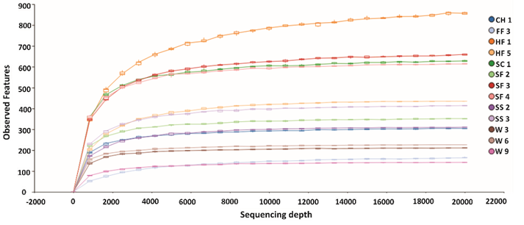
Supplementary Figure 1. Species accumulation curves across thirteen samples at a sampling depth of 20,000 sequence variants.

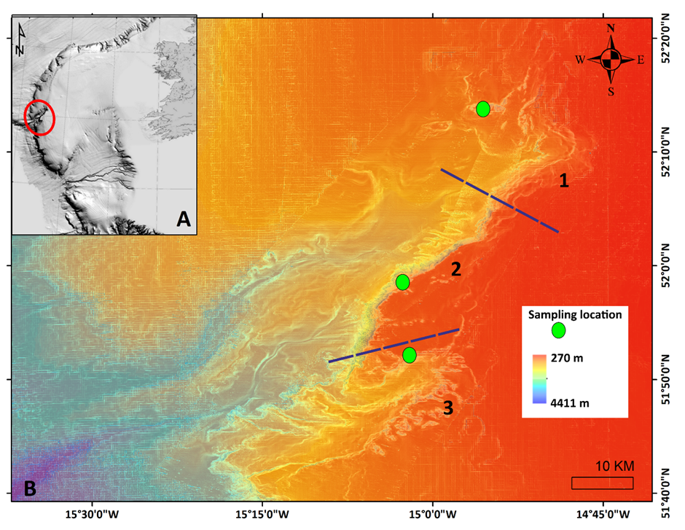
Supplementary Figure 2. Map showing the location of: A) the upper Porcupine Bank Canyon (PBC) on the Irish continental margin (red circle) and, B) the different areas within the upper PBC. The blue broken line demarcates the different areas of the upper PBC while the numbers 1, 2 and 3 represent canyon head, canyon flank and south branch areas, respectively.

Supplementary Table 1: ROV dives, dates, sample types/numbers, coordinates with depth, temperature and salinity readings. All samples were collected between 15-17/05/2019.
Dive/date | Site | sample | Coordinates |  | Depth (m) | Temp. (°C) | Salinity (psu)
Dive/date | Site | sample | Lat | Long | Depth (m) | Temp. (°C)
#2/15 May | canyon head |  | 52°13.63710 | 14°55.53890 | 719
#2/15 May | canyon head | HF1 | 52°13.62980 | 14°55.53560 | 721 | 10.0 | 35.0
#2/15 May | canyon head | HF2 | 52°13.63695 | 14°55.53769 | 719 | 9.6 | 36.0
#2/15 May | canyon head | HF3 | 52°13.62826 | 14°55.53961 | 719 | na | na
#2/15 May | canyon head | HF4 | 52°13.62895 | 14°55.54572 | 718 | na | na
#2/15 May | canyon head | HF5 | 52°13.62616 | 14°55.54294 | 719 | na | na
#2/15 May | canyon head | sediment | 52°13.62660 | 14°55.54270 | 718 | 9.8 | 36.0
#2/15 May | canyon head | water | 52°13.62923 | 14°55.53959 | 718 | 10.0 | 35.0
#6/16 May | canyon flank |  | 51°58.40933 | 15°02.49959 | 685
#6/16 May | canyon flank | FF1 | 51°58.39720 | 15°2.51760 | 693 | 9.4 | 34.0
#6/16 May | canyon flank | FF2 | 51°58.39340 | 15°2.52870 | 690 | 9.4 | 35.0
#6/16 May | canyon flank | FF3 | 51°58.39740 | 15°2.52970 | 691 | 9.4 | 36.0
#6/16 May | canyon flank | FF4 | 51°58.39262 | 15°2.52768 | 694 | 9.4 | 36.0
#6/16 May | canyon flank | FF5 | 51°58.58400 | 15°2.52070 | 688 | 9.4 | 36.0
#6/16 May | canyon flank | sediment | 51°58.40260 | 15°2.52119 | 691 | 9.8 | 35.0
#6/16 May | canyon flank | water | 51°58.40160 | 15°2.51025 | 698 | 9.8 | 35.0
#9/17 May | south branch |  | 51'52.20624 | 15'02.01476 | 605
#9/17 May | south branch | SC1 | 51°52.20370 | 15°1.99106 | 607 | 9.3 | 37.0
#9/17 May | south branch | SF2 | 51°52.20500 | 15°1.98934 | 608 | 8.7 | 37.0
#9/17 May | south branch | SF3 | 51°52.21990 | 15°1.99608 | 609 | 8.8 | 38.0
#9/17 May | south branch | SF4 | 51°52.19837 | 15°2.00000 | 607 | 8.8 | 38.0
#9/17 May | south branch | SF5 | 51°52.19740 | 15°2.00700 | 607 | 8.7 | 38.0
#9/17 May | south branch | sediment | 51°52.19736 | 15°2.00890 | 607 | 8.7 | 38.0
#9/17 May | south branch | water | 51°52.19730 | 15°2.99540 | 607 | 8.7 | 38.0
Temp = temperature; na = not available

Supplementary Table 2 Feature detail, frequency and number of samples observed in. This has been provided as a separate excel file.

