Title Page
Title of the article: A new agent-based model provides insight into assumptions in modeling forest management under deep uncertainty
Journal: Landscape Ecology
Names of the authors: Garry Sotnik*, Brooke A. Cassell**, Matthew J. Duveneck***, Robert M. Scheller****
E-mail address, and telephone number of the corresponding author: Garry Sotnik gsotnik@gmail.com, 734-845-8241
Title of the supplementary document: The ODD protocol for the model used in “A new agent-based model provides insight into assumptions in modeling forest management under deep uncertainty”

The ODD protocol for
the model used in “A new agent-based model provides insight into assumptions in modeling forest management under deep uncertainty”

Table of Contents

Introduction 3
1. Overview: Purpose and patterns 4
2. Overview: Entities, state variables, and scales 4
3. Overview: Process overview and scheduling 5
4. Design concepts 5
4.1 Basic principles 5
4.2 Emergence 7
4.3 Adjustment 7
4.4 Objectives 8
4.5 Learning 10
4.6 Prediction 11
4.7 Sensing 12
4.8 Interaction 12
4.9 Stochasticity 12
4.10 Collectives 13
4.11 Observation 13
5. Details: Initialization 14
6. Details: Input data 15
7. Details: Submodels 15
References 17

Introduction
This document follows the ODD protocol (Grimm et al., 2006, 2010, 2020) to describe the model used in the study “A new agent-based model provides insight into assumptions in modeling forest management under deep uncertainty” (henceforth “the study”). It also follows the criteria established by Müller et al. (2013) in describing the decision-making.
The model, called LANDIS-II (version 7; Scheller et al., 2007), employs extensions to simulate forest and management dynamics under a variety of disturbances. In this study, we use its Biomass Succession extension (BSE) (version 5.2.2; Scheller & Mladenoff, 2004) to simulate establishment, growth, and competition of trees, its Base Wind (version 3.1; Mladenoff & He, 1999) extension to simulate wind events and to induce wind-caused tree mortality, and its new agent-based forest management extension, SOSIEL Harvest (version 1.1.9), which couples the SOSIEL algorithm (version 2.4.4; Sotnik, 2018) with the Biomass Harvest extension (BHE) (version 4.3; Gustafson et al., 2000) to simulate boundedly-rational forest management. Because LANDIS-II, Biomass Succession, Base Wind, BHE, and the SOSIEL algorithm are described in detail elsewhere (Table 1), and in order to ensure consistency with published literature and avoid repetition, this document focuses primarily on describing SHE. Specifically, it focuses on describing SHE in Mode 2, which is the setting used to simulate forest management in the study.
Table 1: The components of the model, their roles from the perspective of SHE in Mode 2, and the related publications.
(Sub)model | Version | Description and role | Publication
LANDIS-II | 7 | The core model that provides the forest landscape and calls extensions. | Scheller et al. (2007)
Biomass Harvest extension (BHE) | 4.3 | A LANDIS-II extension that stores the details of forest management prescriptions and that SHE calls to implement forest management. | Gustafson et al. (2000)
Biomass Succession extension (BSE) | 5.2.2 | A LANDIS-II extension that simulates forest dynamics. | Scheller & Mladenoff (2004)
Base Wind extension | 3.1 | A LANDIS-II extension that simulates wind disturbance. | Mladenoff & He (1999)
SOSIEL Harvest extension (SHE) | 1.1.9 | A LANDIS-II extension that calls SOSIEL to analyze forest change and choose decision options and calls BHE to implement the corresponding prescriptions. | Mode 2 is described in this document.
SOSIEL algorithm | 2.4.4 | An otherwise separate multi-agent model that is called by SHE to analyze forest change and choose decision options. | Sotnik (2018)

The User Guides for LANDIS-II and its extensions (including SHE) can be found at: www.landis-ii.org. The User Guide for the SOSIEL algorithm and its specifications can be found at: http://www.sosiel.org/sosiel.

1. Overview: Purpose and patterns
What is the purpose of the model? The purpose of SHE in Mode 2 is to simulate boundedly-rational and dynamic large-scale forest management on the LANDIS-II landscape.
What is the purpose of the study? To compare three alternative approaches to modeling forest management (A1–A3). As such, there are three different configurations of SHE described in this document.
For whom is the model designed? SHE is designed for LANDIS-II users, who include graduate students, researchers, and forestry specialists.

2. Overview: Entities, state variables, and scales
What kinds of entities are in the model? By what state variables, or attributes, are these entities characterized? There are two entities in the overall model:
- the forest manager agent, which is characterized by its goal, decision options (DOs), and cognitive processes; and
- the tree cohorts, which are characterized by their species, age range, and location.

Are the entities heterogeneous? If yes, which state variables and/or processes differ among them? The study compares three alternative approaches to modeling the decision-making of a forest manager. In other words, there are three models being compared, which differ in their approach to modeling forest management. During any one simulation, only one forest manager is simulated. The three agents differ by their numbers of DOs and types of cognitive processes. The modeled forest manager in the first approach (A1) has 33 DOs and does not activate any decision-making cognitive processes during a simulation. The agent in the second approach (A2) has 99 DOs and can activate the following four cognitive processes during a simulation: anticipatory learning, goal selecting, satisficing, and action-taking. The agent in the third approach (A3) starts with 33 DOs and activates two cognitive processes in addition to those of A2: counterfactual thinking and innovating.
Tree cohorts are the same in all three approaches but differ among themselves in the following ways: their species, age range, and location, with the composition of their overall population changing over time because of new cohorts establishing, older cohorts dying, and cohorts (or partial cohorts) dying after wind events.
What are the exogenous factors/drivers of the model? The model is not driven by any dynamic exogenous factors. Exogenously projected climate data is used to calculate BSE’s probability of establishment values for each of the 33 species of trees, which are used as part of initial conditions and are thereby internal to the model during a simulation.
If applicable, how is space included in the model? LANDIS-II provides a two-dimensional landscape, throughout which tree cohorts are spread out and on which the forest manager agent implements its DOs.
What are the temporal and spatial resolutions and extents of the model? The model simulates for 150 years, with forest management occurring every 5 years.
- Cell length = 142 m, cell area = 2.0164 ha
- Map dimensions: 1,962 rows by 1,886 columns = 3,700,332 cells (forest sites)
- Forest sites: 1,271,793 active (34.4%), 2,428,539 inactive (65.6%)

3. Overview: Process overview and scheduling
What entity does what, and in what order? LANDIS-II calls the extensions at five-year timesteps and in the following order: (1) BSE, which simulates succession (e.g., grows cohorts); (2) Base Wind, which simulates wind disturbance events (e.g., causes mortality to partial or complete cohorts); and then (3) SHE, which simulates the forest management. SHE first calls on the SOSIEL algorithm to analyze forest dynamics and choose DOs and then on BHE to implement the corresponding prescriptions. In A1, analysis of forest dynamics is not activated, and, therefore, the role of SOSIEL is limited.
When are state variables updated? State variables update at every five-year timestep. Since BSE grows tree cohorts, while SHE either reduces their biomass or altogether removes them, the attributes of some tree cohorts are updated twice during a timestep.
How is time modeled, as discrete steps or as a continuum over which both continuous processes and discrete events can occur? As discrete steps.

4. Design concepts

4.1 Basic principles
Which general concepts, theories, hypotheses, or modeling approaches are underlying the model’s design at the system level or at the level(s) of the submodel(s) (apart from the decision model)? Except for SHE, the descriptions of the theoretical foundations of the other components of the model may be found in the respective publications provided in Table 1. The guiding principle behind coupling the SOSIEL algorithm with LANDIS-II and BHE was to take advantage of the strengths of both while keeping things as simple as possible. The strengths of the SOSIEL algorithm include its ability to learn from feedback and choose and create DOs accordingly. The strengths of BHE include a rich library of prescription design options, the ability to implement them accordingly, and an input file that many LANDIS-II users are already familiar with.
What is the link to complexity? Together, LANDIS-II with SHE has the potential to simulate adaptive management in coevolving coupled human and forest landscapes (Fig. 1), which occurs when there is feedback between two or more evolving systems. As a forest simulated by LANDIS-II evolves, it is shaped by internal dynamics as well as climate conditions, forest management, and other disturbances (e.g., fire, insects, windthrow). Forest management, in turn, is shaped by forest conditions and, potentially, by other personal and social dynamics. This interaction drives structural change in both the forest and its management. Management changes the forest structurally through the addition (planting) and removal (harvesting) of trees. Management itself also changes structurally in response to forest conditions through the addition (innovation) and removal (forgetting) of decision options. Such changes across generations and harvesting seasons produces coevolutionary dynamics.

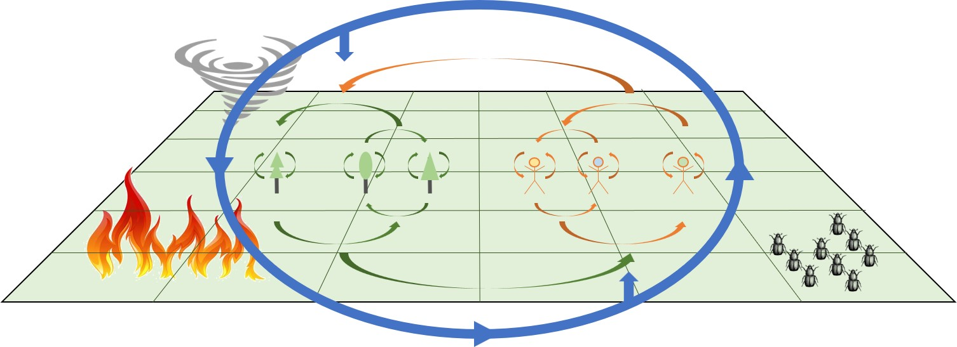
Fig. 1: A process-focused depiction of LANDIS-II with SHE. The (orange) arrows between the human figures represent individual and social processes, the (green) arrows between the trees represent processes within and among tree cohorts, the (orange and green) arrows between the human figures and tree cohorts represent bidirectional influence and feedback, and the (blue) oval and arrows around both represent climate. These processes occur on a two-dimensional landscape, which may also include disturbances, such as fire, insect infestations, and windthrow events.
As a result, LANDIS-II and SHE permit the study of the interaction between forest succession and natural disturbances, on the one hand, and cognitive, behavioral, and demographic processes, on the other. Such interaction is laden with combinatorial and feedback complexity, which SHE helps explore. This study specifically demonstrates some of this complexity and the deep uncertainty it creates for forest management.
Why is/are certain decision model(s) chosen? The design choices for the decision model of the forest manager agent in A1 are described in Gustafson et al. (2000), and those for A2 and A3 are described in Sotnik (2018). The aim of the study is to compare three alternative approaches to modeling forest management. The approaches were chosen in part to represent those that exist in the field and in part to demonstrate the capabilities of LANDIS-II and SHE.
If the (sub)model is based on empirical data, where do the data come from? Duveneck et al. (2014) describe the empirical foundations of the dataset used to parameterize both BSE and SHE in A1, and upon which SHE’s dataset is expanded for A2 and A3.
At which level of aggregation were the data available? BSE data was available at the cohort level, and is used in the study at the cohort, site, stand, and management area levels. Forest management dataset was available at the DO level, which is the level at which it is used in the study.

4.2 Emergence
What key results or outputs of the model are modeled as emerging from the adaptive traits, or behaviors, of individuals? Emergent properties produced by BSE include species competition and shifts in community composition and forest structure. Emergent properties produced by Base Wind are shifts in community composition and forest structure resulting from wind disturbance events. The combination of BSE and SHE provides the opportunity to simulate human–forest coevolution with changes in forest structure and composition, as well as amounts of harvested biomass, ultimately emerging as results of individual decisions and actions.

4.3 Adjustment
This section solely focuses on the capacity to adjust of the forest manager agents. The tree cohort entities do not have the ability to adjust.
What adjustive traits do the individuals have? The three approaches to modeling forest management vary in the flexibility with which forest manager agents respond to forest changes.
- In A1, what the forest manager agent harvests and how much is determined by the set of predefined DOs that are designed to account for forest dynamics. Within the parameters of the set of predefined DOs, current forest conditions influence how the stands are ranked, which stands qualify for harvest, which forest sites are selected, and which cohorts are removed. The use of percentages in determining how much of a specific cohort is to be removed further aligns harvest intensity with current forest conditions.
- In addition to that of A1, what the simulated forest manager harvests and how much in A2 is determined by its assessment of how well it is achieving its goal and its ability to choose between predefined DOs. These differ in their percentages and determine not only how much of a specific cohort is to be removed but also how much of a management area is to be harvested.
- In addition to that of A2, what the simulated forest manager harvests and how much in A3 is determined by its ability to create DOs that include new percentages for how much of a specific cohort is to be removed and how much of a management area is to be harvested. The agent uses its experience to create new DOs when the existing ones do not appear sufficient for goal achievement.

Do these traits explicitly seek to increase some measure of individual success regarding its objectives? Or do they instead simply cause individuals to reproduce observed behaviors that are implicitly assumed to indirectly convey success or fitness? In A1, the DOs were designed to represent forest management on USFS land in Michigan, thereby implicitly representing USFS’s goals. It is assumed that one of USFS’s goals is to maintain the current percentage of mature trees in the management area, which is initialized in Duveneck et al. (2014) at approximately 70 percent. In A2 and A3, the forest manager agents explicitly seek to achieve the specific goal of maintaining the percentage of mature trees in the management area equal to or above 70.
What rules do they have for making decisions or changing behavior in response to changes in themselves or their environment? In A1, such rules are implicitly represented by the use of percentages in determining how much of a tree cohort’s biomass is to be removed, i.e., how much is removed depends on the current amount, which changes each timestep. In A2 and A3, such rules are additionally (to A1) explicitly represented through cognitive processes that analyze forest conditions, adjust experience, and choose (or create) DOs accordingly.

4.4 Objectives
This section solely focuses on the objectives of the modeled forest managers. The tree cohort entities do not have objectives.
If adaptive traits explicitly act to increase some measure of the individual’s success at meeting some objective, what exactly is that objective and how is it measured? The objective, assumed for A1 and made explicit for A2 and A3, is to maintain the percentage of mature trees in the management area equal to or above 70, which is calculated by SHE and represented by the following variable:
manageArea[m].MaturityPercent[t] is a dynamic SHE variable (0 ≤ 0.00 ≤ 100 ) representing the percentage of biomass in a specific management area that is reproductively mature.
$$\sum_{manageArea[m]}{site\left[k\right].Species\left[i\right].Maturity[t]} / site[k].Species[i].Biomass[t]$$
where site[k].Species[i].Maturity[t] is a dynamic SHE variable (x ≥ 0) representing the amount of biomass on a specific site and of a specific species that is above the species’ reproductive maturity:
$$\sum_{\begin{aligned}site[k], \\ species[i] \\ cohort\left[j\right].Age\left[t\right] ≥ species\left[i\right]Maturity\end{aligned}}{cohort\left[j\right].Biomass[t]}$$
and site[k].Species[i].Biomass[t] is a dynamic SHE variable (x ≥ 0) representing the amount of biomass on a specific site and of a specific species:
$$\sum_{\begin{aligned}site[k] \\ species[i]\end{aligned}}{cohort\left[j\right].Biomass[t]}$$
What are the subjects and objects of the decision-making? The subject of the decision-making is the forest manager agent, while the objects are tree cohorts, sites, and stands.
On which level of aggregation is decision-making modeled? Decision-making is modeled at the level of the forest manager agent, which represents both those who design forest management plans and those who implement them.
Are multiple levels of decision-making included? No.
What is the basic rationality behind agent decision-making in the model? The basic rationality is to manage a forest in pursuit of a set goal.
On what assumptions is/are the agents’ decision model(s) based? The approach in A1 assumes that the management strategy designed at time zero will sufficiently represent forest management for the following 150 years. The one in A2 assumes that future forest management will use its updated experience to reevaluate possible forest management options that were devised in time zero and make decisions accordingly. The one in A3 additionally (to A2) assumes that, when necessary, future forest management will also use its experience to create new DOs. See Gustafson et al. (2000) for A1 and Sotnik (2018) for A2 and A3.
When individuals make decisions by ranking alternatives, what criteria do they use? In A1, there is only one DO for each species and, therefore, there are no alternatives to rank. In A2 and A3, the forest manager agent uses the influences it anticipates its DOs will have on the goal variable to rank them.
How do agents make their decisions? In A1, the forest manager agent’s decision-making process is implicitly captured by the set of DOs. Predefined forest-condition parameters dictate which DO is implemented at a given location and timestep. In A2, the agent’s decision-making process is explicitly represented by the following four cognitive processes: anticipatory learning, goal selecting, satisficing, and action-taking. In A3, the decision-making is additionally (to A2) represented by the following two cognitive processes: counterfactual thinking and innovating.
Are the agents heterogeneous in their decision-making? If yes, which decision models or decision objectives differ between the agents? The forest manager agents in A1, A2, and A3 are heterogeneous in their decision-making. See the response to the above question. See Sotnik (2018) for more information about decision models in the SOSIEL algorithm that apply to agents in A2 and A3.
Do the agents adapt their behavior to changing endogenous and exogenous state variables? And, if yes, how? In A1, the quantity the agent harvests, and if it harvests at all, changes with shifts in the amount of biomass because harvesting is proportionally fixed to biomass percentages. In A2 and A3, the quantity the agent harvests may additionally change because the agent reevaluates/updates the influence it anticipates a DO will have on the goal and chooses DOs accordingly. In A3, the quantity may additionally change because the agent can create and implement new DOs that it may evaluate as being better, in terms of helping it achieve its goal, than existing ones.
Do social norms or cultural values play a role in the decision-making process? Any decision-making process relying on empirical data will be at least implicitly influenced by norms and cultural values, especially when a goal is pursued. However, social norms and cultural values do not play an explicit role in any of the compared decision-making processes.
Do spatial aspects play a role in the decision process? A decision made at any specific site is affected by the average maturity proportion at the whole landscape scale.
To which extent and how is uncertainty included in the agents’ decision rules? In A1–A3, the agents are not perfectly rational and, therefore, uncertainty is at least implicitly assumed. In A3, uncertainty is additionally and explicitly modeled as part of the anticipatory learning process, during which the agent evaluates its success in achieving the goal. This determines whether it is confident in its ability to achieve its goal or not and, in turn, whether it will activate counterfactual thinking and, potentially, innovating.

4.5 Learning
This section solely focused on the learning ability of the forest manager agents. The tree cohort entities do not have the ability to learn.
Is individual learning included in the decision process? Yes. Anticipatory learning is activated in A2 and A3, and innovating is additionally activated in A3.
How do agents change their adaptive traits (learn) over time as a consequence of their experience? There is no learning in A1. In A2 and A3, the agent uses feedback from the forest to update its anticipation of the influence the DOs it applied during the prior timestep will have on the goal variable. The updated information is later used during the process of satisficing, which basis the selection of DOs for implementation on their anticipated influence. In A3, if the forest manager agent decides that the available set of DOs is insufficient for achieving its goal, it will use its experience to create new DOs (Fig. 2). The new DOs will include consequent values that the agent expects will improve its ability to achieve its goal.
Fig. 2: SHE’s process flow for creating and implementing DOs and prescriptions. SHE’s decision points and processes are in dark grey, and select SOSIEL algorithm and BHE processes are in light grey. The three dots stand for other SOSIEL processes that are not directly related to the process of creating new DOs.
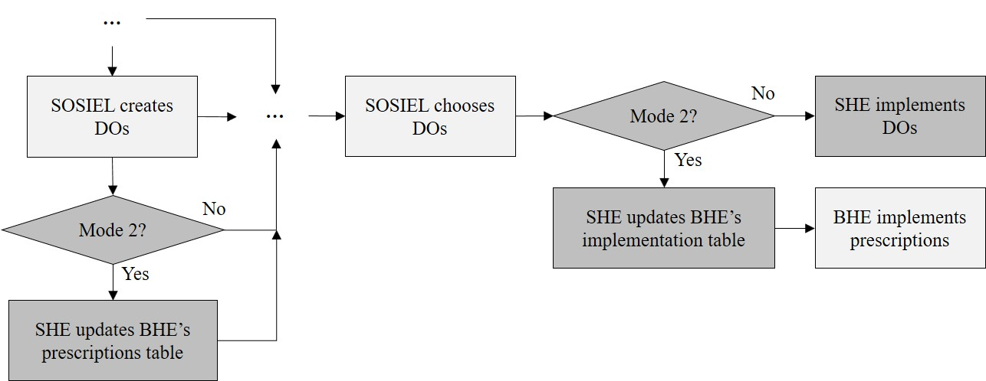

Is collective learning implemented in the model? No.

4.6 Prediction
This section solely focuses on the predicting ability of the forest manager agents. The tree cohort entities do not have the ability to predict.
Which data do the agents use to predict future conditions? In A1, the forest manager agent uses the forest conditions before the start of the simulation to predict all forest conditions during the simulation. In A2 and A3, and during the simulation, agents use the current anticipated influences of each DO to predict future conditions. These influences are initially calculated for each DO before the start of a simulation and are then updated for each DO after its implementation. For the study, the anticipated influences of the core 33 DOs were calculated by simulating each DO on its own and documenting its impact on the percent of mature trees in the management area.
Might agents be erroneous in the prediction process, and how is it implemented? Yes, because the agents are not perfectly rational. For example, in A2 and A3, the anticipated impact of a DO on the percentage of mature trees in the management area is based on its previous implementation, which does not ensure that it will have the same impact in the future.
How do agents predict the future conditions they will experience? In A2 and A3, each DO has an anticipated influence associated with it that represents the impact the simulated forest manager anticipates the DO will have on the percentage of mature trees in the management area. The anticipated influence of a DO is updated after each time it is implemented.
What internal models are agents assumed to use to estimate future conditions or consequences of their decisions? No internal models are used in A1. In A2 and A3, the simulated forest managers use a cognitive process, called anticipatory learning, which updates the anticipated influences of the DOs implemented in the prior period. See Sotnik (2018).
What tacit or hidden predictions are implied in these internal model assumptions? None.

4.7 Sensing
This section solely focuses on the sensing ability of the modeled forest managers. The tree cohorts do not have the ability to sense.
What internal and environmental state variables are individuals assumed to sense and consider in their decisions? Is the sensing process erroneous? In A1–A3, stand ranking and stand, site, and cohort selection, as well as what is harvested and how much, depend on the age, species, and biomass of the respective cohorts. In A2 and A3, the agents are additionally assumed to be capable of observing (sensing) the percentage of mature trees in their management area. The process of observing is accurate.
What state variables of which other individuals and entities can an individual perceive? Is the sensing process erroneous? The forest manager agents in A1–A3 can perceive the species, age range, and biomass volume of cohorts. The sensing process is accurate.
If agents sense each other through social networks, is the structure of the network imposed or emergent? NA
Are the mechanisms by which agents obtain information modeled explicitly, or are individuals simply assumed to know these variables? The mechanism in A2 and A3, namely anticipatory learning, is modeled explicitly.
Are the costs for cognition and the costs for gathering information explicitly included in the model? No. However, in A3, the modeled forest manager activates the mentally-intensive processes of counterfactual thinking and innovating only in situations where it is not confident in its ability to achieve its goal. In other words, avoiding the extra cost of cognition is explicitly part of the SOSIEL algorithm’s design. See Sotnik (2018).

4.8 Interaction
What kinds of interactions among entities are assumed? Are these direct interactions in which individuals encounter and affect others, or are interactions indirect? Tree cohorts interact indirectly through shade. The forest manager agents harvest the biomass from tree cohorts, which directly impacts the affected tree cohorts’ amount of biomass and potentially results in their overall removal.
On what do the interactions depend? Tree cohorts interact indirectly by influencing each other’s shade level, which, in turn, influences their biomass volumes. Harvesting of cohorts depends on their species, age range, and biomass volume and, in the case of A2 and A3, on the current percentage of mature trees present.
If the interactions involve communications, how are such communications represented? NA
If a coordination network exists, how does it affect the agent behavior? Is the structure of the network imposed or emergent? NA

4.9 Stochasticity
What processes are modeled by assuming they are random or partly random? Most of the processes in BHE, BSE, LANDIS-II, and the SOSIEL algorithm are stochastic. SHE in Mode 2 does not add any stochasticity.

4.10 Collectives
Do the individuals form or belong to aggregations that affect, and are affected by, the individuals? How are collectives represented? Is a particular collective an emergent property of the individuals or is it simply a definition by the modeler, defined as a separate kind of entity with its own state variables and traits? LANDIS-II organizes tree cohorts into sites, whereas BHE organizes them into stands and management areas (Fig. 3). Both aggregations are prespecified in accordance with LANDIS-II’s and BHE’s guidelines. SHE in Mode 2 follows BHE’s specifications. In terms of the forest manager agents, this study simulates only one agent at a time, which is therefore not part of any aggregation.
Figure 3: The spatial organization of cohorts.
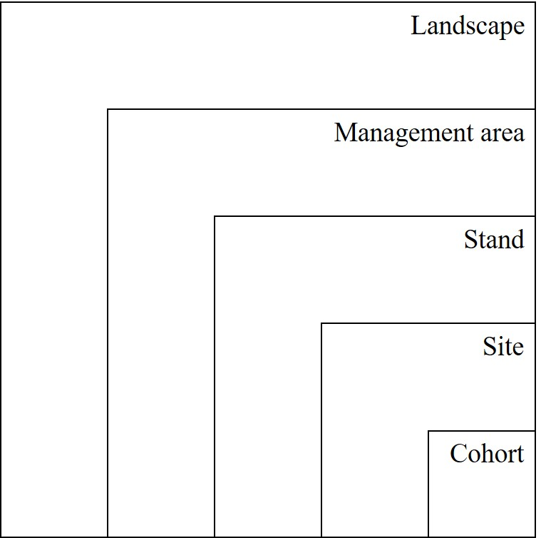

4.11 Observation
What data are collected from the model for testing, understanding, and analyzing it, and how and when are they collected?
SHE generates an event log file that includes the following information about each timestep that SHE is activated:
- Timestep;
- Information about the newly generated DOs including their MA, name, parent DO, consequent variable, and consequent variable value;
- Names of all the DOs selected for implementation.
SHE generates a variables and activity file for each agent that includes the following information for each timestep that SHE is activated:
- Timestep,
- ManagementArea,
- ActivatedDOValues are the consequent values of the DOs that were selected for action-taking,
- ActivatedDO are the consequent variables of the DOs that were selected for action-taking,
- MatchedDO are the DOs that met the conditions for selection,
- MostImportantGoal is the goal that drove DO selection,
- TotalNumberOfDO is the number of DOs in the MMs of the agent,
- BiomassHarvested, if one of the agent’s goal variables, and
- ManageAreaMaturityPercent, if one of the agent’s goal variables.

Are all output freely used, or are only certain data sampled and used, to imitate what can be observed in an empirical study? All data pertaining to tree cohorts on the landscape are freely used (unlike an empirical study that might utilize mean values from a sample to represent the population value). Only a small percentage of the available data is relevant for the study and utilized. The current percentage of mature trees in the management area is empirically observable.

5. Details: Initialization
What is the initial state of the model world? In detail, how many entities of what type are there initially, and what are the exact values of their state variables (or how were they set stochastically)? Are the initial values chosen arbitrarily or based on data? Duveneck et al. (2014) describe the initial conditions for both the forest and the DOs in A1, which are based on empirical data. The initial forest conditions in A2 and A3 are the same as in A1, but the initial DOs in A2 are expanded from those in A1 (99 vs 33 initial DOs). SHE’s input files for this model are available at the following GitHub page: https://github.com/LANDIS-II-Foundation/Project-Michigan-Compare-Harvesting-2021 . Tab. 2 provides select configuration details of A1–A3.
Table 2: Select configuration details of each approach (A1–A3), including the initial or total number of decision options (DOs), the limit on the number of decision options in a mental model (MM), how the goal (maintain percentage of mature trees equal to or above 70%) is modeled, the relationship between decision options and goals, the corresponding cognitive level (CL), and the cognitive processes activated during simulation.
Select configuration details | A1 | A2 | A3
# of DOs | 33 (total) | 99 (total) | 33 (initially)
Max # of DOs/MM | NA | NA | 3
Goal modeled | Implicitly | Explicitly |  | Explicitly
Relationship between DOs and goal | NA | NA | Negative
Cognitive level | CL1 | CL2 | CL4
Cognitive processes activated during simulation. Note: Goal prioritizing is not activated in A2 and A3 because the managers have only one goal. | NA | - Anticipatory learning  - Goal selecting  - Satisficing | - Anticipatory learning  - Counterfactual thinking  - Innovating  - Goal selecting  - Satisficing

Is initialization always the same or is it allowed to vary among simulations? Initialization of the forest is the same across A1–A3. Initialization of forest management is different for each approach (Tab. 2). For the forest manager in A3, we set the relationship between each of the DOs and the goal to negative. This is because increasing the percentage of mature trees requires reducing the percentage of the management area that is harvested.

6. Details: Input data
Does the model use input from external sources such as data files or other models to represent processes that change over time? The initial values of BSE’s probability of establishment for each of the 33 tree species is based on externally forecasted climate data. Otherwise, all the input files are internal to LANDIS-II, BSE, and SHE.

7. Details: Submodels
What, in detail, are the submodels that represent the processes listed in ‘Process overview and scheduling’? What are the model parameters, their dimensions, and reference values? How were submodels designed or chosen, and how were they parameterized and then tested? SHE couples the SOSIEL algorithm with LANDIS-II and BHE. Forest dynamics in the model are simulated by LANDIS-II’s BSE. The related publications that introduce these models and extensions address these questions and are listed in Tab. 1.
Does this model couple existing models? If yes, how? Yes. SHE couples the SOSIEL algorithm with LANDIS-II and BHE (Figure 4).
Figure 4: SHE in the context of LANDIS-II, BHE, and some other LANDIS-II extensions. In the study, the two other extensions are BSE and Base Wind, both of which are called on before SHE. At each timestep, LANDIS-II calls on different extensions to act on the landscape. In Mode 2, SHE calls on the SOSIEL algorithm to analyze landscape conditions and choose DOs, and on BHE to implement them.
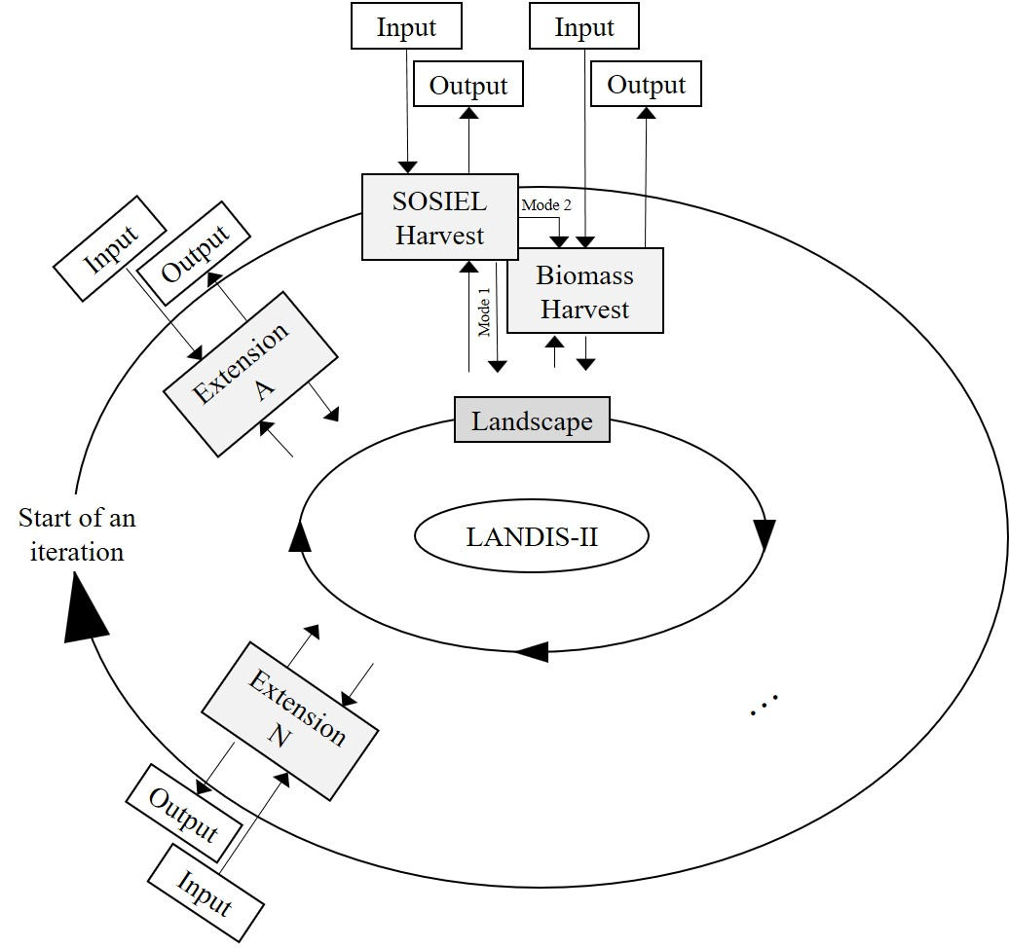
Specifically, in Mode 2, each DO in the SOSIEL algorithm is paired with a corresponding prescription in BHE (Figure 5). The name of a DO and its consequent serve as the two links between it and the corresponding prescription in BHE. For SHE, each BHE prescription consists of two components, one that describes specifically what to manage and how (parameterized through BHE’s prescriptions table) and another that describes the percentage of the management area to which the prescription is to be applied (parameterized through BHE’s implementation table). In the current version of SHE, the value of a DO’s consequent corresponds to the percentage of the management area to which the paired prescription is to be applied.
Figure 5: SHE’s pairing of the SOSIEL algorithm’s DOs with BHE’s prescriptions (Ps) and implementation instructions (IIs). The SOSIEL algorithm organizes the DOs that are variants (substitutes) of one another into mental models (MMs).
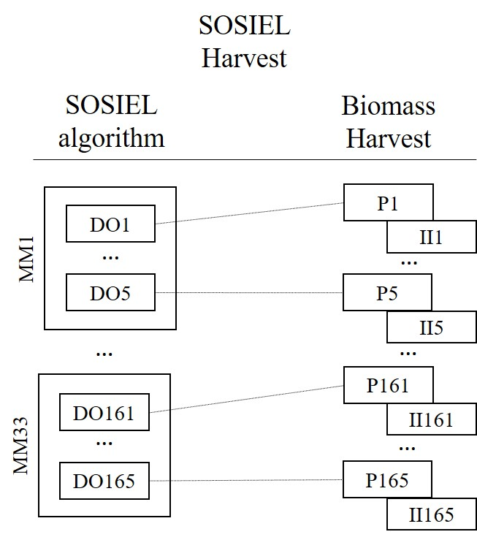
If the (sub)model (e.g., the decision model) is based on empirical data, where do the data come from? Duveneck et al. (2014) describe the empirical data used to parameterize the forest and the DOs in A1. The set of DOs is expanded in A2 to accommodate additional flexibility in decision-making. Specifically, each of the 33 DOs used in A1 were supplemented with two alternatives, increasing the total number of prescriptions to 99. One of these alternatives was created by multiplying an original DO’s percentages of management area to be harvested and cohorts to be removed by 1.1 (increasing the original by 10%), and the other was created by dividing them by 1.1 (decreasing the original by 10%).
At which level of aggregation were the data available? Depending on specific data source, data were available at levels of aggregation ranging from single site (e.g., vegetation, elevation) to sub-landscape level (e.g., soil, weather, projected climate). See Duveneck et al. (2014).

References
Duveneck, M. J., Scheller, R. M., & White, M. A. (2014). Effects of alternative forest management on biomass and species diversity in the face of climate change in the northern Great Lakes region (USA). Canadian Journal of Forest Research, 44(7), 700–710. https://doi.org/10.1139/cjfr-2013-0391
Grimm, V., Berger, U., Bastiansen, F., Eliassen, S., Ginot, V., Giske, J., Goss-Custard, J., Grand, T., Heinz, S. K., Huse, G., Huth, A., Jepsen, J. U., Jørgensen, C., Mooij, W. M., Müller, B., Pe’er, G., Piou, C., Railsback, S. F., Robbins, A. M., … DeAngelis, D. L. (2006). A standard protocol for describing individual-based and agent-based models. Ecological Modelling, 198(1–2), 115–126. https://doi.org/10.1016/j.ecolmodel.2006.04.023
Grimm, V., Berger, U., DeAngelis, D. L., Polhill, J. G., Giske, J., & Railsback, S. F. (2010). The ODD protocol: A review and first update. Ecological Modelling, 221(23), 2760–2768. https://doi.org/10.1016/j.ecolmodel.2010.08.019
Grimm, V., Railsback, S. F., Vincenot, C. E., Berger, U., Gallagher, C., DeAngelis, D. L., Edmonds, B., Ge, J., Giske, J., Groeneveld, J., Johnston, A. S. A., Milles, A., Nabe-Nielsen, J., Polhill, J. G., Radchuk, V., Rohwäder, M.-S., Stillman, R. A., Thiele, J. C., & Ayllón, D. (2020). The ODD Protocol for Describing Agent-Based and Other Simulation Models: A Second Update to Improve Clarity, Replication, and Structural Realism. Journal of Artificial Societies and Social Simulation, 23(2), 7. https://doi.org/10.18564/jasss.4259
Gustafson, E. J., Shifley, S. R., Mladenoff, D. J., Nimerfro, K. K., & He, H. S. (2000). Spatial simulation of forest succession and timber harvesting using LANDIS. Canadian Journal of Forest Research, 30(1), 32–43.
Mladenoff, D. J., & He, H. S. (1999). Design, behavior and application of LANDIS, an object-oriented model of forest landscape disturbance and succession. In Spatial modeling of forest landscape change: Approaches and applications (pp. 125–162). Cambridge University Press.
Müller, B., Bohn, F., Dreßler, G., Groeneveld, J., Klassert, C., Martin, R., Schlüter, M., Schulze, J., Weise, H., & Schwarz, N. (2013). Describing human decisions in agent-based models – ODD + D, an extension of the ODD protocol. Environmental Modelling & Software, 48, 37–48. https://doi.org/10.1016/j.envsoft.2013.06.003
Scheller, R. M., Domingo, J. B., Sturtevant, B. R., Williams, J. S., Rudy, A., Gustafson, E. J., & Mladenoff, D. J. (2007a). Design, development, and application of LANDIS-II, a spatial landscape simulation model with flexible temporal and spatial resolution. Ecological Modelling, 201(3–4), 409–419. https://doi.org/10.1016/j.ecolmodel.2006.10.009
Scheller, R. M., Domingo, J. B., Sturtevant, B. R., Williams, J. S., Rudy, A., Gustafson, E. J., & Mladenoff, D. J. (2007b). Design, development, and application of LANDIS-II, a spatial landscape simulation model with flexible temporal and spatial resolution. Ecological Modelling, 201(3–4), 409–419. https://doi.org/10.1016/j.ecolmodel.2006.10.009
Scheller, R. M., & Mladenoff, D. J. (2004). A forest growth and biomass module for a landscape simulation model, LANDIS: Design, validation, and application. Ecological Modelling, 180(1), 211–229. https://doi.org/10.1016/j.ecolmodel.2004.01.022
Sotnik, G. (2018). The SOSIEL Platform: Knowledge-based, cognitive, and multi-agent. Biologically Inspired Cognitive Architectures, 26, 103–117. https://doi.org/10.1016/j.bica.2018.09.001

