Nano-Metals Forming Bacteria in Egypt. II. Efficacy towards Biomolecules, Ultrastructure, Growth Parameters, and Eco-Friendly Therapeutic of Soft Rot/Blackleg Genera
Alia A. Shoeib^{1*}, Nader A. Ashmawy¹, Ayman Kamal² & Sahar Abd El Fatah Zaki²
¹Plant Pathology Department, Faculty of Agriculture, Alexandria University, Alexandria, Egypt.
²Environmental Biotechnology Department, Genetic Engineering and Biotechnology Research Institute, City of Scientific Research and Technological Applications, Alexandria, Egypt.
*email: aliashoeib@alexu.edu.eg
ORCID iD: 0000-0002-7075-2780
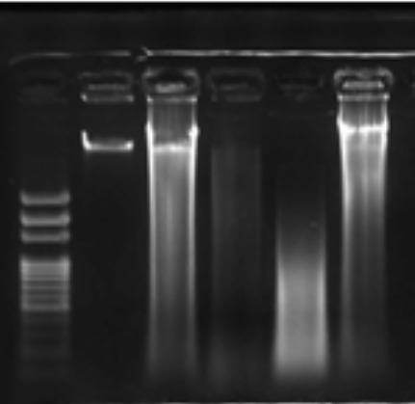
1500 bp
A
D CuNPs FeNPs CoNPs ZnNPs
M
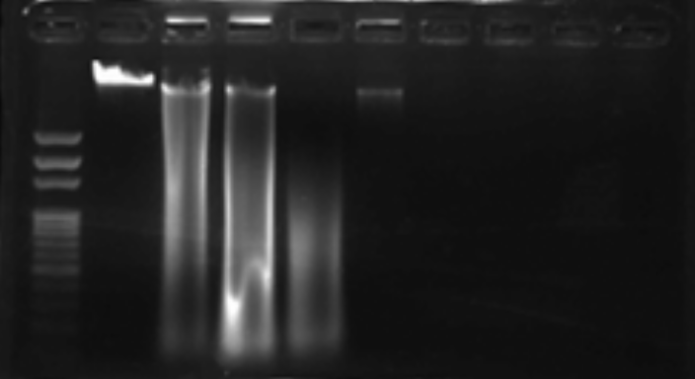
B
1500 bp
D CuNPs FeNPs CoNPs ZnNPs
M
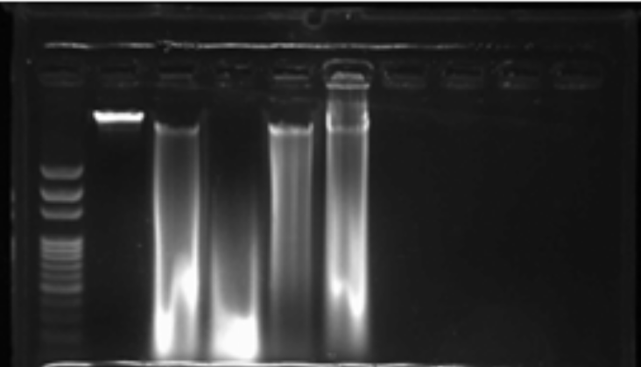
1500 bp
C
D CuNPs FeNPs CoNPs ZnNPs
M
S 1. Effect of CuNPs, FeNPs, CoNPs, and ZnNPs on DNA of Pectobacterium carotovorum subsp. carotovorum (A), Dickeya solani (B), and Enterobacter cloacae (C), DNA from untreated bacterial cells (D), and 100 bp DNA ladder (M).
…………………………………………………..…………………………………………………………………………………

