Histological diagnosis | Number of cases |  | FISH results
ccRCC | 11 | 10 | VHL Loss  One green signal per nuclei (red arrow) | 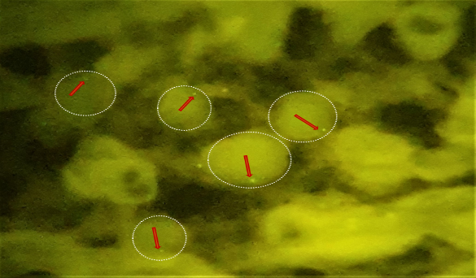
ccRCC | 11 | 1 | Polysomy 17  multiple bleu signals per nuclei | 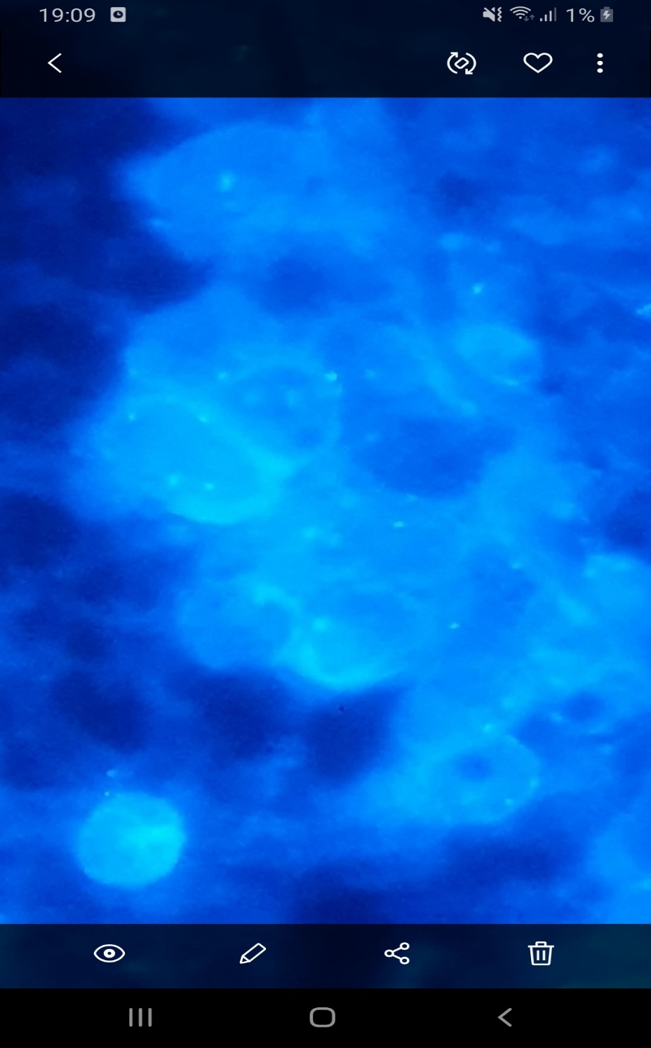
Tubulocystic RCC | 1 |  | Polysomy 17  multiple bleu signals per nuclei
pRCC | 7 | 6 | Polysomy 17  multiple bleu signals per nuclei
pRCC | 7 | 1 | Normal
chRCC | 3 | 1
chRCC | 3 | 2 | Monosomy 17  one bleu signal per nuclei | 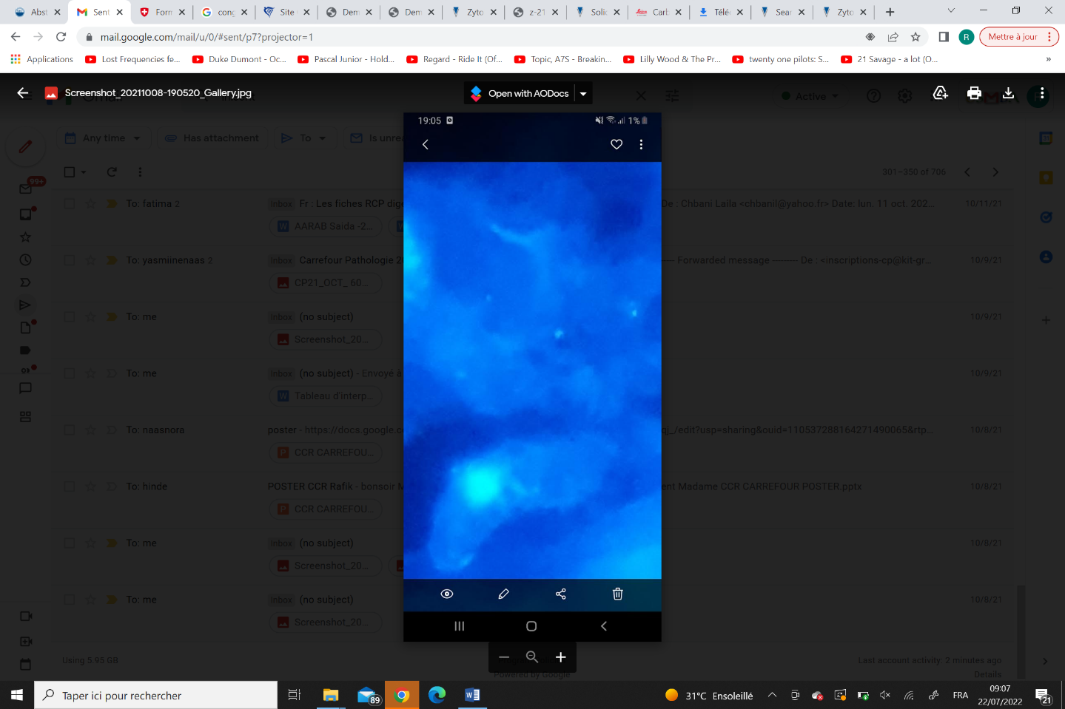
RO | 1 |  | CCND1 rearrangement  Separation of green and orange signals | 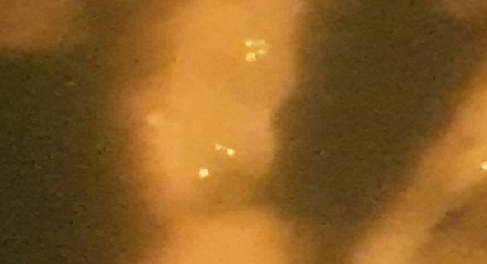
pRCC T2 /ccRCC | 1 |  | No results (pre-analytic artefacts)
TABLE 2: cases of RCC and their corresponding FISH results

