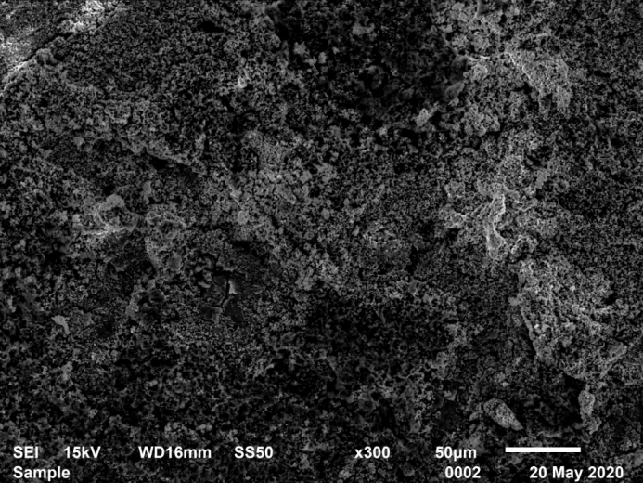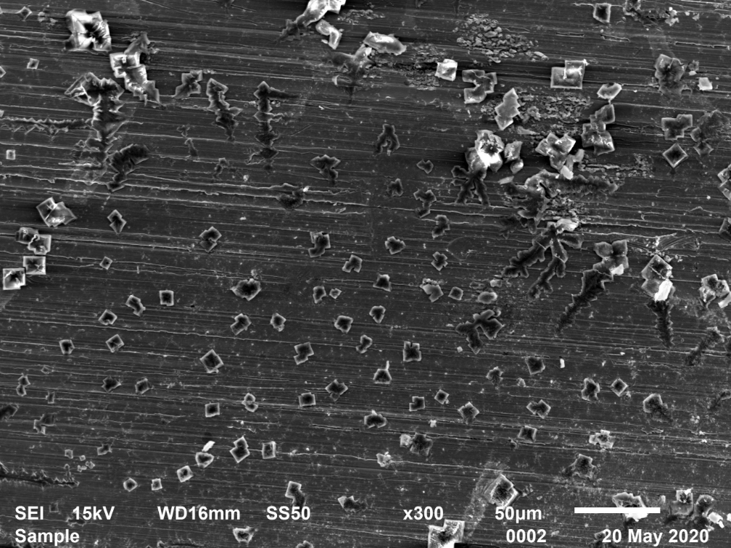

Corrosion inhibitor TZBM effectively slows down the corrosion of carbon steel in 180℃ solutionliquid containing Cl⁻+H₂S+CO₂.

