Figure2
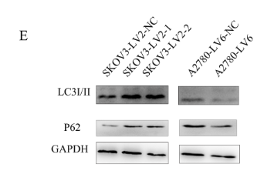
LC3I/II:
Gapdh：

P62:
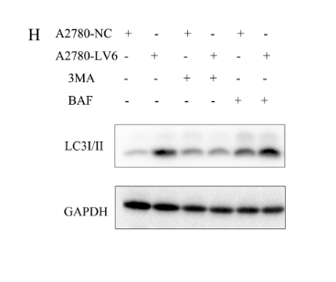
Original blot
LC3I/II:
Gadph:
FIGURE4:
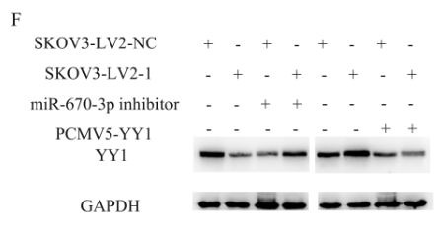
Original blot
YY1
GADPH:
FIGURE5
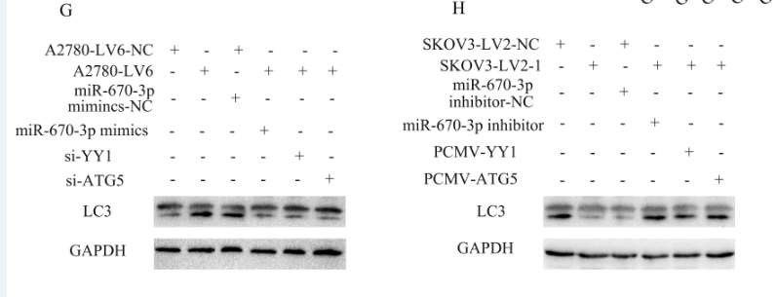

Original blot
LC3
GADPH:

FIGURE6
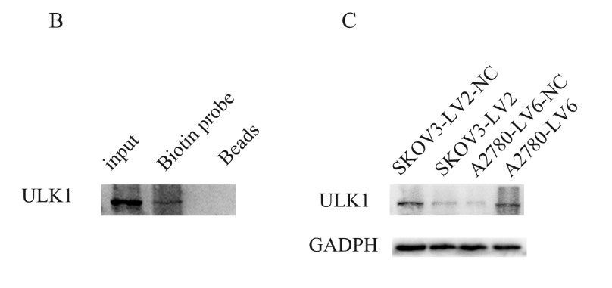
Original blot

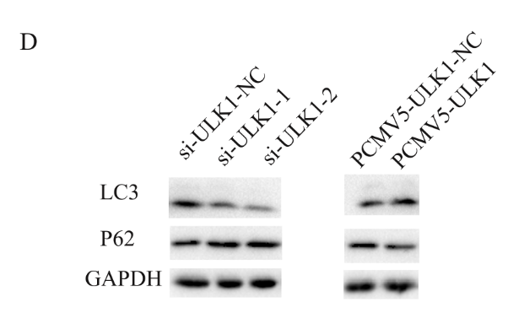

Original blot

P62:

GAPDH

