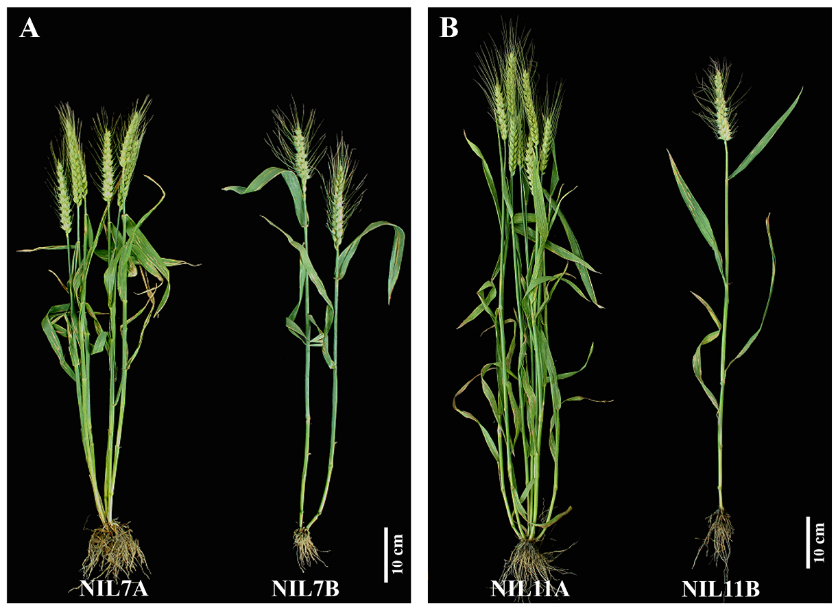
Fig S1. Phenotypic characterization of near-isogenic lines NIL7A and NIL7B, NIL11A and NIL11B.
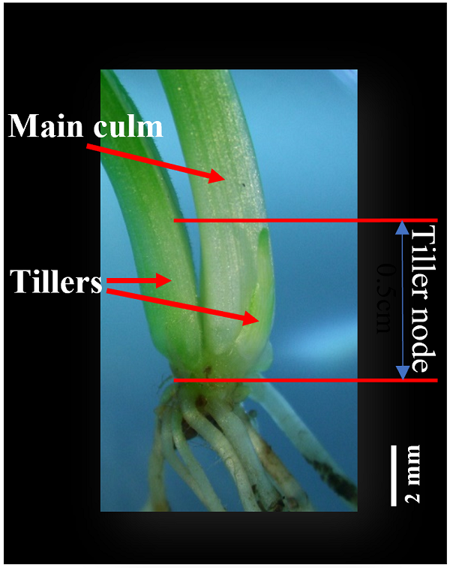
Fig S2. Schematic diagram of tillering node where tillering germinated.
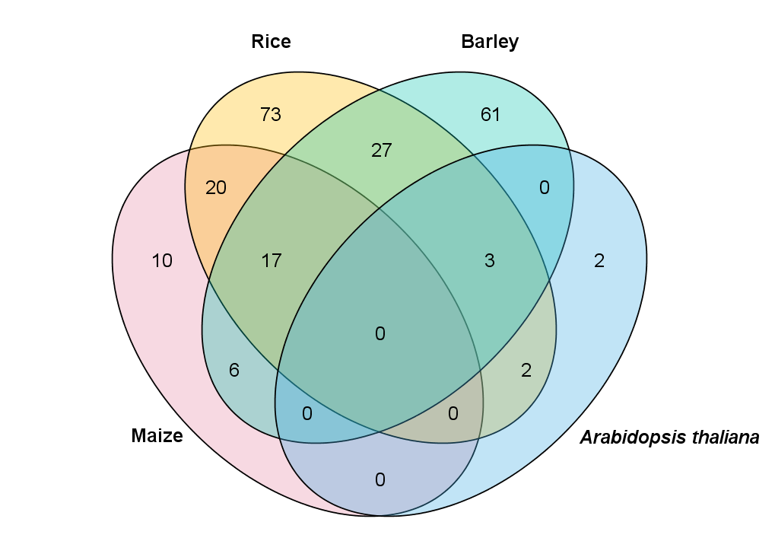
Fig S3. Venn diagrams of the circRNAs conservation among different species.

