Deep Learning Infers Cell-dependent RNA Velocity through a Relay Velocity Model
Shengyu Li^{1,2,3,4, #}, Pengzhi Zhang^{1,2,3,4, #}, Weiqing Chen⁵, Lingqun Ye^{1,2,3}, Kristopher W. Brannan^{2,3,4}, John P. Cooke², Guangyu Wang^{1,2,3,4}
Supplementary Note 1
Develop a model-based neural network for RNA velocity inference
To demonstrate the capability of the deep neural network (DNN) in RNA velocity inference, we rewrite the dynamic model of scVelo by adding a Heaviside step function (Note Figure 1A) to calculate transcription ($α$) rate as following:
Eqn. (1)
$$\frac{du}{dt}=σ\left(βu-γs\right)*α-βu$$
$$\frac{ds}{dt}=βu-γs$$
where $σ(x)≡\left\{\begin{aligned}1, x≥0 \\ 0, x<0\end{aligned}\right.$. The sigmoid function is a widely used activation function in DNN. As the sigmoid function $s\left(x\right)=\frac{1}{1+e^{-1000x}}$ behaves similarly with the step function except for the former is differentiable, we can approximate $σ(x)$ with $s(x)$ in Eqn. (1) and solve Eqn. (1) by developing a simple prototype neural network using the sigmoid function.

First, we build a simplified neural network (Note Figure 1B) which has an input layer, a hidden layer, and an output layer. We separately train a network for each gene. We assume gene-specific constant values of $α$, $β$, and $γ$. Next, we develop a workflow to solve Eqn. (1) by optimizing the network as following:
- For a given gene, the normalized (across all the cells) abundances of the unspliced and spliced mRNA ($u_{i}$ and $s_{i}$) for one cell $i$ are input to the network (Note Figure 1B). Weights {$w$} and biases {$b$} are applied to the input through a hidden layer to get ($w_{β}u_{i}+b_{1}, w_{γ}s_{i}+b_{2})$. Specifically in this simplified demonstration neural network, the weights are analogs of $β$ and $γ$ (($w_{β}\sim β$ and $w_{γ}\sim -γ$ ), and the biases are 0.
- Apply an activation function $σ$ to the hidden layer outputs to obtain the relative reaction rates: ${\tilde{α}}^{i}= σ\left({w_{β}u}_{i}+w_{γ}s_{i}\right)$; $\tilde{β}$ and $\tilde{γ}$ are extracted from the weights $\tilde{β}=w_{β}$, $\tilde{γ}=-w_{γ}$.
- Predict the abundances at the next time step $u_{i, next}=({\tilde{α}}^{i}-\tilde{β}u_{i})∆t+u_{i}$ and $s_{i,next}=(\tilde{β}u_{i}-\tilde{γ}s_{i})∆t+s_{i}$ using the discretized equations from Eqn. (1). Then we compute the predicted displacement vector $v_{i}^{pred}=(u_{i, next}-u_{i}, s_{i, next}-s_{i})$ and estimate the loss function for cell $i$, $L^{i}\left(u_{i},s_{i}\right)=1-corr\left(v_{i}^{pred}, v_{i}^{input}\right)$, where the ground truth displacement $v_{i}^{input}$ is obtained by a neighboring cell $i^{'}$ in the $\{u, s\}$ space which maximizes the correlation between the predicted vector and the input vector $v_{ii^{'}}^{input}=(u_{i^{'}}-u_{i}, s_{i^{'}}-s_{i})$ as in the following equation: $i^{'}=\underset{i^{'}}{argmax}{corr(v_{i}^{pred}, v_{ii^{'}}^{input})}=\underset{i^{'}}{argmax}{\frac{v_{i}^{pred}∙v_{ii^{'}}^{input}}{\left|v_{i}^{pred}\right|\left|v_{ii^{'}}^{input}\right|}}$. The total loss for all the $n$ cells is calculated as sum of the loss of individual cells, $L=\sum_{i=1}^{n}{L^{i}}\left(u_{i},s_{i}\right)$.
- Adjust the $\{w\}$ and $\{b\}$ and repeat steps (2-3) to reduce the total loss $L$ to yield the best estimates of the reaction rates.
We apply this network model to a simulation dataset for a gene following the dynamics in Eqn. (1) ($α=5.2, β=2.0, γ=1.0$; see details of the simulation in Methods). The initial guess was set to $α=1.0, β=1.0, γ=0.5$. We applied the adaptive gradient optimization algorithm Adam to minimize the total loss and the learning rate was 0.001. Results show that after each round (epoch) of training, prediction approaches closer to the ground truth (Note Figure 1C). In 1,500 epochs (within a few seconds), the prediction has converged and matches with the background truth, indicating the applicability of neural network to velocity estimation.

In practice, a more sophisticated deep neural network is constructed in cellDancer and trained to predict the reaction rates for a gene in all $n$ cells ${{\{\tilde{α}}^{i}, {\tilde{β}}^{i}, {\tilde{γ}}^{i}\}}_{i=1,2,…, n}$simultaneously. The network consists of an input layer with abundances of a gene from all the cells, two hidden layers with 100 nodes fully connected to all the input nodes, and an output layer with $3n$ using a sigmoid activation function (see Methods).
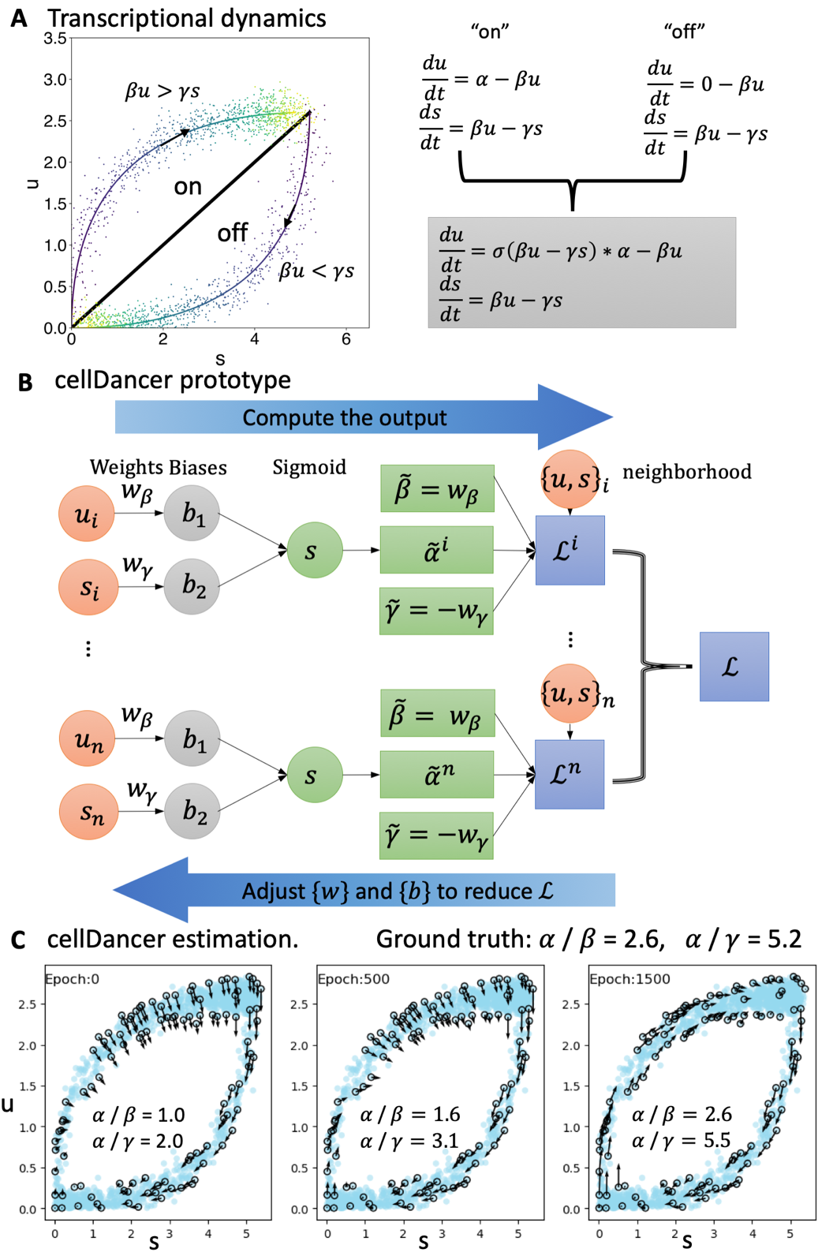
Note Figure 1. A model-based neural network for RNA velocity inference.
A. The transcriptional dynamics of a gene switching between the “on” and the “off” states is generalized with a Heaviside step function. B. A prototype neural network model demonstrates its suitability to learn the reaction rates. “u” and “s” indicate unspliced and spliced reads. C. cellDancer’s network quickly converges to the ground truth in 1,500 epochs of training.

