Supplementary Material

A new platform for the post-functionalization of porous polymer based on calix[4]resorcinarene under thermal solvent-free conditions; as a highly efficient and recyclable PTC containing nanocavity

Somayeh Elahiª, Mehrdad Khodadoost^{*b}, Elham Shahidizadeh^{b}
ªDepartment of Chemical Engineering, Abadan Branch, Islamic Azad University, Abadan, Iran
^{b}Research Center for Environmental Contaminats (RCEC), Abadan University of Medical Sciences, Abadan, Iran
Fax +98(61) 53265364; Tel +98(61) 53265357
∗Corresponding Author E-mail: mehrdad.khodadost@abadanums.ac.ir

Pages
Table of Contents

1. Characterization of the calix[4]resorcinarene (1) 2
2. Characterization of the 3D-network polymer (2) 6
3. Some of compound in table 1 11

1. Characterization of the calix[4]resorcinarene (1)

Calix[4]resorcinarene 1, (C₃₂H₃₂O₈): Yield 60%; white powder; m.p. > 360 ˚C; IR (KBr): ν = 3000-3500 (OH) cm⁻¹; ¹H NMR (400 MHz, DMSO-d₆): δ_{H} = 1.29-1.30 (12H, d, CH₃), 4.43-4.49 (4H, q, H_{l}), 6.15 (4H, s, H_{i}), 6.76 (4H, s, H_{j}), 8.56 (8H, s, OH) ppm. ¹³C NMR (100 MHz, DMSO-d₆): δ = 22.0 (C-m), 29.0 (C-l), 102.5 (C-n), 123.5 (C-i), 125.7 (C-o), 152.3 (C-j) ppm.

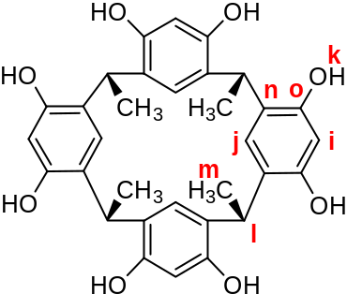

- Copy of the IR, ¹H NMR and ¹³C NMR spectra of the calix[4]resorcinarene:
- IR spectrum of the calix[4]resorcinarene

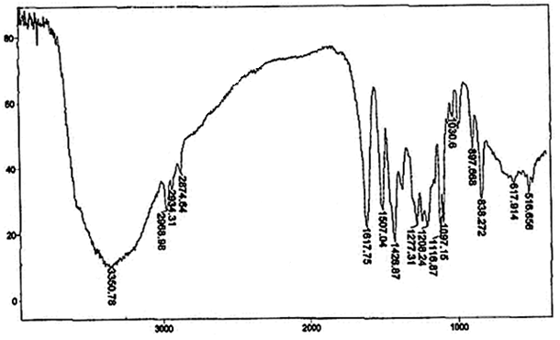

- ¹H NMR spectrum of the calix[4]resorcinarene
The ¹H NMR spectrum of calix[4]resorcinarene 1 in DMSO-d₆ show a doublet signal at δ = 1.29-1.30 ppm (12H) corresponding to four methyl groups (m) and a signal at δ = 4.43-4.49 ppm (4H) assignable to four bridging methine (l). The protons at C-2 (i) and C-5 (j) position of resorcinol rings show two single peaks in 1:1 ratio at δ = 6.15 (4H) and 6.76 ppm (4H), respectively. The proton signal related to OH groups of calix[4]resorcinarene (k) appear at δ = 8.56 ppm (8H).

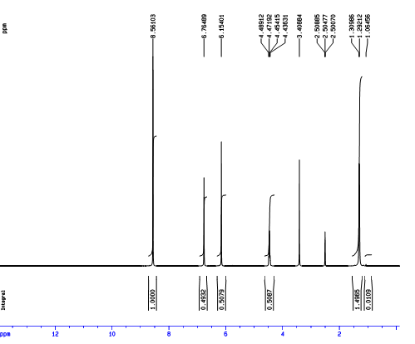
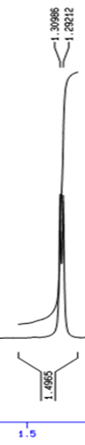
k a

m a

j a

i a

l a

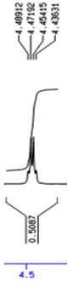
l a

m a

- ¹³C NMR spectrum of the calix[4]resorcinarene
The ¹³C NMR spectrum in DMSO-d₆ show two signals at δ = 22.09 and 29.04 ppm caused by four methyl (m) and bridging methine (l) groups, respectively. The carbon at C-2 (i) and C-5 (j) position of resorcinol ring show two peaks at δ = 123.55 and 152.35 ppm, respectively. The other carbons of resorcinol ring (n & o) show two peaks at δ = 102.56 and 125.77 ppm.

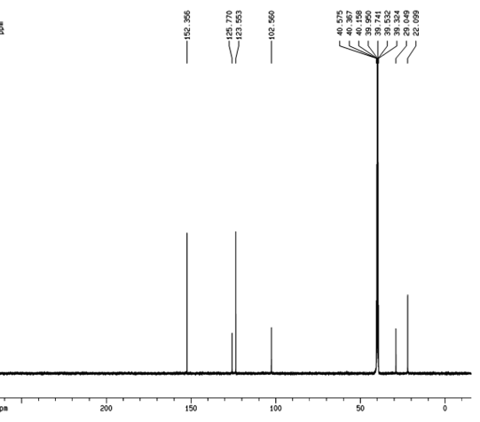
o a

j a

i a

n a

l a

m a

2. Characterization of the 3D-network polymer (2)
- AFM images
In order to gain insight into the surface pores of polymer 2, atomic force microscopy (AFM) was utilized. All of the AFM scans were taken in ambient air in tapping mode, which is ideal for this kind of polymers. The force between the tip and the sample surface was detected and kept constant throughout the scan and the topography of the surface was obtained (a, b). Phase data were utilized to supplement the height data because they provide clearer and higher contrast image of structural features. Representative 1.5 μ×1.5 μ AFM height and phase image suggest a series of pores which have average surface diameter of 300 nm (a). More details could be obtained from 3D height plot (b).
On the whole, AFM revealed that the 3D-network polymer 2 exhibited a porous surface that has the ability for the inclusion of an organic guest.
(a)
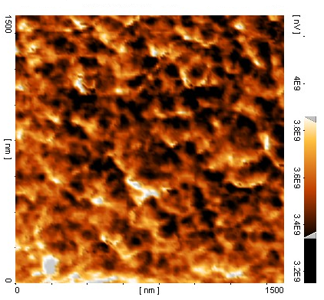
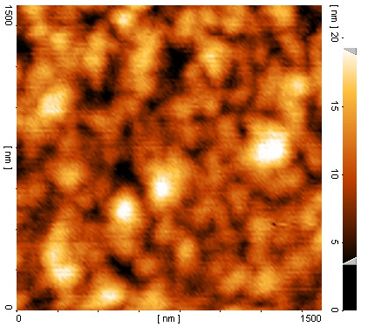

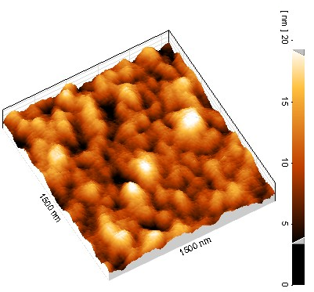
(b)
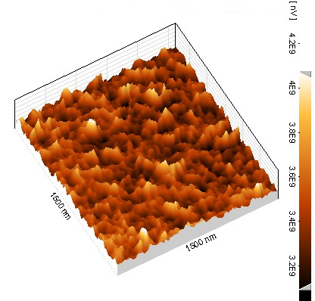

AFM images (1.5μ × 1.5μ) of the polymer 2 (a) 2D height and phase plot and (b) 3D height and phase plot.

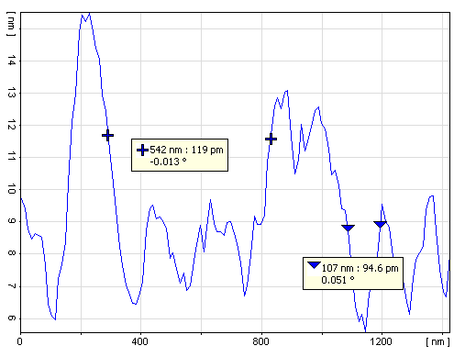
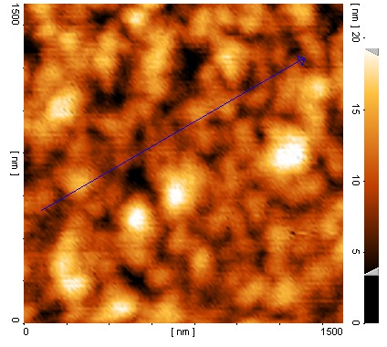

Image profile (the analysis of height along a linear path).
Peak-to-valley measurements of the polymer showed a very good performance of surface morphology and suggest a series of pores which have average surface diameter of 300 nm.

- X-ray diffraction
The XRD patterns of the prepared network polymer and calix[4]resorcinarene are depicted. It seems that based on the intense and sharp diffraction peaks of calix[4]resorcinarene, it exhibited a high degree of crystallinity. This may be attributed to the hydrogen bondings between the resorcinarene units (a). As it can be seen in this figure, most of the peaks in the XRD patterns of the calix[4]resorcinarene samples can be completely indexed with resorcinol in the standard card (JCPDS No. 00-038-1969). It can be observed that when the calix[4]resorcinarene is incorporated into a polymer system crystalline peaks still exist, but the intensities of the peaks decrease and a broad spectrum appears. In other words, the amorphous nature of the polymer increases (b). Some distinct peaks were observed for the network polymer which indicated that the network polymer molecules have the semi crystalline nature but broad spectrum shows that its composition consists predominantly of an amorphous phase.

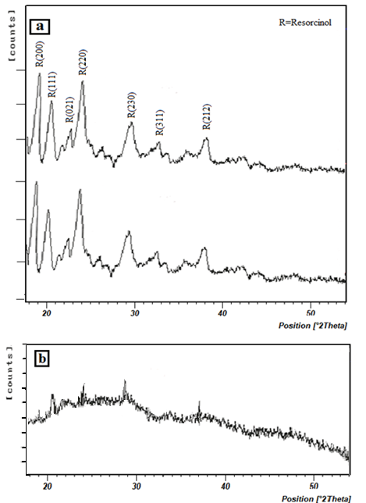

XRD pattern: (a) calix[4]resorcinarene (b) polymer

- SEM image

In this image, one can observe that more porous structure with meshwork was obtained for the network polymer. SEM confirmed that the average size of the pores of the network polymer is in agreement with the AFM data.

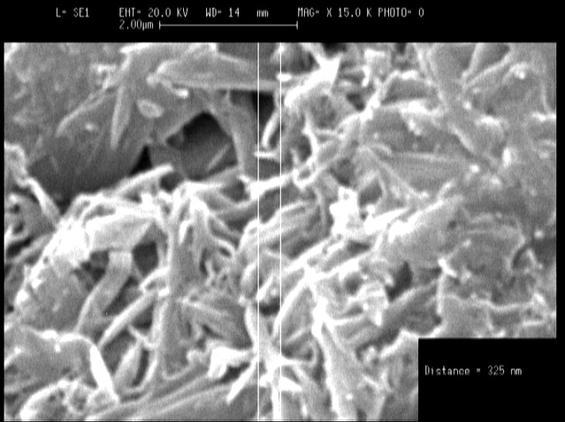
SEM image of the polymer (2)

- TGA curve

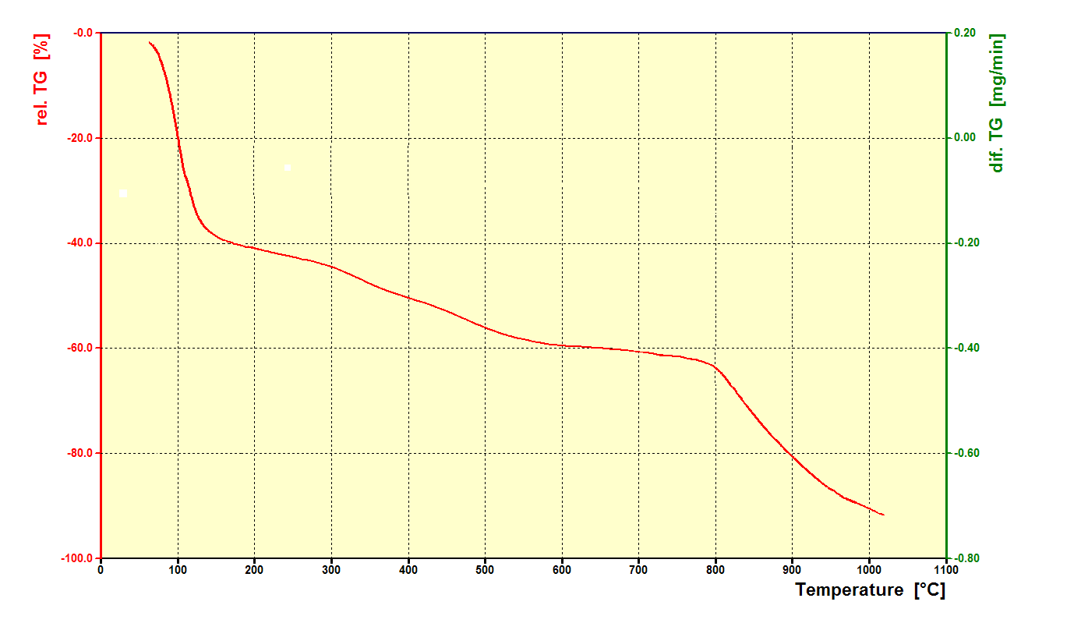
TGA curve of the polymer (2)

3. Some of compounds in table 1

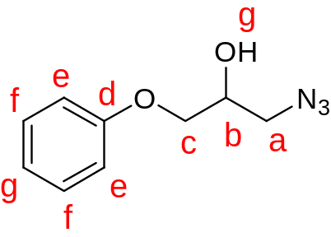

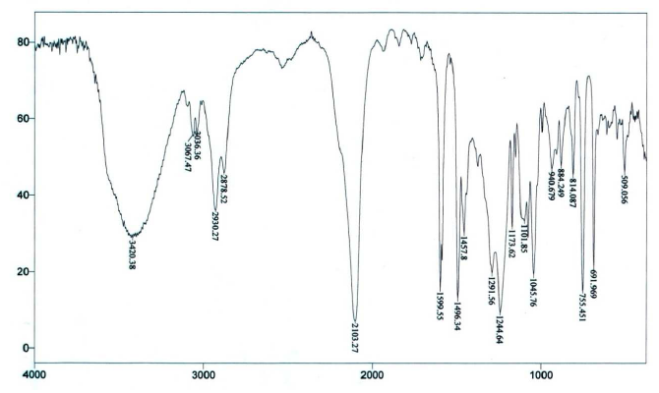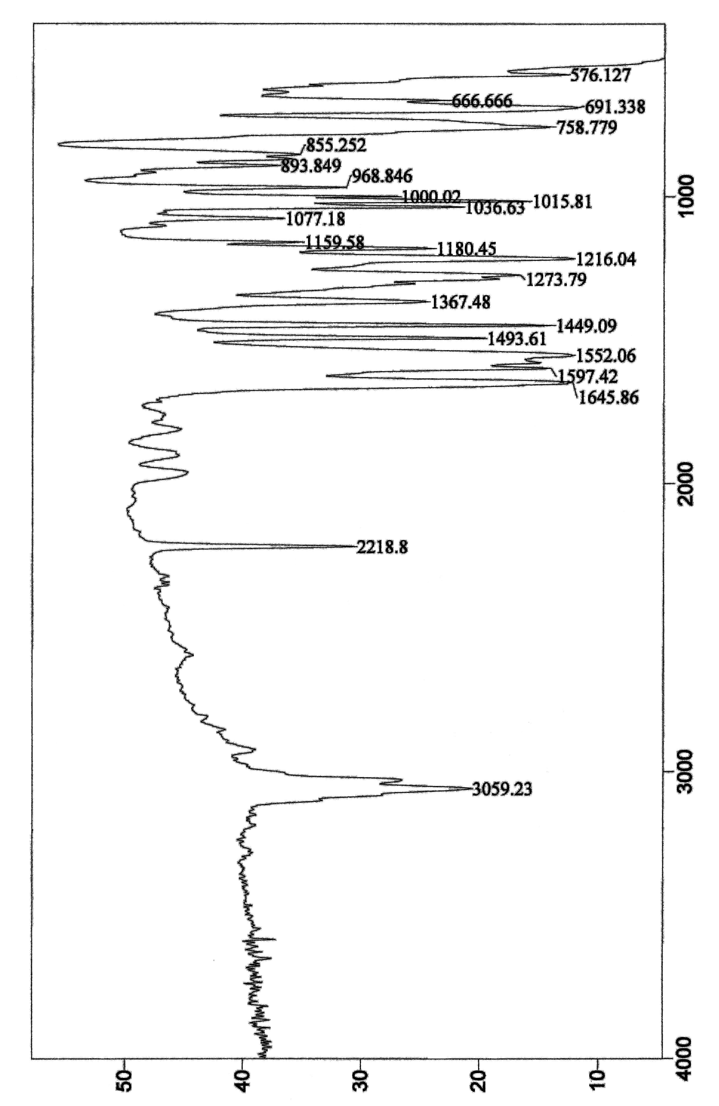

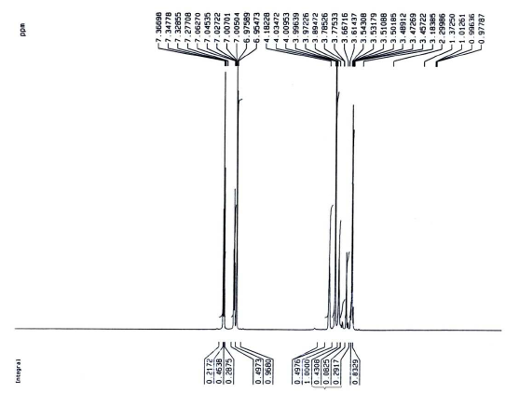

e a

f a

c a

a a

g a

h a

b a

b,c

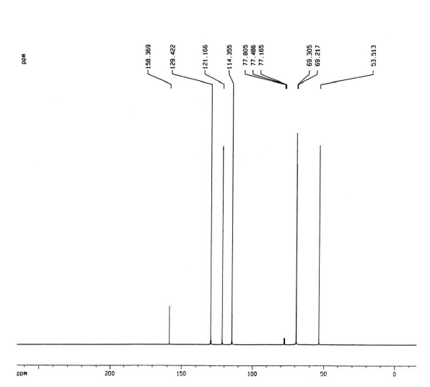
g a

a a

e
f

d

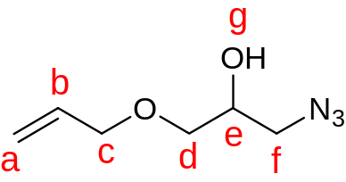

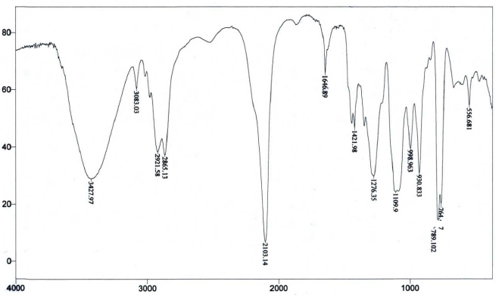

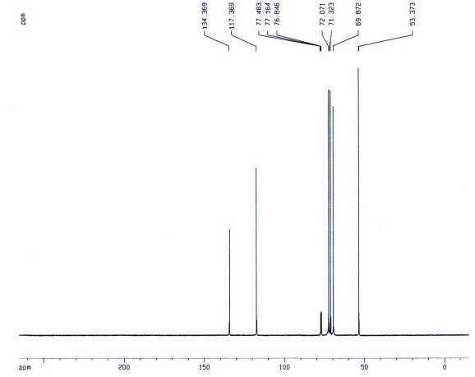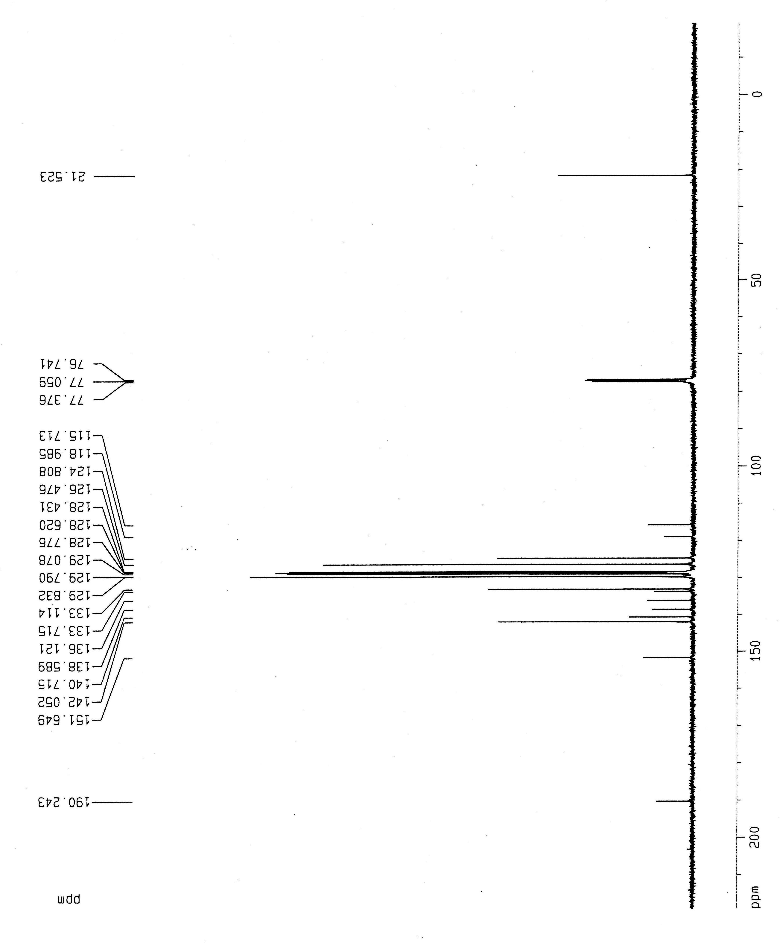

f a

d,e a

c a

a a

b a

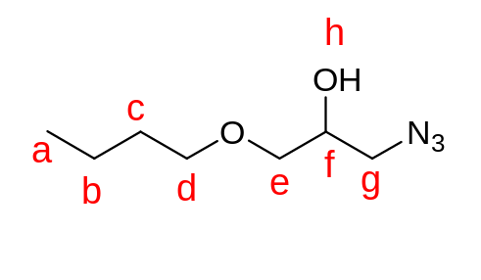

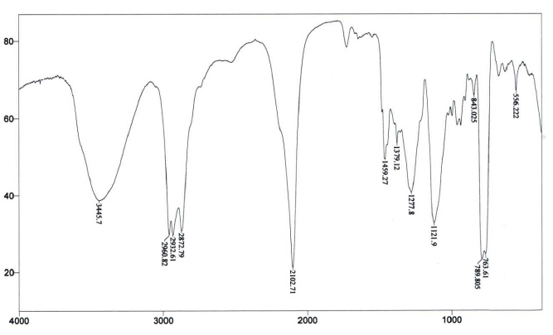

d,g a

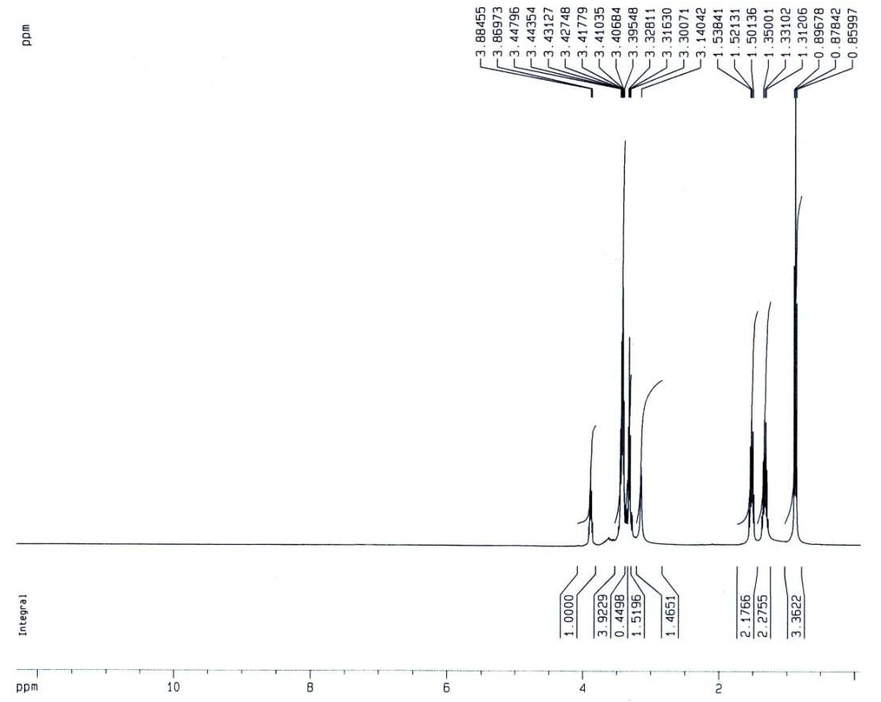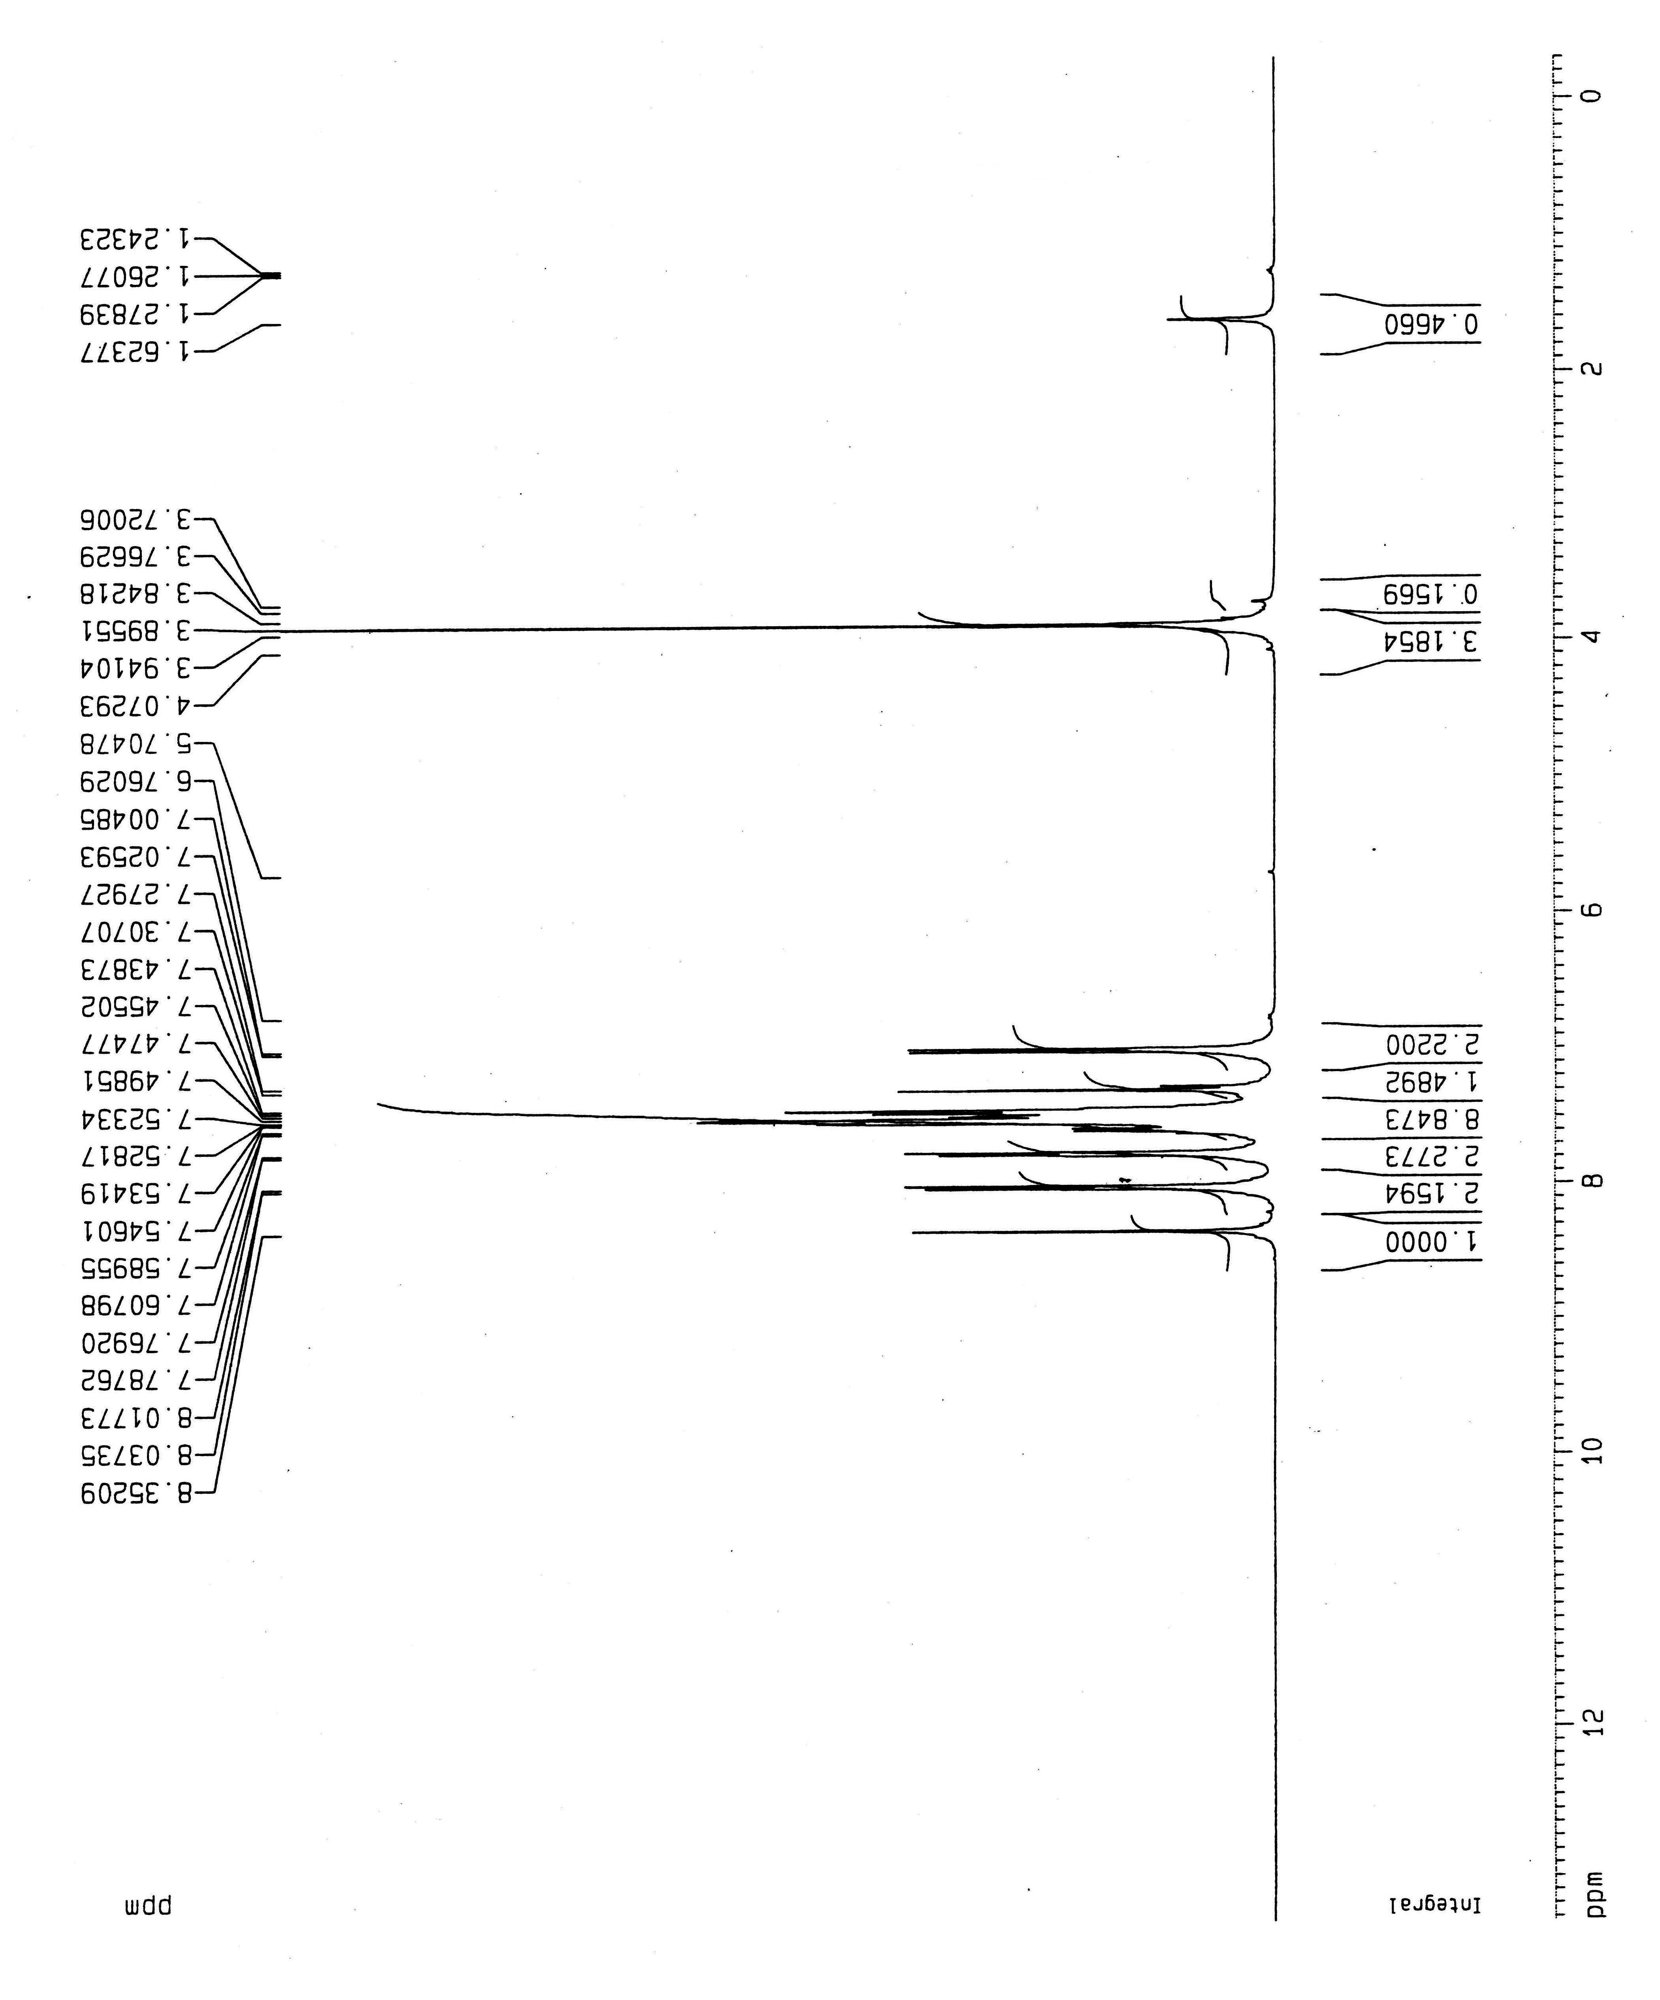

b a

e

c a

a a

a

h a

f a

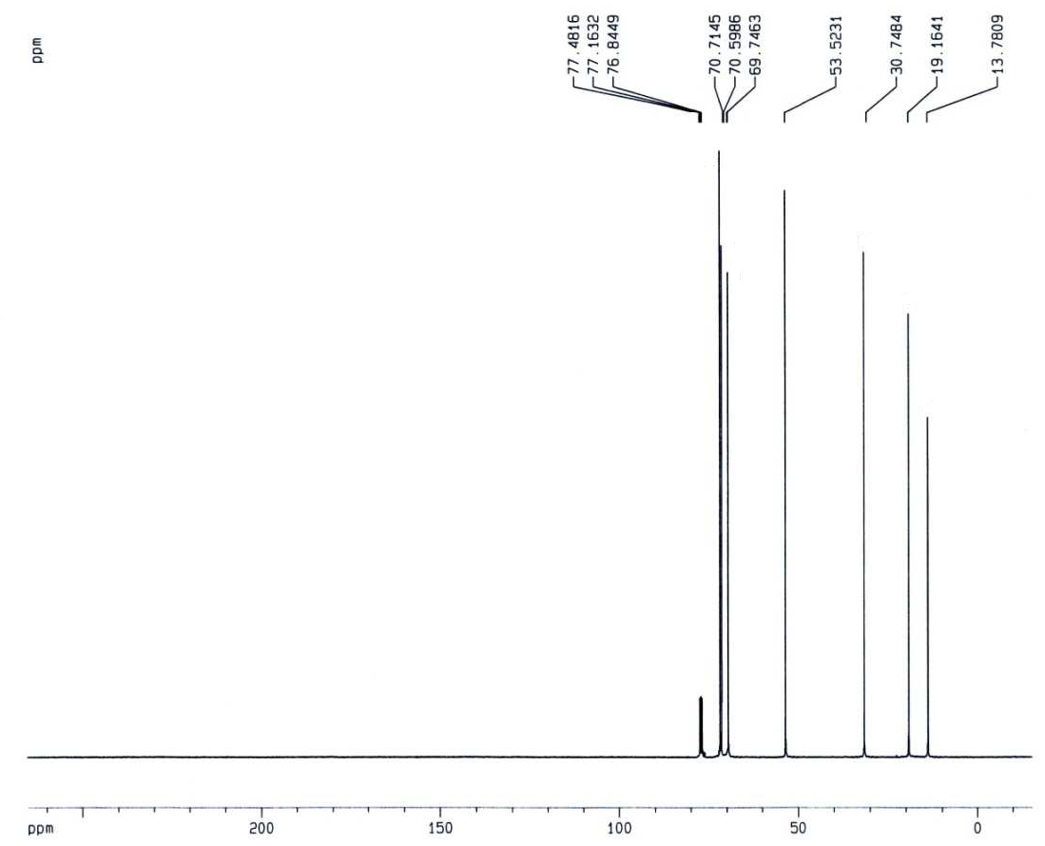

g a

e a

f a

c a

d a

b a

a a

S16

