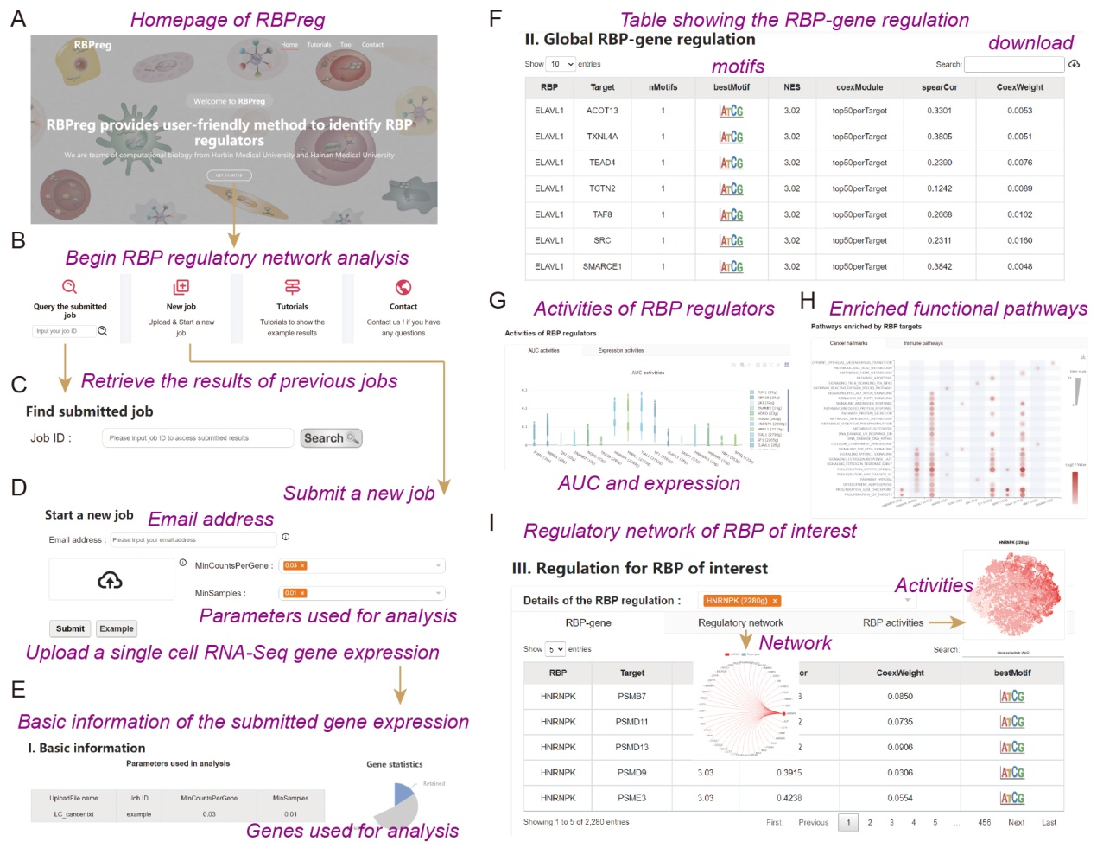
Fig. S1. Workflow for using the RBPreg web server. A, Homepage of RBPreg web server. B, Four functional modules in RBPreg web server. C, Retrieve the results of previous jobs. D, Submission of a new job in RBPreg. E, The basic information of the submitted gene expression profiles. F, Table showing the identified RBP-gene regulation. G, Activities of RBP regulators. H, Enriched functional pathways by potential targets of RBP regulators. I, Network view of RBP-gene regulation.

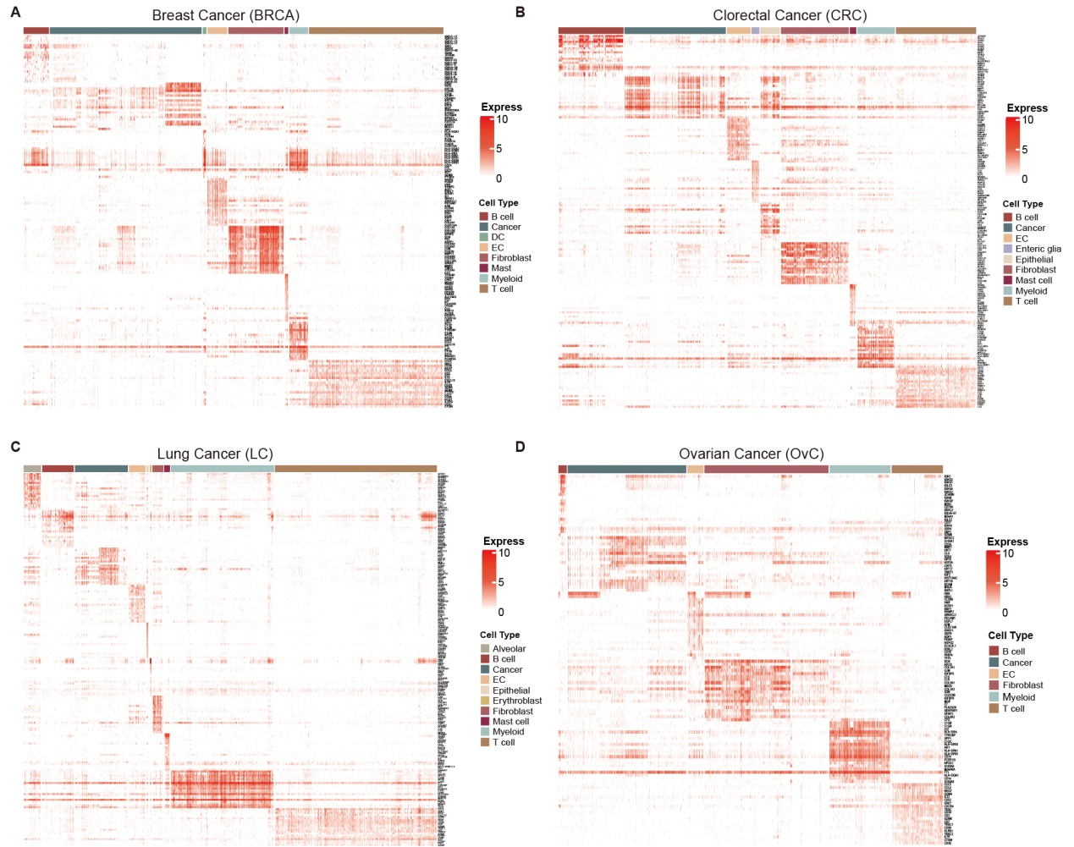
Fig. S2. Heat maps showing the expression of marker genes in different cell types across cancer types. A for BRCA, B for CRC, C for LC and D for OvC.

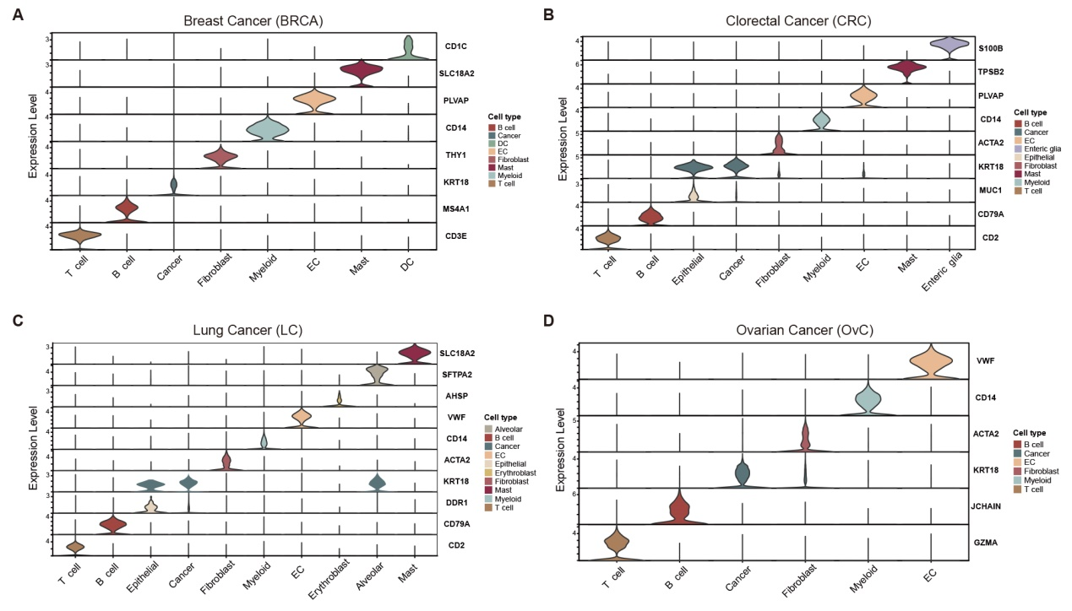
Fig. S3. Violin plots for expressions of marker genes in different cell types across cancer types.

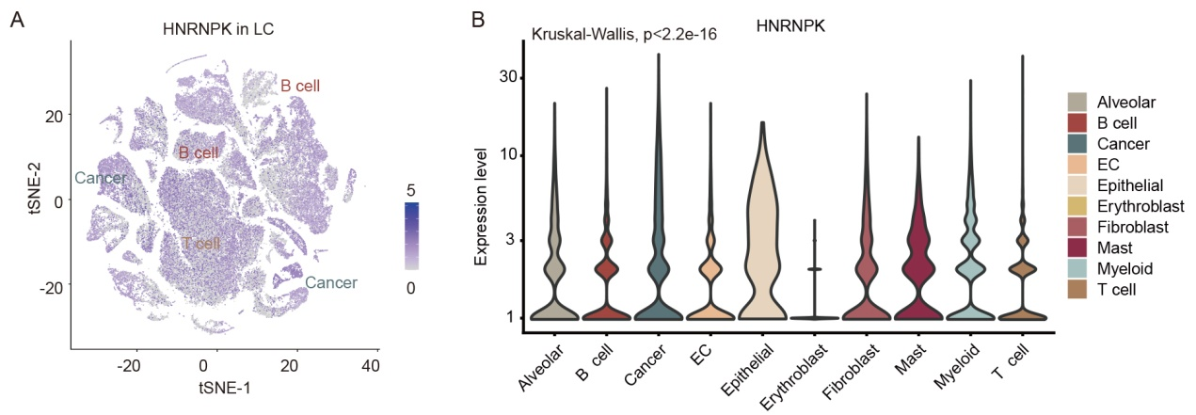
Fig. S4. Expressions of HNRNPK in different cell types of lung cancer. A, t-SNE plot showing the expression of HNRNPK in cells. B, Violin plots showing the expression of HNRNPK across cell types in lung cancer.

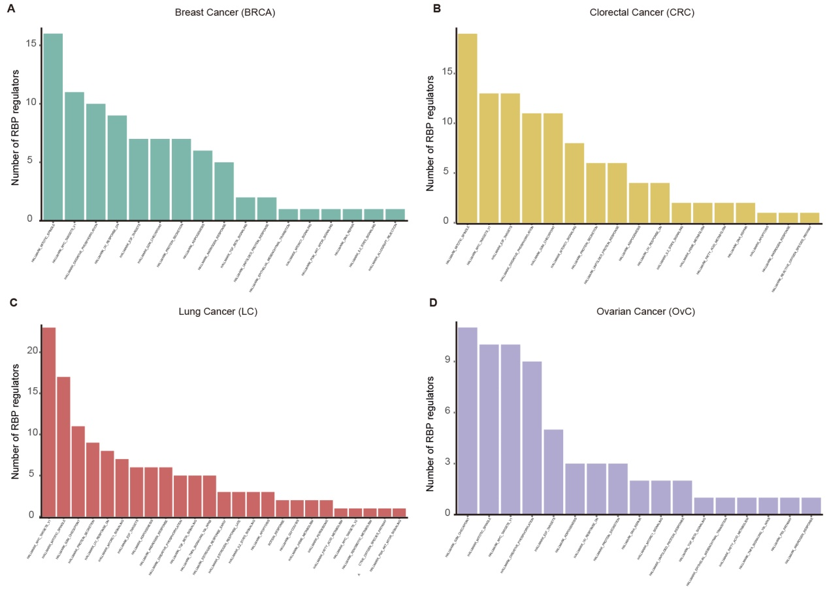
Fig. S5. Numbers of RBP regulators for cancer hallmark pathways across cancer types. A for BRCA, B for CRC, C for LC and D for OvC.

