Foreshock properties illuminate nucleation processes of slow and fast laboratory earthquakes

David C. Bolton^{1*}, Chris Marone^{2,3}, Demian Saffer⁴, and Daniel T. Trugman⁵
¹ Bureau of Economic Geology, Jackson School of Geosciences, University of Texas, Austin, TX.
²Department of Geosciences, Pennsylvania State University, University Park, Pennsylvania.
³Departimento di Scienze della Terra, La Sapienza Universita di Roma, Italy.
⁴ University of Texas Institute for Geophysics, Jackson School of Geosciences, University of Texas, Austin, TX.
⁵Nevada Seismological Laboratory, University of Nevada, Reno, Nevada

Figure S1. A-B: Example of two waveforms recorded on station 15 from 8 MPa. The full waveforms are plotted in black and highlighted in red are the 50 μs templates used for computing cross-correlation coefficients. The red templates start 10 μs prior to the p-wave arrival time and extend 40 μs after the arrival time. C. Cross-correlation function derived from templates in A and B. We quantify waveform similarity by measuring the maximum absolute value of the cross-correlation function. The time-lag of the peak cross-correlation coefficient represents the differential travel-time between event pairs.

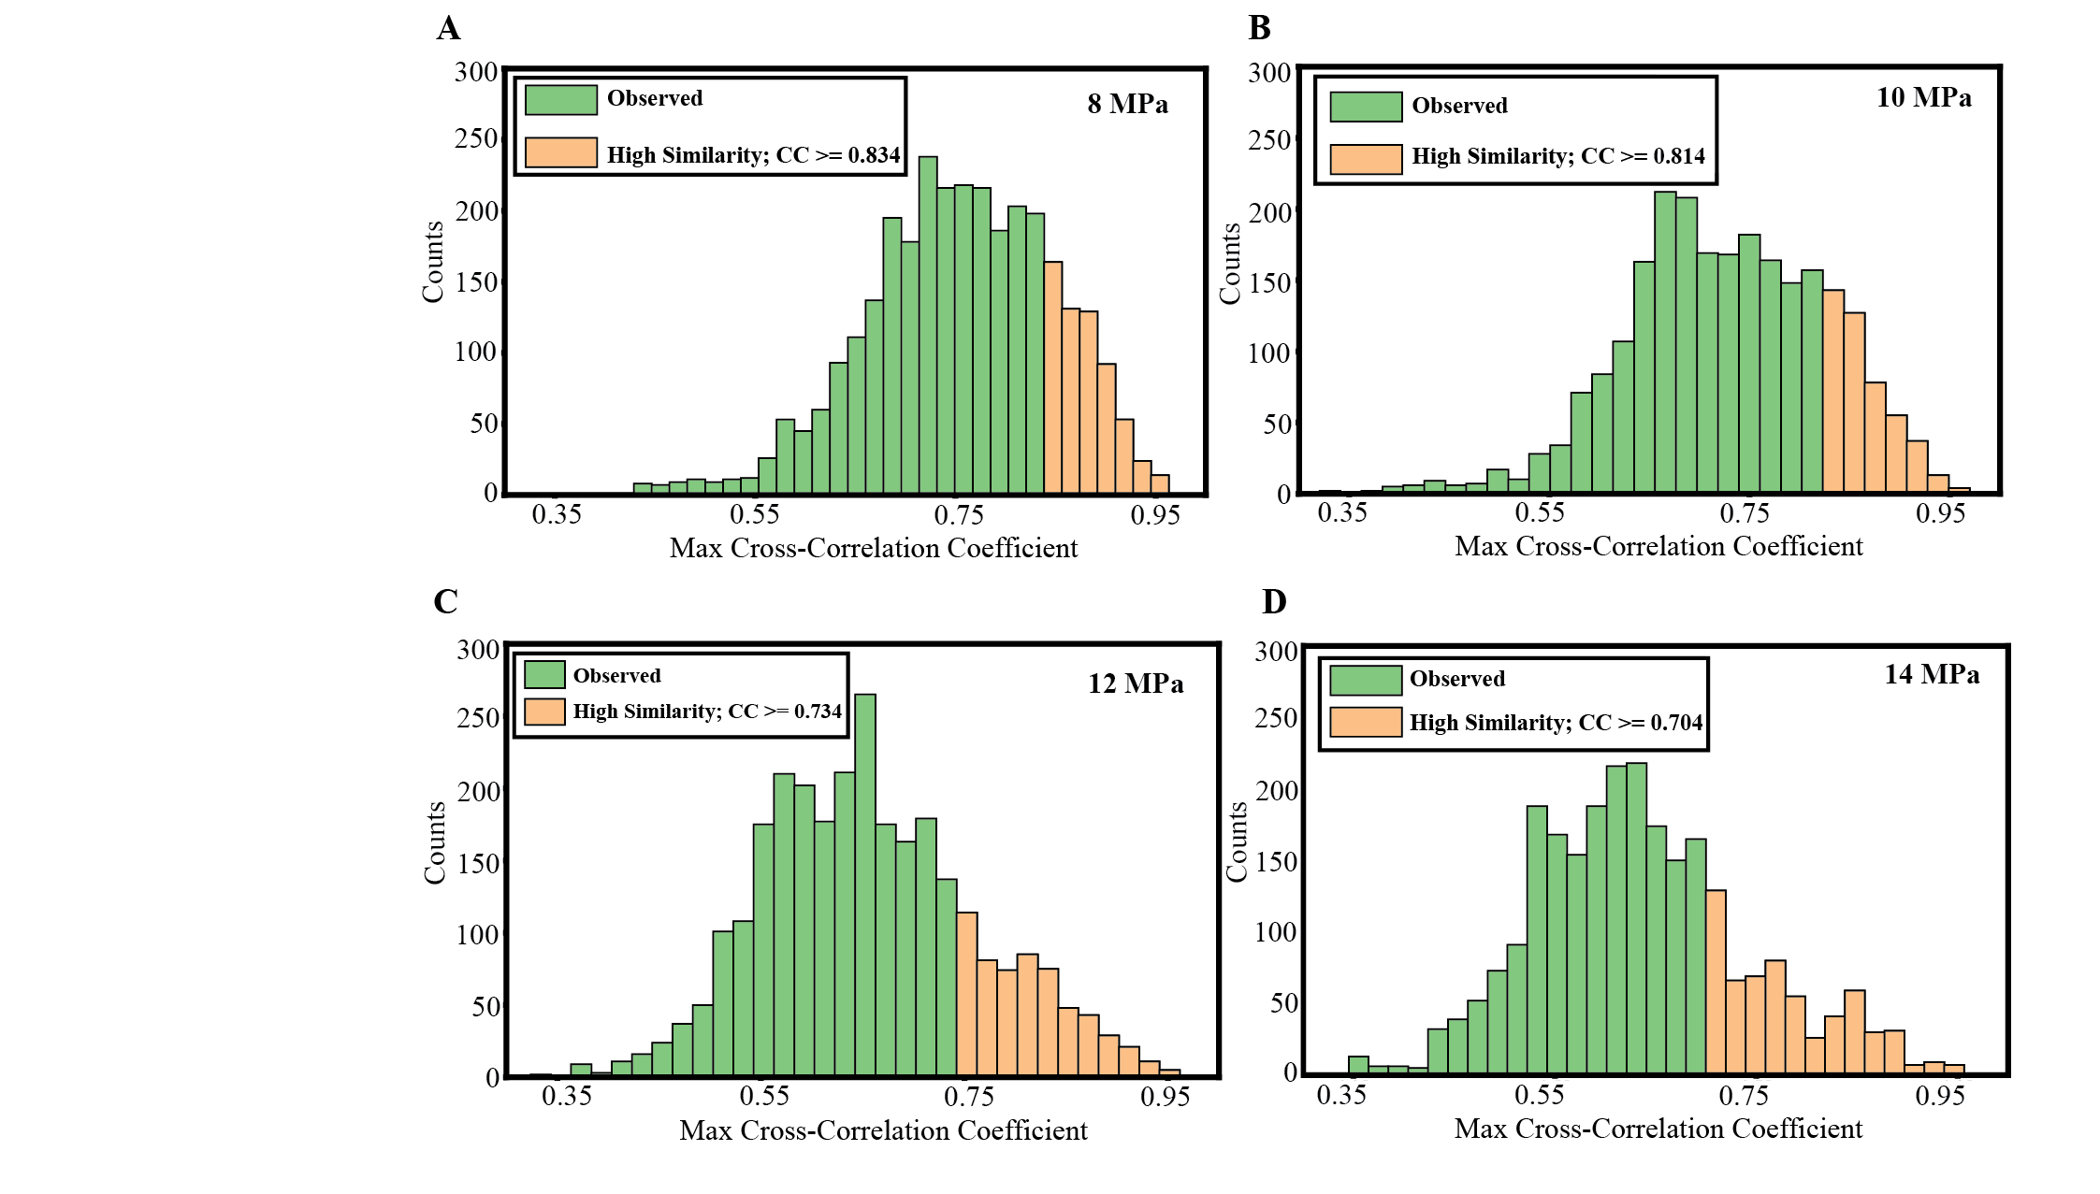

Figure S2. A-D Histograms of maximum cross-correlation coefficients derived from 15 stick-slip cycles at each normal stress (see main text for details). We define “high” waveform similarity for each distribution as event pairs that have cross-correlation coefficients >=75th percentile. Note, that the high similarity threshold scales inversely with normal stress. Defining high similarity at the 75th percentile is arbitrary, but this produces a systematic way to quantify the tails of each distribution. Furthermore, because there are many event pairs (> 100) above the 75th percentile we can further quantify the systematics of these data to better understand their connection and/or lack thereof to faulting processes (e.g., Figure 3; Figure S3).

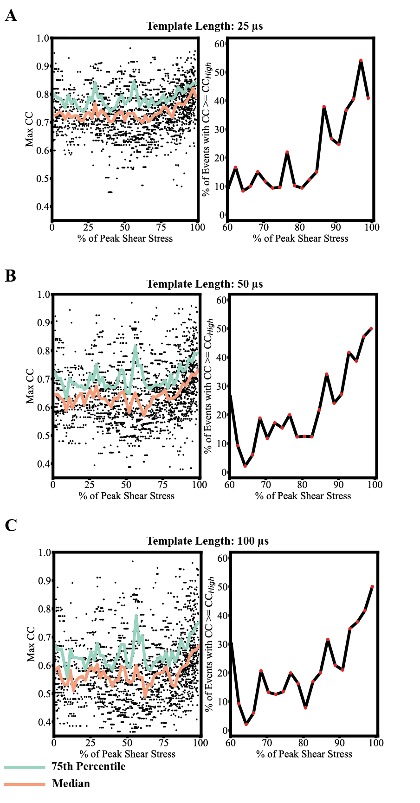

Figure S3 A-C: Maximum cross-correlation coefficient as a function of peak stress for 15 stick-slip cycles at 12 MPa. In panels A-C, we systematically change the template length from 25-100 μs and demonstrate that the results presented in Figure 3 of the main text are unaffected by the template size. Irrespective of the template size, we observe a systematic increase in waveform similarity as the fault approaches failure. In each panel, raw measurements are plotted with black circles, and we use a moving window to estimate the median (orange line), 75th percentile (green line), and percentage of event pairs that have high waveform similarity (black line). Recall, that high waveform similarity is determined from the cross-correlation distributions in Figure S2. Figures in the main text are derived from 50 μs templates.

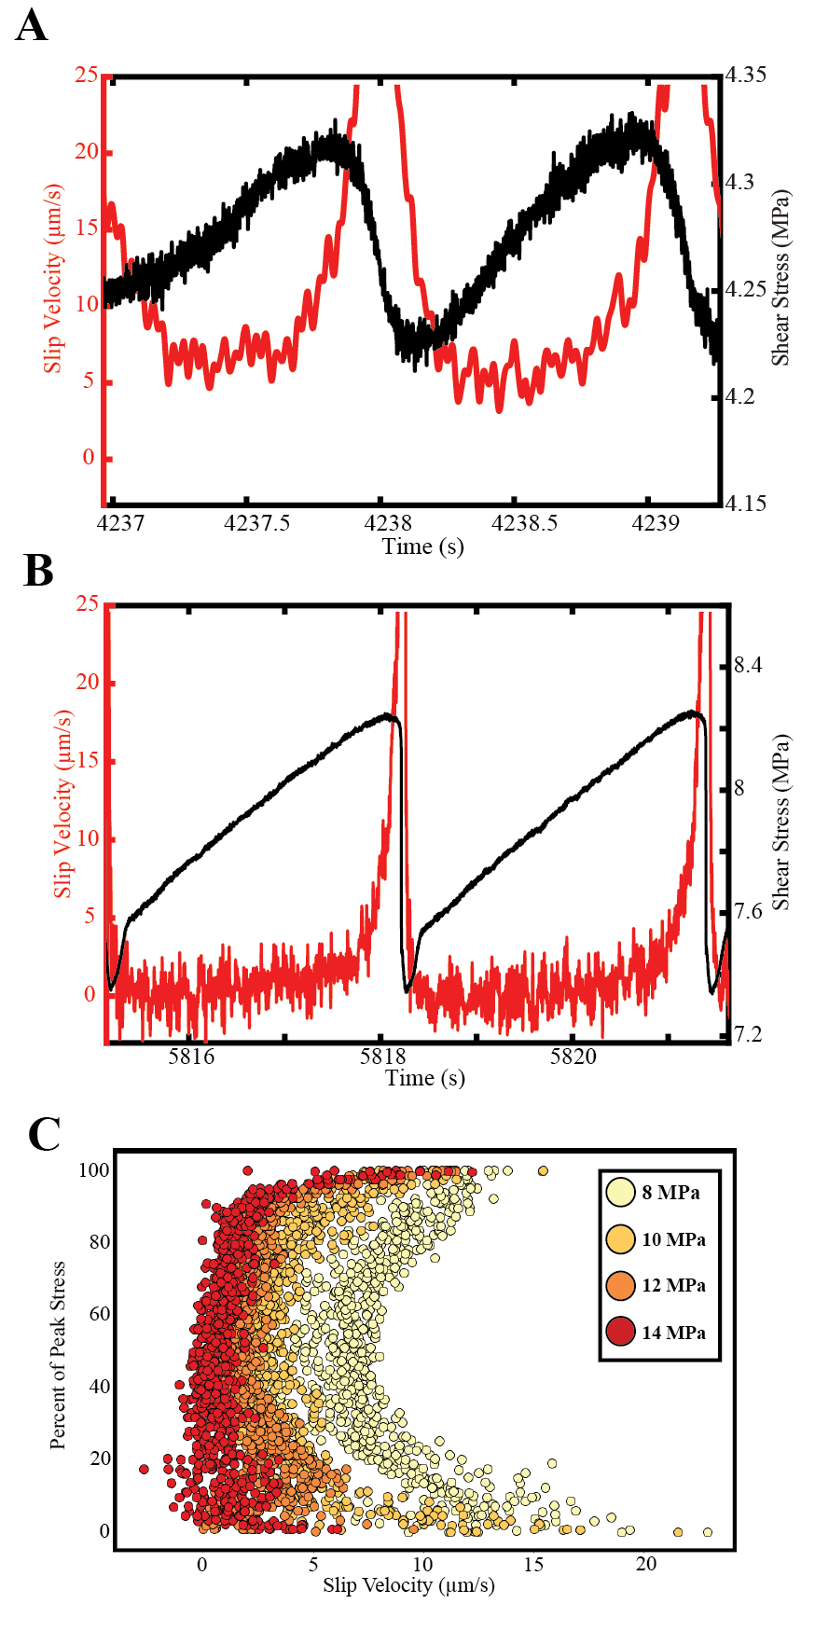

Figure S4 A-B: Fault slip velocity and shear stress as a function of time for slow stick-slip events (A; 8 MPa) and fast stick-slip events (B;14 MPa). For slow slip events, the fault reaches a minimum slip rate of ~ 5 μm/s prior to accelerating during the latter stages of the seismic cycle. In contrast, during the fast stick-slip events (B) the fault locks up and reaches a minimum slip rate of ~ 0 μm/s. C. Normalized shear stress as a function of slip velocity for 5 seismic cycles; data points are color coded according to their respective normal stress. Note, the fault completely locks up during the inter-seismic period for the fast stick-slip events at 12-14 MPa. At 8 MPa the fault never locks up and continues to slip throughout the entire inter-seismic period.

