Supporting Information
“Epiphytic orchids have specialized mycorrhizal fungal niches that are also linked to phenology”
Melania Fernández, Jaspreet Kaur and Jyotsna Sharma

Supplemental Table 1
Diagnostic morphological characters for in situ identification of juvenile and reproductive life stages of the four co-occurring, epiphytic orchid species Dichaea eburnea, Epidendrum odontochilum, Masdevallia nidifica and Oncidium klotzschianum used in this study. Descriptions were modified from Dressler (2003). When not in flower, old peduncles, pedicels and flower bracts were used as indication of reproductive activity.
Orchid species | Distribution | Characters for juvenile individuals | Characters for adult individuals
Dichaea eburnea  (Zygopetaliinae) | Costa Rica and Panama | Suberect to pendulous plants up to 10 cm tall; stems wrapped by basal, conduplicated sheaths; leaves 1 to 10, linguliform, obtuse to subacute, articulated with the sheaths. | Suberect to pendulous plants, up to 25 cm long. Stem laterally flattened, covered by conduplicated sheaths. Leaves oblong to lanceolate, obtuse to subacute, articulated with the sheaths. Flowers succulent with sepals and petals white, and the lip white to lilac. Sepals ovate to triangular and petals sublanceolate. Lip cuneiform, clawed.
Epidendrum odontochilum  (Laelliinae) | Costa Rica and Panama | Erect to suberect plants up to 15 cm tall. Stems laterally flattened, lightly bent in zig-zag. Leaf sheath tubular, covering most of the stem. Leaves 1 to 7, alternate, elliptic to lanceolate, margin entire. | Erect to suberect plants up to 15 cm tall. Stems laterally flattened, lightly bent in zig-zag. Leaf sheath tubular, compressed, covering most of the stem. Leaves 1 to 7, alternate, elliptic to lanceolate, margin entire. Inflorescence apical, with 1 to 5 yellowish green flowers. Sepals obovate with revolute margins. Petals abovate to spatulate. Lip with the margin erose-dentate apically.
Masdevallia nidifica  (Pleurothallidinae) | From Nicaragua to Peru and Ecuador | Cespitose plants, up to 2.0 cm tall, with 1 to 4 stems. Stems abbreviated, covered by 1 to 2 brownish, tubular sheaths, with a single, apical leaf per stem. Leaves widely elliptic to lanceolate, with purplish-green blades. | Cespitose plants, up to 8.0 cm tall, with 5 stems or more. Stems abbreviated, covered by 1 to 2 brownish, tubular sheaths, with a single, apical leaf per stem. Leaves widely elliptic to lanceolate, with purplish-green blades. Flowers with translucid sepals marked with pink along the veins into long, thin apical tails, connate along the margins forming a tube. Petals white and lip light yellow to pink.
Oncidium klotzschianum | From Costa Rica to Peru and Ecuador | Erect plants up to 12 cm tall. Pseudobulbs basal, 1 to 3, narrowly ovoid, sometimes elongated. Leaves 1 to 7, up to 10 cm long, elliptic to ligulate, growing apically or sometimes from the margins. | Suberect to pendent plants, up to 120 cm or more tall. Pseudobulbs 5 or more, narrowly ovoid. Leaves apical, 1 or 2, elliptic to ligulate. Inflorescence a multiflowered panicle to 200 cm long. Flowers yellow with reddish to brown spots. Sepals and petals cuneate to unguiculate, oblanceolate. Lip with two triangular, basal lobes, and a medium lobe 7-13 mm, transversally oblong, with rounded wings.
Supplemental Table 2. Alphabetical list of fungal taxa included in the endophytic fungi (EF), putative orchid mycorrhizal fungi (POMF) and strict orchid mycorrhizal fungi (SOMF) categories applied in this study. Details on the parameters used to classify fungal taxa into the three categories is supplied in the ‘Methods’ section. Taxa included here as EF is not exhaustive.
Fungal taxon | Fungal category |  |  |  | Fungal taxon | Fungal category
Fungal taxon | EF | POMF | SOMF |  | Fungal taxon | EF | POMF | SOMF
Agaricaceae | x |  |  |  | Meripilaceae | x
Atheliaceae | x |  |  |  | Mycenaceae | x | x
Atractiellales | x | x | x |  | Nectriaceae | x | x
Auriculariaceae | x |  |  |  | Pezizaceae | x
Bolbitiaceae | x |  |  |  | Physalacriaceae | x
Bondarzewiaceae | x |  |  |  | Pleosporaceae | x
Cantharellaceae | x |  |  |  | Psathyrellaceae | x | x
Ceratobasidiaceae | x | x | x |  | Pyronemataceae | x
Clavulinaceae | x | x |  |  | Russulaceae | x | x
Corticiaceae | x |  |  |  | Sarcoscyphaceae | x
Cortinariaceae | x | x |  |  | Sarcosomataceae | x
Didymellaceae | x |  |  |  | Sclerodermataceae | x
Dothioraceae | x |  |  |  | Sebacinaceae | x | x | x
Fomitopsidaceae | x |  |  |  | Serendipitaceae | x | x | x
Helvellaceae | x | x |  |  | Sparassidaceae | x
Herpotrichiellaceae | x |  |  |  | Sporidiobolaceae | x
Hydnaceae | x | x |  |  | Terfeziaceae | x
Hydnangiaceae | x | x |  |  | Thelephoraceae | x | x
Hymenochaetaceae | x |  |  |  | Trichocomaceae | x
Hymenogastraceae | x | x |  |  | Tricholomataceae | x | x
Inocybaceae | x | x |  |  | Tuberaceae | x | x
Marasmiaceae | x | x |  |  | Tulasnellaceae | x | x | x

Supplemental Table 3. Taxonomical identity and number of sequence reads of the operational taxonomic units (OTUs) of the juvenile and reproductive life stages of the four co-occurring, epiphytic orchids Dichaea fragrantissima Epidendrum odontochilum, Masdevallia nidifica, Oncidium klotzschianum retained after quality filtering for each individual plant was applied. Clustering of OTU was performed at 97% similarity threshold. Taxonomical names obtained after performing BLAST and UNITE-based searches. All sequences deposited at NCBI under BioProject PRJNA777278.
OTU ID | Taxonomical ID | Number of reads | Dichaea eburnea |  |  | Epidendrum odontochilum |  |  | Masdevallia nidifica |  |  | Oncidium klotzschianum
OTU ID | Taxonomical ID | Number of reads | Juv. | Rep. |  | Juv. | Rep. |  | Juv. | Rep. |  | Juv. | Rep.
OTU6 | Atractiellales | 91117 | 77 | 37109 |  | 50 | 887 |  | 3977 | 8513 |  | 517 | 39987
OTU5 | Atheliaceae | 90845 | 814 | 30577 |  | 600 | 15181 |  | 3069 | 22810 |  | 94 | 17700
OTU7 | Amanitaceae | 59979 | 426 | 21364 |  | 429 | 10894 |  | 1997 | 14245 |  | 45 | 10579
OTU8 | Serendipitaceae | 30572 | 0 | 6 |  | 14 | 30539 |  | 0 | 11 |  | 0 | 2
OTU10 | Hydnodontaceae | 24248 | 5 | 307 |  | 6 | 22972 |  | 544 | 311 |  | 1 | 102
OTU11 | Serendipitaceae | 23219 | 3 | 4 |  | 17 | 23063 |  | 2 | 0 |  | 95 | 35
OTU14 | Tricholomataceae | 20355 | 138 | 7315 |  | 111 | 3522 |  | 580 | 4281 |  | 5 | 4403
OTU31 | Serendipitaceae | 14636 | 0 | 6 |  | 770 | 13744 |  | 0 | 104 |  | 0 | 12
OTU18 | Atheliaceae | 14010 | 128 | 4182 |  | 89 | 2675 |  | 702 | 3333 |  | 5 | 2896
OTU48 | Tulasnellaceae | 11849 | 93 | 4055 |  | 49 | 4008 |  | 88 | 2463 |  | 1 | 1092
OTU19 | Psathyrellaceae | 11492 | 157 | 4120 |  | 104 | 1769 |  | 473 | 2313 |  | 10 | 2546
OTU22 | Auriculariales | 11097 | 0 | 2 |  | 2 | 1 |  | 3 | 2 |  | 404 | 10683
OTU32 | Atractiellales | 10468 | 0 | 31 |  | 0 | 208 |  | 9 | 9882 |  | 40 | 298
OTU20 | Ceratobasidiaceae | 8027 | 1 | 4 |  | 4 | 3 |  | 38 | 7933 |  | 0 | 44
OTU21 | Serendipitaceae | 7995 | 0 | 1 |  | 1 | 7873 |  | 117 | 2 |  | 0 | 1
OTU23 | Serendipitaceae | 7139 | 2 | 5637 |  | 0 | 0 |  | 1478 | 4 |  | 0 | 18
OTU25 | Serendipitaceae | 5672 | 2 | 5018 |  | 0 | 285 |  | 0 | 1 |  | 48 | 318
OTU34 | Ceratobasidiaceae | 4806 | 31 | 1472 |  | 30 | 1556 |  | 39 | 1109 |  | 0 | 569
OTU30 | Serendipitaceae | 4514 | 1 | 1 |  | 2 | 1 |  | 13 | 9 |  | 26 | 4461
OTU27 | Hydnodontaceae | 3680 | 2 | 3471 |  | 0 | 206 |  | 0 | 0 |  | 0 | 1
OTU33 | Omphalotaceae | 2785 | 2 | 113 |  | 0 | 120 |  | 2415 | 119 |  | 0 | 16
OTU38 | Ceratobasidiaceae | 2700 | 4 | 1080 |  | 16 | 632 |  | 19 | 711 |  | 0 | 238
OTU62 | Hydnodontaceae | 2627 | 0 | 637 |  | 0 | 328 |  | 0 | 14 |  | 0 | 1648
OTU49 | Ceratobasidiaceae | 2331 | 7 | 661 |  | 17 | 848 |  | 4 | 546 |  | 0 | 248
OTU56 | Trechisporales | 1586 | 0 | 0 |  | 0 | 0 |  | 1 | 39 |  | 0 | 1546
OTU68 | Russulaceae | 1568 | 8 | 518 |  | 5 | 670 |  | 3 | 281 |  | 0 | 83
OTU41 | Agaricales | 1516 | 0 | 0 |  | 2 | 1514 |  | 0 | 0 |  | 0 | 0
OTU51 | Cortinariaceae | 1419 | 2 | 557 |  | 16 | 464 |  | 12 | 222 |  | 0 | 146
OTU230 | Trechisporales | 1333 | 0 | 96 |  | 0 | 21 |  | 21 | 256 |  | 0 | 939
OTU58 | Malasseziaceae | 1279 | 37 | 360 |  | 15 | 347 |  | 17 | 471 |  | 2 | 30
OTU46 | Tremellales | 1268 | 0 | 53 |  | 2 | 1198 |  | 0 | 2 |  | 0 | 13
OTU47 | Malasseziaceae | 1236 | 2 | 0 |  | 0 | 0 |  | 1234 | 0 |  | 0 | 0
OTU65 | Thelephoraceae | 1187 | 1 | 201 |  | 3 | 603 |  | 9 | 212 |  | 2 | 156
OTU94 | Trechisporales | 1126 | 15 | 43 |  | 7 | 133 |  | 0 | 9 |  | 0 | 919
OTU72 | Meruliaceae | 1120 | 0 | 0 |  | 0 | 0 |  | 0 | 0 |  | 0 | 1120
OTU55 | Piskurozymaceae | 1066 | 1 | 478 |  | 3 | 329 |  | 7 | 206 |  | 0 | 42
OTU64 | Ceratobasidiaceae | 1039 | 2 | 555 |  | 5 | 208 |  | 7 | 191 |  | 0 | 71
OTU54 | Mycosphaerellaceae | 925 | 0 | 0 |  | 0 | 0 |  | 0 | 925 |  | 0 | 0
OTU87 | Serendipitaceae | 840 | 0 | 171 |  | 0 | 326 |  | 0 | 113 |  | 0 | 230
OTU59 | Ceratobasidiaceae | 816 | 0 | 19 |  | 0 | 753 |  | 0 | 36 |  | 0 | 8
OTU66 | Hygrophoraceae | 649 | 0 | 229 |  | 5 | 219 |  | 19 | 75 |  | 0 | 102
OTU126 | Ceratobasidiaceae | 616 | 0 | 80 |  | 0 | 9 |  | 0 | 0 |  | 0 | 527
OTU104 | Auriculariales | 604 | 0 | 256 |  | 0 | 177 |  | 0 | 0 |  | 0 | 171
OTU70 | Meruliaceae | 599 | 29 | 0 |  | 0 | 0 |  | 0 | 7 |  | 1 | 562
OTU98 | Tulasnellaceae | 546 | 0 | 99 |  | 0 | 336 |  | 2 | 73 |  | 0 | 36
OTU300 | Tulasnellaceae | 504 | 4 | 141 |  | 1 | 134 |  | 1 | 120 |  | 0 | 103
OTU91 | Serendipitaceae | 465 | 0 | 465 |  | 0 | 0 |  | 0 | 0 |  | 0 | 0
OTU255 | Trechisporales | 444 | 0 | 13 |  | 0 | 0 |  | 0 | 26 |  | 1 | 404
OTU721 | Atractiellales | 417 | 0 | 1 |  | 0 | 9 |  | 0 | 387 |  | 1 | 19
OTU81 | Hygrophoraceae | 406 | 0 | 262 |  | 0 | 107 |  | 0 | 37 |  | 0 | 0
OTU106 | Malasseziaceae | 402 | 14 | 24 |  | 1 | 164 |  | 138 | 56 |  | 0 | 5
OTU88 | Serendipitaceae | 380 | 0 | 0 |  | 0 | 0 |  | 0 | 370 |  | 0 | 10
OTU82 | Serendipitaceae | 374 | 0 | 374 |  | 0 | 0 |  | 0 | 0 |  | 0 | 0
OTU125 | Clavulinaceae | 293 | 0 | 121 |  | 0 | 157 |  | 0 | 0 |  | 0 | 15
OTU118 | Geastraceae | 292 | 0 | 51 |  | 0 | 103 |  | 3 | 95 |  | 0 | 40
OTU134 | Cantharellales | 261 | 0 | 261 |  | 0 | 0 |  | 0 | 0 |  | 0 | 0
OTU746 | Ceratobasidiaceae | 256 | 5 | 85 |  | 10 | 123 |  | 6 | 12 |  | 0 | 15
OTU102 | Catathelasmataceae | 253 | 2 | 43 |  | 0 | 126 |  | 0 | 42 |  | 0 | 40
OTU147 | Ceratobasidiaceae | 248 | 2 | 34 |  | 0 | 176 |  | 0 | 30 |  | 0 | 6
OTU135 | Auriculariales | 243 | 0 | 235 |  | 0 | 0 |  | 0 | 8 |  | 0 | 0
OTU144 | Auriculariaceae | 227 | 0 | 0 |  | 0 | 227 |  | 0 | 0 |  | 0 | 0
OTU201 | Auriculariales | 227 | 0 | 58 |  | 1 | 0 |  | 8 | 0 |  | 60 | 100
OTU103 | Inocybaceae | 223 | 3 | 31 |  | 1 | 36 |  | 4 | 113 |  | 0 | 35
OTU122 | Auriculariales | 223 | 0 | 40 |  | 0 | 179 |  | 0 | 0 |  | 4 | 0
OTU109 | Thelephoraceae | 214 | 0 | 45 |  | 0 | 136 |  | 0 | 26 |  | 0 | 7
OTU165 | Serendipitaceae | 209 | 0 | 141 |  | 65 | 2 |  | 0 | 0 |  | 1 | 0
OTU148 | Serendipitaceae | 208 | 0 | 18 |  | 0 | 0 |  | 0 | 0 |  | 0 | 190
OTU682 | Malasseziaceae | 207 | 1 | 6 |  | 2 | 3 |  | 169 | 19 |  | 0 | 7
OTU864 | Atractiellales | 195 | 0 | 0 |  | 0 | 0 |  | 0 | 192 |  | 3 | 0
OTU110 | Tulasnellaceae | 192 | 0 | 0 |  | 0 | 0 |  | 192 | 0 |  | 0 | 0
OTU115 | Auriculariales | 192 | 0 | 0 |  | 0 | 192 |  | 0 | 0 |  | 0 | 0
OTU133 | Strophariaceae | 190 | 0 | 23 |  | 0 | 159 |  | 0 | 8 |  | 0 | 0
OTU114 | Agaricaceae | 166 | 0 | 41 |  | 3 | 5 |  | 0 | 113 |  | 0 | 4
OTU137 | Auriculariales | 162 | 0 | 107 |  | 0 | 25 |  | 0 | 11 |  | 0 | 19
OTU180 | Serendipitaceae | 162 | 0 | 80 |  | 0 | 0 |  | 1 | 0 |  | 0 | 81
OTU120 | Ceratobasidiaceae | 155 | 2 | 51 |  | 4 | 11 |  | 3 | 41 |  | 0 | 43
OTU112 | Bulleribasidiaceae | 144 | 0 | 0 |  | 0 | 0 |  | 144 | 0 |  | 0 | 0
OTU136 | Atheliaceae | 144 | 0 | 5 |  | 0 | 139 |  | 0 | 0 |  | 0 | 0
OTU140 | Cystofilobasidiaceae | 141 | 0 | 139 |  | 0 | 0 |  | 0 | 2 |  | 0 | 0
OTU517 | Serendipitaceae | 141 | 0 | 1 |  | 0 | 0 |  | 0 | 0 |  | 0 | 140
OTU146 | Beltraniaceae | 139 | 9 | 5 |  | 0 | 117 |  | 0 | 8 |  | 0 | 0
OTU130 | Serendipitaceae | 138 | 0 | 138 |  | 0 | 0 |  | 0 | 0 |  | 0 | 0
OTU141 | Wallemiaceae | 137 | 0 | 0 |  | 0 | 137 |  | 0 | 0 |  | 0 | 0
OTU145 | Apiosporaceae | 129 | 32 | 0 |  | 0 | 89 |  | 0 | 7 |  | 0 | 1
OTU131 | Serendipitaceae | 124 | 0 | 0 |  | 0 | 124 |  | 0 | 0 |  | 0 | 0
OTU129 | Serendipitaceae | 123 | 123 | 0 |  | 0 | 0 |  | 0 | 0 |  | 0 | 0
OTU186 | Coniophoraceae | 123 | 0 | 14 |  | 0 | 71 |  | 2 | 0 |  | 0 | 36
OTU132 | Serendipitaceae | 120 | 0 | 0 |  | 0 | 120 |  | 0 | 0 |  | 0 | 0
OTU196 | Malasseziaceae | 120 | 2 | 26 |  | 0 | 6 |  | 82 | 3 |  | 0 | 1
OTU142 | Tremellaceae | 115 | 0 | 115 |  | 0 | 0 |  | 0 | 0 |  | 0 | 0
OTU195 | Meruliaceae | 115 | 0 | 0 |  | 0 | 115 |  | 0 | 0 |  | 0 | 0
OTU215 | Pleosporales | 113 | 0 | 74 |  | 0 | 35 |  | 0 | 3 |  | 0 | 1
OTU162 | Schizoporaceae | 110 | 0 | 110 |  | 0 | 0 |  | 0 | 0 |  | 0 | 0
OTU879 | Serendipitaceae | 110 | 0 | 2 |  | 0 | 0 |  | 0 | 4 |  | 0 | 104
OTU166 | Pleosporales | 101 | 0 | 13 |  | 0 | 88 |  | 0 | 0 |  | 0 | 0
OTU174 | Serendipitaceae | 92 | 0 | 0 |  | 0 | 92 |  | 0 | 0 |  | 0 | 0
OTU177 | Inocybaceae | 92 | 0 | 31 |  | 0 | 19 |  | 0 | 40 |  | 0 | 2
OTU226 | Ceratobasidiaceae | 89 | 0 | 0 |  | 0 | 57 |  | 0 | 32 |  | 0 | 0
OTU296 | Ceratobasidiaceae | 89 | 0 | 20 |  | 0 | 8 |  | 0 | 33 |  | 0 | 28
OTU170 | Hydnodontaceae | 87 | 0 | 0 |  | 0 | 87 |  | 0 | 0 |  | 0 | 0
OTU205 | Filobasidiaceae | 84 | 0 | 0 |  | 0 | 0 |  | 84 | 0 |  | 0 | 0
OTU172 | Auriculariales | 83 | 0 | 83 |  | 0 | 0 |  | 0 | 0 |  | 0 | 0
OTU203 | Tremellaceae | 79 | 0 | 71 |  | 0 | 8 |  | 0 | 0 |  | 0 | 0
OTU241 | Hydnodontaceae | 78 | 0 | 0 |  | 0 | 78 |  | 0 | 0 |  | 0 | 0
OTU198 | Polyporaceae | 71 | 0 | 71 |  | 0 | 0 |  | 0 | 0 |  | 0 | 0
OTU189 | Serendipitaceae | 66 | 0 | 66 |  | 0 | 0 |  | 0 | 0 |  | 0 | 0
OTU228 | Agaricaceae | 65 | 0 | 0 |  | 1 | 56 |  | 1 | 7 |  | 0 | 0
OTU185 | Agaricales | 64 | 0 | 19 |  | 0 | 35 |  | 0 | 10 |  | 0 | 0
OTU181 | Schizoporaceae | 62 | 0 | 62 |  | 0 | 0 |  | 0 | 0 |  | 0 | 0
OTU295 | Hydnodontaceae | 62 | 0 | 0 |  | 0 | 0 |  | 0 | 62 |  | 0 | 0
OTU223 | Psathyrellaceae | 61 | 0 | 61 |  | 0 | 0 |  | 0 | 0 |  | 0 | 0
OTU200 | Ganodermataceae | 60 | 0 | 0 |  | 0 | 16 |  | 0 | 24 |  | 0 | 20
OTU216 | Agaricaceae | 60 | 4 | 1 |  | 0 | 28 |  | 2 | 17 |  | 0 | 8
OTU245 | Ceratobasidiaceae | 60 | 0 | 60 |  | 0 | 0 |  | 0 | 0 |  | 0 | 0
OTU210 | Meruliaceae | 59 | 0 | 0 |  | 0 | 59 |  | 0 | 0 |  | 0 | 0
OTU193 | Polyporales | 58 | 0 | 0 |  | 0 | 58 |  | 0 | 0 |  | 0 | 0
OTU219 | Filobasidiaceae | 56 | 16 | 40 |  | 0 | 0 |  | 0 | 0 |  | 0 | 0
OTU270 | Auriculariales | 55 | 55 | 0 |  | 0 | 0 |  | 0 | 0 |  | 0 | 0
OTU275 | Serendipitaceae | 55 | 0 | 42 |  | 0 | 0 |  | 0 | 0 |  | 0 | 13
OTU190 | Ceratobasidiaceae | 54 | 0 | 0 |  | 0 | 54 |  | 0 | 0 |  | 0 | 0
OTU301 | Cantharellales | 50 | 0 | 43 |  | 0 | 0 |  | 0 | 2 |  | 0 | 5
OTU222 | Callistosporiaceae | 48 | 0 | 41 |  | 0 | 0 |  | 0 | 7 |  | 0 | 0
OTU656 | Tulasnellaceae | 48 | 0 | 4 |  | 0 | 4 |  | 1 | 0 |  | 3 | 36
OTU224 | Polyporales | 47 | 0 | 46 |  | 0 | 1 |  | 0 | 0 |  | 0 | 0
OTU263 | Cucurbitariaceae | 47 | 0 | 7 |  | 0 | 0 |  | 0 | 0 |  | 0 | 40
OTU294 | Serendipitaceae | 47 | 0 | 0 |  | 0 | 47 |  | 0 | 0 |  | 0 | 0
OTU395 | Cantharellales | 47 | 0 | 15 |  | 0 | 0 |  | 0 | 0 |  | 0 | 32
OTU227 | Schizophyllaceae | 45 | 0 | 0 |  | 0 | 45 |  | 0 | 0 |  | 0 | 0
OTU258 | Malasseziales | 44 | 0 | 0 |  | 0 | 3 |  | 0 | 28 |  | 0 | 13
OTU286 | Leucosporidiaceae | 44 | 0 | 37 |  | 0 | 1 |  | 2 | 4 |  | 0 | 0
OTU276 | Psathyrellaceae | 43 | 0 | 30 |  | 0 | 0 |  | 1 | 12 |  | 0 | 0
OTU329 | Sakaguchiaceae | 43 | 0 | 43 |  | 0 | 0 |  | 0 | 0 |  | 0 | 0
OTU283 | Didymosphaeriaceae | 42 | 5 | 13 |  | 10 | 5 |  | 9 | 0 |  | 0 | 0
OTU315 | Serendipitaceae | 42 | 0 | 0 |  | 0 | 0 |  | 0 | 42 |  | 0 | 0
OTU779 | Tulasnellaceae | 42 | 7 | 35 |  | 0 | 0 |  | 0 | 0 |  | 0 | 0
OTU242 | Chrysozymaceae | 40 | 0 | 0 |  | 0 | 40 |  | 0 | 0 |  | 0 | 0
OTU244 | Hymenochaetales | 40 | 0 | 9 |  | 0 | 4 |  | 0 | 22 |  | 0 | 5
OTU313 | Atractiellales | 40 | 0 | 0 |  | 0 | 0 |  | 2 | 0 |  | 0 | 38
OTU264 | Wallemiaceae | 39 | 0 | 0 |  | 0 | 39 |  | 0 | 0 |  | 0 | 0
OTU273 | Tremellaceae | 38 | 0 | 38 |  | 0 | 0 |  | 0 | 0 |  | 0 | 0
OTU280 | Auriculariales | 38 | 1 | 2 |  | 0 | 0 |  | 4 | 31 |  | 0 | 0
OTU236 | Wallemiaceae | 37 | 0 | 37 |  | 0 | 0 |  | 0 | 0 |  | 0 | 0
OTU322 | Teratosphaeriaceae | 36 | 0 | 2 |  | 0 | 1 |  | 0 | 0 |  | 0 | 33
OTU367 | Entolomataceae | 35 | 0 | 5 |  | 0 | 4 |  | 0 | 26 |  | 0 | 0
OTU261 | Sporidiobolaceae | 34 | 0 | 0 |  | 0 | 34 |  | 0 | 0 |  | 0 | 0
OTU354 | Ceratobasidiaceae | 34 | 0 | 0 |  | 0 | 3 |  | 0 | 0 |  | 0 | 31
OTU259 | Ceratobasidiaceae | 33 | 0 | 0 |  | 0 | 33 |  | 0 | 0 |  | 0 | 0
OTU308 | Nectriaceae | 33 | 0 | 30 |  | 0 | 0 |  | 0 | 3 |  | 0 | 0
OTU319 | Clavariaceae | 33 | 0 | 33 |  | 0 | 0 |  | 0 | 0 |  | 0 | 0
OTU368 | Ceratobasidiaceae | 33 | 0 | 0 |  | 0 | 7 |  | 0 | 26 |  | 0 | 0
OTU380 | Serendipitaceae | 33 | 0 | 33 |  | 0 | 0 |  | 0 | 0 |  | 0 | 0
OTU764 | Serendipitaceae | 33 | 0 | 33 |  | 0 | 0 |  | 0 | 0 |  | 0 | 0
OTU247 | Lasiosphaeriaceae | 32 | 0 | 0 |  | 0 | 25 |  | 0 | 7 |  | 0 | 0
OTU252 | Hydnodontaceae | 32 | 0 | 0 |  | 0 | 0 |  | 0 | 32 |  | 0 | 0
OTU327 | Serendipitaceae | 32 | 0 | 0 |  | 0 | 0 |  | 0 | 5 |  | 0 | 27
OTU336 | Psathyrellaceae | 29 | 0 | 0 |  | 0 | 11 |  | 0 | 18 |  | 0 | 0
OTU373 | Schizoporaceae | 29 | 1 | 0 |  | 0 | 0 |  | 1 | 7 |  | 0 | 20
OTU413 | Auriculariales | 29 | 0 | 0 |  | 0 | 0 |  | 0 | 0 |  | 0 | 29
OTU282 | Cuniculitremaceae | 27 | 0 | 0 |  | 0 | 27 |  | 0 | 0 |  | 0 | 0
OTU297 | Malasseziaceae | 27 | 1 | 7 |  | 4 | 9 |  | 6 | 0 |  | 0 | 0
OTU370 | Nectriaceae | 26 | 0 | 0 |  | 0 | 6 |  | 0 | 20 |  | 0 | 0
OTU292 | Xenasmataceae | 25 | 0 | 25 |  | 0 | 0 |  | 0 | 0 |  | 0 | 0
OTU302 | Erythrobasidiaceae | 25 | 0 | 25 |  | 0 | 0 |  | 0 | 0 |  | 0 | 0
OTU389 | Trechisporales | 25 | 0 | 10 |  | 0 | 0 |  | 0 | 15 |  | 0 | 0
OTU742 | Cantharellales | 25 | 1 | 0 |  | 0 | 2 |  | 0 | 0 |  | 0 | 22
OTU415 | Diaporthaceae | 24 | 0 | 1 |  | 1 | 0 |  | 0 | 0 |  | 0 | 22
OTU489 | Ganodermataceae | 24 | 0 | 0 |  | 0 | 24 |  | 0 | 0 |  | 0 | 0
OTU356 | Sordariales | 23 | 0 | 23 |  | 0 | 0 |  | 0 | 0 |  | 0 | 0
OTU390 | Cantharellales | 23 | 0 | 0 |  | 0 | 0 |  | 0 | 23 |  | 0 | 0
OTU398 | Auriculariales | 23 | 0 | 13 |  | 0 | 0 |  | 0 | 7 |  | 0 | 3
OTU516 | Clavariaceae | 23 | 0 | 0 |  | 0 | 0 |  | 0 | 0 |  | 0 | 23
OTU615 | Fitobasidiaceae | 23 | 0 | 0 |  | 0 | 0 |  | 0 | 23 |  | 0 | 0
OTU362 | Bulleribasidiaceae | 22 | 0 | 0 |  | 0 | 22 |  | 0 | 0 |  | 0 | 0
OTU466 | Ganodermataceae | 22 | 0 | 0 |  | 0 | 0 |  | 0 | 15 |  | 0 | 7
OTU859 | Atractiellales | 21 | 0 | 0 |  | 0 | 0 |  | 0 | 21 |  | 0 | 0
OTU309 | Ceratobasidiaceae | 20 | 0 | 19 |  | 0 | 0 |  | 1 | 0 |  | 0 | 0
OTU320 | Auriculariales | 20 | 0 | 20 |  | 0 | 0 |  | 0 | 0 |  | 0 | 0
OTU366 | Crepidotaceae | 20 | 0 | 0 |  | 0 | 0 |  | 0 | 11 |  | 0 | 9
OTU396 | Nectriaceae | 20 | 0 | 12 |  | 0 | 6 |  | 0 | 1 |  | 0 | 1
OTU349 | Serendipitaceae | 19 | 0 | 0 |  | 0 | 0 |  | 0 | 19 |  | 0 | 0
OTU359 | Strophariaceae | 19 | 0 | 19 |  | 0 | 0 |  | 0 | 0 |  | 0 | 0
OTU518 | Meruliaceae | 19 | 0 | 8 |  | 0 | 0 |  | 0 | 0 |  | 0 | 11
OTU730 | Massarinaceae | 19 | 0 | 0 |  | 0 | 0 |  | 0 | 0 |  | 0 | 19
OTU343 | Serendipitaceae | 18 | 0 | 18 |  | 0 | 0 |  | 0 | 0 |  | 0 | 0
OTU353 | Tricholomataceae | 18 | 0 | 0 |  | 0 | 0 |  | 0 | 0 |  | 0 | 18
OTU385 | Bionectriaceae | 17 | 0 | 0 |  | 0 | 17 |  | 0 | 0 |  | 0 | 0
OTU590 | Clavariaceae | 17 | 0 | 17 |  | 0 | 0 |  | 0 | 0 |  | 0 | 0
OTU594 | Psathyrellaceae | 17 | 0 | 10 |  | 0 | 0 |  | 0 | 0 |  | 0 | 7
OTU645 | Schizoporaceae | 17 | 1 | 0 |  | 0 | 0 |  | 1 | 0 |  | 15 | 0
OTU745 | Tulasnellaceae | 17 | 0 | 0 |  | 0 | 0 |  | 0 | 0 |  | 0 | 17
OTU314 | Hebelomataceae | 16 | 0 | 0 |  | 0 | 0 |  | 0 | 16 |  | 0 | 0
OTU351 | Amylocorticiaceae | 16 | 0 | 0 |  | 0 | 0 |  | 0 | 16 |  | 0 | 0
OTU468 | Rhynchogastremataceae | 16 | 0 | 0 |  | 0 | 0 |  | 0 | 16 |  | 0 | 0
OTU477 | Serendipitaceae | 16 | 0 | 16 |  | 0 | 0 |  | 0 | 0 |  | 0 | 0
OTU505 | Hydnodontaceae | 16 | 0 | 0 |  | 0 | 0 |  | 0 | 16 |  | 0 | 0
OTU382 | Hymenochaetales | 15 | 0 | 15 |  | 0 | 0 |  | 0 | 0 |  | 0 | 0
OTU434 | Hydnodontaceae | 15 | 0 | 0 |  | 0 | 0 |  | 0 | 15 |  | 0 | 0
OTU487 | Teratosphaeriaceae | 15 | 0 | 0 |  | 0 | 15 |  | 0 | 0 |  | 0 | 0
OTU602 | Auriculariales | 15 | 0 | 0 |  | 0 | 15 |  | 0 | 0 |  | 0 | 0
OTU357 | Hygrophoraceae | 14 | 0 | 14 |  | 0 | 0 |  | 0 | 0 |  | 0 | 0
OTU444 | Agaricales | 14 | 0 | 14 |  | 0 | 0 |  | 0 | 0 |  | 0 | 0
OTU453 | Strophariaceae | 14 | 0 | 0 |  | 0 | 14 |  | 0 | 0 |  | 0 | 0
OTU513 | Stereaceae | 14 | 0 | 0 |  | 0 | 0 |  | 0 | 14 |  | 0 | 0
OTU533 | Cantharellales | 14 | 0 | 0 |  | 0 | 14 |  | 0 | 0 |  | 0 | 0
OTU668 | Tulasnellaceae | 14 | 0 | 14 |  | 0 | 0 |  | 0 | 0 |  | 0 | 0
OTU748 | Tulasnellaceae | 14 | 1 | 4 |  | 0 | 6 |  | 0 | 0 |  | 0 | 3
OTU342 | Conlariaceae | 13 | 0 | 13 |  | 0 | 0 |  | 0 | 0 |  | 0 | 0
OTU408 | Cantharellaceae | 13 | 0 | 0 |  | 0 | 0 |  | 0 | 13 |  | 0 | 0
OTU416 | Microdochiaceae | 13 | 0 | 12 |  | 0 | 1 |  | 0 | 0 |  | 0 | 0
OTU440 | Trechisporales | 13 | 0 | 0 |  | 0 | 0 |  | 0 | 13 |  | 0 | 0
OTU450 | Pluteaceae | 13 | 0 | 13 |  | 0 | 0 |  | 0 | 0 |  | 0 | 0
OTU493 | Steccherinaceae | 13 | 0 | 0 |  | 0 | 13 |  | 0 | 0 |  | 0 | 0
OTU635 | Hygrophoraceae | 13 | 0 | 6 |  | 0 | 0 |  | 0 | 7 |  | 0 | 0
OTU639 | Hymenochaetales | 13 | 0 | 0 |  | 0 | 0 |  | 0 | 13 |  | 0 | 0
OTU387 | Serendipitaceae | 12 | 0 | 0 |  | 0 | 0 |  | 0 | 12 |  | 0 | 0
OTU479 | Cephalothecaceae | 12 | 0 | 7 |  | 0 | 0 |  | 0 | 0 |  | 0 | 5
OTU524 | Auriculariales | 12 | 0 | 0 |  | 0 | 0 |  | 0 | 0 |  | 0 | 12
OTU568 | Ganodermataceae | 12 | 0 | 0 |  | 0 | 0 |  | 0 | 12 |  | 0 | 0
OTU676 | Pleosporales | 12 | 0 | 0 |  | 0 | 12 |  | 0 | 0 |  | 0 | 0
OTU426 | Phanerochaetaceae | 11 | 0 | 0 |  | 0 | 11 |  | 0 | 0 |  | 0 | 0
OTU463 | Russulales | 11 | 0 | 0 |  | 0 | 0 |  | 0 | 11 |  | 0 | 0
OTU571 | Mycenaceae | 11 | 0 | 0 |  | 0 | 0 |  | 0 | 0 |  | 11 | 0
OTU862 | Polyporaceae | 11 | 0 | 0 |  | 0 | 0 |  | 0 | 11 |  | 0 | 0
OTU429 | Agaricales | 10 | 0 | 0 |  | 0 | 10 |  | 0 | 0 |  | 0 | 0
OTU456 | Agaricales | 10 | 0 | 0 |  | 0 | 0 |  | 0 | 10 |  | 0 | 0
OTU501 | Tilletiaceae | 10 | 0 | 0 |  | 0 | 0 |  | 0 | 10 |  | 0 | 0
OTU507 | Meripilaceae | 10 | 0 | 0 |  | 0 | 0 |  | 0 | 10 |  | 0 | 0
OTU570 | Physalacriaceae | 10 | 0 | 0 |  | 0 | 0 |  | 0 | 10 |  | 0 | 0
OTU626 | Agaricaceae | 10 | 0 | 0 |  | 0 | 0 |  | 0 | 10 |  | 0 | 0
OTU452 | Cainiaceae | 9 | 0 | 0 |  | 0 | 9 |  | 0 | 0 |  | 0 | 0
OTU459 | Agaricales | 9 | 0 | 0 |  | 0 | 0 |  | 0 | 9 |  | 0 | 0
OTU490 | Pterulaceae | 9 | 0 | 0 |  | 0 | 9 |  | 0 | 0 |  | 0 | 0
OTU504 | Mycenaceae | 9 | 0 | 0 |  | 0 | 0 |  | 0 | 9 |  | 0 | 0
OTU536 | Polyporaceae | 9 | 0 | 0 |  | 0 | 9 |  | 0 | 0 |  | 0 | 0
OTU563 | Buckleyzymaceae | 9 | 0 | 0 |  | 0 | 0 |  | 0 | 9 |  | 0 | 0
OTU567 | Ceratobasidiaceae | 9 | 0 | 0 |  | 0 | 0 |  | 0 | 9 |  | 0 | 0
OTU647 | Hydnodontaceae | 9 | 0 | 0 |  | 0 | 0 |  | 0 | 0 |  | 0 | 9
OTU649 | Archaeorhizomycetaceae | 9 | 0 | 0 |  | 0 | 0 |  | 0 | 0 |  | 0 | 9
OTU713 | Rhynchogastremataceae | 9 | 0 | 0 |  | 0 | 0 |  | 0 | 9 |  | 0 | 0
OTU494 | Trechisporales | 8 | 0 | 0 |  | 0 | 8 |  | 0 | 0 |  | 0 | 0
OTU510 | Entolomataceae | 8 | 0 | 0 |  | 0 | 0 |  | 0 | 8 |  | 0 | 0
OTU548 | Steccherinaceae | 8 | 0 | 0 |  | 0 | 0 |  | 0 | 8 |  | 0 | 0
OTU551 | Agaricaceae | 8 | 0 | 0 |  | 0 | 0 |  | 0 | 8 |  | 0 | 0
OTU585 | Teratosphaeriaceae | 8 | 0 | 8 |  | 0 | 0 |  | 0 | 0 |  | 0 | 0
OTU611 | Trimorphomycetaceae | 8 | 0 | 0 |  | 0 | 0 |  | 0 | 6 |  | 0 | 2
OTU632 | Agaricales | 8 | 0 | 0 |  | 0 | 0 |  | 0 | 8 |  | 0 | 0
OTU654 | Cuniculitremaceae | 8 | 0 | 0 |  | 0 | 0 |  | 0 | 0 |  | 0 | 8
OTU722 | Ceratobasidiaceae | 8 | 0 | 0 |  | 0 | 0 |  | 0 | 8 |  | 0 | 0
OTU806 | Corticiaceae | 8 | 0 | 0 |  | 0 | 8 |  | 0 | 0 |  | 0 | 0
OTU523 | Sporormiaceae | 7 | 0 | 0 |  | 0 | 0 |  | 0 | 0 |  | 0 | 7
OTU544 | Xylariaceae | 7 | 0 | 0 |  | 0 | 0 |  | 0 | 7 |  | 0 | 0
OTU552 | Cystobasidiaceae | 7 | 0 | 0 |  | 0 | 0 |  | 0 | 7 |  | 0 | 0
OTU562 | Steccherinaceae | 7 | 0 | 0 |  | 0 | 0 |  | 0 | 7 |  | 0 | 0
OTU607 | Meruliaceae | 7 | 0 | 0 |  | 0 | 7 |  | 0 | 0 |  | 0 | 0
OTU617 | Auriculariales | 7 | 0 | 0 |  | 0 | 0 |  | 0 | 7 |  | 0 | 0
OTU733 | Coniothyriaceae | 7 | 0 | 0 |  | 0 | 0 |  | 0 | 0 |  | 0 | 7
OTU880 | Strophariaceae | 7 | 0 | 0 |  | 0 | 0 |  | 0 | 0 |  | 0 | 7
OTU554 | Agaricaceae | 6 | 0 | 0 |  | 0 | 0 |  | 0 | 6 |  | 0 | 0
OTU614 | Agaricaceae | 6 | 0 | 0 |  | 0 | 0 |  | 0 | 6 |  | 0 | 0
OTU622 | Trechisporales | 6 | 0 | 0 |  | 0 | 0 |  | 0 | 6 |  | 0 | 0
OTU630 | Cuniculitremaceae | 6 | 0 | 0 |  | 0 | 0 |  | 0 | 6 |  | 0 | 0
OTU695 | Hydnodontaceae | 6 | 0 | 0 |  | 0 | 0 |  | 0 | 6 |  | 0 | 0
OTU700 | Strophariaceae | 6 | 0 | 0 |  | 0 | 0 |  | 0 | 6 |  | 0 | 0
OTU711 | Rickenellaceae | 6 | 0 | 0 |  | 0 | 0 |  | 0 | 6 |  | 0 | 0
OTU725 | Serendipitaceae | 6 | 0 | 0 |  | 0 | 0 |  | 0 | 0 |  | 0 | 6
OTU900 | Tulasnellaceae | 6 | 0 | 0 |  | 0 | 0 |  | 0 | 0 |  | 0 | 6

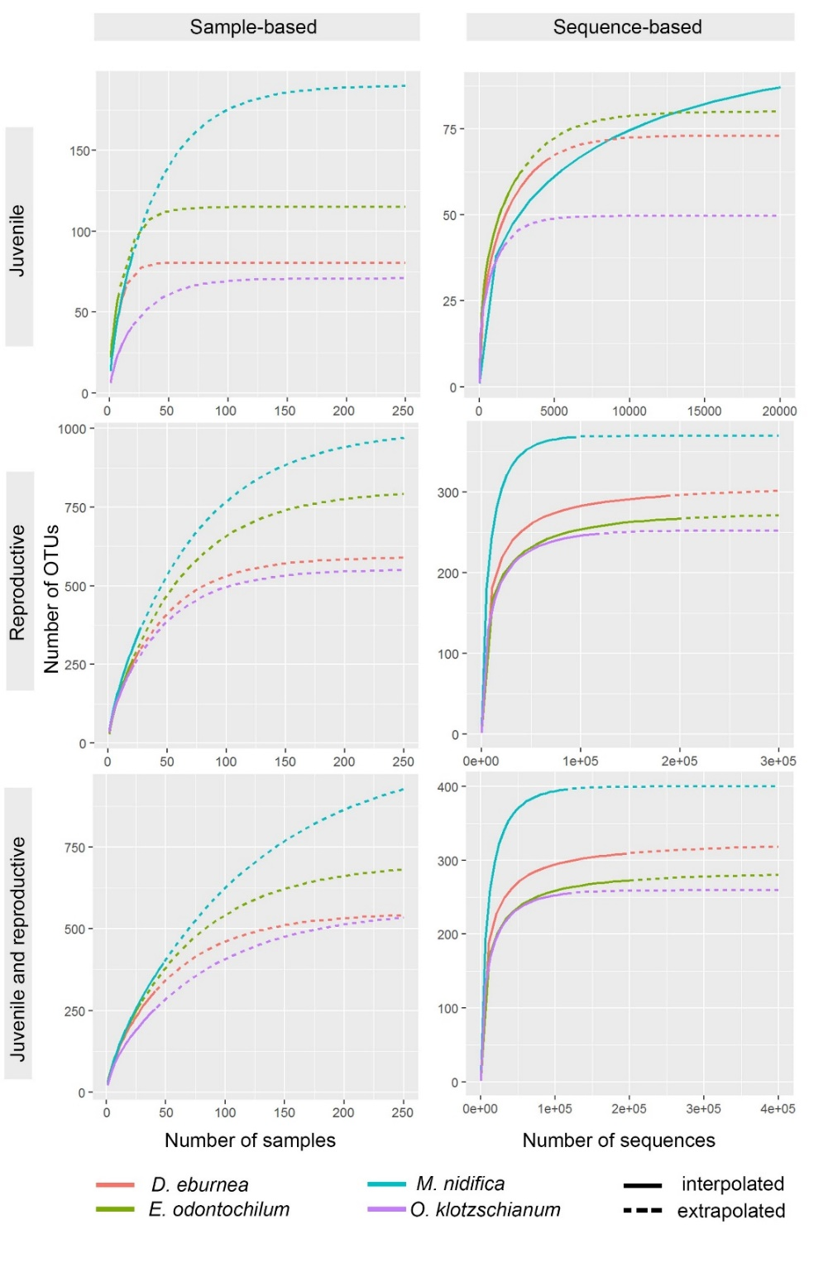

Supplemental Figure 1. Rarefaction and extrapolation curves of the fungal endophytes detected in roots of juvenile and reproductive plants of the co-occurring, epiphytic orchid species Dichaea eburnea, Epidendrum odontochilum, Masdevallia nidifica and Oncidium klotzschianum sampled within Tapantí National Park, Costa Rica across three years. Disjointed curves for juvenile, reproductive and combined life stages are provided, and are based on the number of Operational Taxonomic Units (OTUs; defined at a 97% sequence similarity threshold). For each of the four orchid taxa, sample-based (i.e., based on the number of sampled plant individuals) saturation curves are shown in the left panel, while sequence-based curves are shown in the right panel
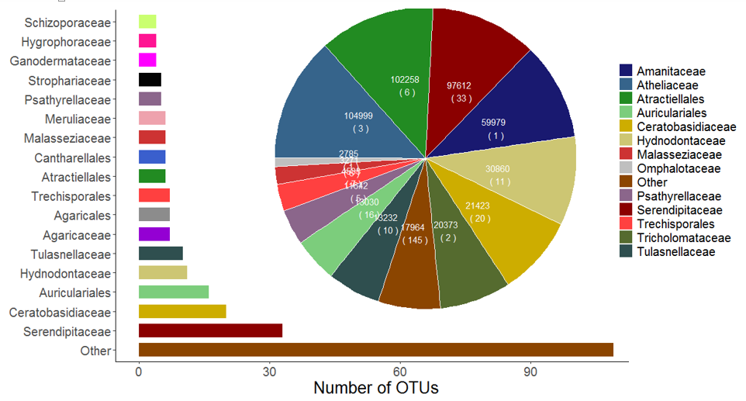
b
a
Supplemental Figure 2. Endophytic root fungal communities detected in the co-occurring, epiphytic orchid species Dichaea eburnea, Epidendrum odontochilum, Masdevallia nidifica and Oncidium klotzschianum. a) Number of operational taxonomic units (OTUs; defined at a 97% sequence similarity threshold) per fungal family or order, and b) sequence abundance per fungal family or order; numbers inside parenthesis represent the number of OTUs. The OTUs with <1000 sequences were grouped in the “Other” category.

Supplemental Table 4. Putative orchid mycorrhizal fungi identified in four co-occurring epiphytic orchid species. Columns summarize the number of plants per orchid species where an operational taxonomic unit (OTU; defined at a 97% sequence similarity threshold) was detected, the total number of sequences per OTU per orchid species, and the frequency of association. Frequency of association (“Assoc. (%)”) determined as the number of sequences of an OTU in an orchid species, divided by the total number of sequences across the four orchid species. Numbers in bold indicate the OTU where > 90% of its sequences associated with a specific orchid species. Rows highlighted in gray indicate OTUs shared by all orchid species.
 |  |  | D. eburnea |  |  |  | E. odontochilum |  |  |  | M. nidifica |  |  |  | O. klotzschianum
Closest UNITE match | OTU ID |  | Indivs. (X/41) | No. of seqs. | Assoc. (%) |  | Indivs. (X/28) | No. of seqs. | Assoc. (%) |  | Indivs. (X/48) | No. of seqs. | Assoc. (%) |  | Indivs. (X/41) | No. of seqs. | Assoc. (%)
Ascomycota
Nectriaceae | OTU308 |  | 2 | 30 | 91 |  | 0 | 0 | 0 |  | 1 | 3 | 9 |  | 0 | 0 | 0
Nectriaceae | OTU370 |  | 0 | 0 | 0 |  | 1 | 6 | 23 |  | 2 | 20 | 77 |  | 0 | 0 | 0
Nectriaceae | OTU396 |  | 5 | 12 | 60 |  | 1 | 6 | 30 |  | 1 | 1 | 5 |  | 1 | 1 | 5
Basidiomycota
Atractiellales | OTU6 |  | 26 | 37186 | 41 |  | 17 | 937 | 1 |  | 30 | 12490 | 14 |  | 37 | 40504 | 44
Atractiellales | OTU32 |  | 3 | 31 | <1 |  | 3 | 208 | 2 |  | 8 | 9891 | 94 |  | 7 | 338 | 3
Atractiellales | OTU313 |  | 0 | 0 | 0 |  | 0 | 0 | 0 |  | 2 | 2 | 5 |  | 1 | 38 | 95
Atractiellales | Otu721 |  | 1 | 1 | <1 |  | 1 | 9 | 2 |  | 3 | 387 | 93 |  | 5 | 20 | 5
Atractiellales | OTU859 |  | 0 | 0 | 0 |  | 0 | 0 | 0 |  | 1 | 21 | 100 |  | 0 | 0 | 0
Atractiellales | OTU864 |  | 0 | 0 | 0 |  | 0 | 0 | 0 |  | 1 | 192 | 98 |  | 1 | 3 | 2
Ceratobasidiaceae | OTU20 |  | 3 | 5 | <1 |  | 3 | 7 | 0 |  | 11 | 7971 | 99 |  | 6 | 44 | 1
Ceratobasidiaceae | OTU34 |  | 33 | 1503 | 31 |  | 20 | 1586 | 33 |  | 34 | 1148 | 24 |  | 21 | 569 | 12
Ceratobasidiaceae | OTU38 |  | 25 | 1084 | 40 |  | 18 | 648 | 24 |  | 29 | 730 | 27 |  | 16 | 238 | 9
Ceratobasidiaceae | OTU49 |  | 26 | 668 | 29 |  | 17 | 865 | 37 |  | 27 | 550 | 24 |  | 16 | 248 | 11
Ceratobasidiaceae | OTU59 |  | 2 | 19 | 2 |  | 5 | 753 | 92 |  | 2 | 36 | 4 |  | 1 | 8 | 1
Ceratobasidiaceae | OTU64 |  | 11 | 557 | 54 |  | 10 | 213 | 21 |  | 16 | 198 | 19 |  | 8 | 71 | 7
Ceratobasidiaceae | OTU120 |  | 3 | 53 | 34 |  | 5 | 15 | 10 |  | 7 | 44 | 28 |  | 8 | 43 | 28
Ceratobasidiaceae | OTU126 |  | 2 | 80 | 13 |  | 1 | 9 | 1 |  | 0 | 0 | 0 |  | 6 | 527 | 86
Ceratobasidiaceae | OTU147 |  | 2 | 36 | 15 |  | 4 | 176 | 71 |  | 6 | 30 | 12 |  | 3 | 6 | 2
Ceratobasidiaceae | OTU190 |  | 0 | 0 | 0 |  | 1 | 54 | 100 |  | 0 | 0 | 0 |  | 0 | 0 | 0
Ceratobasidiaceae | OTU226 |  | 0 | 0 | 0 |  | 1 | 57 | 64 |  | 3 | 32 | 36 |  | 0 | 0 | 0
Ceratobasidiaceae | OTU245 |  | 1 | 60 | 100 |  | 0 | 0 | 0 |  | 0 | 0 | 0 |  | 0 | 0 | 0
Ceratobasidiaceae | OTU259 |  | 0 | 0 | 0 |  | 1 | 33 | 100 |  | 0 | 0 | 0 |  | 0 | 0 | 0
Ceratobasidiaceae | OTU296 |  | 3 | 20 | 22 |  | 2 | 8 | 9 |  | 3 | 33 | 37 |  | 2 | 28 | 31
Ceratobasidiaceae | OTU309 |  | 1 | 19 | 95 |  | 0 | 0 | 0 |  | 1 | 1 | 5 |  | 0 | 0 | 0
Ceratobasidiaceae | OTU354 |  | 0 | 0 | 0 |  | 1 | 3 | 9 |  | 0 | 0 | 0 |  | 1 | 31 | 91
Ceratobasidiaceae | OTU368 |  | 0 | 0 | 0 |  | 1 | 7 | 21 |  | 3 | 26 | 79 |  | 0 | 0 | 0
Ceratobasidiaceae | OTU567 |  | 0 | 0 | 0 |  | 0 | 0 | 0 |  | 1 | 9 | 100 |  | 0 | 0 | 0
Ceratobasidiaceae | OTU722 |  | 0 | 0 | 0 |  | 0 | 0 | 0 |  | 1 | 8 | 100 |  | 0 | 0 | 0
Ceratobasidiaceae | OTU746 |  | 4 | 90 | 35 |  | 7 | 133 | 52 |  | 5 | 18 | 7 |  | 2 | 15 | 6
Clavulinaceae | OTU125 |  | 3 | 121 | 41 |  | 2 | 157 | 54 |  | 0 | 0 | 0 |  | 2 | 15 | 5
Cortinariaceae | OTU51 |  | 17 | 559 | 39 |  | 15 | 480 | 34 |  | 17 | 234 | 16 |  | 12 | 146 | 10
Inocybaceae | OTU103 |  | 5 | 34 | 15 |  | 3 | 37 | 17 |  | 4 | 117 | 52 |  | 5 | 35 | 16
Inocybaceae | OTU177 |  | 2 | 31 | 34 |  | 1 | 19 | 21 |  | 4 | 40 | 43 |  | 1 | 2 | 2
Mycenaceae | Otu504 |  | 0 | 0 | 0 |  | 0 | 0 | 0 |  | 1 | 9 | 100 |  | 0 | 0 | 0
Mycenaceae | Otu571 |  | 0 | 0 | 0 |  | 0 | 0 | 0 |  | 0 | 0 | 0 |  | 1 | 11 | 100
Psathyrellaceae | OTU19 |  | 31 | 4277 | 37 |  | 25 | 1873 | 16 |  | 41 | 2786 | 24 |  | 25 | 2556 | 22
Psathyrellaceae | OTU223 |  | 1 | 61 | 100 |  | 0 | 0 | 0 |  | 0 | 0 | 0 |  | 0 | 0 | 0
Psathyrellaceae | OTU276 |  | 1 | 30 | 70 |  | 0 | 0 | 0 |  | 2 | 13 | 30 |  | 0 | 0 | 0
Psathyrellaceae | OTU336 |  | 0 | 0 | 0 |  | 1 | 11 | 38 |  | 2 | 18 | 62 |  | 0 | 0 | 0
Psathyrellaceae | OTU594 |  | 1 | 10 | 59 |  | 0 | 0 | 0 |  | 0 | 0 | 0 |  | 2 | 7 | 41
Russulaceae | OTU68 |  | 18 | 526 | 34 |  | 10 | 675 | 43 |  | 21 | 284 | 18 |  | 12 | 83 | 5
Serendipitaceae | OTU8 |  | 5 | 6 | <1 |  | 7 | 30553 | 100 |  | 4 | 11 | <1 |  | 2 | 2 | <1
Serendipitaceae | OTU11 |  | 5 | 7 | <1 |  | 4 | 23080 | 99 |  | 1 | 2 | <1 |  | 6 | 130 | 1
Serendipitaceae | OTU21 |  | 1 | 1 | <1 |  | 3 | 7874 | 98 |  | 3 | 119 | 1 |  | 1 | 1 | <1
Serendipitaceae | OTU23 |  | 3 | 5639 | 79 |  | 0 | 0 | 0 |  | 5 | 1482 | 21 |  | 2 | 18 | <1
Serendipitaceae | OTU25 |  | 4 | 5020 | 89 |  | 1 | 285 | 5 |  | 1 | 1 | <1 |  | 14 | 366 | 6
Serendipitaceae | OTU30 |  | 2 | 2 | <1 |  | 3 | 3 | 0 |  | 5 | 22 | <1 |  | 10 | 4487 | 99
Serendipitaceae | OTU31 |  | 2 | 6 | <1 |  | 16 | 14514 | 99 |  | 3 | 104 | 1 |  | 4 | 12 | 0
Serendipitaceae | OTU82 |  | 1 | 374 | 100 |  | 0 | 0 | 0 |  | 0 | 0 | 0 |  | 0 | 0 | 0
Serendipitaceae | OTU87 |  | 5 | 171 | 20 |  | 1 | 326 | 39 |  | 2 | 113 | 13 |  | 2 | 230 | 27
Serendipitaceae | OTU88 |  | 0 | 0 | 0 |  | 0 | 0 | 0 |  | 2 | 370 | 97 |  | 1 | 10 | 3
Serendipitaceae | OTU91 |  | 1 | 465 | 100 |  | 0 | 0 | 0 |  | 0 | 0 | 0 |  | 0 | 0 | 0
Serendipitaceae | OTU129 |  | 2 | 123 | 100 |  | 0 | 0 | 0 |  | 0 | 0 | 0 |  | 0 | 0 | 0
Serendipitaceae | OTU130 |  | 1 | 138 | 100 |  | 0 | 0 | 0 |  | 0 | 0 | 0 |  | 0 | 0 | 0
Serendipitaceae | OTU131 |  | 0 | 0 | 0 |  | 1 | 124 | 100 |  | 0 | 0 | 0 |  | 0 | 0 | 0
Serendipitaceae | OTU132 |  | 0 | 0 | 0 |  | 1 | 120 | 100 |  | 0 | 0 | 0 |  | 0 | 0 | 0
Serendipitaceae | OTU148 |  | 1 | 18 | 9 |  | 0 | 0 | 0 |  | 0 | 0 | 0 |  | 1 | 190 | 91
Serendipitaceae | OTU165 |  | 1 | 141 | 67 |  | 2 | 67 | 32 |  | 0 | 0 | 0 |  | 1 | 1 | <1
Serendipitaceae | OTU174 |  | 0 | 0 | 0 |  | 1 | 92 | 100 |  | 0 | 0 | 0 |  | 0 | 0 | 0
Serendipitaceae | OTU180 |  | 4 | 80 | 49 |  | 0 | 0 | 0 |  | 1 | 1 | 1 |  | 1 | 81 | 50
Serendipitaceae | OTU189 |  | 1 | 66 | 100 |  | 0 | 0 | 0 |  | 0 | 0 | 0 |  | 0 | 0 | 0
Serendipitaceae | OTU275 |  | 1 | 42 | 76 |  | 0 | 0 | 0 |  | 0 | 0 | 0 |  | 1 | 13 | 24
Serendipitaceae | OTU294 |  | 0 | 0 | 0 |  | 1 | 47 | 100 |  | 0 | 0 | 0 |  | 0 | 0 | 0
Serendipitaceae | OTU315 |  | 0 | 0 | 0 |  | 0 | 0 | 0 |  | 1 | 42 | 100 |  | 0 | 0 | 0
Serendipitaceae | OTU327 |  | 0 | 0 | 0 |  | 0 | 0 | 0 |  | 1 | 5 | 16 |  | 1 | 27 | 84
Serendipitaceae | OTU343 |  | 1 | 18 | 100 |  | 0 | 0 | 0 |  | 0 | 0 | 0 |  | 0 | 0 | 0
Serendipitaceae | OTU349 |  | 0 | 0 | 0 |  | 0 | 0 | 0 |  | 1 | 19 | 100 |  | 0 | 0 | 0
Serendipitaceae | OTU380 |  | 3 | 33 | 100 |  | 0 | 0 | 0 |  | 0 | 0 | 0 |  | 0 | 0 | 0
Serendipitaceae | OTU387 |  | 0 | 0 | 0 |  | 0 | 0 | 0 |  | 1 | 12 | 100 |  | 0 | 0 | 0
Serendipitaceae | OTU477 |  | 2 | 16 | 100 |  | 0 | 0 | 0 |  | 0 | 0 | 0 |  | 0 | 0 | 0
Serendipitaceae | OTU517 |  | 1 | 1 | 1 |  | 0 | 0 | 0 |  | 0 | 0 | 0 |  | 1 | 140 | 99
Serendipitaceae | OTU725 |  | 0 | 0 | 0 |  | 0 | 0 | 0 |  | 0 | 0 | 0 |  | 1 | 6 | 100
Serendipitaceae | OTU764 |  | 3 | 33 | 100 |  | 0 | 0 | 0 |  | 0 | 0 | 0 |  | 0 | 0 | 0
Serendipitaceae | OTU879 |  | 1 | 2 | 2 |  | 0 | 0 | 0 |  | 2 | 4 | 4 |  | 1 | 104 | 95
Thelephoraceae | OTU65 |  | 11 | 202 | 17 |  | 11 | 606 | 51 |  | 19 | 221 | 19 |  | 11 | 158 | 13
Thelephoraceae | OTU109 |  | 2 | 45 | 21 |  | 2 | 136 | 64 |  | 4 | 26 | 12 |  | 2 | 7 | 3
Tricholomataceae | OTU14 |  | 37 | 7453 | 37 |  | 23 | 3633 | 18 |  | 42 | 4861 | 24 |  | 21 | 4408 | 22
Tricholomataceae | OTU353 |  | 0 | 0 | 0 |  | 0 | 0 | 0 |  | 0 | 0 | 0 |  | 1 | 18 | 100
Tulasnellaceae | OTU48 |  | 35 | 4148 | 35 |  | 23 | 4057 | 34 |  | 40 | 2551 | 22 |  | 22 | 1093 | 9
Tulasnellaceae | OTU98 |  | 7 | 99 | 18 |  | 10 | 336 | 62 |  | 11 | 75 | 14 |  | 6 | 36 | 7
Tulasnellaceae | OTU110 |  | 0 | 0 | 0 |  | 0 | 0 | 0 |  | 1 | 192 | 100 |  | 0 | 0 | 0
Tulasnellaceae | OTU300 |  | 26 | 145 | 29 |  | 8 | 135 | 27 |  | 22 | 121 | 24 |  | 19 | 103 | 20
Tulasnellaceae | OTU656 |  | 2 | 4 | 8 |  | 3 | 4 | 8 |  | 1 | 1 | 2 |  | 6 | 39 | 81
Tulasnellaceae | OTU668 |  | 6 | 14 | 100 |  | 0 | 0 | 0 |  | 0 | 0 | 0 |  | 0 | 0 | 0
Tulasnellaceae | OTU745 |  | 0 | 0 | 0 |  | 0 | 0 | 0 |  | 0 | 0 | 0 |  | 3 | 17 | 100
Tulasnellaceae | OTU748 |  | 2 | 5 | 36 |  | 1 | 6 | 43 |  | 0 | 0 | 0 |  | 3 | 3 | 21
Tulasnellaceae | OTU779 |  | 15 | 42 | 100 |  | 0 | 0 | 0 |  | 0 | 0 | 0 |  | 0 | 0 | 0
Tulasnellaceae | OTU900 |  | 0 | 0 | 0 |  | 0 | 0 | 0 |  | 0 | 0 | 0 |  | 1 | 6 | 100
No. of dominant OTUs per species |  |  |  | 15 |  |  |  | 11 |  |  |  | 13 |  |  |  | 11

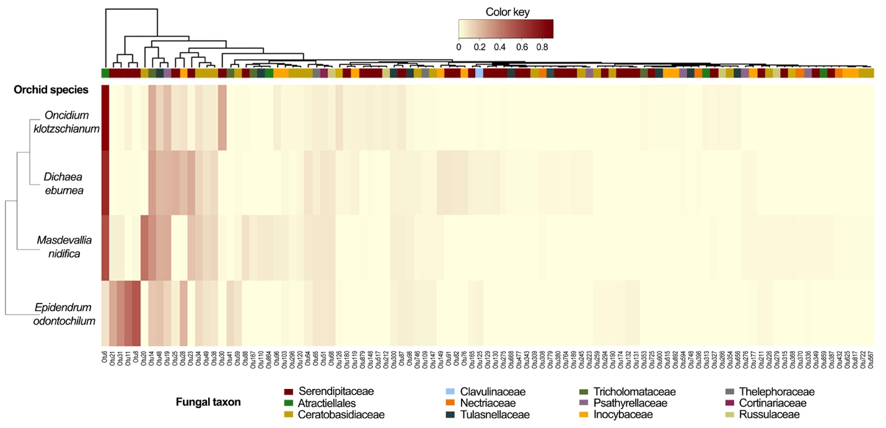
Supplemental Figure 3. Two-way hierarchical cluster and heat map of the four co-occurring, epiphytic orchids Dichaea eburnea, Epidendrum odontochilum, Masdevallia nidifica and Oncidium klotzschianum sampled across three years. Horizontal dendrogram is based on 99 putative orchid mycorrhizal fungal (OMF) Operational Taxonomic Units (OTUs) representing 12 fungal families and 2 fungal orders. Pairwise distances were obtained using the Hellinger-transformed Bray-Curtis dissimilarity index to generate a dendrogram based on OTU abundance dissimilarities among four orchid species

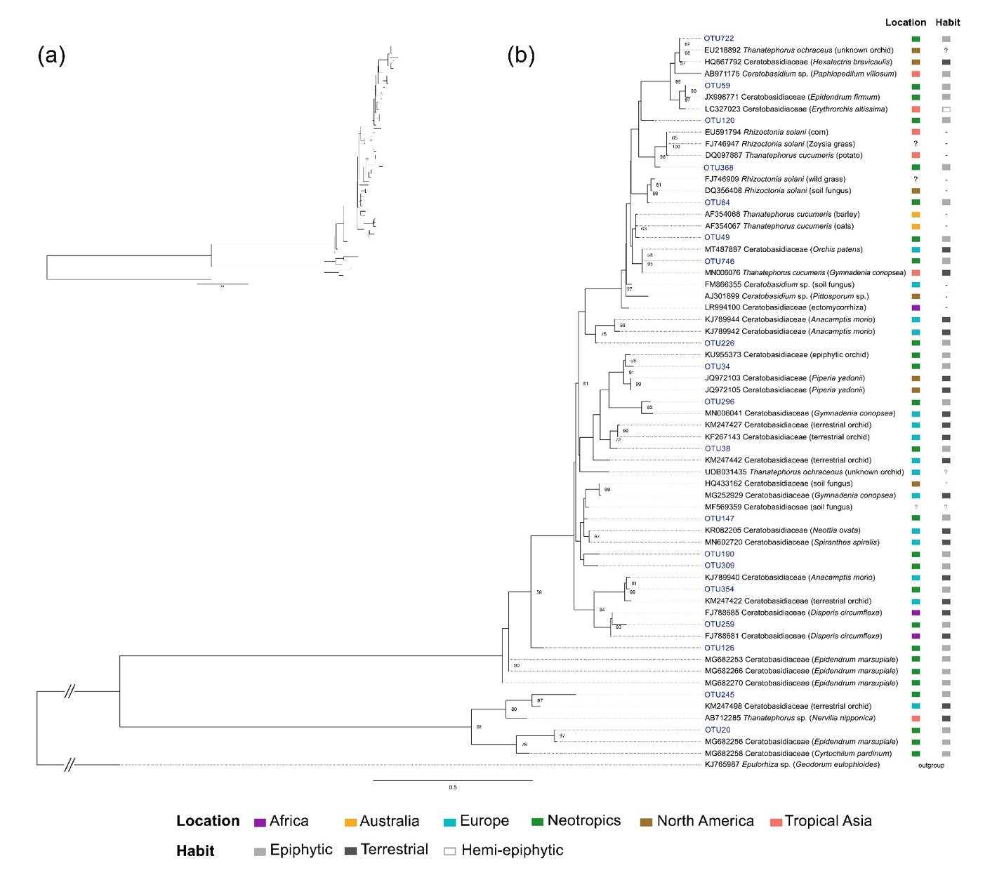
Supplemental Figure 4. Maximum likelihood tree of Ceratobasidiaceae. Phylogram based on orchid mycorrhizal fungal (OMF) Operational Taxonomic Units (OTUs; in blue font) identified from nuclear ribosomal internal transcribed spacer (nrITS) sequences obtained from epiphytic orchids Dichaea eburnea, Epidendrum odontochilum, Masdevallia nidifica and Oncidium klotzschianum along with reference sequences of tropical or temperate, terrestrial or epiphytic orchids, and other plant families. (a) Original topology; (b) modified topology with basal branches shortened as indicated by the double slash. Bootstrap values ≥ 50% are indicated next to each branch. Phylogeny for the Ceratobasidiaceae was rooted with a sequence of Epulorhiza obtained from isolates of root tissue of the orchid Geodorum eulophioides. Color-coded bars on the right indicate the location and the type of habit of the orchid species from which the fungal sequence was obtained.

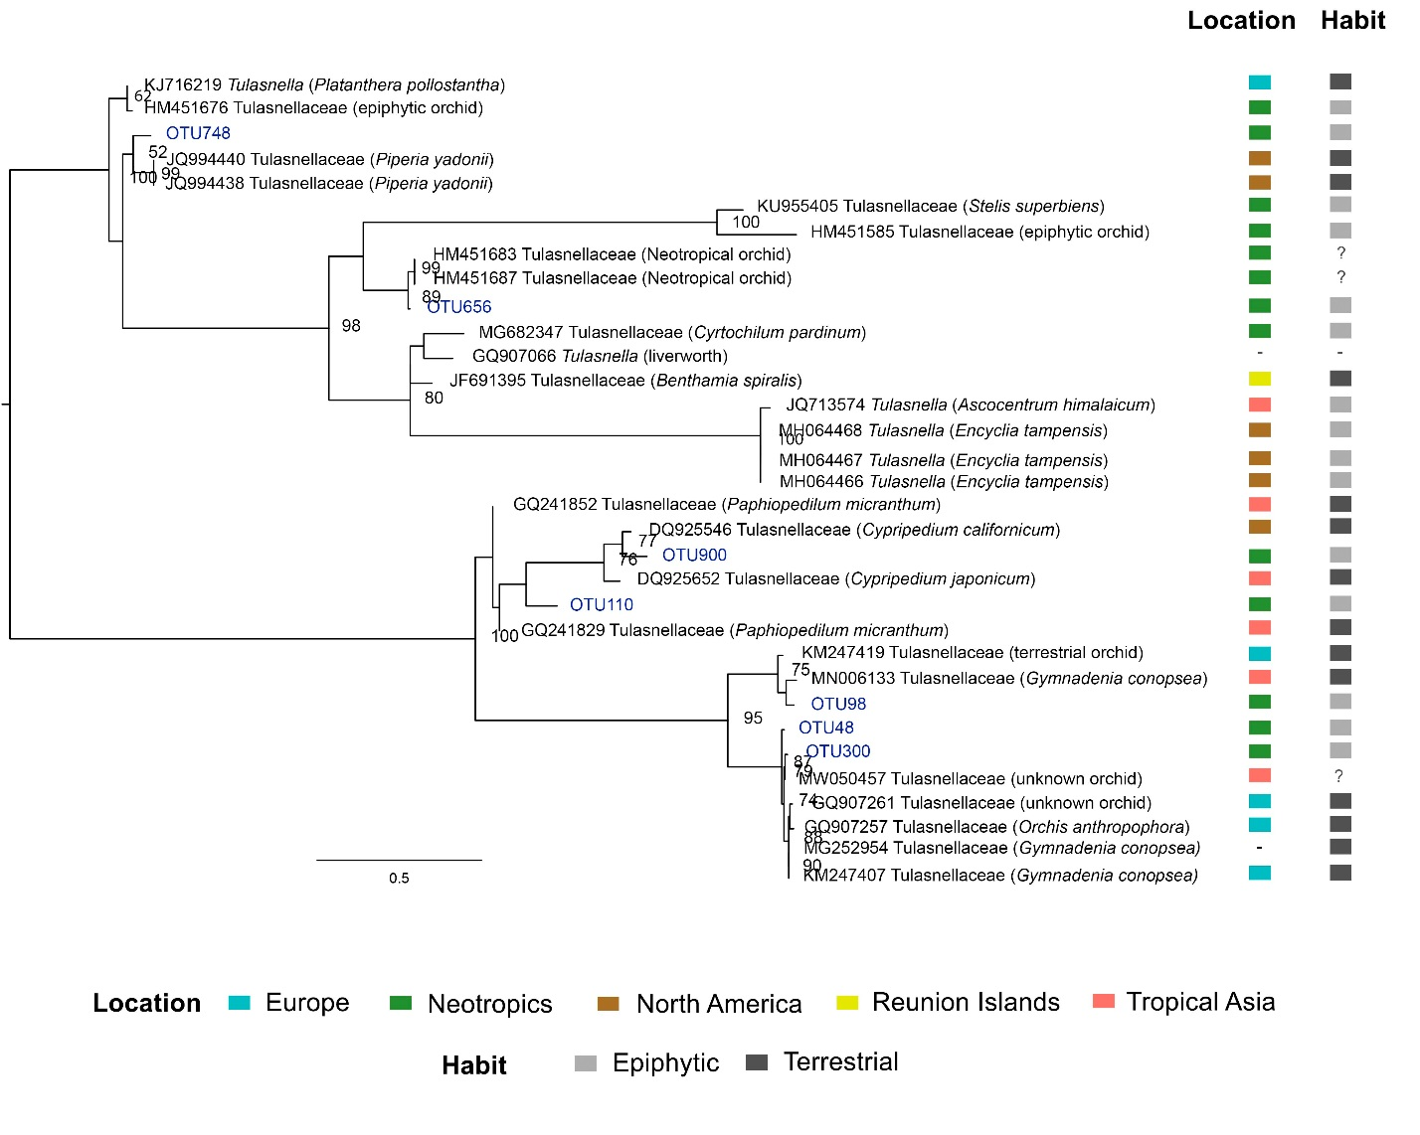Supplemental Figure 5. Maximum likelihood tree of Tulasnellaceae. Phylogram based on orchid mycorrhizal fungal (OMF) Operational taxonomic units (OTUs) identified from nuclear ribosomal internal transcribed spacer (nrITS) sequences obtained from orchid root tissue of Dichaea eburnea, Epidendrum odontochilum, Masdevallia nidifica and Oncidium klotzschianum individual plants, along with reference sequences of tropical or temperate, epiphytic or terrestrial orchid species, and a liverworth. Bootstrap values ≥50% are indicated next to each branch. Phylogeny was mid-pointed due to the lack of recognized ancestors.

