Supplementary Material for
[Predicting Future Extreme Precipitations by Using Polynomial Regression]
[Fatih DIKBASª]
[ªPamukkale University, Civil Engineering Department, Denizli - Turkey,]

Contents of this file

Figures S1-S13
MATLAB code of the software PolReg

Figure S1. Scatterplots of observed (x axis) and estimated (y axis) extreme precipitations. The observed values are the highest observed value for each month for a station and they were removed from the input data prior to the estimations for testing the estimation performance of the developed method.

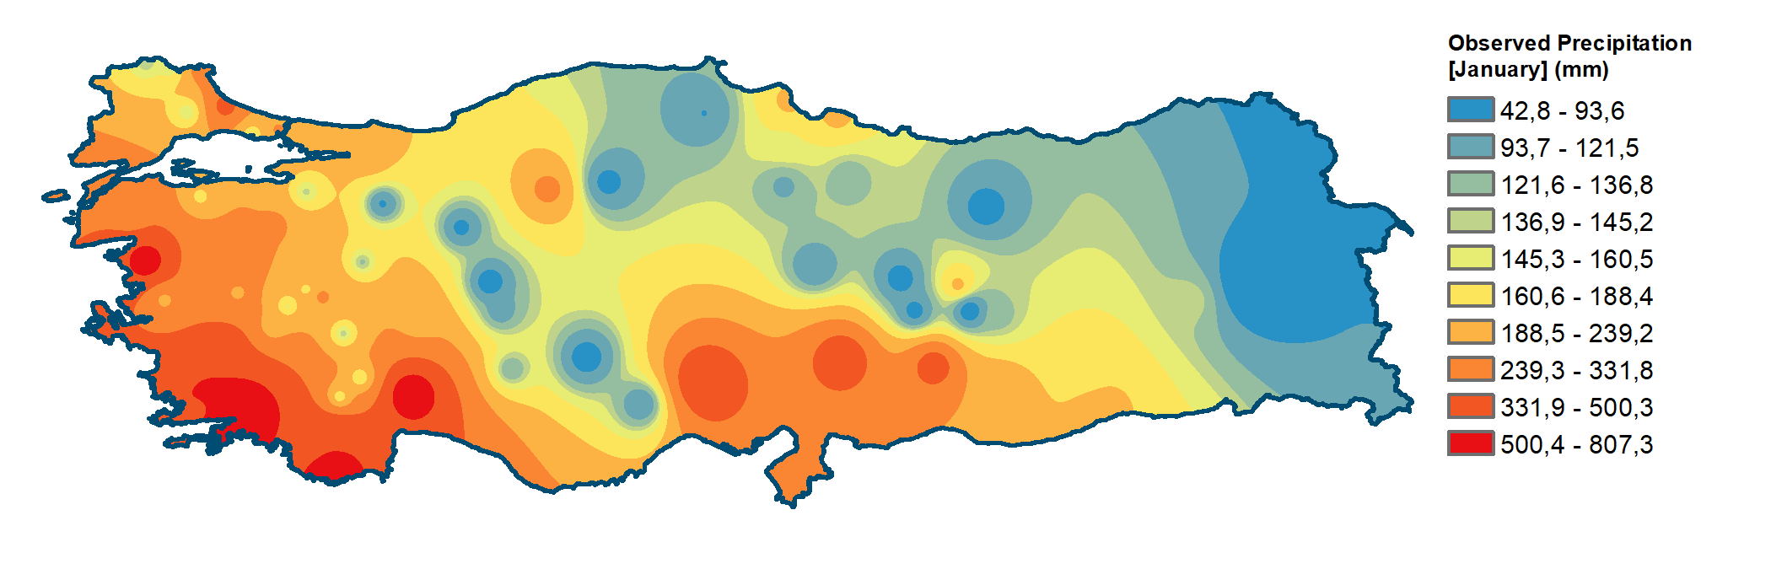

Figure S2: The Observed Precipitation, the Estimated Higher Precipitation and the Difference between the Observed and the Estimated Higher Precipitation in January

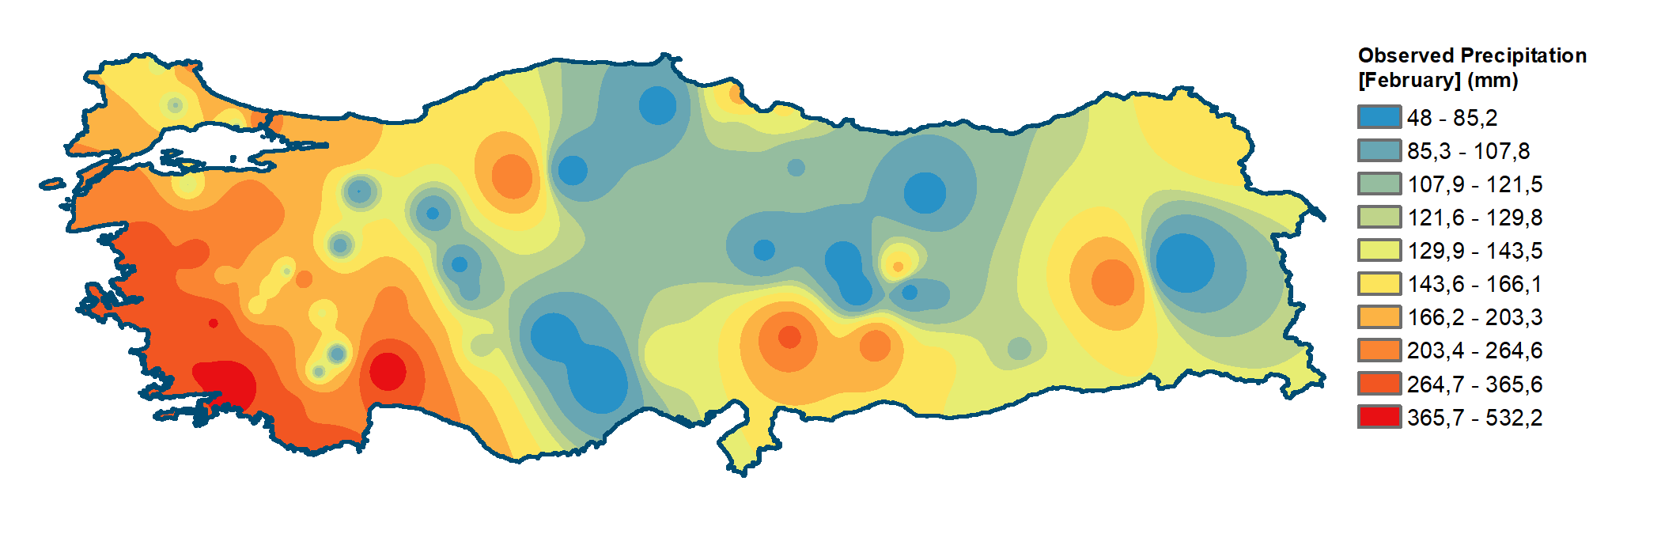

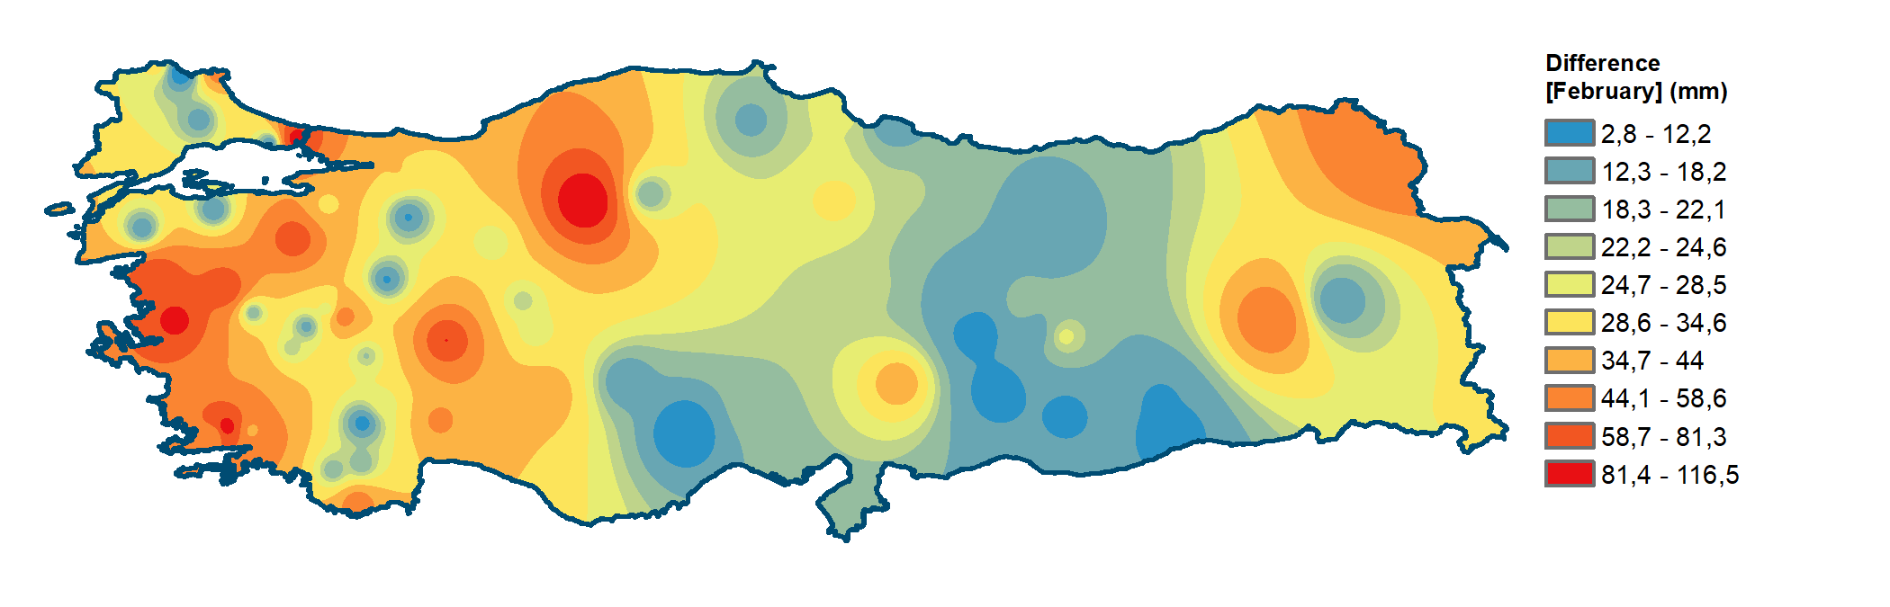
Figure S3: The Observed Precipitation, the Estimated Higher Precipitation and the Difference between the Observed and the Estimated Higher Precipitation in February

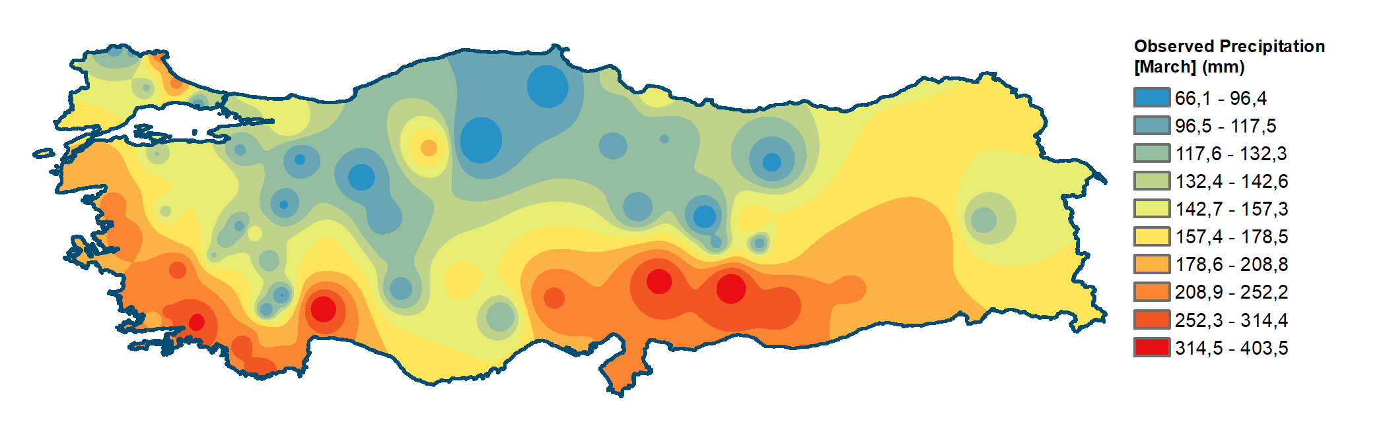

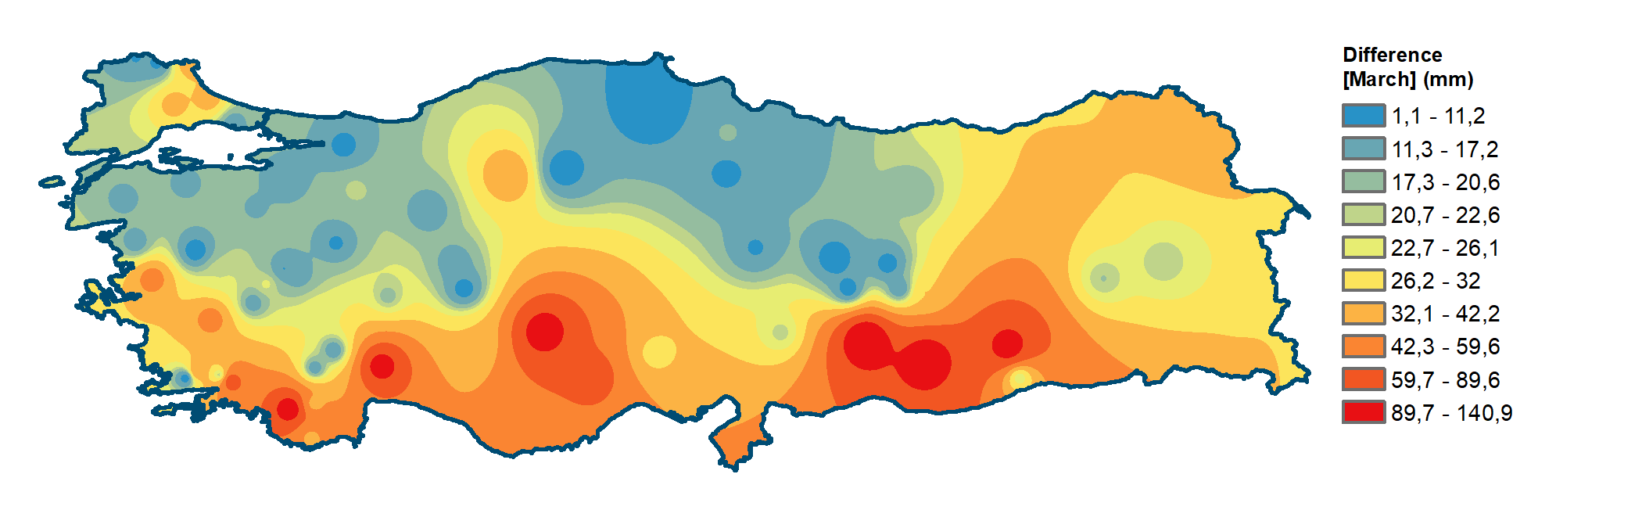
Figure S4: The Observed Precipitation, the Estimated Higher Precipitation and the Difference between the Observed and the Estimated Higher Precipitation in March

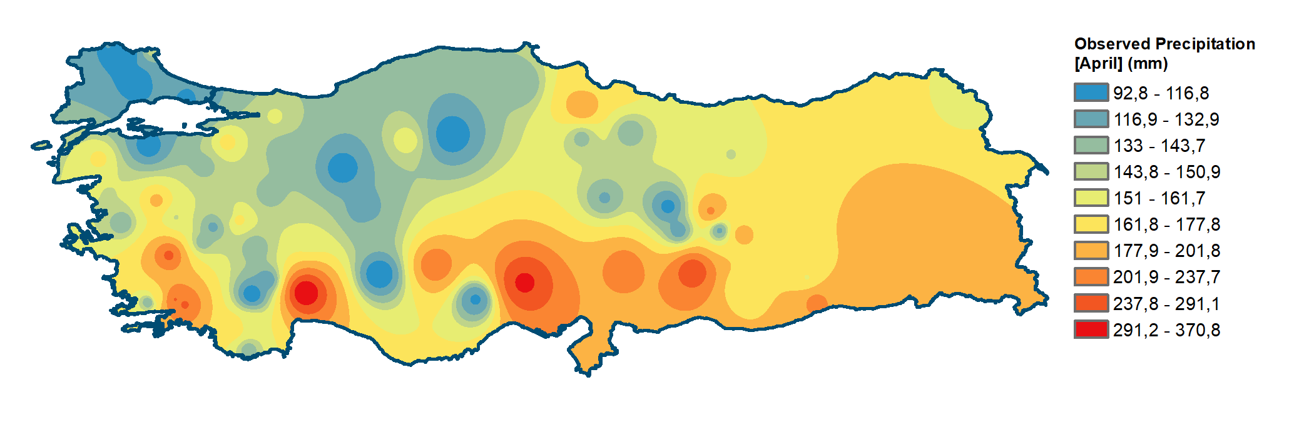

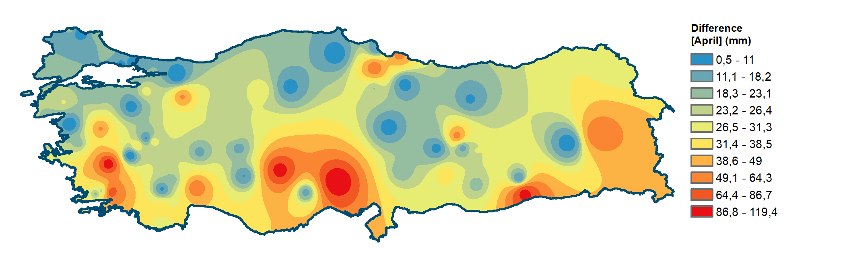
Figure S5: The Observed Precipitation, the Estimated Higher Precipitation and the Difference between the Observed and the Estimated Higher Precipitation in April

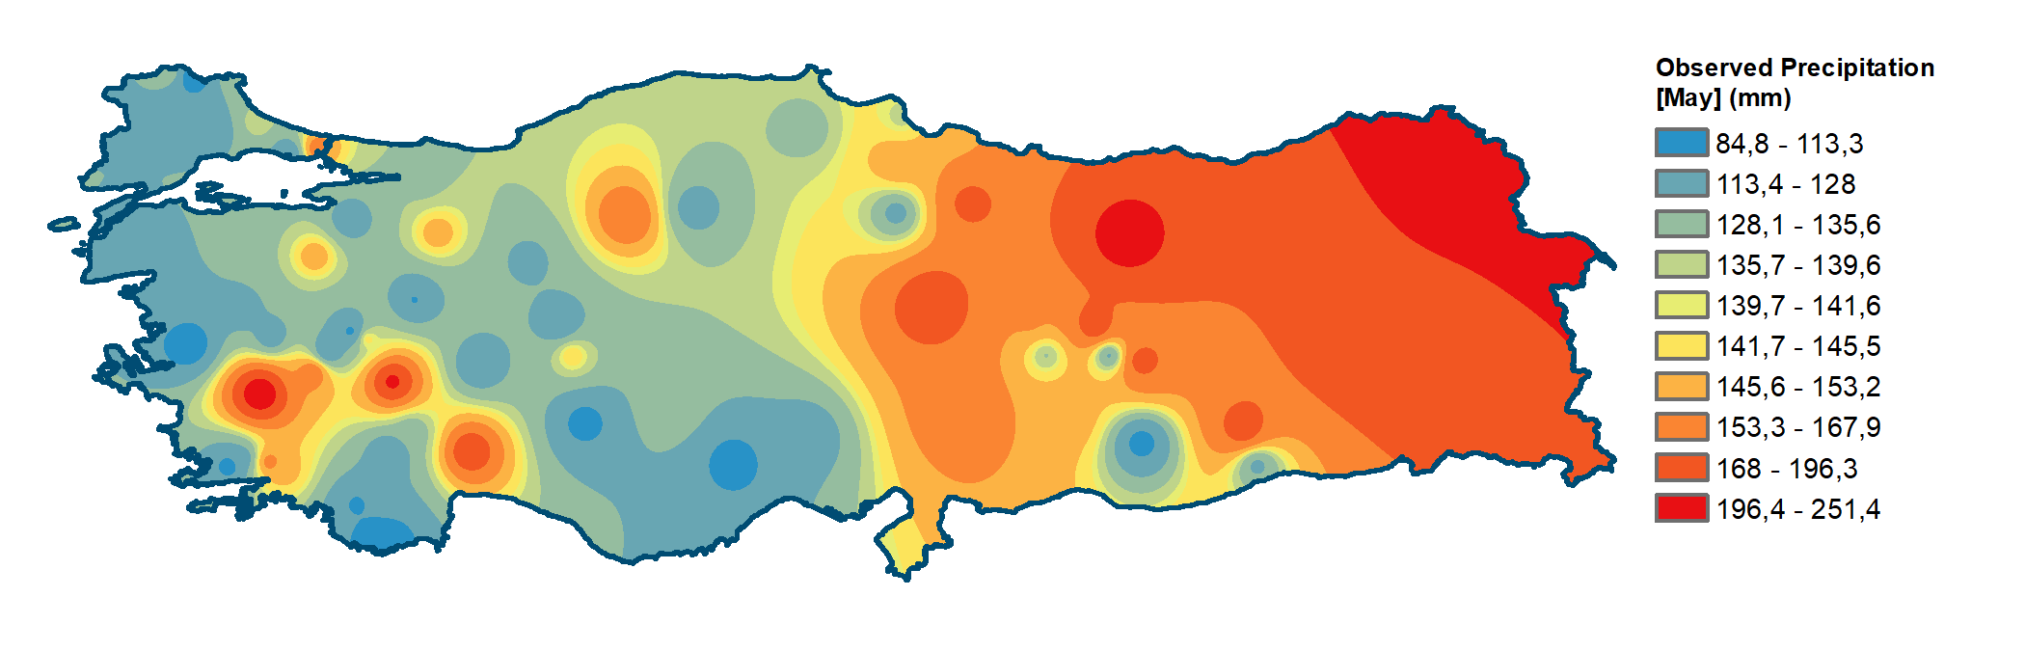

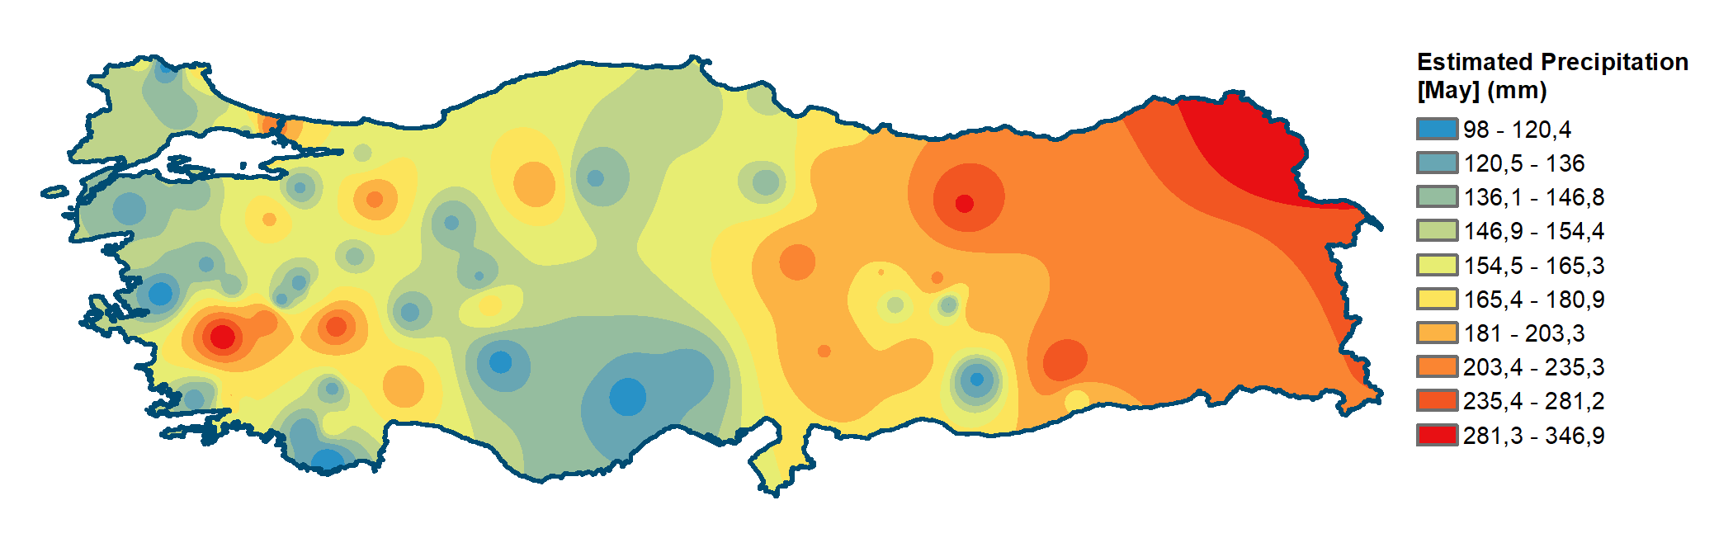

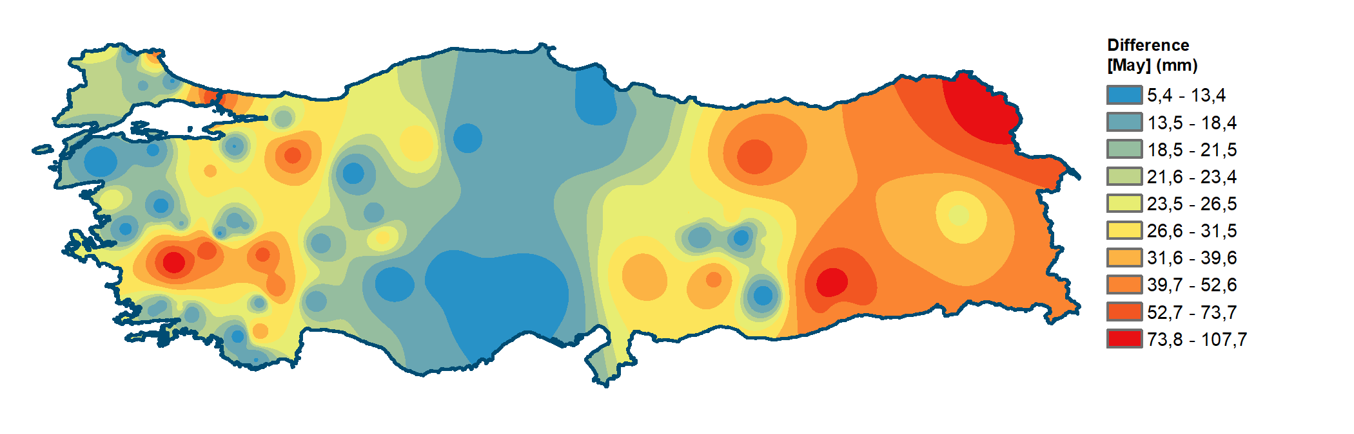
Figure S6: The Observed Precipitation, the Estimated Higher Precipitation and the Difference between the Observed and the Estimated Higher Precipitation in May

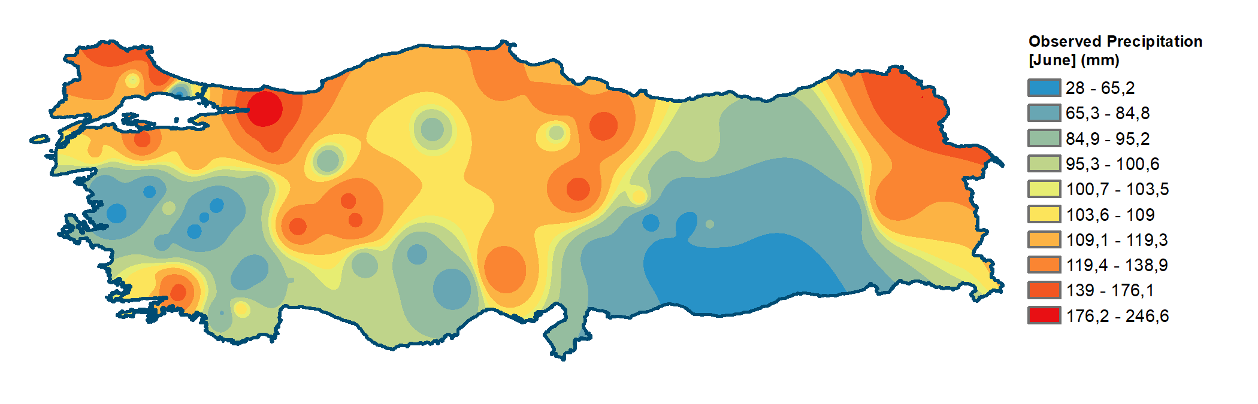

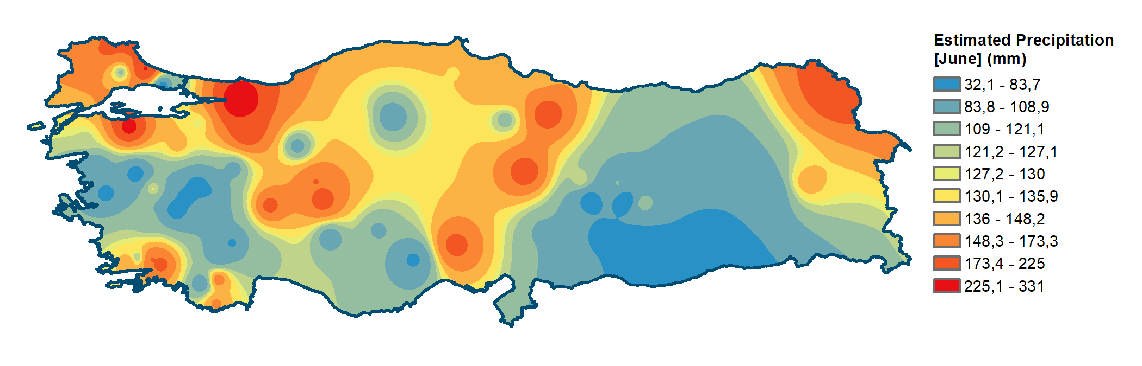

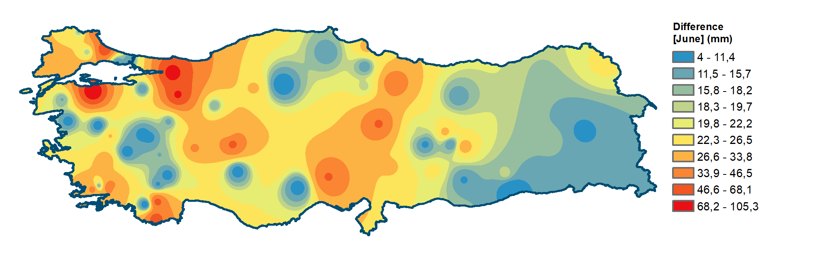
Figure S7: The Observed Precipitation, the Estimated Higher Precipitation and the Difference between the Observed and the Estimated Higher Precipitation in June

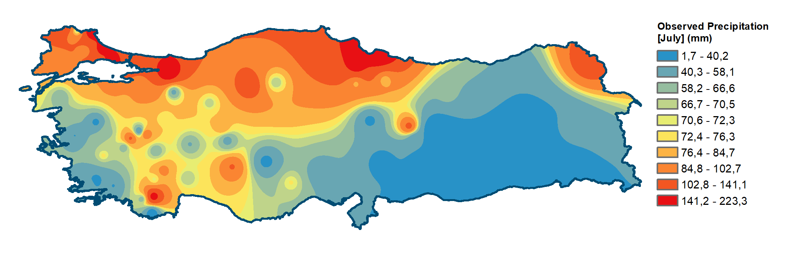

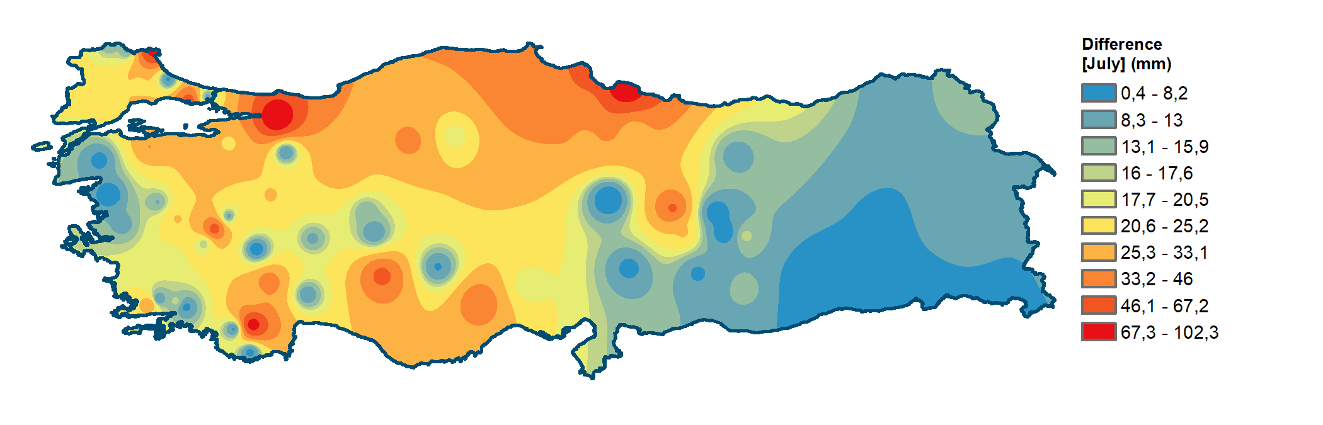
Figure S8: The Observed Precipitation, the Estimated Higher Precipitation and the Difference between the Observed and the Estimated Higher Precipitation in July

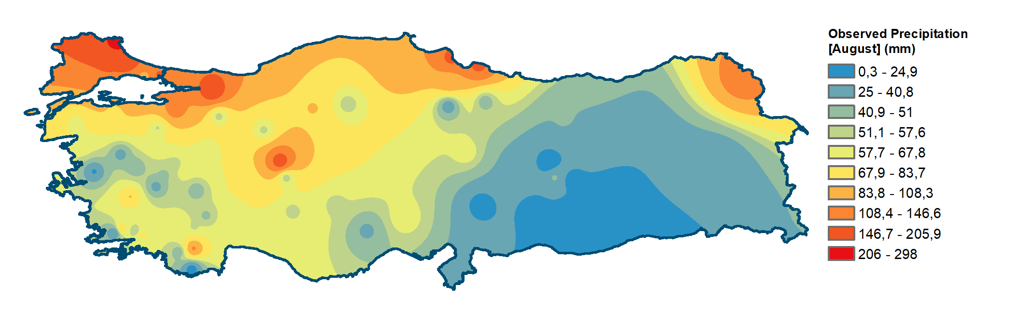

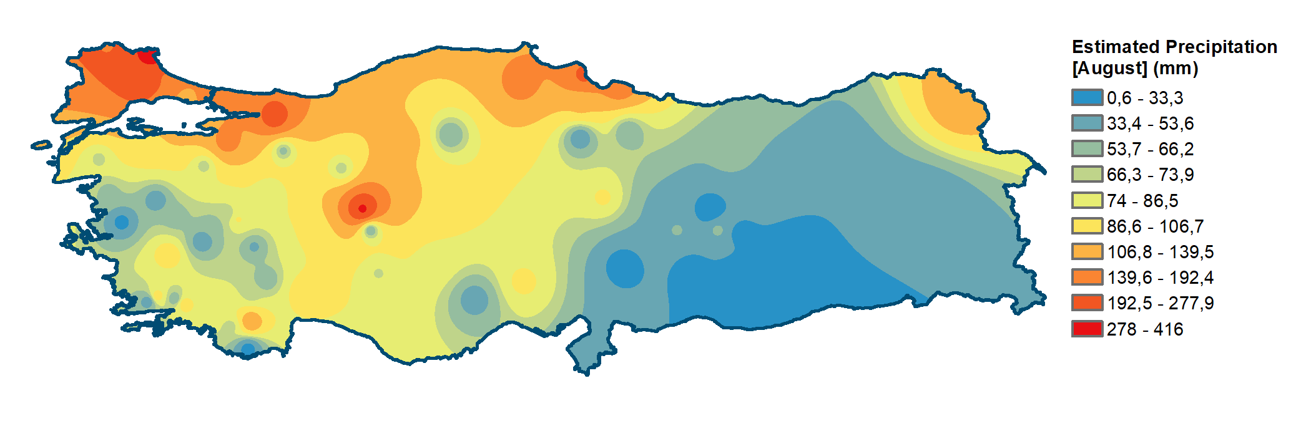

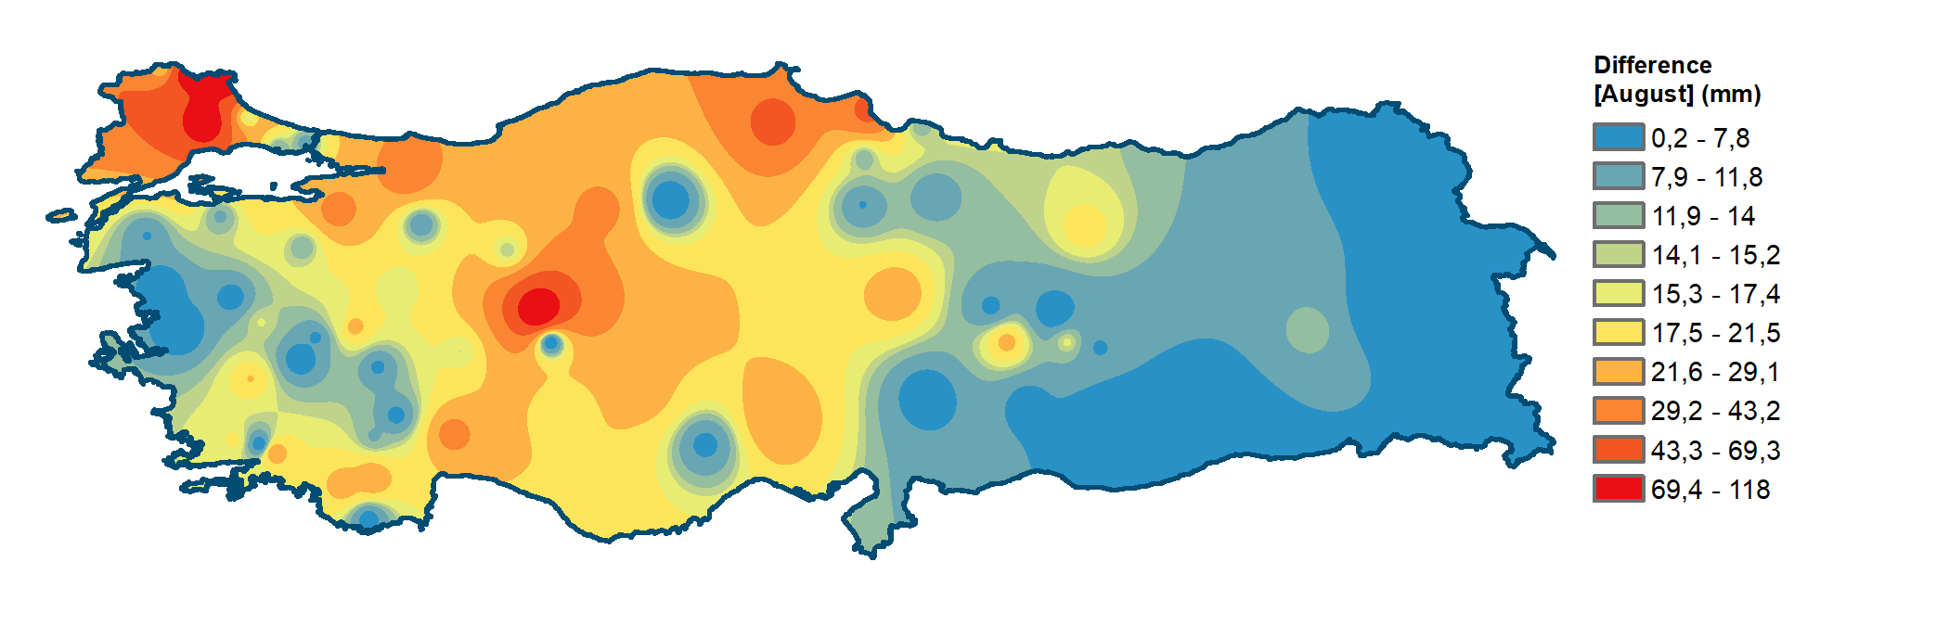
Figure S9: The Observed Precipitation, the Estimated Higher Precipitation and the Difference between the Observed and the Estimated Higher Precipitation in August

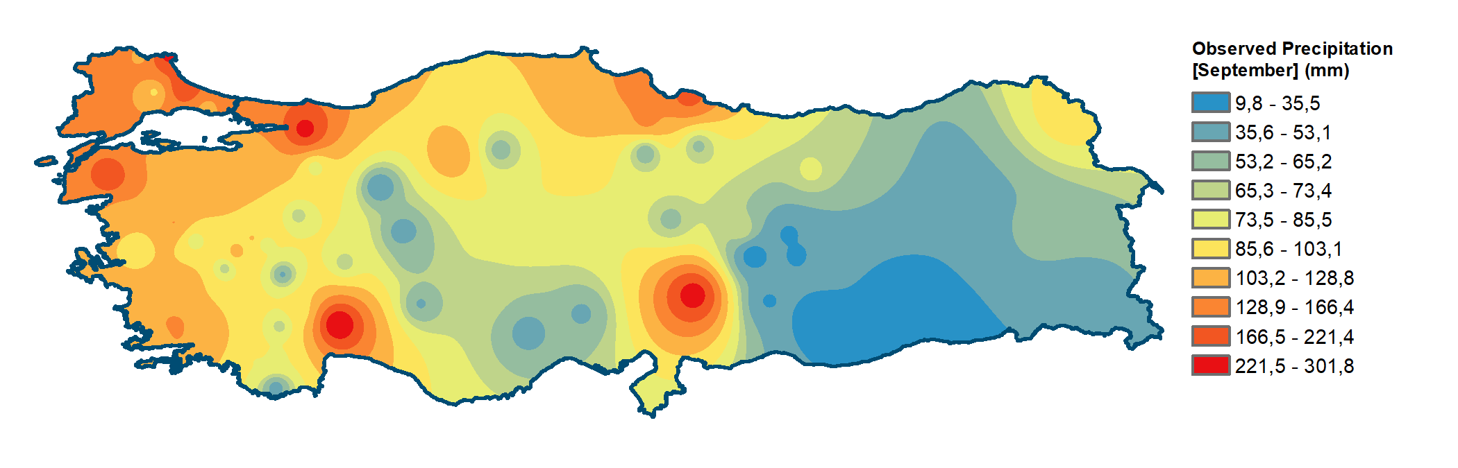

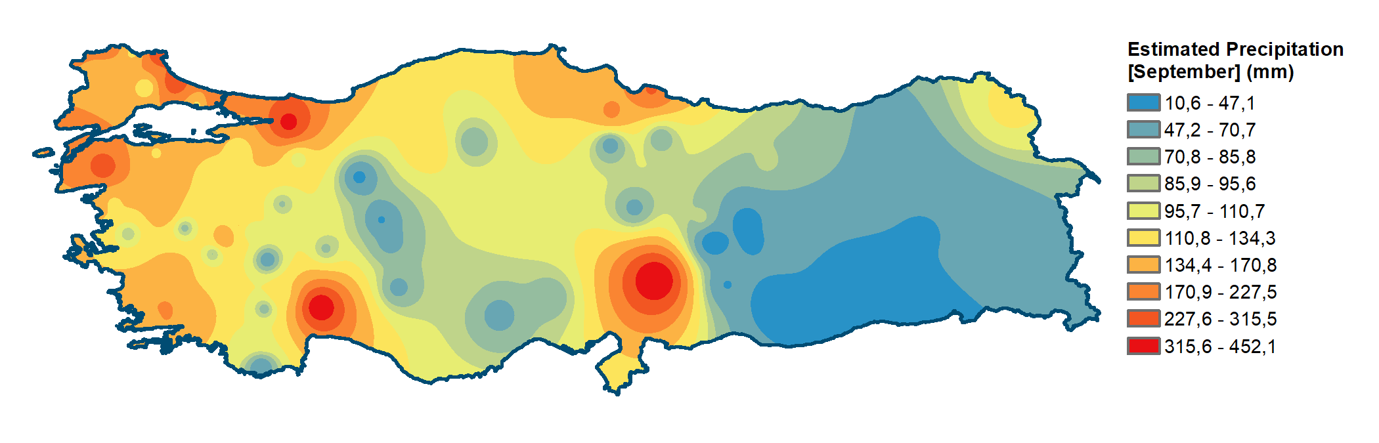

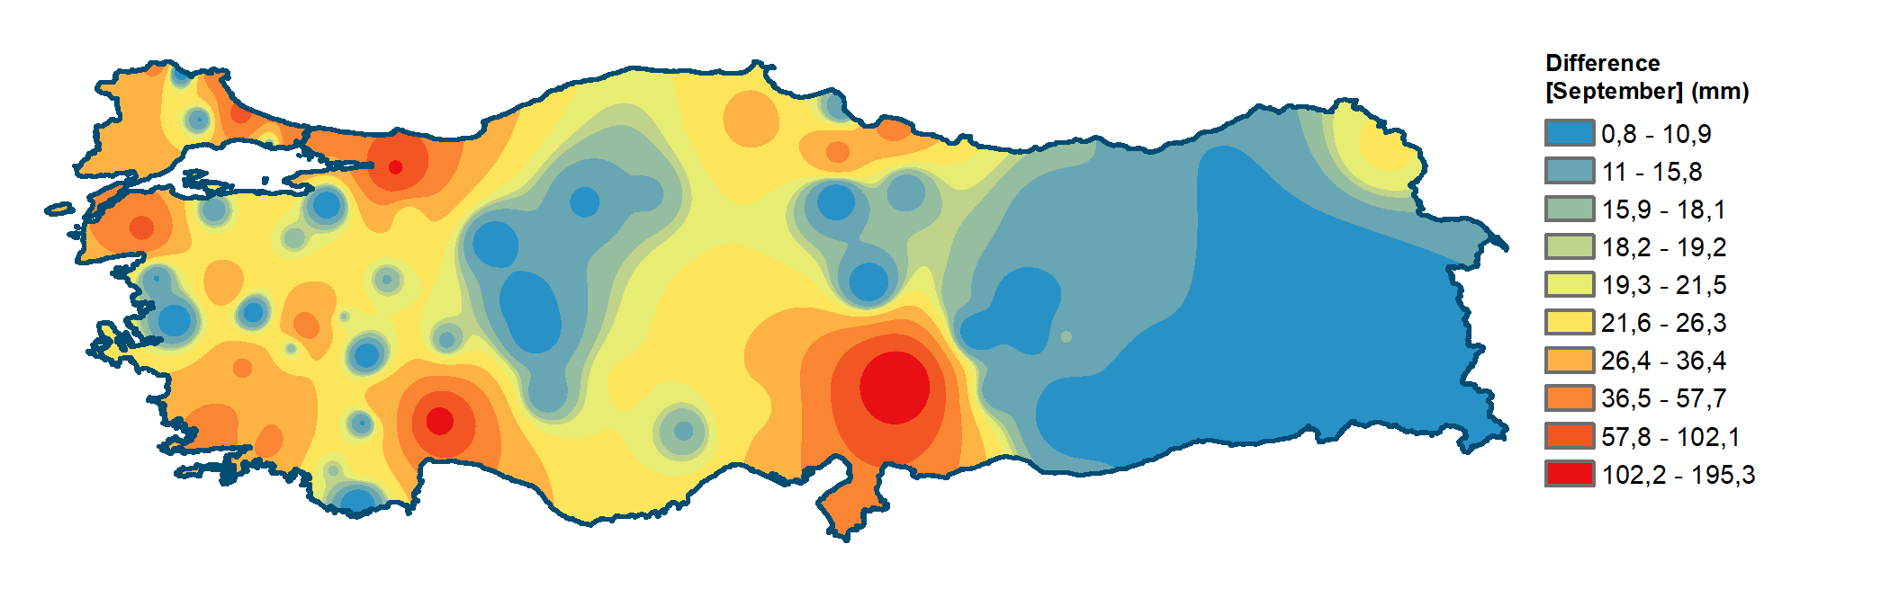

Figure S10: The Observed Precipitation, the Estimated Higher Precipitation and the Difference between the Observed and the Estimated Higher Precipitation in September

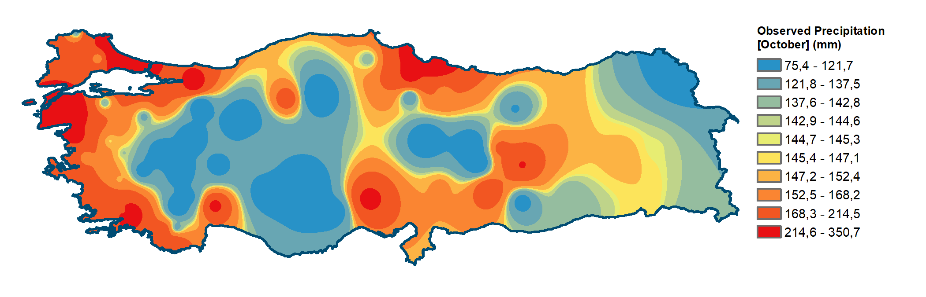

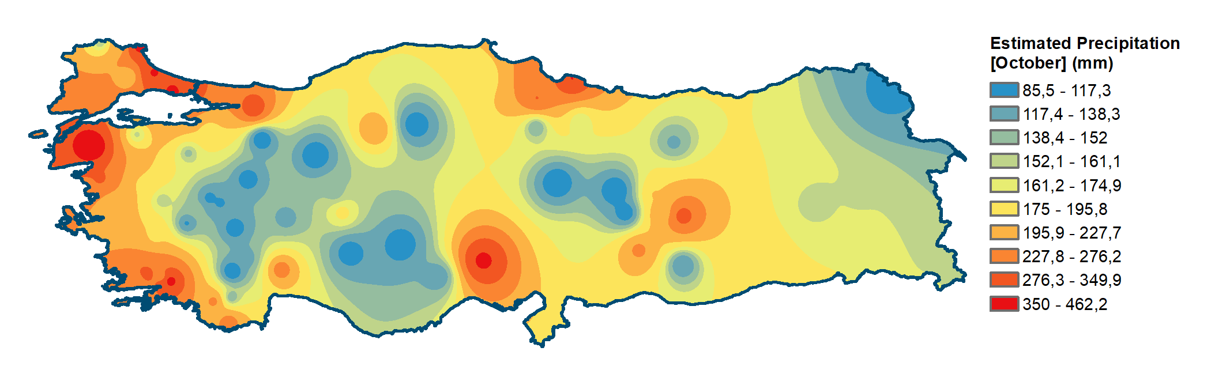

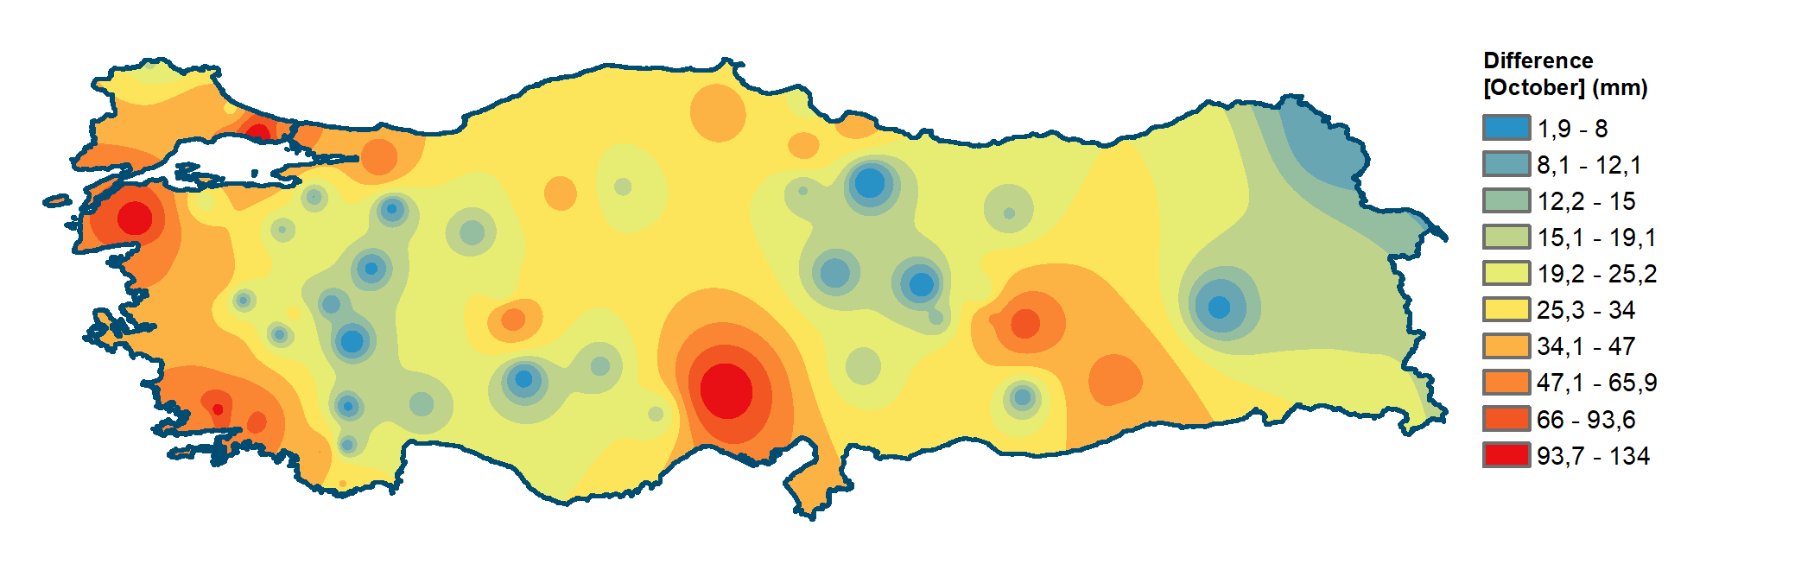
Figure S11: The Observed Precipitation, the Estimated Higher Precipitation and the Difference between the Observed and the Estimated Higher Precipitation in October

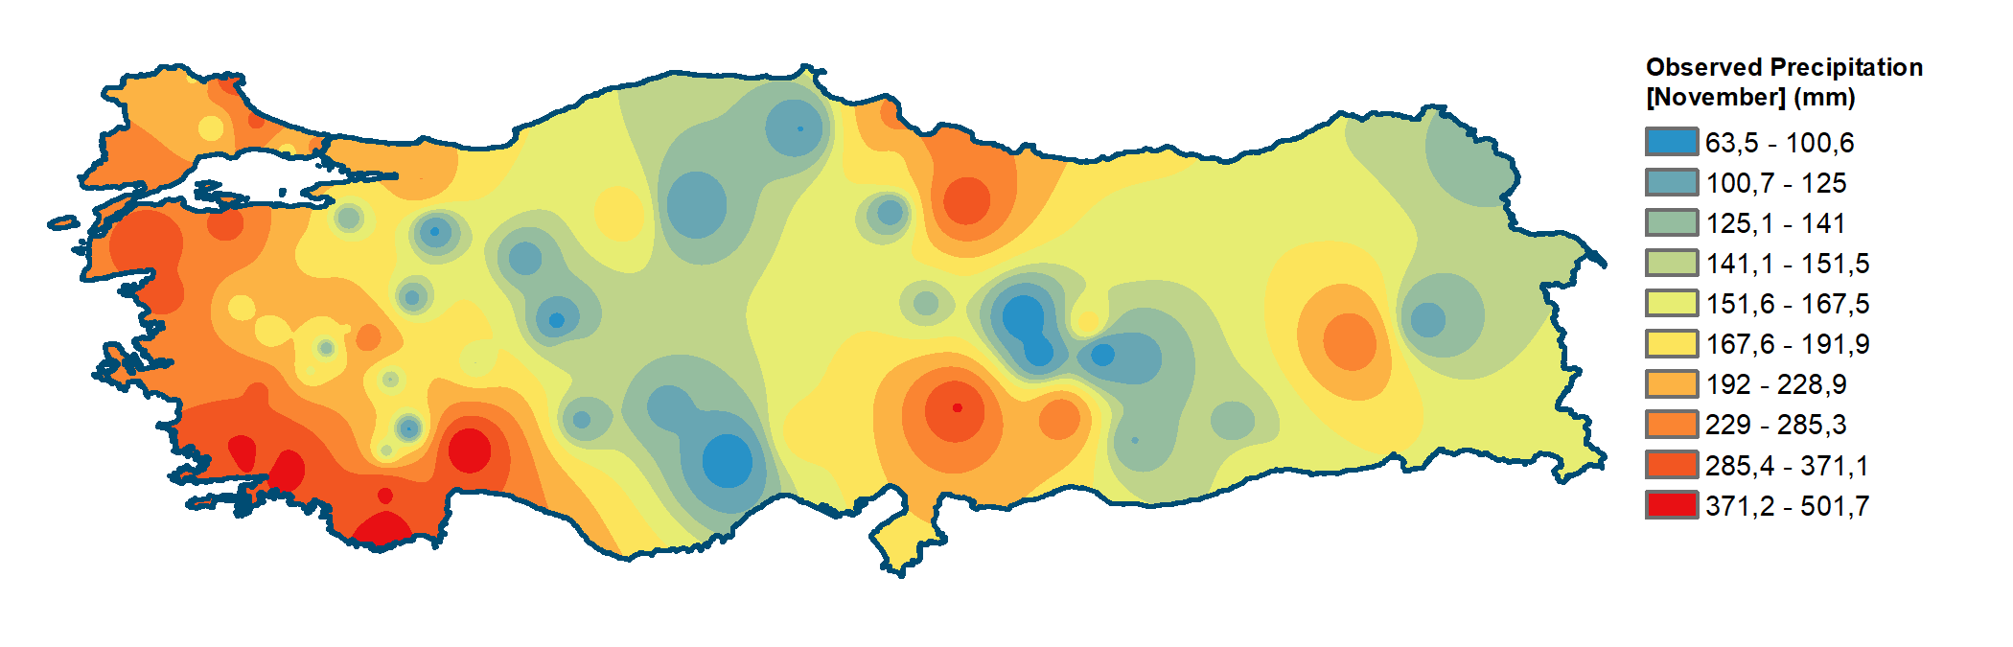

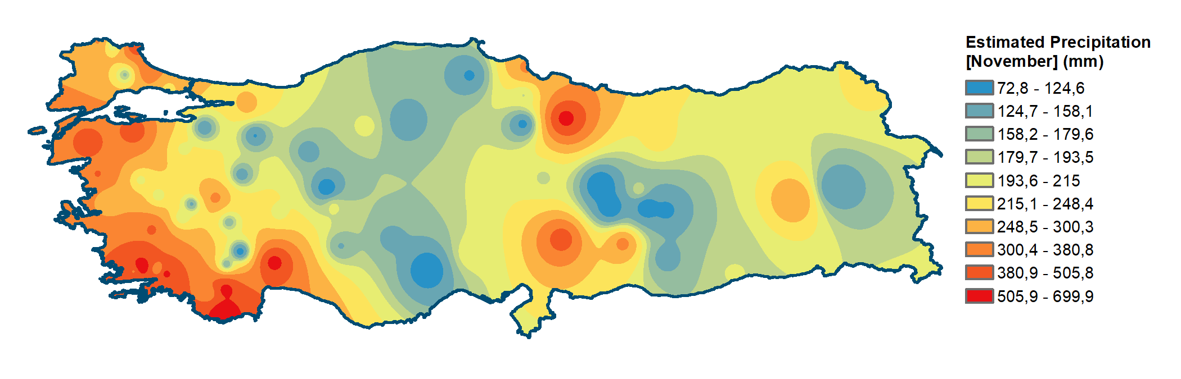

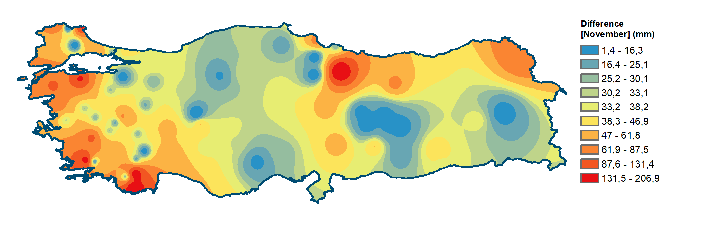
Figure S12: The Observed Precipitation, the Estimated Higher Precipitation and the Difference between the Observed and the Estimated Higher Precipitation in November

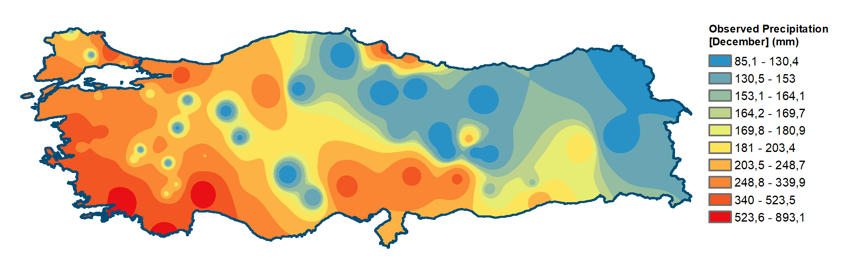

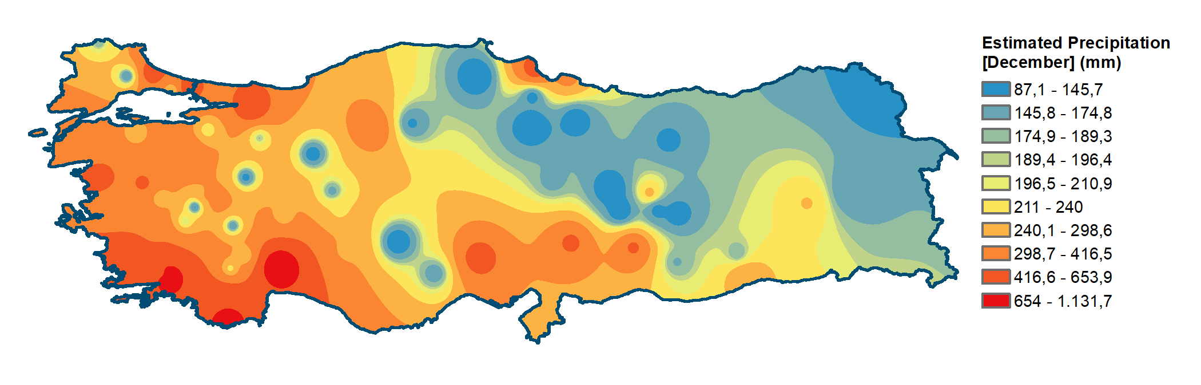

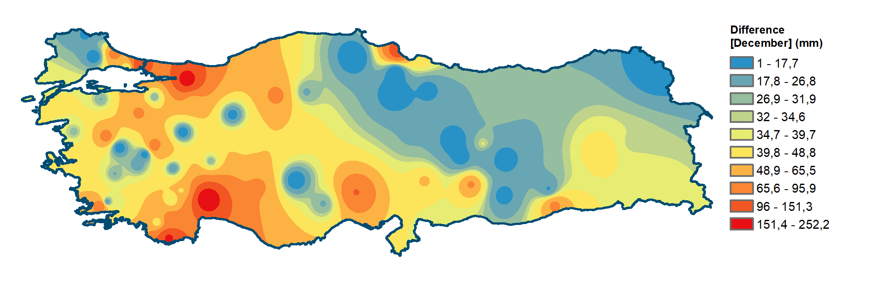
Figure S13: The Observed Precipitation, the Estimated Higher Precipitation and the Difference between the Observed and the Estimated Higher Precipitation in December

MATLAB code of the software PolReg:
% PolReg: Polynomial Regression
% Copyright (c) 2017-2022 Fatih DIKBAS
%
% e-mail:f_dikbas@pau.edu.tr
% Address:
% Pamukkale Universitesi, Insaat Muhendisligi Bolumu,
% Kinikli Kampusu, Denizli, Turkey
%
% This program Is free software: you can redistribute it And/Or modify
% it under the terms Of the GNU General Public License As published by
% the Free Software Foundation, either version 3 Of the License, Or
% (at your option) any later version.
%
% This program Is distributed In the hope that it will be useful,
% but WITHOUT ANY WARRANTY; without even the implied warranty Of
% MERCHANTABILITY Or FITNESS FOR A PARTICULAR PURPOSE.
% See the GNU General Public License For more details.
%
% To receive a copy Of the GNU General Public License see: <http://www.gnu.org/licenses/>.
%
num=zeros;
X=zeros;
Y=zeros;
SortedY=zeros;
SurfaceX=zeros;
SurfaceY=zeros;
SurfaceZ=zeros;
HighestObservationX = 0;
HighestObservationY = 0;
StationNumber ='26-005';
num=xlsread('C:\MatlabCode\2DPolReg\26-005.Input.Data.xlsx');
[m,n] = size(num);
X=1:n;
X2=1:n-1;
Y=num(2:m,1:n);
Months={'JANUARY', 'FEBRUARY', 'MARCH', 'APRIL', 'MAY', 'JUNE', 'JULY', 'AUGUST', 'SEPTEMBER', 'OCTOBER', 'NOVEMBER', 'DECEMBER'};
ShortMonths={'JAN', 'FEB', 'MAR', 'APR', 'MAY', 'JUN', 'JUL', 'AUG', 'SEP', 'OCT', 'NOV', 'DEC'};
OutputVariables={'Max','EstMax','EstNextMax','PredIntU(n)','PredIntL(n)','PredIntU(n+1)','PredIntL(n+1)'};
OutputVariables2={'Max','EstMax','EstNextMax','PredIntU(n-1)','PredIntL(n-1)','PredIntU(n)','PredIntL(n)'};
GoodnessOfFitMeasures = {'MSE', 'NMSE', 'RMSE', 'NRMSE', 'MAE', 'MBE', 'r', 'd', 'E', 'MaxAE', 'MASE'};

%Sort rows of Y
SortedY=sort(Y,2);

OutputFile='C:\MatlabCode\2DPolReg\26-005.BestFittingPolynomials.xlsx';
sheet=1;

xlswrite(OutputFile,num,'Heatmaps','B1');
xlswrite(OutputFile,ShortMonths','Heatmaps','A2');
xlswrite(OutputFile,X,'Heatmaps','B15');
xlswrite(OutputFile,SortedY,'Heatmaps','B16');
xlswrite(OutputFile,ShortMonths','Heatmaps','A16');

Node=0;
for i=1:m-1
for j=1:n
Node=Node+1;
SurfaceX(Node)=j;
SurfaceY(Node)=i;
SurfaceZ(Node)=SortedY(i,j);
end
end

HighestObservationX=max(SurfaceX);
HighestObservationY=max(SurfaceZ);

%XLimit = HighestObservationX*1.2;
XLimit = HighestObservationX+5;

if HighestObservationY < 100
YLimit = ceil(HighestObservationY/10)*10 ;
end

if HighestObservationY >= 100 && HighestObservationY < 1000
YLimit = ceil(HighestObservationY/100)*100;
end

if HighestObservationY >= 1000
YLimit = ceil(HighestObservationY/1000)*1000 ;
end

for i=1:m-1
% Calculations for the whole series in rows
[fitpoly2]=fit(X',SortedY(i,1:n)','poly2','Normalize','off','Robust','off');
[fitpoly3]=fit(X',SortedY(i,1:n)','poly3','Normalize','off','Robust','off');
[fitpoly4]=fit(X',SortedY(i,1:n)','poly4','Normalize','off','Robust','off');
[fitpoly5]=fit(X',SortedY(i,1:n)','poly5','Normalize','off','Robust','off');
[fitpoly6]=fit(X',SortedY(i,1:n)','poly6','Normalize','off','Robust','off');
[fitpoly7]=fit(X',SortedY(i,1:n)','poly7','Normalize','off','Robust','off');
[fitpoly8]=fit(X',SortedY(i,1:n)','poly8','Normalize','off','Robust','off');

[gf2] = gfit2(SortedY(i,1:n)',fitpoly2(1:n));
[gf3] = gfit2(SortedY(i,1:n)',fitpoly3(1:n));
[gf4] = gfit2(SortedY(i,1:n)',fitpoly4(1:n));
[gf5] = gfit2(SortedY(i,1:n)',fitpoly5(1:n));
[gf6] = gfit2(SortedY(i,1:n)',fitpoly6(1:n));
[gf7] = gfit2(SortedY(i,1:n)',fitpoly7(1:n));
[gf8] = gfit2(SortedY(i,1:n)',fitpoly8(1:n));

[gf2last5] = gfit2(SortedY(i,n-4:n)',fitpoly2(n-4:n));
[gf3last5] = gfit2(SortedY(i,n-4:n)',fitpoly3(n-4:n));
[gf4last5] = gfit2(SortedY(i,n-4:n)',fitpoly4(n-4:n));
[gf5last5] = gfit2(SortedY(i,n-4:n)',fitpoly5(n-4:n));
[gf6last5] = gfit2(SortedY(i,n-4:n)',fitpoly6(n-4:n));
[gf7last5] = gfit2(SortedY(i,n-4:n)',fitpoly7(n-4:n));
[gf8last5] = gfit2(SortedY(i,n-4:n)',fitpoly8(n-4:n));

FirstRow=(i-1)*43+1;
SecondRow=num2str(FirstRow+1);
ThirdRow=num2str(FirstRow+2);
TwelfthRow=num2str(FirstRow+11);
ThirteenthRow=num2str(FirstRow+12);
FourteenthRow=num2str(FirstRow+13);
FifteenthRow=num2str(FirstRow+14);
SixteenthRow=num2str(FirstRow+15);
SeventeenthRow=num2str(FirstRow+16);
EighteenthRow=num2str(FirstRow+17);
NineteenthRow=num2str(FirstRow+18);
TwentiethRow=num2str(FirstRow+19);
ThirtyFirstRow=num2str(FirstRow+30);
ThirtySecondRow=num2str(FirstRow+31);
TopRightCell=['A',num2str(FirstRow)];
xlswrite(OutputFile,Months(i),sheet,TopRightCell)
xlswrite(OutputFile,{'RESULTS FOR THE WHOLE SERIES'},sheet,'B1')

xlswrite(OutputFile,{'Pol.Deg.:'},sheet,['A',SecondRow])
xlswrite(OutputFile,[2:8],sheet,['B',SecondRow])
xlswrite(OutputFile,coeffnames(fitpoly8),sheet,['A',ThirdRow])
xlswrite(OutputFile,coeffvalues(fitpoly2)',sheet,['B',ThirdRow])
xlswrite(OutputFile,coeffvalues(fitpoly3)',sheet,['C',ThirdRow])
xlswrite(OutputFile,coeffvalues(fitpoly4)',sheet,['D',ThirdRow])
xlswrite(OutputFile,coeffvalues(fitpoly5)',sheet,['E',ThirdRow])
xlswrite(OutputFile,coeffvalues(fitpoly6)',sheet,['F',ThirdRow])
xlswrite(OutputFile,coeffvalues(fitpoly7)',sheet,['G',ThirdRow])
xlswrite(OutputFile,coeffvalues(fitpoly8)',sheet,['H',ThirdRow])

xlswrite(OutputFile,OutputVariables',sheet,['A',TwelfthRow])
xlswrite(OutputFile,SortedY(i,n),sheet,['B',TwelfthRow,':H',TwelfthRow]) %Maximum Value
xlswrite(OutputFile,fitpoly2(n),sheet,['B',ThirteenthRow])
xlswrite(OutputFile,fitpoly3(n),sheet,['C',ThirteenthRow])
xlswrite(OutputFile,fitpoly4(n),sheet,['D',ThirteenthRow])
xlswrite(OutputFile,fitpoly5(n),sheet,['E',ThirteenthRow])
xlswrite(OutputFile,fitpoly6(n),sheet,['F',ThirteenthRow])
xlswrite(OutputFile,fitpoly7(n),sheet,['G',ThirteenthRow])
xlswrite(OutputFile,fitpoly8(n),sheet,['H',ThirteenthRow])

xlswrite(OutputFile,fitpoly2(n+1),sheet,['B',FourteenthRow])
xlswrite(OutputFile,fitpoly3(n+1),sheet,['C',FourteenthRow])
xlswrite(OutputFile,fitpoly4(n+1),sheet,['D',FourteenthRow])
xlswrite(OutputFile,fitpoly5(n+1),sheet,['E',FourteenthRow])
xlswrite(OutputFile,fitpoly6(n+1),sheet,['F',FourteenthRow])
xlswrite(OutputFile,fitpoly7(n+1),sheet,['G',FourteenthRow])
xlswrite(OutputFile,fitpoly8(n+1),sheet,['H',FourteenthRow])

%Calculation of 95% prediction bounds for the highest observation
PredictionInterval2=predint(fitpoly2,n,0.95,'observation');
PredictionInterval3=predint(fitpoly3,n,0.95,'observation');
PredictionInterval4=predint(fitpoly4,n,0.95,'observation');
PredictionInterval5=predint(fitpoly5,n,0.95,'observation');
PredictionInterval6=predint(fitpoly6,n,0.95,'observation');
PredictionInterval7=predint(fitpoly7,n,0.95,'observation');
PredictionInterval8=predint(fitpoly8,n,0.95,'observation');

xlswrite(OutputFile,PredictionInterval2(:,2),sheet,['B',FifteenthRow])
xlswrite(OutputFile,PredictionInterval3(:,2),sheet,['C',FifteenthRow])
xlswrite(OutputFile,PredictionInterval4(:,2),sheet,['D',FifteenthRow])
xlswrite(OutputFile,PredictionInterval5(:,2),sheet,['E',FifteenthRow])
xlswrite(OutputFile,PredictionInterval6(:,2),sheet,['F',FifteenthRow])
xlswrite(OutputFile,PredictionInterval7(:,2),sheet,['G',FifteenthRow])
xlswrite(OutputFile,PredictionInterval8(:,2),sheet,['H',FifteenthRow])

xlswrite(OutputFile,PredictionInterval2(:,1),sheet,['B',SixteenthRow])
xlswrite(OutputFile,PredictionInterval3(:,1),sheet,['C',SixteenthRow])
xlswrite(OutputFile,PredictionInterval4(:,1),sheet,['D',SixteenthRow])
xlswrite(OutputFile,PredictionInterval5(:,1),sheet,['E',SixteenthRow])
xlswrite(OutputFile,PredictionInterval6(:,1),sheet,['F',SixteenthRow])
xlswrite(OutputFile,PredictionInterval7(:,1),sheet,['G',SixteenthRow])
xlswrite(OutputFile,PredictionInterval8(:,1),sheet,['H',SixteenthRow])

%Calculation of 95% prediction bounds for the next probable highest observation
PredictionInterval2=predint(fitpoly2,(n+1),0.95,'observation');
PredictionInterval3=predint(fitpoly3,(n+1),0.95,'observation');
PredictionInterval4=predint(fitpoly4,(n+1),0.95,'observation');
PredictionInterval5=predint(fitpoly5,(n+1),0.95,'observation');
PredictionInterval6=predint(fitpoly6,(n+1),0.95,'observation');
PredictionInterval7=predint(fitpoly7,(n+1),0.95,'observation');
PredictionInterval8=predint(fitpoly8,(n+1),0.95,'observation');

xlswrite(OutputFile,PredictionInterval2(:,2),sheet,['B',SeventeenthRow])
xlswrite(OutputFile,PredictionInterval3(:,2),sheet,['C',SeventeenthRow])
xlswrite(OutputFile,PredictionInterval4(:,2),sheet,['D',SeventeenthRow])
xlswrite(OutputFile,PredictionInterval5(:,2),sheet,['E',SeventeenthRow])
xlswrite(OutputFile,PredictionInterval6(:,2),sheet,['F',SeventeenthRow])
xlswrite(OutputFile,PredictionInterval7(:,2),sheet,['G',SeventeenthRow])
xlswrite(OutputFile,PredictionInterval8(:,2),sheet,['H',SeventeenthRow])

xlswrite(OutputFile,PredictionInterval2(:,1),sheet,['B',EighteenthRow])
xlswrite(OutputFile,PredictionInterval3(:,1),sheet,['C',EighteenthRow])
xlswrite(OutputFile,PredictionInterval4(:,1),sheet,['D',EighteenthRow])
xlswrite(OutputFile,PredictionInterval5(:,1),sheet,['E',EighteenthRow])
xlswrite(OutputFile,PredictionInterval6(:,1),sheet,['F',EighteenthRow])
xlswrite(OutputFile,PredictionInterval7(:,1),sheet,['G',EighteenthRow])
xlswrite(OutputFile,PredictionInterval8(:,1),sheet,['H',EighteenthRow])

xlswrite(OutputFile,{'Goodness of Fit Measures for the Whole Series:'},sheet,['A',NineteenthRow])
xlswrite(OutputFile,GoodnessOfFitMeasures',sheet,['A',TwentiethRow])
xlswrite(OutputFile,gf2',sheet,['B',TwentiethRow])
xlswrite(OutputFile,gf3',sheet,['C',TwentiethRow])
xlswrite(OutputFile,gf4',sheet,['D',TwentiethRow])
xlswrite(OutputFile,gf5',sheet,['E',TwentiethRow])
xlswrite(OutputFile,gf6',sheet,['F',TwentiethRow])
xlswrite(OutputFile,gf7',sheet,['G',TwentiethRow])
xlswrite(OutputFile,gf8',sheet,['H',TwentiethRow])

xlswrite(OutputFile,{'Goodness of Fit Measures for the Highest 5 Values:'},sheet,['A',ThirtyFirstRow])
xlswrite(OutputFile,GoodnessOfFitMeasures',sheet,['A',ThirtySecondRow])
xlswrite(OutputFile,gf2last5',sheet,['B',ThirtySecondRow])
xlswrite(OutputFile,gf3last5',sheet,['C',ThirtySecondRow])
xlswrite(OutputFile,gf4last5',sheet,['D',ThirtySecondRow])
xlswrite(OutputFile,gf5last5',sheet,['E',ThirtySecondRow])
xlswrite(OutputFile,gf6last5',sheet,['F',ThirtySecondRow])
xlswrite(OutputFile,gf7last5',sheet,['G',ThirtySecondRow])
xlswrite(OutputFile,gf8last5',sheet,['H',ThirtySecondRow])

% Generation of figures
%--------------------------------------------------------------------
figure; % Polynomial Degree = 2
plot(X, SortedY(i,1:n),'DisplayName','Sorted Precipitation',...
'MarkerFaceColor',[0.68 0.92 1],...
'MarkerEdgeColor',[0.2 0.3 0.5],...
'MarkerSize',5,...
'Marker','o',...
'LineStyle','none');
xlim([1,XLimit])
ylim([0,YLimit])

hold on
FutureEstimation = fitpoly2(n+1);
plot(n+1, FutureEstimation,'DisplayName','Estimated Next High',...
'MarkerFaceColor',[0.6 0.6 0.6],...
'MarkerEdgeColor',[0.2 0.3 0.5],...
'MarkerSize',5,...
'Marker','o',...
'LineStyle','none');

plot(fitpoly2);

ConfidenceIntervals=predint(fitpoly2,(1:n+5),0.95,'observation');
plot((1:n+5),ConfidenceIntervals,...
'DisplayName','95% Prediction Interval','LineWidth',1,...
'LineStyle','--','Color',[0 0.5 0]);

legend('Sorted Precipitation (mm)', 'Estimated Next High', 'Fitted Polynomial (Degree 2)','95% Prediction Interval','Location','NorthWest')

% Create axis labels
xlabel({''});
ylabel({''});
hold off

% Save plot as tiff file
set(gcf, 'paperunits', 'centimeters', 'paperposition', [0 0 15 15])
CurrentMonth=Months{i};
PlotFileName=sprintf('%s.M%i.%s.P2.tif',StationNumber,i,CurrentMonth);
print(PlotFileName,'-dtiff','-r600')

%--------------------------------------------------------------------
figure; % Polynomial Degree = 3
plot(X, SortedY(i,1:n),'DisplayName','Sorted Precipitation',...
'MarkerFaceColor',[0.68 0.92 1],...
'MarkerEdgeColor',[0.2 0.3 0.5],...
'MarkerSize',5,...
'Marker','o',...
'LineStyle','none');
xlim([1,XLimit])
ylim([0,YLimit])

hold on
FutureEstimation = fitpoly3(n+1);
plot(n+1, FutureEstimation,'DisplayName','Estimated Next High',...
'MarkerFaceColor',[0.6 0.6 0.6],...
'MarkerEdgeColor',[0.2 0.3 0.5],...
'MarkerSize',5,...
'Marker','o',...
'LineStyle','none');

plot(fitpoly3);

ConfidenceIntervals=predint(fitpoly3,(1:n+5),0.95,'observation');
plot((1:n+5),ConfidenceIntervals,...
'DisplayName','95% Prediction Interval','LineWidth',1,...
'LineStyle','--','Color',[0 0.5 0]);

legend('Sorted Precipitation (mm)', 'Estimated Next High', 'Fitted Polynomial (Degree 3)','95% Prediction Interval','Location','NorthWest')

% Create axis labels
xlabel({''});
ylabel({''});
hold off

% Save plot as tiff file
set(gcf, 'paperunits', 'centimeters', 'paperposition', [0 0 15 15])
CurrentMonth=Months{i};
PlotFileName=sprintf('%s.M%i.%s.P3.tif',StationNumber,i,CurrentMonth);
print(PlotFileName,'-dtiff','-r600')

%--------------------------------------------------------------------
figure; % Polynomial Degree = 4
plot(X, SortedY(i,1:n),'DisplayName','Sorted Precipitation',...
'MarkerFaceColor',[0.68 0.92 1],...
'MarkerEdgeColor',[0.2 0.3 0.5],...
'MarkerSize',5,...
'Marker','o',...
'LineStyle','none');
xlim([1,XLimit])
ylim([0,YLimit])

hold on
FutureEstimation = fitpoly4(n+1);
plot(n+1, FutureEstimation,'DisplayName','Estimated Next High',...
'MarkerFaceColor',[0.6 0.6 0.6],...
'MarkerEdgeColor',[0.2 0.3 0.5],...
'MarkerSize',5,...
'Marker','o',...
'LineStyle','none');

plot(fitpoly4);

ConfidenceIntervals=predint(fitpoly4,(1:n+5),0.95,'observation');
plot((1:n+5),ConfidenceIntervals,...
'DisplayName','95% Prediction Interval','LineWidth',1,...
'LineStyle','--','Color',[0 0.5 0]);

legend('Sorted Precipitation (mm)', 'Estimated Next High', 'Fitted Polynomial (Degree 4)','95% Prediction Interval','Location','NorthWest')

% Create axis labels
xlabel({''});
ylabel({''});
hold off

% Save plot as tiff file
set(gcf, 'paperunits', 'centimeters', 'paperposition', [0 0 15 15])
CurrentMonth=Months{i};
%PlotFileName=sprintf('%s.%s.P4.tif',StationNumber,CurrentMonth);
PlotFileName=sprintf('%s.M%i.%s.P4.tif',StationNumber,i,CurrentMonth);
print(PlotFileName,'-dtiff','-r600')

%--------------------------------------------------------------------
figure; % Polynomial Degree = 5
plot(X, SortedY(i,1:n),'DisplayName','Sorted Precipitation',...
'MarkerFaceColor',[0.68 0.92 1],...
'MarkerEdgeColor',[0.2 0.3 0.5],...
'MarkerSize',5,...
'Marker','o',...
'LineStyle','none');
xlim([1,XLimit])
ylim([0,YLimit])

hold on
FutureEstimation = fitpoly5(n+1);
plot(n+1, FutureEstimation,'DisplayName','Estimated Next High',...
'MarkerFaceColor',[0.6 0.6 0.6],...
'MarkerEdgeColor',[0.2 0.3 0.5],...
'MarkerSize',5,...
'Marker','o',...
'LineStyle','none');

plot(fitpoly5);

ConfidenceIntervals=predint(fitpoly5,(1:n+5),0.95,'observation');
plot((1:n+5),ConfidenceIntervals,...
'DisplayName','95% Prediction Interval','LineWidth',1,...
'LineStyle','--','Color',[0 0.5 0]);

legend('Sorted Precipitation (mm)', 'Estimated Next High', 'Fitted Polynomial (Degree 5)','95% Prediction Interval','Location','NorthWest')

% Create axis labels
xlabel({''});
ylabel({''});
hold off

% Save plot as tiff file
set(gcf, 'paperunits', 'centimeters', 'paperposition', [0 0 15 15])
CurrentMonth=Months{i};
PlotFileName=sprintf('%s.M%i.%s.P5.tif',StationNumber,i,CurrentMonth);
print(PlotFileName,'-dtiff','-r600')

%--------------------------------------------------------------------
figure; % Polynomial Degree = 6
plot(X, SortedY(i,1:n),'DisplayName','Sorted Precipitation',...
'MarkerFaceColor',[0.68 0.92 1],...
'MarkerEdgeColor',[0.2 0.3 0.5],...
'MarkerSize',5,...
'Marker','o',...
'LineStyle','none');
xlim([1,XLimit])
ylim([0,YLimit])

hold on
FutureEstimation = fitpoly6(n+1);
plot(n+1, FutureEstimation,'DisplayName','Estimated Next High',...
'MarkerFaceColor',[0.6 0.6 0.6],...
'MarkerEdgeColor',[0.2 0.3 0.5],...
'MarkerSize',5,...
'Marker','o',...
'LineStyle','none');

plot(fitpoly6);

ConfidenceIntervals=predint(fitpoly6,(1:n+5),0.95,'observation');
plot((1:n+5),ConfidenceIntervals,...
'DisplayName','95% Prediction Interval','LineWidth',1,...
'LineStyle','--','Color',[0 0.5 0]);

legend('Sorted Precipitation (mm)', 'Estimated Next High', 'Fitted Polynomial (Degree 6)','95% Prediction Interval','Location','NorthWest')

% Create axis labels
xlabel({''});
ylabel({''});
hold off

% Save plot as tiff file
set(gcf, 'paperunits', 'centimeters', 'paperposition', [0 0 15 15])
CurrentMonth=Months{i};
PlotFileName=sprintf('%s.M%i.%s.P6.tif',StationNumber,i,CurrentMonth);
print(PlotFileName,'-dtiff','-r600')

%--------------------------------------------------------------------
figure; % Polynomial Degree = 7
plot(X, SortedY(i,1:n),'DisplayName','Sorted Precipitation',...
'MarkerFaceColor',[0.68 0.92 1],...
'MarkerEdgeColor',[0.2 0.3 0.5],...
'MarkerSize',5,...
'Marker','o',...
'LineStyle','none');
xlim([1,XLimit])
ylim([0,YLimit])

hold on
FutureEstimation = fitpoly7(n+1);
plot(n+1, FutureEstimation,'DisplayName','Estimated Next High',...
'MarkerFaceColor',[0.6 0.6 0.6],...
'MarkerEdgeColor',[0.2 0.3 0.5],...
'MarkerSize',5,...
'Marker','o',...
'LineStyle','none');

plot(fitpoly7);

ConfidenceIntervals=predint(fitpoly7,(1:n+5),0.95,'observation');
plot((1:n+5),ConfidenceIntervals,...
'DisplayName','95% Prediction Interval','LineWidth',1,...
'LineStyle','--','Color',[0 0.5 0]);

legend('Sorted Precipitation (mm)', 'Estimated Next High', 'Fitted Polynomial (Degree 7)','95% Prediction Interval','Location','NorthWest')

% Create axis labels
xlabel({''});
ylabel({''});
hold off

% Save plot as tiff file
set(gcf, 'paperunits', 'centimeters', 'paperposition', [0 0 15 15])
CurrentMonth=Months{i};
PlotFileName=sprintf('%s.M%i.%s.P7.tif',StationNumber,i,CurrentMonth);
print(PlotFileName,'-dtiff','-r600')

%--------------------------------------------------------------------
figure; % Polynomial Degree = 8
plot(X, SortedY(i,1:n),'DisplayName','Sorted Precipitation',...
'MarkerFaceColor',[0.68 0.92 1],...
'MarkerEdgeColor',[0.2 0.3 0.5],...
'MarkerSize',5,...
'Marker','o',...
'LineStyle','none');
xlim([1,XLimit])
ylim([0,YLimit])

hold on
FutureEstimation = fitpoly8(n+1);
plot(n+1, FutureEstimation,'DisplayName','Estimated Next High',...
'MarkerFaceColor',[0.6 0.6 0.6],...
'MarkerEdgeColor',[0.2 0.3 0.5],...
'MarkerSize',5,...
'Marker','o',...
'LineStyle','none');

plot(fitpoly8);

ConfidenceIntervals=predint(fitpoly8,(1:n+5),0.95,'observation');
plot((1:n+5),ConfidenceIntervals,...
'DisplayName','95% Prediction Interval','LineWidth',1,...
'LineStyle','--','Color',[0 0.5 0]);

legend('Sorted Precipitation (mm)', 'Estimated Next High', 'Fitted Polynomial (Degree 8)','95% Prediction Interval','Location','NorthWest')

% Create axis labels
xlabel({''});
ylabel({''});
hold off

% Save plot as tiff file
set(gcf, 'paperunits', 'centimeters', 'paperposition', [0 0 15 15])
CurrentMonth=Months{i};
PlotFileName=sprintf('%s.M%i.%s.P8.tif',StationNumber,i,CurrentMonth);
print(PlotFileName,'-dtiff','-r600')

%----------------------------------------------------------------------------
% Calculations for the series in rows when the highest values in each
% row is removed
[fitpoly2]=fit(X2',SortedY(i,1:n-1)','poly2','Normalize','off','Robust','off');
[fitpoly3]=fit(X2',SortedY(i,1:n-1)','poly3','Normalize','off','Robust','off');
[fitpoly4]=fit(X2',SortedY(i,1:n-1)','poly4','Normalize','off','Robust','off');
[fitpoly5]=fit(X2',SortedY(i,1:n-1)','poly5','Normalize','off','Robust','off');
[fitpoly6]=fit(X2',SortedY(i,1:n-1)','poly6','Normalize','off','Robust','off');
[fitpoly7]=fit(X2',SortedY(i,1:n-1)','poly7','Normalize','off','Robust','off');
[fitpoly8]=fit(X2',SortedY(i,1:n-1)','poly8','Normalize','off','Robust','off');

[gf2] = gfit2(SortedY(i,1:n-1)',fitpoly2(1:n-1));
[gf3] = gfit2(SortedY(i,1:n-1)',fitpoly3(1:n-1));
[gf4] = gfit2(SortedY(i,1:n-1)',fitpoly4(1:n-1));
[gf5] = gfit2(SortedY(i,1:n-1)',fitpoly5(1:n-1));
[gf6] = gfit2(SortedY(i,1:n-1)',fitpoly6(1:n-1));
[gf7] = gfit2(SortedY(i,1:n-1)',fitpoly7(1:n-1));
[gf8] = gfit2(SortedY(i,1:n-1)',fitpoly8(1:n-1));

[gf2last5] = gfit2(SortedY(i,n-5:n-1)',fitpoly2(n-5:n-1));
[gf3last5] = gfit2(SortedY(i,n-5:n-1)',fitpoly3(n-5:n-1));
[gf4last5] = gfit2(SortedY(i,n-5:n-1)',fitpoly4(n-5:n-1));
[gf5last5] = gfit2(SortedY(i,n-5:n-1)',fitpoly5(n-5:n-1));
[gf6last5] = gfit2(SortedY(i,n-5:n-1)',fitpoly6(n-5:n-1));
[gf7last5] = gfit2(SortedY(i,n-5:n-1)',fitpoly7(n-5:n-1));
[gf8last5] = gfit2(SortedY(i,n-5:n-1)',fitpoly8(n-5:n-1));

FirstRow=(i-1)*43+1;
SecondRow=num2str(FirstRow+1);
ThirdRow=num2str(FirstRow+2);
TwelfthRow=num2str(FirstRow+11);
ThirteenthRow=num2str(FirstRow+12);
FourteenthRow=num2str(FirstRow+13);
FifteenthRow=num2str(FirstRow+14);
SixteenthRow=num2str(FirstRow+15);
SeventeenthRow=num2str(FirstRow+16);
EighteenthRow=num2str(FirstRow+17);
NineteenthRow=num2str(FirstRow+18);
TwentiethRow=num2str(FirstRow+19);
ThirtyFirstRow=num2str(FirstRow+30);
ThirtySecondRow=num2str(FirstRow+31);
TopRightCell=['J',num2str(FirstRow)];
xlswrite(OutputFile,Months(i),sheet,TopRightCell)
xlswrite(OutputFile,{'RESULTS FOR THE SERIES WITHOUT HIGHEST VALUES IN EACH ROW'},sheet,'K1')

xlswrite(OutputFile,{'Pol.Deg.:'},sheet,['J',SecondRow])
xlswrite(OutputFile,[2:8],sheet,['K',SecondRow])
xlswrite(OutputFile,coeffnames(fitpoly8),sheet,['J',ThirdRow])
xlswrite(OutputFile,coeffvalues(fitpoly2)',sheet,['K',ThirdRow])
xlswrite(OutputFile,coeffvalues(fitpoly3)',sheet,['L',ThirdRow])
xlswrite(OutputFile,coeffvalues(fitpoly4)',sheet,['M',ThirdRow])
xlswrite(OutputFile,coeffvalues(fitpoly5)',sheet,['N',ThirdRow])
xlswrite(OutputFile,coeffvalues(fitpoly6)',sheet,['O',ThirdRow])
xlswrite(OutputFile,coeffvalues(fitpoly7)',sheet,['P',ThirdRow])
xlswrite(OutputFile,coeffvalues(fitpoly8)',sheet,['Q',ThirdRow])

xlswrite(OutputFile,OutputVariables2',sheet,['J',TwelfthRow])
xlswrite(OutputFile,SortedY(i,n-1),sheet,['K',TwelfthRow,':Q',TwelfthRow]) %Maximum Value
xlswrite(OutputFile,fitpoly2(n-1),sheet,['K',ThirteenthRow])
xlswrite(OutputFile,fitpoly3(n-1),sheet,['L',ThirteenthRow])
xlswrite(OutputFile,fitpoly4(n-1),sheet,['M',ThirteenthRow])
xlswrite(OutputFile,fitpoly5(n-1),sheet,['N',ThirteenthRow])
xlswrite(OutputFile,fitpoly6(n-1),sheet,['O',ThirteenthRow])
xlswrite(OutputFile,fitpoly7(n-1),sheet,['P',ThirteenthRow])
xlswrite(OutputFile,fitpoly8(n-1),sheet,['Q',ThirteenthRow])

xlswrite(OutputFile,fitpoly2(n),sheet,['K',FourteenthRow])
xlswrite(OutputFile,fitpoly3(n),sheet,['L',FourteenthRow])
xlswrite(OutputFile,fitpoly4(n),sheet,['M',FourteenthRow])
xlswrite(OutputFile,fitpoly5(n),sheet,['N',FourteenthRow])
xlswrite(OutputFile,fitpoly6(n),sheet,['O',FourteenthRow])
xlswrite(OutputFile,fitpoly7(n),sheet,['P',FourteenthRow])
xlswrite(OutputFile,fitpoly8(n),sheet,['Q',FourteenthRow])

%Calculation of 95% prediction bounds for the highest observation
PredictionInterval2=predint(fitpoly2,n-1,0.95,'observation');
PredictionInterval3=predint(fitpoly3,n-1,0.95,'observation');
PredictionInterval4=predint(fitpoly4,n-1,0.95,'observation');
PredictionInterval5=predint(fitpoly5,n-1,0.95,'observation');
PredictionInterval6=predint(fitpoly6,n-1,0.95,'observation');
PredictionInterval7=predint(fitpoly7,n-1,0.95,'observation');
PredictionInterval8=predint(fitpoly8,n-1,0.95,'observation');

xlswrite(OutputFile,PredictionInterval2(:,2),sheet,['K',FifteenthRow])
xlswrite(OutputFile,PredictionInterval3(:,2),sheet,['L',FifteenthRow])
xlswrite(OutputFile,PredictionInterval4(:,2),sheet,['M',FifteenthRow])
xlswrite(OutputFile,PredictionInterval5(:,2),sheet,['N',FifteenthRow])
xlswrite(OutputFile,PredictionInterval6(:,2),sheet,['O',FifteenthRow])
xlswrite(OutputFile,PredictionInterval7(:,2),sheet,['P',FifteenthRow])
xlswrite(OutputFile,PredictionInterval8(:,2),sheet,['Q',FifteenthRow])

xlswrite(OutputFile,PredictionInterval2(:,1),sheet,['K',SixteenthRow])
xlswrite(OutputFile,PredictionInterval3(:,1),sheet,['L',SixteenthRow])
xlswrite(OutputFile,PredictionInterval4(:,1),sheet,['M',SixteenthRow])
xlswrite(OutputFile,PredictionInterval5(:,1),sheet,['N',SixteenthRow])
xlswrite(OutputFile,PredictionInterval6(:,1),sheet,['O',SixteenthRow])
xlswrite(OutputFile,PredictionInterval7(:,1),sheet,['P',SixteenthRow])
xlswrite(OutputFile,PredictionInterval8(:,1),sheet,['Q',SixteenthRow])

%Calculation of 95% prediction bounds for the next probable highest observation
PredictionInterval2=predint(fitpoly2,n,0.95,'observation');
PredictionInterval3=predint(fitpoly3,n,0.95,'observation');
PredictionInterval4=predint(fitpoly4,n,0.95,'observation');
PredictionInterval5=predint(fitpoly5,n,0.95,'observation');
PredictionInterval6=predint(fitpoly6,n,0.95,'observation');
PredictionInterval7=predint(fitpoly7,n,0.95,'observation');
PredictionInterval8=predint(fitpoly8,n,0.95,'observation');

xlswrite(OutputFile,PredictionInterval2(:,2),sheet,['K',SeventeenthRow])
xlswrite(OutputFile,PredictionInterval3(:,2),sheet,['L',SeventeenthRow])
xlswrite(OutputFile,PredictionInterval4(:,2),sheet,['M',SeventeenthRow])
xlswrite(OutputFile,PredictionInterval5(:,2),sheet,['N',SeventeenthRow])
xlswrite(OutputFile,PredictionInterval6(:,2),sheet,['O',SeventeenthRow])
xlswrite(OutputFile,PredictionInterval7(:,2),sheet,['P',SeventeenthRow])
xlswrite(OutputFile,PredictionInterval8(:,2),sheet,['Q',SeventeenthRow])

xlswrite(OutputFile,PredictionInterval2(:,1),sheet,['K',EighteenthRow])
xlswrite(OutputFile,PredictionInterval3(:,1),sheet,['L',EighteenthRow])
xlswrite(OutputFile,PredictionInterval4(:,1),sheet,['M',EighteenthRow])
xlswrite(OutputFile,PredictionInterval5(:,1),sheet,['N',EighteenthRow])
xlswrite(OutputFile,PredictionInterval6(:,1),sheet,['O',EighteenthRow])
xlswrite(OutputFile,PredictionInterval7(:,1),sheet,['P',EighteenthRow])
xlswrite(OutputFile,PredictionInterval8(:,1),sheet,['Q',EighteenthRow])

xlswrite(OutputFile,{'Goodness of Fit Measures for the Whole Series:'},sheet,['J',NineteenthRow])
xlswrite(OutputFile,GoodnessOfFitMeasures',sheet,['J',TwentiethRow])
xlswrite(OutputFile,gf2',sheet,['K',TwentiethRow])
xlswrite(OutputFile,gf3',sheet,['L',TwentiethRow])
xlswrite(OutputFile,gf4',sheet,['M',TwentiethRow])
xlswrite(OutputFile,gf5',sheet,['N',TwentiethRow])
xlswrite(OutputFile,gf6',sheet,['O',TwentiethRow])
xlswrite(OutputFile,gf7',sheet,['P',TwentiethRow])
xlswrite(OutputFile,gf8',sheet,['Q',TwentiethRow])

xlswrite(OutputFile,{'Goodness of Fit Measures for the Highest 5 Values:'},sheet,['J',ThirtyFirstRow])
xlswrite(OutputFile,GoodnessOfFitMeasures',sheet,['J',ThirtySecondRow])
xlswrite(OutputFile,gf2last5',sheet,['K',ThirtySecondRow])
xlswrite(OutputFile,gf3last5',sheet,['L',ThirtySecondRow])
xlswrite(OutputFile,gf4last5',sheet,['M',ThirtySecondRow])
xlswrite(OutputFile,gf5last5',sheet,['N',ThirtySecondRow])
xlswrite(OutputFile,gf6last5',sheet,['O',ThirtySecondRow])
xlswrite(OutputFile,gf7last5',sheet,['P',ThirtySecondRow])
xlswrite(OutputFile,gf8last5',sheet,['Q',ThirtySecondRow])

end
fitsurface52=fit([SurfaceX',SurfaceY'],SurfaceZ','poly52','Normalize','on');
figure;
plot(fitsurface52,[SurfaceX',SurfaceY'],SurfaceZ')

% Save plot as tiff file
set(gcf, 'paperunits', 'centimeters', 'paperposition', [0 0 15 15])
PlotFileName=sprintf('%s.2D52.tif',StationNumber);
print(PlotFileName,'-dtiff','-r600')

fitsurface53=fit([SurfaceX',SurfaceY'],SurfaceZ','poly53','Normalize','on');
figure;
plot(fitsurface53,[SurfaceX',SurfaceY'],SurfaceZ')

% Save plot as tiff file
set(gcf, 'paperunits', 'centimeters', 'paperposition', [0 0 15 15])
PlotFileName=sprintf('%s.2D53.tif',StationNumber);
print(PlotFileName,'-dtiff','-r600')

fitsurface55=fit([SurfaceX',SurfaceY'],SurfaceZ','poly55','Normalize','on');
figure;
plot(fitsurface55,[SurfaceX',SurfaceY'],SurfaceZ')

% Save plot as tiff file
set(gcf, 'paperunits', 'centimeters', 'paperposition', [0 0 15 15])
PlotFileName=sprintf('%s.2D55.tif',StationNumber);
print(PlotFileName,'-dtiff','-r600')

fitsurface43=fit([SurfaceX',SurfaceY'],SurfaceZ','poly43','Normalize','on');
figure;
plot(fitsurface43,[SurfaceX',SurfaceY'],SurfaceZ')

% Save plot as tiff file
set(gcf, 'paperunits', 'centimeters', 'paperposition', [0 0 15 15])
PlotFileName=sprintf('%s.2D43.tif',StationNumber);
print(PlotFileName,'-dtiff','-r600')

fitsurface44=fit([SurfaceX',SurfaceY'],SurfaceZ','poly44','Normalize','on');
figure;
plot(fitsurface44,[SurfaceX',SurfaceY'],SurfaceZ')

% Save plot as tiff file
set(gcf, 'paperunits', 'centimeters', 'paperposition', [0 0 15 15])
PlotFileName=sprintf('%s.2D44.tif',StationNumber);
print(PlotFileName,'-dtiff','-r600')

% Play Sound
load gong.mat;
soundsc(y);

%N=10000;
%s=zeros(N,1);
%for a=1:N
%s(a)=tan(a)*sin(-a/10);
%end
%Fs=1000; %increase value to speed up the sound, decrease to slow it down
%soundsc(s,Fs)

