Supplementary Information

SI-1: Remnants of granular flow avalanche deposit in the upper Seti valley.

Along the upper Seti, few remnants of the Sabche rock avalanche deposit are preserved along the valley walls or as isolated >200m-high massive spurs remnants (figure SI-1-1). The preservation of the spurs is closely linked to the pinning of the very dynamic Seti River by epigenetic gorges carved into the gneisses of the High Himalayan Cristalline units. These epigenic gorges have been interpreted as resulting from local landslides deposits³⁸. However, the fine and whitish brecciated material, rich in carbonates, as well as the absence of gneissic elements, except at the contact of the wall of the valley, indicate without any ambiguity an origin located in the cirque of Sabche.

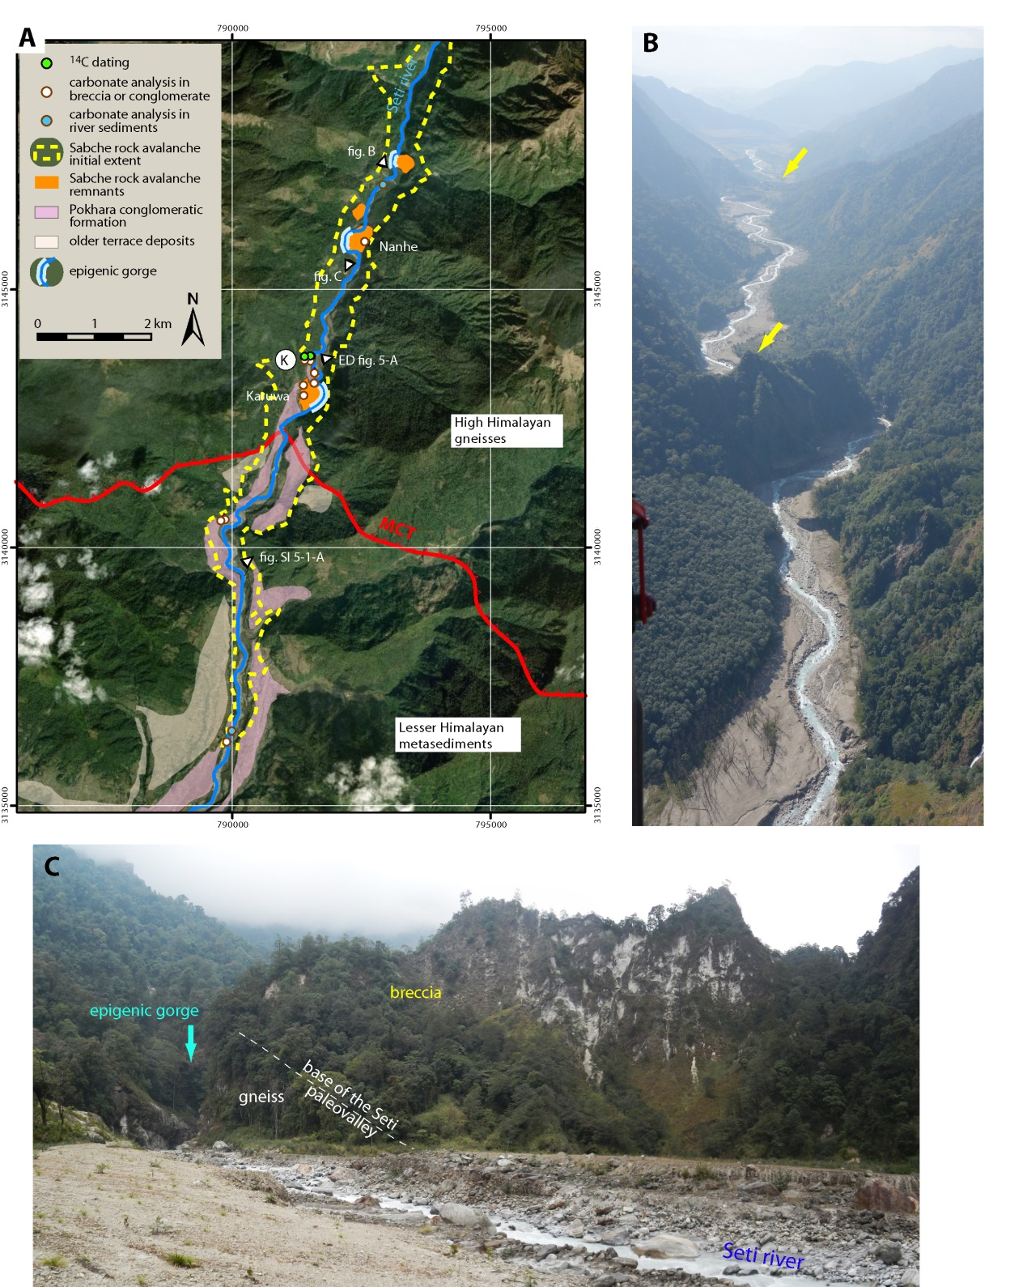

Figure SI-1-1: A. Map of the main remnants of the Sabche rock avalanche deposit along the upper Seti. B. Aerial view (looking southward) of the upper Seti showing two major breccia spurs associated to epigenetic gorges at Nanhe (yellow arrow in the foreground) and Karuwa hill (yellow arrow in the background). C. Picture of the south face of the breccia spur at Nanhe.

SI-2: Digital Terrain Model realization

A high-resolution DTM (Digital Terrain Model) (fig. SI-2-1) has been computed from Pleiades tri-stereoscopic panchromatic images acquired on December 12, 2014 and November 19, 2015 at ~0.5 m spatial resolution.

The DTMs have been calculated through an automatic pipeline which performed the data co-registration and the DTM generation as described in (Guerin, 2017). The data co-registration is realized as a pre-processing step in order to ensure that the images (and hence the DTM) are finely registered between each other’s. This operation consists in a bundle-block adjustment of all the data available that can be performed without any Ground Control Points (GCP).
Once the registration is performed, the DTMs are generated at each date according to the methodology described in (Guérin, 2017) and based on the so-called ground space image matching, performed with the open source software MICMAC, developed by the IGN (French Geographic Institute) (Pierrot-Deseilligny, 2006). This methodology enables the calculation of an elevation value for each point on a grid defined on the ground with a determined planimetric and an altimetric step. Thus, for each ground point of the grid, the images coordinates are obtained according to the refined acquisition models of the images that links the ground position of the point and its coordinates on the images. A correlation score is then computed between the pixels windows selected over each image and at each altitude of the grid. The final altitude value is chosen considering the correlation score and a regularization term. Figure X represents the final DTM generated from the Pleiades tri-stereoscopic images. For this study, both DTM have been generated at a 1 m planimetric and altimetric step and resampled to 50 m for the need of the study.

Cloudy areas partially affect the summits and crests surrounding the southern and western parts of the cirque. In those areas, the DTM was complemented from digitized 1/50 000 topographic maps (40m contour elevation). However, the breccia deposit and the failure surface of the rockslide in the central and north-eastern part of the cirque respectively are well resolved, and well adapted for reconstructing the initial volume of the deposit, measuring bedding dip of structural cliffs or for the calculation of the transverse curvature.

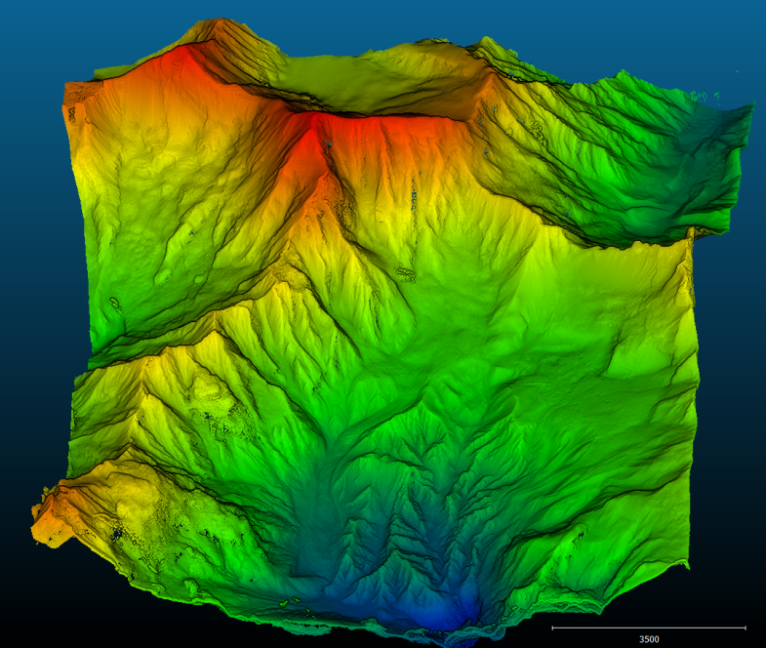

Figure SI-2-1: 2m Tri-stereo DTM, before holes filling and cloud corrections

SI-3: Coefficient of expansion of the breccia material

In order to derive the volume of solid rock that collapsed from the Annapurna IV ridge, the volume of breccia deposit was corrected from breccia porosity. Porosity measurements made on various samples of breccia taken at different places in Annapurna region were realized by measuring density through weighing of samples plunged into water and Archimede’s principle and assuming a rock density of ρ = 2.68±0.06 g/cm³, for the Late Cambrian to Silurian TSS rocks. The porosity or expansion rate of the breccia material slightly depends on the burial depth (figure below). Average value of 15+/-5% was found consistent with previous estimates of 15% made on rock avalanche material⁶⁶.

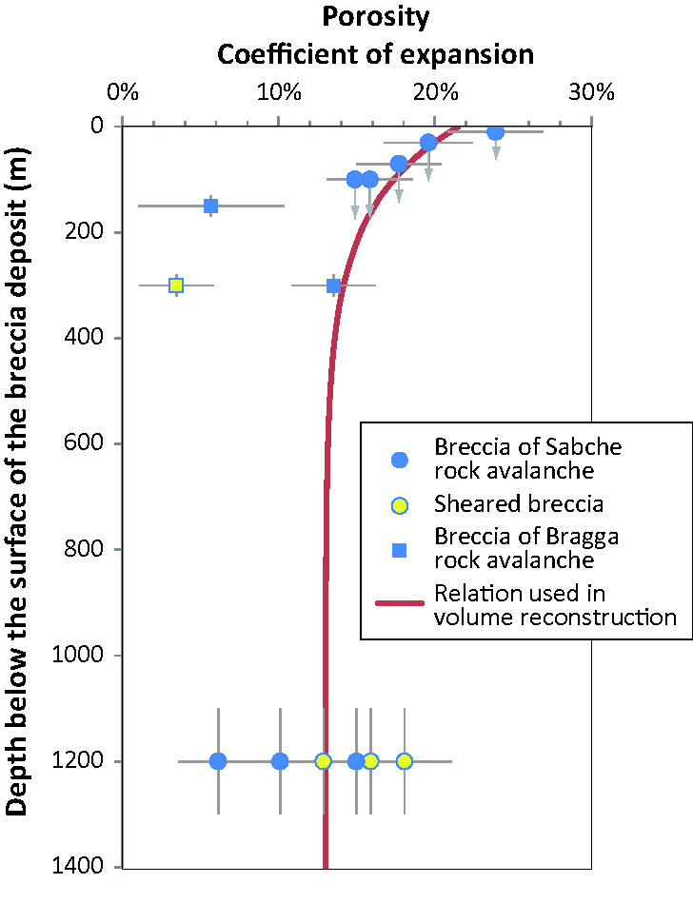

Figure SI-3-1: Average curve of the coefficient of expansion of the breccia material vs burial depth, as derived from density measurements made on rock and granular avalanches deposits in Sabche cirque, Upper Seti valley and upper Marsyandi in Bragga area on the northern part of the Annarpurna massif.

SI-4: Paleotopographic reconstruction

To reconstructed the paleotopography of the collapsed summit, as also explained in the Method section, we have applied the following computing chart:

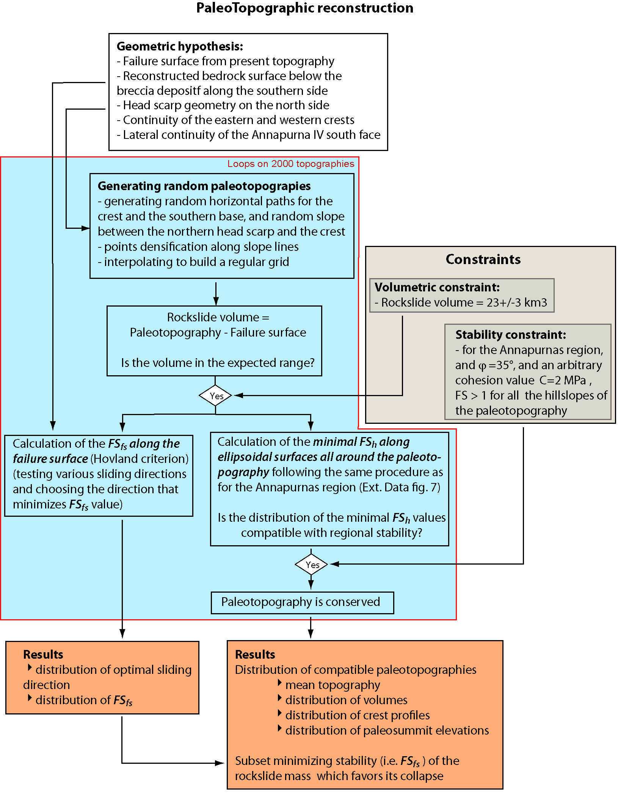

SI-5: The Pokhara conglomeratic deposits

- Sedimentology of the Pokhara conglomeratic formation in the Pokhara basin

The Pokhara conglomeratic Formation is characterized by a succession of planar metric to multi-metric conglomerate beds ago^{32,38}, with different facies (Fig. SI-5-1) and extend from upper Seti (Karuwa = site K of fig.1, down to the mountain front at Naryangad (site N)). All the units are essentially made of angulous to sub-angulous dark limestone pebbles: the origin of the gravels and pebbles is at >95% of TSS limestone and marly limestone, with a few rare granitic or gneissic pebbles, and whose only possible origin is in the Sabche cirque.

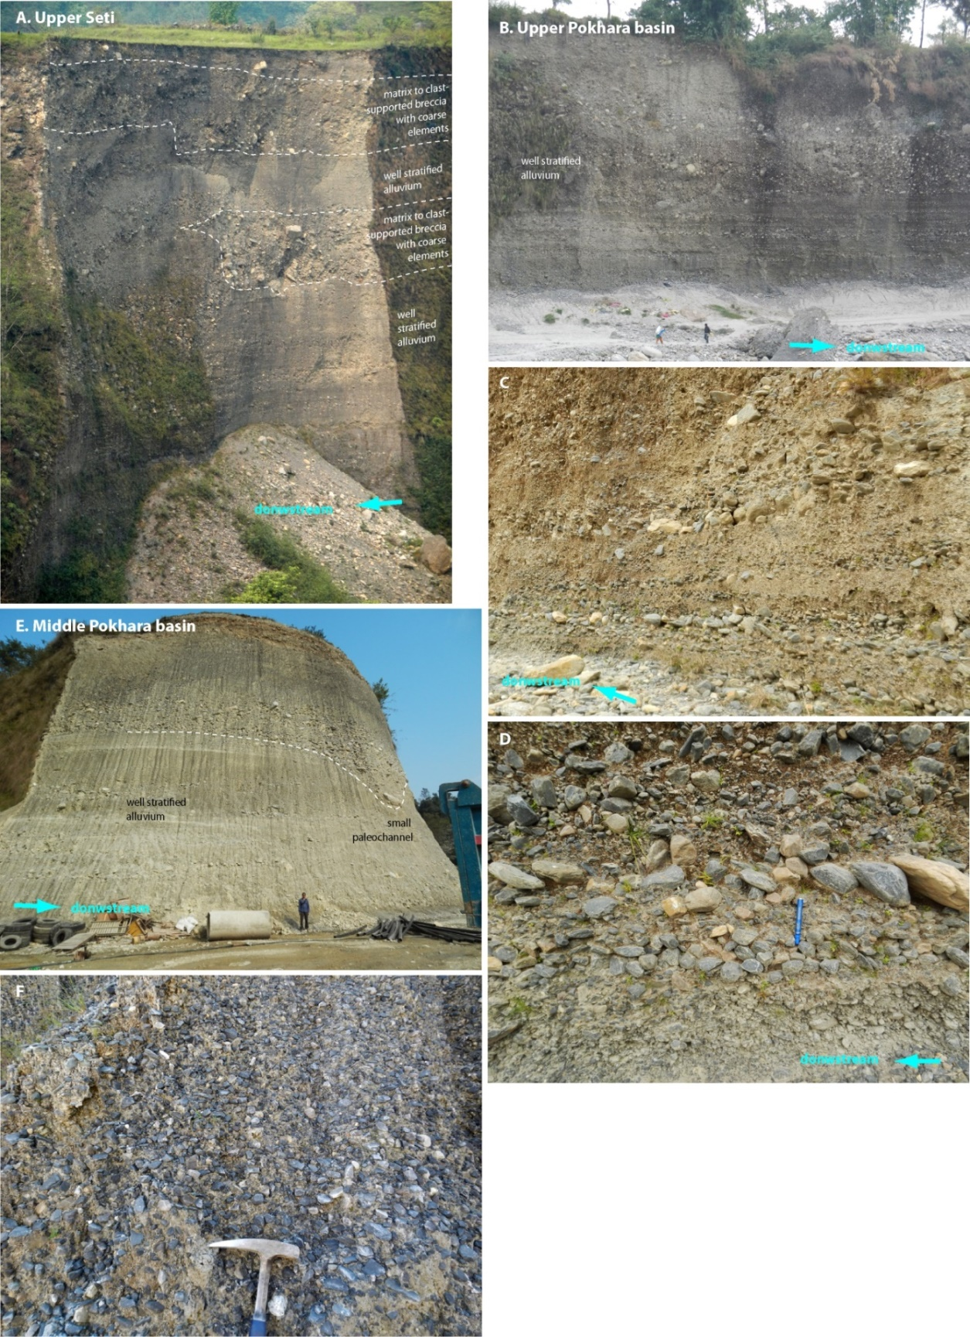

Figure SI-5-1: Pictures of some of the typical facies of the Pokhara conglomeratic Formation

In the center of Pokhara valley, most facies are well stratified conglomeratic alluvium made of alternation of relatively well sorted TSS gravels or pebbles (Figure SI-5-1-b and c) of variable median size (0.5cm < D₅₀ < 5cm). The clasts are subangular to subrounded and are commonly imbricated (Figure SI-5-1-d). The contacts between the layers are mostly planar, without presenting any major unconformity surfaces, except at a few places where small channel reincision by a few meters can be observed (Figure SI-5-1-e). If typical proximal debris-flow units with poorly sorted and matrix-supported material were not observed in the Pokhara basin, layers made of unsorted homometric material (Figure SI-5-1-f), clast- to matrix-supported, suggest clast transport by competent or hyperconcentrated flows. Even in its upstream part (Figure SI-5-1-a), south of Karuwa, a majority of the facies correspond to dominant stratified alluvium, interlayered with a minority of debris-flow-like units. The sorting increases downstream both in the clast and matrix-supported facies.
We interpret these planar conglomeratic units to reflect rapid aggradation during turbulent, sediment-laden flows, with successions of debris floods, sheet and hyperconcentrated flows (ref. 39; Blair and McPherson, 2009), and alluvial reworking. The dominance of sediment-laden or hyperconcentrated require an initial sediment source reach in fine fraction. Finally, it has to be noted that the clasts as well the silty matrix of the conglomerate units display carbonate content very similar to the average material of the Sabche rockslide breccia (fig. 4).

B. Narayangad terrace

The Pokhara conglomeratic formation can be tracked at least down to the Himalayan front, just north of the city of Narayangad (see loc. “N” on fig. 1). There, the remnant of a peculiar fill deposit observed at a few meters above the present river on the left bank of the Narayani river in a somehow sheltered environment. This unit contrasts strongly with the other terrace deposits of the Narayani at that place as much on the level of its much finer granulometry as on the level of its composition much richer in carbonates. This unit presents two sequences of opposite grading but with constant CaCO3 content: a basal unit with normal grading unit terminated by very fine silts is overlain in continuity by an inverse grading sequence that ranges from coarse sand to gravel clast-supported conglomerates made of small subangular, sorted, but unstratified, dark limestone gravels of similar composition as Pokhara conglomerates. We interpret such particular stratigraphic order as a deposition first of a suspended sediment laden front, likely generated just in front of the rock-avalanche, followed by aggradation of the fine pebble load that travelled more slowly as a debris or dense flow. Nevertheless the scarcity of these remnants of units indicates that after the deposition of the sequence, the Narayani river was able to recover rapidly and to wash its banks of these ~10-15m deposits of fine conglomerates, except very locally. A microscopic charcoal or organic debris (C14-68-E) was found at the middle of the silty sequence, and is synchronous of the upper Seti rock avalanche and onset of the filling of Pokhara basin (fig. 3).

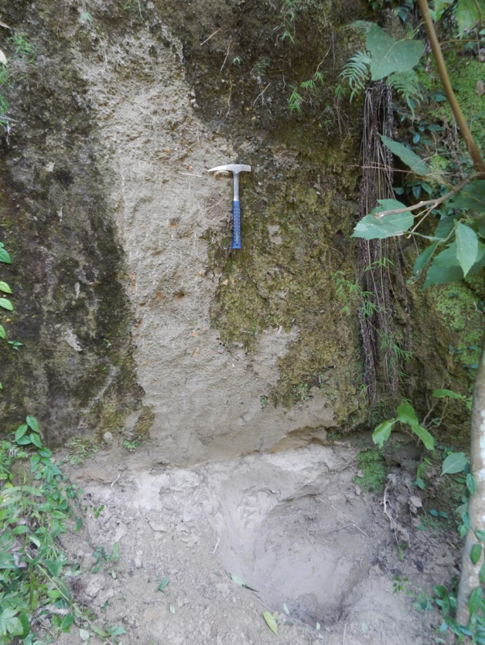
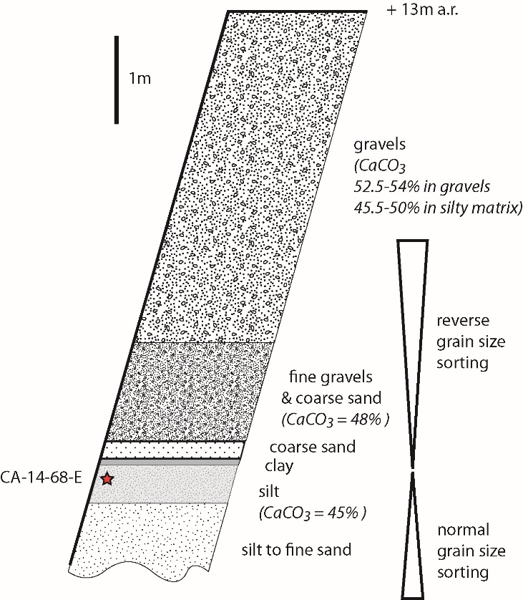

Figure SI-5-2: Micro-conglomerate deposit north of Narayangad (site N on fig.1)

C: Volume of deposited Pokhara type sediments

The volume of conglomerates in the Pokhara and upper Seti valley was estimated to reach ~5 to ~7km3 (refs. 32,41) over a distance of 70 km. Further downstream, the volume of deposited Pokhara sediment was estimated by considering the present geometry of the valley and a sediment filling assuming a linearly decreasing thickness from Pokhara to the Gangetic plain, based on our field measurements: 60m in the southern Pokhara basin, 20m at the confluence of the Seti with the Trisuli, 13m at Narayangad (N site), and 3-5m at the GR2 borehole (G site). In the Gangetic plain, the long and narrow lobe raised on top of the mega-fan (blue-colored in Extended Data fig.10) was assumed to correspond to the deposition of sediments preferentially derived from the rockslide.
Between the southern part of the Pokhara basin and Naryangad (site N), the deposited volume is ~1 km3. Between Naryangad and the MFT (most frontal thrust), in the Chitwan dun (piggy-back basin), an additional volume of ~2km3 of fine gravels and sands could have been deposited. Downstream of the MFT, the lobe deposited at the top in the Narayani mega-fan has represents a volume of sediment of ~6km3 (LxWxH ≈ 120km x 12km x 4m). As a whole, 15km3 of sediments might have been deposited between Pokhara and the Narayani megafan, that is, considering a porosity of 30% of the sediments, ≤50% of the initial rock volume. The other half was presumably exported further downstream as suspended load like most Himalayan sediments that end up in the Bengal Fan⁴².
It has to be noted that we assume above that the downstream units were not fed by the re-erosion of the upstream conglomerates. The synchronism of the sediment at Narayangad (downstream site N) with the initial granular avalanche in the most upstream part supports such hypothesis.

D: Proportion of Sabche material in the Gandak river after the rockslide

The carbonate-rich lobe of the Narayani fan displays variable carbonate concentration between 30 and 60%, but on average it remains slightly lower than the Sabche breccia and Pokhara conglomerate. This likely arises from mixing with background supply of sediments issued from the whole Narayani catchment.
Considering the average carbonate concentrations of around 55, 40, and 10% for breccia material, sediments in the carbonate-rich lobe of the Narayani fan (upper units of GR2), and mean Narayani sediments (in GR1, lower GR2 cores or sandy fraction of modern sediments) respectively, it is shown that the carbonate-rich lobe of the Narayani was corresponding to the mixing of two volumes of Sabche debris and one volume of background Narayani sediments. Following the Annapurna IV collapse, the input of Sabche material would have tripled the Narayani sediment flux compared to average values. In order to evacuate ~15km3 (the total rockslide volume minus the breccia remaining in the Sabche cirque and the deposited part along the middle and lower Seti respectively) of breccia material out of the mountain range at Narayangad, such a situation could have persisted ~150yr, which seems to confirm accelerated erosion of the Sabche deposit over a period of 100yr following the summit collapse.

SI-6: 14C dating of the various organic debris (wood pieces and charcoals) samples of this study

The pdf associated to the mean age for Karuwa and the basal Pokhara conglomerates (Fig. 2) were calculated by computing the uncertainty-weighted average of the 14C raw radiocarbon ages (8 dating for each mean age), before applying the calibration curve of IntCal 13 (ref. ⁵⁸).

Lab.No | Sample ID | Lat [°N] | Lon [°E] | Elevation [m asl] | Material | stratigraphic setting | Radiocarbon age [y BP] | Calibrated age
Karuwa debris flow
SacA-41772 | CA-14-59 | 28° 23.24' | 83° 58.51' | 1460 | wood | base of the granular avalanche breccia | 950 ± 30 | 1085 AD ± 47
SacA-43078 | CA-14-58 | 28° 23.24' | 83° 58.51' | 1460 | wood | base of the granular avalanche breccia | 840 ± 30 | 1199 AD ± 29
SacA-48072 | CA-16-5-C | 28° 23.24' | 83° 58.51' | 1460 | bark | base of the granular avalanche breccia | 830 ± 30 | 1208 AD ± 30
SacA-46539 | CA-16-5-D | 28° 23.24' | 83° 58.51' | 1460 | monocots type stem | base of the granular avalanche breccia | 870 ± 30 | 1139 AD ± 61
SacA-48073 | CA-16-5-D | Replicate |  |  |  |  | 895 ± 30 | 1125 AD ± 52
SacA-48714 | CA-16-7 | 28° 23.25' | 83° 58.43' | 1530 | wood (root) | paleosoil buried by the granular avalanche breccia | 835 ± 30 | 1212 AD ± 30
SacA-46541 | CA-16-8-B | 28° 23.25' | 83° 58.43' | 1530 | small branch | base of the granular avalanche breccia | 935 ± 35 | 1094 AD ± 48
SacA-48715 | CA-16-8-E | 28° 23.25' | 83° 58.43' | 1530 | small branch | base of the granular avalanche breccia | 825 ± 30 | 1229 AD ± 22
Pokhara basin
SacA-41776 | CA-13-245 | 28° 6.62 | 84° 7.18 | 588 | small tree trunk | Paleosoil buried by the Pokhara Fm | 740 ± 30 | 1261 AD ± 15
SacA-41777 | CA-13-246 | 28° 6.64' | 84° 7.19' | 605 | charcoal | Paleosoil buried by the Pokhara Fm | 940 ± 30 | 1090 AD ± 46
SacA-43080 | CA-13-246-B | 28° 6.64' | 84° 7.19' | 605 | charcoal | Paleosoil buried by the Pokhara Fm | 955 ± 30 | 1082 AD ± 47
SacA-41773 | CA-14-63-B | 28° 8.05' | 84° 5.70' | 640 | charcoal | Thin sand layer at the top of Pokhara Fm | 1940 ± 30 | 57 AD ± 33
SacA-43079 | CA-14-64-A | 28° 7.17' | 84° 6.31' | 612 | charcoal | Paleosoil buried by the Pokhara Fm | 940 ± 30 | 1090 AD ± 46
SacA-41774 | CA-14-64-B | 28° 7.17' | 84° 6.31' | 612 | charcoal | Paleosoil buried by the Pokhara Fm | 940 ± 30 | 1090 AD ± 46
SacA-41775 | CA-14-66 | 28° 5.60' | 84° 4.53' | 547 | charcoal | Paleosoil buried by the Pokhara Fm | 3375 ± 35 | 1678 BC ± 45
SacA-46544 | CA-16-27 | 28° 5.57' | 84° 3.89' | 549 | wood | slackwater deposits at tributary damming | 870 ± 30 | 1139 AD ± 61
Narayangad
WHOI-133624 | CA-14-68E | 27°42.83' | 84°26.03' | 198 | Micro-charcoal | Silt layer at the base of fine conglomerates | 885 ± 25 | 1126 AD ± 60

Table SI-6-1: Details of the samples of the organic debris found at Karuwa, in Pokhara basin and Narayangad, and dated by 14C AMS dating. Several charcoals, in particular CA-14-63B and CA-14-66 in paleosoils buried by the Pokhara conglomeratic formation, are clearly too old and suggest either long residence time in the soil (CA-14-66) or reworking (CA-14-63B).

SampleID | River | ref. | Latitude | Longitude | Sample elevation | Material | Pokhara Fm top elevation | Elevation of the Seti river | Age (calibrated 14C age AD)
 |  |  | (°N) | (°E) | (m asl) |  | (m asl) | (m asl) | mediane (P_{50%}) | P_{2.5%} | P_{97.5%}
BIJ02 | Bijaypur | 38 | 28.219 | 84.029 | 820 | Humic Silt | 828 | 710 | 1246 | 1167 | 1290
PH02C | Phusre | 38 | 28.18 | 83.968 | 730 | Leaves | 773 | 680 | 1193 | 1046 | 1269
PHUSRE03 | Phusre | 38 | 28.183 | 83.951 | 740 | Charcoal | 773 | 680 | 1098 | 1016 | 1205
SARA1-1 | Saraudi | 38 | 28.096 | 84.029 | 541 | Wood | 560 | 490 | 1265 | 1215 | 1298
MADHI2 | Magdi | 38 | 28.015 | 84.117 | 495 | Charcoal | 500 | 438 | 1061 | 990 | 1155
PH6 | Phusre | 38 | 28.175 | 83.976 | 703 | Wood | 773 | 680 | 1160 | 1038 | 1224
Phusre010 | Phusre | 38 | 28.175 | 83.982 | 706 | Wood | 773 | 680 | 1170 | 1043 | 1241
Phusre012 | Phusre | 38 | 28.175 | 83.982 | 698 | Leaves | 773 | 680 | 1232 | 1169 | 1270
Phusre013 | Phusre | 38 | 28.175 | 83.982 | 696 | Wood | 773 | 680 | 1199 | 1058 | 1262
Phusre14 | Phusre | 38 | 28.175 | 83.982 | 701 | Charcoal | 773 | 680 | 1219 | 1163 | 1264
PhusreFa | Phusre | 38 | 28.185 | 83.958 | 728 | Charcoal | 773 | 680 | 1106 | 1033 | 1204
PRE14C1 | Phusre | 38 | 28.184 | 83.934 | 748 | Charcoal | 773 | 680 | 1347 | 1298 | 1410
KBP03 | Bijaypur | 38 | 28.218 | 84.027 | 825 | Wood | 828 | 710 | 1289 | 1263 | 1388
TAL02 | Tal | 38 | 28.117 | 84.105 | 583 | Wood | 623 | 530 | 1214 | 1161 | 1264
TAL05 | Tal | 38 | 28.117 | 84.105 | 614 | Wood | 623 | 530 | 1099 | 1025 | 1165
Anpu02 | Anpu | 38 | 28.109 | 84.116 | 591 | Humic Silt | 618 | 530 | 1097 | 1024 | 1155
KBP02 | Bijaypur | 40 | 28.218 | 84.027 | 825 | Humic Silt | 828 | 710 | 1176 | 1045 | 1250
Phusre11 | Phusre | 40 | 28.175 | 83.982 | 698 | Wood | 773 | 680 | 1186 | 1049 | 1256
Tal01 | Tal | 40 | 28.117 | 84.105 | 585 | Humic Silt | 623 | 530 | 1224 | 1165 | 1265
14CAnpu11 | Anpu | 40 | 28.108 | 84.114 | 590 | Charcoal | 618 | 530 | 1099 | 1025 | 1165
14CAnpu01 | Anpu | 40 | 28.111 | 84.105 | 556 | Leaves | 618 | 530 | 1186 | 1049 | 1256
14CAnpu16 | Anpu | 40 | 28.11 | 84.12 | 592 | Charcoal | 618 | 530 | 1214 | 1161 | 1264
BIJ03 | Bijaypur | 40 | 28.219 | 84.029 | 820 | Humic Silt | 828 | 710 | 1299 | 1270 | 1390
Ph6u_14C | Phusre | 40 | 28.176 | 83.977 | 704 | Wood | 773 | 680 | 1113 | 1037 | 1207
EBGcc01 | Anpu | 40 | 28.111 | 84.12 | 609 | Charcoal | 618 | 530 | 698 | 656 | 769
PhTree1 | Phusre | 41 | 28.183 | 83.953 | 725 | tree trunk | 773 | 680 | 1232 | 1169 | 1270
PhTree2 | Phusre | 41 | 28.183 | 83.953 | 725 | tree trunk | 773 | 680 | 1272 | 1223 | 1295
AnpuTrib | Anpu | 41 | 28.118 | 84.105 | 587 | tree trunk | 623 | 530 | 1209 | 1157 | 1264
AnpuTree1 | Anpu | 41 | 28.111 | 84.12 | 601 | tree trunk | 618 | 530 | 1242 | 1190 | 1279
AnpuTree2 | Anpu | 41 | 28.11 | 84.122 | 608 | tree trunk | 618 | 530 | 1240 | 1189 | 1277
AnpuTree3 | Anpu | 41 | 28.111 | 84.121 | 591 | tree trunk | 618 | 530 | 1228 | 1168 | 1266
AnpuTree4 | Anpu | 41 | 28.111 | 84.121 | 591 | tree trunk | 618 | 530 | 1199 | 1058 | 1262
AnpuTree5 | Anpu | 41 | 28.11 | 84.12 | 592 | tree trunk | 618 | 530 | 1224 | 1165 | 1265
CA-14-63-B | upper Begnas | this study | 28.1342 | 84.0950 | 640 | charcoal in sand lense | 640 | 560 | 62 | -20 | 130
CA-14-64-A | Rupa | this study | 28.1195 | 84.1052 | 612 | charcoal in paleosoil | 623 | 532 | 1098 | 1025 | 1160
CA-14-64-B | Rupa | this study | 28.1195 | 84.1052 | 612 | charcoal in paleosoil | 623 | 532 | 1098 | 1025 | 1160
CA-14-66 | Seti Majuwa | this study | 28.0933 | 84.0755 | 547 | charcoal in paleosoil | 585 | 507 | -1669 | -1753 | -1549
CA-13-245 | Anpu | this study | 28.1103 | 84.1197 | 588 | small tree trunk base | 618 | 530 | 1270 | 1224 | 1291
CA-13-246 | Anpu | this study | 28.1107 | 84.1198 | 605 | charcoal in paleosoil | 618 | 530 | 1098 | 1025 | 1160
CA-13-246B | Anpu | this study | 28.1107 | 84.1198 | 605 | charcoal in paleosoil | 618 | 530 | 1096 | 1022 | 1155
CA-16-27 | Rudi | this study | 28.0929 | 84.0649 | 549 | wood | 580 | 500 | 1176 | 1045 | 1250

Table SI-6-2: Published 14C dating (dated by AMS) of the various organic debris samples of the Pokhara conglomeratic formation, including their location and their elevation as well as that of the Seti and the top of the Pokhara formation used in fig.2b. The sample names in bold correspond to the most basal ones, used in fig.2a.
SI-7: ³⁶Cl dating of blocks at the rockslide deposit summit (4600m)

³⁶Cl exposure ages of the blocks sampled at the top of the deposit at ~4600m have been calculated incorporating snow cover correction and potential erosion. The snow cover correction corresponds to about 25-30cm of snow (in water equivalent) during 120 days (mainly from January to May) and is calculated on the basis of 50% of the snow cover measured at several stations located between 3200 and 4400m along the ridges that dominate the Khudi Khola (25km east of Sabche cirque in a slightly more advanced position on the southern flank of the Himalayas) between 1999 and 2002 (ref. 61).
Using depth and duration of snow cover measured on the Himalayan southern flanks 25km to the east⁶¹, estimate of the shielding factor by snow would reach 0.87. However, as observed on site or on satellite images, the top of the plurimetric blocks are cleared of their snow cover much faster than the rest of the flat surrounding ground. Considering also that the Sabche cirque may be partially sheltered compared to the most exposed southern flank and receives less snow precipitation, we therefore adopt a conservative snow shielding factor of 0.95+/-0.5.

Sample name | Lithology | Latitude | Longitude | Altitude | boulder height above ground | sample thickness | Bulk  density | Possible erosion of the block surface | Topographic shielding | Snow shielding
 |  | (° N) | (° E) | (m) | (m) | (cm) | (g/cm³) | (cm)
CA13-260 | marly limestone | 28.5352 | 84.0274 | 4590 | 5 | 3 | 2.6 | 0 | 0.975 | 0.94±0.05
CA13-261 | schistosed marly sandstone | 28.5359 | 84.0271 | 4590 | 2.5 | 3 | 2.6 | 2±2 | 0.975 | 0.94±0.05
CA13-262 | schistosed marl | 28.5365 | 84.0276 | 4590 | 5 | 4 | 2.6 | 1±1 | 0.975 | 0.94±0.05
CA13-263 | schistosed marl | 28.5374 | 84.0281 | 4590 | 1 to 4 | 10 | 2.6 | 3±3 | 0.975 | 0.94±0.05
CA13-264 | schistosed marl | 28.5382 | 84.0284 | 4590 | 1.2 | 5 | 2.6 | 2±2 | 0.975 | 0.94±0.05
CA13-265 | schistosed marly sandstone | 28.5394 | 84.0297 | 4590 | 1.1 | 10 | 2.6 | 1±1 | 0.975 | 0.94±0.05

Table SI-7-1: Location and characteristics of the 6 blocks sampled on Nov. 2013 at the top of the relic surface of the rockslide deposit.

Sample name | % dissolved rock |  | ³⁵Cl/³⁷Cl | ³⁶Cl  (/g of dissolved rock) | Cl  (/m of dissolved rock) | CaO in target fraction | K₂O | TiO₂ | Fe₂O₃ | Exposure age  without snow shielding | Exposure age with snow shielding
  ³⁶Cl/³⁵Cl
 | % | (×10⁻ ¹³) |  | 10³ atoms/g | [ppm] | % | % | % | % | yr | yr
CA13-260 | 82.2 | 2.706 ± 0.081 | 33.387 ± 0.793 | 168.3 ± 5.2 | 4.4 | 52.36 | 0 | 0 | 0 | 796 ± 70 | 839 ± 76
CA13-261 | 52.8 | 1.551 ± 0.058 | 40.284 ± 1.317 | 165.5 ± 6.5 | 6.2 | 54.28 | 0 | 0 | 0 | 758 ± 69 | 799 ± 74
CA13-262 | 75.6 | 2.493 ± 0.075 | 24.061 ± 0.886 | 170.5 ± 5.3 | 6.8 | 51.86 | 0 | 0 | 0 | 816 ± 70 | 860 ± 80
CA13-263 | 72.9 | 2.157 ± 0.071 | 27.046 ± 1.115 | 145.1 ± 4.9 | 5.9 | 52.69 | 0 | 0 | 0 | 749 ± 73 | 790 ± 76
CA13-264 | 75.7 | 1.130 ± 0.049 | 31.172 ± 1.218 | 84.7 ± 3.8 | 5.7 | 52.65 | 0 | 0 | 0 | 423 ± 39 | 446 ± 43
CA13-265 | 26.0 | 0.515 ± 0.032 | 31.209 ± 1.295 | 93.6 ± 6.4 | 14.0 | 54.41 | 0 | 0 | 0 | 446 ± 46 | 470 ± 49
Blank |  | 0.072 ± 0.012 | 427.025 ± 3.187

Table SI-7-2: Sample information, AMS measurement results, and calculated ³⁶Cl and chlorine concentrations and concentration of Ca measured at ICP-AES (inductively coupled plasma atomic emission spectrometry). Exposure ages calculated with Online Chronus Calculator (http://hess.ess.washington.edu/math/index_dev.html). Reported analytical uncertainties include uncertainties in AMS counting statistics, the isotopic ratios of the standards, and on the blank chemical measurements, an external AMS error of 0.5% (Arnold et al., 2010), and the uncertainties associated with the cosmogenic nuclide half-lives. External uncertainties include the uncertainties associated with the cosmogenic nuclide production rates, the sample thickness, the estimated surface and snow shielding.

Sample Name | SiO₂ | TiO₂ | Al₂O₃ | Fe₂O₃ | MnO | MgO | CaO | Na₂O | K₂O | H₂O | Cl | B | Sm | Gd | U | Th | Cr | Li
 | % | % | % | % | % | % | % | % | % | % | ppm | ppm | ppm | ppm | ppm | ppm | ppm | ppm
CA13-260 | 9.65 | 0.09 | 1.80 | 0.76 | 0.01 | 2.36 | 45.49 | 0.41 | 0.51 | 0.43 | 10 | 9 | 0.92 | 0.75 | 0.69 | 2.60 | 4.3 | 5.2
CA13-261 | 31.12 | 0.26 | 4.79 | 0.89 | 0.02 | 2.09 | 31.64 | 1.11 | 1.16 | 0.79 | 10 | 22 | 2.07 | 1.71 | 1.49 | 8.13 | 15.3 | 12.8
CA13-262 | 13.70 | 0.13 | 2.52 | 0.81 | 0.02 | 2.53 | 42.45 | 0.65 | 0.70 | 0.49 | 10 | 12 | 1.60 | 1.29 | 0.84 | 3.66 | 7.2 | 6.2
CA13-263 | 15.83 | 0.19 | 3.60 | 1.00 | 0.02 | 2.65 | 40.65 | 0.58 | 1.12 | 0.61 | 10 | 17 | 2.45 | 1.95 | 0.81 | 5.22 | 14.5 | 11.3
CA13-264 | 15.62 | 0.19 | 3.70 | 1.18 | 0.02 | 1.80 | 41.05 | 0.55 | 1.03 | 0.65 | 10 | 36 | 2.13 | 1.80 | 0.70 | 5.54 | 16.5 | 9.8
CA13-265 | 45.41 | 0.44 | 8.57 | 2.84 | 0.03 | 3.03 | 19.02 | 1.21 | 2.58 | 1.31 | 25 | 46 | 4.21 | 3.49 | 1.55 | 11.9 | 33.2 | 23

Table SI-7-3: Bulk rocks geochemical composition of the 6 blocks sampled at the top of the relic surface of the rockslide deposit: Major and trace elements composition measured by ICP-MS (SARM, CRPG).

SI-8: Infra-red stimulated luminescence (IRSL) measurements and results on sheared breccia deposits

Breccia samples were first sawed in subdued light conditions to remove the exposed outer rock surfaces. Samples were then dissolved in HCl. and the silicate fraction was treated using H₂O₂ (30%) and sieved to coarse sand fraction before density separation with LST to isolate K-felspar fraction (d<2.58). K-feldspar separates were settled on 10-mm diameter stainless steel discs for subsequent luminescence analyses. About 50 g of bulk sample was saved (external breccia surface) and sent to Actlabs or SARM-CRPG for ICP analysis to quantify U, Th and K contents (Table SI-8-1). Final dose rate determination, using grainsize range and estimated water content, were obtained through the Dose Rate and Age Calculator⁶³ (DRAC).

All conventional luminescence measurements were carried out using TL/OSLDA-20 Risø readers, equipped with a calibrated ⁹⁰Sr/⁹⁰Y beta source (reader dose rate ~0.1Gy/s; Institute of Earth Surface Dynamics, University of Lausanne, Switzerland). Luminescence signals were detected using an EMI 9235QA photomultiplier tube, in the blue region through a Schott BG-39 filter for IRSL measurements. We used the post-IR IRSL protocol⁶⁴, applying first a preheat treatment at 250°C for 60s before a single-aliquot regenerative-dose (SAR) protocol (Murray & Wintle 2000) with a first IRSL stimulation at 50 °C (100 s, IR50) followed by a second IRSL stimulation at 225 °C (100 s, pIR225). For all the samples, residual doses and dose recovery ratios were quantified. Dose–response curves were constructed using an exponential+linear fitting (with recycling ratios within 15% of unity and recuperation within 10% of the natural dose were used as acceptance criteria for the single-aliquot data).
We used the Luminescence R package (Kreutzer et al. 2012) to quantify the Central Age Model (CAM) for all samples⁶⁵, and based on the overdispersion in De distributions we also calculated a Minimum Age Model (MAM) for sample CA-13-283 ref. ⁶⁵). Fading rates (g_{2days}) were measured following Auclair et al. (2003) (Figure SI-8-1). Final fading-corrected ages were calculated following ref. 66 fading correction procedure (Table SI-8-2).

Sample | Coordinates (WGS84, °N/°E, and elevation, m a.s.l.) | Radionuclide concentration¹ |  |  | Grain size range² (μm) | Total dose rate³ (Gy ka⁻¹)
Sample | Coordinates (WGS84, °N/°E, and elevation, m a.s.l.) | U (ppm) | Th (ppm) | K (%) | Grain size range² (μm) | Total dose rate³ (Gy ka⁻¹)
CA-13-273 | 28.5058; 84.0001  3410 | 1.69±0.06 | 10.8±0.38 | 1.82±0.06 | 90-180 | 3.83±0.21
CA-13-274 | 28.5058; 84.0001  3410 | 1.64±0.06 | 10.3±0.36 | 1.90±0.07 | 90-180 | 3.85±0.21
CA-13-283 | 28.5055; 83.9999  3405 | 2.15±0.08 | 12.6±0.44 | 2.04±0.07 | 180-250 | 4.39±0.17

Table SI-8-1. Details of dose-rate calculations for IRSL dating.
Samples were collected at the base of the breccia deposit (see Extended Data Figs. 2 and 4) but this was rapidly incised after deposition. To account for this, a 0.25 Gy dose has been substracted for post-deposition exposure to cosmic rays.
¹Radionuclide concentrations were quantified on bulk samples using ICP at Actlabs (CA-13-273/-274) and at SARM-CRPG (CA-13-283).
²Coarse-grain fraction of 90-180 μm was isolated for samples CA-13-273 and CA-13-274, and of 180-250 μm for CA-13-283, to ensure material abundance for IRSL measurements.
³Dose rate calculations were performed with DRAC⁶³, assuming water content of 2±2%, an internal K-content of 12.5±0.5% (Huntley and Baril, 1997) and an alpha efficiency value of 0.15±0.05 (Balescu and Lamothe, 1994).

Sample  (aliquots) | Signal | Dose recovery ratio¹ | residuals¹  (Gy) | CAM² uncorrected D_{e} (Gy) | OD² (%) | MAM³ uncorrected D_{e} (Gy) | Fading⁴  g_{2days} (%/decade) | CAM or MAM* fading-corrected age (ka)
CA-13-273  (17) | IR50 | 0.94±0.04 | 0.57 | 84.2±9.0 | 9.2 | / | 1.40±0.48 | 31.9±4.3
CA-13-273  (17) | pIR225 | 0.90±0.03 | 2.27 | 156.7±25.8 | 15.0 | / | 0.58±0.34 | 34.6±4.1
CA-13-274  (17) | IR50 | 0.94±0.04 | 0.57 | 90.5±8.8 | 8.0 | / | 1.47±0.75 | 64.4±7.4
CA-13-274  (17) | pIR225 | 0.91±0.03 | 2.26 | 155.8±26.0 | 15.3 | / | 0.63±0.28 | 48.1±2.5
CA-13-283  (60) | IR50 | 0.88±0.02 | 0.25 | 7.5±2.2 | 28.7 | 5.2±0.6 | 1.37±0.64 | 1.21±0.23*
CA-13-283  (60) | pIR225 | 0.86±0.02 | 0.27 | 8.7±2.9 | 32.3 | 6.2±1.0 | 0.59±0.39 | 1.50±0.30*

Table SI-8-2. IRSL dating of the base of the breccia deposit (see Extended Data Figs. 2d and 4) on small-aliquots, using feldspar infra-red luminescence at 50°C (IR50) and post-infra-red infra-red luminescence at 225°C (pIR225) signals. Analytical details and measurement protocols are given in supplementary text.
¹Dose recovery ratios have been calulated for each individual sample and using a given dose of 60Gy for 5 aliquots. Residuals have been estimated for 4 aliquots per sample, with an additional 0.25 Gy to account for post-deposition cosmic-ray exposure following rapid breccia incision.
²De = Equivalent doses, CAM = Central Age Model, OD = overdispersion of D_{e} distribution⁶⁵.
³MAM = Minimum Age Model⁶⁵ (MAM-3). It was applied for D_{e} distributions with OD > 25%, i.e. for sample CA-13-283. Sigma-b (σ_{b}) values of 0.085 and 0.152 were used for IR50 and pIR225 signals, respectively, based on OD values for CA-13-273/-274 samples. No MAM was run for CA-13-273/-274, due to the low OD in the D_{e} distribution (Fig. SI-8-1).
⁴Fading measurements have been performed on 12-14 aliquots per sample to evaluate the variability in fading rates for IR50 and pIRI225 signals (Fig. SI-8-1).

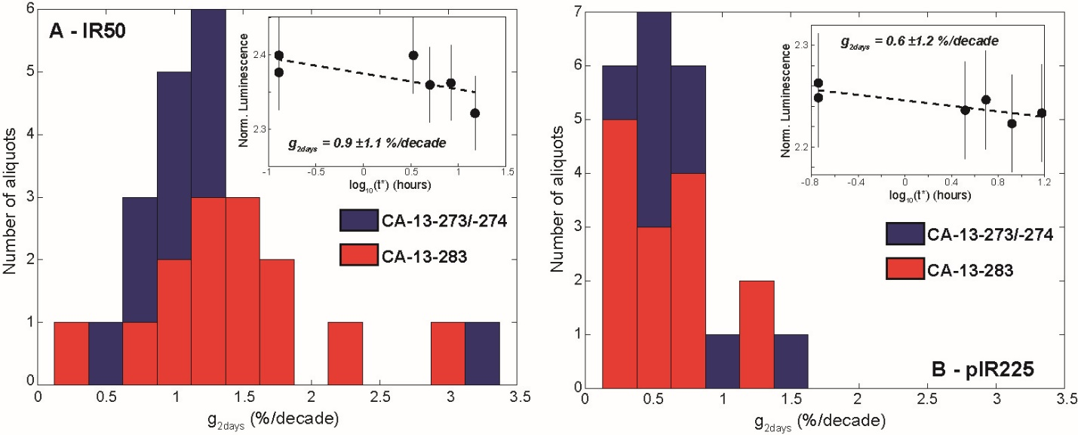

Fig. SI-8-1. Fading rate (g2days values) distributions for K-feldspar IR50 (A) and pIRIR225 (B) signals. Insets show representative examples of fading measurements. Fading rate distributions illustrate similar behaviour between CA-13-273, -274 and -283.

SI-9: Carbonate content

Total carbonate (Table SI-9-1) content was measured by phosphoric acid dissolution at 70°C on a gas-bench coupled to a MAT253 spectrometer using internal concentration standards. Concentrations are expressed in equivalent CaCO3 wt% and the overall uncertainty is ± 2% relative.

Sample | Sample Type | Lithology | river / location | Latitude | Longitude | distance from Sabche divide | CaCO₃
 |  |  |  | (°N) | (°E) | (km) | %
Rivers
Seti & downstream (Trisuli, Narayani)
HF 10 | sand (bank) | sand | Seti Kh. North of Pokhara | 28.4200 | 83.9921 | 19 | 56.0
CA-13-232 | sand (bank) | sand | Seti Kh. North of Pokhara | 28.3219 | 83.9573 | 30 | 29.4
CA-13-233 | sand (bank) | silt | Seti Kh. North of Pokhara | 28.3219 | 83.9573 | 30 | 48.5
HF 11 | sand (bank) | sand | Seti Khola | 28.3015 | 83.9429 | 36 | 44.0
LO 313 | sand (bank) | sand | Seti Khola | 28.1274 | 84.0836 | 69.5 | 44.4
MO 305 | Suspended Load | silt | Seti Khola | 28.0500 | 84.0700 | 78.5 | 47.0
CA-14-72 | sand (bank) | sand | Seti Khola | 27.8273 | 84.4662 | 142 | 11.0
LO 303 | sand (bank) | sand | Seti Khola | 27.8255 | 84.4635 | 142 | 24.7
CA 11133 | sand (bank) | sand | Seti Khola | 27.8292 | 84.4667 | 142 | 17
CA13-251 | sand (bank) | sand | lower Trisuli | 27.7564 | 84.4638 | 157.3 | 8.2
CA-14-67 | sand (bank) | sand | Narayani | 27.7022 | 84.4262 | 166.5 | 9.18
LO 309 | sand (bank) | sand | Narayani | 27.7020 | 84.4260 | 166.5 | 14.7
NAG 48 | sand (bank) | sand | Narayani | 27.7020 | 84.4260 | 166.5 | 13.8
LO 741 | sand (bank) | sand | Nayayani | 27.7020 | 84.4260 | 166.5 | 15.0
CA 11-140 | sand (bank) | sand | Narayani | 27.7020 | 84.4260 | 166.5 | 9.19
Narayani | sand (mean) | sand | Narayani @ Narayangad | 27.7020 | 84.4260 | 166.5 | 12.4
 | (std) |  |  |  |  |  | 2.9
Narayani | Suspended load (average 2010 monsoon) | silt | Narayani @ Narayangad | 27.7020 | 84.4260 | 166.5 | 16.4
 | (std) |  |  |  |  |  | 3.9
CA 11305 | sand (bank) | sand | Narayani | 26.8598 | 84.2098 | 337 | 9.3
CA 11306A | sand (bank) | Bank | Narayani | 27.2059 | 83.9300 | 284 | 10.1
CA 11306B | sand (bank) | Bank | Narayani | 27.2059 | 83.9300 | 284 | 7.8
CA 11306D | sand (bank) | Bank | Narayani | 27.2059 | 83.9300 | 284 | 7.9
CA 11307 | sand (bank) | Bank | Narayani | 27.1215 | 84.0609 | 301 | 9.4
CA 11308 | sand (bank) | Bank | Narayani | 26.6890 | 84.4333 | 369 | 11.2
Main Tributaries
CA-13-237 | sand (bank) | sand | Mardi Khola | 28.2996 | 83.9267 | 38 | 7.9
CA-13-238 | sand (bank) | sand | Madi Khola | 28.2341 | 84.0868 | 113 | 2.4
CA-13-239 | silt (bank) | silt | Madi Khola | 28.2243 | 84.0592 | 113 | 4.2
CA-13-247 | sand (bank) | sand | Madi Khola | 27.9783 | 84.2600 | 113 | 3.64
LO 305 | sand (bank) | sand | Trisuli | 27.8180 | 84.4640 | 144 | 3.2
LO 307 | sand (bank) | sand | Kali Gandaki | 27.7486 | 84.4194 | 161 | 12.3
CA11136 | sand (bank) | sand | Kali Gandaki | 27.7486 | 84.4194 | 161 | 21.2
CA-13-126 | sand (bank) | sand | Kali Gandaki | 27.7486 | 84.4194 | 161 | 15.6
CA-13-128 | sand (bank) | sand | Kali Gandaki | 27.7486 | 84.4194 | 161 | 17.9
Breccia (Sabche rockslide deposit)
CA-13-270 | breccia | matrix | Sabche cirque _ base of deposit | 28.5061 | 83.9999 | 5 | 48.6
CA-13-275 | sediment in gully | sand | Sabche cirque _ base of deposit | 28.5039 | 83.9996 | 5 | 65.1
 |  |  |  |  |  |  | 66.7
CA13-275_A | sediment in gully | clast | Sabche cirque _ base of deposit | 28.5039 | 83.9996 | 5 | 15.9
CA13-275_B | sediment in gully | clast | Sabche cirque _ base of deposit | 28.5039 | 83.9996 | 5 | 99.0
CA13-275_C | sediment in gully | clast | Sabche cirque _ base of deposit | 28.5039 | 83.9996 | 5 | 82.6
CA13-275_D | sediment in gully | clast | Sabche cirque _ base of deposit | 28.5039 | 83.9996 | 5 | 87.7
CA-13-280 |  | mixed clasts | Sabche cirque _ base of deposit | 28.5056 | 83.9999 | 5 | 79.2
CA13-280_A | breccia | mixed clasts | Sabche cirque _ base of deposit | 28.5056 | 83.9999 | 5 | 58.7
CA13-280_B | breccia | mixed clasts | Sabche cirque _ base of deposit | 28.5056 | 83.9999 | 5 | 75.1
CA-13-281 |  | matrix | Sabche cirque _ base of deposit | 28.5056 | 83.9999 | 5 | 41.2
CA13-281_A | breccia | clast | Sabche cirque _ base of deposit | 28.5056 | 83.9999 | 5 | 55.6
CA13-281_B | breccia | clast | Sabche cirque _ base of deposit | 28.5056 | 83.9999 | 5 | 20.8
CA13-281_C | breccia | clast | Sabche cirque _ base of deposit | 28.5056 | 83.9999 | 5 | 88.5
CA13-281_D | breccia | clast | Sabche cirque _ base of deposit | 28.5056 | 83.9999 | 5 | 71.0
Breccia (upper Seti rock avalanche deposit)
CA-14-57 | avalanche deposit (top) | matrix | upper Seti Kh. _ Nanhe spur | 28.4112 | 83.9871 | 21 | 55.9
CA-14-56 | fluid injection vein | greenish part | upper Seti Kh. _ Karuwa | 28.3870 | 83.9751 | 24 | 42.9
 |  | pinkish part |  |  |  |  | 43.8
 |  | whitish part |  |  |  |  | 19.8
CA-14-60 | breccia of light tone clasts |  | upper Seti Kh. _ Karuwa | 28.3870 | 83.9751 | 24 | 46.5
 |  |  |  |  |  |  | 41.3
CA-16-9 | avalanche deposit (base) | matrix | upper Seti Kh. _ Karuwa | 28.3875 | 83.9738 | 24 | 21.8
CA-16-10 | avalanche deposit (base) | matrix | upper Seti Kh. _ Karuwa | 28.3875 | 83.9738 | 24 | 27.4
CA-16-11 | avalanche deposit (base) | matrix | upper Seti Kh. _ Karuwa | 28.3875 | 83.9738 | 24 | 35.4
CA-16-12 | avalanche deposit (base) | matrix | upper Seti Kh. _ Karuwa | 28.3875 | 83.9738 | 24 | 33.2
 |  | gravels |  |  |  |  | 39.9
CA-16-13 | avalanche deposit (base) | matrix | upper Seti Kh. _ Karuwa | 28.3875 | 83.9738 | 24 | 29.7
CA-16-14 | avalanche deposit (base) | matrix | upper Seti Kh. _ Karuwa | 28.3875 | 83.9738 | 24 | 55.9
CA-16-15 | avalanche deposit (base) | light tone gravels | upper Seti Kh. _ Karuwa | 28.3875 | 83.9738 | 24 | 39.6
 |  | dark gravels |  |  |  |  | 33.3
 |  | matrix |  |  |  |  | 41.5
CA-16-17 | avalanche deposit (base) | matrix | upper Seti Kh. _ Karuwa | 28.3873 | 83.9750 | 24 | 32.3
CA-16-18 | avalanche deposit (base) | matrix | upper Seti Kh. _ Karuwa | 28.3873 | 83.9750 | 24 | 45.5
 |  | light tone gravels |  |  |  |  | 26.9
 |  | dark gravels |  |  |  |  | 13.6
CA-16-19 | avalanche deposit (base) | matrix | upper Seti Kh. _ Karuwa | 28.3873 | 83.9750 | 24 | 30.3
CA-16-20 | avalanche deposit (base) | matrix | upper Seti Kh. _ Karuwa | 28.3869 | 83.9750 | 24 | 30.9
CA-16-4 | avalanche deposit (base) | matrix | upper Seti Kh. _ Karuwa | 28.3846 | 83.9757 | 24.5 | 38.2
CA-16-21 | avalanche deposit (base) | matrix | upper Seti Kh. _ Karuwa | 28.3828 | 83.9754 | 24.8 | 28.6
CA-16-2 | avalanche deposit (middle height) | gravels | upper Seti Kh. _ Karuwa | 28.3806 | 83.9733 | 25 | 59.8
 |  | matrix |  |  |  | 25 | 68.3
CA-16-3 | avalanche deposit (middle height) | matrix | upper Seti Kh. _ Karuwa | 28.3825 | 83.9732 | 25 | 70.5
CA-16-22 | avalanche deposit (middle height) | matrix | upper Seti Kh. | 28.3594 | 83.9571 | 29 | 59.6
CA-13-234 | avalanche deposit (middle height) | matrix | Seti Kh. _ North of Pokhara | 28.3203 | 83.9567 | 34 | 28.2
CA-14-62 | isolated breccia remnant | matrix | Seti Kh. _ South of Pokhara | 28.1229 | 84.0849 | 68.5 | 40.3
Pokhara formation
CA-19-18 | conglomerate | gravels | upper Seti Kh. _ Karuwa | 28.3860 | 83.9750 | 24 | 32.7
CA19-18_A | conglomerate | individual gravel | upper Seti Kh. _ Karuwa | 28.3860 | 83.9750 | 25 | 14.3
CA19-18_B | conglomerate | individual gravel | upper Seti Kh. _ Karuwa | 28.3860 | 83.9750 | 25 | 75.0
CA19-18_C | conglomerate | individual gravel | upper Seti Kh. _ Karuwa | 28.3860 | 83.9750 | 25 | 58.0
CA19-18_D | conglomerate | individual gravel | upper Seti Kh. _ Karuwa | 28.3860 | 83.9750 | 25 | 74.4
CA-16-24 | conglomerate | gravels | upper Seti Kh. | 28.3591 | 83.9566 | 29 | 59.1
 |  | matrix |  |  |  | 29 | 52.7
CA-13-236 | conglomerate |  | Seti Kh. _ north of Pokhara | 28.3096 | 83.9406 | 37 | 58.5
CA-14-61 | fine conglomerate | matrix | Seti Kh. _ north of Pokhara | 28.1340 | 84.0731 | 66.3 | 55.7
CA-13-240 | slackwater deposit | silt | Seti Kh. _ south of Pokhara | 28.1088 | 84.1151 | 70 | 58.1
 |  |  |  |  |  | 70 | 57.1
 |  |  |  |  |  | 70 | 58.9
CA-13-241 | unstratified angular clasts unit | gravels | Seti Kh._ south of Pokhara | 28.1083 | 84.1156 | 70 | 63.1
 |  |  |  |  |  | 70 | 62.2
 |  | matrix |  |  |  | 70 | 59.9
 |  |  |  |  |  | 70 | 58.6
 |  |  |  |  |  | 70 | 62.6
 |  |  |  |  |  | 70 | 62.5
CA-14-65 | unstratified angular clasts unit | matrix | Seti Kh. | 28.0933 | 84.0755 | 73 | 63.7
CA-16-30 | upper part of Pokhara Fm | silt | Seti Kh. _ south of Pokhara basin | 28.0926 | 84.0688 | 73.5 | 55.1
CA-16-31 | unstratified angular clasts unit | matrix | Seti Kh. _ south of Pokhara | 28.0182 | 84.0967 | 83 | 53.8
CA-13-249 | fine conglomerate |  | lower Trisuli | 27.7564 | 84.4638 | 157.3 | 51.5
 |  |  |  |  |  | 157.3 | 52.8
CA-13-252 | fine conglomerate | gravels | Narayani at Narayangad | 27.7137 | 84.4339 | 164 | 54.5
 |  |  |  |  |  | 164 | 58.4
 |  | matrix |  |  |  | 164 | 50.4
 |  |  |  |  |  | 164 | 50.4
CA-14-69 | conglomerate | matrix | Narayani at Narayangad | 27.7140 | 84.4339 | 164 | 45.6
 |  | mixed gravels |  |  |  | 164 | 52.5
CA14-69_A | conglomerate | gravel | Narayani at Narayangad | 27.7140 | 84.4339 | 164 | 79.1
CA14-69_B | conglomerate | gravel | Narayani at Narayangad | 27.7140 | 84.4339 | 164 | 38.7
CA14-69_C | conglomerate | gravel | Narayani at Narayangad | 27.7140 | 84.4339 | 164 | 65.2
CA14-69_D | conglomerate | gravel | Narayani at Narayangad | 27.7140 | 84.4339 | 164 | 68.7
CA14-69_E | conglomerate | gravel | Narayani at Narayangad | 27.7140 | 84.4339 | 164 | 10.5
CA-14-70 | coarse sand unit | sand | Narayani at Narayangad | 27.7140 | 84.4339 | 164 | 48.6
 |  |  |  |  |  | 164 | 47.5
CA-14-71 | silty unit | silt | Narayani at Narayangad | 27.7140 | 84.4339 | 164 | 45.3
 |  |  |  |  |  | 164 | 45.2
pit near GR2 core (Gandak fan)
GR2 16-5 | sediment @ -2.85m below surface | sand | Dudahi (India) | 26.8161 | 84.1458 | 337 | 73.1
GR2 16-6 | sediment @ -2.45m below surface | fine sand | - | - | - | 337 | 32.5
GR2 16-7 | sediment @ -2m below surface | micaceous sand | - | - | - | 337 | 18.5
GR2 16-8 | sediment @ -1.7m below surface | silt / fine sand | - | - | - | 337 | 33.7
GR2 16-9 | sediment @ -1.2m below surface | silt / fine sand | - | - | - | 337 | 41.9
GR2 16-2 | sediment @ -0.9m below surface | silt / fine sand | - | - | - | 337 | 36.6
GR2 16-10 | sediment @ -0.65m below surface | silt | - | - | - | 337 | 44.4
TSS Rocks
CA-13-260 | block on surface of rockslide deposit | Sombre Fm (Silurian) | Seti (upper) | 28.5352 | 84.0274 |  | 90.7
 |  |  |  |  |  |  | 86.6
 |  |  |  |  |  |  | 85.6
CA-13-261 | block on surface of rockslide deposit | Sombre Fm (Silurian) | Seti (upper) | 28.5359 | 84.0271 |  | 48.7
 |  |  |  |  |  |  | 44.9
 |  |  |  |  |  |  | 48.7
CA-13-265 | block on surface of rockslide deposit | Sombre Fm (Silurian) | Seti (upper) | 28.5394 | 84.0297 |  | 41.3
 |  |  |  |  |  |  | 40.7
CA-14-29 | morainic block | Sombre Fm (Silurian) | Upper Marsyandi | 28.6069 | 84.0525 |  | 62.4
CA-14-32 | morainic block | Sombre Fm (Silurian) | Upper Marsyandi | 28.6042 | 84.0516 |  | 41.4
 |  |  |  |  |  |  | 40.5
CA-14-36 | glacial striated surface | lower Nilgiri Fm (ordovicien) | Upper Marsyandi | 28.6012 | 84.0508 |  | 49.0
 |  |  |  |  |  |  | 51.3
CA-14-38 | morainic block | Sombre Fm (Silurian) | Upper Marsyandi | 28.5977 | 84.0510 |  | 59.3
CA-14-40 | morainic block | Sombre Fm (Silurian) | Upper Marsyandi | 28.5957 | 84.0513 |  | 88.1
CA-14-44 | morainic block | Sombre Fm (Silurian) | Upper Marsyandi | 28.5985 | 84.0563 |  | 81.9
UM-18-3 | bedrock | annapurna lm (cambrien) | Upper Marsyandi | 28.5590 | 84.2220 |  | 58.0
UM-18-4 | bedrock | annapurna lm (cambrien) | Upper Marsyandi | 28.5758 | 84.1870 |  | 55.2
UM-18-8 | bedrock | top of annapurna lm (cambrien) | Upper Marsyandi | 28.5905 | 84.1949 |  | 59.8
UM-18-10 | bedrock | top of annapurna lm (cambrien) | Upper Marsyandi | 28.5923 | 84.1949 |  | 60.9
UM-18-11 | bedrock | lower Nilgiri Fm (ordovicien) | Upper Marsyandi | 28.6029 | 84.1742 |  | 78.6
UM-18-12 | bedrock | Nilgiri Fm (ordovicien) | Upper Marsyandi | 28.6105 | 84.1514 |  | 32.0
UM-18-13 | bedrock | top of Nilgiri Fm (Silurian) | Upper Marsyandi | 28.6252 | 84.1331 |  | 56.2

Table SI-9-1: Summary of the CaCO3 content of Sabche rocklside deposit, related sediments further downstream, modern river sediment of the area, and of the Silurian to Cambrian TSS units typical of rockslide source.

References:

Arnold, M., Merchel, S., Bourlès, D. L., Braucher, R., Benedetti, L., Finkel, R. C., ... & Klein, M. (2010). The French accelerator mass spectrometry facility ASTER: improved performance and developments. Nuclear Instruments and Methods in Physics Research Section B: Beam Interactions with Materials and Atoms, 268(11-12), 1954-1959.
Auclair, M., Lamothe, M. & Huot, S. 2003: Measurement of anomalous fading for feldspar IRSL using SAR. Radiation Measurements 37, 487–492.
Balescu, S. & Lamothe, M., 1994: Comparison of TL and IRSL age estimates of feldspar coarse grains from waterlain sediments. Quat. Sci. Rev. 13, 437-444.
Blair, T. C., & McPherson, J. G. (2009). Processes and forms of alluvial fans. In Geomorphology of desert environments (pp. 413-467). Springer, Dordrecht.
Buylaert, J.P., Murray, A.S., Thomsen, K.J. & Jain, M. 2009: Testing the potential of an elevated temperature IRSL signal from K-feldspar. Radiation Measurements 44, 560–565.
Durcan, J.A., King, G.E. & Duller, G.A.T. 2015: DRAC: Dose Rate and Age Calculator for trapped charge dating. Quaternary Geochronology 28, 54–61.
Galbraith, R.F., Roberts, R.G., Laslett, G.M., Yoshida, H. & Olley, J.M., 1999: Optical dating of single and multiple grains of quartz from jinmium rock shelter, northern Australia: part i, experimental design and statistical models. Archaeometry 2, 339-364.
Guérin, C. (2017). Effect of the DTM quality on the bundle block adjustment and orthorectification process without GCP: Exemple on a steep area. In 2017 IEEE International Geoscience and Remote Sensing Symposium (IGARSS) (pp. 1067-1070). IEEE.Huntley, D.J. & Baril, M.R., 1997: The K content of the K-feldspars being measured in optical dating or in thermoluminescence dating. Anc. TL 15, 11-13.
Kreutzer, S., Schmidt, C., Fuchs, M.& Dietze, M. 2012: Introducing an R package for luminescence dating analysis. Ancient TL 30, 1–8.
Murray, A.S. & Wintle, A.G. 2000: Dating quartz using an improved single-aliquot regenerative-dose (SAR) protocol, Radiation Measurements 32, 57–73.
Pierrot-Deseilligny, M., & Paparoditis, N. (2006). A multiresolution and optimization-based image matching approach: An application to surface reconstruction from SPOT5-HRS stereo imagery. Archives of Photogrammetry, Remote Sensing and Spatial Information Sciences, 36(1/W41), 1-5.

