Extended Data

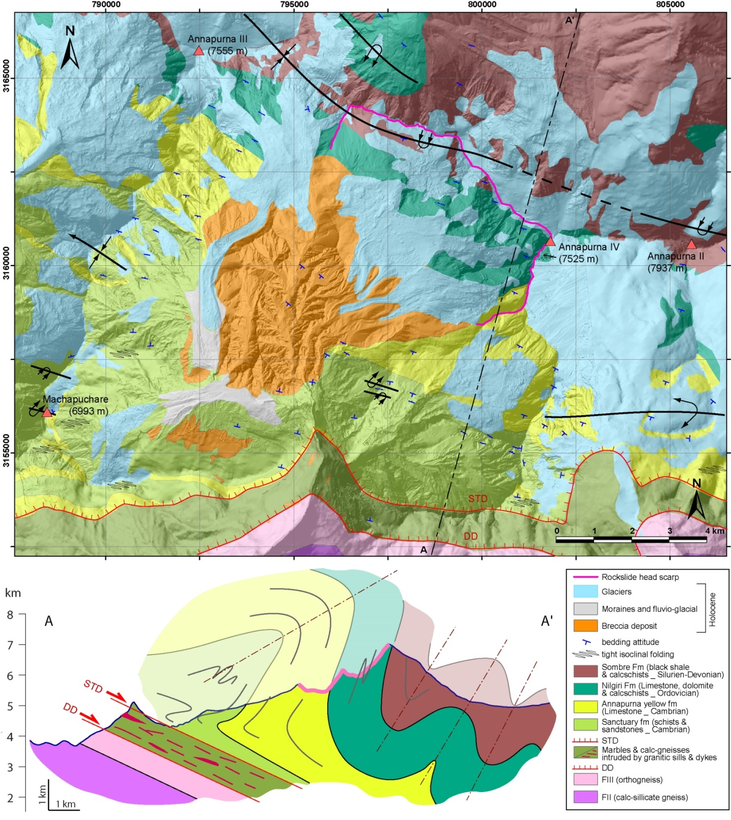

Extended Data Fig. 1: (upper) Interpretative geologic map of the Sabche cirque area based on published maps^{30,75} West and North of the cirque. The TSS units that outcrop along those cliffs correspond to the base of the TSS series, namely carbonate-rich sediments, Cambrian to Silurian in age, and presenting an upward decreasing degree of metamorphism³⁰. The different lithologic limits were extrapolated across the cirque based according to our observations made on photos taken from ultralight aeroplane and helicopter, and from satellite images. Structures and bedding attitudes were also estimated from photos or from the tri-stereo DEM. (lower) Interpretative structural cross section AA’ (see location on main map) built according to published sections further West^{30,75} and to the bedding attitude we estimated from a large set of airplane photos or from the DEM. The northern part of the section, which has been affected by the rockslide, is relatively well constrained since bedding are pretty well identifiable on photos. The southern part is much less constrained because the Sanctuary units display less identifiable beddings and because the structure is much more heckled with numerous small-scale folding. STD = South Tibetan Detachment, DD = Deodali detachment.

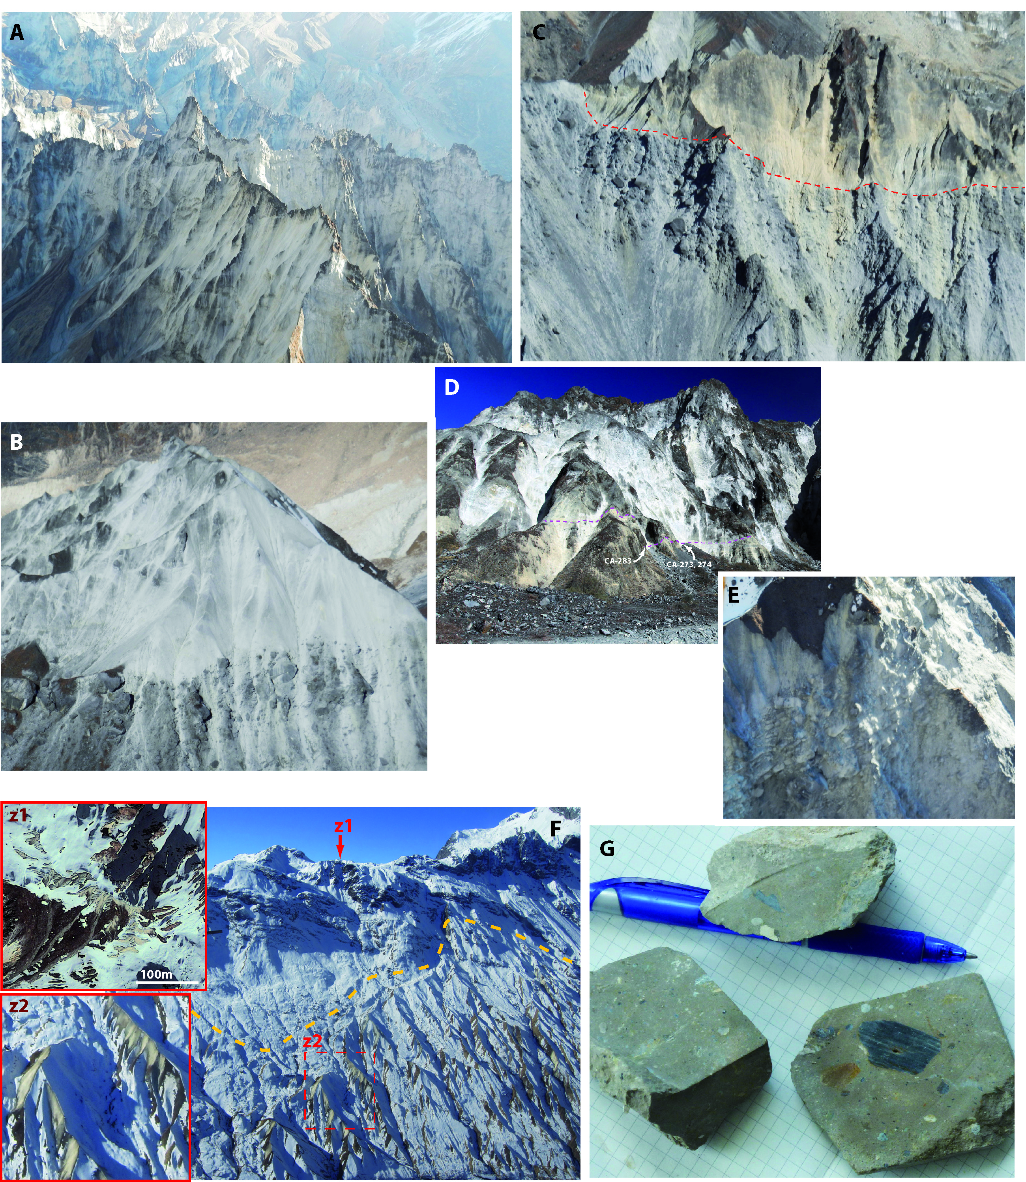

Extended Data Fig. 2: Different facies of the breccia deposit in Sabche cirque (photos A to F = taken from an ultra-light aeroplane _ See pictures location on fig. 1 in Supp. Info.): (A) compact, homogeneous, pulverized and indurated fine grained breccia exposed over ~200 m high cliffs; (B) and (C) package of coarse and blocky material topped by more finely pulverized fine grained breccia material; (C) and (D) Internal contacts between grey and yellowish breccia facies (issued from the Annapurna Yellow Limestone formation³⁰) presenting inverted order and suggesting limited mixing during the rockslide collapse; (D) Contact close to the southern base of the cirque deposit in its southern part: this contact, slightly sloping towards the N or NW, presents as a thin band of shearing and micro-crushing where IRSL samples were taken (CA-273, -274 and -283). (E) Rare preserved phantom of limestone dismantled strata, or jigsaw facies. (F) In the southern part of the cirque, veneers of breccia deposit are preserved on the N-dipping flank of the cirque up to 4250m altitude (z2), and even at the top of the eastern ridge of Macchapuchare (fig. 1) at ~4570m altitude (z1 = satellite image taken on 30/12/2011); (G) Saw-cut samples of compact and indurated facies exposed in the basal part of the deposit (CA-273, site of panel D): the breccia is made of finely crushed material with a few angular clasts.

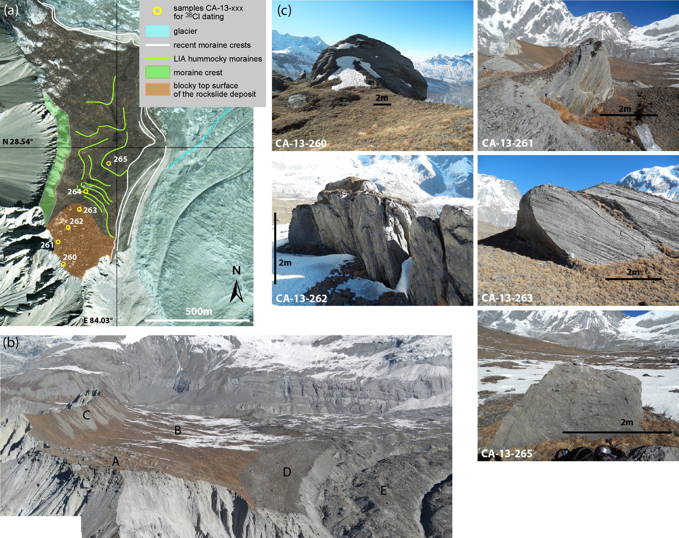

Extended Data Fig. 3: The main dated relic of the rockslide deposit surface in the upper Sabche cirque
(a) Satellite image (Google Earth) of a large flat area in the northern part of the Sabche cirque. This flat area corresponds to the top of the rockslide deposit (4600m), which was amply resurfaced by glaciers except along its southern part where the original surface is covered with numerous multi-metric blocks. (b) Picture taken from an ultra-light aeroplane of the area, south of which the multi-meter blocks CA-13-260 to 265 were sampled. (A: original chaotic upper surface of the rockslide deposit; B: gently hilly surface of the hummocky moraine deposits; C: crested moraine left by the glacier issued from the South-Eastern face of the Annapurna III and which is now deeply entrenched into the breccia deposit; D: recent moraine left by the glacier issued from the West face of the Annapurna IV; E: present-day glacier issued from the West face of the Annapurna IV). (c) Five of the six blocks sampled for cosmogenic ³⁶Cl dating at the top of this relic surface. All the blocks of the surface consist of carbonate rocks: limestone, marly to sandstone limestone, sandstone marl. These lithologies are finely schistosed and their surface physically weathered.

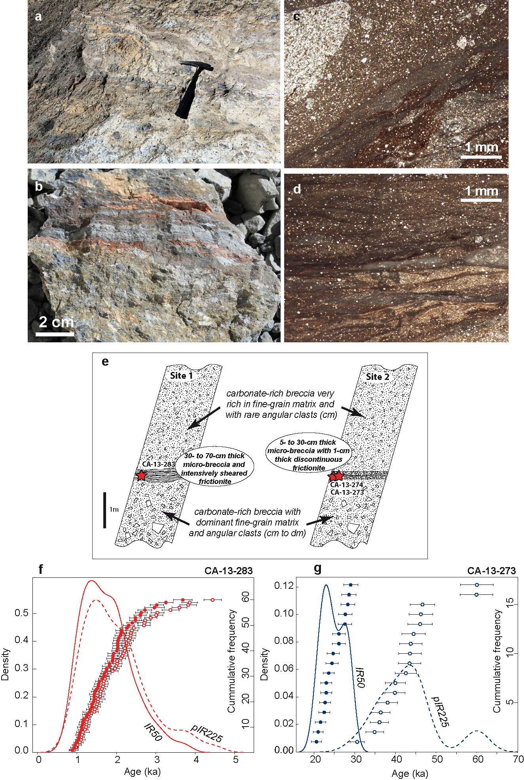

Extended Data Fig. 4: Internal shear zone near the basal part of the rockslide deposit in the Sabche cirque and IRSL dating (see location on fig. 1C). (a) The shear zone varies in thickness from a few centimetres up to 30cm at the level of fish-like structures (to the left of the hammer). (b) The shear zone (sample CA-13-283) appears as colored bands of relatively compact breccia made of centimeter size angular clast within a finer yellowish matrix; (c & d) Thin sections observed under polarizing microscope, cut into the shear zone perpendicularly to the shearing plane and showing thin zones of homogeneous finely fragmented almost glassy material within microbreccia facies with locally remnant of larger clasts. (e) Schematic sedimentologic description of the breccia around shear zone at 2 sites, around 40m apart (Extended Data fig. 2D). (f and g) Age distributions (fading-corrected) and kernel density estimate (KDE) plots for samples CA-13-283 and -273 respectively. IR50 ages and KDE are represented by filled circles and thick line, respectively. pIR225 ages and KDE are represented by open circles and dashed line, respectively.

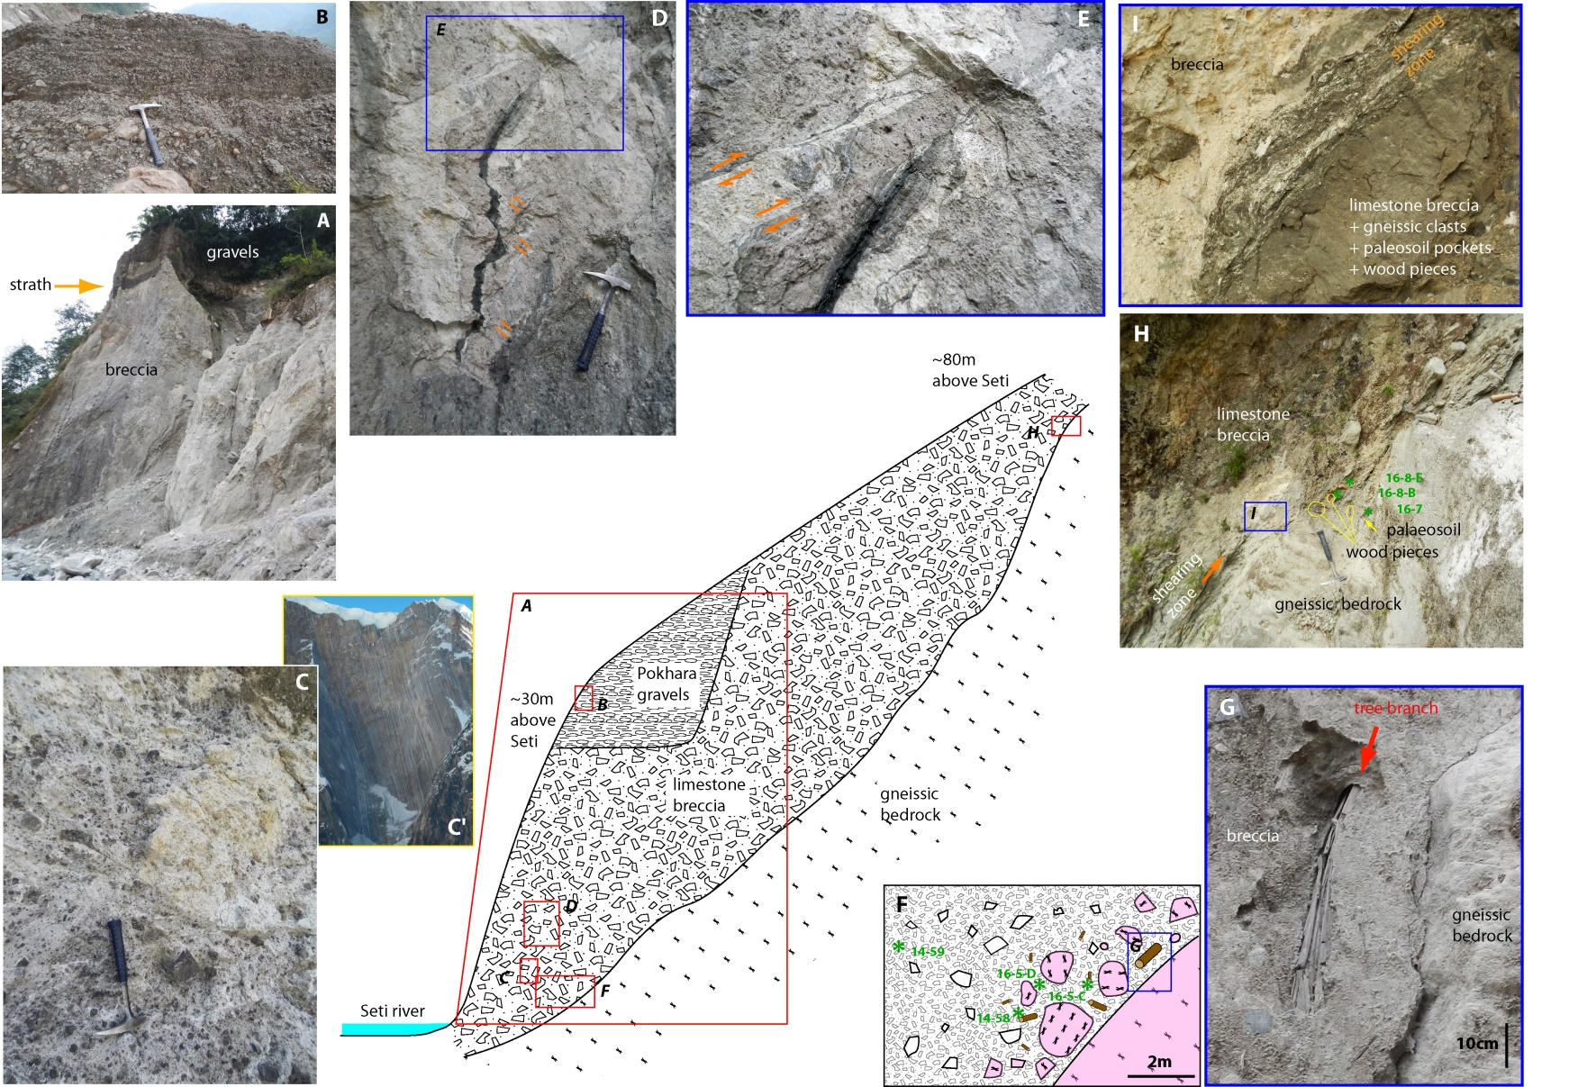

Extended Data Fig. 5: Outcrops near Karuwa (site K on fig. 1) exposing the stratigraphy of the granular avalanche breccia deposit.
(A) 40-m-high cliff overhanging the Seti river, exposing breccia of the granular avalanche material and cut by a small inset terrace capped by a filling of (B) finely-layered limestone rich gravels of Pokhara conglomerates. (C) Breccia facies with juxtaposition of parts made of limestone/marble of different colors with pockets of whitish elements and matrix within a set of darker elements and matrix. The size of elements, the proportion of clast vs. matrix, as well as the carbonate content remain however similar between the different colored areas. They are interpreted as figure of incomplete mixing at meter-scale of the avalanche material issued from the basal Ordovician units that display alternation of light and dark layers in the Sabche cirque along the steep SW face of the Annapurna IV (C’). (D) Internal part of the breccia displaying dyke injection of a fluid rich phase that coloured the breccia, and the post-injection (E) multiple brittle to ductile faulting and shearing of this dyke and of its shoulders. (F) Schematic section of the contact between the avalanche brecciatic deposit and the gneissic bedrock of the Seti valley flanks. This contact displays a transition in terms of lithology and clast size: breccia with large (up to >1m) and sub-angular to rounded boulders of local biotitic gneisses are progressively replaced by smaller angular elements (<30cm) within a matrix-dominant material made of ~100% of TSS lithologies. The gneiss rich unit, which corresponds to local material dragged and entrained at the base of the avalanche, contained quantity of millimetric to sub-metric pieces of vegetal debris (root, branch and trunk (G)) ripped from the sides of the valley, and whose density decreases also rapidly away from the former valley wall. (H) Bedrock/breccia contact in the upper part of the talweg displaying a contact zone, 0 to 40-cm thick, made of a mixture between limestone breccia, local gneissic clasts, and paleosoil pockets, including numerous wood debris, and the presence of a (I) shearing zone of a few centimetres thickness. Green numerical codes correspond to the names of the samples (CA-xx-xx) dated by ¹⁴C.

²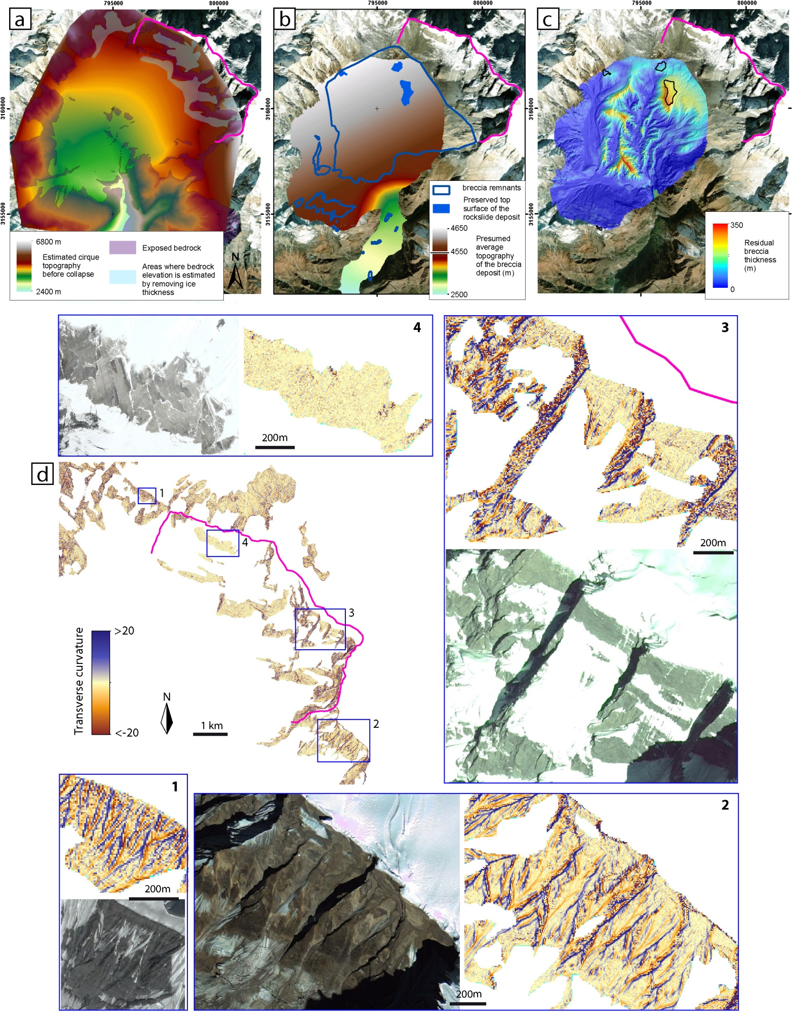

Extended Data Fig. 6: Maps of the base (a) and top (b) of the rock avalanche brecciated deposits, including the interpolation constraints, and (c) present-day residual thickness of the breccia deposits.
(d) Sabche rockslide scar identification from the transverse curvature (m⁻¹) computed from the high resolution (2-m pixel) topography. The recent scar surface (3 and 4) is characterized by step like dihedrals that delineate planar faces with low curvature along the stratification/foliation planes and irregular faces following a set of fractures at 90°. In contrast, outside the scar (1 and 2), the topography displays the first marks of erosion and gullies organisation toward a converging network.
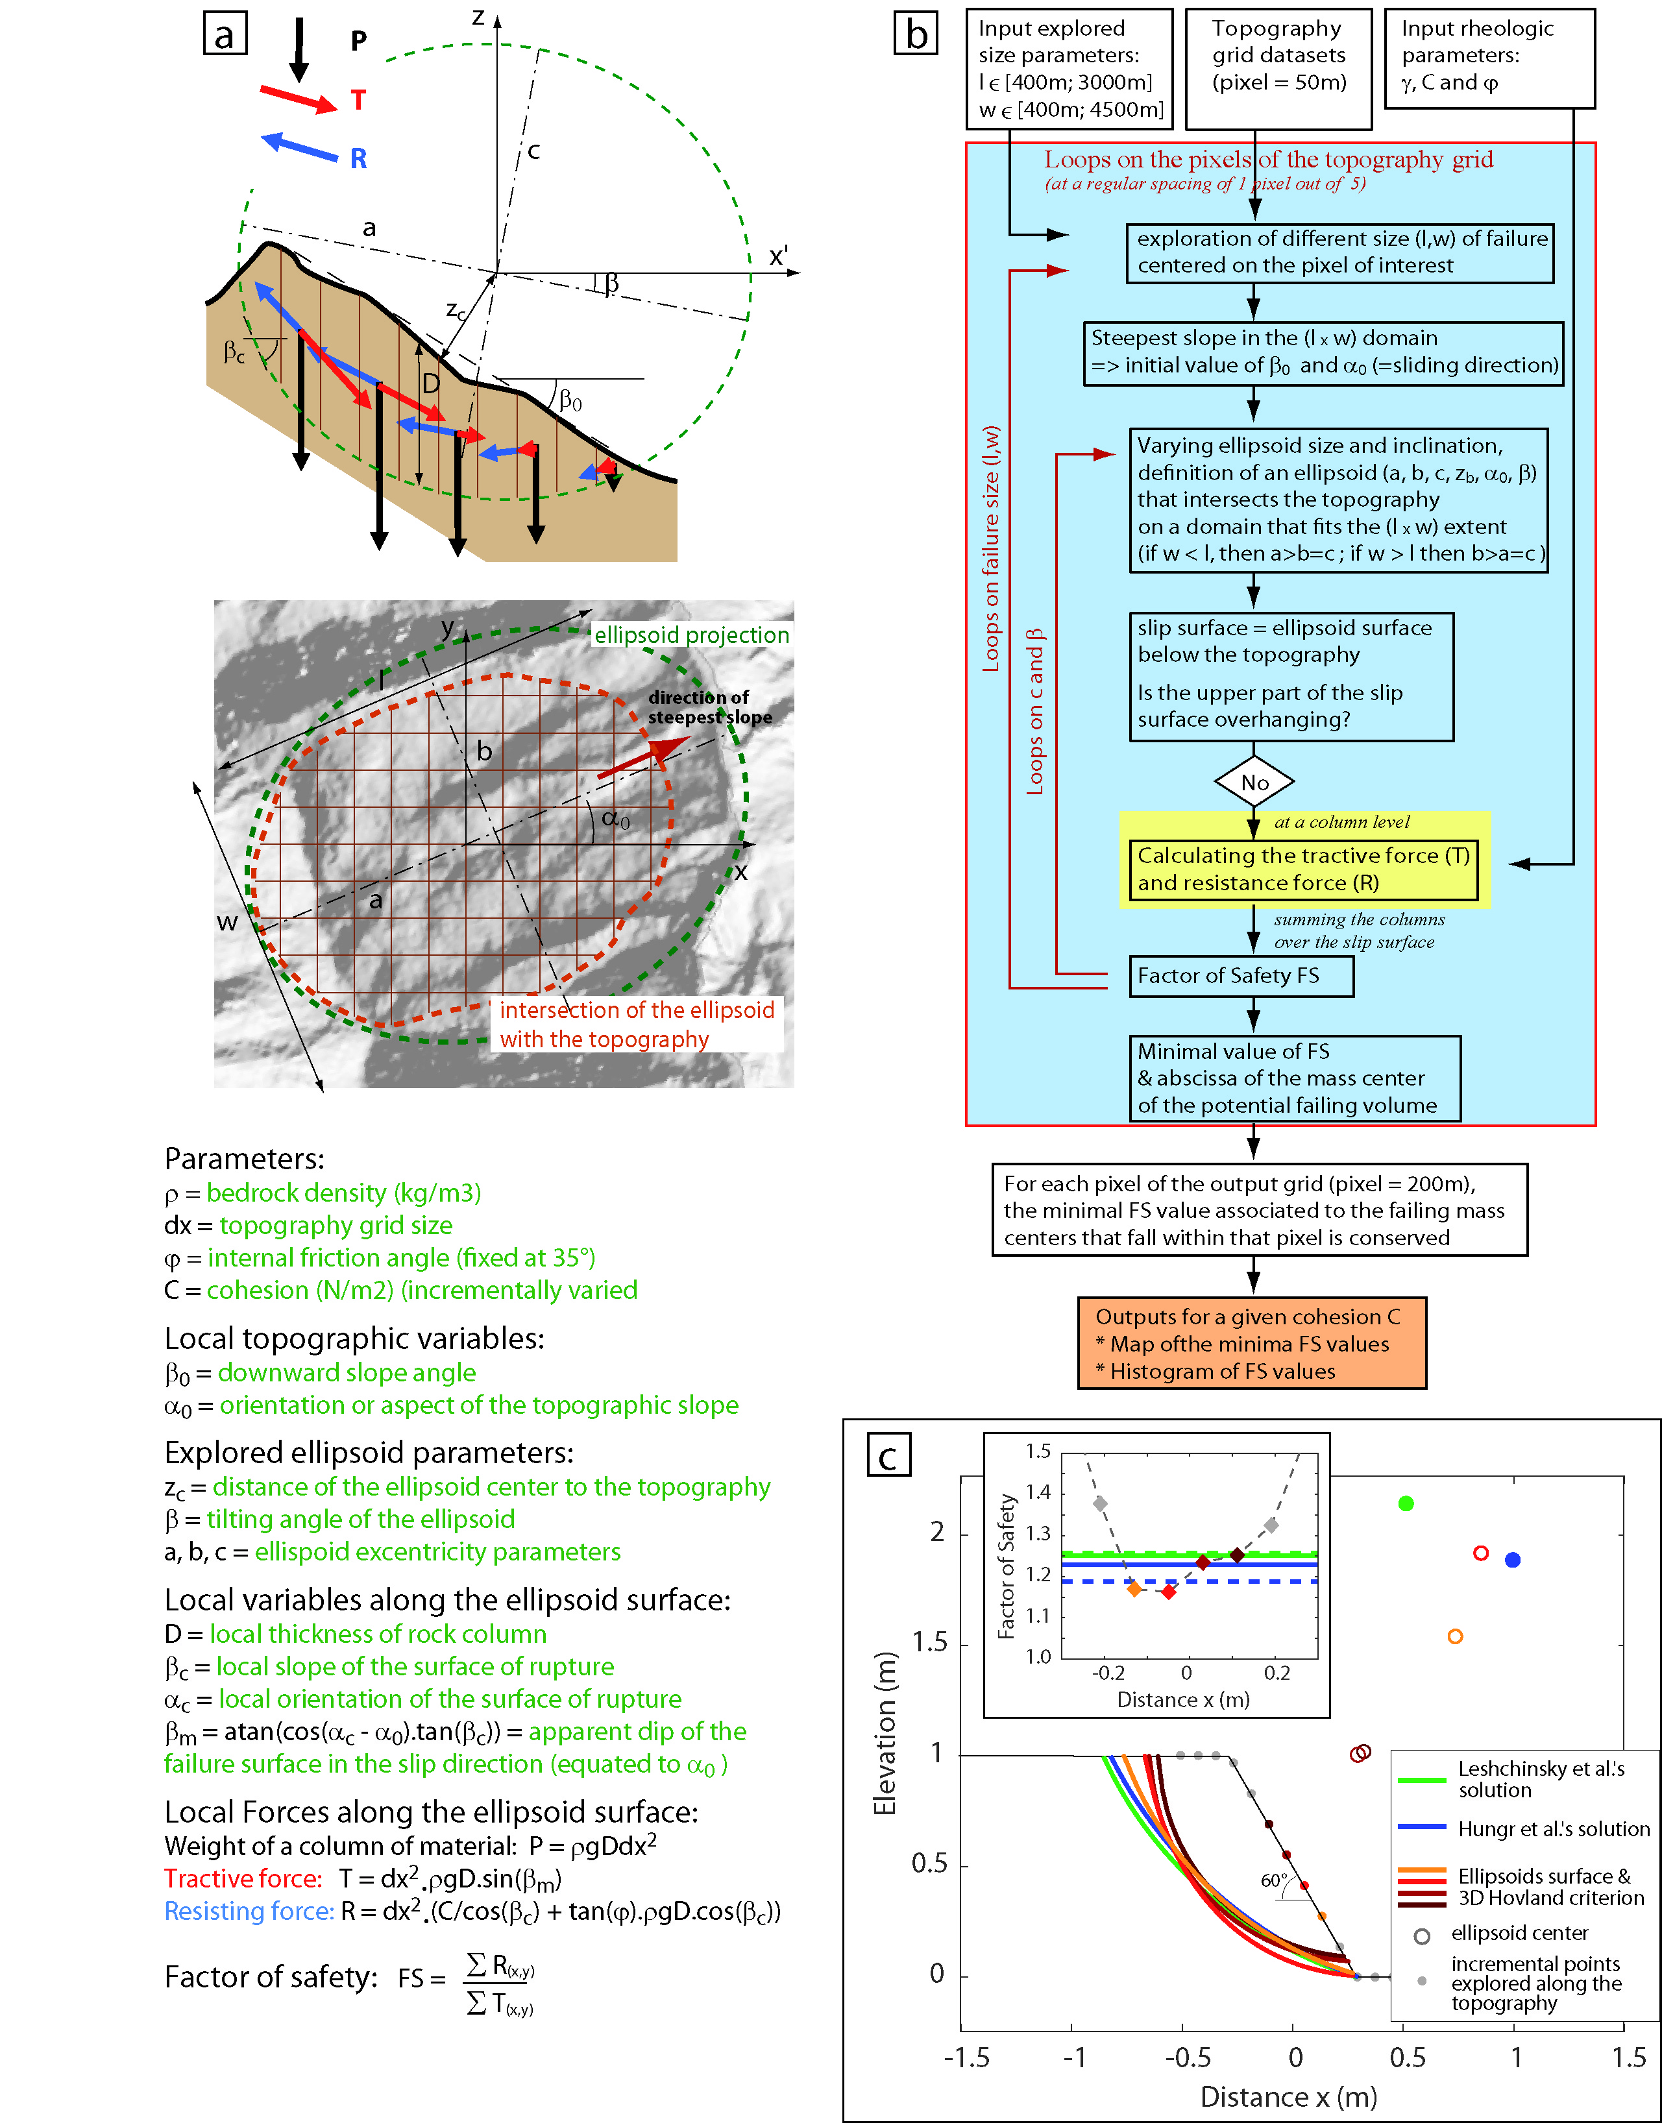

Extended Data Fig. 7: (a) Definition of the variables for the computation of the Factor of Safety (FoS) according to 3D-Hovland criterion⁷¹, and (b) computation chart of the searching procedure of the ellipsoid-type failure surfaces that minimize the FoS all over the topography of a given region. (c) Validation test of the searching procedure in the case of a topographic step, 1-m high, dipping at 60° with ϕ = 15° and C = 0.116 Pa. The optimal ellipsoids surfaces at the four increments that present minimal FoS are compared with close-formed solutions^{72,73}. The FoS values remain within 5% of the ones associated to these solutions whatever the nominal value (solid line) or the one calculated with 3D-Hovland criterion applied to their geometry (dashed line) is considered.

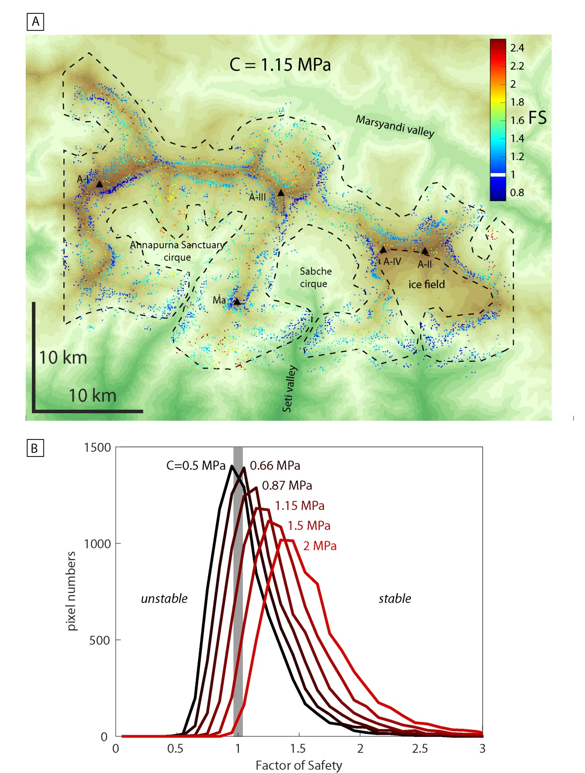

Extended Data Fig. 8: (A) Map of the minimum FoS along the hillslopes of the Annapurna high relief found using the systematic searching procedure (ED-fig. 7) within the area delineated by the dashed line. Calculation is made for an internal angle of friction of 35° and a cohesion, C, of 1.15 MPa. The steepest faces surrounding the highest peaks (black triangles), like the SSE face of the Annapurna I (A-I), one of the most challenging climbing route in High Himalaya, present a Factor of Safety lower than 1 and would be considered as unstable for this given cohesion value. Note that for a given pixel, the search procedure may have found several optimal failures, of different sizes, whose centers of mass related to the same pixel: in this case, the failure with the minimum FoS was chosen. A-II =Annapurna II, A-III =Annapurna III, A-IV =Annapurna IV, and Ma = Machapuchare. (B) Histograms of the values of the FoS for different values of cohesion, C, between 0.5 and 2 MPa. For C=2MPa, almost all the hillslopes are apparently stable.

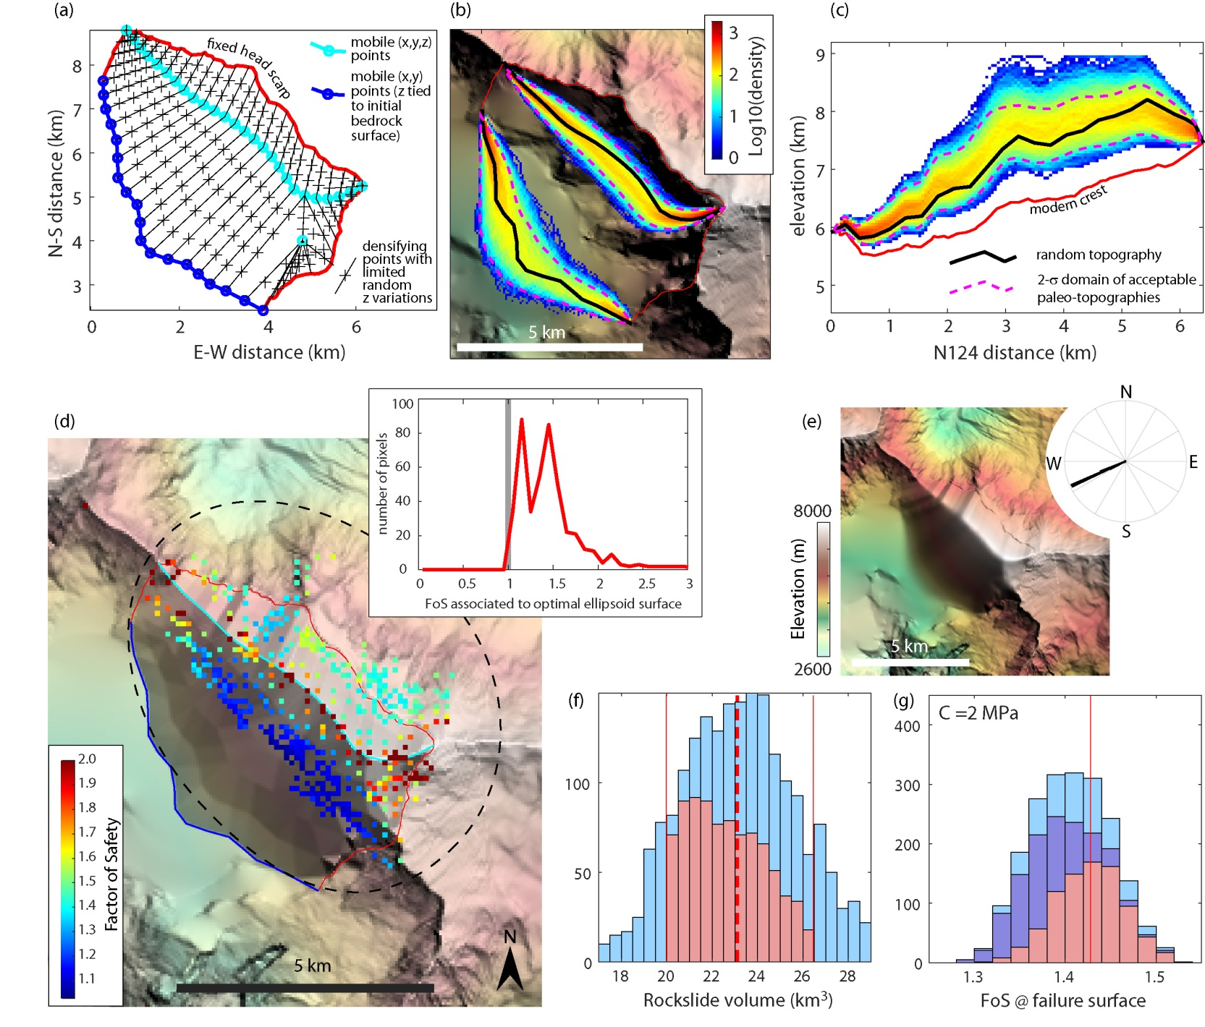

Extended Data Fig. 9: Paleo-summit reconstruction
(a) Construction points used to build simplified topography of the paleosummit. This construction is essentially based on two main lines, whose geometry is explored in a random way: the paleocrest (in cyan) and the paleocliff SW base (in blue). These lines are built as the sum of harmonics function (up to the 8th term) of random amplitude and phase. The two extremities of the paleocrest have been chosen to prolong on average the direction of the present crests line further West and East. Similarly, the extremities of the base of the SW cliff and the isolated mobile point (in cyan) were chosen to prolong the SW-facing cliffs of the Sabche cirque. Densifying points are then added before using Matlab© interpolation function griddata. (b) Map extent of the density (in log scale) of the random paths explored for the paleocrest and the paleobase, with one random example of path (black solid line). (c) Same as (b) but for the elevation profile of the paleocrest. In both graphs, purple lines indicate the 95% probability of the density of the a posteriori paths that respect both rockslide volume and hillslope stability constraints. (d) Map and histogram (inset graph) of the FoS values obtained through the searching procedure (ED-fig. 7) applied, within dashed lines and for a cohesion value of C=2 MPa, to one of the randomly generated paleotopography. (e) Average shape of the topographies that satisfy rockslide volume and regional stability criterion, including a rose diagram of the optimal sliding direction N245 (i.e. the direction that minimizes the FoS on the failure surface). (f) Histogram of the volumes of the collapsed summit explored by the generator of random topographies. 75% of the values fall within the range of the volume estimated for the rockslide. The topographies that satisfy the regional stability criterion are superimposed in pink colour. (g) Histograms of the FoS on the failure surface for cohesion values C=2 MPa. The topographies that satisfy the rockslide volume are superimposed in darker colour, and the ones that satisfy both rock volume and regional stability criterion in pink colour.

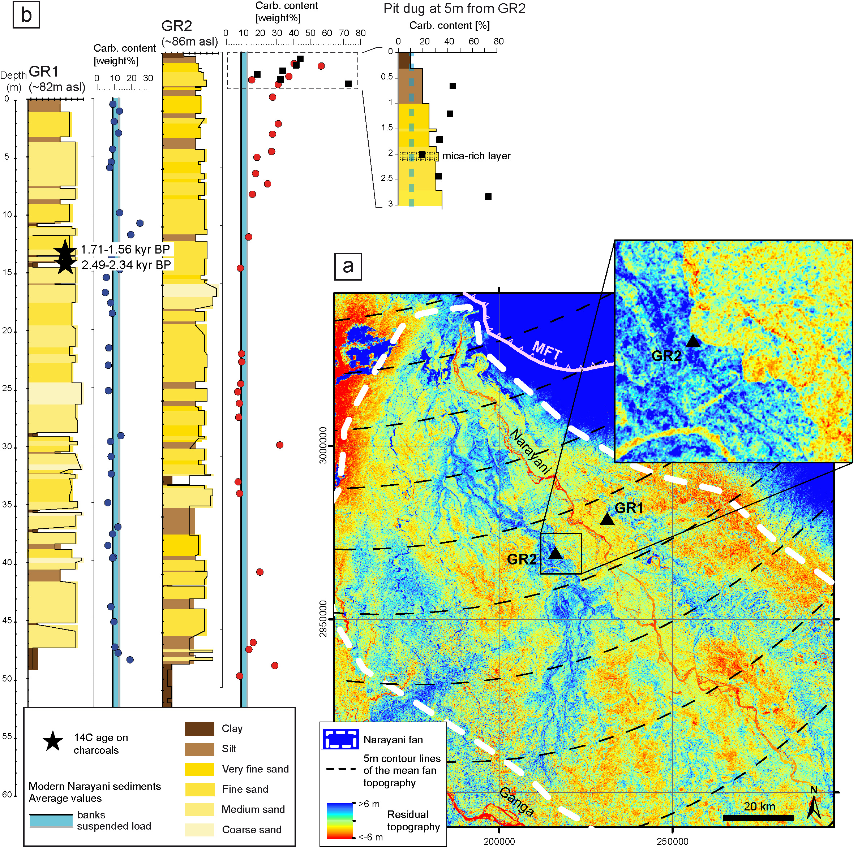

Extended Data Fig. 10: Possible Sabche rockslide signature in the Gandak fan?
(a) Stratigraphic log and carbonate content of two 50-m long cores, GR1 and GR2, drilled in the Gandak fan⁷⁶. The two boreholes GR1 and GR2 show relatively constant carbonate percentages close to the current river values (represented by the blue and gray lines respectively). Nevertheless, GR2 is characterized by a 25-30% anomaly between -10 and -3m, and by a very strong 35-70% carbonate anomaly between -3m and the surface. This anomaly was corroborated by additional measurements on samples taken in a 3-m-deep small pit dug in the close vicinity of the GR2 drill site. Such a recent anomaly in carbonate content might correspond to deposition of the fine fraction of the sediments issued from the Sabche cirque erosion, 300km further downstream. Whereas these carbonate rich units are not directly dated, ¹⁴C ages in GR1 core indicate that they are probably younger than ~1.5 kyr, which is compatible with a deposit related to the Annapurna IV collapse and more or less synchronous of the Pokhara conglomerate deposits.
(b) Residual topography obtained by subtracting a second order polynomial fit (dashed lines = Trend function in ArcGis) to the topography (30m SRTM) of the Narayani fan. This residual topography enables to highlight small topographic variations on the surface of the fan. It is seen that GR1 was drilled in the recent flood plain of the Narayani (in yellow to reddish colors), while GR2 was drilled in a N-S lobe 3 to 5 meters higher than the rest of the fan (in bluish colors). This lobe, which was then re-incised on its eastern border by the Narayani (see zoomed image) could have been built during the episode of strong sediment input that followed the collapse in the Sabche cirque.

