89 full-text articles excluded, with reasons:

- Overlapping samples
- Conference Abstracts
- Wrong units (i.e. cm3)
- Different methods
- No control groups
- Missing SD for means

968 records identified through database searching
318 duplicates removed
650 Abstracts screened for eligibility
535 records excluded, not eligible
Identification
Screening
Included
Eligibility
26* studies included in quantitative synthesis (meta-analysis)
115 full-texts assessed for eligibility

Supplementary Figure 1: PRISMA flowchart detailing the process for screening and including relevant studies
*Ibrahim et at (2017) reported results on males and females separately and for the purposes of our analysis, we counted this as two ‘studies’, therefore final n= 27
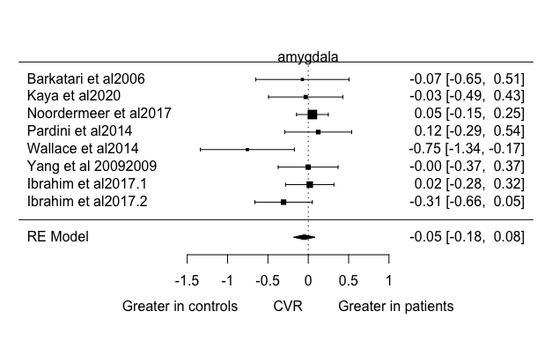

Supplementary Figure 1A: Forest plot depicting coefficient variability ratio (CVR) in studies measuring amygdala volume.

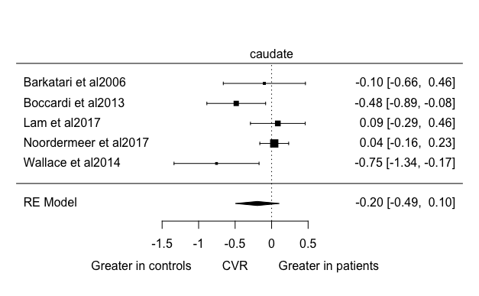

Supplementary Figure 1B: Forest plot depicting coefficient variability ratio (CVR) in studies measuring caudate volume.

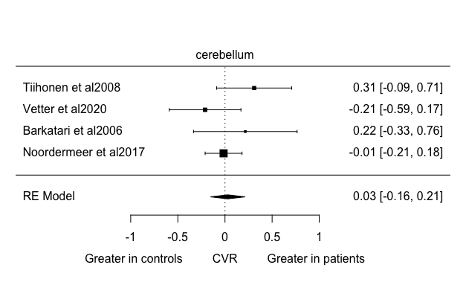

Supplementary Figure 1C: Forest plot depicting coefficient variability ratio (CVR) in studies measuring cerebellum volume.

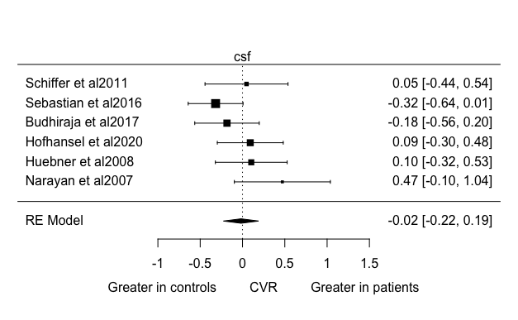

Supplementary Figure 1D: Forest plot depicting coefficient variability ratio (CVR) in studies measuring CSF volume.

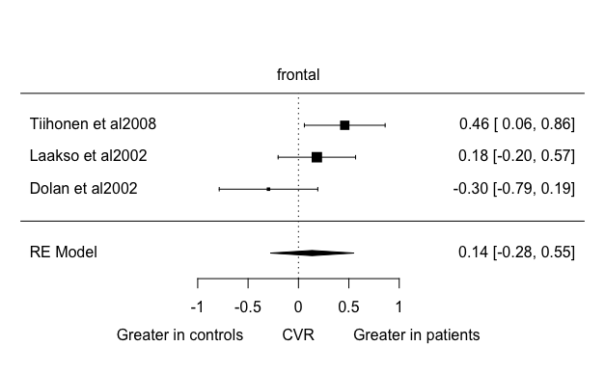

Supplementary Figure 1E: Forest plot depicting coefficient variability ratio (CVR)) in studies measuring frontal lobe volume.

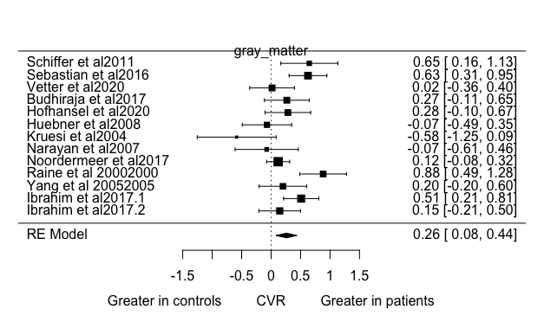

Supplementary Figure 1F: Forest plot depicting coefficient variability ratio (CVR)) in studies measuring gray matter volume.

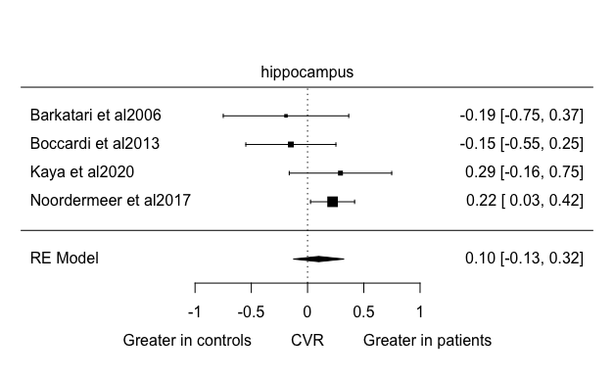

Supplementary Figure 1G: Forest plot depicting coefficient variability ratio (CVR)) in studies measuring hippocampal volume.

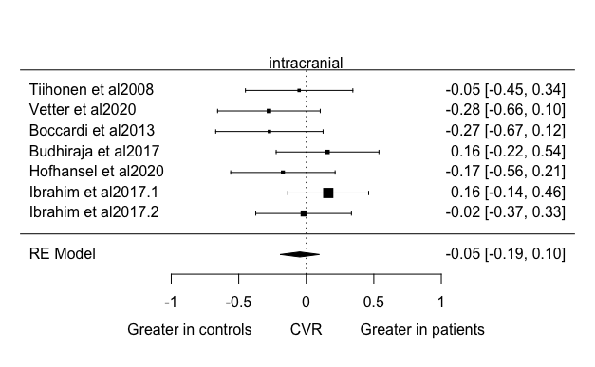

Supplementary Figure 1H: Forest plot depicting coefficient variability ratio (CVR) in studies measuring intracranial volume

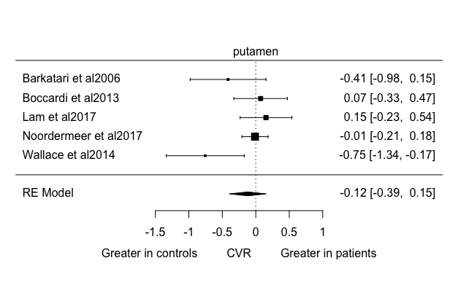

Supplementary Figure 1I: Forest plot depicting coefficient variability ratio (CVR) in studies measuring putamen volume.

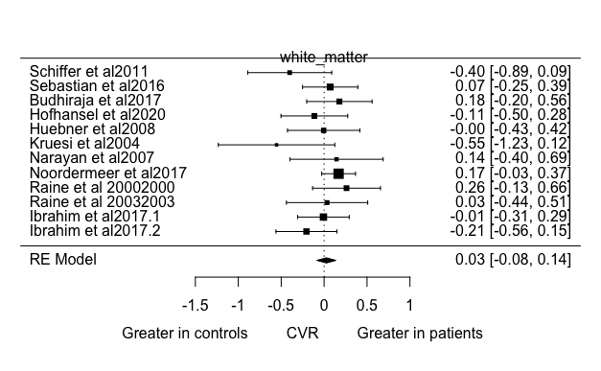

Supplementary Figure 1J: Forest plot depicting coefficient variability ratio (CVR)) in studies measuring white matter volume.

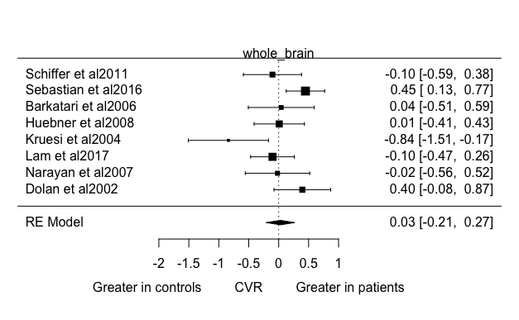

Supplementary Figure 1K: Forest plot depicting coefficient variability ratio (CVR) in studies measuring whole brain volume.

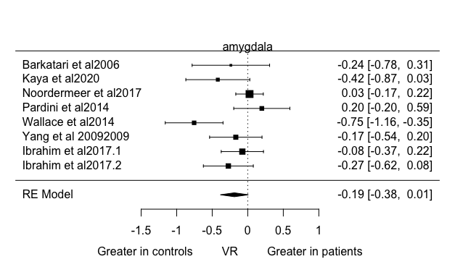

Supplementary Figure 2A: Forest plot depicting variability ratio (VR) in studies measuring amygdala volume.

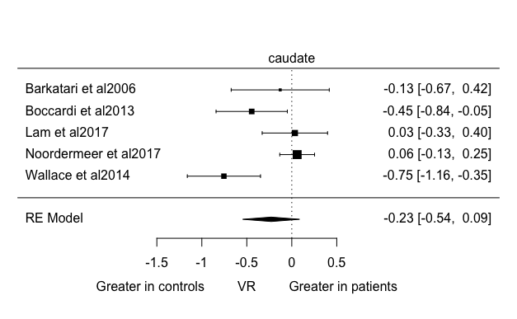

Supplementary Figure 2B: Forest plot depicting variability ratio (VR) in studies measuring caudate volume.

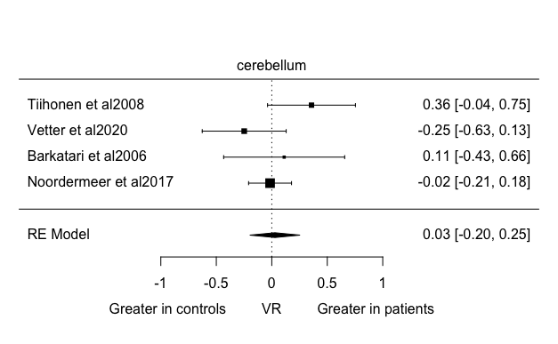

Supplementary Figure 2C: Forest plot depicting variability ratio (VR) in studies measuring cerebellum volume.

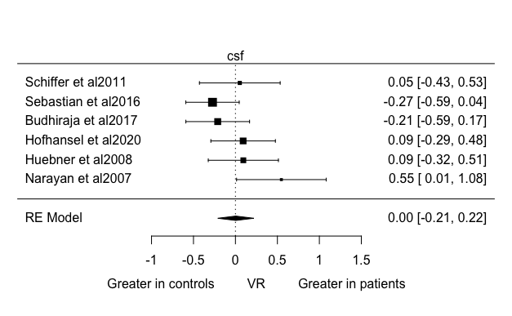

Supplementary Figure 2D: Forest plot depicting variability ratio (VR) in studies measuring CSF volume.

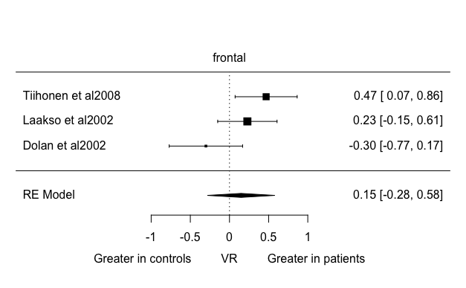

Supplementary Figure 2E: Forest plot depicting variability ratio (VR) in studies measuring frontal lobe volume

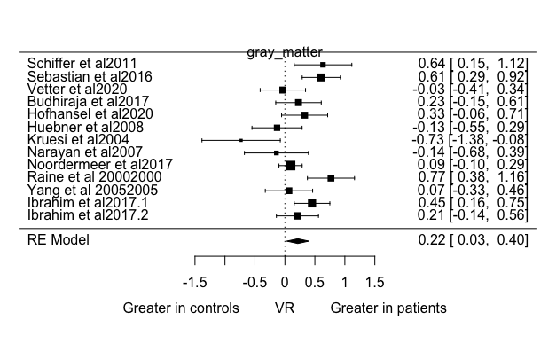

Supplementary Figure 2F: Forest plot depicting variability ratio (VR) in studies measuring Gray matter volume.

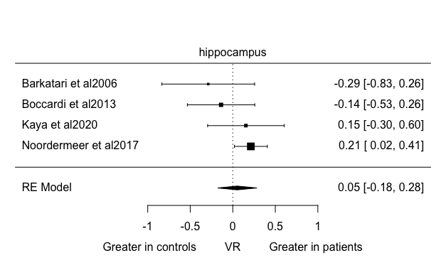

Supplementary Figure 2G: Forest plot depicting variability ratio (VR) in studies measuring hippocampal volume.

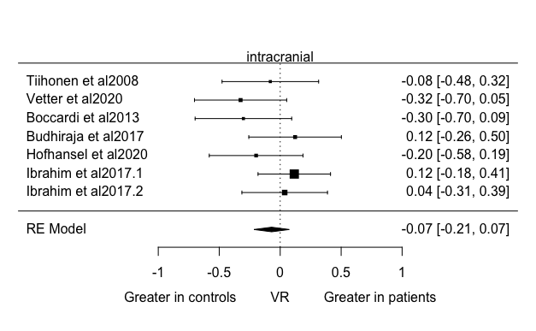

Supplementary Figure 2H: Forest plot depicting variability ratio (VR) in studies measuring intracranial volume.

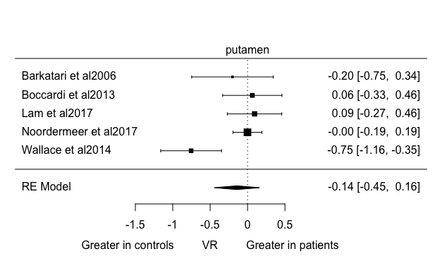

Supplementary Figure 2I: Forest plot depicting variability ratio (VR) in studies measuring putamen volume.

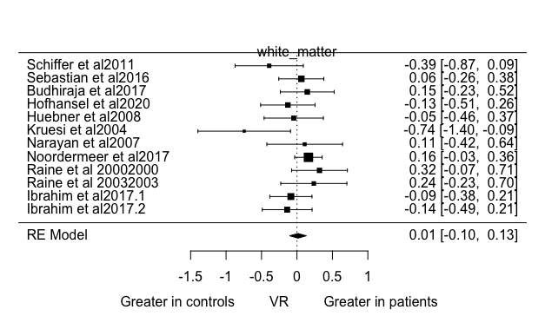

Supplementary Figure 2J: Forest plot depicting variability ratio (VR) in studies measuring white matter volume.

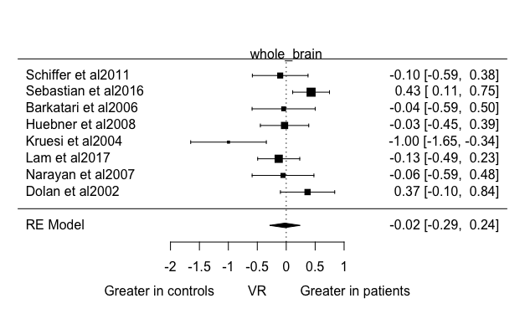

Supplementary Figure 2K: Forest plot depicting variability ratio (VR) in studies measuring whole brain volume.

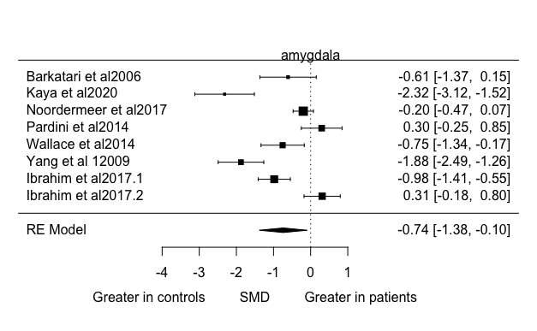

Supplementary Figure 3A: Forest plot depicting standard mean difference (SMD) in studies measuring amygdala volume.

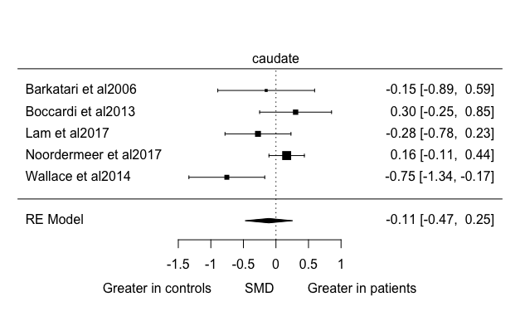

Supplementary Figure 3B: Forest plot depicting standard mean difference (SMD) in studies measuring caudate volume.

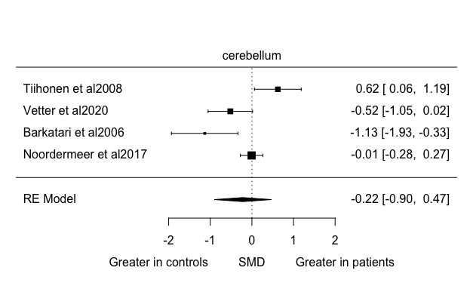

Supplementary Figure 3C: Forest plot depicting standard mean difference (SMD) in studies measuring cerebellum volume.

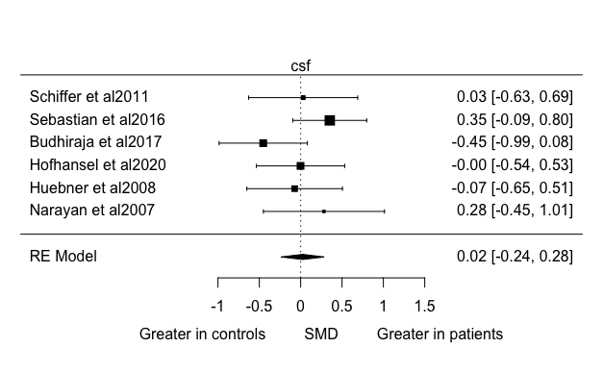

Supplementary Figure 3D: Forest plot depicting standard mean difference (SMD) in studies measuring CSF volume.

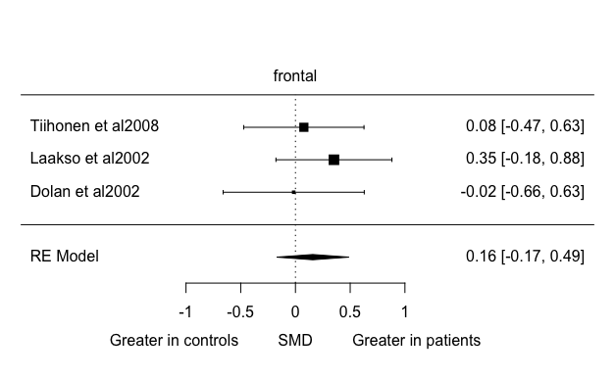

Supplementary Figure 3E: Forest plot depicting standard mean difference (SMD) in studies measuring frontal lobe volume.

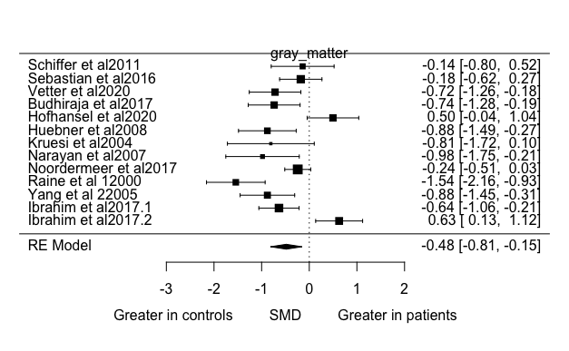

Supplementary Figure 3F: Forest plot depicting standard mean difference (SMD) in studies measuring gray matter volume.

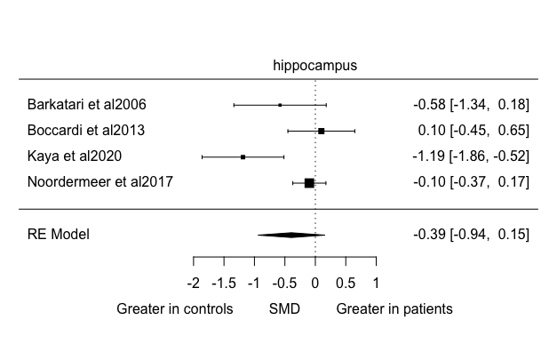

Supplementary Figure 3G: Forest plot depicting standard mean difference (SMD) in studies measuring hippocampal volume.

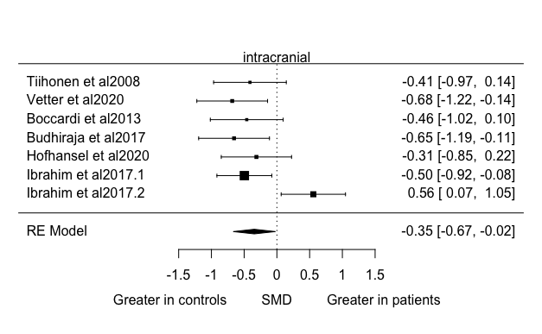

Supplementary Figure 3H: Forest plot depicting standard mean difference (SMD) in studies measuring intracranial volume.

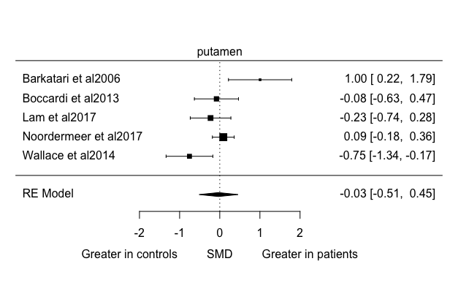

Supplementary Figure 3I: Forest plot depicting standard mean difference (SMD) in studies measuring putamen volume.

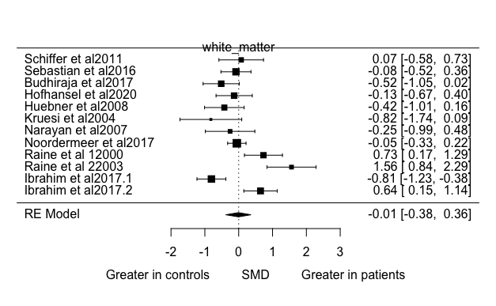

Supplementary Figure 3J: Forest plot depicting standard mean difference (SMD) in studies measuring white matter volume.

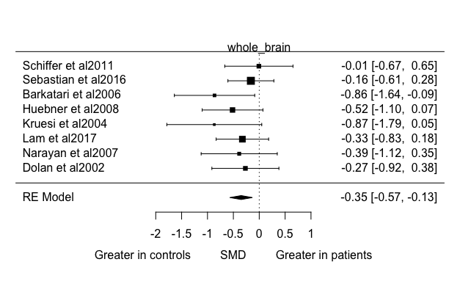

Supplementary Figure 3K: Forest plot depicting standard mean difference (SMD) in studies measuring whole brain volume.

Supplementary Table 1: Correlation coefficient for each combined left and right hemisphere brain region

Strategy for studies where subregional volumes reported
For regions such as frontal, temporal, occipital, and parietal lobes, where subregions were reported (e.g. orbitofrontal cortex or lateral temporal pole), we planned to combine any subregions reported within a region, and use these data in our analysis.

Metaregressions for variability- lnVR
Control:patient IQ ratio was significantly associated with variability (lnVR) in whole brain and amygdala (Z= -3.34, p = 0.0008; Z= -2.064, p = 0.039 respectively.
Age was not associated with variability differences for any region, and there were insufficient studies including female participants for the planned meta-regression of sex.

