Supplementary Information for
In-situ buried interface passivation enables efficient and stable inverted perovskite solar modules
Lin Li¹†, Haipeng Zeng¹†, Mingyang Wei²†, Virginia Carnevali³†, Min Li¹, Nikolaos Lempesis³, Felix Thomas Eickemeyer², Long Luo¹, Lorenzo Agosta³, Mathias Dankl³, Shaik M. Zakeeruddin², Yaoguang Rong^{1*}, Ursula Roethlisberger^{3*}, Michael Grätzel^{2*}, Xiong Li^{1*}
¹Michael Grätzel Center for Mesoscopic Solar Cells, Wuhan National Laboratory for Optoelectronics, Huazhong University of Science and Technology, Wuhan 430074 China.
²Laboratory of Photonics and Interfaces, Institute of Chemical Sciences and Engineering, École Polytechnique Fédérale de Lausanne (EPFL), CH-1015 Lausanne, Switzerland.
³Laboratory of Computational Chemistry and Biochemistry, Institute of Chemical Sciences and Engineering, École Polytechnique Fédérale de Lausanne (EPFL), CH-1015 Lausanne, Switzerland.

†These authors contributed equally to this work.
*Corresponding author. Email: ursula.roethlisberger@epfl.ch; ygrong@hust.edu.cn; michael.graetzel@epfl.ch; xiongli@hust.edu.cn.

Materials and Methods
Materials
Nickel (II) nitrate hexahydrate, (Alfa Aesar, 99.99%), (DMF, 99.8%), dimethyl sulfoxide (DMSO, 99.7%), γ-butyrolactone (GBL, 99.5%) and chlorobenzene (CB, 99.8%) were purchased from Acros. Lead iodide (PbI₂, 99.99%), cesium iodide (CsI, 99.99%), lead bromide (PbBr₂, 98%), and bathocuproine (BCP) were purchased from TCI. FAI and MABr were purchased by Suzhou SolarFlex Tech. PCBM was purchased from Xi’an Polymer Light Technology Corp. Indium tin oxide (ITO) (transmission>95%) substrates were purchased from Yingkou OPV Tech Co., Ltd. All the materials were used as received unless specified. We synthesize BT-T according to the reported method.^{1,2} NiO_{x} NPs were synthesized according to a previously reported method as well.³
PSCs and PSMs fabrication
The ITO substrates were sequentially ultrasonic cleaned with detergent, deionized water (DI water), acetone, and isopropanol (IPA) for 20 min, respectively. Then, the ITO substrates were dried with nitrogen and treated in plasma for 4 min. Pristine NiO_{x} films were formed on ITO by spin coating 15 mg NiO_{x} in 1 mL of a mixed solution of deionized water and IPA (4:1, v/v) at 3500 rpm for 40 s and then annealed at 100°C for 20 min in an air-filled glovebox (humidity~45%). Mixed-cation/anion perovskite absorber films 1.4 M Cs_{0.05}(FA_{0.90}MA_{0.10})_{0.95}Pb(I_{0.905}Br_{0.095})₃ precursor solution with 2% excess PbI₂ in 1 mL of a mixed anhydrous solvent of DMF and DMSO. The ratio of the solvents was fixed at 4/1 (DMF/ DMSO) by volume. For fabrication of the perovskite film, the substrate was spun at 1,000 r.p.m. for 10 s with an initial acceleration of 500 r.p.m., and then at 5000 r.p.m. for 25 s with an acceleration of 2000 r.p.m. per second. In the second step, ethyl acetate (EA, 125 μL) was added dropwise onto the substrate during the last 5 s of spinning. The substrate was immediately placed on a hotplate and annealed at 120 °C for 30 min. CsFAMA-BT-T was prepared by adding 0.24 wt% BT-T into the perovskite precursor solution. PCBM (20 mg mL⁻¹ in CB) was spin-coated on top of the perovskite films at a speed of 3500 r.p.m. for 30 s. The BCP solution (0.5 mg·mL⁻¹ in IPA) was spin-coated with 5,000 r.p.m. for 40 s. All the steps were undertaken in a nitrogen-filled glovebox. Finally, the samples were taken from the glove box and finished by thermally evaporating silver (Ag, 100 nm) electrodes.
For the PSMs fabrication: the mini-modules were fabricated on the pre-patterned 5 cm-by-5 cm ITO glass substrates using laser scribing (P1, 1064 nm), following the same HTL procedures as the solar cells. The perovskite films were deposited by a vacuum flash–assisted solution process (VASP), which was used according to our previous work.⁴ Mixed-cation/anion perovskite absorber films 1.4 M Cs_{0.05}(FA_{0.90}MA_{0.10})_{0.95}Pb(I_{0.905}Br_{0.095})₃ precursor solution with 2% excess PbI₂ in 1 mL of a mixed anhydrous solvent of DMF, GBL, and DMSO. The ratio of the solvents was fixed at 2/2/1 (DMF/GBL/DMSO) by volume. The wet film was put into a sealed sample chamber connected to a home-built vacuum pumping system and immediately exposed to low pressure (20 Pa) for 10 s. Subsequently, the perovskite film was put on a hotplate and annealed at 120 °C for 30 min in a nitrogen-filled glove box. PCBM was formed by spin coating the PCBM solution (20 mg mL⁻¹ in CB) at 3,500 r.p.m. for 30 s. After that, the laser of 1064 nm etched the samples to remove the perovskite/PCBM for low contact resistance (P2). After P2, mini-modules were deposited ~ 10 nm atomic-layer-deposited tin (IV) oxide (ALD-SnO₂) as an interdiffusion barrier with 68 ALD cycles. Then Ag electrode (100 nm) was deposited by thermal evaporation using a shadow mask to pattern the electrodes and etched by mechanical scribing (P3) to form the series-connected module.
Device characterization and stability measurement
J-V measurements were conducted using a Keithley 2400 source meter. Simulated AM1.5G irradiation (100 mW cm^{–2}) was produced by a xenon-lamp-based solar simulator (Oriel 94023A, Newport). The light intensity was calibrated by a standard silicon reference cell (Oriel, VLSI standards). The small-area PSCs and PSMs are measured using masks with aperture areas of 1.01 cm² and 17.1 cm², respectively. For the thermal stability tests, all PSCs were aged at 100 ℃ for 100 h under a nitrogen atmosphere. The operational stability tests were carried out at the MPP for the encapsulated PSCs, and PSMs under constant illumination were generated by a 1-sun equivalent white-light LED array with MPP tracking at 65 °C in N₂ atmosphere. The bias at the MPP was calculated and applied automatically. The cells were encapsulated in an N₂-filled glovebox. A hot melt film was attached around the active area of the cells, and a glass slide was employed as the back sheet. The 1-cm² sized PSCs and large-area PSMs are measured using masks with an active area of 1.01 cm² and 17.1 cm², respectively. The mini-module with six strips in the series-connection design.⁵
Film characterization
The surface microstructure of perovskite films was investigated by field-emission scanning electron microscopy (FE-SEM, Hitachi SU8010). The spectra were recorded with a VERTEX 70 Infrared Fourier transform microscope (Bruker Co., Germany). The infrared spectra were recorded with a VERTEX 70 Fourier transform microscope (FTIR, Bruker Co., Germany). The X-ray diffraction (XRD) patterns were collected from an X-ray diffractometer (D8 Advance). X-ray photoelectron spectroscopy (XPS) spectra were measured by a Thermo-Fisher ESCALAB 250Xi system with a monochromatized Al Kα (for XPS mode) under a pressure of 5.0 × 10⁻⁷ Pa.
Photoluminescence quantum yield (PLQY) and time-resolved photoluminescence (TRPL) measurements
TRPL signal was measured via time-correlated single photon counting (TCSPC) using a LifeSpec II (Edinburgh Instruments) fluorescence spectrometer with a picosecond pulsed diode laser (EPL-510, Edinburgh Instruments) at 510 nm wavelength and 85 ps pulse width. The laser fluence used was 5 nJ/cm². PLQY was determined following the procedure suggested by de Mello et al.⁶ The samples were excited using a continuous-wave laser (OBIS LX, 660 nm) whose power was adjusted to match the photogeneration rate under one Sun illumination (0.324 mW, 0.786 mm effective beam FWHM). The signal was collected using an integrating sphere (Gigahertz Optik, UPB-150-ARTA) connected via a multimode, 400 µm diameter optical fiber (Thorlabs BFL44LS01) and a F/#-matcher (SR-ASM-0038, Oxford instruments) to a spectrometer (Andor, Kymera 193i). The system was spectrally calibrated using an irradiance calibration standard lamp (Gigahertz Optik, BN-LH250-V01). Perovskites with a stoichiometry of Cs_{0.05}(FA_{0.87}MA_{0.13})_{0.95}Pb(I_{0.876}Br_{0.0124})₃ were prepared for the measurements.
Nanoscale infrared spectroscopy measurements
AFM-IR experiments were carried out using a commercial AFM-IR setup (NanoIR3s, Bruker, CA, USA) that consists of an AFM microscope operating in contact mode and a Quantum Cascade Laser or QCL laser (MIRcat, Daylight Solutions Inc., CA, USA), that is tunable from 2350 cm⁻¹ to ≈ 870 cm⁻¹ (from 4.25 μm to 11.49 μm). The repetition rate of the QCL laser is tunable to match the contact resonance frequencies of the AFM cantilever. The typical laser spot size is ≈ 50 µm at the sample. AFM-IR experiments were obtained under a nitrogen atmosphere at 1 atm in a custom enclosure built around the sample.
Time-of-flight secondary-ion mass spectrometry (ToF-SIMS) measurements
Compositional depth profiling of perovskite films was carried out using a ToF-SIMS 5 system from IONTOF, operated in the spectral mode and using a 30-keV Bi³⁺ primary ion beam with an ion current of 0.8 pA. For depth profiling, a 1-keV Cs⁺ sputter beam with a current of 28 nA was used to remove material layer by layer in interlaced mode from a raster area of 300 μm × 300 μm. Mass spectrometry was performed on an area of 80 μm × 80 μm in the center of the sputter crater.
Kelvin probe force microscopy measurements
Veeco D5000 atomic force microscope equipped with a Cypher S controller. The system is set up in an Ar-filled glovebox with water/oxygen content <0.1 ppm. KPFM measures the contact potential difference between the probe (Nanosensor PPP-EFM, Cr/Au-coated) and sample by probing and nullifying the Coulombic force between the probe and sample. Topographic and potential images were collected simultaneously during the probe scanning. The potential profiles and image subtractions were performed on the same locations with an uncertainty of <10 nm, as aligned by the corresponding AFM images taken simultaneously.
Computational methods
All electronic structure calculations, including DFT relaxations and ab-initio molecular dynamics (MD), were performed with the CP2K⁷ and QUANTUM ESPRESSO⁸ (QE) packages as embedded in the high-throughput infrastructure AFLOW𝝿.⁹ To reproduce the correct NiO_{x} band gap, we self-consistently determined the values for the Hubbard corrections for NiO_{x} (U(Ni) = 7.3 eV and U(O) = 3 eV); we performed QE spin-polarized calculations with norm-conserving PBE pseudopotentials,¹⁰ well-converged basis sets corresponding to an energy cutoff of 150 Ry for the wave functions and 600 Ry for the charge density, a 8×4×2 Γ-point centered k-point Monkhorst-Pack grid,¹¹ and the ACBN0¹² functional approach as implemented in PAOFLOW.¹³ The in-plane size of the NiO slab considers the spin texture due to the surface orientation. To correctly describe the BT-T/NiO_{x} and BT-T/FAPbI₃ interactions, semiempirical corrections accounting for the van der Waals interactions were included with the DFT-D3 approach.¹⁴ All the calculations of composite systems (BT-T/NiO_{x}, BT-T/FAPbI₃, and FAPbI₃/BT-T/NiO_{x}) were performed using periodically repeated supercells. In order to avoid interactions between BT-T replicas, slab repeated images were separated by 12 Å of vacuum. For BT-T/NiO_{x} and BT-T/FAPbI₃, we considered a slab thickness of three NiO_{x} layers and three FAPbI₃ bulk unit cells, respectively. The calculations were performed at Γ-point with PBE ultrasoft pseudopotentials,¹⁵ and well-converged basis sets corresponding to an energy cutoff of 60 Ry for the wave functions and 480 Ry for charge density. Interaction energies were calculated according to the following equation:
$ΔE_{int}=E_{slab+BT-T+H} - E_{slab} - E_{BT-T+H}$,
where $E_{slab+BT-T}$ is the energy of the fully relaxed BT-T molecule on a surface of NiO_{x} or perovskite: because the BT-T molecule is considered deprotonated, an H is added to have a neutral charged system; $E_{slab}$ is the energy of the fully relaxed slab; $E_{BT-T}$ is the energy of the relaxed deprotonated BT-T molecule assumed isolated according to the Makov-Payne scheme:¹⁶ again, the H is added to compensate the charge.
The FAPbI₃/BT-T/NiO_{x} band alignment has been achieved by adopting the hybrid PBE0 functional¹⁷ in CP2K for the same slab geometries used with QE Use of the auxiliary density matrix method¹⁸ (ADMM) and double-ζ Gaussian basis set with polarisation functions (DZVP) ¹⁹ together with Goedecker, Teter, and Hutter pseudopotentials^{20,21} ensured the convergence of the self consistent Kohn-Sham system. The energy cutoff for the electron density expansion was set to 400 Ry. Grimme DFT-D3²² dispersion and dipole corrections necessary for periodic boundary conditions along the perpendicular direction to the surface were included. The band gap of NiO_{x} and FAPbI₃ as well the BT-T HOMO-LUMO separation results in perfect agreement with the experimental values. Born-Oppenheimer ab initio MD simulations were performed for the FAPbI₃/BT-T system with an integration time step of 0.5 fs with the temperature controlled by the thermostat of Bussi et al.²³ Extracted frames from the MD trajectories were further used for minimization with QE.
The LAMMPS²⁴ MD simulator was used for classical MD simulations in the NPT ensemble at T = 300 K and p = 1 atm. The equations of motion were integrated using the Velocity-Verlet²⁵ algorithm with a 1 fs time step. The deterministic Nosé–Hoover^{26,27} thermostat and barostat were utilised throughout the simulations to maintain isothermal and isobaric conditions with constants coupling of 0.1 and 1 ps, respectively. Periodic boundary conditions were applied in all three directions. Each simulation ran for a total of 5 to 8 ns, the first 3 ns of which were used for equilibration and thus excluded from the sampling process, being effectuated every 500 fs for the computation of ensemble averages. The total instantaneous stress tensor components were calculated based on the Irving and Kirkwood method.²⁸ To accurately capture the inter- and intramolecular interactions in FAPbI₃, the classical force field, originally developed by Mattoni et al.^{29,30} for methylammonium lead iodide (MAPbI₃) with recent refinements to better match the interactions in FAPbI₃³¹ was employed. The LigParGen web-based tool ³² was utilised to obtain all-atom OPLS interaction parameters for the BT-T molecule, while the classical force field developed by Anspoks et al. REF was used for the NiO crystal. The estimation of the covered surface area proceeded with the help of the VolArea tool,³³ a plug-in of the widely used molecular visualisation software Visual Molecular Dynamics (VMD).³⁴
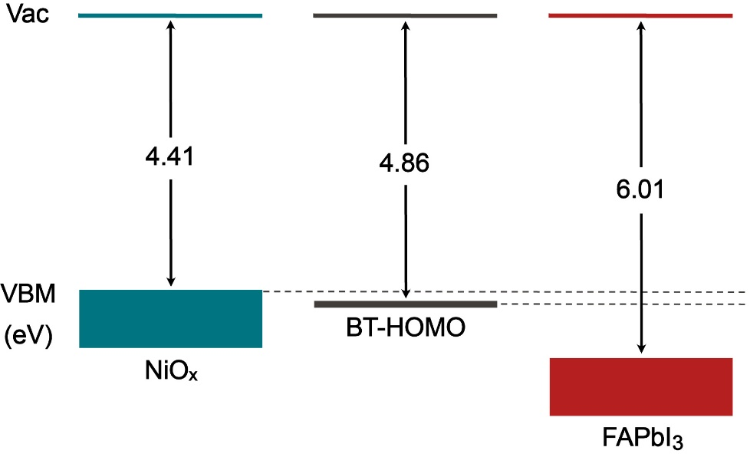
Supplementary Figure 1 | DFT energy-level diagram between NiO_{x}, BT-T molecule, and FAPbI₃; the diagram is built with the computed work functions. FAPbI₃ is considered by having two electron holes.

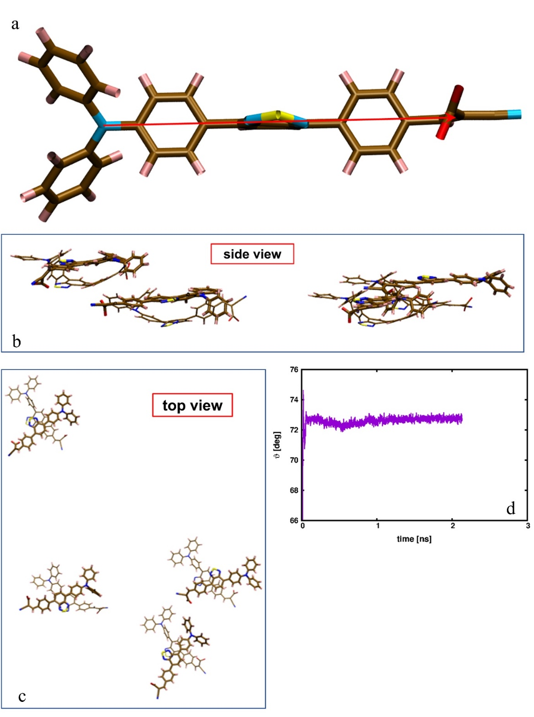
Supplementary Figure 2 | Molecular conformations, side (b) and top view (c), of two stacked BT-T molecules and average angle (d) between the vectors running through the backbone of two overlapping BT-T molecules indicated as red arrow in (a). In the molecular representations, thick and thin lines represent molecules lying top and below, respectively.

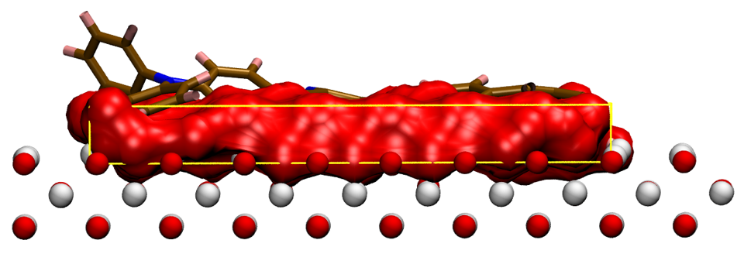
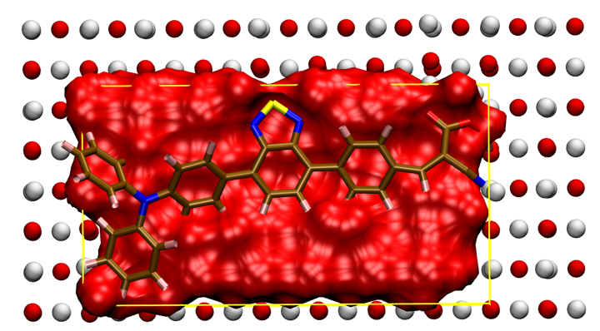
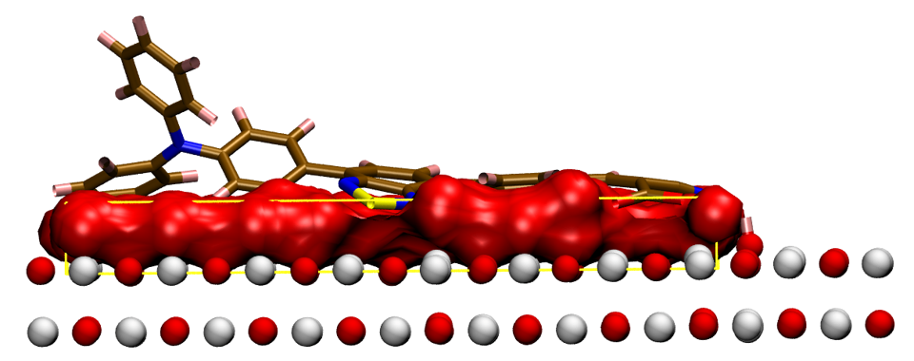
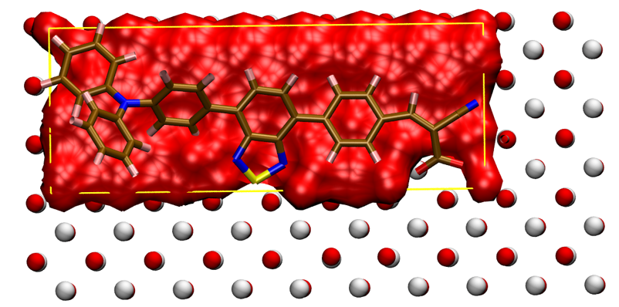
Supplementary Figure 3 | Top and side views of the surface area (red surface) occupied by a BT-T molecule bonded to Ni (001) (left) and Ni (110) (right) surfaces. The effective values of the covered surface area are 221.5 Å² and 331.0 Å² for Ni (001) and Ni (110), respectively.

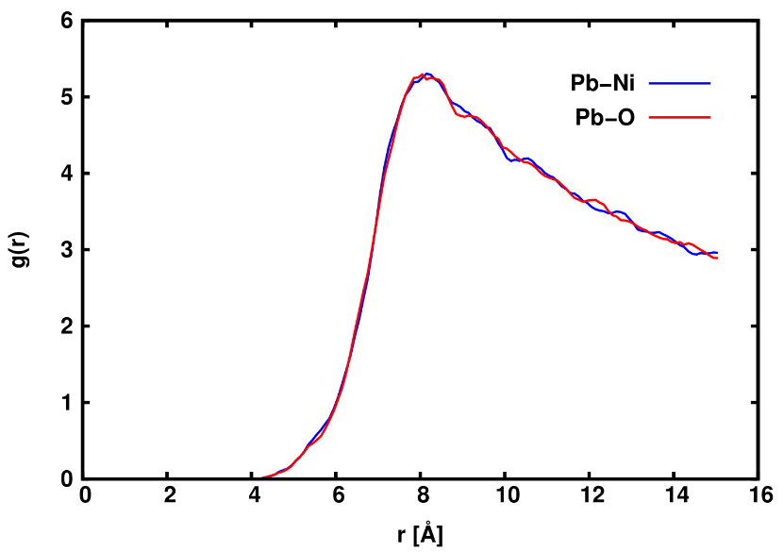
Supplementary Figure 4 | Probability distribution of characteristic distances between FAPbI₃ and NiO_{x} slabs during an equilibrated 5 ns long classical MD trajectory of the composite FAPbI₃/BT-T/NiO_{x} system. The average distance is a measure of the thickness of the BT-T monolayer buried interface.

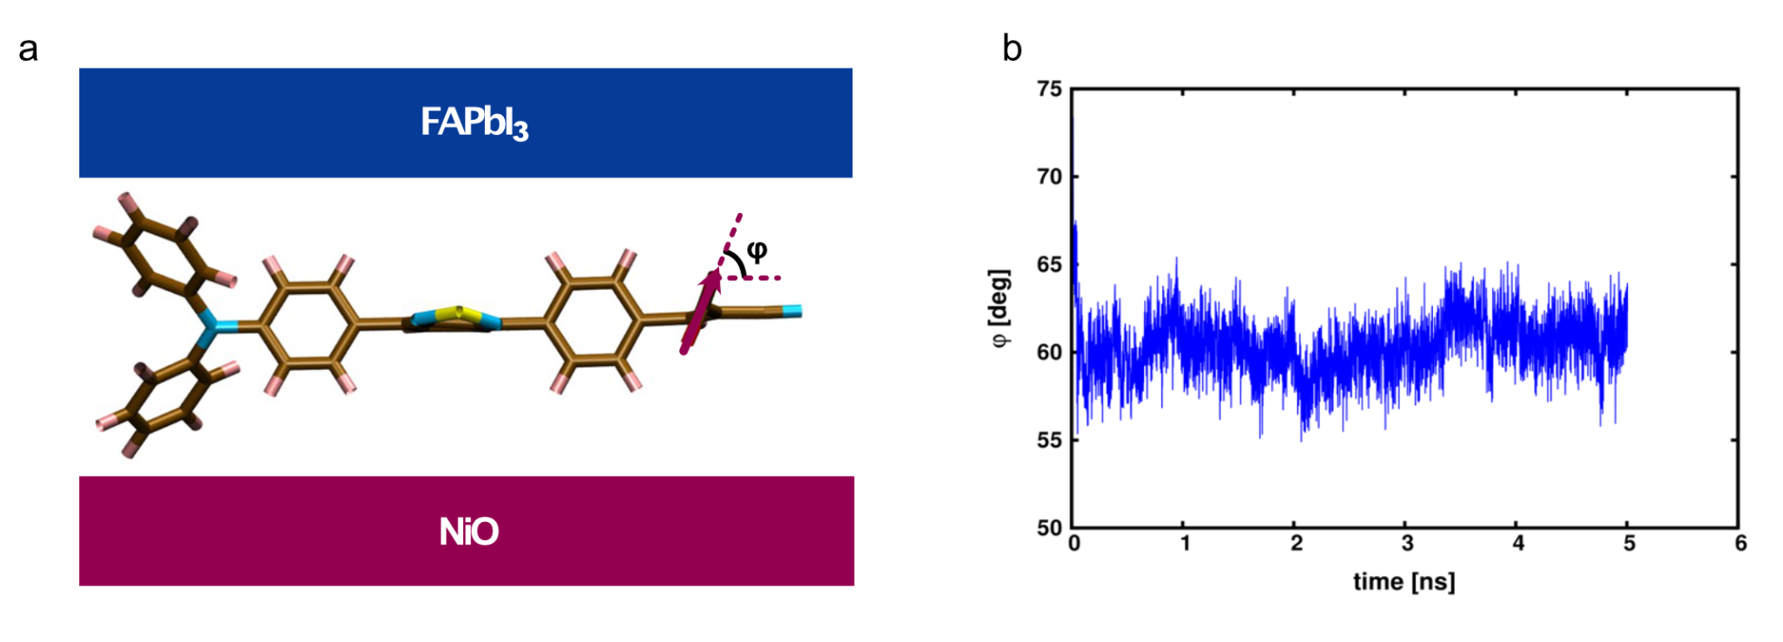
Supplementary Figure 5 | Schematic representation of FAPbI₃/BT-T/NiO_{x} system; angle φ defines the carboxyl-group orientation with respect to the NiO_{x} surface. (b) Instantaneous angle φ averaged over thirty BT-T molecules during a 5 ns long FAPbI₃/BT-T/NiO_{x} classical MD trajectory at 300 K and 1 atm.

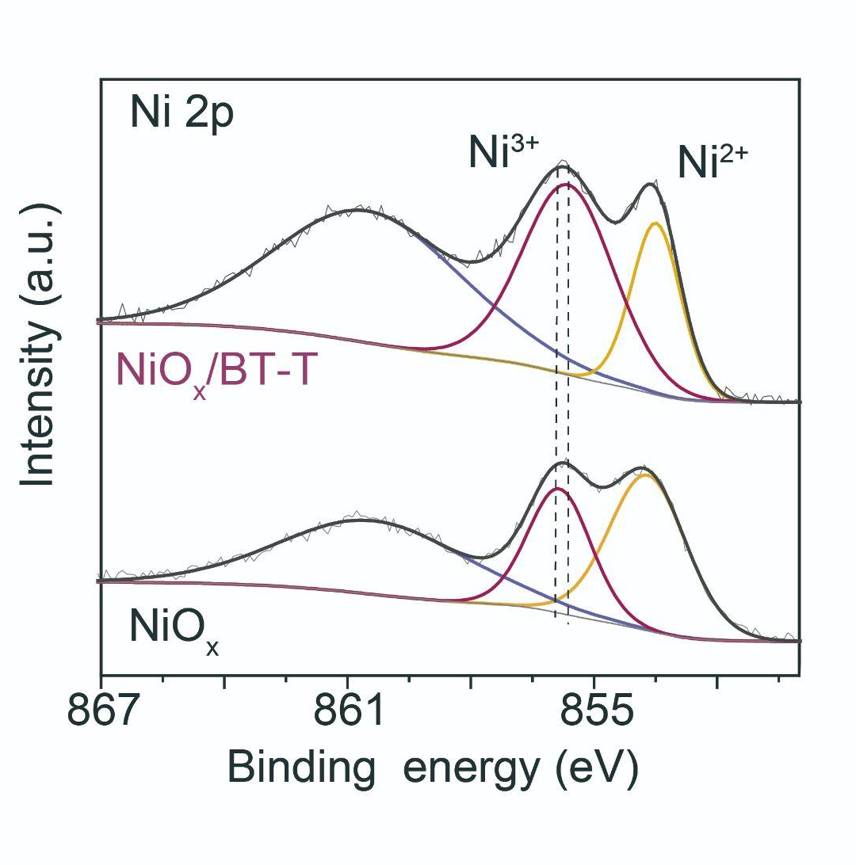
Supplementary Figure 6 | XPS of perovskite films deposited on NiO_{x} and NiO_{x}/BT-T substrates.

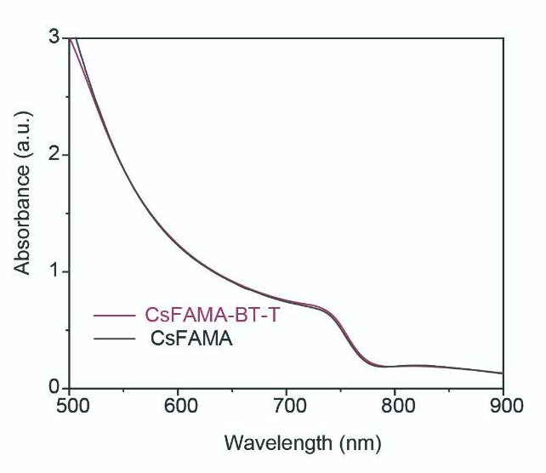
Supplementary Figure 7 | UV-vis of CsFAMA and CsFAMA-BT-T perovskite films.

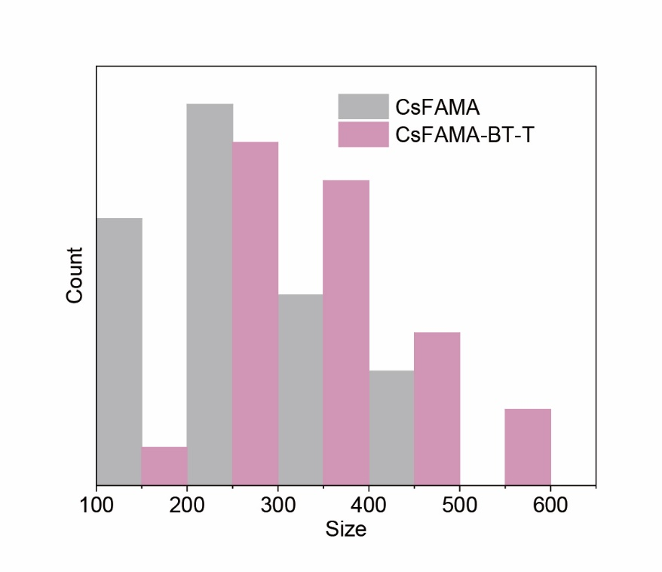
Supplementary Figure 8 | Grain size distribution of CsFAMA and CsFAMA-BT-T perovskite films.

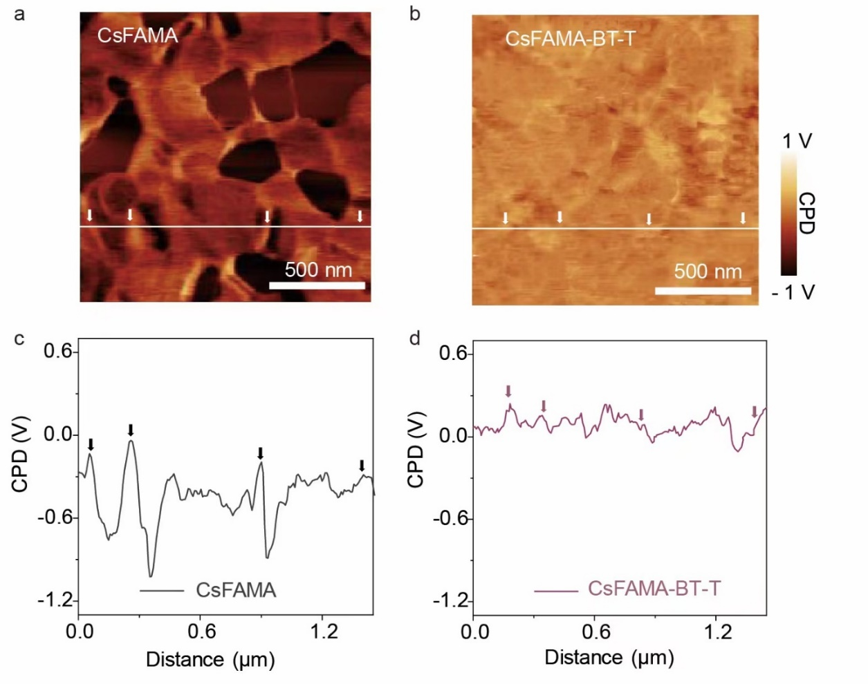
Supplementary Figure 9 | KPFM of CsFAMA and CsFAMA-BT-T perovskite films.

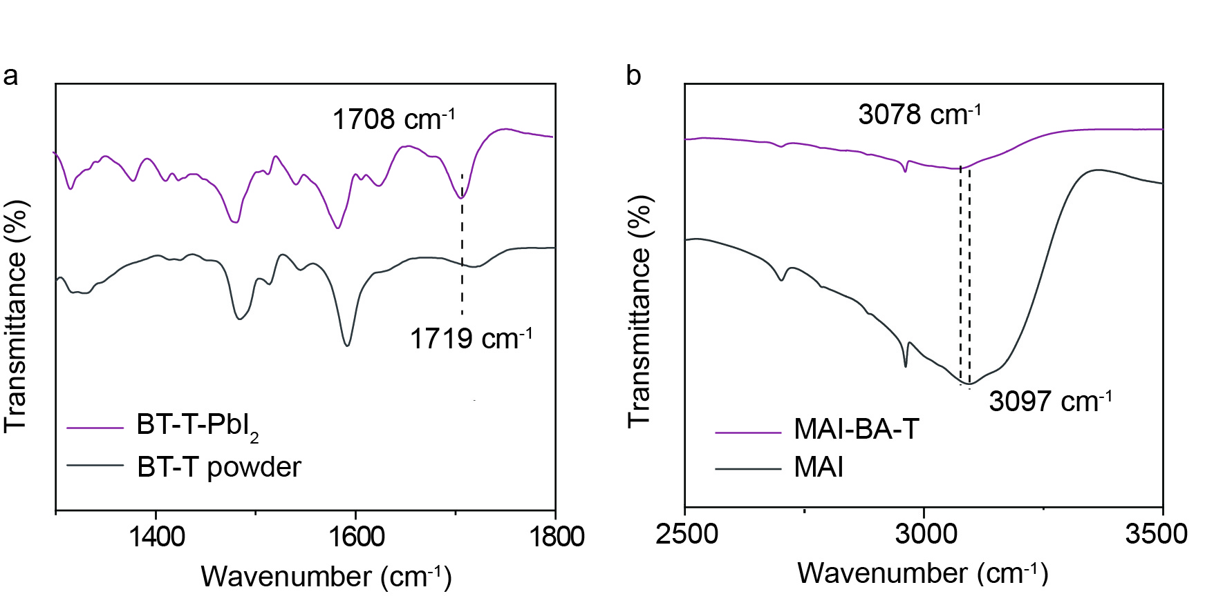
Supplementary Figure 10 | FTIR of (a) BT-T powder and BT-T-PbI₂ film; (b) FTIR of (a) MAI powder and BT-T-MAI film.

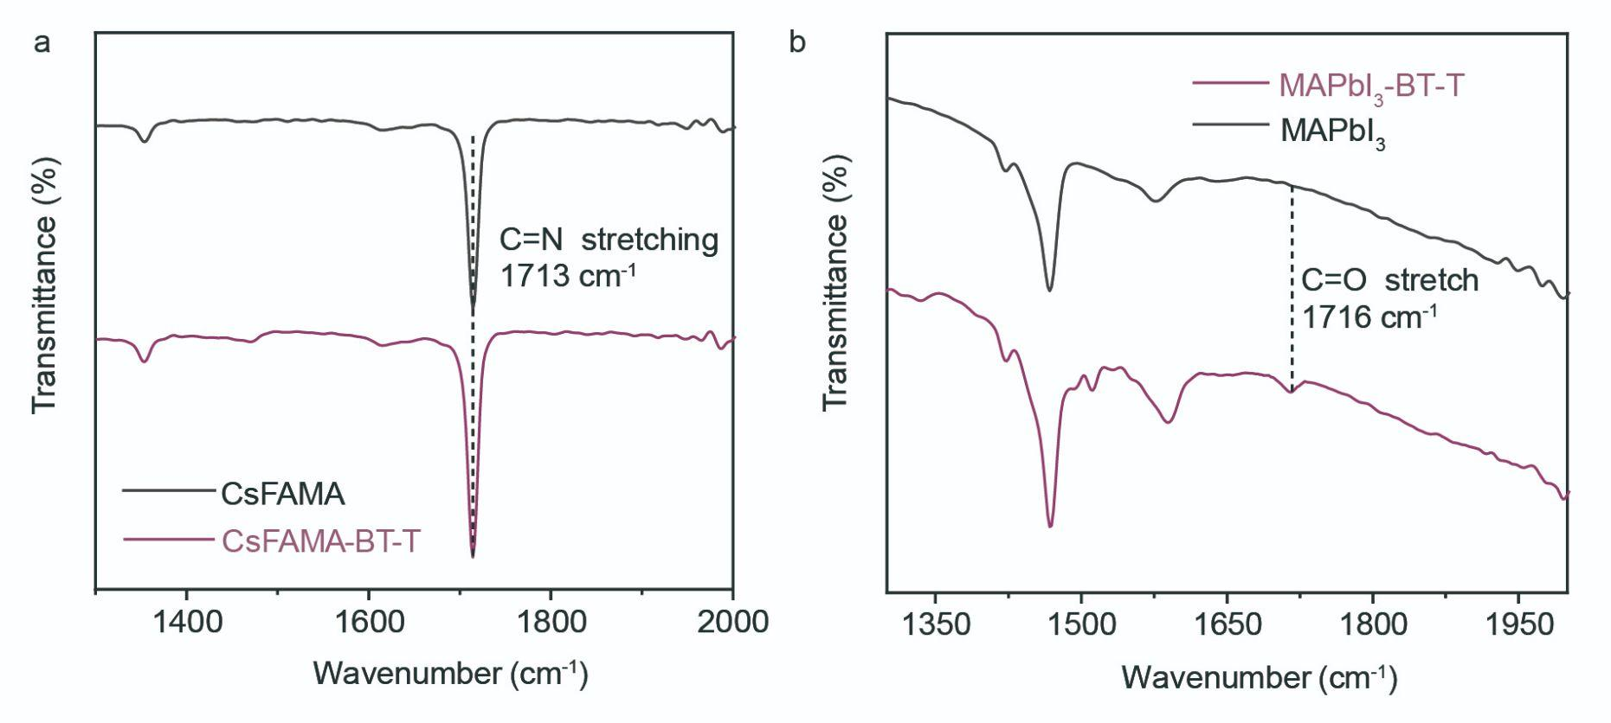
Supplementary Figure 11 | FTIR for (a) CsFAMA and CsFAMA-BT-T perovskite films and (b) MAPbI₃ and MAPbI₃-BT-T perovskite films. BT-T presented a characteristic peak at 1719 cm⁻¹ due to the stretching vibration of the C=O bond, while CsFAMA film showed a C=N stretching peak at 1713 cm⁻¹. To distinguish BT-T from perovskites, we employed MAPbI₃ instead of CsFAMA, which has no signal at around 1716 cm⁻¹.

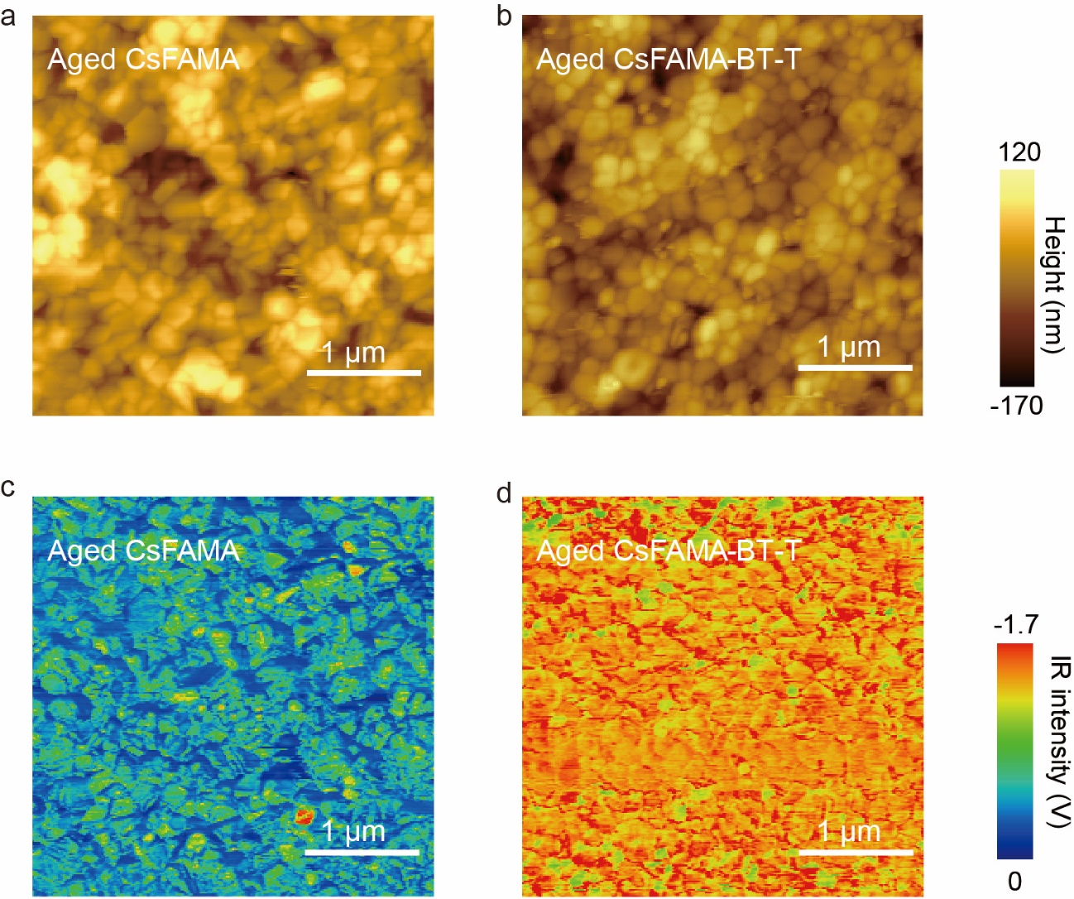
Supplementary Figure 12 | AFM-IR of aged CsFAMA and CsFAMA-BT-T films

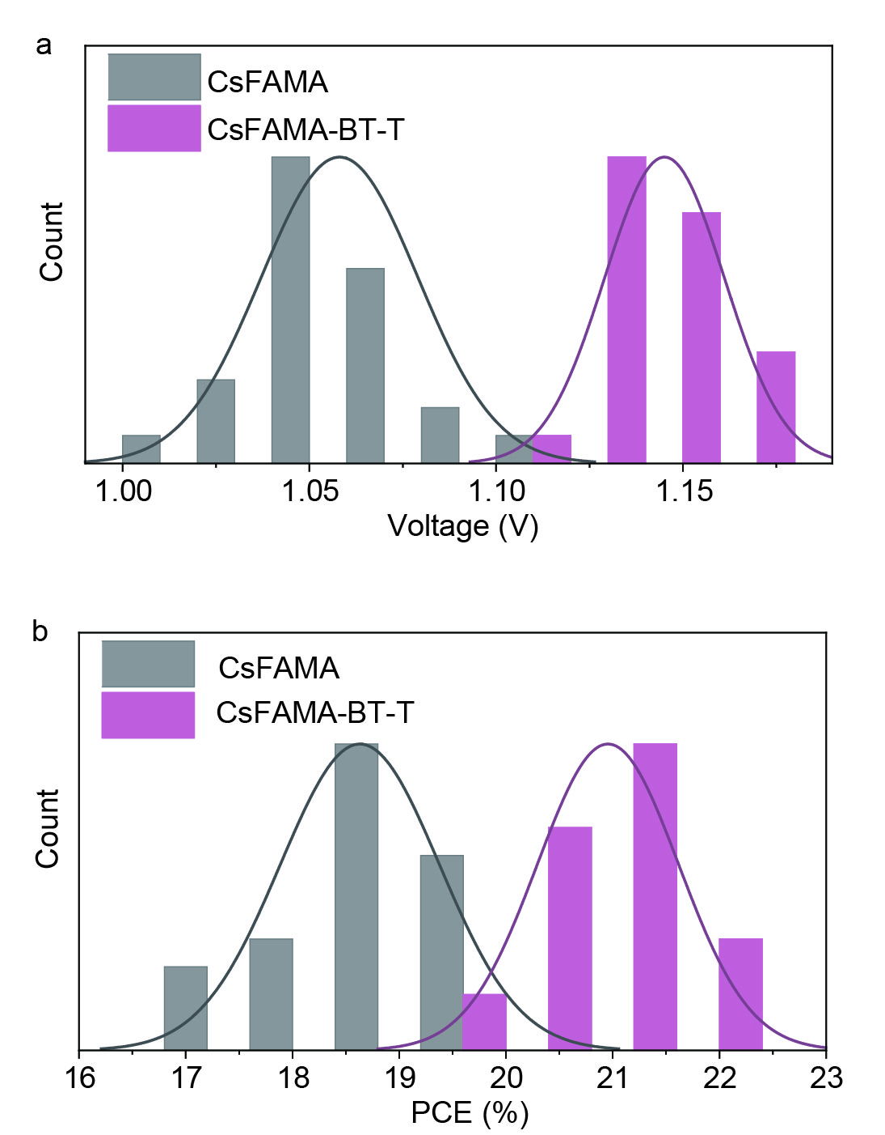
Supplementary Figure 13 | The histogram of V_{OC} and PCE for 50 1-cm²-sized devices (25 pristine devices and 25 devices with BT-T).

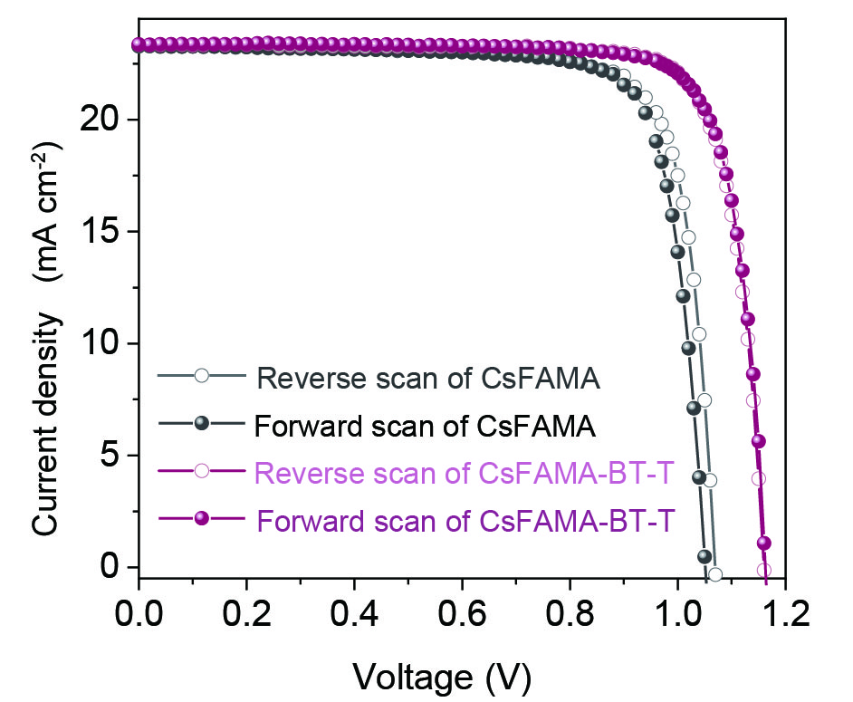
Supplementary Figure 14 | J-V curves of champion cells fabricated with CsFAMA and CsFAMA-BT-T perovskite films under forward (-0 to 1.2 V) and reverse (1.2 to -0 V) scans.

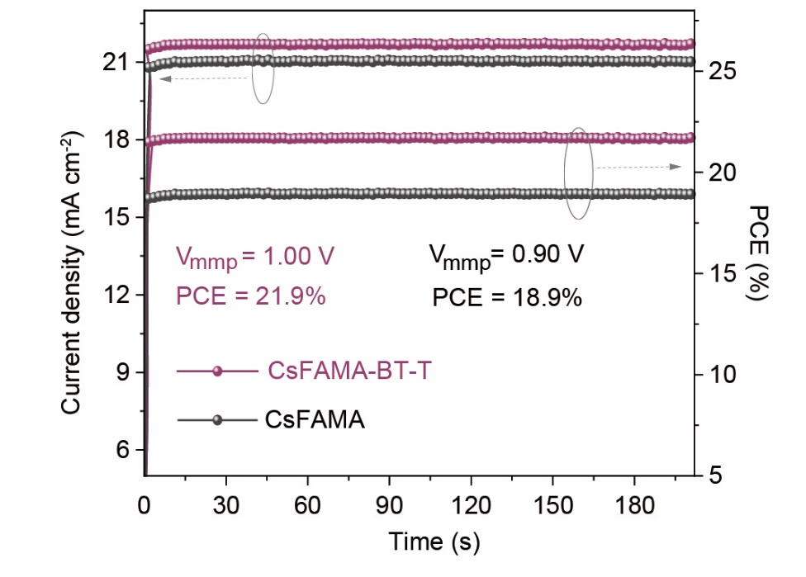
Supplementary Figure 15 | The steady-state output of cells fabricated with CsFAMA and CsFAMA-BT-T perovskite films at the fixed bias voltages of 0.90 V and 1.00 V, corresponding to stabilized PCE values of 18.9% and 21.9%, respectively.

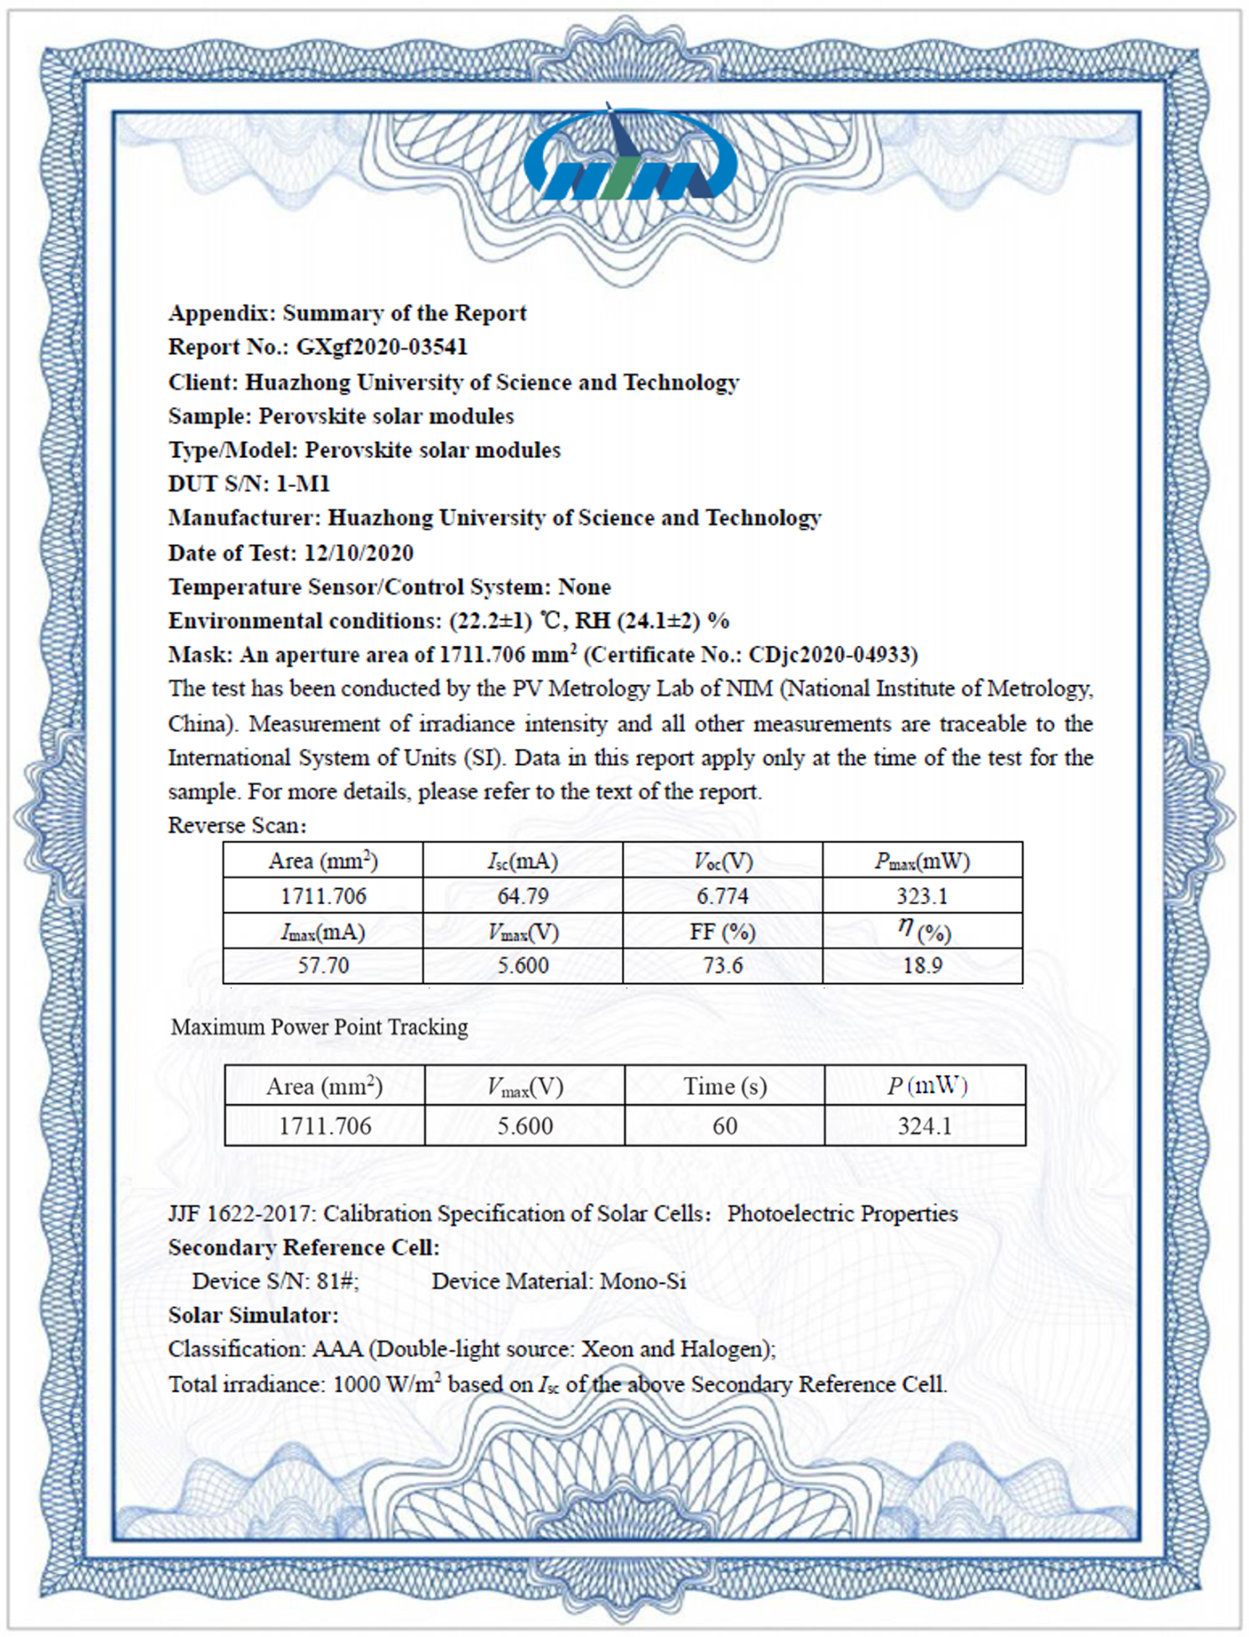

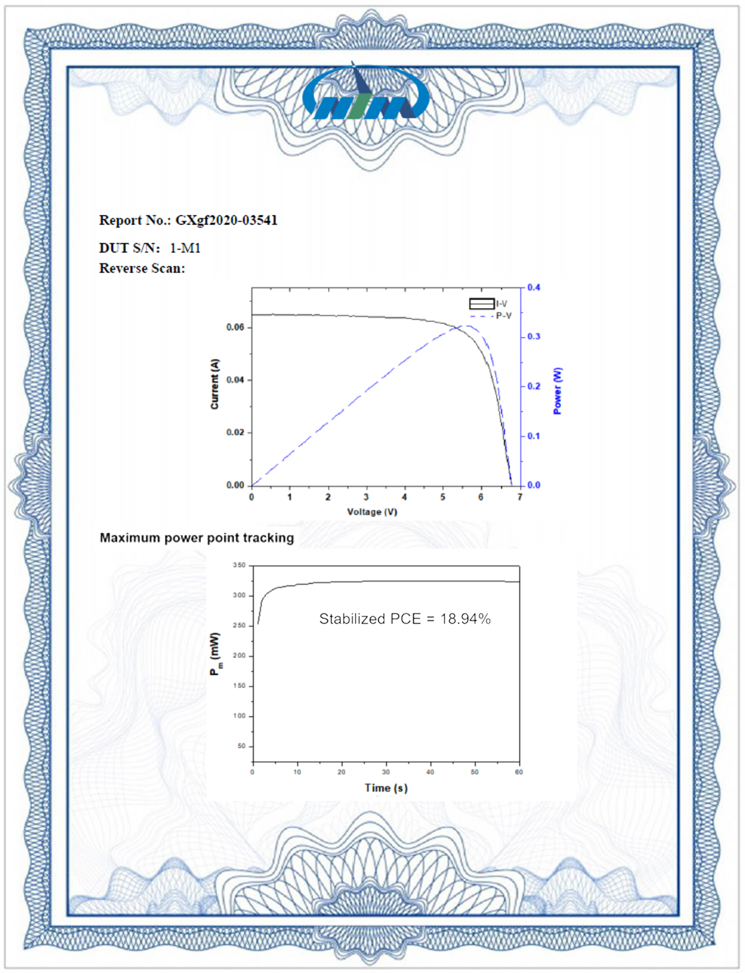
Supplementary Figure 16 | Certificate of the efficiency of the perovskite solar mini-module (Certification was carried out by the National Institute of Metrology, China).
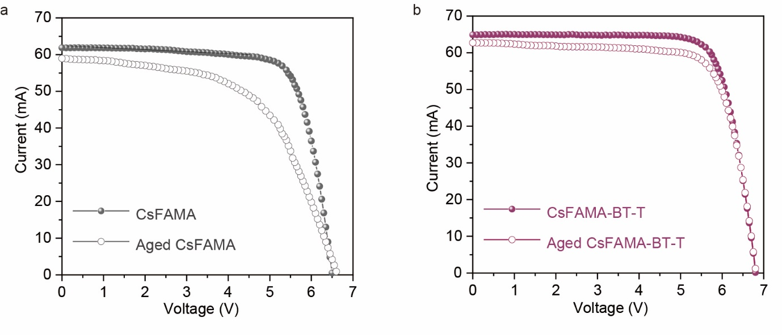
Supplementary Figure 17 | J-V curves of encapsulated modules fabricated with CsFAMA and CsFAMA-BT-T perovskite films before and after 1817 h aged at 65 °C in an N₂ atmosphere under 1-sun-equivalent white-LED light illumination.

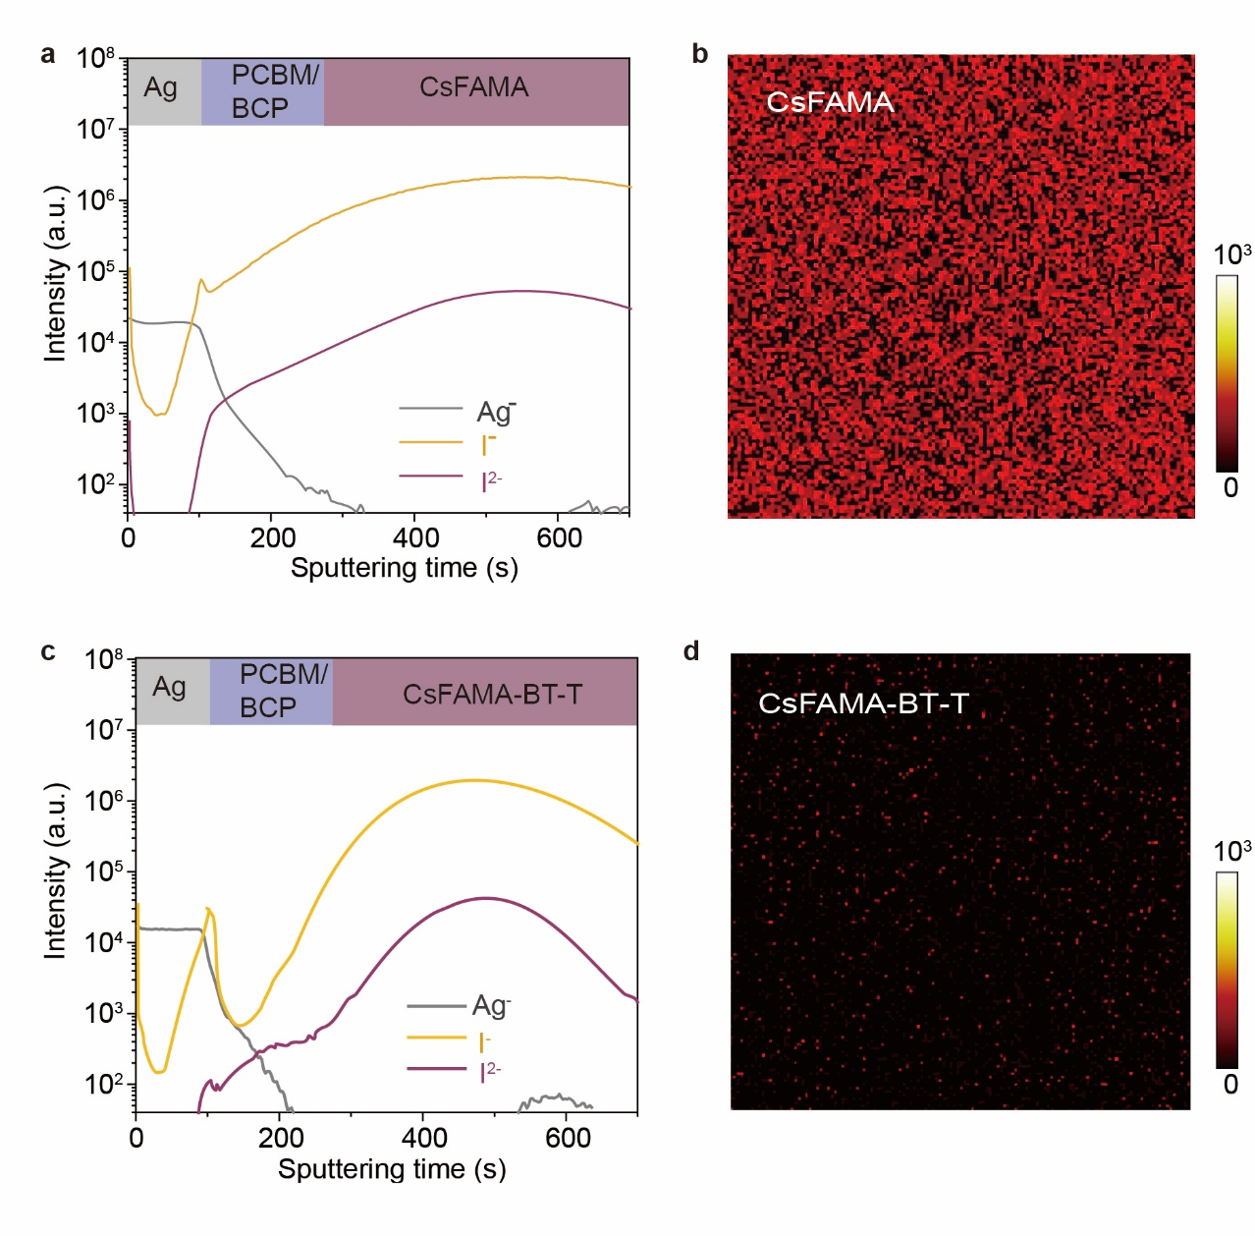
Figure 18 | (a, c) ToF-SIMS elemental depth profiles of films with the structure of Ag/BCP/PCBM/CsFAMA/NiO_{x}/ITO. (b, d) Mapping of I⁻ signals on top of the PCBM layer after peeling-off the silver contact. All the devices were aged after 200 h of light-soaking at 85 ℃ in nitrogen.

Table S1 DFT adsorption energies [eV] for the deprotonated BT-T molecule in different binding configurations on Ni (001), Ni (110), Pb- and FA- terminated perovskite surfaces.
Ni (001) | Ni (110) | Pb-FAPbI₃ | FA-FAPbI₃
-3.38 | -10.95 | -2.96 | -2.53
-4.13 | -11.89 | -3.14 | -1.52
– | -12.29 | -3.53 | –
– | -12.86 | -2.13 | –
– | – | -2.64 | –

Table S2 Fitted parameters of averaged TRPL decay of CsFAMA perovskite films deposited on ITO/NiO_{x} and ITO/NiO_{x} substrates. τ₁ is the decay time of the initial fast signal decrease whereas τ₂ is the decay time of the slower signal decrease at later times.
Sample | A₁ | τ₁ [ns] | A₂ | τ₂ [ns]
NiO_{x} | 70 | 5.2 | 30 | 72.5
NiO_{x}/BT-T | 79 | 4.1 | 21 | 64.0

Table S3 Summary of the absolute intensity PL spectral photon flux measurements of perovskite films with and without BT-T passivation deposited on NiO_{x}/ITO substrates (2 samples were measured for each condition).
Sample No. | PLQY  (%) | PL peak  (nm) | Eg  (eV) | Vsq  (V) | QFLS/q  (V)
CsFAMA | 0.20 | 776 | 1.597 | 1.321 | 1.162
CsFAMA | 0.22 | 771 | 1.608 | 1.332 | 1.175
CsFAMA-BT-T | 0.72 | 773 | 1.604 | 1.328 | 1.201
CsFAMA-BT-T | 0.96 | 773 | 1.603 | 1.327 | 1.208

Table S4. Summary of the absolute intensity PL spectral photon flux measurements of perovskite films with and without BT-T deposited on glass substrates.
Sample | PLQY  (%) | PL peak  (nm) | Eg  (eV) | Vsq  (V) | QFLS/q  (V)
CsFAMA | 3.3 | 785 | 1.578 | 1.306 | 1.216
CsFAMA | 3.3 | 783 | 1.584 | 1.309 | 1.221
CsFAMA-BT-T | 4.8 | 786 | 1.578 | 1.303 | 1.225
CsFAMA-BT-T | 4.9 | 784 | 1.581 | 1.306 | 1.231

Table S5 Summary of the absolute intensity PL spectral photon flux measurements of the full device stack with a structure of PCBM/perovskites/NiO_{x}/ITO.
Sample | PLQY  (%) | PL peak  (nm) | Eg  (eV) | Vsq  (V) | QFLS/q  (V)
CsFAMA | 0.03 | 776 | 1.597 | 1.321 | 1.113
CsFAMA | 0.05 | 775 | 1.599 | 1.323 | 1.127
CsFAMA-BT-T | 0.08 | 772 | 1.607 | 1.330 | 1.147
CsFAMA-BT-T | 0.07 | 771 | 1.607 | 1.331 | 1.145

Table S6 The photovoltaic parameters of inverted PSCs (active area = 1.01 cm²) fabricated with different concentrations of BT-T in the precusor solution (25 pristine devices and 25 devices for each concentration BT-T).
BT-T concentration (wt%) | Voc  (V) | Jsc  (mA·cm⁻²) | FF | PCE  (%)
0.00 | 1.06 ± 0.03 | 22.97 ± 0.28 | 0.767 ± 0.023 | 18.63 ± 0.73
0.12 | 1.12± 0.02 | 22.92 ± 0.45 | 0.775 ± 0.024 | 19.70 ± 0.53
0.24 | 1.15 ± 0.02 | 23.08 ± 0.27 | 0.792 ± 0.015 | 20.95 ± 0.64
0.36 | 1.11 ± 0.02 | 22.89 ± 0.46 | 0.761 ± 0.021 | 19.27 ± 0.61

Table S7 The initial and final photovoltaic parameters of a batch of four unencapsulated inverted PSCs with and without BT-T under thermal stress at 100 °C for 100 hours.
Sample | Without BT-T |  |  |  | With BT-T
No. | V_{OC}  (V) | J_{SC}  (mA·cm²) | FF | PCE  (%) | V_{OC}  (V) | J_{SC}  (mA·cm²) | FF | PCE  (%)
1^{I} | 1.05 | 22.99 | 0.788 | 19.0 | 1.15 | 23.15 | 0.779 | 20.7
2^{I} | 1.08 | 23.15 | 0.788 | 19.7 | 1.15 | 22.91 | 0.797 | 21.0
3^{I} | 1.02 | 23.39 | 0.772 | 18.4 | 1.14 | 23.40 | 0.815 | 21.7
4^{I} | 1.06 | 22.86 | 0.784 | 19.0 | 1.15 | 22.84 | 0.796 | 20.9
Average^{I} | 1.05±  0.02 | 23.10±  0.23 | 0.783±  0.008 | 19.0±  0.53 | 1.15±  0.01 | 23.07±  0.26 | 0.797±  0.015 | 21.1±0.44
1^{F} | 1.07 | 16.94 | 0.535 | 9.7 | 1.17 | 21.88 | 0.747 | 19.1
2 ^{F} | 1.09 | 17.39 | 0.543 | 10.3 | 1.16 | 22.17 | 0.746 | 19.2
3 ^{F} | 1.02 | 16.00 | 0.458 | 7.5 | 1.15 | 22.45 | 0.769 | 19.8
4 ^{F} | 1.07 | 16.51 | 0.530 | 9.4 | 1.16 | 22.23 | 0.748 | 19.3
Average^{F} | 1.06±  0.03 | 16.71±  0.59 | 0.516±  0.039 | 9.2±  1.22 | 1.16±  0.01 | 22.18±  0.23 | 0.752±  0.011 | 19.4±  0.33
I: The initial PCE of PSCs.
F: The fininal PCE of PSCs after 100 h heating aged.

Table S8 Summary of reported large-area perovskite solar cells (area = 1 cm ²).

Ref.  1 cm² | Structure  HTL |  | Efficiency  (%) | Certified efficiency  (%) | Aging condition  (illumination/heat) | Lifetime
Na. Energy  3,  847-854  (2018) |  | P-i-N  (PTAA) | 20 | 19.83 | N.A. | N.A.
Science,  371,  390–395  (2021) |  | N-i-P  (P3HT:CuPc) | 21.6 | N.A. | 1-sun illumination MPP test/N₂  damp heat test  (85°C and 85% relative humidity in the dark) | T_{95.3} = 260 hrs  (PCE_{inital/final} = 21.45%/20.44%)  T_{91.7} = 1009 hrs  (PCE_{inital/final} = 19.8%/18.1
Science,  373,  561–567  (2021) |  | N-i-P (Spiro-OMeTAD) | 23.15 | 22.3 | 1-sun illumination MPP test/N₂ | T₉₀ = 1000 hrs  (N.A.)
Science,  375,  434–437  (2022) |  | P-i-N (P3CT-N) | 20.7 | N.A. | N.A. | (N.A.)
This work |  | P-i-N  (NiO_{x}) | 22.11 | N.A. | 1-sun illumination MPP test/65 ºC in N₂  100°C in the dark  /N₂ | T_{95.4} = 1960 hrs  (PCE_{inital/final} = 21.9%/20.9%)  T_{91.5} = 100 hrs  (PCE_{inital/final} = 21.1%/19.3

Table S9 Summary of reported mini perovskite solar modules (area ≥ 10 cm²).

Ref.  module | Structure  HTL |  | Efficiency (%)  area (cm²) | Certified efficiency  (%) |  | Aging condition  (illumination/heat) | Lifetime
Nat. Energy  5,  596–604 (2020) |  | N-i-P  (Spiro-OMeTAD) | 16.6  (22.4) | N.A. |  | 1-sun illumination MPP test/40 °C in N₂ | T₉₀ = 1540 hrs (PCE_{initial} N.A.)
Nat. Energy  6,  633-641 (2021) |  | P-i-N  (PTAA) | N.A.  (29.5) | 18.6 |  | 1-sun illumination MPP test/50 °C in air (encapsulated) | T_{93.6} = 1056 hrs (PCE_{initial/final} = 17.4%/14.9%)
Science,  372, 1327-1332  (2021) |  | N-i-P  (Spiro-OMeTAD) | 20.4  (17.11) | 19.3 |  | N.A. | N.A.
Sci. Adv.,  7,  3749  (2021) |  | P-i-N  (NiMgLi-O) | N.A.  (20.77) | 16.63 |  | 1-sun illumination MPP test/50 °C in air (encapsulated) | T₉₅ = 1187 hrs  (PCE_{initial} = ~17.5%)
Nat. Photonics  16,  119–125 (2022) |  | N-i-P  (Spiro-OMeTAD) | 21.8  (25) | N.A. |  | N.A. | N.A.
Science, 373, 902–907 (2022) |  | P-i-N  (PTAA) | 20.1  (18.1) | 19.25 |  | 1-sun illumination MPP test/50 °C in air (encapsulated) | T₈₅ = 1000 hrs (PCE_{initial} = ~18.5%)
Science, 375, 302–306 (2022) |  | N-i-P  (Spiro-OMeTAD) | 21.7  (20) | N.A. |  | N.A. | N.A.
Nat. Nanotechnol, 17, 598-605 (2022) |  | N-i-P  (Spiro-OMeTAD) | 22.87  (24.63) | 22.72 |  | N.A. | N.A.
This work |  | P-i-N  (NiO_{x}) | 20.3  (17.11) | 18.94 | 1-sun illumination MPP test/65ºC inthe N₂ (encapsulated) |  | T_{92.5} = 1817 hrs  (PCE_{inital/final} = 20.2%/18.7%)
References
1 Roh, D.-H. et al. Strategy for improved photoconversion efficiency in thin photoelectrode films by controlling π-spacer dihedral angle. The Journal of Physical Chemistry C 120, 24655-24666 (2016). https://doi.org:10.1021/acs.jpcc.6b08262
2 Anspoks, A. & Kuzmin, A. Interpretation of the Ni k-edge EXAFS in nanocrystalline nickel oxide using molecular dynamics simulations. Journal of Non-Crystalline Solids 357, 2604-2610 (2011). https://doi.org:https://doi.org/10.1016/j.jnoncrysol.2011.02.030
3 Chen, W. et al. Molecule-doped nickel oxide: Verified charge transfer and planar inverted mixed cation perovskite solar cell. Advanced Materials 30, 1800515 (2018). https://doi.org:https://doi.org/10.1002/adma.201800515
4 Li, X. et al. A vacuum flash–assisted solution process for high-efficiency large-area perovskite solar cells. Science 353, 58-62 (2016). https://doi.org:10.1126/science.aaf8060
5 Zeng, H. et al. Improved performance and stability of perovskite solar modules by regulating interfacial ion diffusion with nonionic cross-linked 1D lead-iodide. Advanced Energy Materials 12, 2102820 (2022). https://doi.org:https://doi.org/10.1002/aenm.202102820
6 de Mello, J. C., Wittmann, H. F. & Friend, R. H. An improved experimental determination of external photoluminescence quantum efficiency. Advanced Materials 9, 230-232 (1997). https://doi.org:https://doi.org/10.1002/adma.19970090308
7 Kühne, T. D. et al. Cp2k: An electronic structure and molecular dynamics software package - quickstep: Efficient and accurate electronic structure calculations. The Journal of Chemical Physics 152, 194103 (2020). https://doi.org:10.1063/5.0007045
8 Giannozzi, P. et al. Quantum espresso: A modular and open-source software project for quantum simulations of materials. Journal of Physics: Condensed Matter 21, 395502 (2009). https://doi.org:10.1088/0953-8984/21/39/395502
9 Supka, A. R. et al. Aflowπ: A minimalist approach to high-throughput ab initio calculations including the generation of tight-binding hamiltonians. Computational Materials Science 136, 76-84 (2017). https://doi.org:https://doi.org/10.1016/j.commatsci.2017.03.055
10 van Setten, M. J. et al. The pseudodojo: Training and grading a 85 element optimized norm-conserving pseudopotential table. Computer Physics Communications 226, 39-54 (2018). https://doi.org:https://doi.org/10.1016/j.cpc.2018.01.012
11 Monkhorst, H. J. & Pack, J. D. Special points for brillouin-zone integrations. Physical Review B 13, 5188-5192 (1976). https://doi.org:10.1103/PhysRevB.13.5188
12 Agapito, L. A., Curtarolo, S. & Buongiorno Nardelli, M. Reformulation of DFT+U as a pseudohybrid hubbard density functional for accelerated materials discovery. Physical Review X 5, 011006 (2015). https://doi.org:10.1103/PhysRevX.5.011006
13 Buongiorno Nardelli, M. et al. Paoflow: A utility to construct and operate on ab initio hamiltonians from the projections of electronic wavefunctions on atomic orbital bases, including characterization of topological materials. Computational Materials Science 143, 462-472 (2018). https://doi.org:https://doi.org/10.1016/j.commatsci.2017.11.034
14 Grimme, S. Density functional theory with london dispersion corrections. WIREs Computational Molecular Science 1, 211-228 (2011). https://doi.org:https://doi.org/10.1002/wcms.30
15 Prandini, G., Marrazzo, A., Castelli, I. E., Mounet, N. & Marzari, N. Precision and efficiency in solid-state pseudopotential calculations. npj Computational Materials 4, 72 (2018). https://doi.org:10.1038/s41524-018-0127-2
16 Makov, G. & Payne, M. C. Periodic boundary conditions in ab initio calculations. Physical Review B 51, 4014-4022 (1995). https://doi.org:10.1103/PhysRevB.51.4014
17 Guidon, M., Hutter, J. & VandeVondele, J. Robust periodic hartree-fock exchange for large-scale simulations using gaussian basis sets. Journal of Chemical Theory and Computation 5, Medium: X; Size: p. 3010-3021 (2009). https://doi.org:10.1021/ct900494g
18 Guidon, M., Hutter, J. & VandeVondele, J. Auxiliary density matrix methods for hartree-fock exchange calculations. Journal of Chemical Theory and Computation 6, Medium: X; Size: p. 2348-2364 (2010). https://doi.org:10.1021/ct1002225
19 VandeVondele, J. & Hutter, J. Gaussian basis sets for accurate calculations on molecular systems in gas and condensed phases. The Journal of Chemical Physics 127, 114105 (2007). https://doi.org:10.1063/1.2770708
20 Goedecker, S., Teter, M. & Hutter, J. Separable dual-space gaussian pseudopotentials. Physical Review B 54, 1703-1710 (1996). https://doi.org:10.1103/PhysRevB.54.1703
21 Krack, M. Pseudopotentials for h to kr optimized for gradient-corrected exchange-correlation functionals. Theoretical Chemistry Accounts 114, 145-152 (2005). https://doi.org:10.1007/s00214-005-0655-y
22 Grimme, S., Antony, J., Ehrlich, S. & Krieg, H. A consistent and accurate ab initio parametrization of density functional dispersion correction (DFT-D) for the 94 elements H-Pu. The Journal of Chemical Physics 132, 154104 (2010). https://doi.org:10.1063/1.3382344
23 Bussi, G., Donadio, D. & Parrinello, M. Canonical sampling through velocity rescaling. The Journal of Chemical Physics 126, 014101 (2007). https://doi.org:10.1063/1.2408420
24 Plimpton, S. Fast parallel algorithms for short-range molecular dynamics. Journal of Computational Physics 117, 1-19 (1995). https://doi.org:https://doi.org/10.1006/jcph.1995.1039
25 Swope, W. C., Andersen, H. C., Berens, P. H. & Wilson, K. R. A computer simulation method for the calculation of equilibrium constants for the formation of physical clusters of molecules: Application to small water clusters. The Journal of Chemical Physics 76, 637-649 (1982). https://doi.org:10.1063/1.442716
26 Nosé, S. A unified formulation of the constant temperature molecular dynamics methods. The Journal of Chemical Physics 81, 511-519 (1984). https://doi.org:10.1063/1.447334
27 Hoover, W. G. Canonical dynamics: Equilibrium phase-space distributions. Physical Review A 31, 1695-1697 (1985). https://doi.org:10.1103/PhysRevA.31.1695
28 Irving, J. H. & Kirkwood, J. G. The statistical mechanical theory of transport processes. Iv. The equations of hydrodynamics. The Journal of Chemical Physics 18, 817-829 (1950). https://doi.org:10.1063/1.1747782
29 Mattoni, A., Filippetti, A. & Caddeo, C. Modeling hybrid perovskites by molecular dynamics. Journal of Physics: Condensed Matter 29, 043001 (2016). https://doi.org:10.1088/1361-648x/29/4/043001
30 Mattoni, A., Filippetti, A., Saba, M. I. & Delugas, P. Methylammonium rotational dynamics in lead halide perovskite by classical molecular dynamics: The role of temperature. The Journal of Physical Chemistry C 119, 17421-17428 (2015). https://doi.org:10.1021/acs.jpcc.5b04283
31 Ahlawat, P. et al. A combined molecular dynamics and experimental study of two-step process enabling low-temperature formation of phase-pure α-fapbi₃. Science Advance 7, eabe3326 (2021). https://doi.org:doi:10.1126/sciadv.abe3326
32 Dodda, L. S., Cabeza de Vaca, I., Tirado-Rives, J. & Jorgensen, W. L. Ligpargen web server: An automatic opls-aa parameter generator for organic ligands. Nucleic Acids Research 45, W331-W336 (2017). https://doi.org:10.1093/nar/gkx312 %J Nucleic Acids Research
33 Ribeiro, J. V., Tamames, J. A. C., Cerqueira, N. M. F. S. A., Fernandes, P. A. & Ramos, M. J. Volarea – a bioinformatics tool to calculate the surface area and the volume of molecular systems. Chemical Biology & Drug Design
82, 743-755 (2013). https://doi.org:https://doi.org/10.1111/cbdd.12197
34 Humphrey, W., Dalke, A. & Schulten, K. Vmd: Visual molecular dynamics. Journal of Molecular Graphics 14, 33-38 (1996). https://doi.org:https://doi.org/10.1016/0263-7855(96)00018-5

