Supporting Information

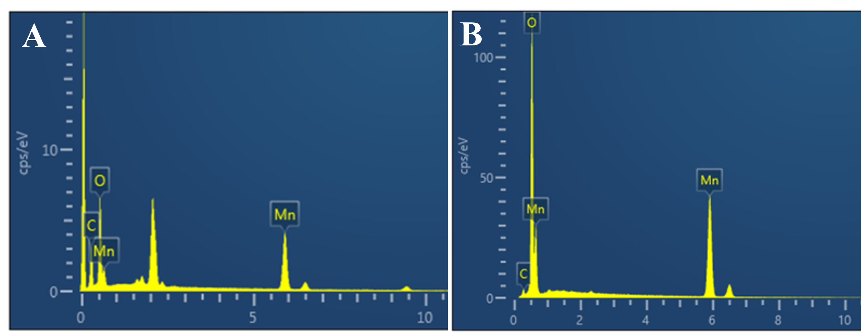
Figure S1, Elemental ratio of biological Mn₂O₃(A）to Mn₂O₃(B) analyzed by energy dispersive X-ray spectroscopy (EDS).

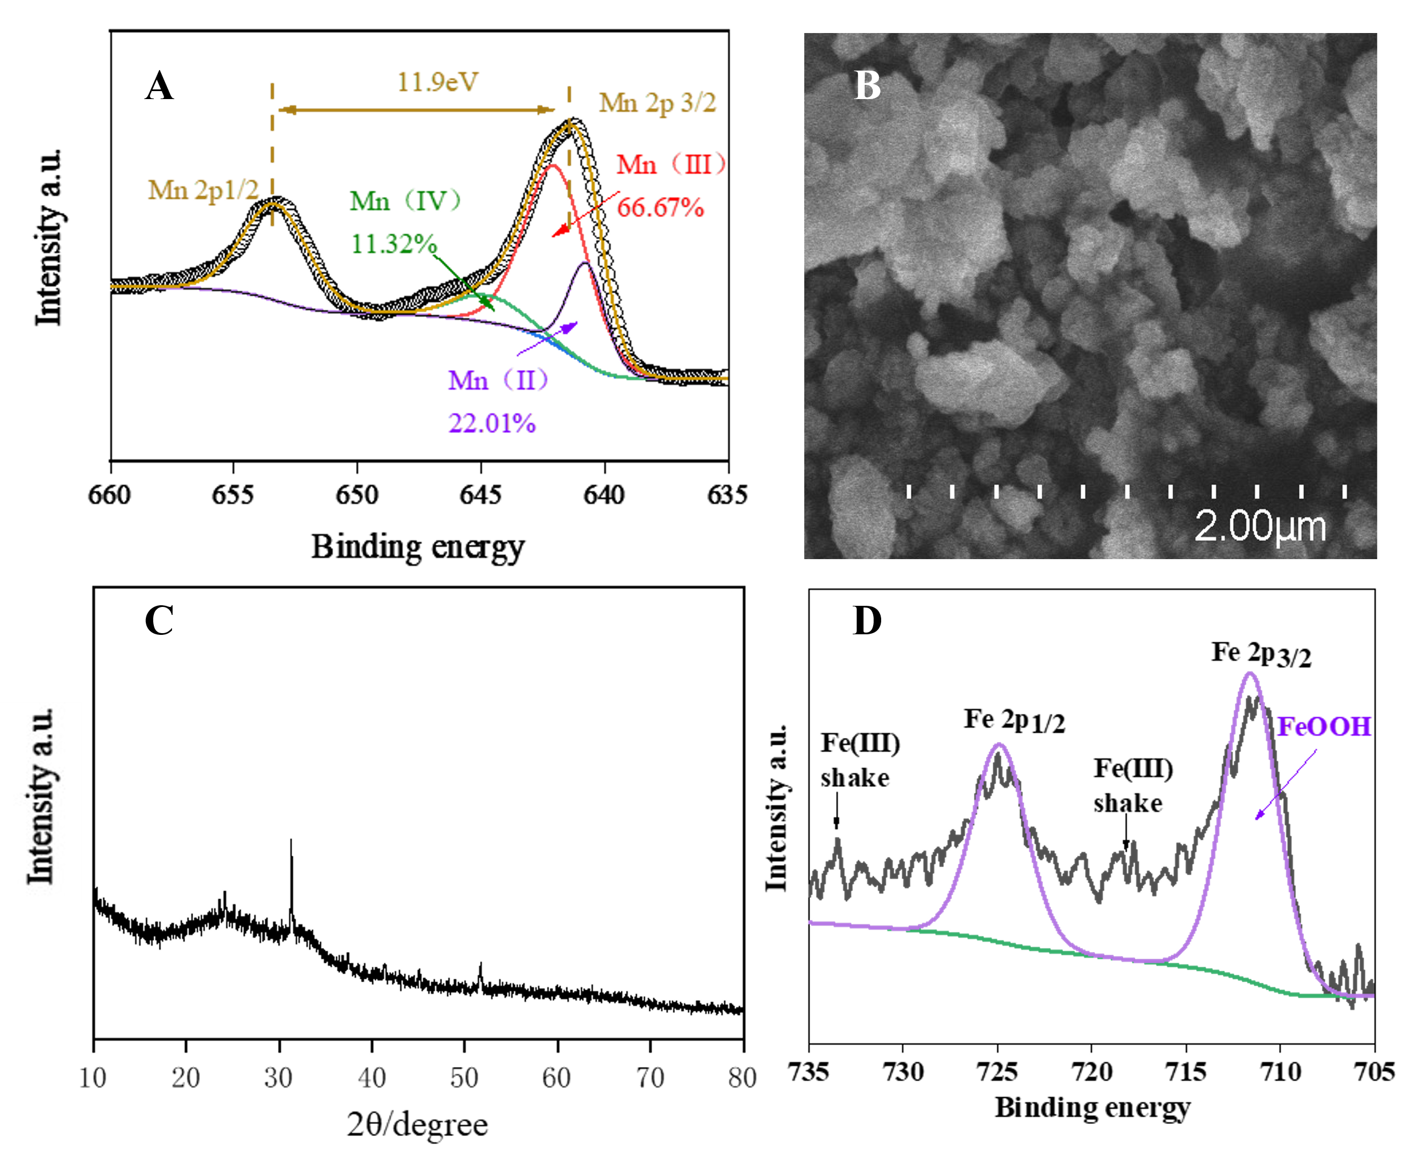
Figure S2. Morphology and characterization of iron-modified biogenic MnO_{X}: (A) X-ray photoelectron spectroscopy (XPS) spectra of Mn 2p orbitals and fitted by software Thermo Advantage (V5.948). The binding energy of the samples was calibrated by the carbon C1s binding energy (284.6 eV). (B) Scanning electron microscope (SEM) image of iron-modified biological Mn₂O₃. (C) XRD diffraction pattern of iron-modified biogenic MnO_{X}. (D) X-ray photoelectron spectroscopy (XPS) spectra of Fe 2p orbitals and fitted by the software Thermo Advantage (V5.948). The binding energy of the samples was calibrated by the carbon C1s binding energy (284.6 eV).

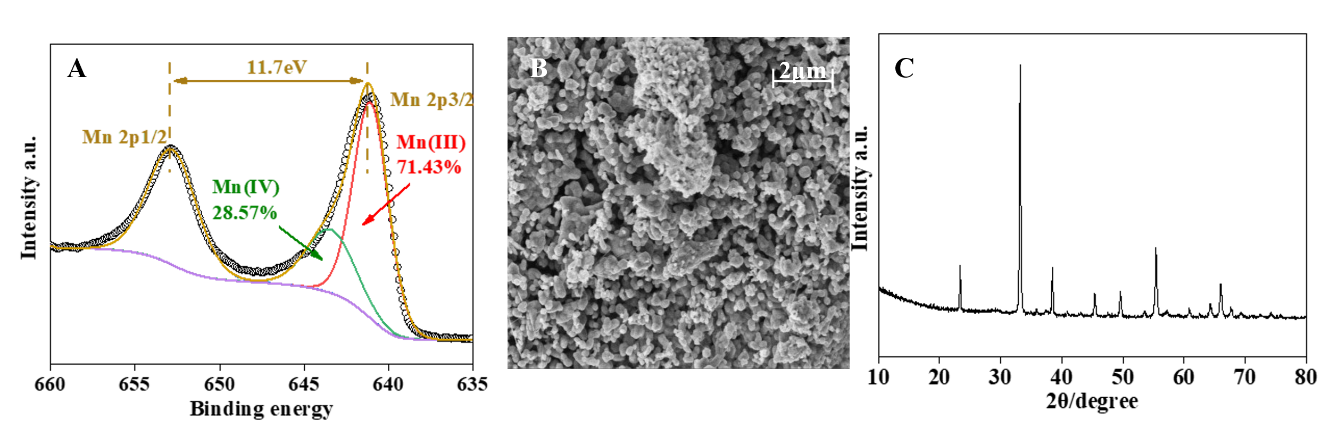
Figure S3. Morphology and characterization of commercial Mn₂O₃: (A) X-ray photoelectron spectroscopy (XPS) spectra of Mn 2p orbitals and fitted by the software Thermo Advantage (V5.948). The binding energy of the samples was calibrated by the carbon C1s binding energy (284.6 eV). (B) Scanning electron microscope (SEM) image of Mn₂O₃. (C) XRD pattern of Mn₂O₃

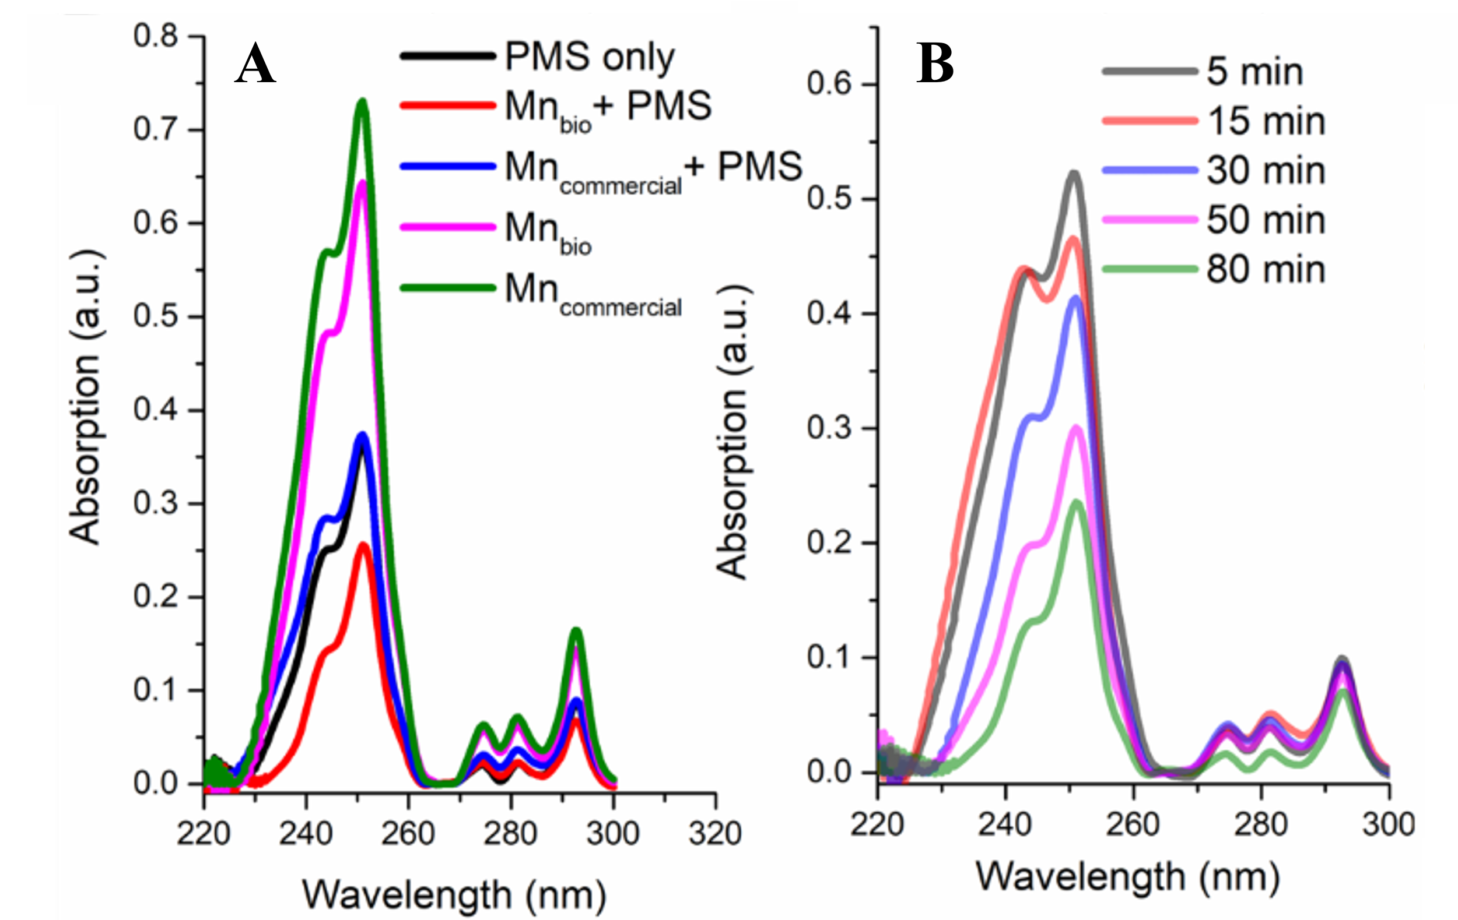
Figure S4, UV-Vis spectrum scan of phenanthrene degradation process, (A) UV-Vis spectrum of phenanthrene degradation by biological Mn₂O₃ and chemical Mn₂O₃ catalyzed by PMS for 120 min. (B) UV-Vis spectra of bio-Mn2O3-catalyzed PMS degradation of phenanthrene at different time points.

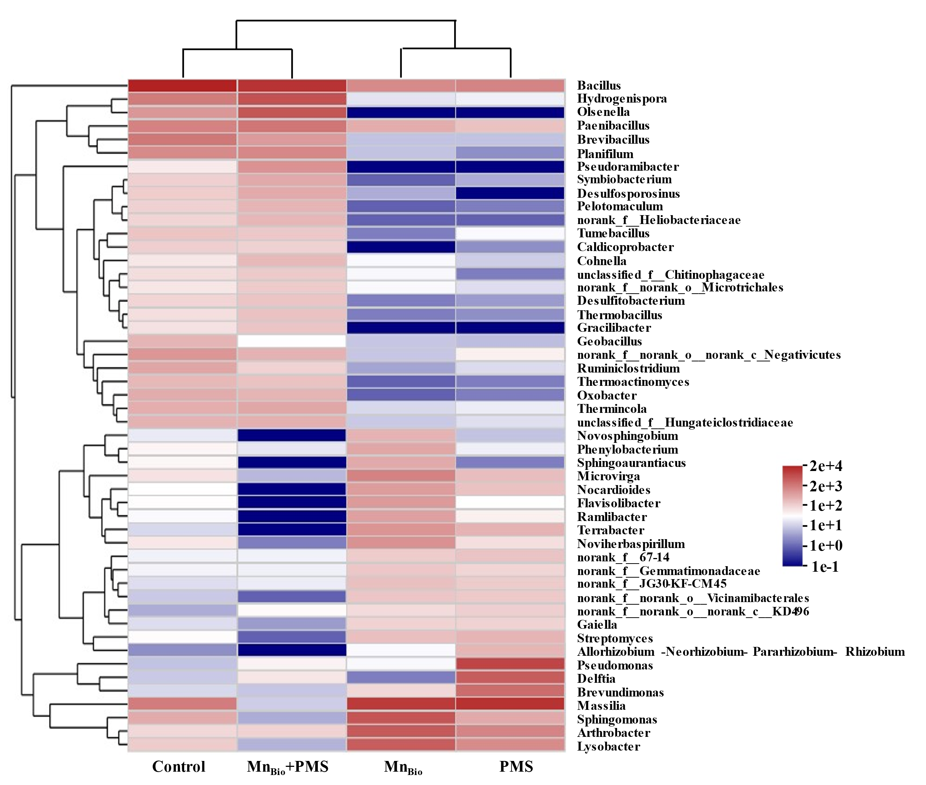
Figure S5. Heat map of microbial communities after the PMS AOP.

Table S1.EDS element ratio table of biological Mn₂O₃ and Mn₂O₃
Biological Mn₂O₃
Element | Line type | Wt% | Wt%Sigma | At%
C | K line system | 21.67 | 0.40 | 41.42
O | K line system | 25.42 | 0.31 | 36.48
Mn | K line system | 52.90 | 0.39 | 22.10
Mn₂O₃
C | K line system | 3.80 | 0.25 | 8.92
O | K line system | 33.29 | 0.21 | 58.74
Mn | K line system | 62.92 | 0.25 | 32.33

