A
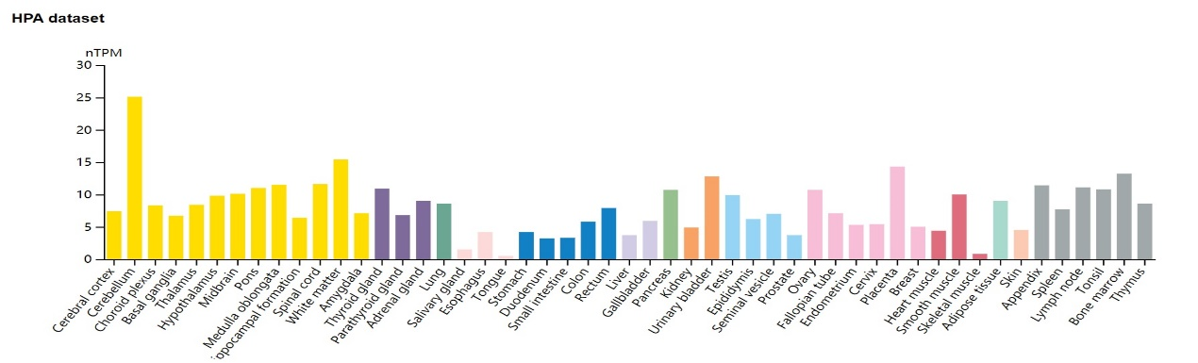
B
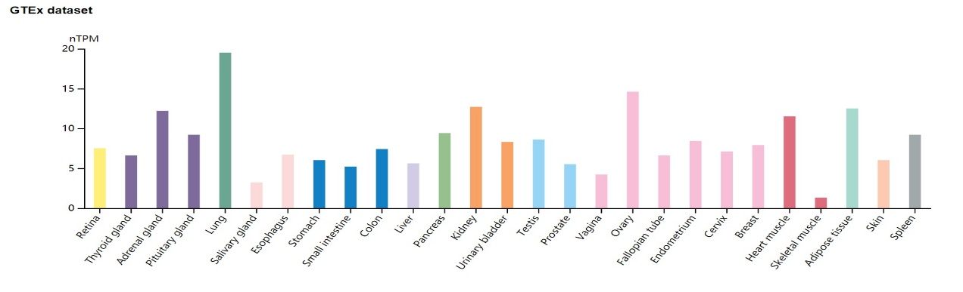
C
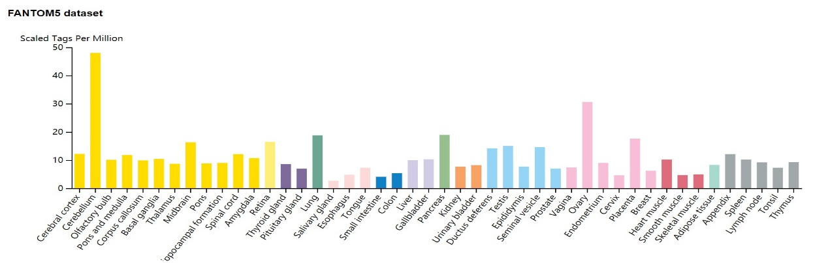
D
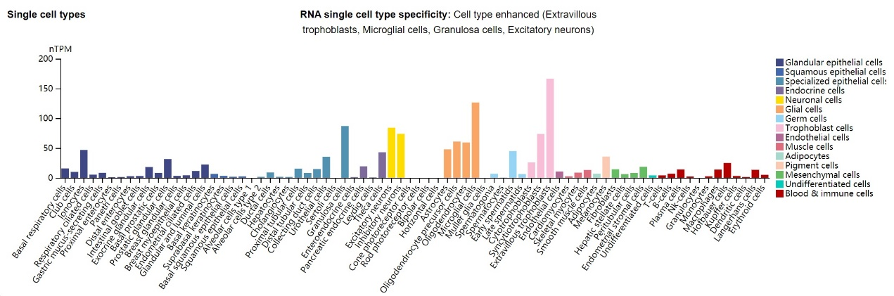
Supplementary Fig.1 MTHFD1L expression status in different normal tissues. (a-c) MTHFD1L tissue expression based on datasets of the HPA (Human protein atlas), GTEx, and FANTOM5 (Function annotation of the mammalian genome 5). (d) MTHFD1L expression in various cell types.

A
B
C
D
Supplementary Fig.2 CLPP, CS, LRPPRC and MTIF21 expression status in different normal tissues. (A-D) The expression status of CLPP, CS, LRPPRC and MTIF21 in different tumor types was visualized. * P < .05; ** P < .01; *** P < .001.

