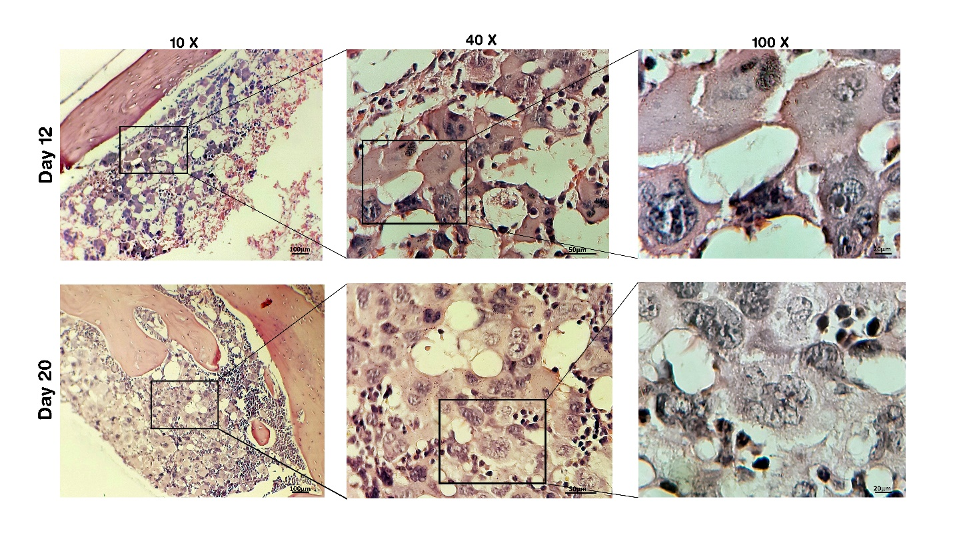

Supplementary Fig. 2: Regions of LMC enrichment in BM of mice at day-12 and 20 post myeloablation.

