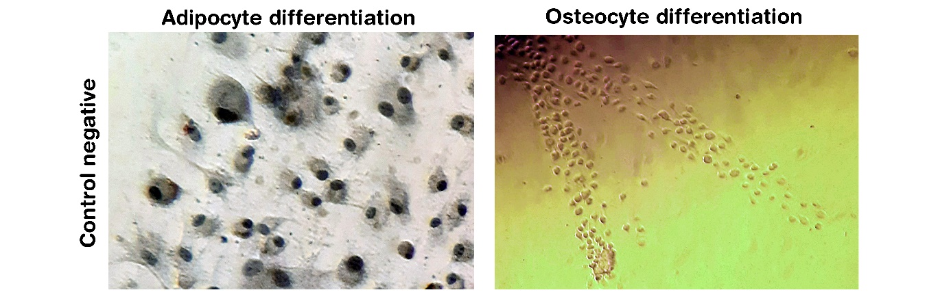
Supplementary Fig. 1: Control negative of adipocyte and osteocyte differentiation. Parallel to culture of LMCs in adipocyte and osteocyte differentiation medium, some wells were treated with DMEM, 10% FBS as negative control. Spheroid formation did not happen in the negative control tube of chondrocyte differentiation, and thus no image is available.

