SUPPLEMENTARY DATA
Entropy based analysis of SARS-CoV-2 Spread in India using Informative Subtype Markers
Piyush Mathur¹, Pratik Goyal¹, Garima Verma², Pankaj Yadav¹
- Department of Bioscience & Bioengineering, Indian Institute of Technology, Jodhpur, Rajasthan, India
- Department of Experimental Medicine, System Biology Group, University La Sapienza Università di Roma, Roma, Italy

Materials and Methods
Spike protein entropy analysis
The spike glycoprotein region has been closely observed. The masked entropy values used for Figure 1 have been used to take a closer look at the spike glycoprotein. We have plotted the masked entropy values against their positions only for the glycoprotein region in Supplementary Figure 1.
RGD motif Analysis
We have observed the masked entropy values of the RGD motif in the spike glycoprotien. Firstly, the original reference genome sites are mapped with the sites in the reference genome after the MSA. Then the range for spike glycoprotein mentioned in the reference genome is used to analyse the spike glycoprotein region particularly. The masked entropy of all the sites in spike glycoprotein region is separately plotted. The spike glycoprotein contains an RGD motif. Several integrins have a high affinity for RGD motifs. So, the site of the RGD motif present in the spike protein is traced using reference genome and the information entropies of the sites having RGD motif are observed. The masked entropy values for the sites coding for the RGD motif are shown in Supplementary Table 1.
Selection of ISM sites
To select the sites for ISMs, we have used NULL frequency as a parameter. NULL frequencies of all the sites are calculated as number of ‘N’ or ‘-’ at a position in all the aligned sequences divided by the total number of these sequences. We plot the count of positions having particular NULL frequency values against their NULL frequencies in Supplementary Figure 2b. We use the calculated masked entropy to plot the count of positions having particular masked entropy values against their masked entropies. We use these plots to set the thresholds for the parameters to select sites for ISMs. The sites with high number of ‘N’ or ‘-’ do not have high information (or high mutation) and cannot be used to create ISM, so we observe the distribution of masked entropy and NULL frequency across the sites in Supplementary Figure 2a and 2b respectively.
Progression of mutations
The 50 most abundant unique ISMs which are used for heirarchical clustering in Figure 2 are also used to observe the overall progression of the mutations in SARS-CoV-2. In Supplementary Figure 3, the hamming distances of these 50 ISMs from the reference ISM are calculated and are plotted against the number of days from the reference date to the date of their first incidence. To compare this progression in mutation with the rise in worldwide cases, the total cases are also plotted against the number of days since the reference date on the same plot.
Relative abundance of ISM
The relative abundance of an ISM in a region standardly corresponds to the fraction of that ISM sequenced among all the ISMs sequenced in that region. The relative abundance of India’s most abundant ISM TCTGTCGGAAC is shown in Supplementary Figure 4. The geographical distributions of ISMs in Supplementary Figure 6 and strains in Supplementary Figure 7 across different states and UTs in India also use relative abundance for visualization.
The temporal analysis shows the progression of the SARS-CoV-2 subtypes as a function of time. The dates associated with the sequences is used to find out the relative abundance of the viral subtypes at a point of time in a country through the course of time since a given point of time. The relative abundance ISM_{(s,c)}(t) of a subtype s, in a region c at a given point of time t, is calculated as:
$${ISM}_{(s, c)}(t) = \frac{{ N}_{(s,c)}(t)}{N_{c}(t)}$$

Where, N_{(s,c)}(t) indicates total number of instances of subtype s in a region c till a point of time t, and N_{c}(t) is the total number of sequences in the location c till a point of time t. The temporal analysis of relative abundance of strains sequenced in India is shown in Supplementary Figure 8.
Supplementary Tables
Table 1. Show the masked entropy values of region coding for RGD motif.
Bases | Position | Masked Entropy
A | 39680 | 3.96×10⁻⁴
G | 39681 | 2.76 ×10⁻³
A | 39682 | 1.98 ×10⁻⁴
G | 39683 | 5.95 ×10⁻⁴
G | 39684 | 9.38 ×10⁻⁴
T | 39685 | 1.98 ×10⁻⁴
G | 39686 | 1.98 ×10⁻⁴
A | 39687 | 1.98 ×10⁻⁴
T | 39688 | 1.98 ×10⁻⁴
Bases: nucleotide bases coding for RGD motif; Position: base-pair position in the reference genome post multiple sequence alignment; Masked Entropy: masked entropy value at respective ISM position.
Supplementary Figures
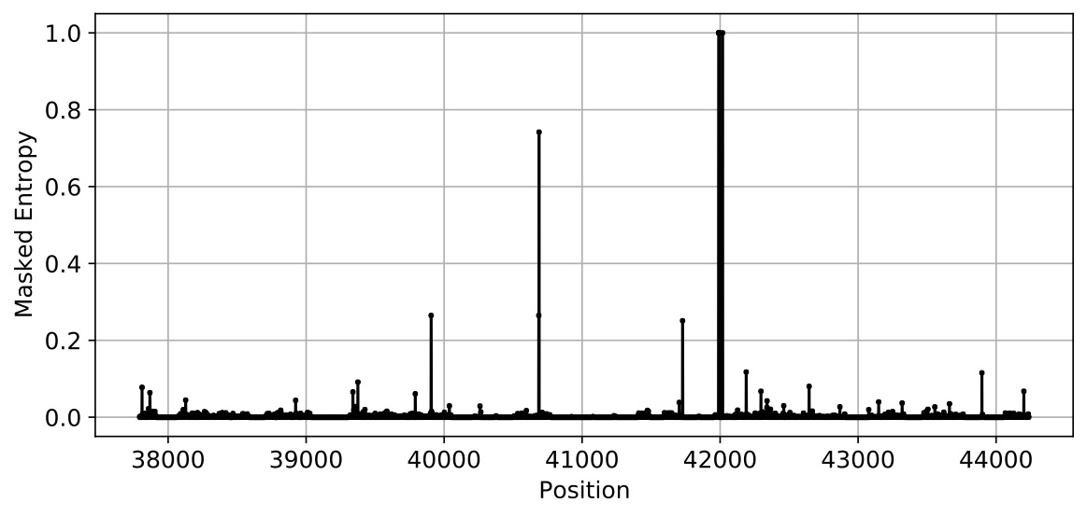
Figure 1: Shows masked entropies of different positions in the spike glycoprotein region of the SARS-CoV-2 genome. There are a few positions with high masked entropy (entropy> 0.4). The position 40689 with masked entropy 0.74 is used for constructing ISMs (see Table 1 in main text). The other positions near 42000 also shows a very high entropy but they are not selected for ISM owing to their high null frequency.
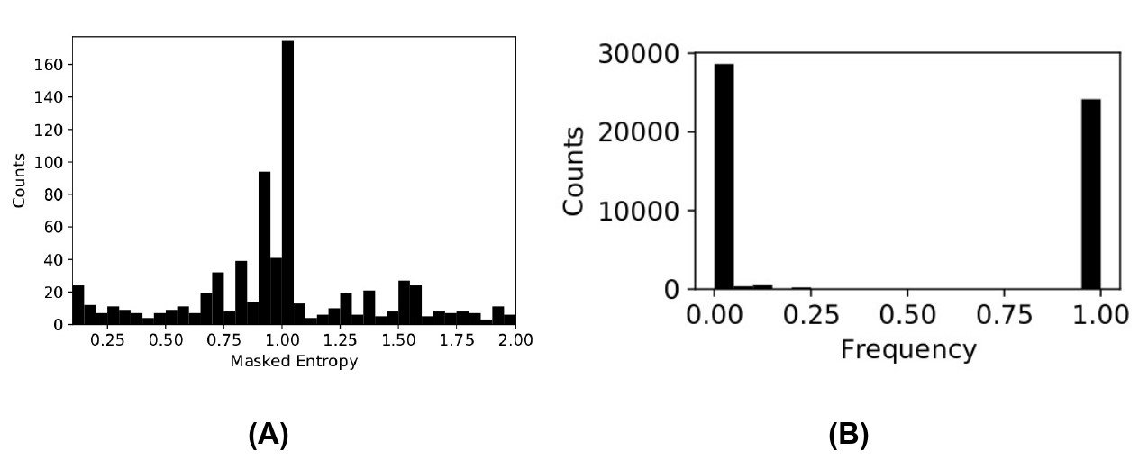Figure 2: The histogram of a) masked entropies and, b) null frequencies at different positions of SARS CoV-2 genome. These distributions were used to set thresholds for masked entropy and null frequency values for selection of positions for ISMs.
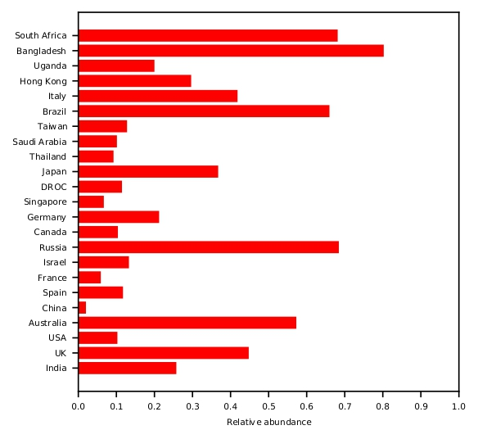
Figure 3: Shows the relative abundance of ISM TCTGTCGGAAC in different countries. This ISM was identified to be the top most abundant in India (25.7%). The red colour chosen for distribution of this ISM is as per the global color map (see Supplementary Figure 5).

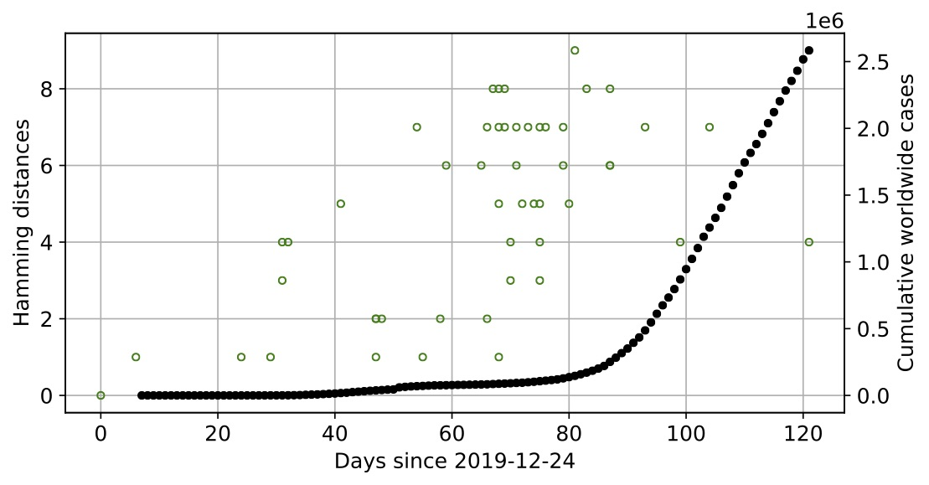
Figure 4: Shows overall progression of mutations in SARS-CoV-2 genome as a function of the number of COVID-19 cases worldwide. The green circle refers to an ISM along with their first sequenced date (on horizontal axis) and its hamming distances (left vertical axis). The black filled circles indicates the number of COVID-positive cases (in millions, right vertical axis). The hamming distances were computed using 50 most abundant ISMs with the reference ISM.
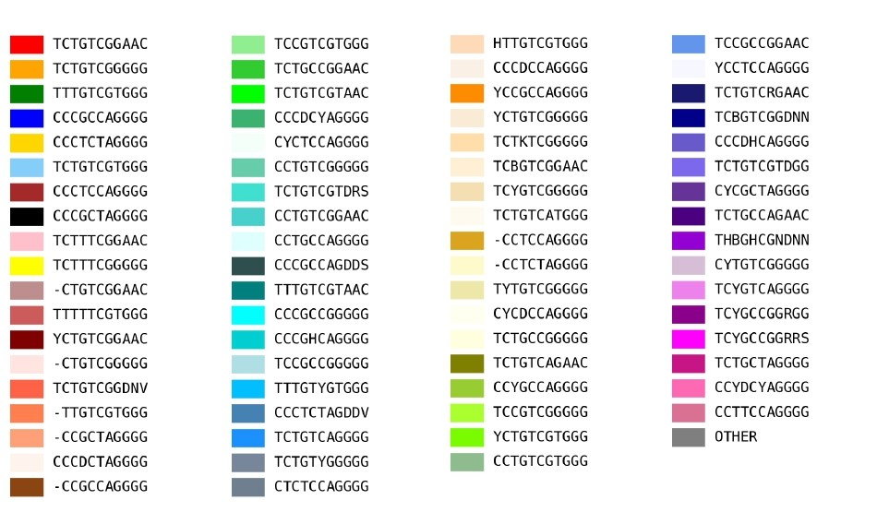
Figure 5: Shows the global color map used throughout in this study for different viral subtypes as represented by unique ISMs.

Figure 6: Shows the geographical distribution of different viral subtypes across different states or union territories (UTs) in India. The legend box beside the pie chart indicates the ISM’s first sampling date in that region. The color key at the bottom shows the colour map for ISMs corresponding to viral subtypes. The viral subtypes highly abundant in India corresponding to red (TCTGTCGGAAC; 25.7%), yellow (TCTGTCGGGGG; 20.7%), blue (TCTGTCGTGGG; 18.3%) and brown (CCCTCCAGGGG; 14.7%) contribute to most of the states and UTs.
Figure 7: Shows geographical distribution of different strains across different states or UTs in India. The legend at right bottom mentions the colours corresponding to different strains. ‘D’ and ‘G’ refer to the S-D614 and S-G614 strains respectively. ‘OTHER’ refers collectively to the strains with abundance less than 0.5% and ‘-’ refers to the samples which could not code for an amino acid at position 614 of the S-protein.
Figure 8: Show the relative abundance of strains of genome sequences from India as sampled over time. For legend refer to Supplementary Figure 7.

