Table 5. Unique components extracted from Phoebe zhennan.
ID | Chemical name | Chemical structure | Formula | Molecular weight
1 | (1R)-2,6,6-Trimethylbicyclo[3.1.1]hept-2-ene | 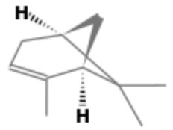 | C₁₀H₁₆ | 136
2 | o-Cymene | 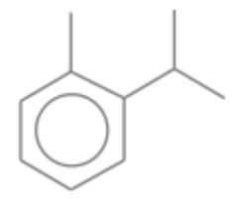 | C₁₀H₁₄ | 134
3 | Benzene, 1-methyl-4-(1-methylethenyl)- | 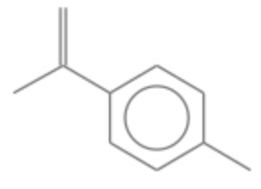 | C₁₀H₁₂ | 132
4 | 3-Cyclopentene-1-acetaldehyde, 2,2,3-trimethyl-, (R)- | 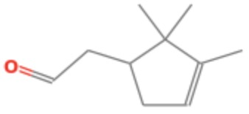 | C₁₀H₁₆O | 152
5 | Bicyclo[3.1.1]heptan-2-one, 6,6-dimethyl-, (1R)- | 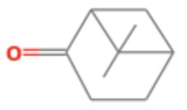 | C₉H₁₄O | 138
6 | Ylangene | 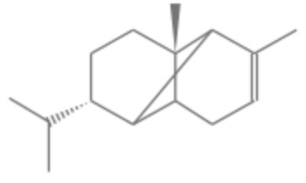 | C₁₅H₂₄ | 204
7 | γ-Muurolene | 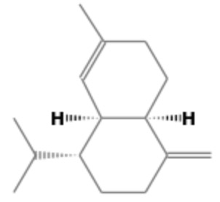 | C₁₅H₂₄ | 204
8 | β-Guaiene | 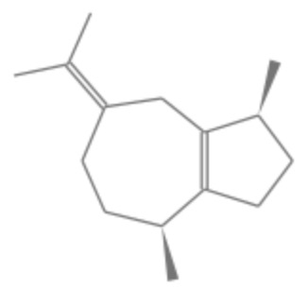 | C₁₅H₂₄ | 204
9 | Naphthalene, 1,2,3,5,6,7,8,8a-octahydro-1,8a-dimethyl-7-(1-methylethenyl)-, [1R-(1α,7β,8aα)]- | 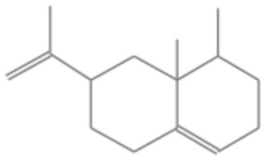 | C₁₅H₂₄ | 204
10 | (3R,3aR,3bR,4S,7R,7aR)-4-Isopropyl-3,7-dimethyloctahydro-1H-cyclopenta[1,3]cyclopropa[1,2]benzen-3-ol | 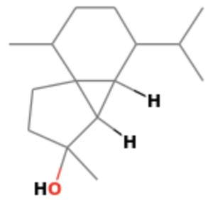  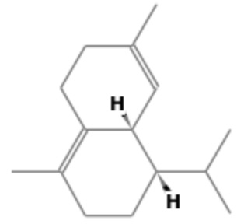 | C₁₅H₂₆O | 222
11 | Naphthalene, 1,2,3,5,6,8a-hexahydro-4,7-dimethyl-1-(1-methylethyl)-, (1S-cis)- |  | C₁₅H₂₄ | 204
12 | Cubenene | 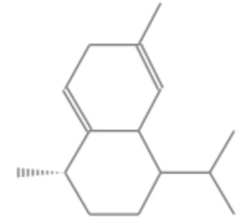 | C₁₅H₂₄ | 204
13 | α-Calacorene | 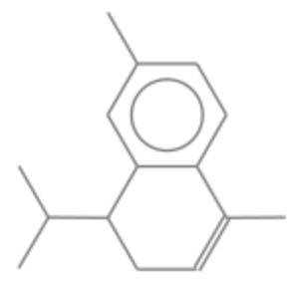  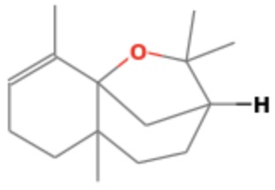 | C₁₅H₂₀ | 200
14 | (3R,5aS,9aR)-2,2,5a,9-Tetramethyl-3,4,5,5a,6,7-hexahydro-2H-3,9a-methanobenzo[b]oxepine |  | C₁₅H₂₄O | 220
15 | 1-((1R,2R,3R)-2-(3-Isopropylfuran-2-yl)-3-methylcyclopentyl)ethanone | 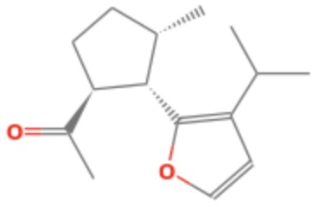 | C₁₅H₂₂O₂ | 234
16 | (1R,3E,7E,11R)-1,5,5,8-Tetramethyl-12-oxabicyclo[9.1.0]dodeca-3,7-diene | 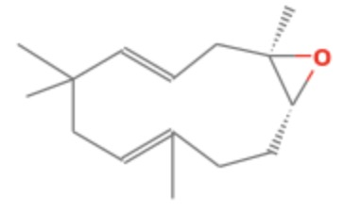 | C₁₅H₂₄O | 220
17 | Longiverbenone | 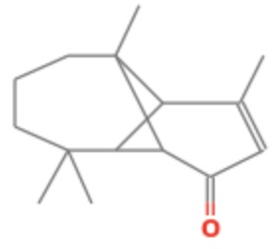 | C₁₅H₂₂O | 218

Table 6. Unique components extracted from Phoebe bournei.
ID | Chemical name | Chemical structure | Formula | Molecular weight
1 | Benzene, 1-methyl-3-(1-methylethyl)- | 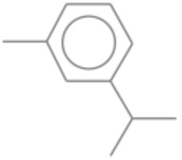 | C₁₀H₁₄ | 134
2 | Borneol | 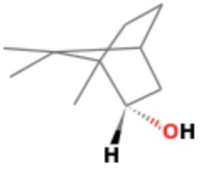 | C₁₀H₁₈O | 154
3 | Benzenemethanol, α,α,4-trimethyl- | 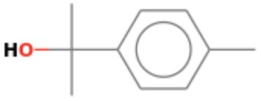 | C₁₀H₁₄O | 150
4 | 1,2,4-Metheno-1H-indene, octahydro-1,7a-dimethyl-5-(1-methylethyl)-, [1S-(1α,2α,3aβ,4α,5α,7aβ,8S*)]- | 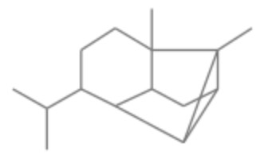 | C₁₅H₂₄ | 204
5 | (1S,4aR,8aS)-1-Isopropyl-7-methyl-4-methylene-1,2,3,4,4a,5,6,8a-octahydronaphthalene | 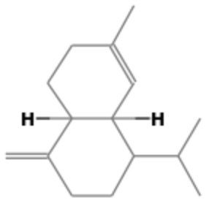 | C₁₅H₂₄ | 204
6 | Naphthalene, 1,2,4a,5,6,8a-hexahydro-4,7-dimethyl-1-(1-methylethyl)- | 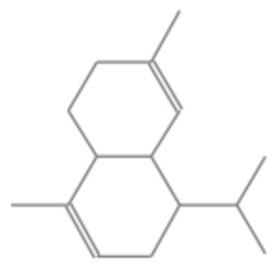  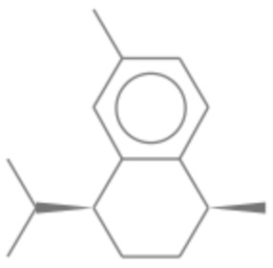 | C₁₅H₂₄ | 204
7 | Naphthalene, 1,2,3,4-tetrahydro-1,6-dimethyl-4-(1-methylethyl)-, (1S-cis)- |  | C₁₅H₂₂ | 202
8 | Cyclohexanemethanol, 4-ethenyl-α,α,4-trimethyl-3-(1-methylethenyl)-, [1R-(1α,3α,4β)]- | 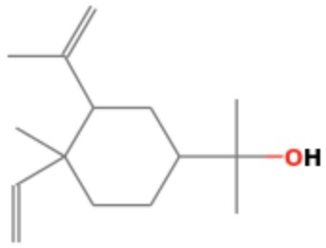  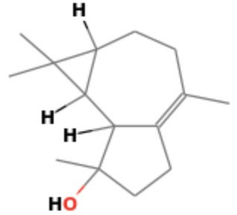  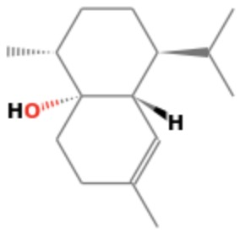  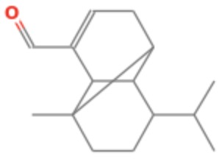 | C₁₅H₂₆O | 222
9 | Isospathulenol |  | C₁₅H₂₄O | 220
10 | Cubenol |  | C₁₅H₂₆O | 222
11 | Ylangenal |  | C₁₅H₂₂O | 218
12 | Cyclohexanemethanol, 4-ethenyl-α,α,4-trimethyl-3-(1-methylethenyl)-, acetate, [1R-(1α,3α,4β)]- | 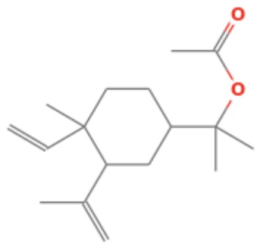 | C₁₇H₂₈O₂ | 264

