Supplementary Materials
Supplementary methods
Exon capture and whole exome sequencing
All samples were collected with written informed consent from the patient and her parents. Genomic DNA was isolated from peripheral blood using DNA Isolation Kit (Blood DNA Kit V2, CW2553) according to standard procedure from the patient and her parents. 1 μg isolated DNA was fragmented into around 200 bp with Bioruptor UCD-200. Then, DNA libraries were prepared with KAPA Library Preparation Kit (Kapa Biosystems, KR0453) following the manufacturer’s instructions. The procedure comprises three standard steps: end-repair of fragmented DNA, A-tailing, adapter ligation and amplification. Hybridization of pooled libraries to the capture probes and removal of non-hybridized library molecules were carried out according to the SeqCap hybrid Mix system using Qubit dsDNA HS Assay kit (Invitrogen, Q32851). Sample dilution, flowcell loading and sequencing were performed according to the Illumina specifications. DNA libraries were sequenced on the illumina novaseq platform as paired-end 200-bp reads.
For the quality control, the Cutadapt and FastQC were used to remove 3′-/5′- adapters and low-quality reads, respectively. The clean reads were mapped to the reference human genome (hg19) using the BWA (Burrows–Wheeler Aligner) program with at most two mismatches. The alignment files (.bam) were generated with SAM tools. Clonal duplicated reads that may be derived from PCR artifacts were removed using Picard Tools by default parameters. Short read alignment and annotation visualization were performed using the IGV (Integrative Genomics Viewer). The percentage of alignment of the clean read to the exome regions was obtained using our custom Perl scriptson the base of alignment files. SNVs and indels were detected by GATK (Genome Analysis ToolKit). Comprehensive annotation of all the detected SNVs and indels were annotated by Annovar software, including function implication (gene region, functional effect, mRNA GenBank accession number, amino acid change, cytoband, etc.) and allele frequency in dbSNP, 1000 Genomes, ESP6500, ExAc. Damaging missense mutations were predicted by SIFT, PolyPhen-2, and MutationTaster. Finally, the candidate causal genes discovered via WES were then confirmed by Sanger sequencing. All samples were obtained with written informed consent from patient and her parents.
Patient collection and information extraction
The previously published papers and the information on the patients with ZTTK syndrome were searched in OMIM and Clinvar database using the keywords “ZTTK” or “ZTTK syndrome”, and 4 related papers were subsequently obtained. Then, the papers cited by the 4 papers mentioned above were sought and screened in PubMed database before 10 December, 2019. The clinical, neuroradiologic and genetic information were finally extracted and curated using manual methods.

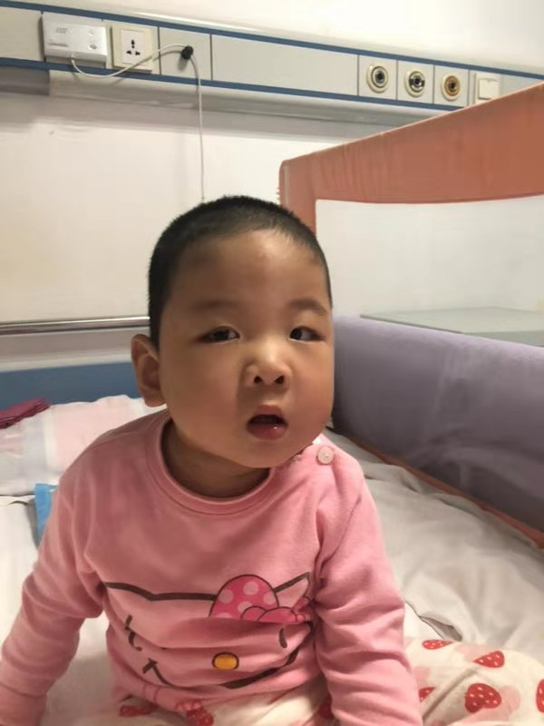
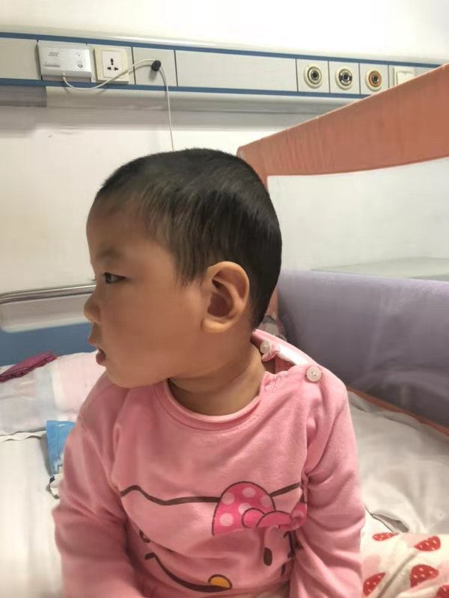
Supplementary Figures
A
B

Fig. S1 Facial features of the proband. He presented the prominent forehead, curly hair, sparse eyebrows, epicanthal folds, flat nasal bridge, short nose, protruding ears and full cheeks.

Fig. S2 Video electroencephalogram (VEEG) of the proband. (A, B) At the age of 1 year and 16 days, the VEEG result showed aberrant and slowing background rhythm, discontinuous waves in bilateral hemispheres with the asymmetry in the right side lower than that in the left side and more significant in the temporal region, and multiple sporadic, clustered or non-rhythmic and long-path frequently sharp waves in the left-central, parietal and middle-posterior temporal regions, even sometimes generalized in the left brain. (C, D). At the age of 1 year and 7 months, the result of VEFG was similar to that at the age of 1 year 16 days, therefore, few low-medium wave amplitude and sporadic sharp wave in left front, central, and pre-temporal region in asleep, few medium-high wave amplitude and sporadic slow wave in left occipital lobe and mid-posterior temporal gyrus.

Supplementary Tables
Table S1. Characteristics of seizures during the age of 16 months to 20 months.
Table S2. The adjuvant examinations of this patient with ZTTK syndrome.
Table S3. The clinical, neuroimaging, genetical information in ZTTK syndrome patients.
Table S4. Comparison of clinical features of patients with ZTTK syndrome in different mutations.

