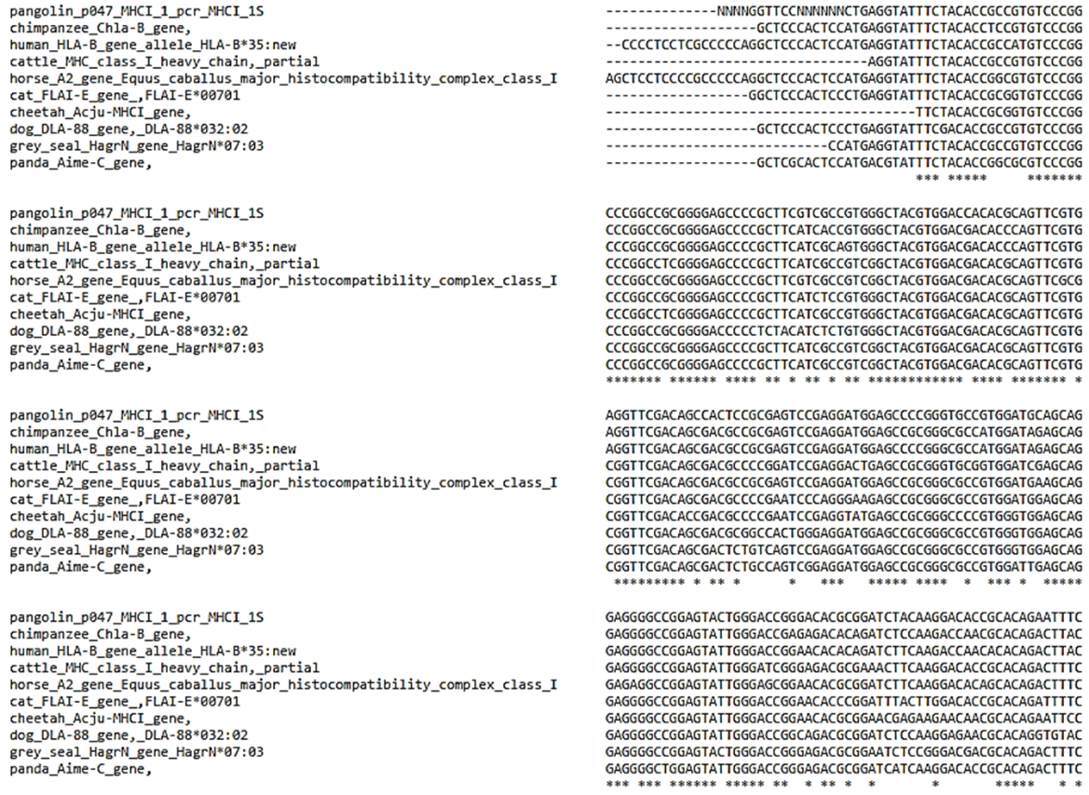
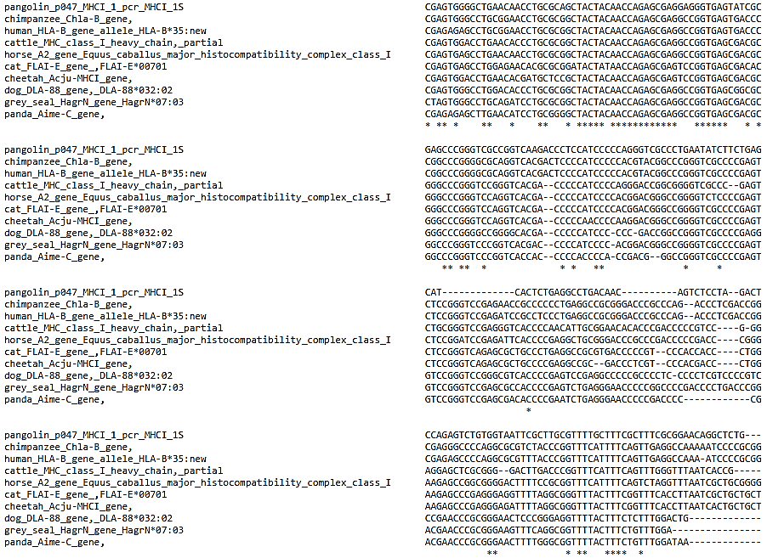
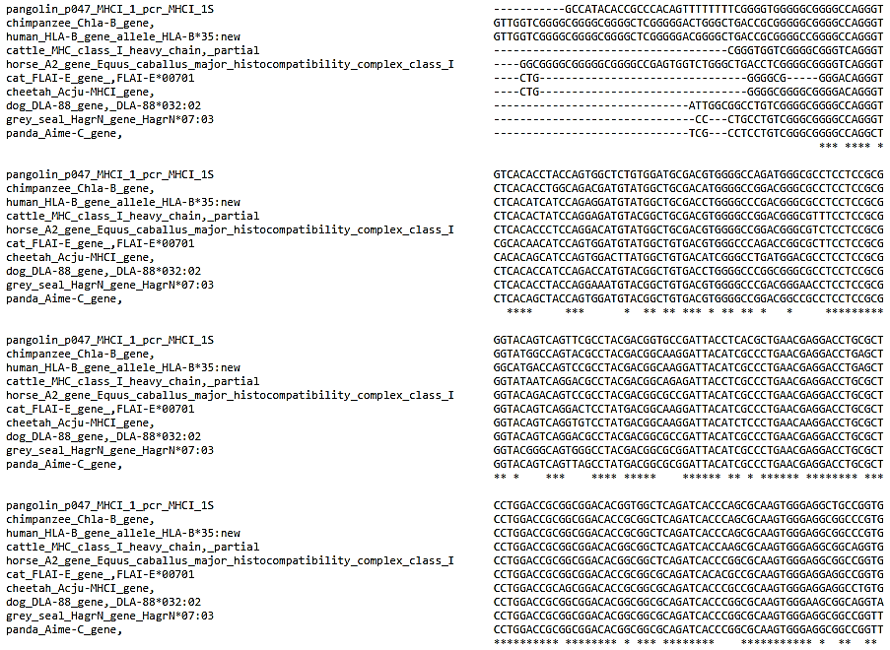
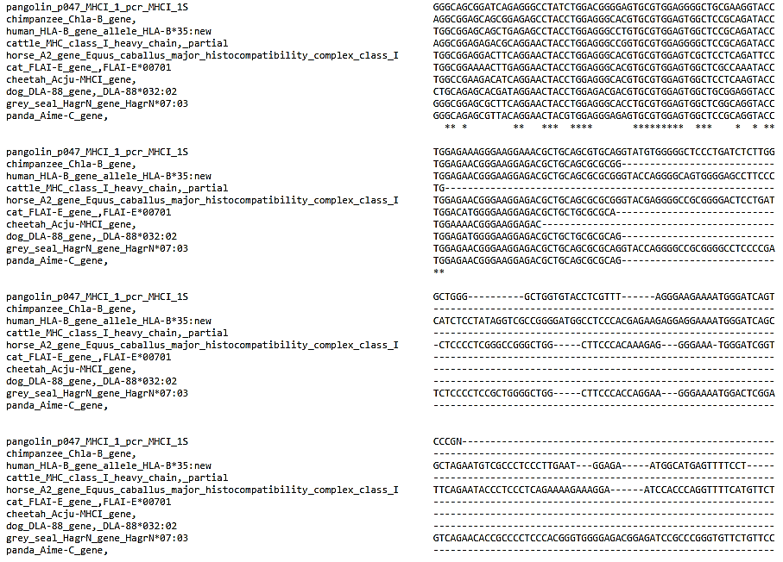
Supplementary Figure 1. Sequence similarity among pangolin, chimpanzee, human, cattle, horse, cat, cheetah, dog, grey seal, and panda at Formosan pangolin HLA class I B-14 alpha chain-like locus with its similar sequences

Supplementary Table 1. Percentage of identity matrix among pangolin, chimpanzee, human, cattle, horse, cat, cheetah, dog, grey seal, and panda at Formosan pangolin HLA class I B-14 alpha chain-like locus with its similar sequences.
 | Pangolin | Chim-panzee | Human | Cattle | Horse | Cat | Cheetah | Dog | Grey seal | Panda
Pangolin | -
Chimpanzee | 74.24 | -
Human | 70.59 | 95.95 | -
Cattle | 74.93 | 78.27 | 77.38 | -
Horse | 73.48 | 80.82 | 77.28 | 85.65 | -
Cat | 73.68 | 77.90 | 78.03 | 81.80 | 84.83 | -
Cheetah | 73.80 | 76.54 | 76.37 | 81.14 | 83.47 | 90.55 | -
Dog | 75.35 | 79.03 | 77.69 | 79.59 | 82.48 | 81.24 | 79.28 | -
Grey seal | 73.16 | 79.86 | 74.42 | 81.31 | 82.07 | 82.52 | 81.27 | 82.60 | -
Panda | 76.27 | 78.93 | 78.66 | 80.56 | 84.40 | 80.61 | 80.20 | 83.26 | 90.95 | -
Unit: percentage (%)

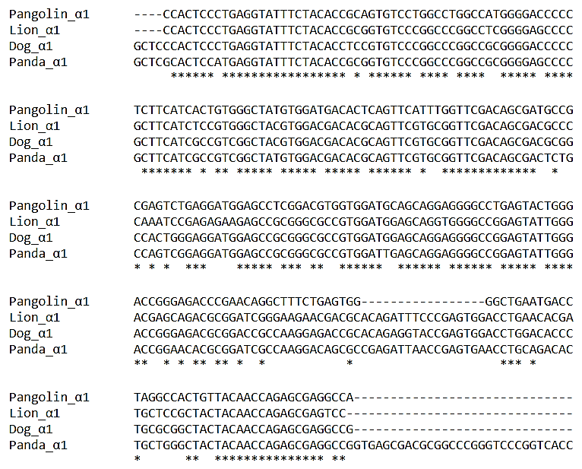
Supplementary Figure 2. Sequence similarity among dog, lion, panda and Formosan pangolin at Formosan pangolin HLA class I A-11 alpha chain-like locus exon 2 with its similar sequences.

Supplementary Table 2. Percentage of identity matrix among dog, lion, panda and Formosan pangolin at Formosan pangolin HLA class I A-11 alpha chain-like locus exon 2 with its similar sequences.
 | Pangolin | Lion | Dog | Panda
Pangolin | -
Lion | 74.19 | -
Dog | 78.31 | 86.42 | -
Panda | 75.50 | 85.28 | 90.00 | -
Unit: percentage (%)

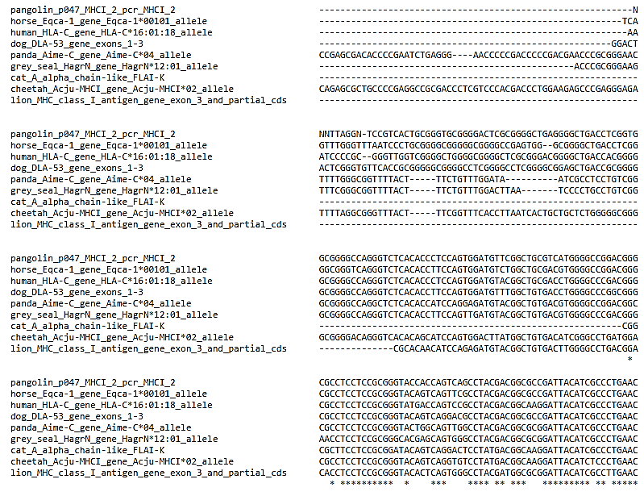
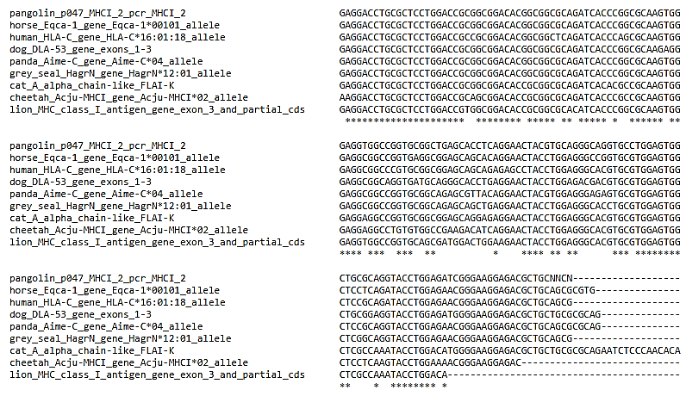
Supplementary Figure 3. Sequence similarity among pangolin, horse, human, dog, panda, grey seal, cat, cheetah, and lion at Formosan pangolin HLA class I A-11 alpha chain-like locus exon 3 with its similar sequences.

 | Pangolin | Horse | Human | Dog | Panda | Grey seal | Cat | Cheetah | Lion
Pangolin | -
Horse | 80.53 | -
Human | 80.88 | 82.60 | -
Dog | 81.23 | 80.92 | 80.65 | -
Panda | 80.06 | 82.88 | 79.75 | 78.87 | -
Grey seal | 79.94 | 81.33 | 82.37 | 80.24 | 90.53 | -
Cat | 83.48 | 87.72 | 86.61 | 86.46 | 81.87 | 86.16 | -
Cheetah | 72.78 | 75.30 | 73.09 | 72.29 | 80.06 | 81.33 | 85.35 | -
Lion | 79.59 | 80.82 | 79.18 | 78.37 | 81.63 | 82.86 | 86.14 | 78.78 | -
Supplementary Table 3. Percentage of identity matrix among pangolin, horse, human, dog, panda, grey seal, cat, cheetah, and lion at Formosan pangolin HLA class I A-11 alpha chain-like locus exon 3 with its similar sequences.
Unit: percentage (%)

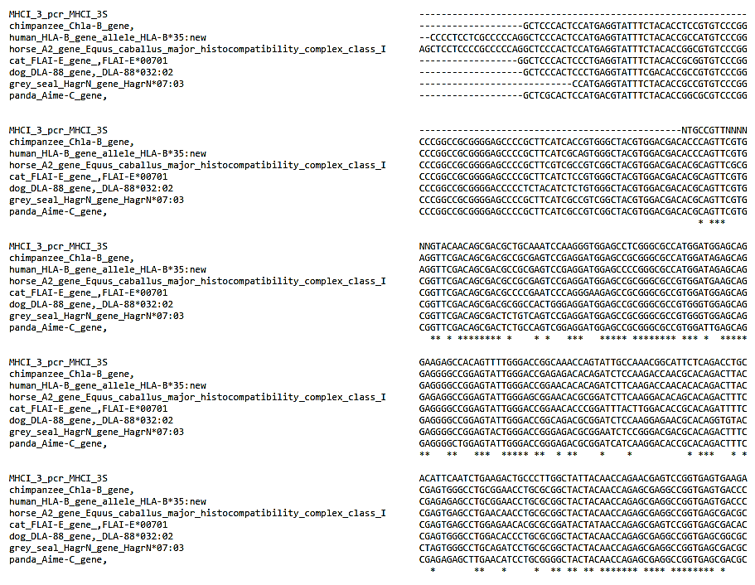
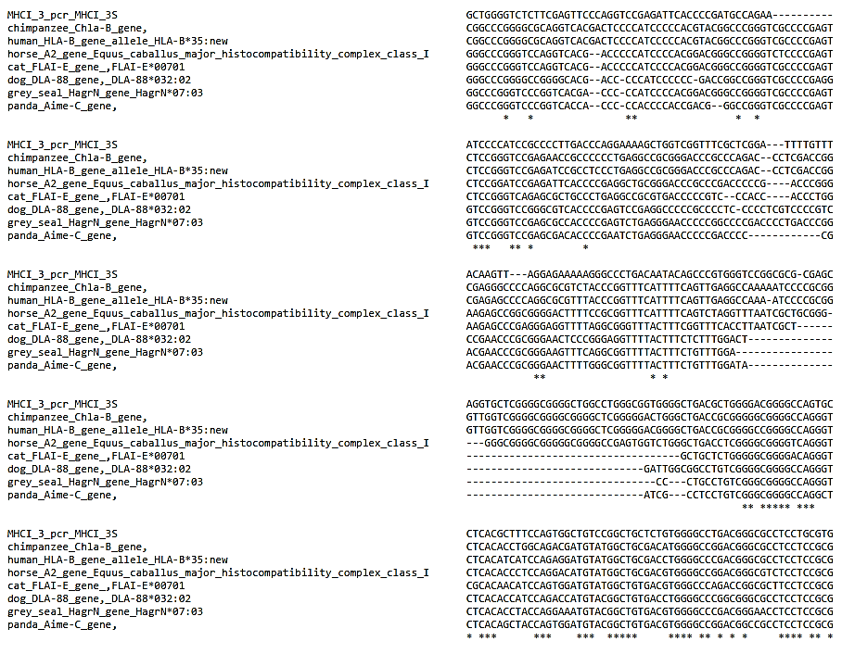
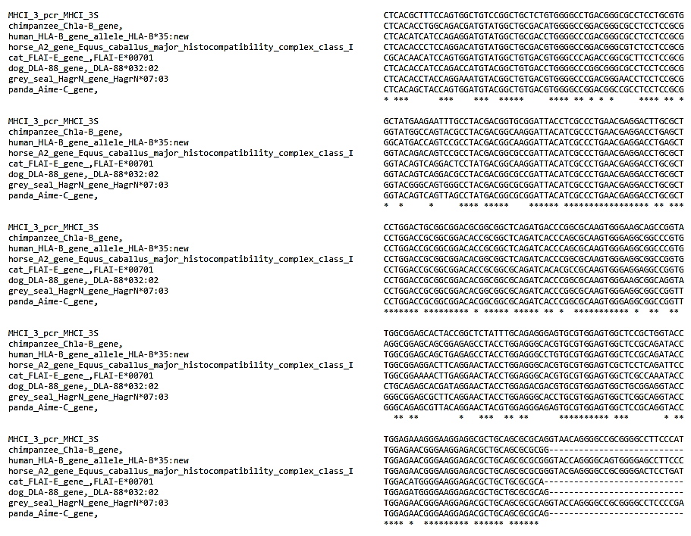
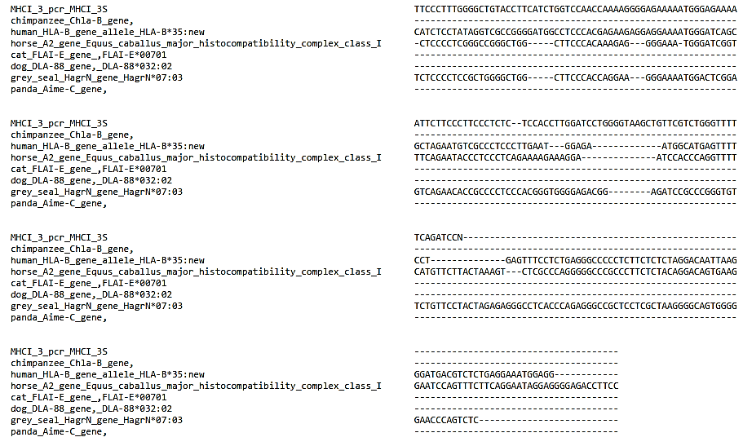
Supplementary Figure 4. Sequence similarity among pangolin, chimpanzee, human, horse, cat, dog, grey seal, and panda at Formosan pangolin HLA class I G alpha chain-like locus with its similar sequences

Supplementary Table 4. Percentage of identity matrix among pangolin, chimpanzee, human, horse, cat, dog, grey seal, and panda at Formosan pangolin HLA class I G alpha chain-like locus with its similar sequences.
 | Pangolin | Chimpanzee | Human | Horse | Cat | Dog | Grey seal | Panda
Pangolin | -
Chimpanzee | 61.72 | -
Human | 60.02 | 95.95 | -
Horse | 61.65 | 80.59 | 77.10 | -
Cat | 61.21 | 78.33 | 78.33 | 85.64 | -
Dog | 63.96 | 78.76 | 77.42 | 82.35 | 80.90 | -
Grey seal | 61.11 | 80.27 | 74.75 | 82.28 | 82.85 | 82.60 | -
Panda | 64.39 | 79.34 | 79.07 | 84.68 | 80.80 | 83.26 | 90.95 | -
Unit: percentage (%)

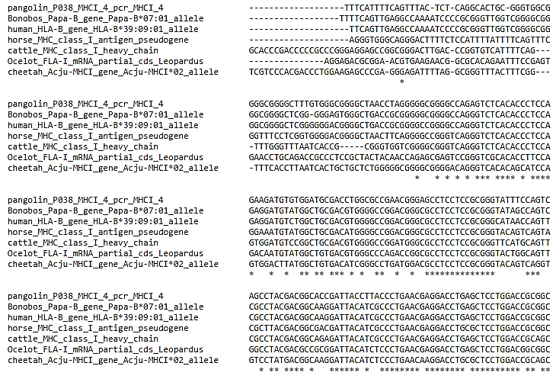
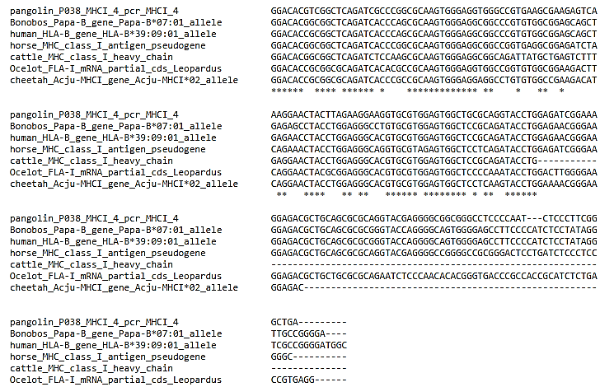
Supplementary Figure 5. Sequence similarity among pangolin, bonobos, human, horse, cattle, ocelot and cheetah at Formosan pangolin HLA class I B-15 alpha chain-like locus with its similar sequences.

Supplementary Table 5. Percentage of identity matrix among pangolin, bonobos, human, horse, cattle, ocelot and cheetah at Formosan pangolin HLA class I B-15 alpha chain-like locus with its similar sequences
 | Pangolin | Bonobos | Human | Horse | Cattle | Ocelot | Cheetah
Pangolin | -
Bonobos | 76.19 | -
Human | 76.44 | 97.07 | -
Horse | 72.11 | 75.19 | 75.00 | -
Cattle | 67.92 | 75.94 | 76.49 | 76.80 | -
Ocelot | 61.15 | 65.36 | 66.26 | 65.67 | 70.90 | -
Cheetah | 64.31 | 72.43 | 72.65 | 73.24 | 79.62 | 74.20 | -
Unit: percentage (%)

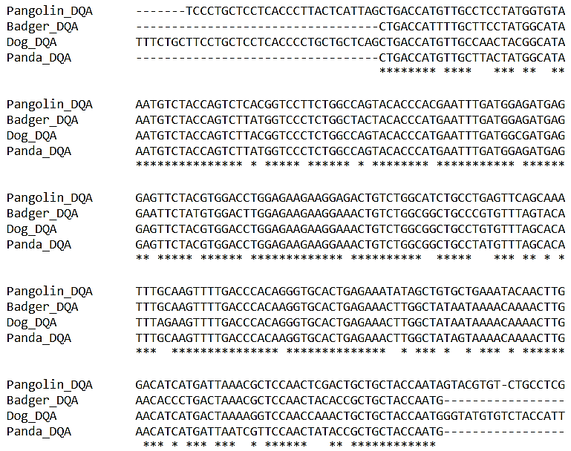
Supplementary Figure 6. Sequence similarity among dog, badger, panda and Formosan pangolin at MHC class II DQA loci.

Supplementary Table 6. Percentage of identity matrix among dog, badger, panda and Formosan pangolin at MHC class II DQA loci
 | Pangolin | Badger | Dog | Panda
Pangolin | -
Badger | 84.34 | -
Dog | 79.12 | 90.36 | -
Panda | 87.15 | 93.17 | 93.17 | -
Unit: percentage (%)

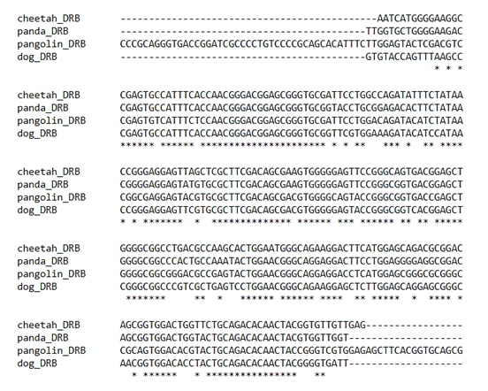
Supplementary Figure 7. Sequence similarity among dog, cheetah, panda and Formosan pangolin at MHC class II DRB loci.

Supplementary Table 7. Percentage of identity matrix among dog, badger, panda and Formosan pangolin at MHC class II DRB loci
 | Pangolin | Cheetah | Dog | Panda
Pangolin | -
Cheetah | 80.67 | -
Dog | 83.12 | 80.85 | -
Panda | 81.01 | 85.53 | 79.75 | -
Unit: percentage (%)

