Supplementary Tables and Figures

Supplementary Table S1. Numbers of reads, library size and HTSeq gene count for samples from CHL1 and A375 cells.
Sample | Number of Read Pairs (Picard) | Estimated Library Size (Picard) | Expressed gene
A375_Control_72hours_replicate1 | 29445687 | 130995840 | 23456
A375_Control_72hours_replicate2 | 31607087 | 125259365 | 22953
A375_CDK4/6i_72hours_replicate1 | 31321381 | 98816131 | 23660
A375_CDK4/6i_72hours_replicate2 | 32851773 | 115445154 | 23726
A375_PRMT5i_72hours_replicate1 | 28600785 | 93590565 | 23511
A375_PRMT5i_72hours_replicate2 | 29683128 | 87086633 | 22675
A375_Control_6days_replicate1 | 54976837 | 339099090 | 24596
A375_Control_6days_replicate2 | 47990586 | 337523343 | 24723
A375_CDK4/6i_6days_replicate1 | 49311674 | 179617096 | 25278
A375_CDK4/6i_6days_replicate2 | 48510771 | 111721929 | 25750
CHL1_Control_72hours_replicate1 | 46071287 | 283848084 | 23331
CHL1_Control_72hours_replicate2 | 44361715 | 297983024 | 23365
CHL1_CDK4/6i_72hours_replicate1 | 44430155 | 219996906 | 23586
CHL1_CDK4/6i_72hours_replicate2 | 44359734 | 250220140 | 23673
CHL1_PRMT5i_72hours_replicate1 | 52590095 | 355772547 | 22992
CHL1_PRMT5i_72hours_replicate2 | 51944543 | 352381305 | 23296
CHL1_CDK4/6i_6days_replicate1 | 44562890 | 204237467 | 23707
CHL1_CDK4/6i_6days_replicate2 | 38032201 | 235212234 | 23848

Supplementary Table S2. Number of differentially expressed genes in CHL1 cells under different treatments.
Regulation direction | CDK4/6i (72hr)  (A) | CDK4/6i (6days)  (B) | PRMT5i (72hr)  (C)
Up | 445 | 1689 | 5134
Down | 498 | 1611 | 5754
Total | 943 | 3300 | 10888
Supplementary Table S3. Numbers of differential splicing events of each type detected by rMATs at each time point post-treatment for CHL1 and A375 cells.
Cell line |  | Sample (vs DMSO control) | A3SS | A5SS | MXE | RI | SE | Total
CHL1 | CDK4/6i 72hours |  | 158 | 166 | 339 | 202 | 876 | 1741
CHL1 | PRMT5i 72hours |  | 676 | 929 | 2453 | 2102 | 4683 | 10843
CHL1 | CDK4/6i 6days |  | 197 | 194 | 413 | 299 | 1288 | 2391
A375 | CDK4/6i 72hours |  | 264 | 270 | 356 | 413 | 1318 | 2621
A375 | PRMT5i 72hours |  | 457 | 641 | 585 | 1013 | 3172 | 5868
A375 | CDK4/6i 6days |  | 412 | 417 | 1242 | 828 | 2005 | 4904

Supplementary Table S4. Overlap of enriched GO terms in DEGs and DSGs for CDK4/6i and 72 hours PRMT5i samples from CHL1 and A375 cells.
 |  | CHL1 |  | A375
 |  | CDK4/6i | PRMT5i | CDK4/6i | PRMT5i
Differentially expressed genes (DEG)
 | Total (adj.p<0.05) | 852 | 2462 | 1163 | 967
 | Cell cycle | 30 | 37 | 32 | 29
 | DNA repair | 4 | 11 | 10 | 5
 | translation | 0 | 17 | 4 | 0
 | splicing | 0 | 13 | 2 | 0
 | Selected terms | 34 | 78 | 48 | 34
Differentially spliced genes (DSG)
 | Total (adj.p<0.05) | 553 | 1445 | 1993 | 424
 | Cell cycle | 19 | 35 | 27 | 27
 | DNA repair | 1 | 9 | 4 | 6
 | translation | 1 | 12 | 7 | 5
 | splicing | 0 | 12 | 10 | 9
 | Selected terms | 21 | 68 | 48 | 47
DEG and DSG
 | Overlap (Total) | 292 | 1268 | 896 | 225
 | Overlap (Selected terms) | 19 | 61 | 34 | 29

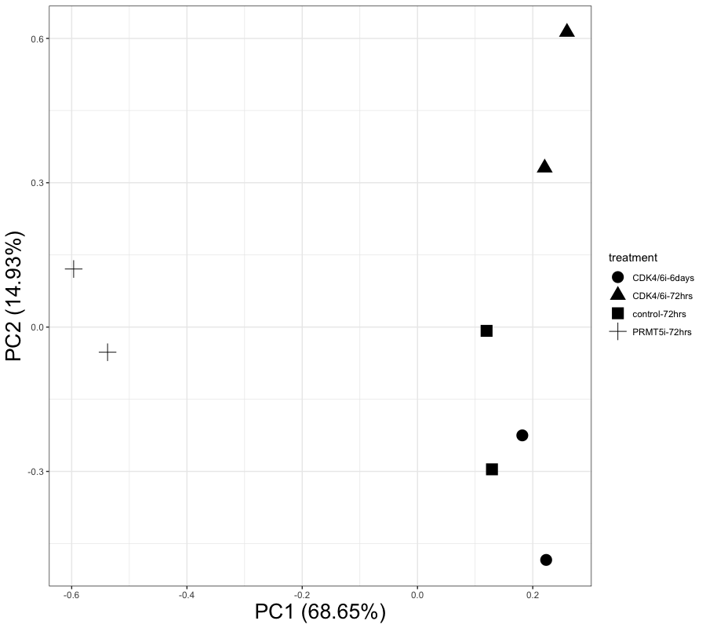
Supplementary figure S1. Plot of the first two principal component for each RNA-sequencing sample from CHL1 cell, based on total gene expression.

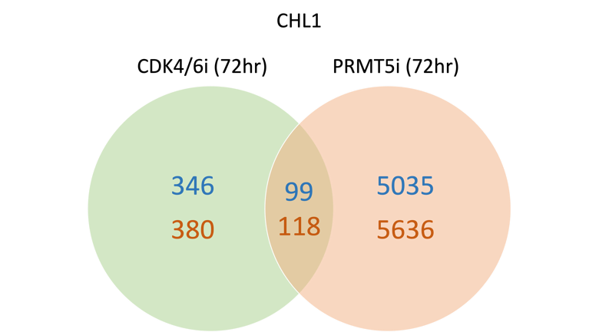

Supplementary figure S2. Numbers of up-regulated (blue) and down-regulated (orange) differentially expressed genes at 72hrs of CDK4i and PRMT5 inhibition in CHL1 cells.

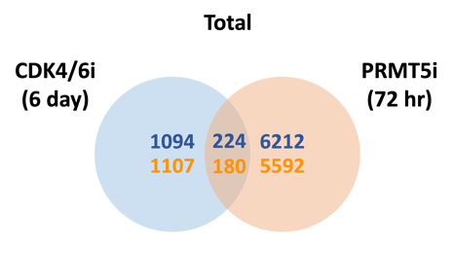
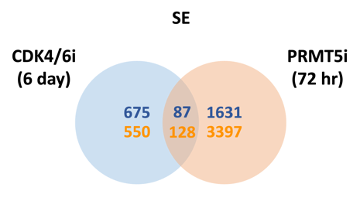
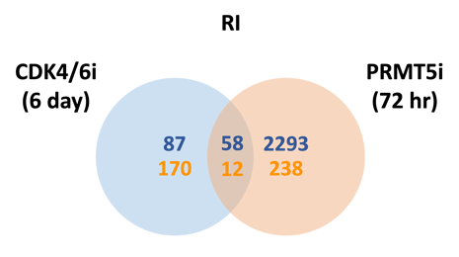
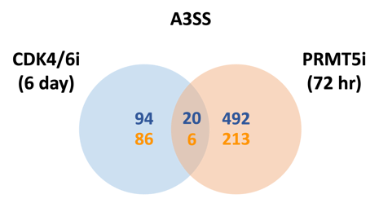
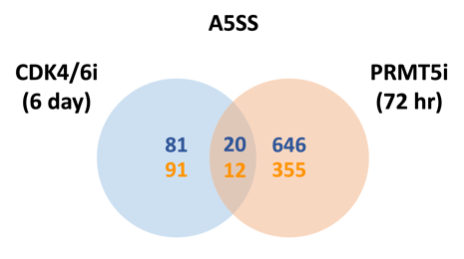
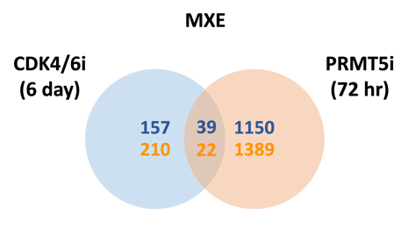

Supplementary figure S3A. Numbers of up-regulated (blue) and down-regulated (orange) differentially spliced events between CDK4i 6 day and PRMT5 inhibition in CHL1 cells.

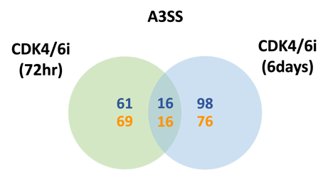
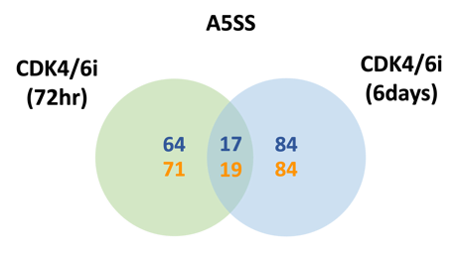
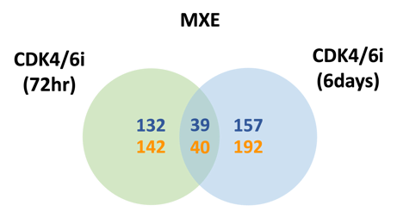
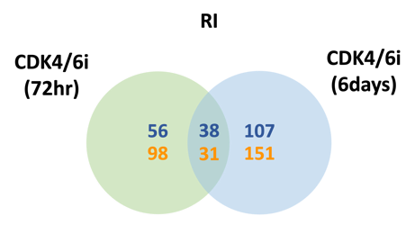
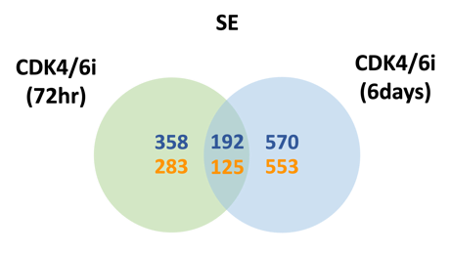
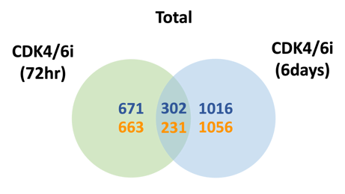

Supplementary figure S3B. Numbers of up-regulated (blue) and down-regulated (orange) differentially spliced events between 72 hours and 6 days CDK4i inhibition in CHL1 cells.

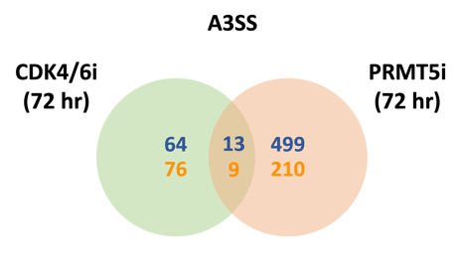
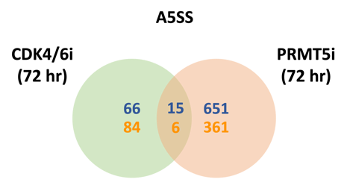
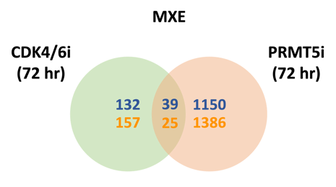
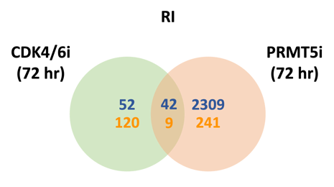
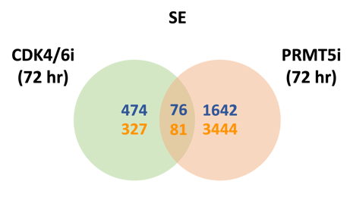
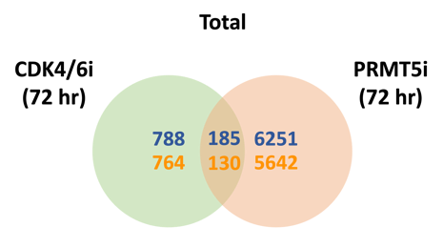

Supplementary figure S3C. Numbers of up-regulated (blue) and down-regulated (orange) differentially spliced events between 72 hours CDK4i and PRMT5 inhibition in CHL1 cells.

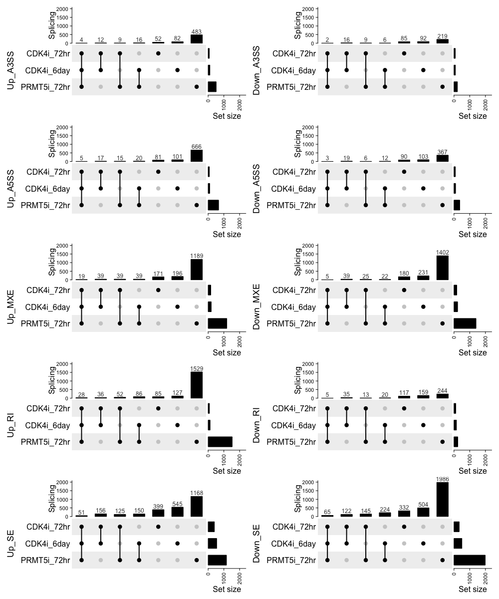
Supplementary figure S3D. Numbers of up-regulated (left) and down-regulated (right) differentially spliced events between treatments in CHL1 cells.

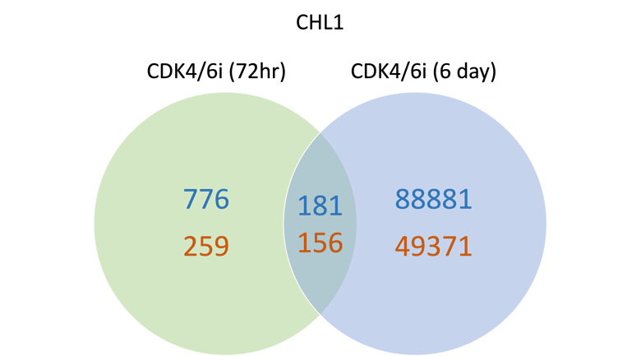
Supplementary figure S4. Numbers of up-regulated (blue) and down-regulated (orange) differentially expressed exons (DEE) between CDK4i 6 day and PRMT5 inhibition in CHL1 cells.

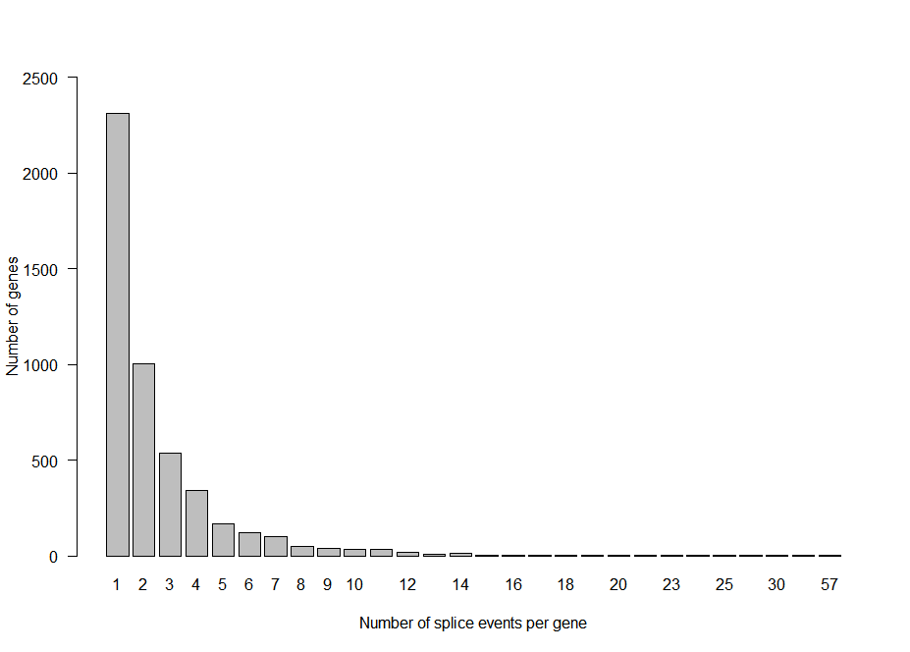
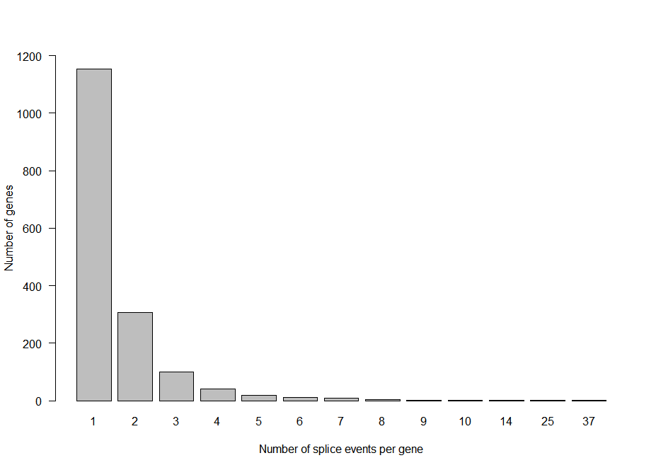
A
B

Supplementary figure S5. Number of splicing events per gene for (A) 6 days CDK4/6i and (B) 72 hours PRMT5i in CHL1 cells.

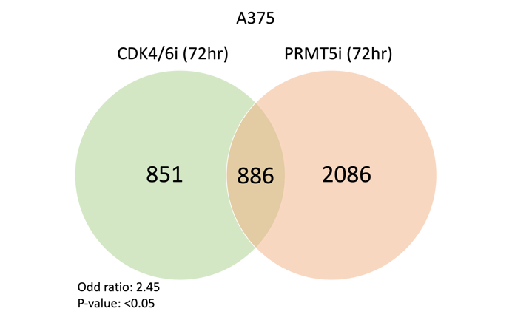
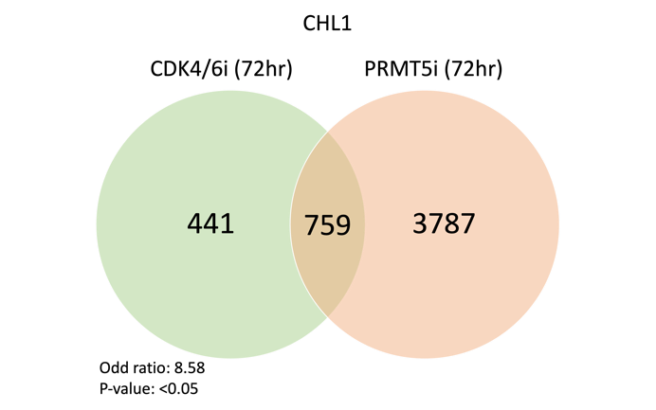
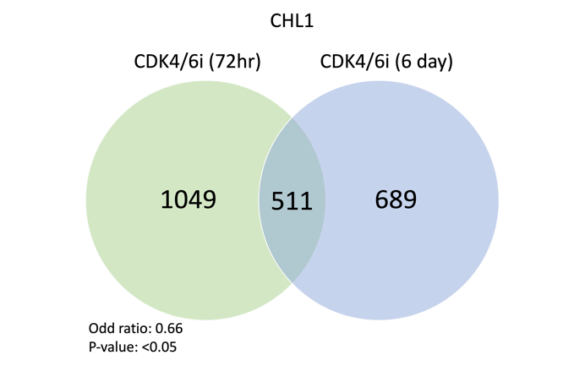
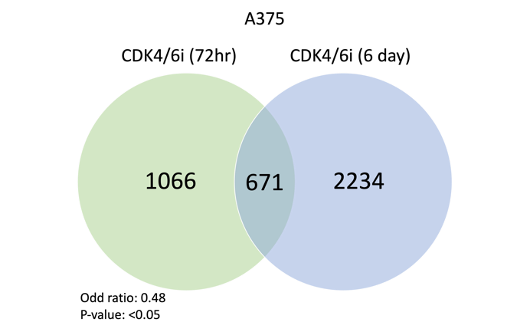
C
D
B
A
Supplementary figure S6. Overlap in differentially spliced genes (DSG) for CHL1 between (A) 72 hours CDK4/6i and PRMT5 inhibition and (B) 72 hours and 6 days CDK4/6i inhibitions and for A375 between (C) 72 hours CDK4/6i and PRMT5 inhibition and (D) 72 hours and 6 days CDK4/6i inhibitions.

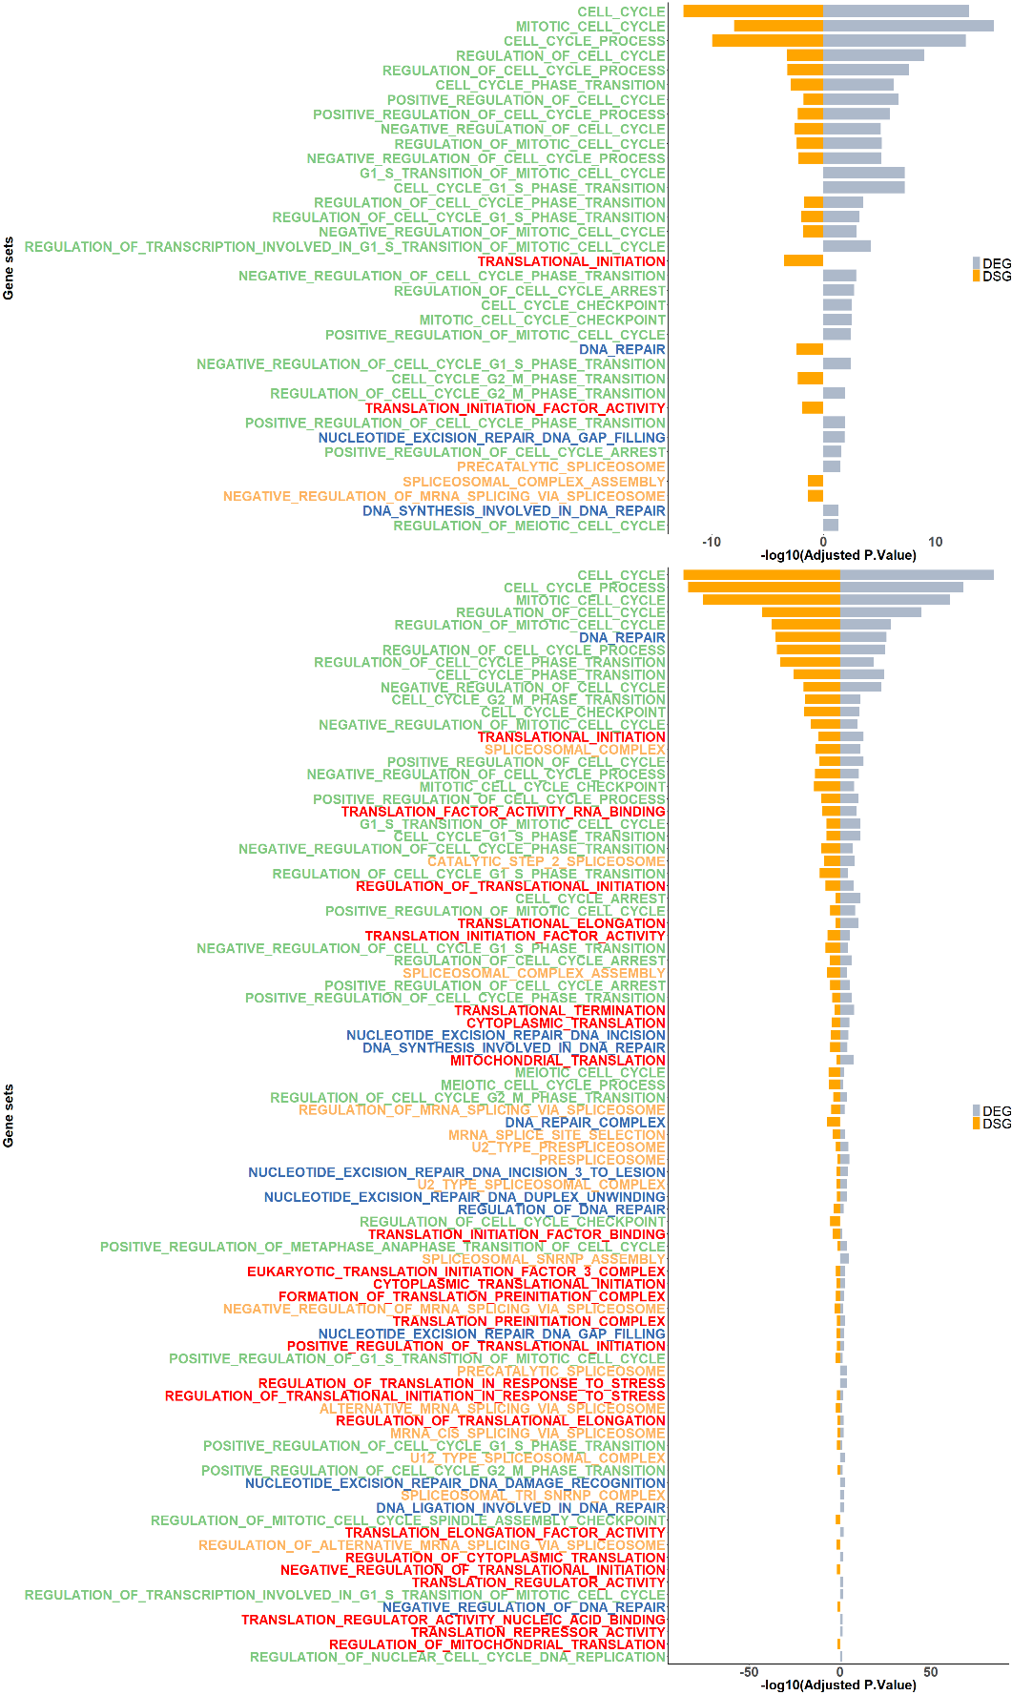
B
A
Supplementary figure S7. All Gene Ontology terms in CHL1 related to cell cycle (green), DNA repair (blue), protein translation (red) and splicing (orange) that were enriched in differentially spliced genes (DSGs) and differentially expressed genes (DEGs) with an adjusted p value <0.05, in the (A) CDK4/6i 6days samples and (B) PRMT5i 72 hours samples. Orange bars indicate adjusted p value for enrichment in DSGs, grey bars adjusted p value for enrichment in DEGs.

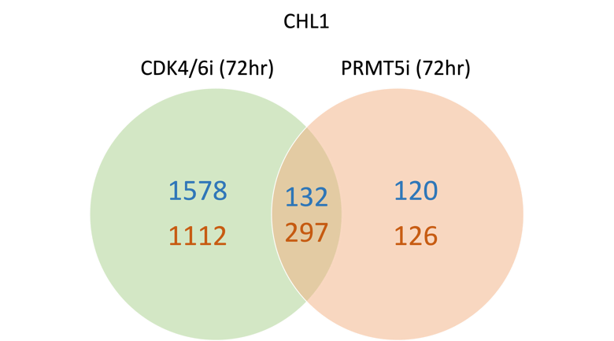
Supplementary figure S8. Numbers of up-regulated (blue) and down-regulated (orange) differentially expressed genes at 72hrs of CDK4i and PRMT5 inhibition in CHL1 cells.

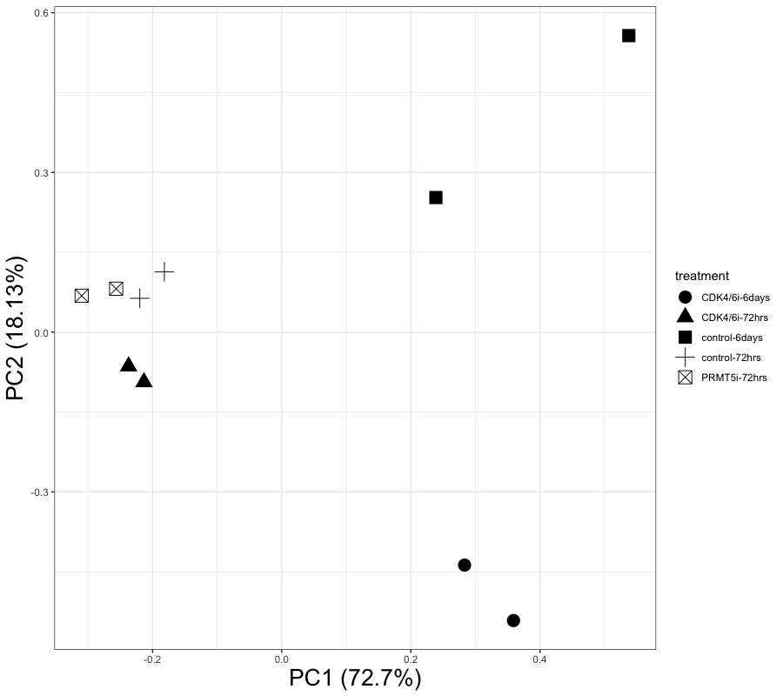
Supplementary figure S9. Plot of the first two principal component for each RNA-sequencing sample from A375 cell, based on total gene expression.

