Supplementary Document

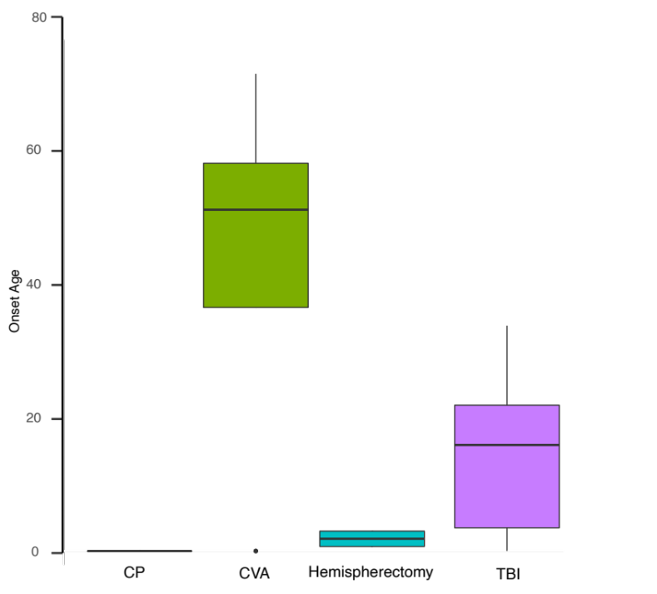

Supplementary Figure 1: Age of disease onset, showing CP and Hemispherectomy as the youngest patients, followed by TBI and CVA as the oldest.

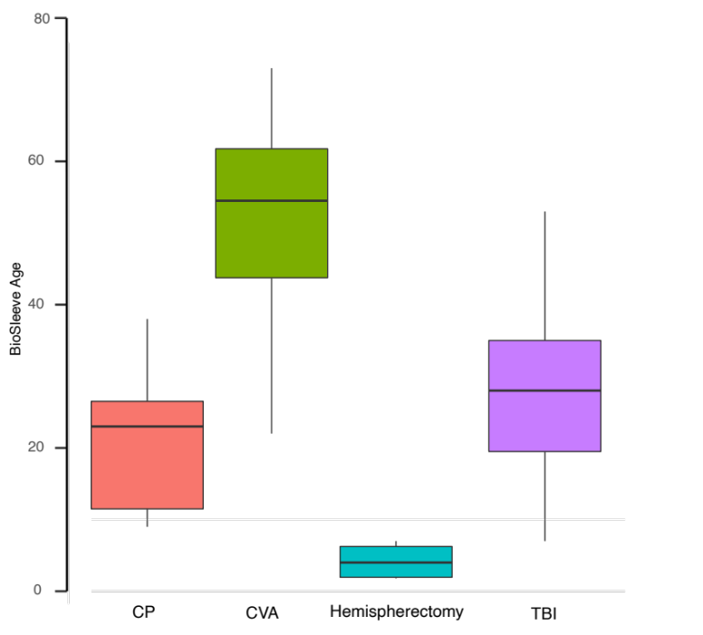

Supplementary Figure 2: Age the BioSleeve was initiated. Hemispherectomy was the youngest age group to receive the BioSleeve, followed by CP, TBI, and CVA as the oldest, respectively.

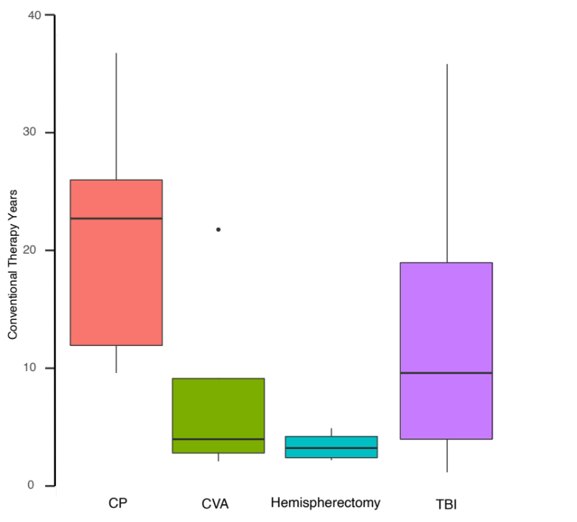

Supplementary Figure 3: The number of years patients underwent conventional therapy prior to BioSleeve intervention. Hemispherectomy underwent the the lowest number of conventional therapy years, followed by CVA, TBI and CP, respectively.

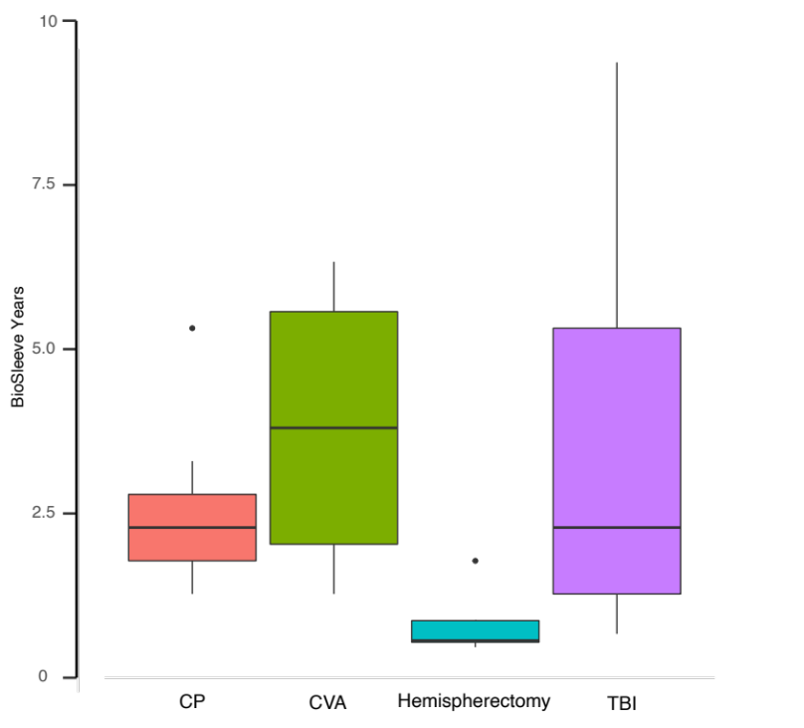

Supplementary Figure 4: The number of years patients used the BioSleeve intervention. Hemispherectomy was used the lowest number of years, followed by CP, TBI and CVA, respectively.

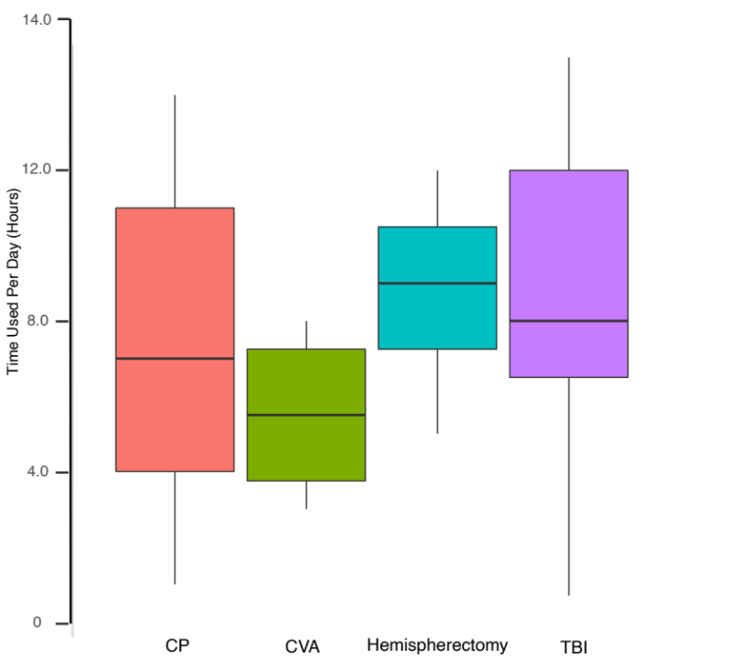

Supplementary Figure 5: Time that the BioSleeve device was used by each subcohort. Hemispherectomy used the BioSleeve the greatest number of hours per day, followed by TBI, CP and CVA, respectively. Collectively, the average amount of time the BioSleeve was used was 8 hours per day.

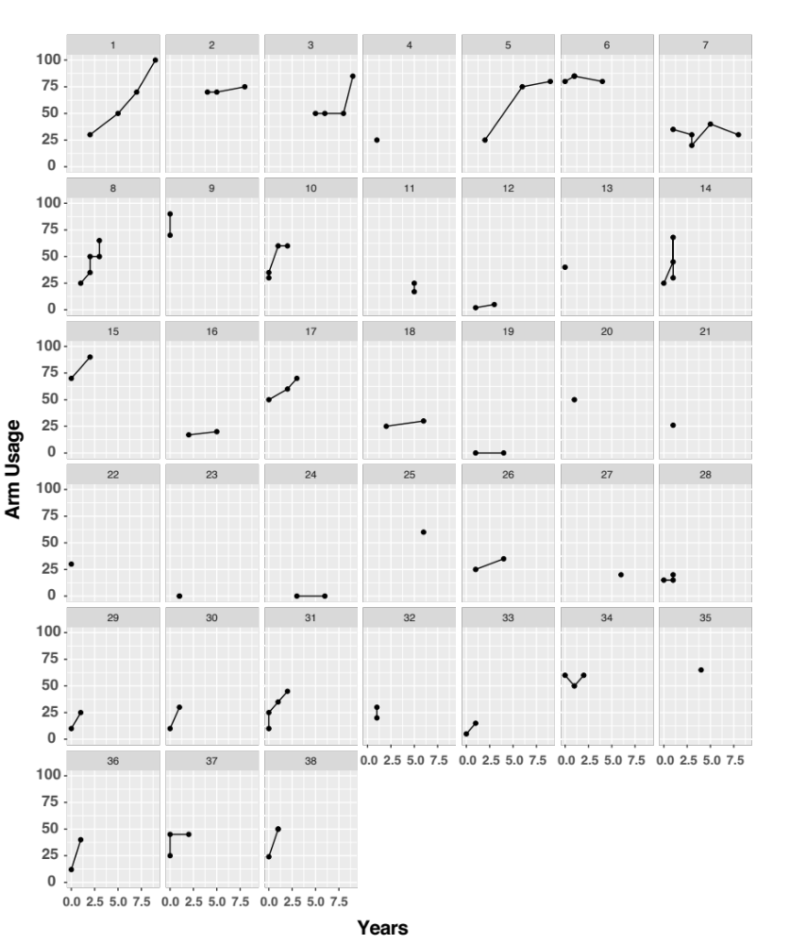

Supplementary Figure 6: Arm usage per patient with the BioSleeve across the follow up years, by patient ID, followed up to 10 years. The plot shows all patients follow up timeline. The plot showed heterogeneity in patient response to the BioSleeve.

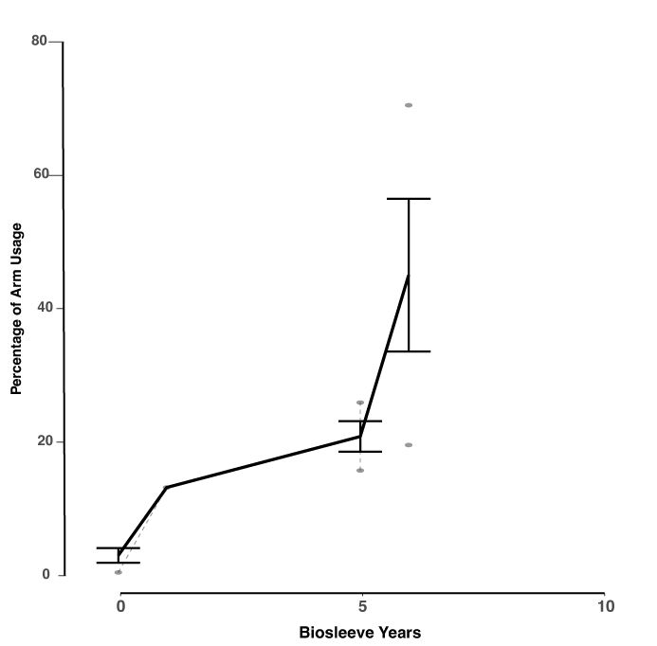

Supplementary Figure 7: Longitudinal arm usage for all CVA patients. All patients were baselined to the fitting date at 0 years with patient follow-up continuing for up to 10 years, with some patients lost to follow-up. The plot shows the average arm usage per year across all patients who wore the BioSleeve in the follow-up phase. The percentage of the group that reported arm usage every year is represented by an average ± 1.96 * standard error. The plot also includes dotted connected lines per patient who show per patient performance. Arm usage at 0 years should be taken as the baseline after conventional therapy.

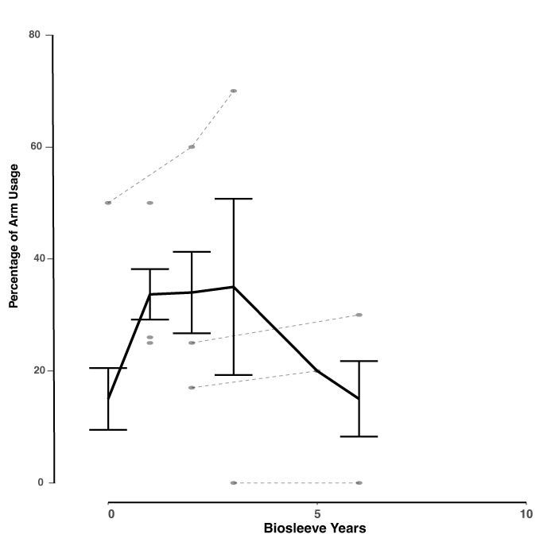

Supplementary Figure 8. Longitudinal arm usage for all CP patients. All patients were baselined to the fitting date at 0 years with patient follow-up continuing for up to 10 years, with some patients lost to follow-up. The plot shows the average arm usage per year across all patients who wore the BioSleeve in the follow-up phase. The percentage of the group that reported arm usage every year is represented by an average ± 1.96 * standard error. The plot also includes dotted connected lines per patient who show per patient performance. Arm usage at 0 years should be taken as the baseline after conventional therapy.

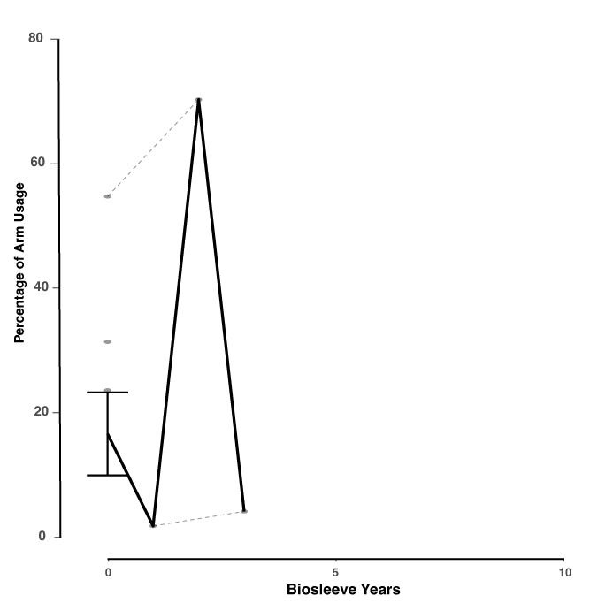

Supplementary Figure 9: Longitudinal arm usage for all Hemispherectomy patients. All patients were baselined to the fitting date at 0 years with patient follow-up continuing for up to 10 years, with some patients lost to follow-up. The plot shows the average arm usage per year across all patients who wore the BioSleeve in the follow-up phase. The percentage of the group that reported arm usage every year is represented by an average ± 1.96 * standard error. The plot also includes dotted connected lines per patient who show per patient performance. Arm usage at 0 years should be taken as the baseline after conventional therapy.

