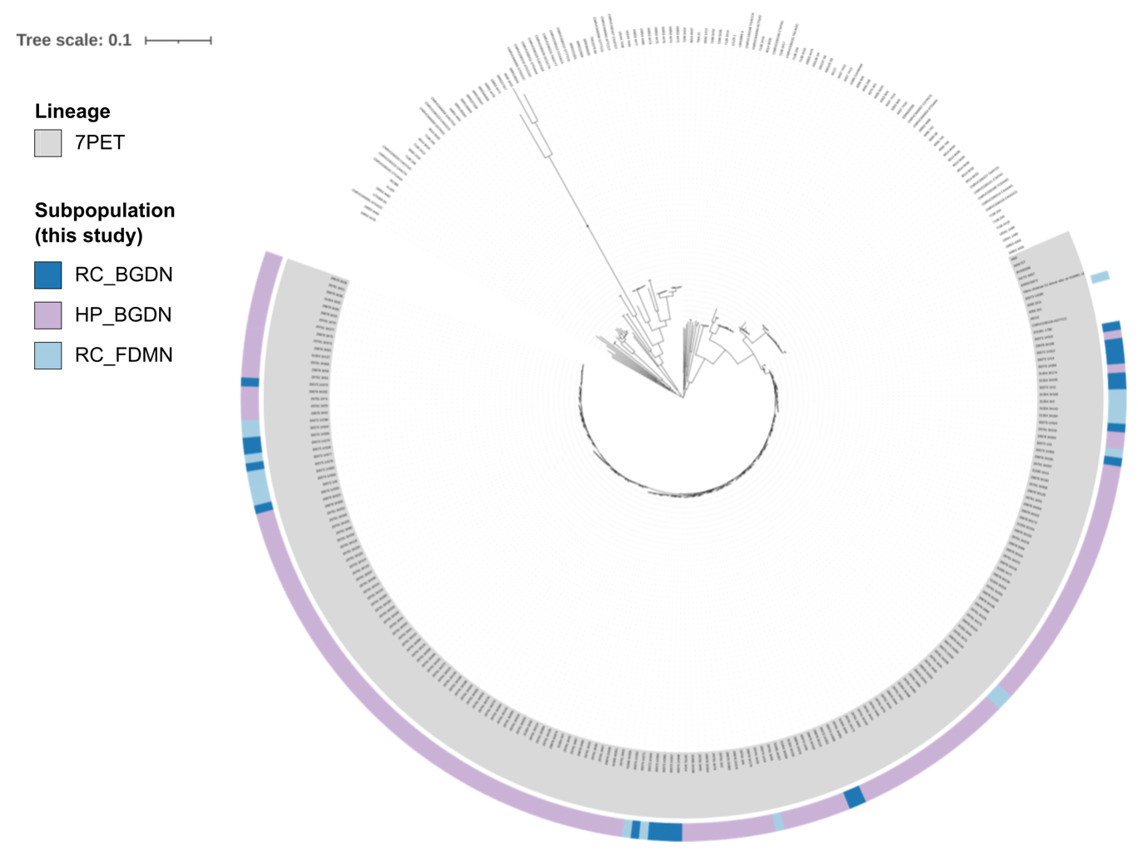
Supplementary Figure S1: V. cholerae core genome single nucleotide variant (SNV) phylogeny. A maximum likelihood phylogeny was constructed using SNVs (n = 130,502) from the alignment of genes core to the 223 genomes sequenced in this study and 144 V. cholerae genomes representative of the diversity within the species (n = 2,919 genes). Grey shading on the tree tips depicts the 7PET lineage whilst coloured strip denotes subpopulations from which our samples were isolated (see key). Scale bar represents substitutions per site.

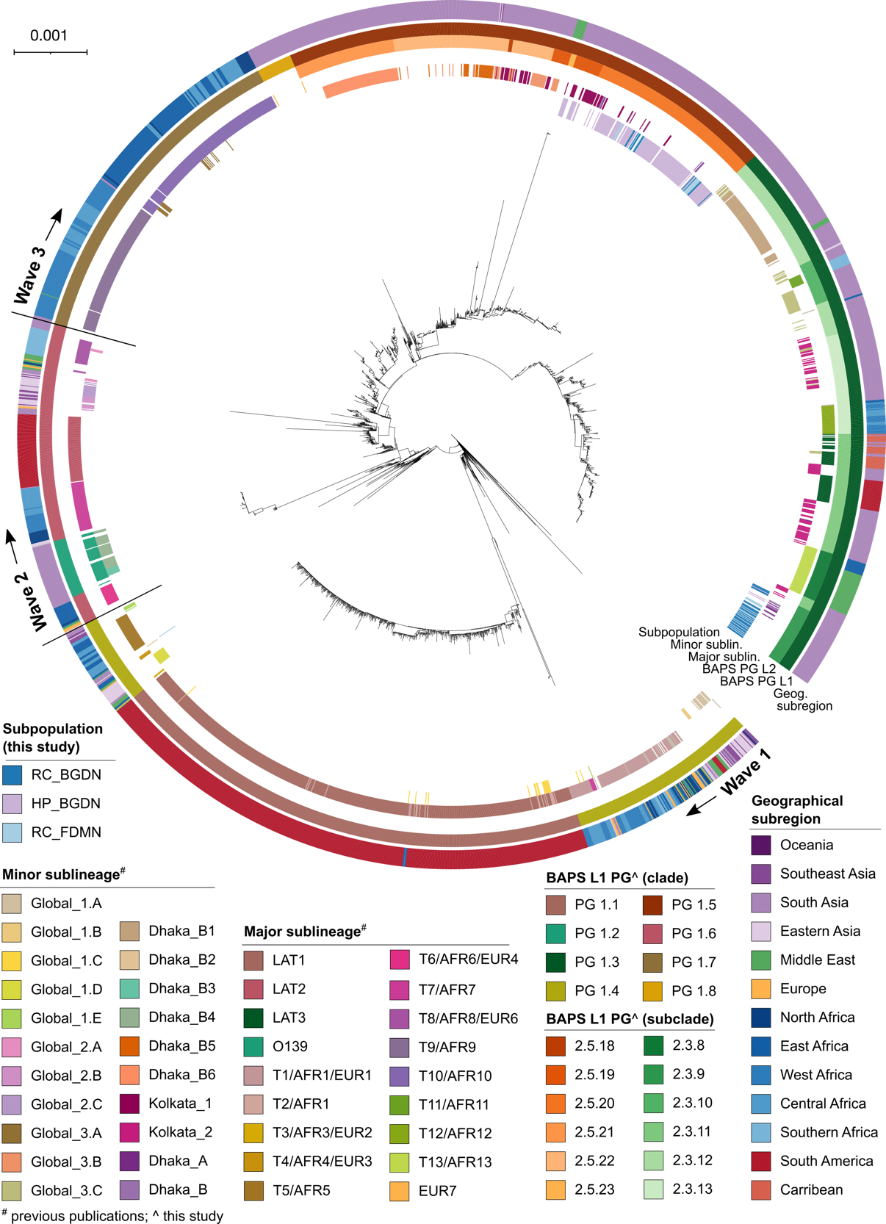
Supplementary Figure S2: V. cholerae 7PET whole genome single nucleotide variant (SNP) phylogeny. Whole genome SNP maximum-likelihood outgroup-rooted phylogenetic tree of 223 V. cholerae strains from Cox’s Bazar from this study and 2,384 published genomes. Coloured strips denote geographical subregion, major and minor sublineages from previous studies, hierBAPS phylogroups, and the subpopulations from which our samples were isolated (see key).

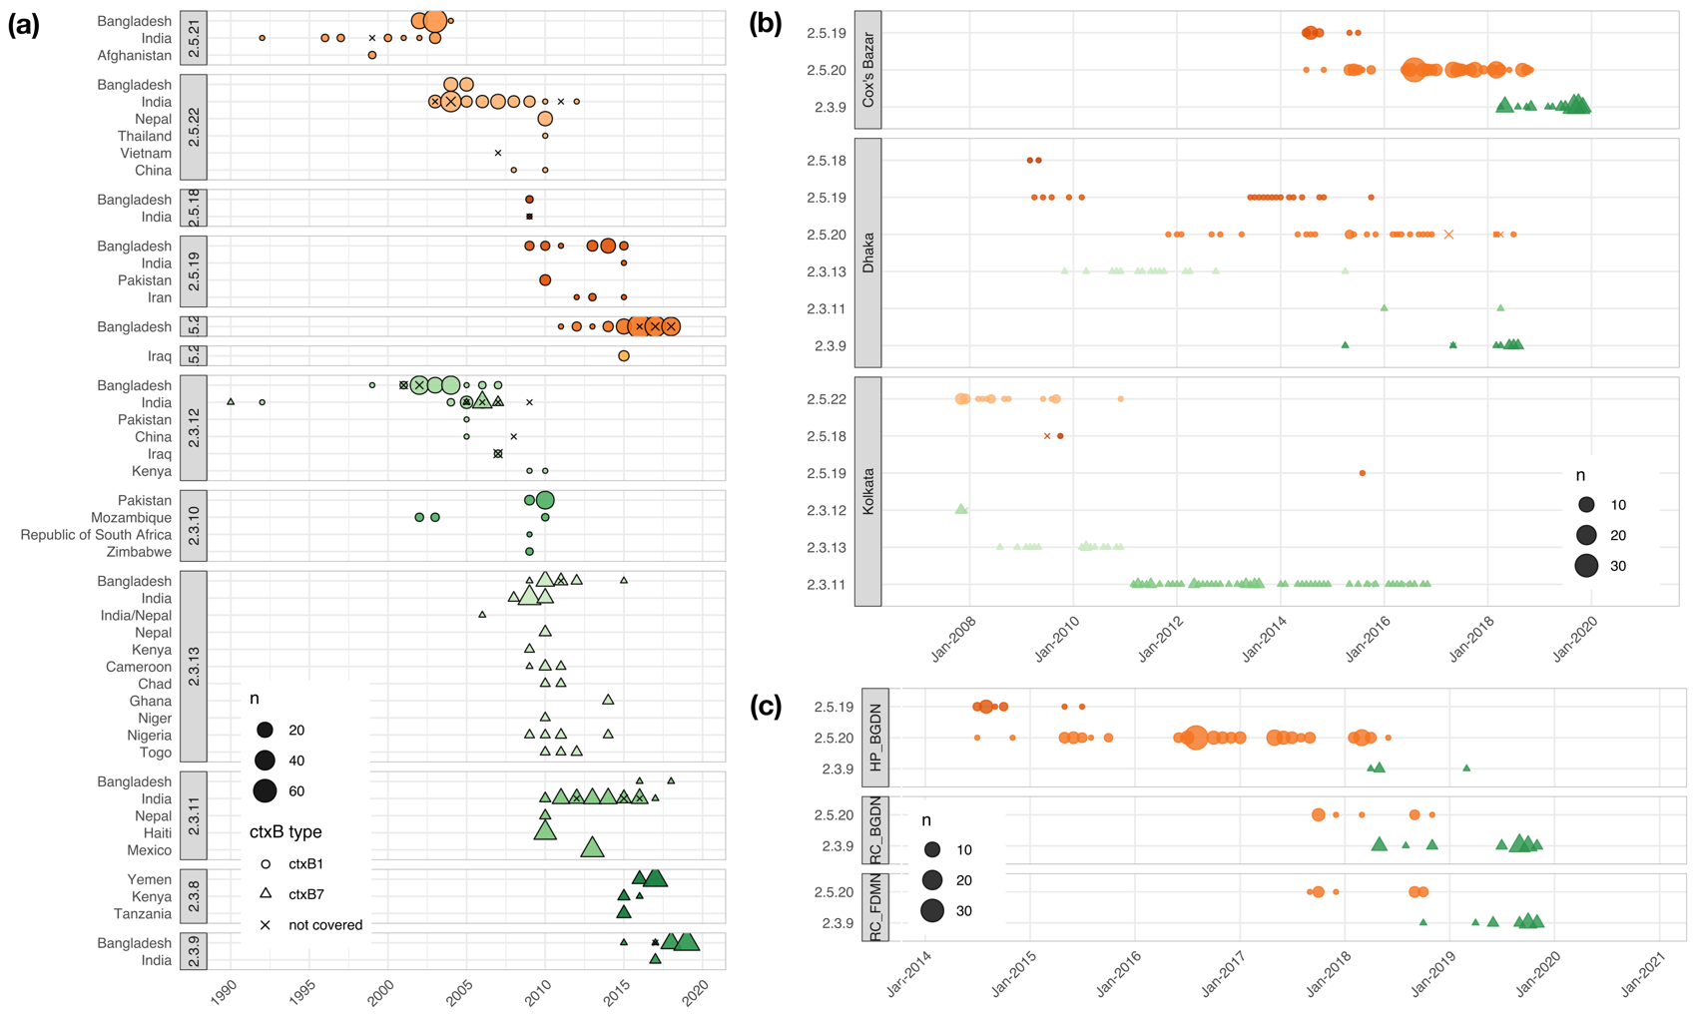
Supplementary Figure S3: Temporal and geographic distribution of PG 1.3 and 1.5. Plots depict the distribution of subclades globally (a), in the Bay of Bengal (b) and Cox’s Bazar (c). Genome counts are denoted by the size of the point, while the shape denotes the ctxB type (see key).
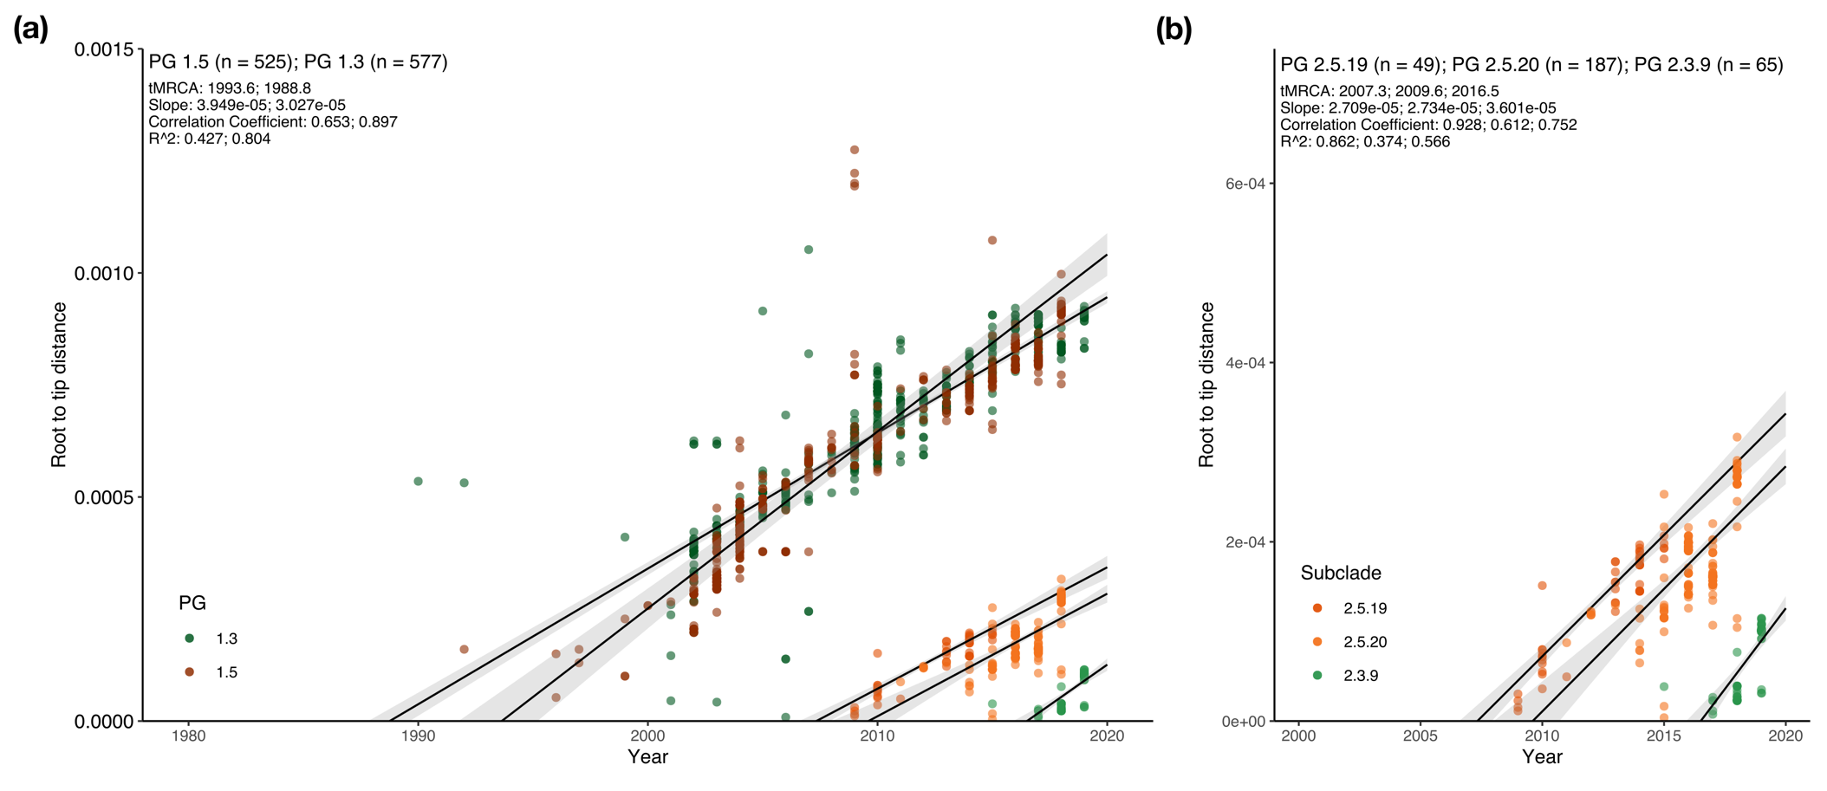
Supplementary Figure S4: Evolutionary dynamics of PG 1.3 and 1.5. Plots depict the relationship between root to tip distance (linear regression representing the mean +/- standard error depicted by grey shading) and year of isolation for PGs 1.3 and 1.5 (a) and their subclades present in Cox’s Bazar (b). Points are coloured by PG or subclade (see key). Note the different axis ranges for (a) and (b).

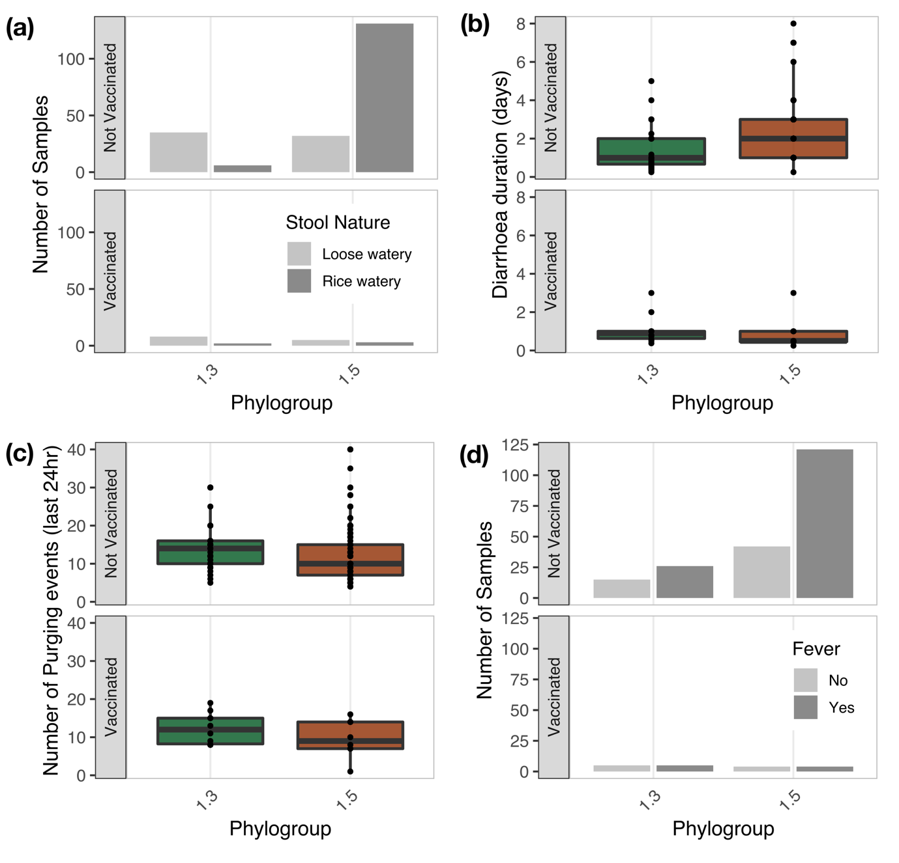
Supplementary Figure S5: Epidemiology of V. cholerae in Cox’s Bazar. Distribution of samples by stool nature (a), mean duration of diarrhoea (b), mean number of purging events (c), and distribution of samples by presence of fever (d) across vaccination status and phylogroup. For (b) and (c), the median value, interquartile ranges and individual values are shown by the bordered coloured boxes and free points, respectively.
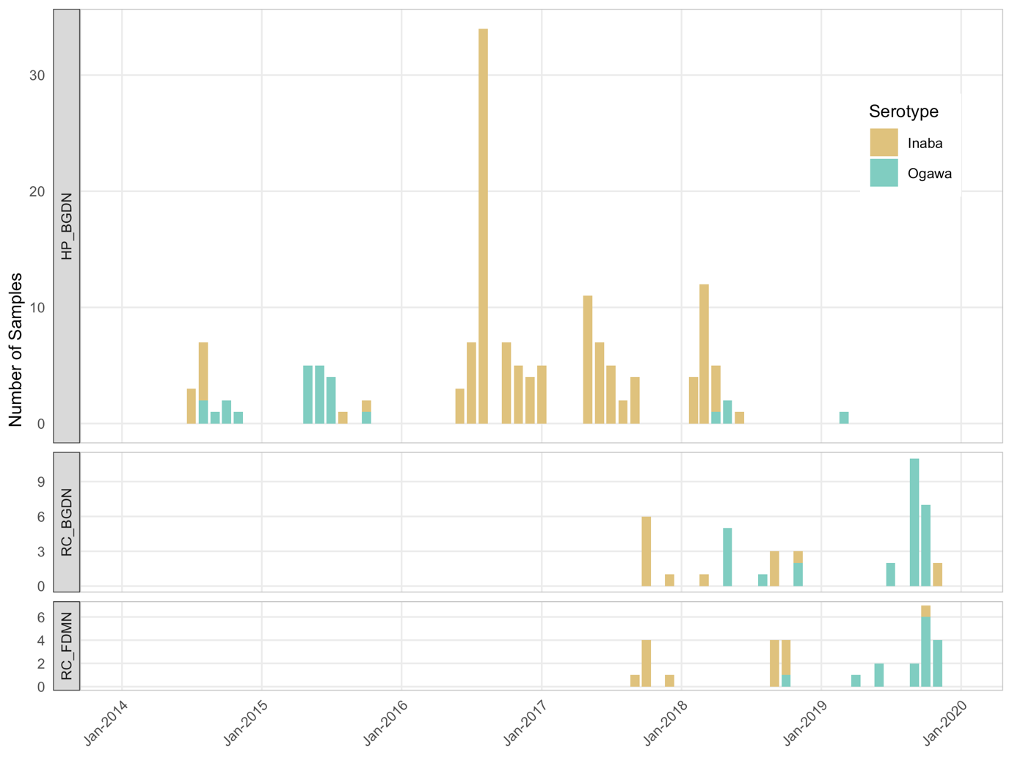
Supplementary Figure S6: Serotype switching over time in the Cox’s Bazar subpopulations. Number of samples per month are plotted over time. Bars are coloured by serotype (see key). Note the different y axis ranges for the different subpopulations.
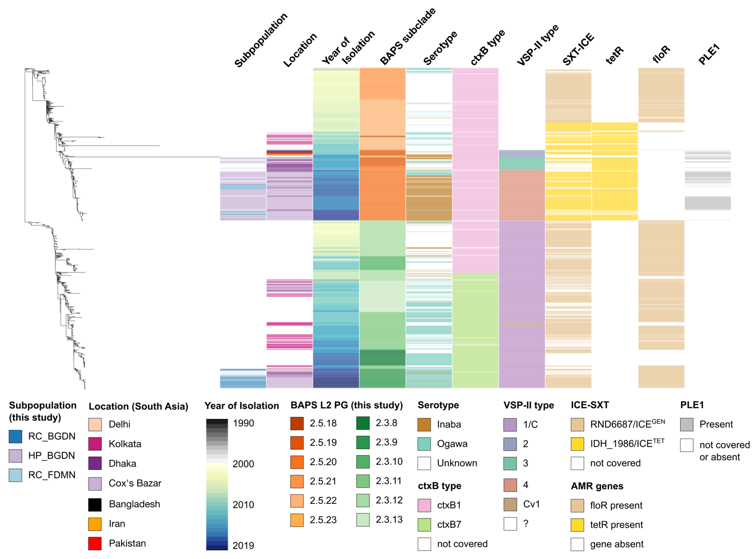
Supplementary Figure S7: Genetic microvariation within V. cholerae clades present in Cox’s Bazar. A subtree of the V. cholerae 7PET phylogeny containing PG 1.5 and PG 1.3 plotted against selected metadata and gene presence. Coloured strips denote the subpopulation, location, year of isolation, subclade, serotype, ctxB type, VSP-II type, SXT-ICE type, tetR and floR genes, and PLE1 presence (see key).

