Supplementary Information for

Accumulation and release of organic pollutants by conventional and biodegradable microplastics in the marine environment
Camilla Catarci Carteny*, Elvio Diego Amato, Fabienne Pfeiffer, Christina Christia,
Nicolas Estoppey, Giulia Poma, Adrian Covaci, Ronny Blust

Corresponding author: *Tel: +3232653482; e-mail: camilla.catarcicarteny@uantwerpen.be

This file contains:
16 pages
Chemical and reagents (p. S2)
In situ measurements of pollutant dissolved concentrations (p. S3-S4)
Instrumental analysis (p. S4-S5)
Extraction and clean-up (p. S6)
Quality assurance and quality control (p. S7)
References cited (p. S8)
Table S1 (p. S9-S12)
Table S2 (p. S13)
Figure S1 (p. S14), S2 (p. S15), and S3 (p. S16)
1.1 Chemicals and reagents
Certified reference standards (CRS) of the non-polar target compounds (PCBs 28, 52, 101, 118, 138, 153 and 180, acenaphthylene (ACY), acenaphthene (ACE), fluoranthene (FLE), phenanthrene (PHE), anthracene (ANT), fluorene (FLU), pyrene (PYE), benzo(a)anthracene (BaA), chrysene (CHR), benzo(b)fluorene (BbF), benzo(k)fluoranthene (BkF), benzo-a-pyrene (BaP), indeno(1,2,3-cd)pyrene (IDP), dibenzo(a,h)anthracene (DBahA), and benzo(ghi)perylene (BghiP)) were purchased from LGC Standards (Germany), their mass labelled analogues (13C-PCBs and d-PAHs) from Cambridge Isotope Laboratories (UK). Internal standards (ISs) of labelled triphenyl phosphate (TPHP-d15), tris(1,3-dichloro-2-propyl)phosphate (TDCIPP-d15), tris(2-butoxyethyl) phosphate (TBOEP-d6), and tris(2-chloroethyl) phosphate (TCEP-d12) with isotopic purity >98% were custom synthesized by Dr. Vladimir Belov, Max Planck Institute for Biophysical Chemistry (Göttingen, Germany). Labelled dibenzyl phthalate (DBzP-d4) was purchased from AccuStandard (New Heaven, CT, USA); labelled bis (2-ethylhexyl) phthalate (DEHP-d4) and labelled di-N-butyl phthalate (DNBP-d4) were purchased from Sigma-Aldrich (St. Louis, MO, USA). Triamyl phosphate (TAP) was used as recovery standard (RS) and was purchased from TCI Europe (Zwijndrecht, Belgium). Standards of targeted analytes 2,2-bis(chloromethyl)-propane-1,3-diyltetrakis(2-chloroethyl) biphosphate (V6), resorcinol bis(diphenylphosphate) (RDP), bis(diphenyl phosphate) (Bisphenol A, BDP), isodecyl diphenyl phosphate (iDPP), dimethyl phthalate (DMP), diethyl phthalate (DEP), di-N-butyl phthalate (DNBP), di-iso-butyl phthalate (DIBP), benzyl butyl phthalate (BBP), bis(2-ethylhexyl) phthalate (DEHP), di-iso-butyl adipate (DIBA), acetyltriethyl citrate (ATEC), dibutyl sebacate (DBS), acetyltributyl citrate (ATBC), diethylhexyl adipate (DEHA), cresyl diphenyl phosphate (CDPHP), butyryl trihexyl citrate (BTHC), bis (2-ethylhexyl) terephthalate (DEHT), tris(2-ethylhexyl) trimellitate (TOTM), 1,2- cyclohexane dicarboxylic acid diisononyl ester (DINCH), di iso nonyl phthalate (DINP), and di iso decyl phthalate (DIDP) were purchased from AccuStandard (New Heaven, CT, USA). Standards of targeted analytes tri-iso-butyl phosphate (TIBP) and tri-N-butyl phosphate (TNBP), tris(1,3-dichloro-2-propyl) phosphate (TDCIPP), tris(chloro-2-propyl) phosphate (TCIPP), tris(2-ethylhexyl) phosphate (TEHP), tris(2-chloroethyl) phosphate (TCEP), tri-P-cresyl phosphate (TPTP), 2-ethylhexyl diphenyl phosphate (EHDPHP), triethyl phosphate (TEP), triphenyl phosphate (TPHP), tris(2-butoxyethyl) phosphate (TBOEP), and tris(4-tert-butylphenyl) phosphate (TBuPHP) were purchased from Chiron AS (Trondheim, Norway). Ethyl acetate (EtAc), dichloromethane (DCM), and acetone were purchased from Merck (Darmstadt, Germany). Hexane (Hex) was purchased from Acros Organics (Geel, Belgium). Methanol (MeOH) was purchased from Fischer Scientific (Loughborough Leics, United Kingdom) and LC-grade ultrapure water (H₂O) was obtained from a PURELAB Flexsystem (18.2 MΩ cm, Milli-Q, Millipore). DCM and 2,2,4-trimethylpentane employed in PAH and PCB extraction were acquired from Acros Organics (Geel, Belgium); Hex was purchased from Biosolve (Dieuze, France). All solvents used were of chromatographic grade. Centrifugal filters (modified Nylon membrane) of 0.2 μm were purchased from VWR™ (North America). Further information regarding the analytes is given in Table S1.

1.2 In situ measurements of pollutant dissolved concentrations
Time-averaged dissolved concentrations of PAHs and PCBs in seawater were measured using silicone rubber (SR) passive samplers. SR sheets (0.25 mm thickness) were purchased from Shielding-solutions (UK), Soxhlet extracted (100 h with ethyl acetate, 48 h with methanol) and spiked with performance reference compounds. Detailed procedures on the preparation, deployment and retrieval of the devices, as well as extraction and analysis of organic compounds, have been described elsewhere (Amato et al.¹). The sampling devices were deployed alongside MPs for a period of 30 days. Seawater concentrations of PFRs, phthalates, and alternative plasticizers were measured in water samples periodically collected during the exposure of MPs to seawater, using a liquid-liquid extraction method adapted from Amato et al.² . After addition of IS, water samples (25 mL) were extracted using ethyl acetate (15 mL), vortexed for 1 min, and sonicated for 5 min. The extract was transferred into a clean glass vial and the procedure repeated one more time. The two extracts were combined and blown down to dryness under a gentle flow of N₂. Samples were reconstituted using 100 µL of MeOH and stored refrigerated until analysis. For the determination of DEHP and DEHT, a solvent exchange to ethyl acetate was performed for analysis using GC-MS. Extraction efficiencies³ and method accuracies are reported in Table S2.
1.3 Instrumental analysis
PAH and PCB concentrations in MP extracts were analysed by gas chromatography-tandem mass spectrometry (GC-MSMS, Agilent 7890A GC coupled to an Agilent 7000 Triple Quadrupole MS/MS). The GC-MSMS was equipped with a ZB-5MS (20 m × 0.18 mm x 0.18 μm, Zebron) column. The injection volume was 2 µL and injections were performed in splitless mode. The initial temperature of the programmed temperature vaporizer (PTV) injector was set to 75 °C (hold for 0.1 min) and then increased to 300 °C at 600 °C/min (hold for 2.5 min). Helium was used as carrier gas at 1.2 ml/min. The temperature program started at 50 °C (0.5 min), increased to 170 °C (50 °C/min), and then to 320 °C (5 °C/min) and was hold for 12.1 min. The transfer line and ion source temperatures were set at 290 °C and 280 °C respectively. The mass spectrometer was operated in electron impact at −70 eV in the multiple reaction monitoring (MRM) mode (nitrogen was used as collision gas). For each compound, two SRM specific transitions were used.
Agilent 1200 Infinity liquid chromatography (LC) system coupled to an Agilent 6410 Triple Quadrupole mass spectrometer (MS) (Agilent Technologies, Santa Clara, CA, USA) was used for PFRs, phthalates, and alternative plasticizers analysis. For chromatographic separation, a Kinetex Biphenyl column (100 x 2.1 mm, 2.6 µm) was used at 40 °C working temperature. The mobile phases were (A) ultrapure H₂O with buffer of 5 mM ammonium formate and (B) MeOH with buffer of 5 mM ammonium formate. Flow rate was 0.25 mL/min and injection volume 5 µL. The detailed chromatographic program is given in Table S2. Source parameters were set as: gas temperature at 350 °C, gas flow at 10 mL/min, nebulizer gas at 40 psi, and capillary voltage at 4000 V. The targeted analytes were analysed in positive electrospray ionization (ESI+) and the detailed chromatographic and mass spectrometric information is given in Table S1. The Agilent Mass Hunter software (version B.06.00) was operated for the data analysis.
Finally, Agilent GC coupled to an Agilent 5973 MS operated in electron ionization mode (EI) was used for the analysis of DEHP and DEHT. A GC HT-8 column (25 m × 0.22 mm, 0.25 μm), electronic pressure control, and a programmable-temperature vaporizer (PTV) inlet were used. The injection temperature was set at 90 °C, hold time was 0.04 min, ramped at 700 °C/min to 300 °C, hold time 25 min. Injection volume was 1 μL and injection was performed under a pressure of 14.36 psi until 1.25 min and purge flow to split vent of 50 mL/min after 1.25 min, ramped at 30 °C/min to 250 °C, hold time 1.5 min, ramped at 10 °C/min to 310 °C, hold time 7 min. Helium was the carrier gas with a flow rate of 1.0 mL/min until 28 min, and then increased to 1.5 mL/min. The mass spectrometer was run in selected ion monitoring (SIM) mode with two characteristic ions acquired for each analyte and for the IS DEHP-d4 (Table S1).

1.4 Extraction and clean-up
Pollutant concentrations in MPs were measured before (i.e., reference MPs, C_{ref}) and after exposure (i.e., exposed MPs, C_{exp}). For the determination of PAHs and PCBs, MPs were weighed in a glass tube (100 mg) and the surrogate internal standard (i.e. 15 ng of each 13C-PCB and 37 ng of each d-PAH in methanol) was added. The extraction was done with 2.5 mL of a Hex/dichloromethane (1:1 v/v) mixture. The sample was vortexed for 1 min, sonicated for 30 min and then centrifuged at 3000 RPM for 3 min. The supernatant was transferred to a clean vial and concentrated to 0.5 mL under a nitrogen stream. The extraction was repeated with 2.5 mL of fresh solvent. Solvent from the first and second extractions were combined, reduced to 0.5 mL, solvent exchanged to 2,2,4-trimethylpentane, concentrated to 0.3 mL and transferred to a vial for GC-MS/MS analysis.
A modified protocol from Malarvannan et al.⁴ was applied for sample preparation in the extraction of PFRs, phthalates, and alternative plasticisers. Approximately 100 mg of sample was weighted into a 15 mL glass tube and spiked with surrogate internal standards TCEP-d12, TDCIPP-d15, TPhP-d15 and TBOEP-d6 (100 ng each), and DBzP-d4, DEHP-d4 and DNBP-d4 (500 ng each). Samples were extracted using 2.5 mL of a mixture of Hex:Acetone (1:1 v/v) followed by 1 min vortexing, 30 min ultrasonication, and 3 min centrifugation at 3000 rpm. The procedure was repeated twice, the supernatants pooled into new glass tubes and evaporated to near dryness under a gentle nitrogen stream. Samples were reconstituted using 50 µL of MeOH and 50 µL of recovery standard (RS) and vortexed for 30 s. An aliquot of 15 µL of extract was transferred into a vial, and mixed with 135 µL of EtAc for the analysis of DEHP and DEHT in GC-EI-MS. The remaining extract was filtered using a 0.2 µm centrifugal filter for 5 min at 8000 rpm and transferred to a vial for LC-MS/MS analysis.

1.5 Quality assurance and quality control
For PAH and PCB analysis in MPs, three procedural blanks and three reference MP samples were measured to check for background contamination; glassware used was first heated at 450°C overnight, then cleaned with acetone and Hex. Limits of quantification (LOQ) were calculated from the lowest acceptable level of the calibration curve (i.e. sufficient quantifying/qualifying ion ratio, and peak signal to noise ratio ≥ 10), and ranged between 2.5-7.4 ng/g for PAHs, and 1.0-3.2 ng/g for PCBs. The recoveries of the internal standards were on average 86±32% for 13C-PCBs, and 83±34% for d-PAHs.
For the analysis of PFRs and plasticizers in MPs, three procedural blanks and three reference plastics (in duplicate per material type) were measured in parallel to check background contamination. All glassware was pre-cleaned using Hex solvent and dried in a 400 °C oven overnight. Centrifugal filters were tested free of targeted compounds. Solvent injections were applied to control any impurities or additives in MeOH and H₂O. Average procedural blank levels were subtracted from the sample results; LOQs were calculated as 3 × SD (standard deviation) of the average procedural blank measurements and ranged 0.1-3.8 ng/g for PFRs, 0.2-500 ng/g for phthalates and 0.01-300 ng/g for alternative plasticizers. The recoveries of the internal standards were: TCEP-d12 109±52%, TDCIPP-d15 139±52%, TPhP-d15 101±12%, TBOEP-d6 138±42%, DNBP-d4 113±32%, DBzP-d4 124±35%, DEHP-d4 106±33%. LOQs were expressed as the highest value between (i) the concentration obtained by dividing the lowest calibration standard by the volume of seawater sample extracted (0.025 L), and (ii) the concentration measured in the blank (MQ water, n = 1). For concentrations that exceeded LOQ, values were reported upon subtraction of concentrations measured in the blank.

1.6 References cited
(1) Amato, E. D.; Pfeiffer, F.; Estoppey, N.; Subotic, D.; Herweyers, L.; Breugelmans, T.; Weyn, M.; Du Bois, E.; Dardenne, F.; Covaci, A.; Town, R. M.; Blust, R. Field Application of a Novel Active-Passive Sampling Technique for the Simultaneous Measurement of a Wide Range of Contaminants in Water. Chemosphere 2021, 279, 130598. https://doi.org/10.1016/j.chemosphere.2021.130598.
(2) Amato, E. D.; Covaci, A.; Town, R. M.; Hereijgers, J.; Bellekens, B.; Giacometti, V.; Breugelmans, T.; Weyn, M.; Dardenne, F.; Bervoets, L.; Blust, R. A Novel Active-Passive Sampling Approach for Measuring Time-Averaged Concentrations of Pollutants in Water. Chemosphere 2018, 209, 363–372. https://doi.org/10.1016/j.chemosphere.2018.06.079.
(3) Marchi, I.; Viette, V.; Badoud, F.; Fathi, M.; Saugy, M.; Rudaz, S.; Veuthey, J.-L. Characterization and Classification of Matrix Effects in Biological Samples Analyses. J. Chromatogr. A 2010, 1217 (25), 4071–4078. https://doi.org/10.1016/j.chroma.2009.08.061.
(4) Malarvannan, G.; Onghena, M.; Verstraete, S.; van Puffelen, E.; Jacobs, A.; Vanhorebeek, I.; Verbruggen, S. C. A. T.; Joosten, K. F. M.; Van den Berghe, G.; Jorens, P. G.; Covaci, A. Phthalate and Alternative Plasticizers in Indwelling Medical Devices in Pediatric Intensive Care Units. J. Hazard. Mater. 2019, 363, 64–72. https://doi.org/10.1016/j.jhazmat.2018.09.087.

Table S1. List of target compounds, their molecular formula and weight, corresponding InCHI key, vapour pressure, LogK_{ow}, and analytical parameters.
Compound Name | Acronym | Molecular Formula | Molecular Weight | InCHI Key | Vapor pressure¹ | LogKow² | Retention time (min) | Precursor (m/z) | Fragmentor Voltage (V) | Quantitative Ion (m/z) | Collision energy (eV) | Qualitative Ion (m/z) | Collision energy (eV)
ISs
Bis(2-ethylhexyl) phthalate-d4 | DEHP-d4 | C24D4H34O4 | 394.6 | BJQHLKABXJIVAM-SAQXESPHSA-N | 1.23E-06 | 8.39 | 18.3 | 395.3 | 95 | 153.0 | 20 | 71.1 | 10
Di-N-butyl phthalate-d4 | DNBP-d4 | C16D4H18O4 | 282.4 | DOIRQSBPFJWKBE-ULDPCNCHSA-N | 4.57E-05 | 4.61 | 12.7 | 283.2 | 35 | 153.1 | 10 | 125.1 | 40
Di-benzyl-butyl phtalate-d4 | DBzP-d4 | C22H14D4O4 | 350.4 | UCVPKAZCQPRWAY-ZZRPVTOQSA-N | 1.19E-06 | n.a | 14.6 | 351.2 | 58 | 91.0 | 20 | 181.0 | 5
Tris(2-chloroethyl) phosphate-d12 | TCEP-d12 | C9H4D12ClO6P | 297.6 | HQUQLFOMPYWACS-LBTWDOQPSA-N | n.a | 1.63 | 7.5 | 297.1 | 95 | 67.0 | 25 | 102.0 | 25
Triphenyl phosphate-d15 | TPHP-d15 | C18D15O4P | 341.4 | n.a. (Cas N. 1173020-30-8) | n.a | n.a | 12.4 | 342.3 | 103 | 82.0 | 45 | 160.0 | 50
Tris(1,3-dichloro-2-propyl) phosphate-d15 | TDCIPP-d15 | C9D15Cl6O4P | 443.0 | ASLWPAWFJZFCKF-UHFFFAOYSA-N | 2.60E-05 | 3.65 | 11.2 | 446.9 | 95 | 102.0 | 25 | 332.0 | 10
Tris(2-butoxyethyl) phosphate-d6 | TBOEP-d6 | C18H33D6O7P | 404.2 | WTLBZVNBAKMVDP-UHFFFAOYSA-N | 5.51E-06 | 3.00 | 13.1 | 405.3 | 110 | 57.2 | 30 | 202.0 | 12
RS
Triamyl phosphate | TAP | C15H33O4P | 308.3 | QJAVUVZBMMXBRO-UHFFFAOYSA-N | 1.14E-03 | 5.29 | 14.2 | 332.0 | 80 | 191.0 | 5 | 135.0 | 13
PFRs
Tris(2-chloroethyl) phosphate | TCEP | C6H12Cl3O4P | 285.4 | HQUQLFOMPYWACS-UHFFFAOYSA-N | 1.71E-02 | 1.63 | 7.5 | 285.0 | 88 | 93.0 | 27 | 99.0 | 23
Tris(2-ethylhexyl) phosphate | TEHP | C24H51O4P | 434.6 | GTVWRXDRKAHEAD-UHFFFAOYSA-N | 1.50E-06 | 9.49 | 18.8 | 435.4 | 95 | 99.0 | 12 | 71.0 | 13
Tris(2-butoxyethyl) phosphate | TBOEP | C18H39O7P | 398.4 | WTLBZVNBAKMVDP-UHFFFAOYSA-N | 5.51E-06 | 3.00 | 13.2 | 399.3 | 110 | 299.2 | 10 | 199.0 | 10
Triphenyl phosphate | TPHP | C18H15O4P | 326.2 | XZZNDPSIHUTMOC-UHFFFAOYSA-N | 2.39E-05 | 4.70 | 12.4 | 327.0 | 148 | 77.0 | 45 | 152.0 | 50
2-ethylhexyl diphenyl phosphate | EHDPHP | C20H27O4P | 362.4 | CGSLYBDCEGBZCG-UHFFFAOYSA-N | 6.12E-05 | 6.30 | 15.1 | 363.2 | 50 | 251.0 | 30 | 77.0 | 50
Tris(chloro-2-propyl) phosphate | TCIPP | C9H18Cl3O4P | 327.5 | KVMPUXDNESXNOH-UHFFFAOYSA-N | 4.44E-03 | 2.89 | 9.5 | 327.1 | 65 | 99.0 | 20 | 175.0 | 5
Tris(1,3-dichloro-2-propyl) phosphate | TDCIPP | C9H15Cl6O4P | 430.8 | ASLWPAWFJZFCKF-UHFFFAOYSA-N | 2.60E-05 | 3.65 | 11.2 | 432.9 | 95 | 99.0 | 27 | 211.0 | 10
Tri-iso-butyl phosphate | TIBP | C12H27O4P | 266.3 | HRKAMJBPFPHCSD-UHFFFAOYSA-N | 3.57E-02 | 3.60 | 10.8 | 267.2 | 65 | 99.0 | 10 | 81.0 | 50
Tri-N-butyl phosphate | TNBP | C12H27O4P | 266.3 | STCOOQWBFONSKY-UHFFFAOYSA-N | 8.36E-03 | 3.82 | 11.3 | 267.2 | 65 | 99.0 | 15 | 81.0 | 50
Tri-P-cresyl phosphate | TPTP | C21H21O4P | 368.3 | BOSMZFBHAYFUBJ-UHFFFAOYSA-N | 3.18E-06 | 6.34 | 15.8 | 369.2 | 185 | 165.0 | 50 | 91.0 | 45
Triethyl phosphate | TEP | C6H15O4P | 182.1 | DQWPFSLDHJDLRL-UHFFFAOYSA-N | 2.28E-01 | 0.87 | 6 | 183.1 | 65 | 99.0 | 18 | 81.0 | 45
Tris(4-tert-butylphenyl) phosphate | TBuPHP | C30H39O4P | 494.6 | LORSVOJSXMHDHF-UHFFFAOYSA-N | 3.43E-08 | n.a. | 20.2 | 495.2 | 200 | 327.0 | 35 | 383.0 | 28
ePFRs
2,2-bis(chloromethyl)-propane-1,3-diyltetrakis(2-chloroethyl) biphosphate | V6 | C13H24Cl6O8P2 | 582.9 | ZGHUDSLVQAGWEY-UHFFFAOYSA-N | 3.45E-06 | 3.31 | 11.4 | 582.9 | 140 | 360.9 | 15 | 235.0 | 35
Compound Name | Acronym | Molecular Formula | Molecular Weight | InCHI Key | Vapor pressure¹ | LogKow² | Retention time (min) | Precursor (m/z) | Fragmentor Voltage (V) | Quantitative Ion (m/z) | Collision energy (eV) | Qualitative Ion (m/z) | Collision energy (eV)
Isodecyl diphenyl phosphate | iDPP | C22H31O4P | 390.4 | n.a. (Cas N. 29761-21-5) | 8.3 × E-08** | 5.44** | 16.7 | 391.2 | 80 | 251.0 | 7 | 77.0 | 50
Resorcinol bis(diphenylphosphate) | RDP | C30H24O8P2 | 574.4 | OWICEWMBIBPFAH-UHFFFAOYSA-N | 2.74E-08 | 7.41 | 17.5 | 592.1 | 110 | 575.0 | 15 | 481.0 | 45
Bisphenol A - bis(diphenyl phosphate) | BDP | C39H34O8P2 | 692.6 | BQPNUOYXSVUVMY-UHFFFAOYSA-N | 9.14E-10 | 10.02 | 21.2 | 710.1 | 150 | 367.0 | 40 | 693.0 | 17
LPs
Dimethyl phthalate | DMP | C10H10O4 | 194.1 | NIQCNGHVCWTJSM-UHFFFAOYSA-N | 3.77E-03 | 1.66 | 7.3 | 195.1 | 57 | 163.0 | 5 | 77.0 | 40
Diethyl phthalate | DEP | C12H14O4 | 222.2 | FLKPEMZONWLCSK-UHFFFAOYSA-N | 1.63E-03 | 2.65 | 8.6 | 223.1 | 72 | 148.9 | 13 | 177.0 | 1
Di-N-butyl phthalate | DNBP | C16H22O4 | 278.3 | DOIRQSBPFJWKBE-UHFFFAOYSA-N | 4.46E-05 | 4.61 | 12.6 | 279.2 | 72 | 149.0 | 9 | 77.0 | 45
Di-iso-butyl phthalate | DIBP | C16H22O4 | 278.3 | MGWAVDBGNNKXQV-UHFFFAOYSA-N | 4.06E-04 | 4.46 | 12.4 | 279.2 | 72 | 149.0 | 10 | 77.0 | 40
Benzyl butyl phthalate | BBP | C19H20O4 | 312.3 | IRIAEXORFWYRCZ-UHFFFAOYSA-N | 5.17E-06 | 4.84 | 13.8 | 313.2 | 72 | 149.0 | 5 | 91.0 | 1
Bis(2-ethylhexyl) phthalate (in GC-EI-MS) | DEHP* | C24H38O4 | 390.5 | BJQHLKABXJIVAM-UHFFFAOYSA-N | 1.23E-06 | 8.39 | 12.1 | - | - | 279.0 | - | 167.0 | -
Di iso nonyl phthalate | DINP | C26H42O4 | 418.6 | n.a. (Cas N. 28553-12-0) | n.a. | n.a. | 19.3 | 419.3 | 110 | 71.2 | 13 | 57.3 | 25
Di iso decyl phthalate | DIDP | C28H46O4 | 446.6 | ZVFDTKUVRCTHQE-UHFFFAOYSA-N | 2.16E-07 | 10.36 | 20.2 | 447.5 | 125 | 85.0 | 10 | 71.0 | 15
APs
Di-iso-butyl adipate | DIBA | C14H26O4 | 258.3 | RDOFJDLLWVCMRU-UHFFFAOYSA-N | 1.83E-03 | 4.19 | 11.5 | 259.2 | 80 | 129.0 | 5 | 111.0 | 13
Acetyltriethyl citrate | ATEC | C14H22O8 | 318.3 | WEAPVABOECTMGR-UHFFFAOYSA-N | 7.61E-05 | 1.34 | 8.6 | 319.0 | 65 | 157.0 | 15 | 139.0 | 22
Dibutyl sebacate | DBS | C18H34O4 | 314.4 | PYGXAGIECVVIOZ-UHFFFAOYSA-N | 1.46E-05 | 6.30 | 15.5 | 315.2 | 110 | 185.0 | 10 | 241.2 | 5
Acetyltributyl citrate | ATBC | C20H34O8 | 402.4 | QZCLKYGREBVARF-UHFFFAOYSA-N | 7.97E-07 | 4.29 | 14.4 | 403.3 | 80 | 129.0 | 33 | 139.0 | 23
Diethylhexyl adipate | DEHA | C22H42O4 | 370.5 | SAOKZLXYCUGLFA-UHFFFAOYSA-N | 3.36E-06 | 8.12 | 17.9 | 371.3 | 110 | 129.1 | 10 | 111.0 | 20
Cresyl diphenyl phosphate | CDPHP | C19H17O4P | 340.3 | n.a. (Cas N. 26444-49-5) | 4.70E-06 ** | 4.51** | 13.9 | 341.1 | 170 | 91.1 | 40 | 152.1 | 42
Butyryl trihexyl citrate | BTHC | C28H50O8 | 514.7 | GWVUTNGDMGTPFE-UHFFFAOYSA-N | 9.98E-09 | 8.21 | 19.6 | 515.3 | 95 | 129.0 | 27 | 213.0 | 15
Bis (2-ethylhexyl) Terephthalate (in GC-EI-MS) | DEHT* | C24H38O4 | 390.5 | RWPICVVBGZBXNA-UHFFFAOYSA-N | 8.70E-07 | 8.39 | 13.5 | - | - | 261.0 | - | 167.0 | -
Tris(2-ethylhexyl) trimellitate | TOTM | C33H54O6 | 546.4 | KRADHMIOFJQKEZ-UHFFFAOYSA-N | 1.19E-07 | 11.59 | 21.8 | 547.5 | 110 | 305.2 | 17 | 139.1 | 47
1,2- Cyclohexane dicarboxylic acid diisononyl ester | DINCH | C26H48O4 | 424.6 | n.a. (Cas N. 166412-78-8) | n.a. | n.a. | 19.8 | 425.3 | 95 | 155.0 | 10 | 71.0 | 15
¹EPA dashboard
²predicted value via EPIWEB Suite (version 4.1)
*GC amenable compounds
**Christia et al., 2019 Anal Bioanal Chem 411(26) 7015-7025

 |  |  |  |  |  |  |  | First transition (Quantifier) |  |  |  | Second transition (Qualifier)
Compound name | Acronym | Molecular Formula | Molecular Weight | InCHI Key | Vapor pressure (mmHg) | logKow^{c} | Retention time (min) | Precursor ion | Product ion | Dwell | Collision energy | Precursor ion | Product ion | Dwell | Collision energy
PCB
2,4,4′-Trichlorobiphenyl | PCB28 | C12H7Cl3 | 257.5 | BZTYNSQSZHARAZ-UHFFFAOYSA-N | 1.40E-04 | 6.05 | 7.2 | 257.9 | 185.9 | 100 | 20 | 255.9 | 185.9 | 100 | 20
2,2′,5,5′-Tetrachlorobiphenyl | PCB52 | C12H6Cl4 | 292.0 | HCWZEPKLWVAEOV-UHFFFAOYSA-N | 2.54E-05 | 6.22 | 8.0 | 291.9 | 219.9 | 100 | 20 | 289.9 | 219.9 | 100 | 20
2,2′,4,5,5′-Pentachlorobiphenyl | PCB101 | C12H5Cl5 | 326.4 | LAHWLEDBADHJGA-UHFFFAOYSA-N | 1.55E-05 | 6.82 | 10.3 | 325.9 | 255.9 | 70 | 20 | 323.9 | 253.9 | 70 | 20
2,3′,4,4’,5-Pentachlorobiphenyl | PCB118 | C12H5Cl5 | 326.5 | IUTPYMGCWINGEY-UHFFFAOYSA-N | 4.99E-06 | 7.00 | 12.1 | 325.9 | 255.9 | 80 | 20 | 323.9 | 253.9 | 80 | 20
2,2′,3,4,4′,5′-Hexachlorobiphenyl | PCB138 | C12H4Cl6 | 360.9 | RPUMZMSNLZHIGZ-UHFFFAOYSA-N | 2.47E-06 | 7.34 | 13.6 | 359.8 | 289.9 | 120 | 25 | 357.8 | 287.9 | 120 | 25
2,2′,4,4′,5,5′-Hexachlorobiphenyl | PCB153 | C12H4Cl6 | 360.9 | MVWHGTYKUMDIHL-UHFFFAOYSA-N | 1.99E-06 | 7.34 | 12.8 | 359.8 | 289.9 | 120 | 25 | 357.8 | 287.9 | 120 | 25
2,2′,3,4,4′,5,5′-Heptachlorobiphenyl | PCB180 | C12H3Cl7 | 395.3 | WBHQEUPUMONIKF-UHFFFAOYSA-N | 5.79E-07 | 7.66 | 15.8 | 393.8 | 323.8 | 80 | 25 | 391.8 | 321.8 | 80 | 25
PAH
Acenaphthene | ACE | C12H10 | 154.2 | CWRYPZZKDGJXCA-UHFFFAOYSA-N | 2.15E-03 | 3.97 | 4.2 | 154.0 | 153.0 | 40 | 10 | 153.0 | 152.0 | 40 | 10
Acenaphthylene | ACY | C12H8 | 152.2 | HXGDTGSAIMULJN-UHFFFAOYSA-N | 6.68E-03 | 3.80 | 4.0 | 152.0 | 151.1 | 40 | 16 | 152.0 | 126.1 | 40 | 16
Fluorene | FLE | C13H10 | 166.2 | NIHNNTQXNPWCJQ-UHFFFAOYSA-N | 6.00E-04 | 4.14 | 4.7 | 166.2 | 165.0 | 60 | 30 | 166.2 | 164.0 | 60 | 30
Phenanthrene | PHE | C14H10 | 178.2 | YNPNZTXNASCQKK-UHFFFAOYSA-N | 1.21E-04 | 4.62 | 6.3 | 178.0 | 176.0 | 60 | 30 | 178.0 | 152.0 | 60 | 30
Anthracene | ANT | C14H10 | 178.2 | MWPLVEDNUUSJAV-UHFFFAOYSA-N | 6.53E-06 | 4.73 | 6.5 | 178.0 | 176.0 | 60 | 30 | 178.0 | 152.0 | 60 | 30
Fluoranthene | FLU | C16H10 | 202.3 | GVEPBJHOBDJJJI-UHFFFAOYSA-N | 9.22E-06 | 5.34 | 9.6 | 202.0 | 201.0 | 70 | 10 | 202.0 | 200.1 | 70 | 10
Pyrene | PYE | C16H10 | 202.3 | BBEAQIROQSPTKN-UHFFFAOYSA-N | 4.50E-06 | 5.41 | 10.3 | 202.0 | 201.0 | 70 | 10 | 202.0 | 200.1 | 70 | 10
Benz[a]anthracene | BaA | C18H12 | 228.3 | DXBHBZVCASKNBY-UHFFFAOYSA-N | 2.10E-07 | 5.97 | 15.1 | 228.1 | 226.0 | 80 | 20 | 228.1 | 202.1 | 80 | 20
Chrysene | CHR | C18H12 | 228.3 | WDECIBYCCFPHNR-UHFFFAOYSA-N | 6.23E-09 | 5.95 | 15.2 | 228.1 | 226.0 | 80 | 20 | 228.1 | 202.1 | 80 | 20
Benzo[a]pyrene | BaP | C20H12 | 252.3 | FMMWHPNWAFZXNH-UHFFFAOYSA-N | 5.49E-09 | 6.69 | 20.6 | 252.1 | 250.1 | 160 | 30 | 252.1 | 226.1 | 160 | 30
Benzo[b]fluoranthene | BbF | C20H12 | 252.3 | FTOVXSOBNPWTSH-UHFFFAOYSA-N | 5.00E-07 | 6.50 | 19.4 | 252.1 | 250.1 | 60 | 36 | 252.1 | 226.1 | 60 | 36
Benzo[k]fluoranthene | BkF | C20H12 | 252.3 | HAXBIWFMXWRORI-UHFFFAOYSA-N | 9.65E-10 | 6.63 | 19.5 | 252.1 | 250.1 | 60 | 42 | 252.1 | 226.1 | 60 | 42
Benzo[ghi]perylene | BghiP | C22H12 | 276.3 | GYFAGKUZYNFMBN-UHFFFAOYSA-N | 1.00E-10 | 7.24 | 25.3 | 276.1 | 275.1 | 70 | 38 | 276.1 | 274.0 | 70 | 38
Dibenz[a,h]anthracene | DBahA | C22H14 | 278.4 | LHRCREOYAASXPZ-UHFFFAOYSA-N | 9.55E-10 | 7.22 | 24.8 | 278.1 | 276.1 | 70 | 38 | 278.1 | 252.0 | 70 | 38
Indeno[1,2,3-cd]pyrene | IDP | C22H12 | 276.3 | SXQBHARYMNFBPS-UHFFFAOYSA-N | 7.05E-10* | 7.23 | 24.6 | 276.1 | 275.0 | 70 | 42 | 276.1 | 274.1 | 70 | 42
IS
2,4,4′-Trichlorobiphenyl-C13 | PCB28-C13 | 13C12H7Cl3 | 269.5 | na (CAS N. 208263-76-7) | na | na | 7.2 | 268.0 | 198.1 | 100 | 20
Compound name | Acronym | Molecular Formula | Molecular Weight | InCHI Key | Vapor pressure (mmHg) | logKow^{c} | Retention time (min) | Precursor ion | Product ion | Dwell | Collision energy | Precursor ion | Product ion | Dwell | Compound name
2,2′,5,5′-Tetrachlorobiphenyl-C13 | PCB52-C13 | 13C12H6Cl4 | 303.9 | na (CAS N. 208263-80-3) | na | na | 8.0 | 301.9 | 231.9 | 100 | 20
2,2′,4,5,5′-Pentachlorobiphenyl-C13 | PCB101-C13 | 13C12H5Cl5 | 338.4 | LAHWLEDBADHJGA-WCGVKTIYSA-N | 1.74E-05* | 6.23^{d} | 10.3 | 335.9 | 266.0 | 70 | 20
2,3′,4,4’,5-Pentachlorobiphenyl-C13 | PCB118-C13 | 13C12H5Cl5 | 338.4 | na (CAS N. 104130-40-7) | na | na | 12.1 | 335.9 | 265.9 | 80 | 20
2,2′,3,4,4′,5′-Hexachlorobiphenyl-C13 | PCB138-C13 | 13C12H4Cl6 | 372.8 | na (CAS N. 208263-66-5) | na | na | 13.6 | 369.8 | 299.9 | 120 | 25
2,2′,4,4′,5,5′-Hexachlorobiphenyl-C13 | PCB153-C13 | 13C12H4Cl6 | 372.8 | na (CAS N. 185376-58-3) | na | na | 12.8 | 369.9 | 299.9 | 120 | 25
2,2′,3,4,4′,5,5′-Heptachlorobiphenyl-C13 | PCB180-C13 | 13C12H3Cl7 | 407.2 | na (CAS N. 208263-72-3) | na | na | 15.8 | 403.8 | 333.9 | 80 | 25
Acenaphthene-d10 | ACE-d10 | C12D10 | 164.3 | CWRYPZZKDGJXCA-WHUVPORUSA-N | 4.56E-03* | 4.03^{d} | 4.1 | 162.0 | 160.0 | 40 | 10
Acenaphthylene-d8 | ACY-d8 | C12D8 | 160.2 | HXGDTGSAIMULJN-PGRXLJNUSA-N | 4.40E-03* | 4.02^{d} | 4.0 | 160.0 | 158.0 | 40 | 10
Fluorene-d10 | FLE-d10 | C13D10 | 176.3 | NIHNNTQXNPWCJQ-QNNBDYQESA-N | 1.35E-03* | 4.13^{d} | 4.7 | 176.0 | 174.0 | 60 | 30
Phenanthrene-d10 | PHE-d10 | C14D10 | 188.3 | YNPNZTXNASCQKK-LHNTUAQVSA-N | 1.59E-04* | 4.62^{d} | 6.3 | 188.0 | 184.0 | 60 | 30
Fluoranthene-d10 | FLU-d10 | C16D10 | 212.3 | GVEPBJHOBDJJJI-LHNTUAQVSA-N | 1.32E-05* | 5.15^{d} | 9.6 | 212.0 | 208.0 | 70 | 10
Pyrene-d10 | PYE-d10 | C16D10 | 212.3 | BBEAQIROQSPTKN-LHNTUAQVSA-N | 3.38E-06* | 4.99^{d} | 10.3 | 212.0 | 208.0 | 70 | 10
Benz[a]anthracene-d12 | BaA-d12 | C18D12 | 240.4 | DXBHBZVCASKNBY-AQZSQYOVSA-N | 1.33E-07* | 5.81^{d} | 15.0 | 240.0 | 236.0 | 80 | 20
Chrysene-d12 | CHR-d12 | C18D12 | 240.4 | WDECIBYCCFPHNR-AQZSQYOVSA-N | 4.58E-08* | 5.81^{d} | 15.1 | 240.0 | 236.0 | 80 | 20
Benzo[a]pyrene-d12 | BaP-d12 | C20D12 | 264.4 | na (CAS N. 63466-71-7) | na | na | 20.5 | 264.1 | 236.0 | 160 | 30
Benzo[b]fluoranthene-d12 | BbF-d12 | C20D12 | 264.4 | FTOVXSOBNPWTSH-AQZSQYOVSA-N | 9.88E-09* | 6.34^{d} | 19.3 | 264.0 | 260.0 | 60 | 36
Benzo[k]fluoranthene-d12 | BkF-d12 | C20D12 | 264.4 | na (CAS N. 93952-01-3) | na | na | 19.5 | 264.0 | 260.0 | 60 | 42
Benzo[ghi]perylene-d12 | BghiP-d12 | C22D12 | 288.4 | na (CAS N. 93951-66-7) | na | na | 25.3 | 288.0 | 284.0 | 70 | 45
Dibenz[a,h]anthracene-d14 | DBahA-d14 | C22D14 | 292.4 | na (CAS N. 13250-98-1) | na | na | 24.7 | 292.0 | 288.0 | 70 | 50
Indeno[1,2,3-cd]pyrene-d12 | IDP-d12 | C22D12 | 288.4 | na (CAS N. 203578-33-0) | na | na | 24.5 | 288.0 | 284.0 | 70 | 50

Table S2. PFRs, alternative plasticizers, and phthalates in seawater samples concentration, extraction efficiency, and accuracy of the method used for the determination (means ± SE, n = 3; * indicates value <LOQ).

Compound | Concentration (pmol/L) | Extraction efficiency (%) | Accuracy (%)
DMP | 88.56 ±11.89 | 69 ± 8 | 55 ± 11
DPP | 56.82 ± 20.03 | 88 ± 2 | 63 ± 1
DnBP | 283.53* | 84 ± 1 | 47 ± 2
DEP | 39.58 ± 24.32 | 78 ± 5 | 66 ± 9
DEHT | 947.36* | 94 ± 14 | 137 ± 4
DEHP | 128.81* | 78 ± 28 | 61 ± 9
ATEC | 15.49* | 85 ± 2 | 82 ± 1
DIBA | 11.75* | 78 ± 1 | 50 ± 1
CDPHP | 99.40* | 88 ± 3 | 97 ± 2
ATBC | 12.72* | 91 ± 1 | 88 ± 2
DBS | 56.68* | 86 ± 2 | 93 ± 2
DEHA | 7.77* | 81 ± 1 | 96 ± 1
BTHC | 36.60* | 86 ± 2 | 142 ± 1
THTM | 447.83* | 88 ± 1 | 156 ± 2
TOTM | 110.69* | 103 ± 15 | 60 ± 8
DIDP | 477.78* | 127 ± 24 | 127 ± 26
DINCH | 88.56* | 87 ± 2 | 149 ± 5
DINP | 56.82* | 52 ± 9 | 41 ± 21
TEP | 69.94 ± 29.34 | 51 ± 6 | 37 ± 9
TCEP | 20.18 ± 7.41 | 78 ± 1 | 100 ± 2
TCIPP | 219.37 ± 105.59 | 91 ± 1 | 107 ± 3
TBP1 | 6.45 ± 1.86 | 84 ± 2 | 86 ± 4
TDCIPP | 69.62* | 79 ± 2 | 103 ± 2
V6 | 3.43* | 85 ± 2 | 109 ± 2
TBP2 | 112.65* | 81 ± 0 | 64 ± 1
TPhP | 79.69* | 89 ± 1 | 112 ± 2
TBOEP | 5.02* | 75 ± 2 | 99 ± 1
TDBPP | 234.55* | 79 ± 2 | 105 ± 2
EHDPHP | 5.43* | 100 ± 3 | 141 ± 2
TpTP | 5.12* | 86 ± 2 | 106 ± 4
iDPP | 3.48* | 84 ± 3 | 134 ± 3
RDP | 4.60* | 86 ± 2 | 116 ± 1
TEHP | 4.04* | 84 ± 3 | 133 ± 4
TBuPhP | 2.89* | 86 ± 2 | 152 ± 3
BDP | 69.94* | 85 ± 2 | 146 ± 1

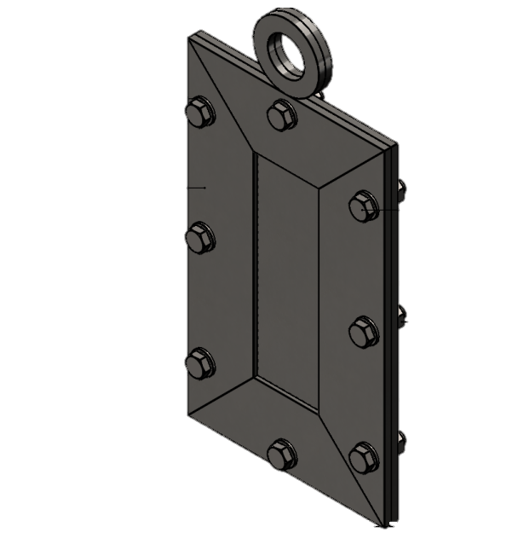
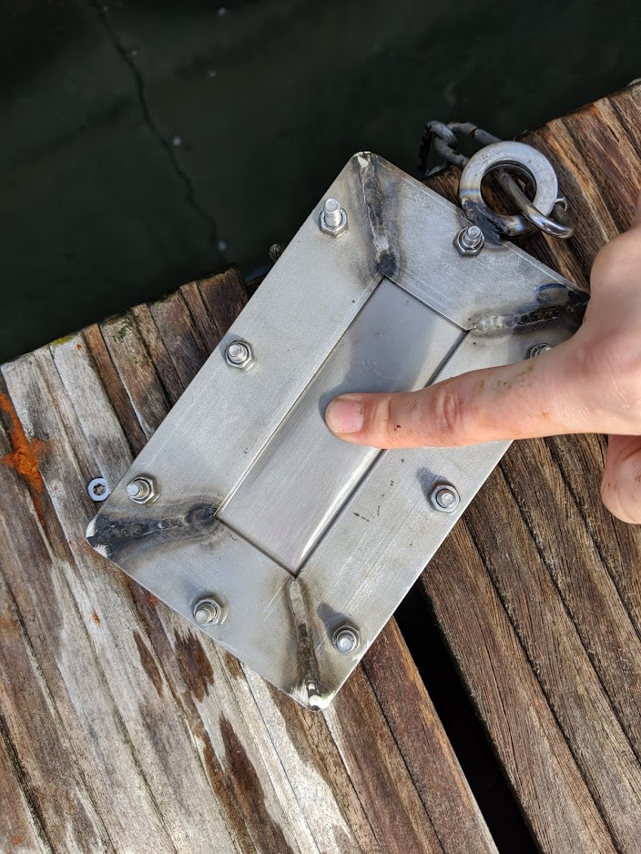
31 mm
90 mm
90 mm
150 mm

Fig. S1 Photograph (left) and diagram (right) of the device used for MPs exposure in seawater. Diagram mesh pore size is not shown up to scale

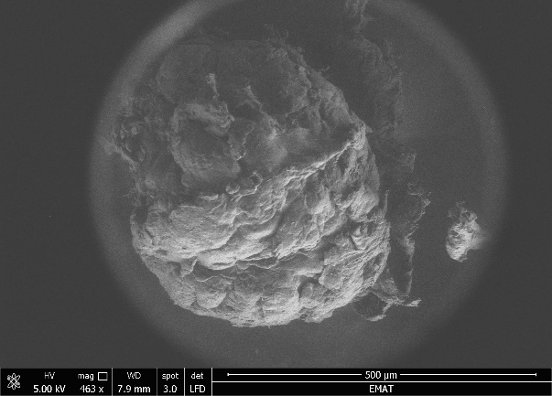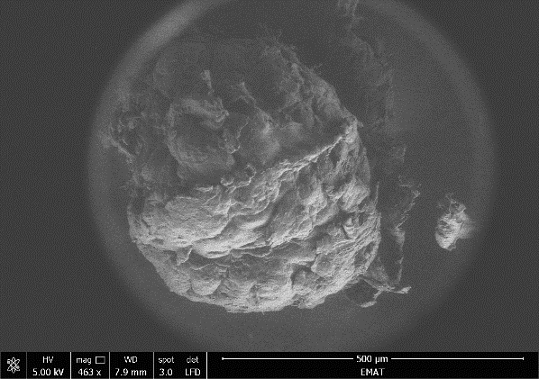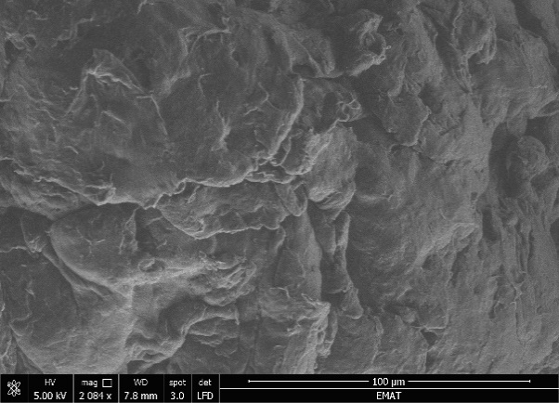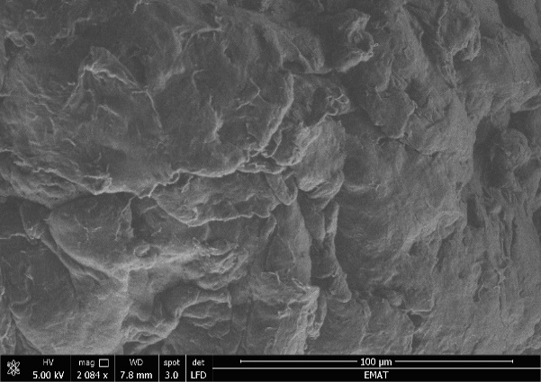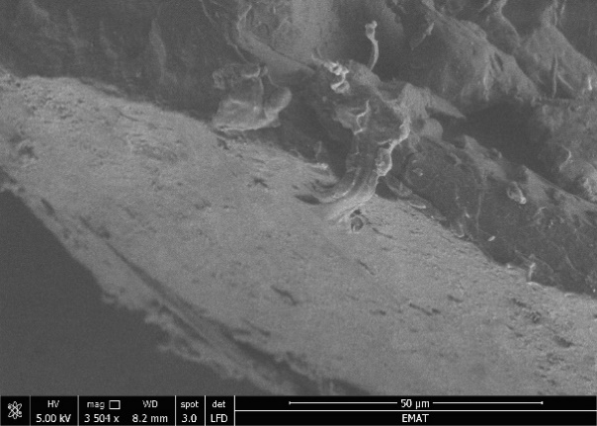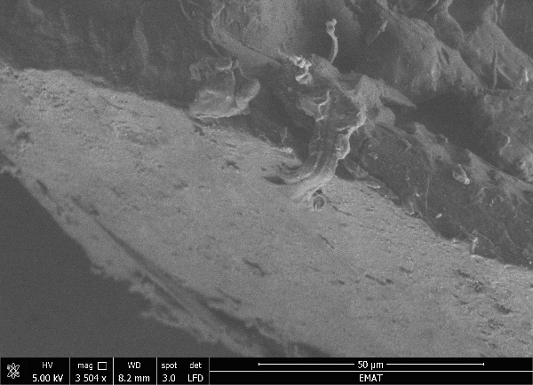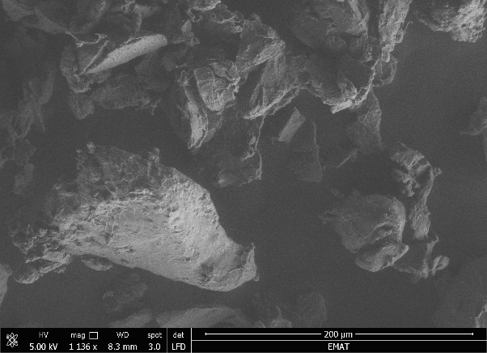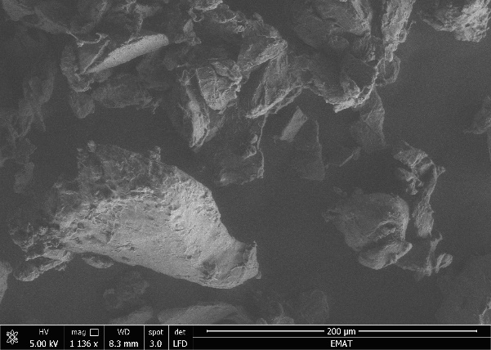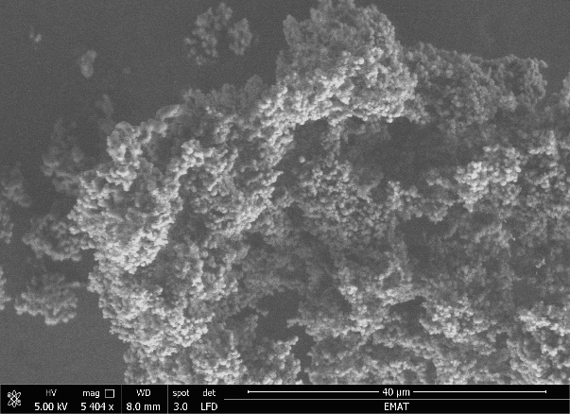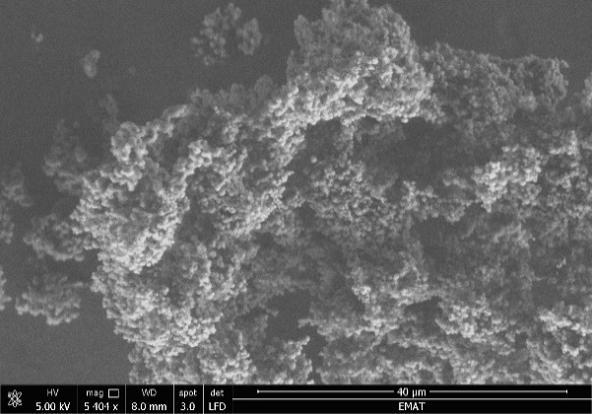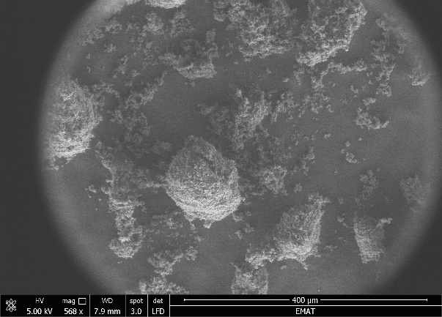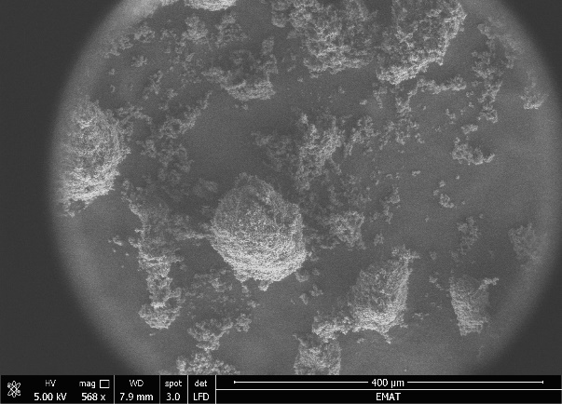
A
B
F
E
D
C
Fig. S2 SEM photographs of the MPs analysed in this study; A and B (PE-MPs), C and D (PHA-MPs), and E and F (PBS-MPs)

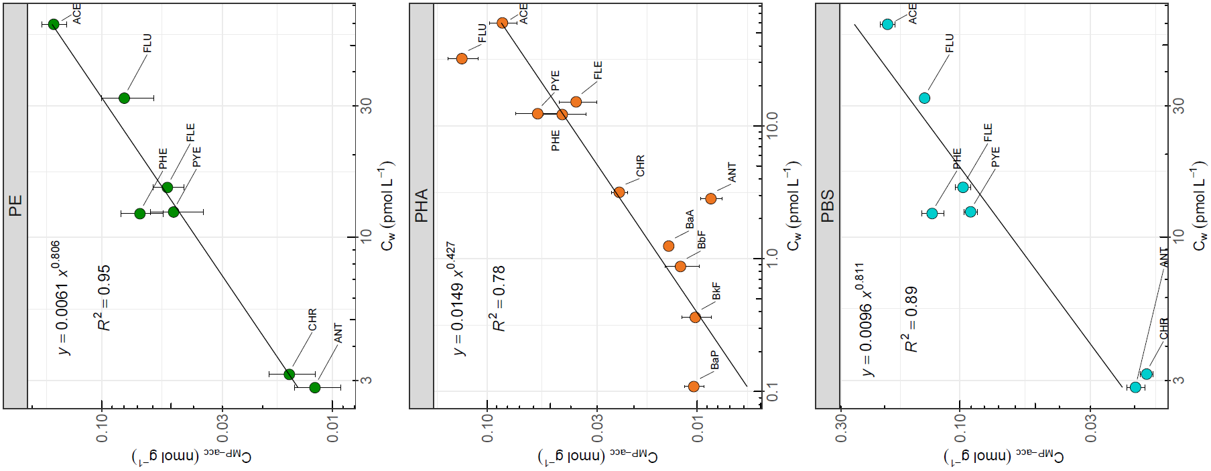
Fig. S3 Relationships between the fraction of PAHs accumulated on MPs after exposure (i.e., C_{MP-acc} = C_{MP-exp} - C_{MP-ref}, mean ± SE, n = 4) and time-averaged dissolved concentrations measured in seawater (mean ± SE, n = 3)

