BOPH-D-20-00313
The role of JNK 1 in controlling AQP-1 and choroidal thickness during recovery from form-deprivation myopia in guinea pigs
Wei Chen; Li zhi Wei; Wang qi Miao; Wang Yan; Zhang Yue
BMC Ophthalmology
Dear Dr Yue,
Your manuscript "The role of JNK 1 in controlling AQP-1 and choroidal thickness during recovery from form-deprivation myopia in guinea pigs" (BOPH-D-20-00313) has been assessed by our reviewers. They have raised a number of points which we believe would improve the manuscript and may allow a revised version to be published in BMC Ophthalmology.
Their reports, together with any other comments, are below. Please also take a moment to check our website at https://www.editorialmanager.com/boph/ for any additional comments that were saved as attachments.
If you are able to fully address these points, we would encourage you to submit a revised manuscript to BMC Ophthalmology.
Once you have made the necessary corrections, please submit online at:
https://www.editorialmanager.com/boph/
If you have forgotten your password, please use the 'Send Login Details' link on the login page at https://www.editorialmanager.com/boph/. For security reasons, your password will be reset.
Please include a cover letter with a point-by-point response to the comments, describing any additional experiments that were carried out and including a detailed rebuttal of any criticisms or requested revisions that you disagreed with. Please also ensure that all changes to the manuscript are indicated in the text by highlighting or using track changes.
Please also ensure that your revised manuscript conforms to the journal style, which can be found at the Submission Guidelines on the journal homepage.
A decision will be made once we have received your revised manuscript, which we expect by 01 Jun 2020.
Please note that you will not be able to add, remove, or change the order of authors once the editor has accepted your manuscript for publication.
Any proposed changes to the authorship must be requested during peer-review, and adhere to our criteria for authorship as outlined in BioMed Central's policies.
To request a change in authorship, please download the 'Request for change in authorship form' which can be found here - http://www.biomedcentral.com/about/editorialpolicies#authorship.
Please note that incomplete forms will be rejected.
Your request will be taken into consideration by the editor, and you will be advised whether any changes will be permitted.
Please be aware that we may investigate, or ask your institute to investigate, any unauthorized attempts to change authorship or discrepancies in authorship between the submitted and revised versions of your manuscript.
I look forward to receiving your revised manuscript and please do not hesitate to contact us if you have any questions.
Best wishes,
Sang Beom Han
BMC Ophthalmology
https://bmcophthalmol.biomedcentral.com/
Technical Comments:
Editor Comments:
We operate a transparent peer review process for this journal where reviewer reports are published with the article but the reviewers are not named (unless they opt in to include their name).
Reviewer reports:
Thank you for the advice and the professional revision. We are very sorry for the inconvenience because of our negligence.
Thank you very much for your review during the COVID-19 epidemic and wish you good health.
We have answered the questions in details as follows:
Reviewer 1: This is a well-executed research study. In this article, the authors investigated the relationship between Aquaporin-1 protein or p-JNK1 expression and the recovery from myopia using guinea pig animal model. Previous studies from same authors revealed that AQP-1 protein expression in the choroid was upregulated following recovery of form-deprivation myopia in guinea pigs, and these changes correlated with alterations in choroidal thickness (CT) and axial length. And In this study, they found the levels of p-JNK1 and AQP-1 in the choroid and CT were higher than those in the normal control eyes during the recovery from myopia and returned to normal at 7 days after removal of the deprivation. This is an important area to look for the critical role of choroid in controlling the recovery from myopia.
Major suggestion
Method - animal, line 89
Did deprivation start at 3 weeks of age? Previous studies usually induced deprivation from the third day of life. And the emmetropization of guinea pig has known to be completed in about 6 weeks after birth. Is there any reason why authors decided to start deprivation in 3 weeks after birth? Please explain the rationale of using 3 weeks old guinea pig for this experiment.
Thank you for the advice.
This is a very good suggestion. We also considered it for a long time before designing the experiment and looked up a lot of literature.
Many authors have used 3-week-old guinea pigs in their experiments to from myopia in guinea pigs，such as Fan Lu used pigmented guinea pigs (3-week old) to obtain myopic model[1] and Fang Fang also by woring a latex facemask in the right eye of 3-weeks old Guinea pigs for 21 days to induce FD myopia[2].
The younger the guinea pigs were, the more difficult they were to survive and cover them for three weeks.Guinea pigs need to be fed by their mothers two weeks ago,before that, guinea pigs were hard to cover,so we chose 3-week-old guinea pigs for this experiment.
1. Lu F, Zhou X, Jiang L, et al. Axial myopia induced by hyperopic defocus in guinea pigs: A detailed assessment on susceptibility and recovery. Exp Eye Res. 2009;89(1):101‐108. doi:10.1016/j.exer.2009.02.019
2.Fang F, Pan M, Yan T, et al. The role of cGMP in ocular growth and the development of form-deprivation myopia in guinea pigs. Invest Ophthalmol Vis Sci. 2013;54(13):7887‐7902. Published 2013 Dec 3. doi:10.1167/iovs.13-11999
Thanks.
Method - animal, line 90
Please specify what light source was used and brightness of the lighting (using lux).
Thank you for your advice.
We didn't say it clearly. I’m sorry we didn't describe it clearly in the article.We used light-emitting diode (LED) lights (500 Lux)in this experiment.
We changed to “A total of 136 pigmented guinea pigs (3 weeks old) from the Beijing Keyu Animal Centre (Beijing, China) were raised on a daily cycle of 12-h illumination(500 Lux) and 12-h darkness during the experimental period (on at 8:00 AM, off at 8:00 PM), with free access to water and food supplemented with vitamin C.”
Thanks.
Method - animal, line 96
How could authors keep the latex facial mask from contacting cornea of the right eye? It seems difficult for a resilient mask to keep a certain distance from the cornea of the guinea pig. Did authors use special materials? If authors provide a supplementary figure of guinea pig wearing facial mast, I think it will help readers' understanding.
Thank you for your advice.
We didn’t use special materials. We used latex balloons to trap the right eye of the guinea pig。
There are several reasons for this question.
First,the animals were monitored 3 times during the 12-hour light period to ensure that the face masks were in place and were promptly changed to a suitable size when necessary. Second,when we removed the masks, no corneal damage was found. The cornea was transparent, so we speculated that the mask did not contact the cornea.Third,because of the existence of eyelid tissue, the eyelid is closed when the cover is placed, when the eyelid is opened, there is a certain distance between the masks and the cornea because of the existence of the eyelid.Forth, because the balloon is smooth, there is no corner to stimulate the cornea.
We used latex balloons to trap the right eye of the guinea pig.
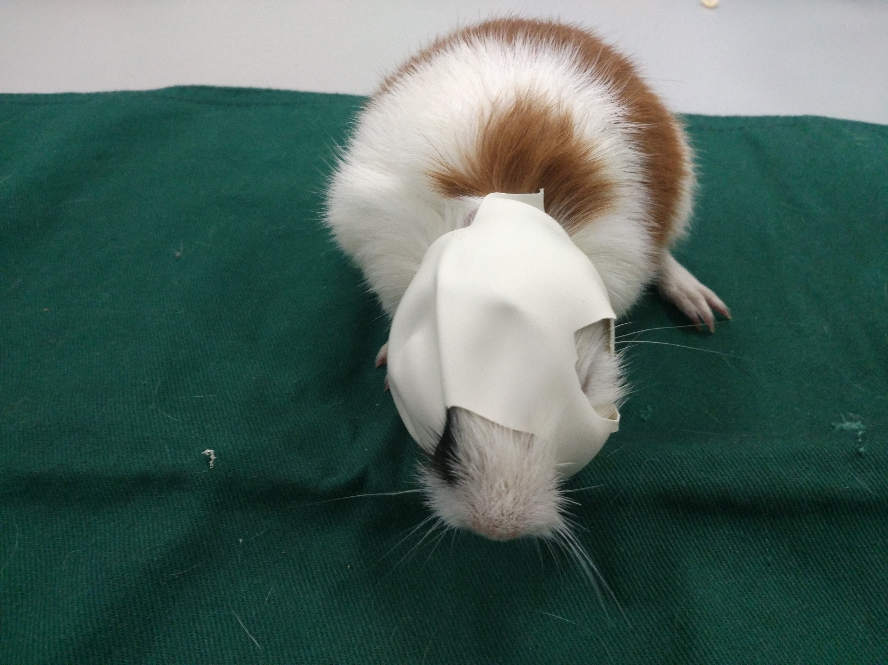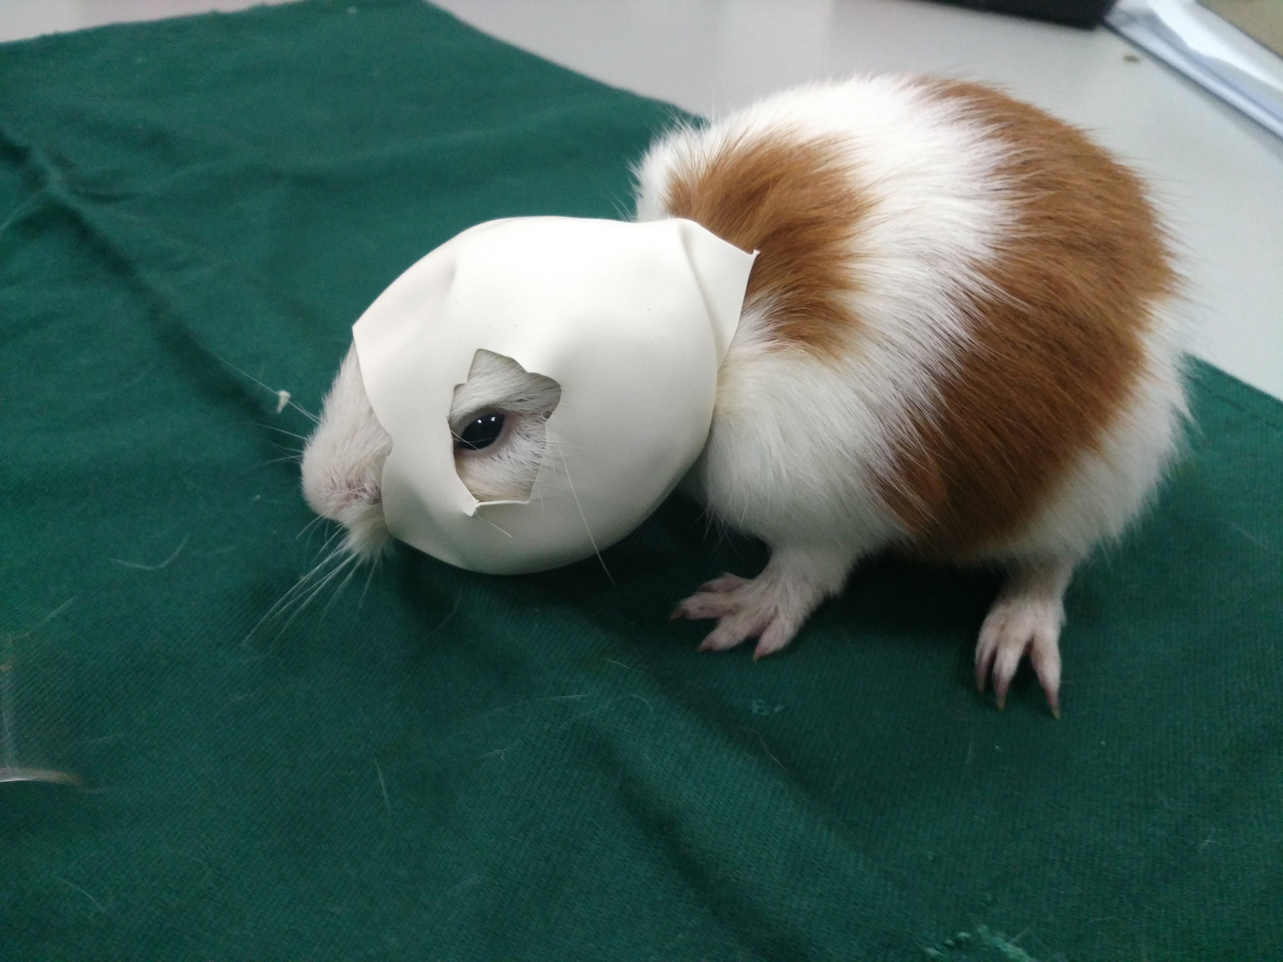
Thanks.
Method - animal, line 118
The authors did not mention when and how many times intravitreal injection was performed. Please add this information in the method section. I think changing Table 1 to a picture to show the number and timing of injections could improve the reader's understanding.

Thank you for your advice.
I’m sorry we didn't describe it clearly in the article.
We have added “All intravitreal injections were performed once using a microinjector (Shanghai Meter Glass Factory, Shanghai, China) with a 30-gauge needle at 1.5 mm posterior to the temporal limbus under anesthesia with 2.5 g/kg chloral hydrate (intraperitoneal injection) when the face masks were removed.”in Experimental Design and Groups part.
I also agree with you about the changing Table 1 to a picture to show the number and timing of injections could improve the reader's understanding.
But we only injected once when the face masks were removed, I hope you understand me, thank you
Thanks.
Method - animal, line 138
Is refractive data which was measured using retinoscopy reliable while guinea pigs awake? Are there references for this method?
Thank you for your advice.
The refractive errors were examined with a streak retinoscope at a working distance in a dark environment. Animals were only slightly restrained by controlling their bodies without anesthesia. The refraction of each eye was obtained by averaging three collected sets of the measurements and expressed as spherical equivalents.
Because it's an average, we think it's credible.
Tian Tian et al has used streak retinoscopy for measuring refraction in guinea pigs[3].
In Xiu-juan Li et al article, refractive status and axial length were determined by streak retinoscopy and A-scan ultrasonography in guinea pigs, respectively [4]. The refraction, axial length (AL), and corneal radius of curvature (CRC) were measured using streak retinoscopy, A-scan ultrasonography, and keratometry, respectively by Xiumei Luo et et al in guinea pigs[5].
3.Tian T, Zou L, Wu S, Liu H, Liu R. Wavelength Defocus and Temporal Sensitivity Affect Refractive Development in Guinea Pigs. Invest Ophthalmol Vis Sci. 2019;60(6):2173‐2180. doi:10.1167/iovs.18-25228.
4.Li XJ, Yang XP, Wan GM, Wang YY, Zhang JS. Expression of hepatocyte growth factor and its receptor c-Met in lens-induced myopia in guinea pigs. Chin Med J (Engl). 2013;126(23):4524‐4527.
5. Luo X, Li B, Li T, et al. Myopia induced by flickering light in guinea pig eyes is associated with increased rather than decreased dopamine release. Mol Vis. 2017;23:666‐679. Published 2017 Sep 29.
Thanks.
Method - animal, line 145
Was ocular axial length also measured on awake or under anesthesia? Please add this information in the method section.
Thank you for your advice.
No general anesthesia was necessary for any of the measurement procedures since the animals were very cooperative.
We changed to: Topical cornea anesthesia was carried out by administering a drop of 0.5% proparacaine hydrochloride (Alcon, Puurs, Belgium) 2 minutes prior to the ultrasound measurement on awake animal.
Thanks.
Table 1.
The expression NC 3d NC 7d NC 10d can be misleading. Does the NC 3d group mean guinea pigs 45 days old? The lack of explanation for the methods should be supplemented and revised for clarity.
Table 1. Experimental animal group classification (n=8 in each group)
Groups | Time after removal of deprivation (or the corresponding time in the NC group) |  |  | Time of deprivation | Intravitreal injection
Groups | 3 days | 7 days | 10 days | 21 days
REC | REC 3d | REC 7d | REC 10d
REC-SP | REC-SP 3d | REC-SP 7d | REC-SP 10d |  | SP600125
REC-AN | REC-AN 3d | REC-AN 7d | REC-AN 10d |  | anisomycin
REC-DM | REC-DM 3d | REC-DM 7d | REC-DM 10d |  | DMSO
FD |  |  |  | FD 21d
NC | NC 3d | NC 7d | NC 10d | NC 21d
Thank you for your advice. We didn't say it clearly. I’m sorry we didn't describe it clearly in the manuscript.
We have added “NC 3d group mean 45 days old guinea pigs in normal control group, NC 7d group mean 49 days old guinea pigs in normal control group, NC 10d group mean 52 days old guinea pigs in normal control group.”below the table 1.
Thanks.
Figure 2A, 2B, and 2C
The purpose of presenting these figures is to show that the choroidal thickness for each period varies from group to group. However, current figures have failed to achieve this purpose due to insufficient magnification. Please re-edit these figures and allow us to accurately compare the thickness of the choroid among groups.
Figure 2A the differences in CT are not able to be resolved in the images so unless the magnification is increased so the difference observable there is not much point to this figure
Thank you for your advice.
At first, we didn't want to put so many pictures in this manuscript, but all the pictures prove the point .Only when the OCT image is enlarged can we see the measured thickness accurately, so we can only mark the measured thickness with red numbers in the case of small pictures.
We added numbers in the diagram to show choroid thickness.
Thank you.
We can see clearly only when we put the original picture size picture in the article , so we marked the size. If we used the original picture, they take up too much space. Thank you
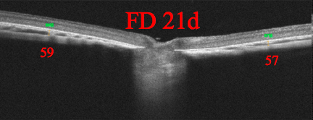
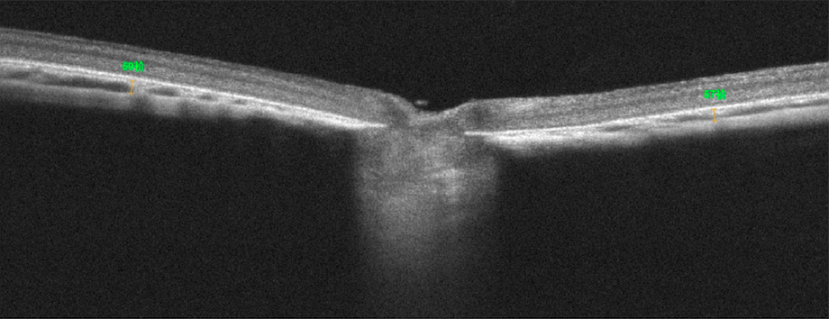
Results line 251~265
Please provide the average values of p-JNK1 protein and AQP1 protein level for each group.
Thank you for your advice.
I'm very sorry. Actually, we have carefully considered this problem. Adding fd21 and nc21d separately in fig3d and fig3e will make the figure appear particularly disorderly. Therefore, we have written their values in the article. Based on the principle that they can't be repeated in fig and result part, we haven't writed the p-jnk1 protein and AQP1 protein level of other groups in the article, Thank you.
We can provide data if necessary.
The values of AQP-1
 | REC | REC-SP | REC-AN | REC-DM | NC group
3 d | 1.365 ±0.18 | 1.02±0.168 | 1.815±0.21 | 1.335±0.23 | 0.36±0.075
7 d | 0.39±0.08 | 0.66±0.11 | 0.42±0.103 | 0.405±0.09 | 0.375±0.07
10d | 0.405±0.105 | 0.405±0.09 | 0.39±0.080 | 0.39±0.108 | 0.39±0.11
The values of p-JNK 1
 | REC | REC-SP | REC-AN | REC-DM | NC group
3 d | 1.455 ±0.27 | 1.14±0.225 | 1.92±0.31 | 1.47±0.255 | 0.63±0.18
7 d | 0.675±0.165 | 0.87±0.159 | 0.705±0.156 | 0.675±0.135 | 0.66±0.15
10d | 0.69±0.152 | 0.66±0.135 | 0.66±0.15 | 0.63±0.154 | 0.675±0.167
Thank you
Minor revision
Background line 57-58
The word "Multifunctional' is repeated. Please remove one.
Thank you for your advice.
We have omitted “Multifunctional” from this sentence.
From “The choroid is a dense network of multifunctional blood vessels with multiple functions” to“The choroid is a dense network of blood vessels with multiple functions.”
Thanks.
Method - animal, line 120
i.p. is the abbreviation first used here. Add the original word and add this abbreviation on the abbreviations part.
Thank you for your advice.
We have changed “i.p.” to “intraperitoneal injection” in this sentence.
“All intravitreal injections were performed once using a microinjector (Shanghai Meter Glass Factory, Shanghai, China) with a 30-gauge needle at 1.5 mm posterior to the temporal limbus under anesthesia with 2.5 g/kg chloral hydrate (intraperitoneal injection) when the face masks were removed.”
We've also changed two other places.
Thanks.
Method - animal, line 148
Min is the abbreviation first used here. Add the original word minutes and add this abbreviation on the abbreviations part.
Thank you for your advice.
We have changed “min” to “minutes” in this sentence.
“Ocular axial length was measured by high frequency A-scan ultrasonography (10-MHz, Suoer, Tianjin, China) on the same day following refraction measurements. Topical cornea anesthesia was carried out by administering a drop of 0.5% proparacaine hydrochloride (Alcon, Puurs, Belgium) 2 minutes prior to the ultrasound measurement on awake animal.”
Thanks.
Method - animal, line 152
'SD' was specified as an abbreviation for standard deviation, so in this sentence, SD should be changed to 'spectral domain'.
Thank you for your advice.
We have changed “SD” to “spectral-domain” in this sentence.
“With the spectral-domain RTVue OCT (Optovue XR-100-2, Fremont, CA, USA)”
Thanks.
Discussion line 284
AQP-1 expression was as follows -> is as follows
Thank you for your advice.
We are very sorry for the inconvenience because of our negligence.
We have changed “was as follows” to “is as follows” in this sentence.
“The mechanism for the regulation of AQP-1 expression is as follows:”
Thanks.
Discussion line 287
Please correct the reference insertion format.
Thank you for your advice.
18 and 19 are incorrect copies of the original documents, not references of this manuscript. We have deleted them. Thank you.
“first, the AQP1 transcript is upregulated by a hypertonicity response element (HRE) in the promoter region of the AQP1 gene, which can be activated by hypertonicity through three mitogen-activated protein kinases (MAPK) (ERK, p38 kinase, and JNK) signaling pathways.”
Thanks.
Discussion line 287
Please write the original word for the abbreviation MAPK (major mitogen-activated protein kinases).
Thank you for your advice.
We have changed ：
“first, the AQP1 transcript is upregulated by a hypertonicity response element (HRE) in the promoter region of the AQP1 gene, which can be activated by hypertonicity through three mitogen-activated protein kinases (MAPK) (ERK, p38 kinase, and JNK) signaling pathways. “
We also add this abbreviation on the abbreviations part.
Thanks.
Discussion line 294
Please write the original word for the abbreviation AP1.
Thank you for your advice.
We have added the original word in this sentence:”Second, AQP1, -4, and -9 have an adaptor primers 1 (AP1) element in their promoter region, allowing JNK-dependent transcriptional regulation [16].”
We also add this abbreviation on the abbreviations part.
Thanks.
Discussion line 296
Please add reference of this sentence.
Thank you for your advice.
We have added this reference in References section.
“Furthermore, AQP1 may lead to increased vascular permeability and interstitial fluid effusion, thus causing choroid thickening [17].”
17. Mobasheri A, Airley R, Hewitt SM, Marples D. Heterogeneous expression of the aquaporin 1 (AQP1) water channel in tumors of the prostate, breast, ovary, colon and lung: a study using high density multiple human tumor tissue microarrays. Int J Oncol. 2005;26:1149‐1158.
Thanks.
Figure 3D, 3E
Please write the original word for the abbreviation GAPDH in figure legend.
Thank you for your advice.
Thank you for your advice.
We have added the the original word for this abbreviation in figure legend.
“Figure 3. (A, B, C) The p-JNK 1 and AQP-1 protein levels were measured by Western blots in the form deprivation 21 days (FD 21d) group at different time points after removal of the deprivation in the recovery (REC, REC-SP, REC-AN, REC-DM) group and at different time points in the normal control (NC) group. (D, E) Mean p-JNK 1 and AQP-1 protein levels at different time points after removal of the deprivation in the REC group, the REC-SP group, the REC-AN group, the REC-DM group and the NC group. The results are the geometric mean and 95% CI. ∗p<0.05; **: compared with the other groups at the same time point, p < 0.05. GAPDH： glyceraldehyde-3phosphate dehydrogenase .”
Thanks.
Discussion line 312-314
Please add reference of this sentence.
Chen W, Zhang H, Zhang Y, Wang Q, Wang Y, Li ZW. Relationship between Aquaporin-1 Protein Expression and Choroidal Thickness during the Recovery of Form-deprivation Myopia in Guinea Pigs. Curr Eye Res. 2020;45(6):705‐712.

Thank you for your advice.
We have added the reference for this sentence.
“In our previous research, we also found a significant positive correlation between AQP-1 and CT in FD and the recovery period, indicating that the regulation of AQP-1 expression is related to changes in the CT [3].”
At the same time, we modified the format of this reference.
Thanks.

Thank you very much again.
I have learnt a lot from your advice.

Reviewer 2: The work of this paper "The role of JNK 1 in controlling AQP-1 and choroidal thickness during recovery from form-deprivation myopia in guinea pigs" is clear and logical. However, there are some problems to be further improved as well:

Thank you for the advice and the professional revision. We are very sorry for the inconvenience because of our negligence.
Thank you very much for your review during the COVID-19 epidemic and wish you good health.
We have answered the questions in details as follows:
1.The quality of English needs to be improved before resubmission. We strongly suggest that you obtain assistance from a colleague whose native language is English. If the writing is more fluent and smoother, the results and discussion of the study are clearer to the reader.
Thank you for your advice. We have revised this manuscript by American Journal Experts which is the recommended company.
We've made some changes and highlight the changes in red color.
Thanks



2.In Line 109, the author didn't mention when the guinea pigs in the REC-SP group and the REC-AN group got injected. Was it just before the animals wore face masks?
Thank you for your advice. We didn't say it clearly. I’m sorry we didn't describe it clearly in the article.
We have adde “All intravitreal injections were performed once using a microinjector (Shanghai Meter Glass Factory, Shanghai, China) with a 30-gauge needle at 1.5 mm posterior to the temporal limbus under anesthesia with 2.5 g/kg chloral hydrate (intraperitoneal injection) when the face masks were removed.” in this manuscript form line 114 to line 117.
Thanks.

Thank you very much again.
I have learnt a lot from your advice.
If improvements to the English language within your manuscript have been requested, you should have your manuscript reviewed by someone who is fluent in English. If you would like professional help in revising this manuscript, you can use any reputable English language editing service. We can recommend our affiliates Nature Research Editing Service (http://bit.ly/NRES_BS) and American Journal Experts (http://bit.ly/AJE_BS) for help with English usage. Please note that use of an editing service is neither a requirement nor a guarantee of publication. Free assistance is available from our English language tutorial (https://www.springer.com/gb/authors-editors/authorandreviewertutorials/writinginenglish) and our Writing resources (http://www.biomedcentral.com/getpublished/writing-resources). These cover common mistakes that occur when writing in English.
--------------------
Editorial Policies
--------------------
Please read the following information and revise your manuscript as necessary. If your manuscript does not adhere to our editorial requirements, this may cause a delay while this is addressed. Failure to adhere to our policies may result in rejection of your manuscript.
In accordance with BioMed Central editorial policies and formatting guidelines, all manuscript submissions to BMC Ophthalmology must contain a Declarations section which includes the mandatory sub-sections listed below.
Please refer to the journal's Submission Guidelines web page for information regarding the criteria for each sub-section (https://bmcophthalmol.biomedcentral.com/).
Where a mandatory Declarations section is not relevant to your study design or article type, please write "Not applicable" in these sections.
For the 'Availability of data and materials' section, please provide information about where the data supporting your findings can be found.
We encourage authors to deposit their datasets in publicly available repositories (where available and appropriate), or to be presented within the manuscript and/or additional supporting files.
Please note that identifying/confidential patient data should not be shared.
Authors who do not wish to share their data must confirm this under this sub-heading and also provide their reasons.
For further guidance on how to format this section, please refer to BioMed Central's editorial policies page (see links below).
Declarations
-
Ethics approval and consent to participate
-
Consent to publish
-
Availability of data and materials
-
Competing interests
-
Funding
-
Authors' Contributions
-
Acknowledgements
Further information about our editorial policies can be found at the following links:
Ethical approval and consent:
http://www.biomedcentral.com/about/editorialpolicies#Ethics
Availability of data and materials section:
http://www.biomedcentral.com/submissions/editorial-policies#availability+of+data+and+materials
As a result of the significant disruption that is being caused by the COVID-19 pandemic we are very aware that many researchers will have difficulty in meeting the timelines associated with our peer review process during normal times. Please do let us know if you need additional time. Our systems will continue to remind you of the original timelines but we intend to be highly flexible at this time.
This letter contains confidential information, is for your own use, and should not be forwarded to third parties.
Recipients of this email are registered users within the Editorial Manager database for this journal. We will keep your information on file to use in the process of submitting, evaluating and publishing a manuscript. For more information on how we use your personal details please see our privacy policy at https://www.springernature.com/production-privacy-policy. If you no longer wish to receive messages from this journal or you have questions regarding database management, please contact the Publication Office at the link below.
__________________________________________________
In compliance with data protection regulations, you may request that we remove your personal registration details at any time. (Use the following URL: https://www.editorialmanager.com/boph/login.asp?a=r). Please contact the publication office if you have any questions.

