Supporting information

S1 Additional file . Experimental setup.
Section A: Laboratory room.
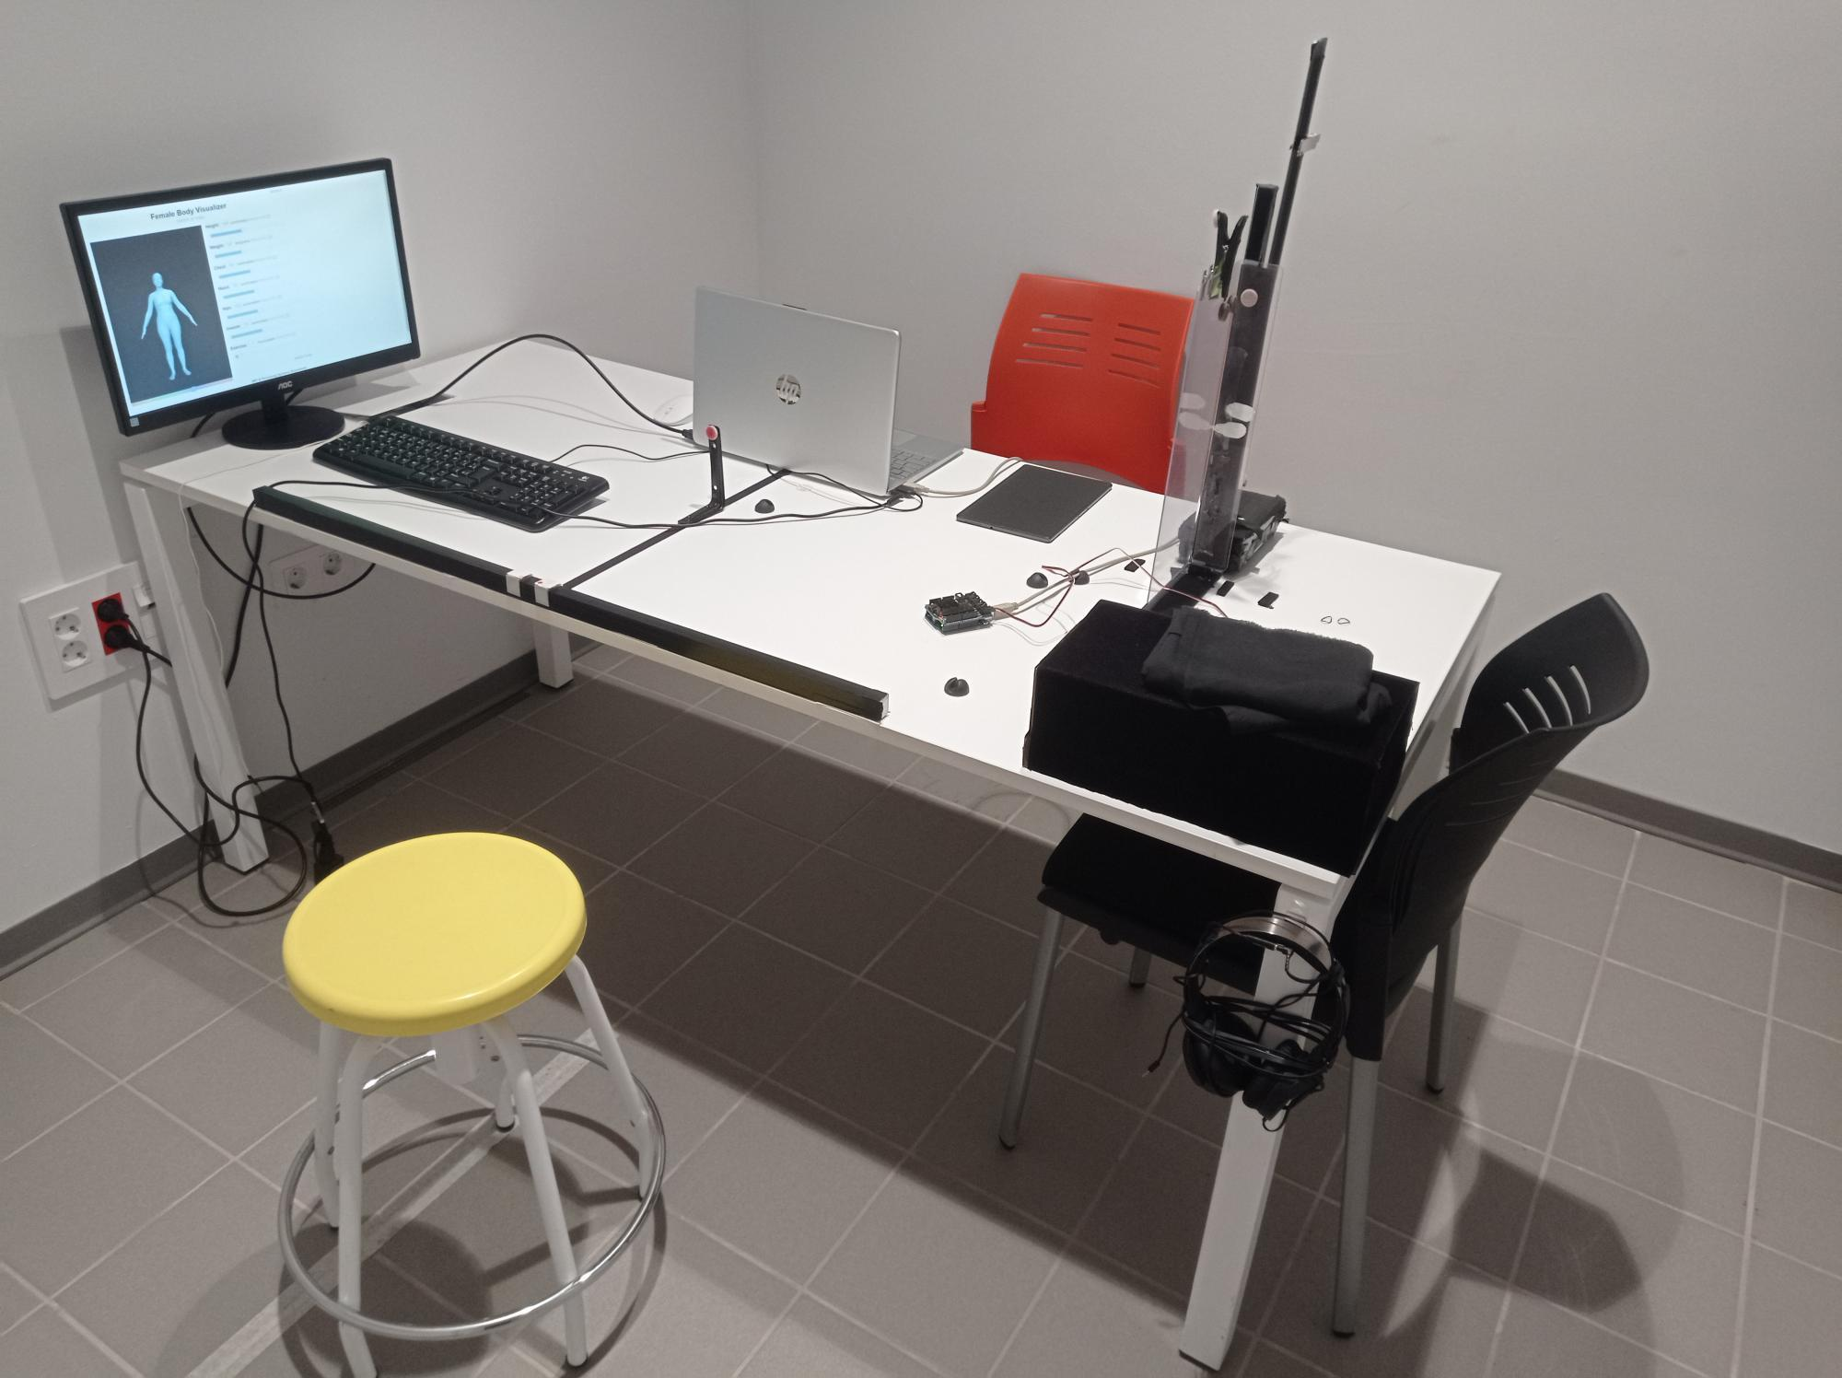
Section B: Anthropometric instruments: Vernier caliper and pediatric stadiometer.
