Rational construction of NH₂-UiO-66/Bi₂MoO₆ nanocomposite with accelerating charge transfer for enhanced visible-light photocatalytic activity

Qingsong Hu^{a*}, Zhixin Wangª, Ting Zhouª, Zhenxing Wangª, Jintao Dong^{b}, Xingwang Zhuª, Jianjian Yiª, Yiqun Xu^{a*}
ªCollege of Environmental Science and Engineering, Yangzhou University, 196 West Huayang Road, Yangzhou, 225127, PR China
^{b}School of Chemistry and Chemical Engineering, Institute for Energy Research, Jiangsu University, 301 Xuefu Road, Zhenjiang, 212013, PR China.

*Corresponding author:
Dr. Qingsong Hu
Tel.: +86-514-87979528, Fax: +86-514-87978626
E-mail address: huqs@yzu.edu.cn
Dr. Yiqun Xu
Tel.: +86-514-87979528, Fax: +86-514-87978626
E-mail address: yqxu@yzu.edu.cn

Supplementary information
Synthesis of NH₂-UiO-66
0.23 g zirconium(IV) chloride and 0.18 g 2-aminoterephthalic acid were dissolved into 50 mL N,N-dimethyl formamide (DMF) and stirred for 1 h. The mixture was then transfered into a 100 mL Teflon-lined autoclave and reacted at 120 °C for 48 h, then cooled. The obtained sample was centrifuged at high speed and washed with DMF and methanol to remove the unreacted 2-aminoterephthalic acid. The yellow liquid was suspended into methanol and stirred for 24 h to remove the residual DMF. The final product was dried under vacuum at 80 °C for 24 h.

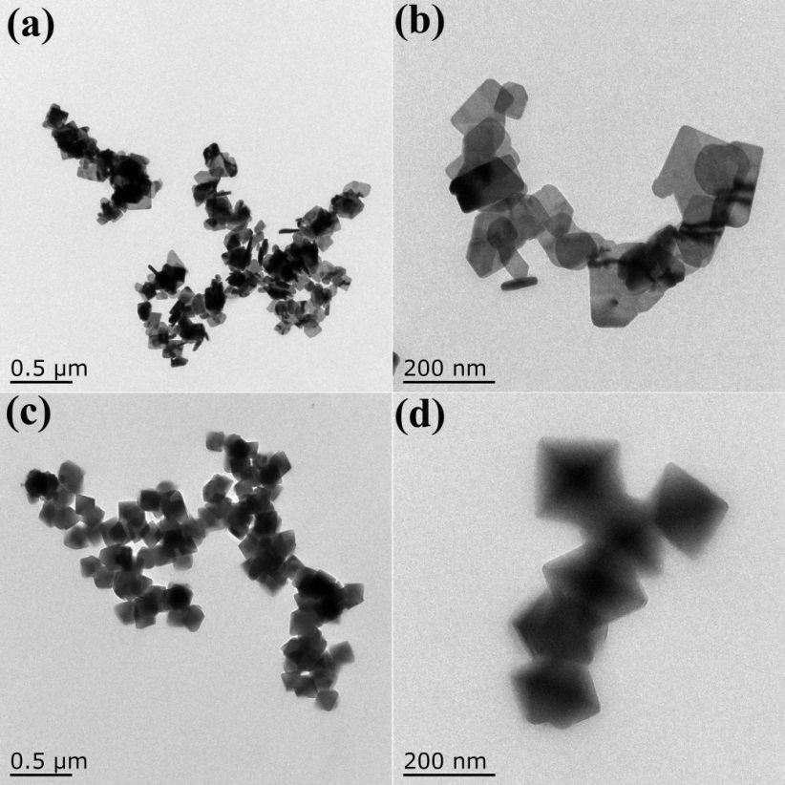
Fig. S1. TEM images of Bi₂MoO₆ (a,b) and NH₂-UiO-66 (c,d).

Fig. S2. XPS spectra of 5 wt% NU/BMO.

Fig. S3 Nitrogen absorption-desorption isotherms and pore diameter distribution of NH₂-UiO-66.
Fig. S4. The adsorption equilibrium of RhB over different samples in the darkness.

Fig. S5. Cycling runs for RhB degradation over 5 wt% NU/BMO under visible light irradiation (a), the XRD patterns of 5 wt% NU/BMO before and after five cycles (b).

Fig. S6. (αhν)^{0.5} vs. hν (photon energy) curves of Bi₂MoO₆ and NH₂-UiO-66.

Fig. S7. The Motty-Schottky plots of NH₂-UiO-66 (a) and Bi₂MoO₆ (b).

Fig. S8. Valence-band XPS spectra of NH₂-UiO-66 (a) and Bi₂MoO₆ (b).

