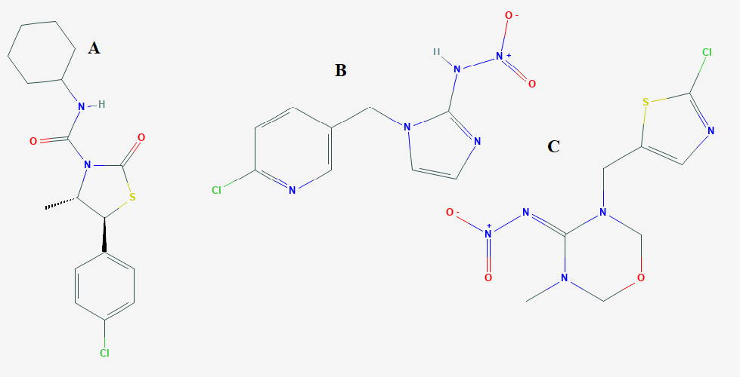

Figure S1: Molecular configurations of hexythiazox (A), imidacloprid (B) and thiamethoxam (C).

Table S1:
Application of the proposed methods to the field samples to determine residuals of hexythiazox (HTX), imidacloprid (IDD) and thiamethoxam (TTM).
Pesticides | Residue founded* (mg Kg⁻¹) |  |  |  | Safe dose**  (mg Kg⁻¹)
Pesticides | By day 1 |  | By day 10 |  | Safe dose**  (mg Kg⁻¹)
Pesticides | HP-TLC method | RP-HPLC method | HP-TLC method | RP-HPLC method | Safe dose**  (mg Kg⁻¹)
HTX | 2.50 | 2.51 | 1.02 | 1.01 | 2.50
IDD | 41.01 | 41.00 | 23.22 | 23.11 | 42.00
TTM | 31.00 | 30.98 | 14.80 | 14.75 | 34.00
*Average of three determinations.
**Recommended dose for human and vegetable productivity [20:22].

