Human viral encephalitis associated with suid herpesvirus 1
Yiyi Zhou, Chong Nie, Han Wen, Yong Long, Meihong Zhou, Zunchun Xie, Daojun Hong
Department of Neurology, the First Affiliate Hospital of Nanchang University, Nanchang, China

Corresponding author:

Dr. Daojun Hong
E-mail: hongdaojun@hotmail.com
Department of neurology, the first affiliated hospital of Nanchang university, Nanchang, China

Yong Wai Zheng Street 17#, Nanchang, 330006, Jiangxi Province, P.R.China
Telephone number: 86-791-8869-2511; Fax: 86-791-8869-2511

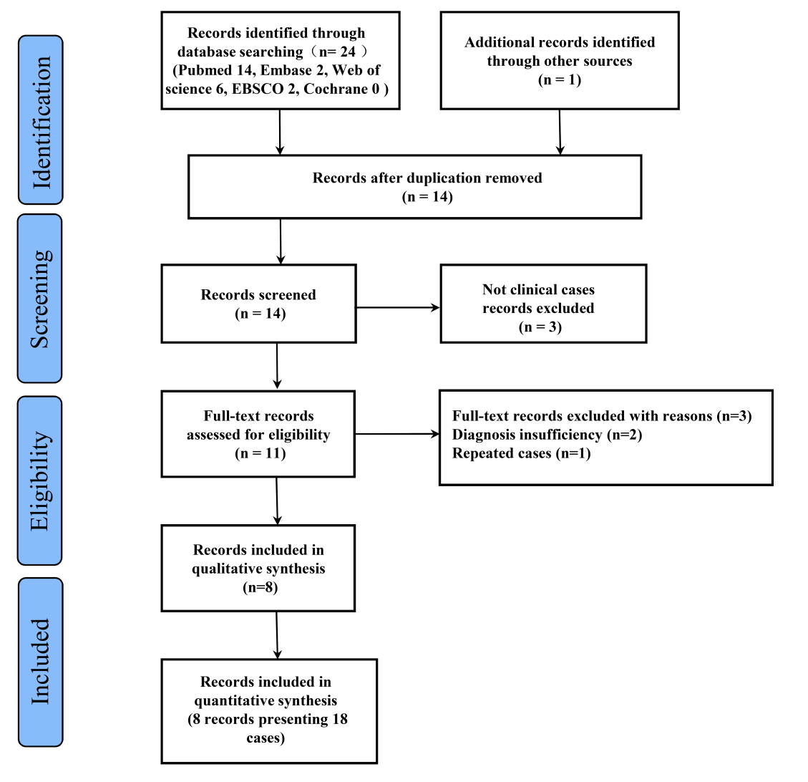
Supplemental Figure 1. The patient enrollment was depicted in PRISMA workflow. In total, 25 records were identified by the keywords in the multiple databases. After removing the duplication records, 14 of 25 records were screened for cases with SHV1 encephalitis, and then 3 of 14 records were removed due to not clinical reports. Three of 11 records were excluded due to diagnosis ineligibility with evidence insufficiency (n=2) and repeated report (n=1). Finally, 8 of 11 records including 18 cases were qualified to summarize the clinical data of human SHV1 encephalitis.

Supplemental Table 1. Clinical summarizations of 20 cases with SHV1 encephalitis.
Variables | Positive number (n=20 ) | N (%)
Age (years)
20-44 | 8 | 40%
45-54 | 8 | 40%
55-65 | 4 | 20%
Male | 17 | 85%
Symptoms
Fever | 20 | 100%
Seizure | 20 | 100%
Disturbed consciousness | 20 | 100%
Respiratory failure | 16 | 80%
Headache | 10 | 50%
Eye involvement | 10 | 50%
Psychiatric symptoms | 4 | 20%
Stiff-neck sign | 10 | 50%
Outcomes
mRS: 2 | 2 | 10%
mRS: 3 | 5 | 25%
mRS: 4 | 2 | 10%
mRS: 5 | 7 | 35%
Died | 4 | 20%
mRS: modified Rankin scale

Supplemental Table 2. Detailed results of auxiliary examinations in 20 cases with SHV1 encephalitis.
Case | Blood WBC (10⁹/L) | EEG | MRI distributions | CSF
 |  |  |  | Day | Opening pressure (mmH₂O) | WBC (10⁶/L) | Protein (g/L) | Chloride  (mmol/L) | Glucose (mmol/L)
1 | 12.47 | diffuse slowing wave | temporal lobe, insular cortex | 2  7 | 220  190 | 1  1 | 0.34  0.95 | 122.3  127.7 | 3.05  2.53
2 | 16.33 | diffuse slowing wave | frontal, temporal, parietal lobes, insular cortex | 2  5 | 190  180 | 20  3 | 1.29  1.28 | 120.6  129.7 | 6.95  3.15
3 | 6.39 | ND | basal ganglia, occipital lobe and limbic lobe | 1  8 | 90  175 | 189  174 | 1.45  2.71 | ND  ND | 1.86  2,29
4 | 9.3 | diffuse slowing wave | frontal, temporal, parietal lobes, insular cortex, basal ganglia | 2  16  34 | 300  300  330 | 8  64  23 | 0.41  1.13  0.64 | 114  120  120 | 5.87  5.45  4.43
5 | 9.26 | paroxysmal spike, slow wave | brain CT no abnormal | 4 | 290 | 14 | 0.33 | 125 | 5.51
6 | ND | ND | temporal lobe, insular cortex，basal ganglia | 6 | 135 | 44 | 0.39 | ND | ND
7 | ND | ND | temporal lobe, insular cortex | 7 | 160 | 98 | 0.41 | ND | ND
8 | ND | ND | temporal lobe, insular cortex，basal ganglia | 3 | 195 | 6 | 0.3 | ND | ND
9 | ND | ND | ND | 7 | 275 | 30 | 0.39 | ND | 4.2
10 | ND | ND | temporal lobe, insular cortex | 4 | ND | 0 | 0.61 | ND | ND
11 | ND | ND | frontal, temporal, insular cortex，hippocampus，brainstem | 2  14 | 230  280 | 23  39 | 0.49  0.66 | ND  ND | 7.01  3.16
12 | ND | ND | frontal, temporal, parietal lobes, insular cortex, basal ganglia | 11  25  45 | 270  230  205 | 60  200  40 | 0.36  0.67  0.47 | ND  ND  ND | 4.61  2.47  2.94
13 | ND | ND | insula cortex, thalamus, limbic, corpus callosum | 12  27  35 | ND  ND  ND | 105  91  25 | 0.3  0.77  0.58 | 110  121  119 | 4.8  4.4  4.2
14 | 11.08 | diffuse slowing wave | frontal, temporal, insula lobe, basal ganglia | ND | 220 | 5 | 0.2 | 116 | 4.5
15 | ND | ND | frontal, temporal lobes, insular cortex | 5  14 | 180  102 | 4  14 | 0.4  0.3 | 119  128 | 4.7  3.9
16 | ND | ND | temporal lobe, insular cortex | 9 | 130 | 26 | 0.9 | 125 | 3.9
17 | ND | ND | temporal lobes, insular cortex | 10  14 | ND  290 | 24  4 | 0.5  0.6 | 108  123 | 4.1  3.5
18 | ND | ND | temporal lobes, insular cortex | 5  11 | ND  165 | 23  4 | 0.4  0.5 | 126  142 | 6.0  6.9
19 | ND | ND | temporal lobes, insular cortex, caudate nucleus | 12  15 | ND  165 | 12  32 | 0.3  0.5 | ND  120 | 4.8  3.7
20 | ND | ND | temporal lobe, hippocampus | ND | ND | ND | ND | ND | ND
WBC: white blood cell; EEG: electroencephalogram; CSF: cerebrospinal fluid; ND: no data

Supplemental Table 3. Summarization of auxiliary examinations in 20 cases with SHV1 encephalitis.
Variables | Positive number
EEG (n=5)
Slow activity | 5
Epileptic activity | 3
Brain MRI (n=19)
Frontal lobe | 8
Temporal lobes | 16
Parietal lobe | 3
Insular cortex | 19
Basal ganglia | 10
Brainstem | 3
CSF (n= 33 times)
Increased opening pressure  (n=26 measurements) | 17
Increased WBC counting | 23
Increased protein level | 19

