Supplementary Materials for

Novel Xylose and Shikimate Transporters Facilitating the design of a Microbial Consortium as a Chassis for Benzylisoquinoline Alkaloid Production

Meirong Gao, Yuxin Zhao, Qianhe Su, and Zengyi Shao

This file includes:
- Supplementary Tables
- Supplementary Figures
References
1. Supplementary Tables

Table S1. The differential expression of the genes involved in xylose uptake and utilization under various sugar conditions from Scheffersomyces stipitis. RNA-seq was performed to analyze cells growing in different sugars following the protocol reported earlier(1). The ratio of the average sequencing reads for each gene under three different growing conditions (i.e., X/G and X/GX) was calculated. X, YPA+15 g/L xylose; G, YPA+35 g/L glucose; GX, YPA+35 g/L glucose and 15 g/L xylose.
Carbon source | Sampling time | Target genes
Carbon source | Sampling time | XYL1 | XYL2 | XYL3 | TKT1 | TAL1 | XUT1
X/G | 15 h | 34.7 | 7.3 | 56.3 | 3.8 | 5.6 | 16.7
X/G | 48 h | 14.0 | 2.2 | 5.3 | 1.8 | 2.1 | 18.8
X/G | 72 h | 0.2 | 0.2 | 0.3 | 0.5 | 0.4 | 1.2
X/GX | 15 h | 21.3 | 7.0 | 9.7 | 4.0 | 4.2 | 15.0
X/GX | 48 h | 1.0 | 0.7 | 0.6 | 1.0 | 0.8 | 15.4
X/GX | 72 h | 0.007 | 0.03 | 0.02 | 0.3 | 0.1 | 0.09

Table S2. Strains and plasmids constructed in this study.

Strains or plasmids | Description | Reference
Strains
S. cerevisiae YSG50 | MATα, ade2-1, ade3Δ22, ura3-1, his3-11, 15, trp1-1, leu2-3, 112, and can1-100 | (2)
S. stipitis FPL-UC7 | NRRL Y-21448, ura3-3 | (3)
S. stipitis FPL-UC7 leu2Δ | ura3-3, leu2-2 | Unpublished data
BY4741 | MATa, his3Δ1, leu2Δ0, met15Δ0, ura3Δ0
CEN.PK2-1c | MATa ura3-52 trp1-289 leu2-3,112 his3Δ1 MAL2-8C SUC2
Ss-xyl | S. stipitis FPL-UC7, pMG-xyl | This study
Ss-xyl-SsXUT1 | S. stipitis FPL-UC7, pMG-xyl-SsXUT1 | This study
Ss-xyl-SsXUT2 | S. stipitis FPL-UC7, pMG-xyl-SsXUT2 | This study
Ss-xyl-SpXUT1 | S. stipitis FPL-UC7, pMG-xyl-SpXUT1 | This study
Ss-SpXUT1 | S. stipitis FPL-UC7, pMG-SpXUT1 | This study
Ss-xyl-ScHXT11-N366T | S. stipitis FPL-UC7, pMG-xyl-ScHXT11-N366T | This study
Ss-xyl-NcAN25-R4.18 | S. stipitis FPL-UC7, pMG-xyl-NcAN25-R4.18 | This study
SA1 | S. stipitis FPL-UC7 leuΔ-pMG-xyl, pMG-SA | This study
SA2 | S. stipitis FPL-UC7 leuΔ-pMG-SpXUT1, pMG-SA | This study
SA3 | S. stipitis FPL-UC7 leuΔ-ARS/CEN5-750bp-eGFP, pMG-SA | This study
SA4 | S. stipitis FPL-UC7 leuΔ-pMG-xyl-SpXUT1, pMG-SA | This study
NC3 | CEN.PK2-1c, pRS413-AnQut1co-TyrH*-DODC-NCS, pRS415-TyrH*-DODC-NCS, pSR416-AnQut1co-TyrH*-DODC-NCS | This study
Plasmids
ARS/CEN5-750bp-eGFP | URA3, a centromeric plasmid | (4)
pMG-xyl | ARS/CEN5-750bp, SsADH1p-SsTEF1t, SsENO1p-xyl1-SsGLN1t, SsGLN1p-xyl2-SsAOX1t, SsOLE1p-xyl3-SsUAGt, SsPIR1p-tkt1-SsOLE1t, and SsTEF1p-tal1-SsADH1t | This study
pMG-xyl-SsXUT1 | pMG-xyl-SsADH1p-Ssxut1-SsTEF1t | This study
pMG-xyl-SsXUT2 | pMG-xyl-SsADH1p-Ssxut2-SsTEF1t | This study
pMG-xyl-SpXUT1 | pMG-xyl-SsADH1p-Spxut1-SsTEF1t | This study
pMG-SpXUT1 | ARS/CEN5-750bp-SsTEF1p-Spxut1-SsTEF1t | This study
pMG-xyl-ScHXT11-N366T | pMG-xyl-SsADH1p-Schxt11-N366T-SsTEF1t | This study
pMG-xyl-NcAN25-R4.18 | pMG-xyl-SsADH1p-NcAN25-R4.18-SsTEF1t | This study
pMG-eGFP | ARS/CEN5-750bp-eGFP, leu marker was used to replace ura marker | This study
pMG-SA | LEU2, ARS/CEN5-750bp-SsADH1p-tkt1-SsPGK1t, SsPIR1p-aro4_{K220L}-SsADH1t, SsUAGp-aro1_{D900A}-SsPIR1t | This study

Table S3. Xylose assimilating capability of CUG clade yeasts, and the maximal identities of the corresponding homologs to SpXut1.

Microorganism | Xylose-assimilating ability | Maximal identity (%)
Spassaspora passalidarum | yes | 100
Scheffersomyces stipitis | yes | 79
Candida albicans | yes | 67
Candida dubliniensis | only 5% assimilate xylose | 67
Candida maltosa | yes | 67
Candida tropicalis | yes | 66
Candida tenuis | yes | 56
Candida guilliermondii | yes | 41
Candida auris | no | 39
Debaryomyces hansenii | yes | 37
Lodderomyces elongisporus | yes | 37
Candida tanzawaensis | no | 36
Hyphopichia burtonii | yes (weak) | 34
Canada lusitaniae | yes | 34
Metschnikowia bicuspidata | some yes, some no | 34
Candida orthopsilosis | yes | 32
Candida parapsilosis | yes | 32
Metschnikowia fructicola | yes (weak) | n/a
Meyerozyma caribbica | yes | n/a
Spassaspora arborariae | yes | n/a
Candida oleophila | yes | n/a
Candida sojae | yes | n/a
Note: n/a, no genome sequence is available, or no significant similarity was found. All data of xylose-assimilating ability were collected from National Collection of Yeast Cultures (https://catalogue.ncyc.co.uk/) except Candida auris(5) and Spassaspora arborariae(6), which were individually reported.

Table S4. Eight quinate permeases for shikimate uptake assay. The query sequence was AnQut1.

Transporters | NCBI gene ID | Number of intron(s) | NCBI accession number | Protein length (aa) | Identity to AnQut1 (%) | Similarity to AnQut1 (%)
AnQut1 | 4982700 | 1 | XP_001392502.1 | 535 | 100 | 100
AnQut2 | 4979277 | 2 | XP_001399921.1 | 536 | 64 | 78
AnQut3 | 4987285 | 2 | XP_001401052.1 | 518 | 36 | 56
AnQut4 | 4988028 | 3 | XP_001396962.2 | 543 | 33 | 53
AnQut5 | 4985506 | 4 | XP_001395243.2 | 534 | 34 | 51
AnQut6 | 4989730 | 3 | XP_001398629.1 | 553 | 31 | 52
AnQut7 | 4985176 | 11 | XP_001394918.2 | 566 | 33 | 50
AnQut8 | 4978462 | 3 | XP_001388526.2 | 532 | 33 | 52

Table S5. Ethanol production from the recombinant S. stipitis strains. The initial cell density of all three strains were at ~10. Fermentation was carried out in Sc-ura media supplemented with 28 g/L glucose and 12 g/L xylose. Standard deviations were calculated from triplicates.

Strain | Time (h) | Titer (g/L) | Yield (g _{ethanol}/g _{sugar}) | Productivity (g _{ethanol}/(h*L))
Ss-xyl | 48 | 11.58±0.50 | 0.29±0.01 | 0.24±0.01
Ss-SpXUT1 | 48 | 11.78±0.65 | 0.29±0.02 | 0.25±0.01
Ss-xyl-SpXUT1 | 36 | 15.30±0.54 | 0.38±0.01 | 0.43±0.02

Table S6. Primers used in this study.

Pathway engineering in S. stipitis
SsADH1p-For | ctcactatagggcgaattgggtaccgggccccccctcgagcagcatcatcaccatgttgt
SsADH1p-Rev | ttaatcagccccgggtctgcagtcctaggtggcgcgccgataatttggatggatcgcagc
SsTEF1t-For | cggcgcgccacctaggactgcagacccggggctgattaatttacgtatattcagtttaat
SsTEF1t-Rev | gagcagtgatacggtggctggtgatgtagataatataaggttattgtagacactaatcat
SsENO1p-For | ttccaagtatgattagtgtctacaataaccttatattatctacatcaccagccaccgtat
SsENO1p-Rev | atgtcgtaaccagagttcaacttaatagaaggcattgttagtgcgggaatcgataaagaa
Ssxyl1-For | taattacttgcttctttatcgattcccgcactaacaatgccttctattaagttgaactct
Ssxyl1-Rev | agggtaaagtacagcagaaggaaaccagccagacatttagacgaagataggaatcttgtc
SsGLN1t-For | gacccatgggactgggacaagattcctatcttcgtctaaatgtctggctggtttccttct
SsGLN1t-Rev | ttcaggaagacaccgacagtttttttttaacgaataatgaacattagtaccaccaaaatg
SsGLN1p-For | atctgcattttggtggtactaatgttcattattcgttaaaaaaaaactgtcggtgtcttc
SsGLN1p-Rev | tgttcaacaccaaggaagggttagcagtcatgatggaaattgtatgtgattctaatagtta
Ssxyl2-For | tgcattttctaactattagaatcacatacaatttccatcatgactgctaacccttccttg
Ssxyl2-Rev | caaaaatgatgtagaaagaaatcgggaaacctgagcaattcttactcagggccgtcaatg
SsGLN1t-For | gggtgctgtcaagtgtctcattgacggccctgagtaagaattgctcaggtttcccgattt
SsGLN1t-Rev | ctattagcatacgcaccaatgtcagaaagatctgctttgtataatatttctccgttctct
SsOLE1p-For | ggccgataagagaacggagaaatattatacaaagcagatctttctgacattggtgcgtat
SsOLE1p-Rev | atctggagcatcaaatggggtagtggtcatactgaaatcgaaatagaatcagaagttgaa
Ssxyl3-For | tttgtagcttcaacttctgattctatttcgatttcagtatgaccactaccccatttgatg
Ssxyl3-Rev | tcatcggagatttaaggaaaggaaaaataaaattagtgtttcaattcactttccatcttg
SsGLN1t-For | tggccaagatggaaagtgaattgaaacactaattttatttttcctttccttaaatctccg
SsGLN1t-Rev | tttctttacaacaccggaaccaaaacggtccaaaaaaaagcaatcttggggtagattccg
SsPIR1p-For | tccaaaaatggagcaatcggaatctaccccaagattgcttttttttggaccgttttggtt
SsPIR1p-Rev | gctgatagctttttgatcgacggacgacattgtaaatcaatcaggtttattgtagatagc
Sstkt1-For | acatacattcgctatctacaataaacctgattgatttacaatgtcgtccgtcgatcaaaa
Sstkt1-Rev | tctttctctattctctaatgtgctatcttggctagtatagttcagaaggcagaacgcaat
SsOLE1t-For | gcaaggatgttgtgtctccattgcgttctgccttctgaactatactagccaagatagcac
SsOLE1t-Rev | ttaccaaccttatcgtacttcatgaaggccggcctttcgcatacgatgaacaaattaaaa
SsTEF1p-For | ggtttttaatttgttcatcgtatgcgaaaggccggccttcatgaagtacgataaggttgg
SsTEF1p-Rev | tcaattgttcaagggagttggaggacattgtagatagacttagattgtatgaaactaaag
Sstal1-For | ttttgtcctttagtttcatacaatctaagtctatctacaatgtcctccaactcccttgaa
Sstal1-Rev | tggaatagaacaaagcactatctagcacggcttgtttagaatctggcttccaattgttcc
SsADH1t-For | acgctgtcaccttgttggaacaattggaagccagattctaaacaagccgtgctagatagt
SsADH1t-Rev | acaccatatcctatactgaattcatcgatggcgcctagcctcttaaagtttgctttttcc
SsXUT1-For | attgcacccaattgcataagtgctgcgatccatccaaattatcatgcacggtggtggtga
SsXUT1-Rev | atattaaactgaatatacgtaaattaatcagcttatttttcaacgtggtagacatcagcc
SsXUT2-For | ttgcataagtgctgcgatccatccaaattatcatgaagtattttcaaatctggaaatcag
SsXUT2-Rev | cgtattgatattaaactgaatatacgtaaattaatcagctcagaacaaatcgtcaatggc
SsXUT3-For | caattgcataagtgctgcgatccatccaaattatcatgagagaagttggtattcttgatg
SsXUT3-Rev | ttgatattaaactgaatatacgtaaattaatcagcttattctgacatttcaatcgagttg
SsXUT4-For | attgcataagtgctgcgatccatccaaattatcatgtcttcgttattgactaacgaatac
SsXUT4-Rev | aacgtattgatattaaactgaatatacgtaaattaatcagcttactgtctgcggagaagc
SsXUT5-For | gcacccaattgcataagtgctgcgatccatccaaattatcatgacggaaagaagcattgg
SsXUT5-Rev | ttaaactgaatatacgtaaattaatcagcttacttctttgtattaacaacaaaaccttgt
SsXUT6-For | acccaattgcataagtgctgcgatccatccaaattatcatgtccagtgttgaaaaaagtg
SsXUT6-Rev | gtattgatattaaactgaatatacgtaaattaatcagcttagctgatgttttcgacatgc
SsXUT7-For | cccaattgcataagtgctgcgatccatccaaattatcatgatatcatcgcttttggtagc
SsXUT7-Rev | tgatattaaactgaatatacgtaaattaatcagcctagagtaatgttcttcttggagact
SpXUT1-For | ttgcacccaattgcataagtgctgcgatccatccaaattatcatgcacggaggttcagac
SpXUT1-Rev | cgtattgatattaaactgaatatacgtaaattaatcagcttaagcactgtcagcatcagc
SpXUT4-For | acccaattgcataagtgctgcgatccatccaaattatcatggaaggtataccaaatagcc
SpXUT4-Rev | attgatattaaactgaatatacgtaaattaatcagcctaaacatcctgtgagctaaatgt
SpXUT7-For | caattgcataagtgctgcgatccatccaaattatcatggctcatttaagttggagattgc
SpXUT7-Rev | aacgtattgatattaaactgaatatacgtaaattaatcagcttacaacatctgcctccgc
SpHXT2.4-For | ttgcataagtgctgcgatccatccaaattatcatggctgatttaaaagacaaccaaatta
SpHXT2.4-Rev | attaaactgaatatacgtaaattaatcagcttagaccaacttttcggcg
SpHGT2-For | aattgcataagtgctgcgatccatccaaattatcatgtcttctaaaatagagagtgcttt
SpHGT2-Rev | gatattaaactgaatatacgtaaattaatcagcttaaacctggttatcagaattagtttc
SpRGT2.1-For | ttgcataagtgctgcgatccatccaaattatcatgggtttagaagataatcaatatttgc
SpRGT2.1-Rev | gatattaaactgaatatacgtaaattaatcagcctaaactgaatgttcgatttcattaac
SpRGT2.2-For | tgcataagtgctgcgatccatccaaattatcatgggtattgaagaaagtttattcttaca
SpRGT2.2-Rev | tgatattaaactgaatatacgtaaattaatcagcttatacagataccttttcagcttgtt
SpRGT2.3-For | gcataagtgctgcgatccatccaaattatcatgggtattgaagaaagtttattcttacaa
SpRGT2.3-Rev | ttgatattaaactgaatatacgtaaattaatcagcttaaaccttttcgatttgttcagtc
SpSNF3-For | gcataagtgctgcgatccatccaaattatcatgttcaaatttctagagcgaatattatac
SpSNF3-Rev | tattgatattaaactgaatatacgtaaattaatcagcttatggtctcttttcttgtgact
ScHXT11N366MinSs-For | caattgcataagtgctgcgatccatccaaattatcatgtccggtgtcaacaacacctctg
ScHXT11N366MinSs-Rev | tgatattaaactgaatatacgtaaattaatcagcctaggagctgaagaatctcttgtaga
AN25R4.18inSs-For | caattgcataagtgctgcgatccatccaaattatcatggctccaccaaagttcttgggtt
AN25R4.18inSs-Rev | tgatattaaactgaatatacgtaaattaatcagcctatctagtctctttggtgttgatac
DhXUT1-For | cccaattgcataagtgctgcgatccatccaaattatcatgactactgctgttggattaga
DhXUT1-Rev | tattaaactgaatatacgtaaattaatcagcttaatcagaataatgtgcttccgaaatat
CdXUT1-For | tgcacccaattgcataagtgctgcgatccatccaaattatcatgctgacgggagacttgg
CdXUT1-Rev | tgaatatacgtaaattaatcagctcattcactgtgtgtttctttttctttatattcaact
CgXUT1.1-For | cccaattgcataagtgctgcgatccatccaaattatcatgggattagaagataacgcact
CgXUT1.1-Rev | attgatattaaactgaatatacgtaaattaatcagcttatacagaagcatcttcgacctc
CgXUT1-For | tgcacccaattgcataagtgctgcgatccatccaaattatcatgagcagtctgcagaacc
CgXUT1-Rev | taaactgaatatacgtaaattaatcagcctataacattgttctttcgtaatccatatcgt
CmXUT1-For | ccaattgcataagtgctgcgatccatccaaattatcatgcacggaggaaatttagaagga
CmXUT1-Rev | ttgatattaaactgaatatacgtaaattaatcagcctatttggcatgttcgacagtttca
CpXUT1-For | cacccaattgcataagtgctgcgatccatccaaattatcatgtcatacaatccactaagc
CpXUT1-Rev | atattaaactgaatatacgtaaattaatcagcctatatatctggattctcataatccatt
CtrXUT1-For | acccaattgcataagtgctgcgatccatccaaattatcatgcacggtggtgatttagaag
CtrXUT1-Rev | tgatattaaactgaatatacgtaaattaatcagcctatttactgttgacttcggaactgg
CtXUT1-For | acccaattgcataagtgctgcgatccatccaaattatcatgggactcgaagactctaaat
CtXUT1-Rev | gatattaaactgaatatacgtaaattaatcagcttatacagattcgttttcagaaacagc
CtXUT1.1-For | aattgcataagtgctgcgatccatccaaattatcatgtggctcttaagtaaatttgccca
CtXUT1.1-Rev | cgtattgatattaaactgaatatacgtaaattaatcagctcacacctcctgtatactgcg
LeXUT1-For | attgcataagtgctgcgatccatccaaattatcatgtcttcagaagctaagattgaaatc
LeXUT1-Rev | attgatattaaactgaatatacgtaaattaatcagcttactcaagcatgctattaacctc
CaXUT1-For | gcataagtgctgcgatccatccaaattatcatgtcagctattcaaaagactttaaaacga
CaXUT1-Rev | atattaaactgaatatacgtaaattaatcagcttacttcaaatcagggaatccatcattt
TcXUT1-For | ataaacacaaaaacaaaaagtttttttaattttaatcaaaaaatggctccagggggacac
TcXUT1-Rev | gggctcctatgactacattctcggtggtcggttcgtcaccggtatcggcgtcggctcgct
Leu2(pMG-SA7.3)-For | ggagagagaaggtacttgtcagagaagaatgcatgctagtacgataaggctcacatcacc
Leu2(pMG-SA7.3)-Rev | ggtttggtcgctaagattagtgacacgtgcggccgccatctcctactatttccagtgacg
Pathway engineering in S. cerevisiae
ScTEF1p(AroL)-For | tgcagcccgggggatccactagttctagagcggccgccccacacaccatagcttcaaaat
ScTEF1p(AroL)-Rev | agccccgaggcccgatcagaaaaagaggttgtgtcatcgccccttagattagattgctat
EcAroL-For | tagaaagaaagcatagcaatctaatctaaggggcgatgacacaacctctttttctgatcg
EcAroL-Rev | ttagagcgtgatcatgaattaataaaagtgttcgcaaatcaacaattgatcgtctgtgcc
ScHxt7t(AroL)-For | gcgccctggcacagacgatcaattgttgatttgcgaacacttttattaattcatgatcac
ScHxt7t(AroL)-Rev | cctcactaaagggaacaaaagctggagctcataactgactcattagacactttttgaagc
PGK1p(Aro7)-For | ggcgaattgggtaccgggccccccctcgaggtcgacacgcacagatattataacatctg
PGK1p(Aro7)-Rev | acagtttctggttttgtgaaatccattgttttatatttgttgtaaaaagtagataattac
ScAro7-For | ctactttttacaacaaatataaaacaatggatttcacaaaaccagaaactgttttaaatc
ScAro7-G141S-Rev | tctagtggcaacagatgagaagttattctt
ScAro7-G141S-For | aagaataacttctcatctgttgccactaga
ScAro7-Rev | aaatcattaaagtaacttaaggagttaaatttactcttccaaccttcttagcaagtattc
ScTDH2t(Aro7)-For | acttgctaagaaggttggaagagtaaatttaactccttaagttactttaatgatttagtt
ScTDH2t(Aro7)-Rev | gccgctctagaactagtggatcccccgggctgcaggaattcgcgaaaagccaattagtgt
ScPGK1p(Aro1)-For | tgcagcccgggggatccactagttctagagcggccgcacgcacagatattataacatctg
ScPGK1p(Aro1)-Rev | ttgggactttggctaactgcaccattgttttatatttgttgtaaaaagtagataattact
ScAro1-For | aggaagtaattatctactttttacaacaaatataaaacaatggtgcagttagccaaagtc
ScAro1-Rev | gcgtgatcatgaattaataaaagtgttcgcaaactactctttcgtaacggcatcaaaaat
ScHxt7t(Aro1)-For | aggccatttttgatgccgttacgaaagagtagtttgcgaacacttttattaattcatgat
ScHxt7t(Aro1)-Rev | aaccctcactaaagggaacaaaagctggagctcataactgactcattagacactttttga
proTyrHDODCter-For | attggcttttcgcgaattcctgcagcccgggcagttcgagtttatcattatcaatactgc
proTyrHDODCter-Rev | aaccctcactaaagggaacaaaagctggagctcgcggccgcgaaatggggagcgatttgc
ScTEF1p(NCS)-For | gcggccgctctagaactagtggatccgcacacaccatagcttcaaaatgttt
ScTEF1p(NCS)-Rev | aacaaaggtctaccgttcatttgtaattaaaacttagattagattgctatgctttctttc
NCS-For | agaaagcatagcaatctaatctaagttttaattacaaatgaacggtagacctttgttgca
NCS-Rev | tatttagaagtgtcaacaacgtatctactcattcagatgacttatgtttgttttccaaga
ScADH1t(NCS)-For | ggaaaacaaacataagtcatctgaatgagtagatacgttgttgacacttctaaataagcg
ScADH1t(NCS)-Rev | accgggccccccctcgaggtcgacggtatcgataagcttgagcgacctcatgctatacct
proTyrHDODCNCSter-For | atcacactaattggcttttcgcgaattcctgcagcccgggtcgcgttcgggaccataaaa
proTyrHDODCNCSter-Rev | ccctcactaaagggaacaaaagctggagctcgcggccgcgaaatggggagcgatttgcag
Shikimate transport
ScADH1p-For | gtaatacgactcactatagggcgaattgggtaccgggccccaaggtgagacgcgcataac
ScADH1p-Rev | tgtatatgagatagttgattgtatgcttggtatagcttga
ScCYC1t-For | cacgtccgacggcggcccacgggtcccaggcctcggagatcc
ScCYC1t-Rev | ggaattcgatatcaagcttatcgataccgtcgacagcttgcaaattaaagccttcgagcg
EcShiAco-For | ataccaagcatacaatcaactatctcatatacaatggactccactttgatttctaccaga
EcShiAco-Rev | ccgaggcctgggacccgtgggccgccgtcggacgtgtcaggctctttgagagtccttcat
CgShiAco-For | gctataccaagcatacaatcaactatctcatatacaatgaccattaactctccagctcca
CgShiAco-Rev | cgaggcctgggacccgtgggccgccgtcggacgtgtcatttacccaacaagtgagttggg
AnQut1-For | agctataccaagcatacaatcaactatctcatatacaatgtctatcctgtcgatggtcga
AnQut1-Rev | tctccgaggcctgggacccgtgggccgccgtcggacgtgtcattccttccggtcggtatc
AnQut2-For | gctataccaagcatacaatcaactatctcatatacaatgggtggaattcttcacctcgt
AnQut2-Rev | tctccgaggcctgggacccgtgggccgccgtcggacgtgttaagcgctctcgacatgctc
AnQut3-For | ccaagcatacaatcaactatctcatatacaatgagtctcctcaagaactatcgtgtttac
AnQut3-Rev | ctccgaggcctgggacccgtgggccgccgtcggacgtgctagaccttgtcctgctcatgg
AnQut4-For | tcaagctataccaagcatacaatcaactatctcatatacaatggctggaggtaccagcat
AnQut4-Rev | ggcctgggacccgtgggccgccgtcggacgtgctagacacgttcaacatgatccacagattg
AnQut5-For | gctataccaagcatacaatcaactatctcatatacaatgggtcttatcactgagacgagg
AnQut5-Rev | ctccgaggcctgggacccgtgggccgccgtcggacgtgtcatgccctctcaacatgctca
AnQut6-For | taccaagcatacaatcaactatctcatatacaatggcaggttccaagaaaccag
AnQut6-Rev | ggatctccgaggcctgggacccgtgggccgccgtcggacgtgttacacccgctcgcgatg
AnQut7-For | agctataccaagcatacaatcaactatctcatatacaatggcctccagtactcagaatcc
AnQut7-Rev | tctccgaggcctgggacccgtgggccgccgtcggacgtgtcaagcaacgtcctcttcctc
AnQut8-For | caagctataccaagcatacaatcaactatctcatatacaatggcgctttggaagtttccc
AnQut8-Rev | tccgaggcctgggacccgtgggccgccgtcggacgtgttacgaccgccgcttaaaattcg
ScADH1p(AnQut_{CO})-For | aaagggagcccccgatttagagcttgacggggaaagccggcaaggtgagacgcgcataac
ScADH1p(AnQut_{CO})-Rev | tgtatatgagatagttgattgtatgcttggtatagc
AnQut1_{CO}-For | gctataccaagcatacaatcaactatctcatatacaatgtccatcttgtccatggttgaa
AnQut1_{CO}-Rev | caagaatctttttattgtcagtactgattactctttacggtcagtatcttctacttgttc
AnQut2_{CO}-For | taccaagcatacaatcaactatctcatatacaatgggtggtattttacatttggttgaag
AnQut2_{CO}-Rev | tgaaaacaagaatctttttattgtcagtactgattaagcagattcaacatgttcttgtgg
ScTEF1t(AnQut_{CO})-For | tcagtactgacaataaaaagattcttgttttcaagaac
ScTEF1t(AnQut_{CO})-For | aagcttatcgataccgtcgacctcgagggggggcccattaagggttctcgagagctcgtt

Supplementary Figures

Figure S1. The growth and sugar consumption profiles of S. stipitis cultured in YPA plus 35 g/L glucose (a), YPA plus 35g/L glucose and 15 g/L xylose (b), and YPA plus 15 g/L xylose (c). Initial cell density was at ~0.2. Error bars represent standard deviations of quadruplicates. This figure was borrowed from one of our previous publications to demonstrate the level of CCR in S. stipitis (1).

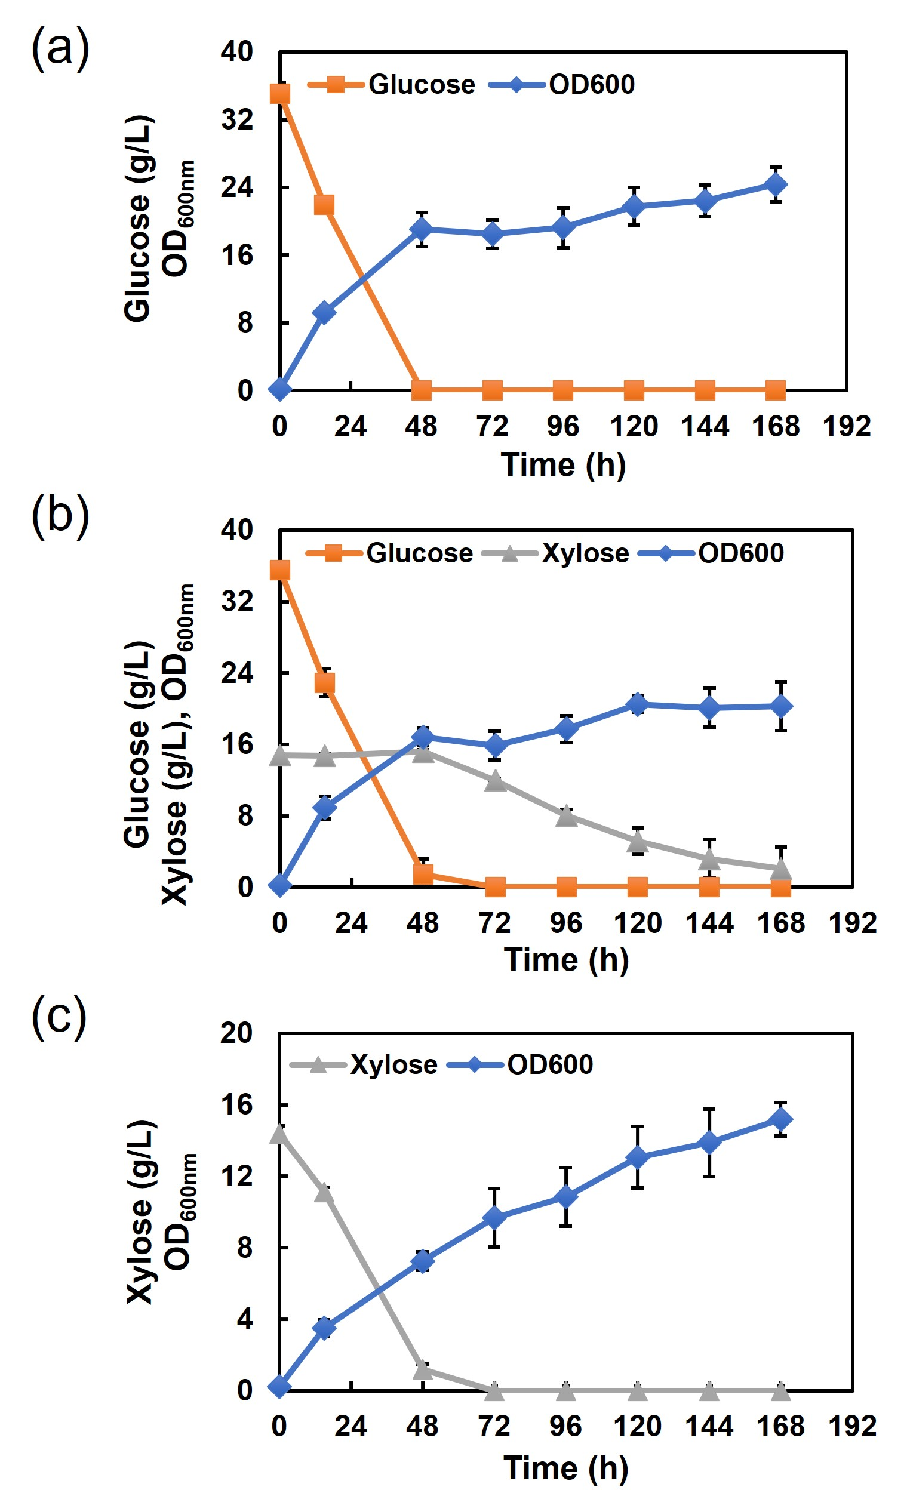

Figure S2. The vector maps of the major plasmids constructed in this study.

Figure S3. (a) The shikimate-to-norcoclaurine pathway. (b) Shikimate uptake by S. cerevisiae strains containing various combinations of genes from downstream pathway. (c) The growth curves of S. cerevisiae strains overexpressing ScAro7_{G141S}, ScAro1, and/or EcAroL together with AnQut1co in SC-his-leu-ura media plus 40 g/L glucose and 1 g/L shikimate. Enzymes: AnQut1, quinate permease from Aspergillus niger; Aro7_{G141S}, feedback resistant chorismate mutase mutant; AroL, shikimate kinase; Aro1, pentafunctional AROM polypeptide. Error bars represent standard deviations of triplicates.
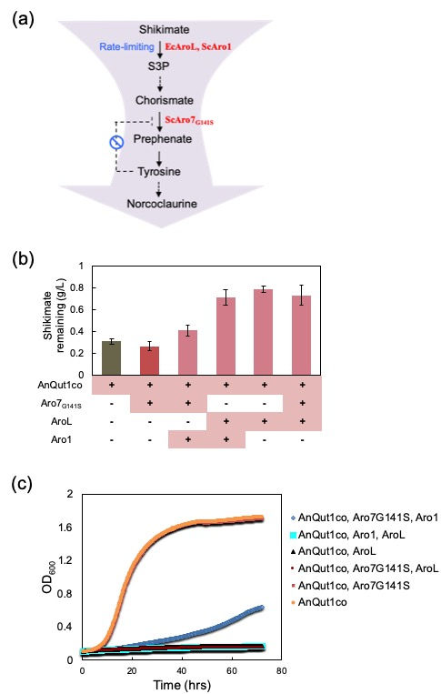
Figure S4. The chemical structures of quinate and shikimate.

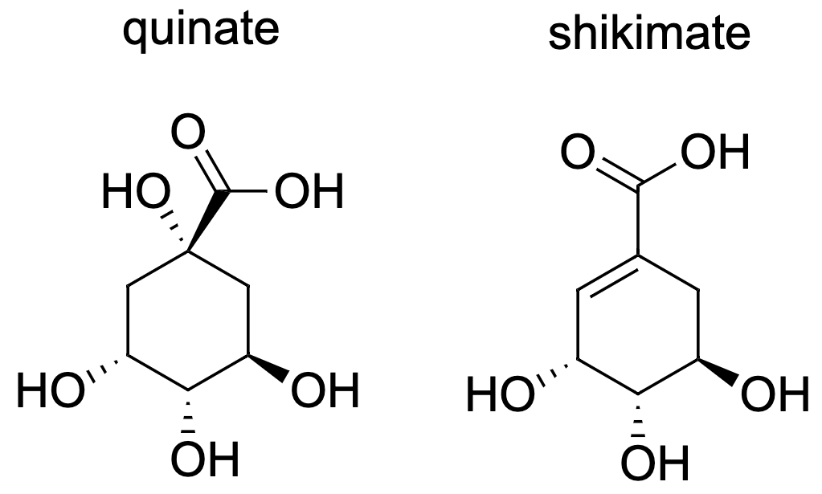

Figure S5. Shikimate utilization by NC3 monocultures to produce (S)-norcoclaurine. (a) Shikimate utilization profile of NC3 strain with different initial cell densities. (b) (S)-norcoclaurine titer from different initial cell densities. The NC3 strain was inoculated at different cell densities in 2xSC-his-leu-ura supplemented with 80 g/L glucose and 1 g/L shikimate. Samples were taken after four-day fermentation. Error bars represents the standard deviations of triplicates. Cells with density at five were selected for the subsequent co-culture setup.

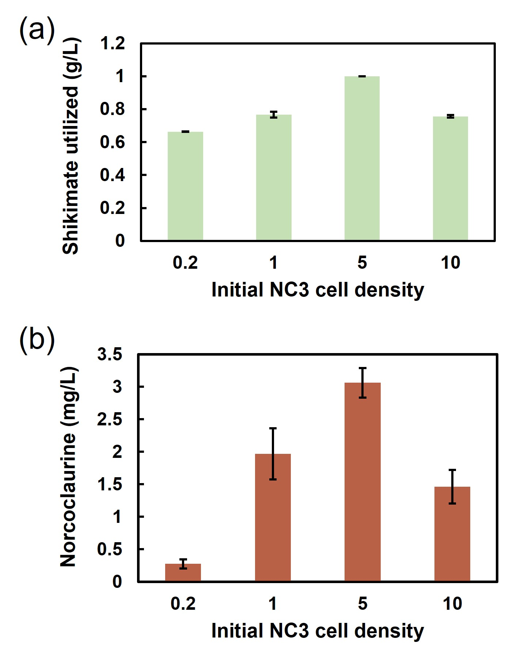

Figure S6. Quantification of shikimate remaining in the coculture consisting of SA4 and NC3. After strain SA4 was cultivated for 12 h, NC3 with cell density of five were inoculated into the culture. Error bars represents standard deviations of triplicates.

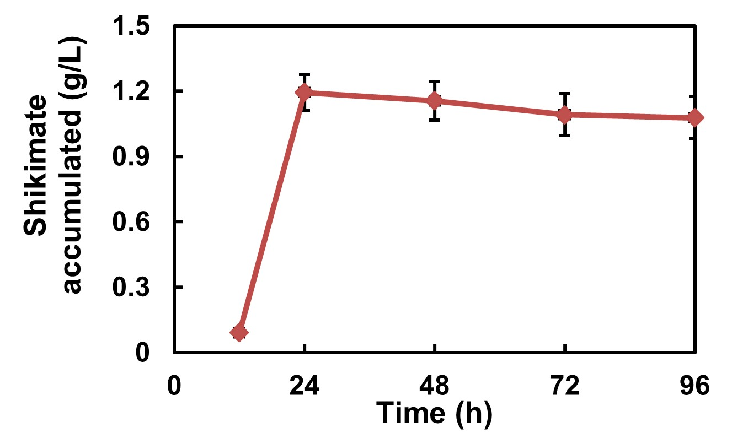

Figure S7. The performance of xylose transporters from other CUG yeasts in S. stipitis FPL-UC7 strain. The recombinant S. stipitis FPL-UC7 strains containing each of the transporters was cultured in SC-ura plus 70 g/L glucose and 40 g/L xylose with initial cell density of 10. The S. stipitis FPL-UC7 strain carrying the plasmid pMG-xyl was used as a negative control. Abbreviations: Cp, Candida parapsilosis; Cg, Candida guilliermondii; Ctr, Candida tropicalis; Ct, Candida tenuis; Ca, Candida albican; and Dh, Debaryomyces hansenii. Error bars represent standard deviations of triplicates. Asterisks indicate p values generated by independent unpaired t-tests. ✱✱ p < 0.01.

References

1. M. R. Gao et al., Innovating a Nonconventional Yeast Platform for Producing Shikimate as the Building Block of High-Value Aromatics. Acs Synth. Biol. 6, 29-38 (2017).
2. Z. Y. Shao, H. Zhao, H. M. Zhao, DNA assembler, an in vivo genetic method for rapid construction of biochemical pathways. Nucleic Acids Res. 37, (2009).
3. P. Lu, B. P. Davis, J. Hendrick, T. W. Jeffries, Cloning and disruption of the beta-isopropylmalate dehydrogenase gene (LEU2) of Pichia stipitis with URA3 and recovery of the double auxotroph. Appl. Microbiol. Biotechnol. 49, 141-146 (1998).
4. M. Cao et al., Centromeric DNA facilitates nonconventional yeast genetic engineering. ACS Synth. Biol. 6, 1545-1553 (2017).
5. K. Satoh et al., Candida auris sp. nov., a novel ascomycetous yeast isolated from the external ear canal of an inpatient in a Japanese hospital. Microbiol. Immunol. 53, 41 (2009).
6. R. M. Cadete et al., Spathaspora arborariae sp. nov., a d-xylose-fermenting yeast species isolated from rotting wood in Brazil. FEMS Yeast Res. 9, 1338-1342 (2009).

