Supplementary Material

Green Synthesis of Piper nigrum Copper-based Nanoparticles: In-Silico Study and ADMET Analysis to Assess Their Antioxidant, Antibacterial, and Cytotoxic Effects

Y. Anusha¹, Nambi Rajesh¹, M. Vidya Vani¹, Habeeb Khadri², Khateef Riazunnisa1*, Arifullah Mohammed³*, Ashaimaa Y. Moussa⁴

¹Department Biotechnology and Bioinformatics, Yogi Vemana University Kadapa, Andhra Pradesh, India-516005
²Department of Medical Laboratories, College of Applied Medical Sciences, Qassim University, Qassim 51452, Kingdom of Saudi Arabia.
³Department of Agriculture Science, Faculty of Agro-Based Industry, UniversitiMalaysiaKelantan,17600Jeli, Kelantan, Malaysia.
⁴Department of Pharmacognosy, Faculty of Pharmacy, Ain shams University, Cairo, Egypt, 11566
*Corresponding Authors. K. Riazunnisa, E-mail: khateefriaz@gmail.com, krbtbi@yogivemanauniversity.ac.in;
Ashaimaa Y. Moussa, Ashaimaa_yehia@pharma.asu.edu.eg;

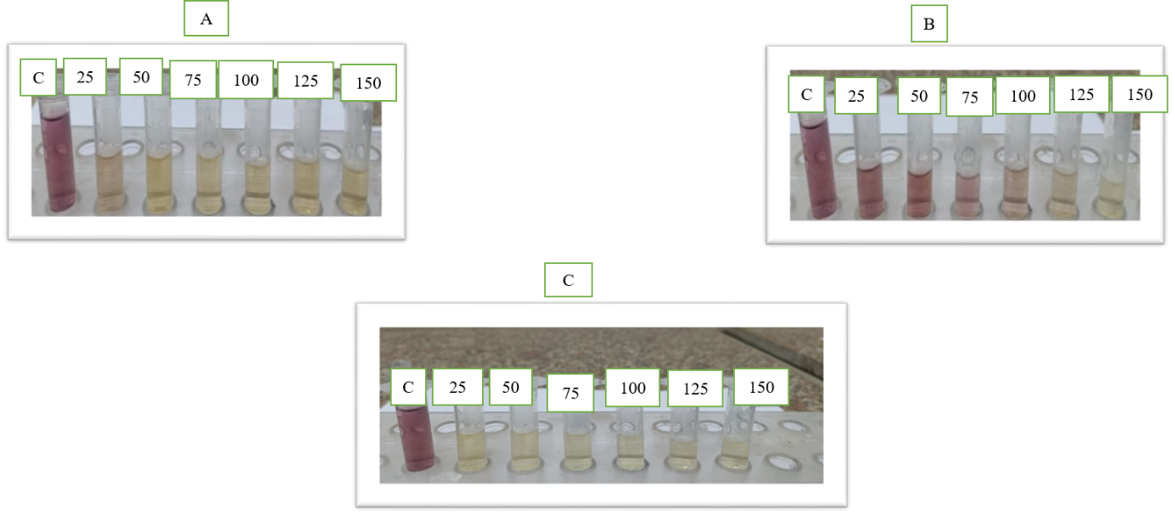

Fig. S1 _ Colour change of DPPH free radical scavenging activity of P. nigrum fruits extract and PN-CuNPs at various concentrations ranging from 25-150 µg/ml (a) PN-CuNPs (b) P. nigrum fruits extract (c) Ascorbic acid (positive control); C- Positive Control (Ascorbic acid).

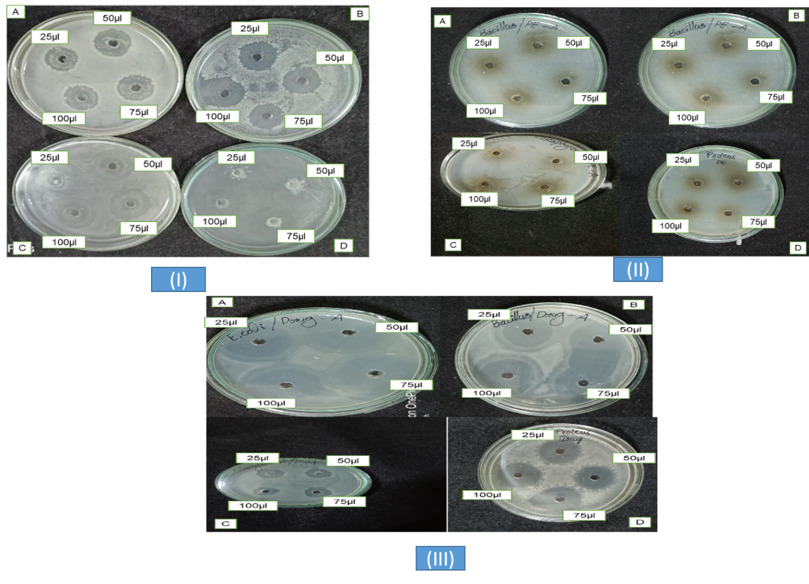
Fig. S2 _ Antibacterial zone of inhibition of P. nigrum fruits extract and PN-CuNPs along with positive control (Ampicillin) at various concentration ranging from 25-100 µg/ml. (I) Antibacterial activity of PN-CuNPs. (II) Antibacterial activity of P. nigrum fruits extract (III) Antibacterial activity of Positive control (Ampicillin). A. Staphylococcus aureus B. Bacillus subtilis; C. Escherichia coli; D. Proteus vulgaris.

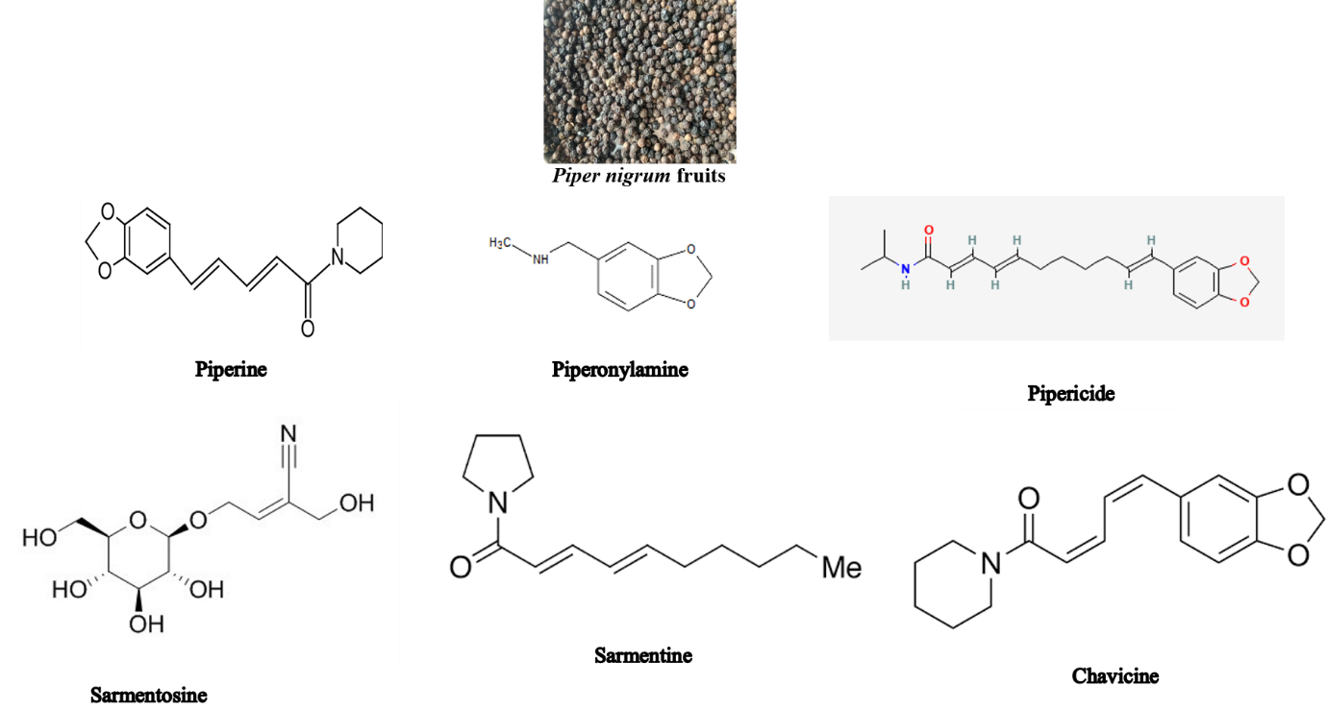

Fig. S3 Piper nigrum fruits and some main chemical structures adopted from Shityakov et al. [7]

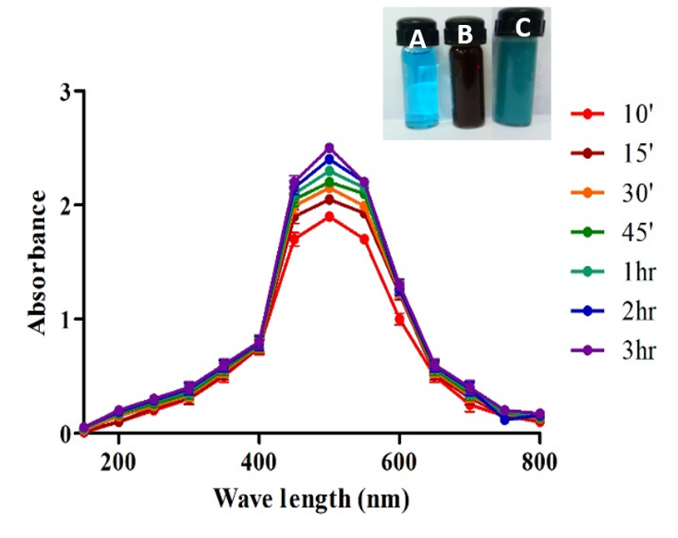
Fig. S4 UV visible spectrum of PN-CuNPs. Inset: color change from brown to blue (A) Copper acetate (B) P. nigrum fruits extract (C) PN-CuNPs.

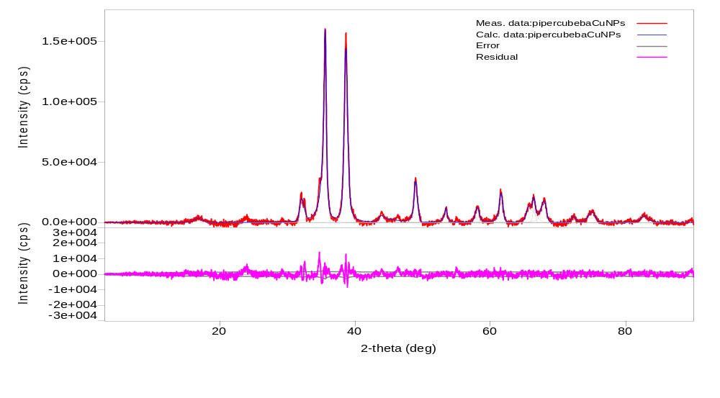
Fig.S5 XRD analysis of PN-CuNPs

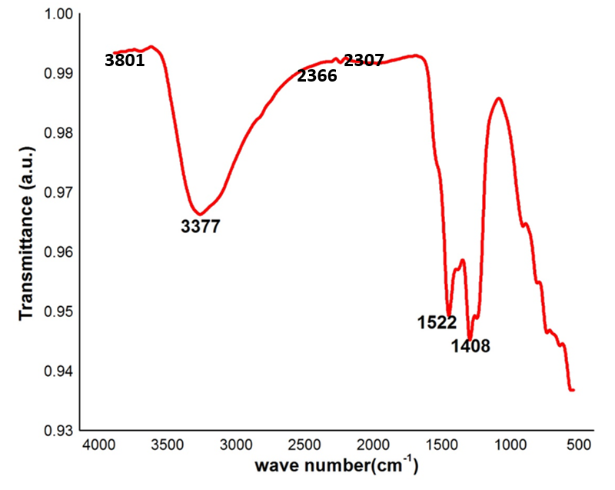
Fig.S6 FTIR spectrum of PN-CuNPs

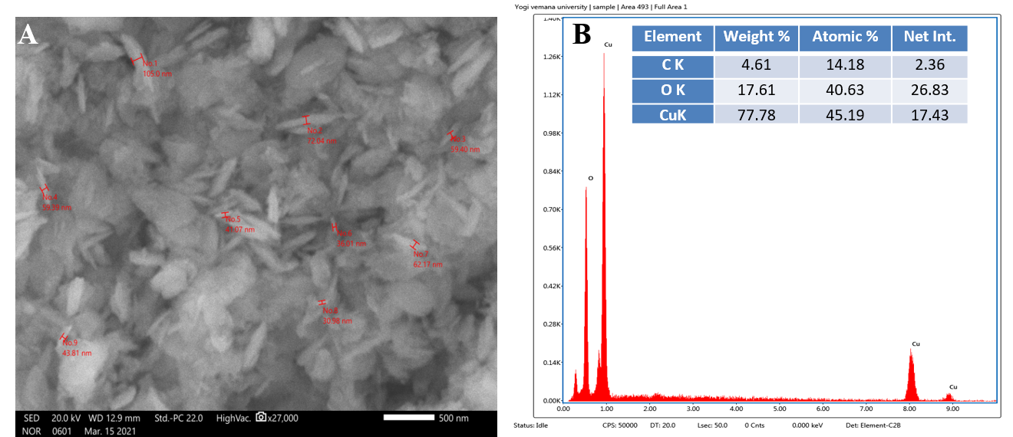
Fig.S7 (A) SEM image (B) EDX analysis of PN-CuNPs. Inset figure illustrates the elemental composition of nanoparticles.

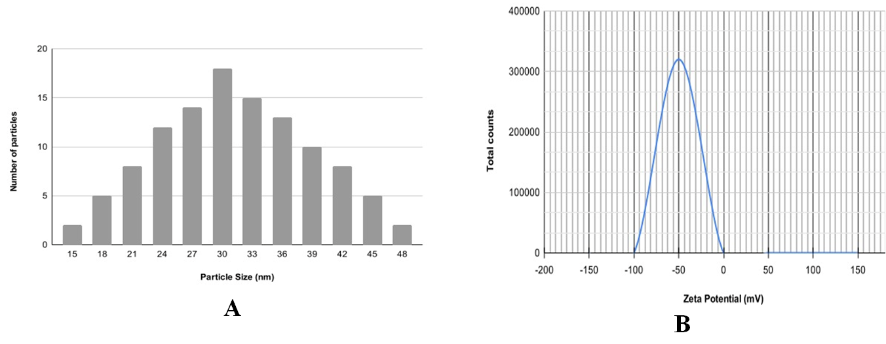
Fig.S8 (A) Particle size distribution and (B) zeta potential of PN-CuNPs

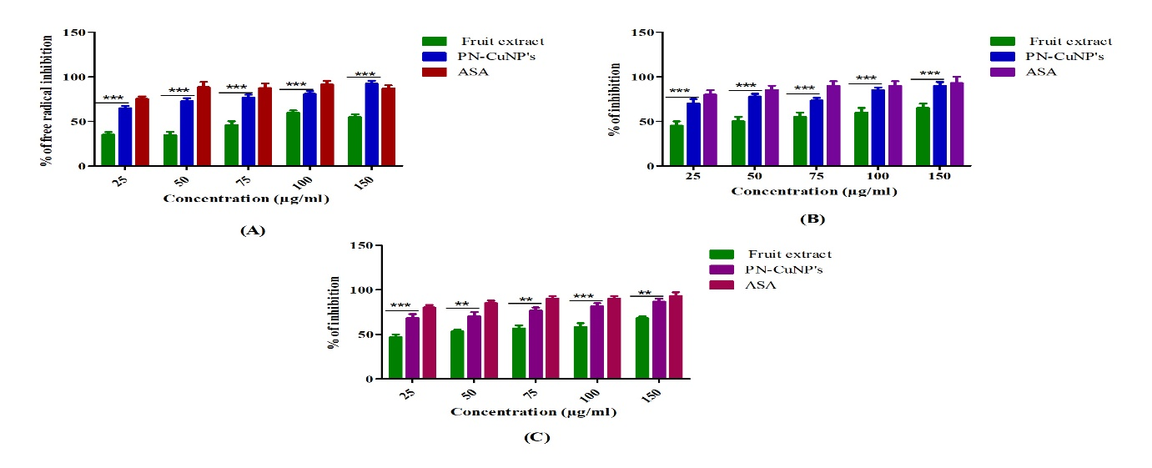
Fig.S9 Antioxidant activity of P. nigrum fruits extract and PN-CuNPs. (A) DPPH free radical scavenging activity of P. nigrum fruits extract and PN-CuNPs (B) Hydroxy radical scavenging activity of P. nigrum fruits extract and PN-CuNPs. (C) Total antioxidant activity of P. nigrum fruits extract and PN-CuNPs. All experiments were run in triplicates and values are expressed as mean ± SEM. PN-CuNPs; P. nigrum copper nanoparticles. ASA- Ascorbic acid (Positive control).
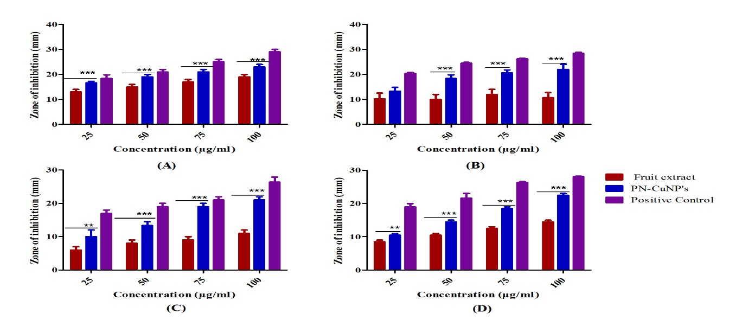
Fig.S10 Antibacterial activity of P. nigrum fruits extract and PN-CuNPs along with positive control (Ampicillin). A. Staphylococcus aureus B. Bacillus subtilis; C. Escherichia coli and D. Proteus vulgaris. The data in all figures was measured in at least 3 samples the mean of three replicates S.D. are shown. Statistical analysis was done using TWO WAY ANOVA. ∗ Denotes significant difference of positive control with test samples at P < 0.001.
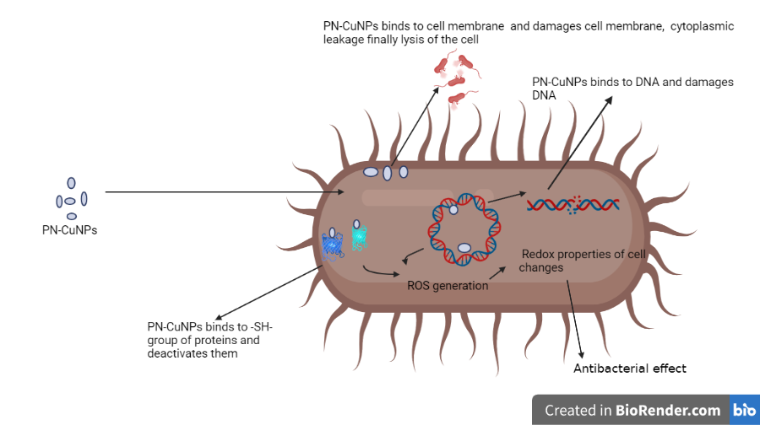
Fig.S11 Proposed mechanism of antibacterial activity of PN-CuNPs against pathogenic bacteria.

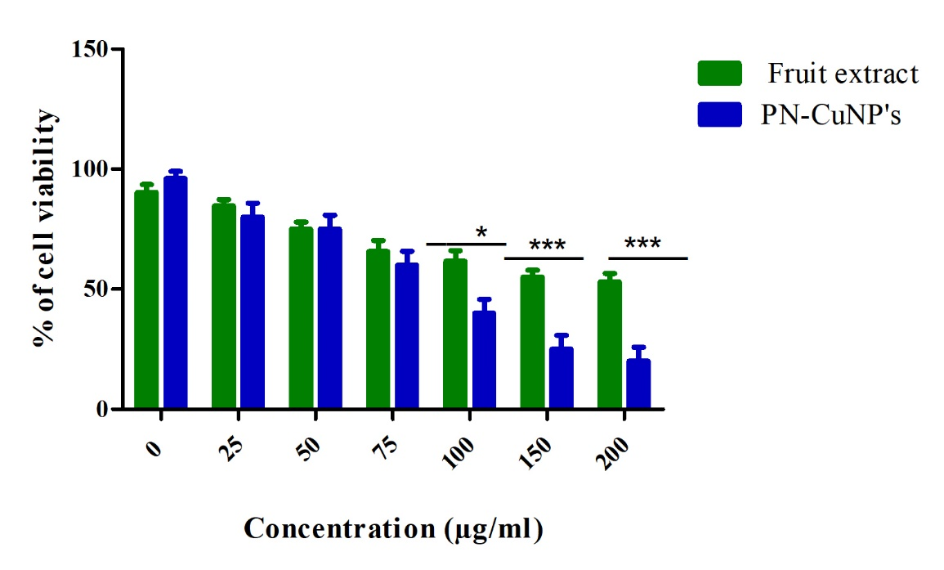
Fig.S12 Cytotoxicity activity of P. nigrum fruits extract and PN-CuNPs against MCF-7 cancerous cell lines. Data expressed as mean ± SD (n = 3). *** Indicates a significant increase relative to the untreated control (p < 0.001).

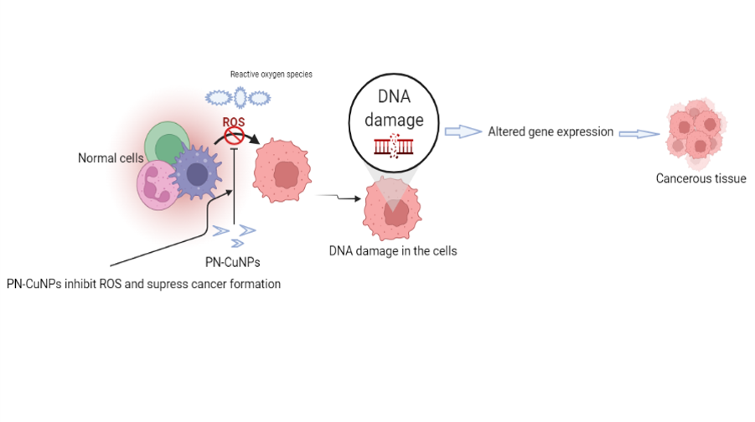
Fig. S13 Proposed mechanism of cytotoxicity of PN-CuNPs against MCF-7 cancerous cell lines.

Table S1. FT-IR analysis and probable functional groups of PN-CuNPs
PN-CuNPs wave  number | Probable functional group | Compound class
3801 | O-H strech | Alcohol
3377 | N-H stretch | Primary amine
2366 | Strong for C–H | Alkyne
2307 | Strong for C–H | Alkyne
1522 | C–H, C=C | Aromatic
1408 | O-H stretch | Alcohol

Supplementary legends
Figure S1: Colour change of DPPH free radical scavenging activity of P. nigrum fruits extract and PN-CuNPs at various concentrations ranging from 25-150 µg/ml (a) PN-CuNPs (b) P. nigrum fruits extract (c) Ascorbic acid (positive control); C- Positive Control (Ascorbic acid).
Figure S2: Antibacterial zone of inhibition of P. nigrum fruits extract and PN-CuNPs along with positive control (Ampicillin) at various concentration ranging from 25-100 µg/ml. (I) Antibacterial activity of PN-CuNPs. (II) Antibacterial activity of P. nigrum fruits extract (III) Antibacterial activity of positive control (ampicillin). A. Staphylococcus aureus B. Bacillus subtilis; C. Escherichia coli; D. Proteus vulgaris.
Figure S3: Piper nigrum fruits and some main chemical structures adopted from Shityakov et al.
Figure S4: UV visible spectrum of PN-CuNPs. Inset: color change from brown to blue (A) Copper acetate (B) P. nigrum fruits extract (C) PN-CuNPs.
Figure S5 XRD analysis of PN-CuNPs
Figure S6 FTIR spectrum of PN-CuNPs
Figure S7 (A) SEM image (B) EDX analysis of PN-CuNPs. Inset figure illustrates the elemental composition of nanoparticles.

Figure S8 (A) Particle size distribution and (B) zeta potential of PN-CuNPs
Figure S9 Antioxidant activity of P. nigrum fruits extract and PN-CuNPs. (A) DPPH free radical scavenging activity of P. nigrum fruits extract and PN-CuNPs (B) Hydroxy radical scavenging activity of P. nigrum fruits extract and PN-CuNPs. (C) Total antioxidant activity of P. nigrum fruits extract and PN-CuNPs. All experiments were run in triplicates and values are expressed as mean ± SEM. PN-CuNPs; P. nigrum copper nanoparticles. ASA- ascorbic acid (positive control).
Figure S10 Antibacterial activity of P. nigrum fruits extract and PN-CuNPs along with positive control (ampicillin). A. Staphylococcus aureus B. Bacillus subtilis; C. Escherichia coli and D. Proteus vulgaris. The data in all figures was measured in at least 3 samples the mean of three replicates S.D. is shown. Statistical analysis was done using TWO WAY ANOVA. ∗ Denotes significant difference of positive control with test samples at P < 0.001.
Figure S11 Proposed mechanism of antibacterial activity of PN-CuNPs against pathogenic bacteria.
Figure S12 Cytotoxicity activity of P. nigrum fruits extract and PN-CuNPs against MCF-7 c
Figure S13 Proposed mechanism of cytotoxicity of PN-CuNPs against MCF-7 cancerous cell lines. Data expressed as mean ± SD (n = 3). *** Indicates a significant increase relative to the untreated control (p < 0.001).

