Supplementary information
2D carbon network arranged into high-order 3D nanotube arrays on flexible microelectrode: integrated in electrochemical micro-biosensor devices for cancer detection
Yimin Sun¹, Xulin Dong², Yan Zhang², Kai Chi², Yun Xu², Muhammad Asif¹, Wenshan He³, Kin Liao⁴ and Fei Xiao^{2,5}

Correspondence: Fei Xiao (xiaofei@hust.edu.cn), Wenshan He (hewenshan@hust.edu.cn) or Kin Liao (kin.liao@ku.ac.ae)
¹ Hubei Key Laboratory of Plasma Chemistry and Advanced Materials, School of Materials Science and Engineering, Wuhan Institute of Technology, Wuhan 430073, P.R China
² Key laboratory of Material Chemistry for Energy Conversion and Storage, School of Chemistry and Chemical Engineering, Huazhong University of Science & Technology, Wuhan 430074, P. R. China
³ Department of Breast and Thyroid Surgery, Union Hospital, Tongji Medical College, Huazhong University of Science and Technology, Wuhan 430022, China.
⁴ Department of Aerospace Engineering, Khalifa University of Science and Technology, P. O. Box 127788, Abu Dhabi, United Arab Emirates
⁵ Shenzhen Huazhong University of Science and Technology Research Institute Shenzhen 518000, P. R. China

Experimental section
Electrodeposition of ZnO-NRAs on CF microelectrode
The electrodeposition of ZnO-NRAs on CF was carried out in a two-electrode system at a current density of 0.8 mA cm⁻² using ACF as the working electrode, and a pure Zn (99.99% purity) rod as both the counter electrode and the reference electrode. The electrolyte Zn(NH₃)₄(NO₃)₂ solution was prepared by dropwisely adding the ammonium hydroxide (28% NH₃ in water, 99.99%) into 0.2 M zinc nitrate hexahydrate (Zn(NO₃)₂·6H₂O, 98%) aqueous solution until the solution became clear, with a pH value of ~10. During the electrodeposition process, the electrochemical cell was heated at 85 °C by placing in oil bath for 4 h. Then, the product was washed by deionized water and dried in room temperature.

Preparation of microfluidic electrochemical chip
The microfluidic chip was elaborately designed using AutoCAD 2008 software (Autodesk, U.S.A.) and fabricated by Mesobiosystem Co., Ltd (Wuhan, China). The top layer and substrate layer (length: 55 mm; width: 25 mm) were made of polycarbonate (PC), with inlet and outlet channels on top layer. The layer sandwiched between the top layer and substrate layer are the detection chamber (diameter: 4 mm; depth: 0.5 mm) with flow channel (width: 0.5 mm; depth: 0.5 mm), which prepared by photolithography and polydimethylsiloxane (PDMS) curing molding processes.

Characterization
SEM was carried out on a FEI, Nova NanoSEM 450 microscope with an acceleration voltage of 10 kV. TEM and corresponding energy-dispersive spectrometer (EDS) were acquired from a JEOL-2100 microscope operated at 200 kV acceleration voltage. XRD pattern was recorded using a diffractometer (X’Pert PRO, Panalytical B.V., Almelo, The Netherlands) equipped with a Cu-Ka radiation source (λ=1.5406 Å). XPS was performed on a Kratos-Axis spectrometer with monochromatic Al-Ka (1486.71 eV) X-ray radiation (15 kV and 10 mA). The molecular weight of P[VEIM]BF₄ was measured by GPC (Waters GPC 1515). CV and amperometric experiments for the electrochemical characterization. were carried out on a CHI660E electrochemical workstation (CH Instrument Company, Shanghai, China) by using a standard three-electrode system, with flexible NBP-CNW-NTAs/CF WE, commercial Pt wire CE and Ag/AgCl RE. The electrochemical tests of the cells and tissue samples were performed by a portable bipotentiostat (μStat200, Metrohm DropSens AG).

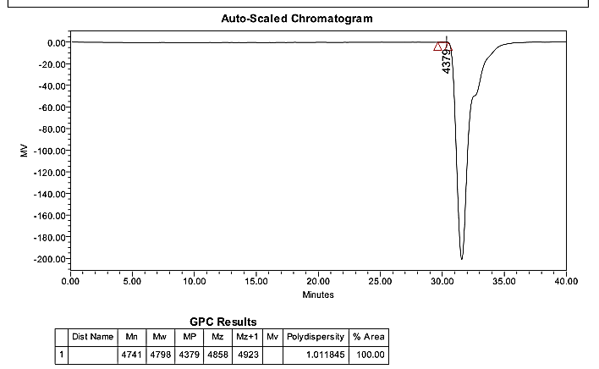
Fig. S1 GPC results of P[VEIM]BF₄.

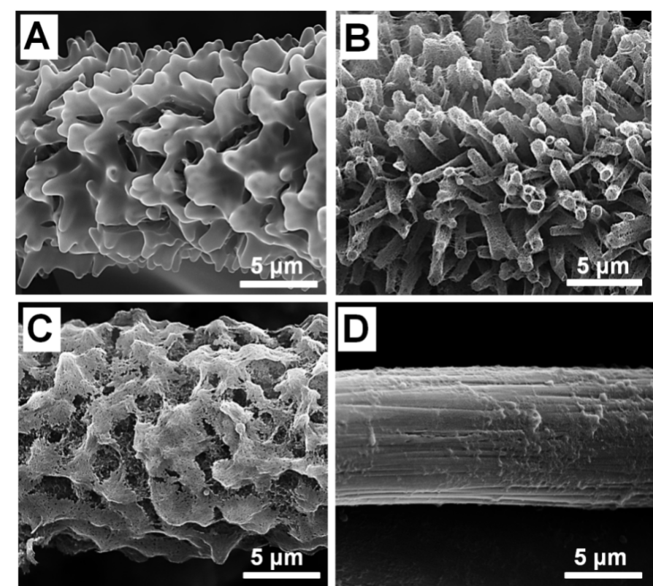
Fig. S2 SEM images of carbon nanomaterials synthesized on CF substrate using IL precursor of [VEIM]BF₄ and [OMIM]PF₆ with different volume ratio. (A) NB-CNTAs synthesized using pure [VEIM]BF₄, (B) NBP-CNW-NTAs synthesized using [VEIM]BF₄ and [OMIM]PF₆ with volume ratio of 4:1, (C) NBP-CNWs synthesized using [VEIM]BF₄ and [OMIM]PF₆ with volume ratio of 1:1, (D) Carbonaceous material synthesized using pure [OMIM]PF₆.

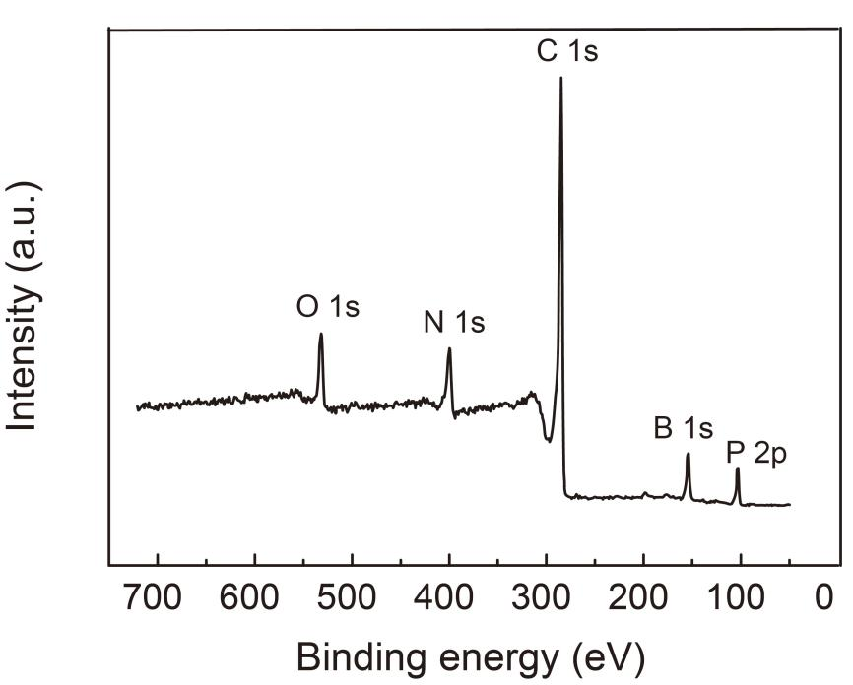
Fig. S3 XPS survey spectrum of NBP-CNW-NTAs.

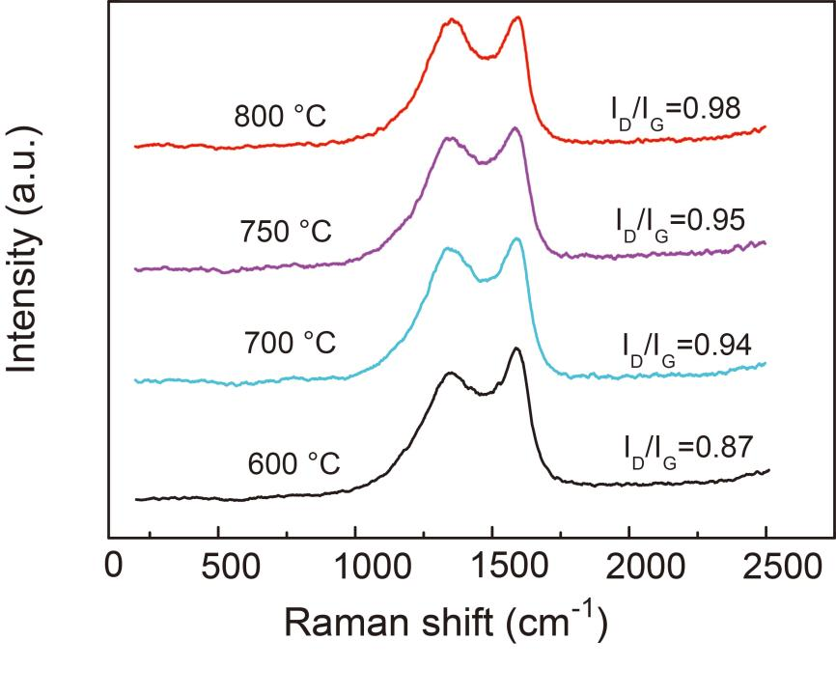
Fig. S4 Raman spectrum of NBP-CNW-NTAs/CF treated in different temperature.

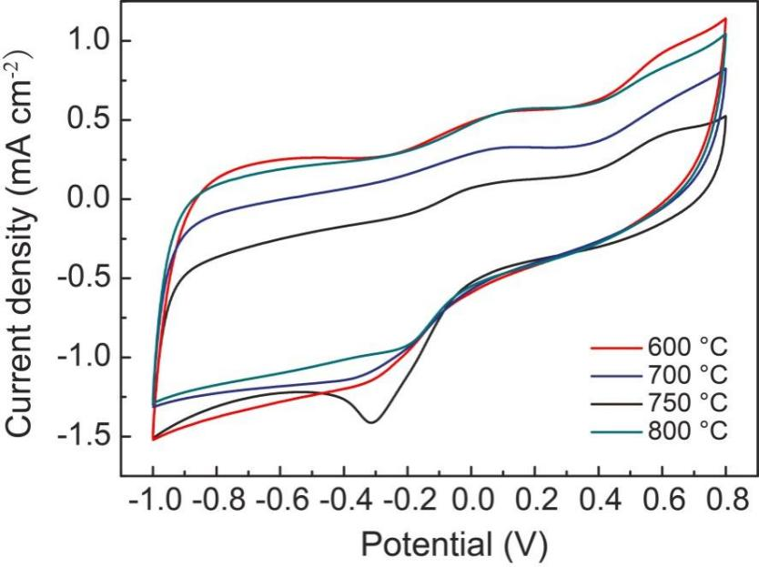
Fig. S5 CV curves of NBP-CNW-NTAs/CF microelectrode carbonized at different temperature in 0.1 mol L⁻¹ PBS solution (pH 7.4) containing 8 mM H₂O₂.

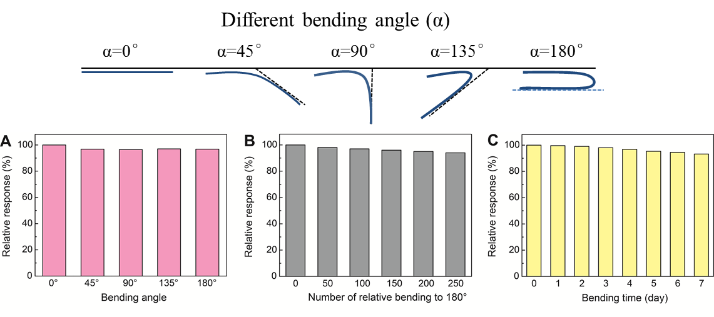
Fig. S6 Relative amperometric response of NBP-CNW-NTAs/CF microelectrode to 0.5 mM H₂O₂ under different bending statuses: (A) bending of the flexible microelectrode to different angle, (B) the number of repeated bending of the flexible microelectrode to 180°, (C) the time of the flexible microelectrode being bending to 180°.

