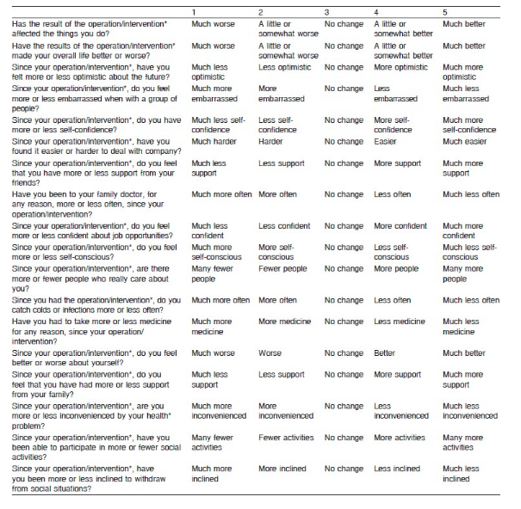
Additional file 1. The Glasgow Benefit Inventory Questionnaire using 5-point Likert scale

