CaSR modulates proliferation of the superficial zone cells in temporomandibular joint cartilage via the PTHrP nuclear localization sequence

Table S1. Primers for genotyping
Genes Forward primer Reverse primer
CaSR^{flox/flox} GTGACGGAAAACATACTGC CGAGTACAGGCTTTGATGC
PTHrP^{flox/flox} GAGGCTAAGCCAGGAGGATT CCCCATCCTCTCTCCTCTCT
Prg4^{creET2} TGACTATCTCAGGAATTCAAGCTG CGCTTTTGACGCTGAAGTTAC

Supplementary Figures

Supplemental figure 1 (figure S1). The negative control of immunofluorescent with mouse antibodies.
The sections were stained with PBS (A), IgG2a Mouse IgG2a kappa Monoclonal (B), CaSR primary antibody with CaSR fusion protein (C), CaSR primary antibody (D), and the anti-mouse secondary antibodies. The tissue between the two white dotted lines is the full zone condyle cartilage, and above the yellow dotted line is the condyle superficial zone cartilage. Scale bar, 100μm.

Supplemental figure 2 (figure S2). The expression of Prg4 in condylar cartilage of mice.
(A) IF staining of TMJ condylar cartilage of 6-week-old TDT-Prg4-Cre^{ERT2} mice, which was intraperitoneally injected with tamoxifen for 3-days. Prg4-Positive cells were all located in the superficial zone of cartilage. (B) The statistics of cartilage thickness expressing Prg4+ of mice. The tissue between the two white dotted lines is the full zone condyle cartilage, and above the yellow dotted line is the condyle superficial zone cartilage. Scale bar, 100μm. n=6. Values are represented as the mean with lower and upper limits of 95% CI.

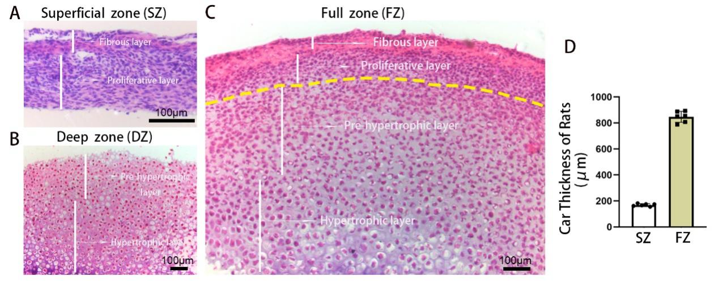

Supplemental figure 3 (figure S3). Cell phenotype of each layer of condylar cartilage.
(A) HE staining of the superficial zone, deep zone, and full zone TMJ cartilage from 3-week-old female rats. (B)The statistics of the thickness of rats’ superficial zone and full zone condylar cartilage. The tissue above the yellow dotted line is the condyle superficial zone cartilage. Scale bar, 100μm. n= 6. Values are represented as the mean with lower and upper limits of 95% CI.

Supplemental figure 4 (figure S4). The timeline of the whole process of the experiment and genotyping of mice.
(A) At 6 weeks of age, CaSR^{flox/flox}; Prg4-Cre^{ERT2} and PTHrP^{flox/flox}; Prg4-Cre^{ERT2} mice were treated with TM (0.1 mg/g of body weight for 5 days). On the second day, BAE was applied. If needed, local injection of PTHrP₈₇₋₁₃₉ peptide or Cinacalcet in TMJ was applied every 2 days at 9 weeks of age for 4 weeks. (B) Genotyping confirmed the presence of the Cre and flox transgene in CaSR^{flox/flox}; Prg4-Cre^{ERT2} and PTHrP^{flox/flox}; Prg4-Cre^{ERT2} homozygote mice and its absence in wild-type mice.

